9. Perform Rotation of an image to clockwise and counter clockwise direction.

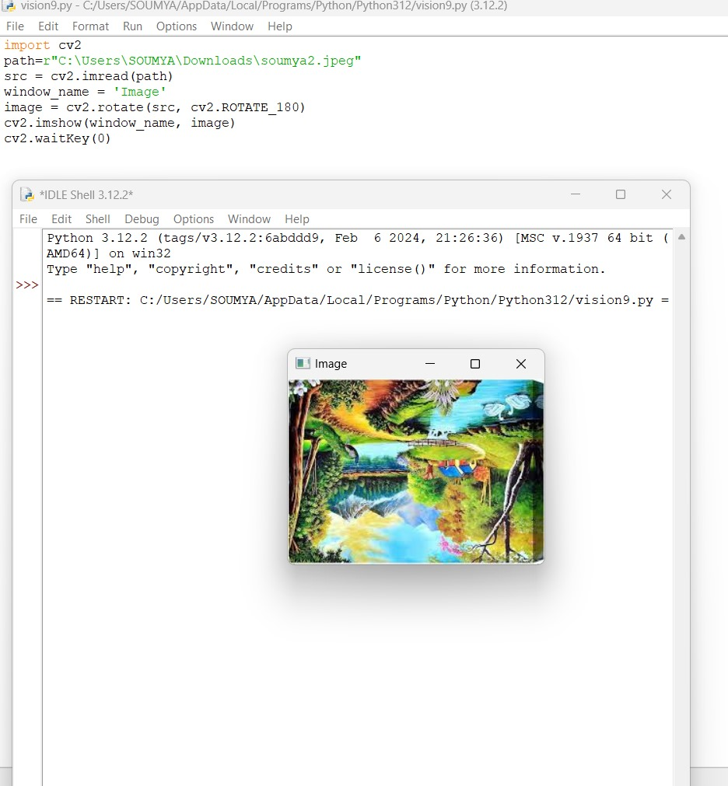

11. Perform Affine Transformation on the image.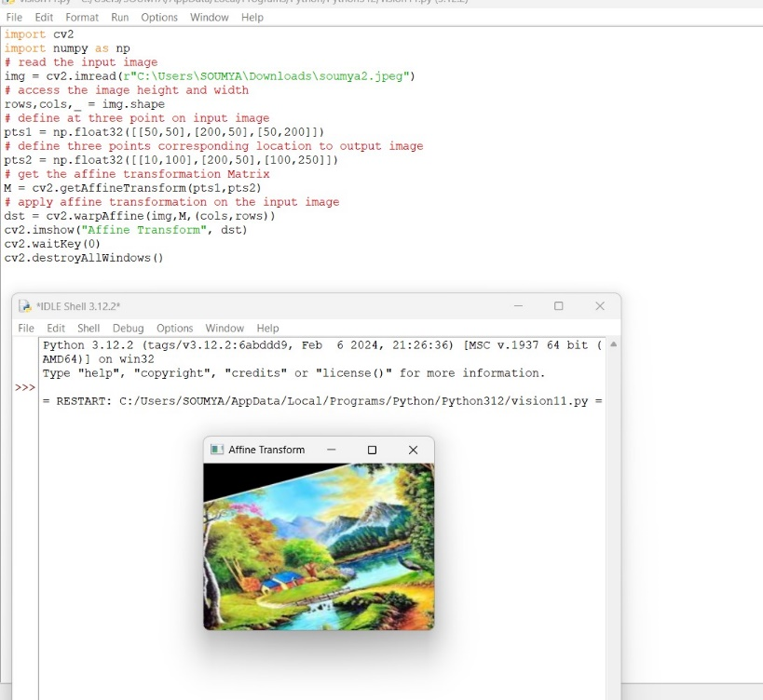

12. Perform Perspective Transformation on the image.

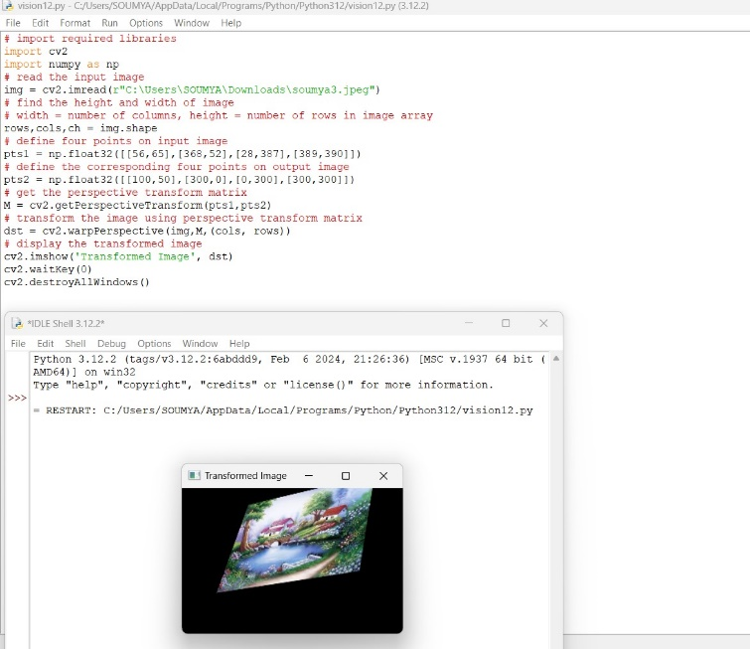

13. Perform Perspective Transformation on the Video.

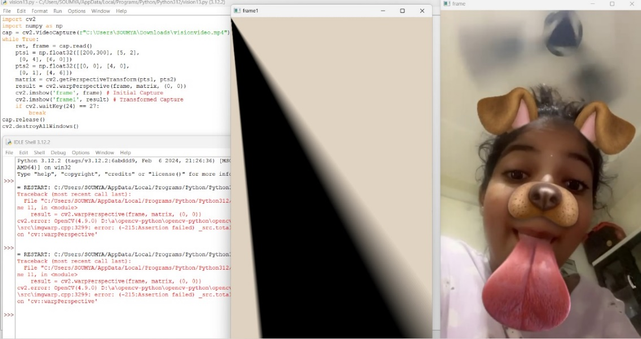

14. Perform transformation using Homography matrix.

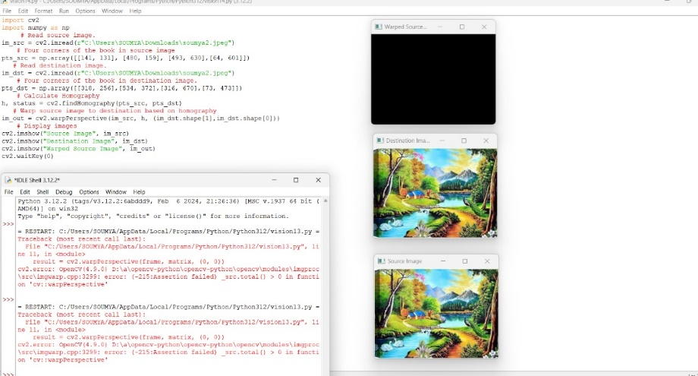

15. Perform transformation using Direct Linear Transformation

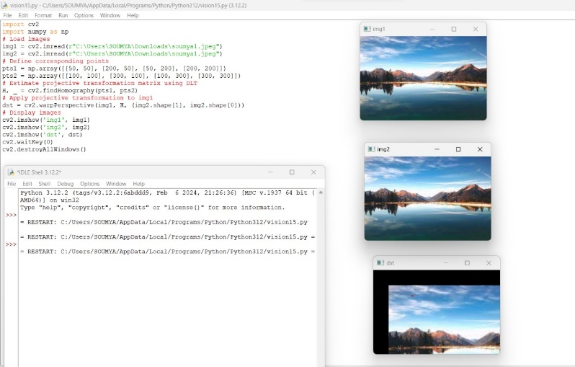

16. Perform Edge detection using canny method

