

**Supply Chain Management (SCM)**

**Overview:**  
  
**Supply Chain Management (SCM)** defines the overall responsibility and coordination of the logistics of making products and services. This concerns all the processes starting from the acquisition of the inputs that are necessary in the production process all the way down to the distribution and sale of the product to the final user. **Supply Chain Planning (SCP)** comprises of more activities like sourcing, procurement, conversion, and the management of the material or product. It also requires proper management and interaction with partners and other associates like suppliers, intermediaries, third party service providers, customers etc.

**Purpose:**

SCM’s main purpose is to optimize every process involved so that every segment works the most effectively with the other segments. This is a comprehensive approach to ensuring that in the production and delivery of the products, costs and time are optimally used in a way that the customer’s needs are met and at the same time the demanded quality is achieved.   
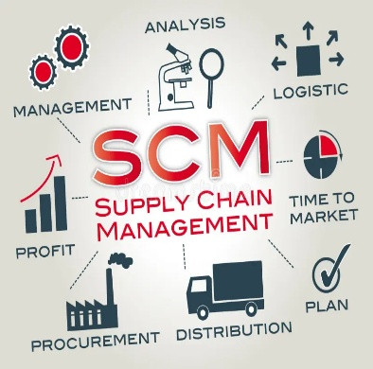

**Stages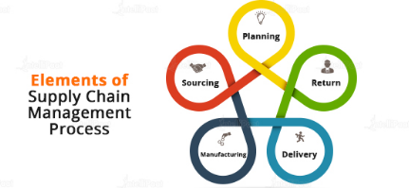:**  
**A) Operation Diagnosis & Development of Operation Plan**  
**B) Sourcing**  
**C) Manufacturing**  
**D) Delivery**  
**E) Returns**

**Key Points:**  
**1) Integration:**  
The effective SCM can only occur if internal and external supply and demand are fully synchronized.

This integration involves:  
**A) Vertical Integration:** Coordinating processes within the company, of the buyer, manufacturer and seller organizations integrated in an overall supply chain system.  
**B) Horizontal Integration:** Creating a system of external working relationships with suppliers and distributors — both internal and external — with the aim of attaining better cooperation and sharing of information.  
**C) End-to-End Visibility:** The following management responsibilities are achieved: making sure all parties have access to up-to-date information to improve the supply chain.

**2) Efficiency:**  
SCM centers on the efficient workflows to cut expenses and bring an enhancement of the consumer satisfaction levels.

Key efficiency strategies include:  
**A) Lean Manufacturing:** These major goals can therefore be explained as follows: consolidation and minimization of wastage with a view to increasing the efficiency of production processes.  
**B) Just-In-Time (JIT) Inventory:** Another corporate strategy to reduce inventory levels includes aligning the production calendar with near-term sales expectations.

**3) Technology:**

Advanced technologies play a crucial role in modern SCM by enhancing transparency, efficiency, and decision-making capabilities:

**A) Internet of Things (IoT):** It enables real-time tracking and monitoring of goods throughout the supply chain, improving inventory management and reducing loss.

**B) Artificial Intelligence (AI):** This helps to do predictive analytics to forecast demand, optimize routes, and manage inventory levels.

**C) Blockchain:** It provides a secure and transparent ledger for recording transactions, ensuring traceability and authenticity of products.

## **4) Risk Management:**

Identifying and mitigating risks within the supply chain is essential to ensure continuity and resilience:

**A) Risk Assessment:** Regularly evaluating potential risks such as supply disruptions, natural disasters, and geopolitical issues is a crucial factor.

**B) Contingency Planning:** Developing and implementing plans to respond to and recover from supply chain disruptions.

**C) Supplier Diversification:** Reducing dependency on a single supplier by diversifying the supplier base.

## **5) Sustainability:**

Sustainable SCM practices aim to minimize environmental impact and improve social responsibility:

**A) Green Logistics:** Implementing eco-friendly transportation and warehousing practices to reduce carbon footprint.

**B) Circular Economy:** Promoting recycling, reusing, and remanufacturing to extend product lifecycles and reduce waste.

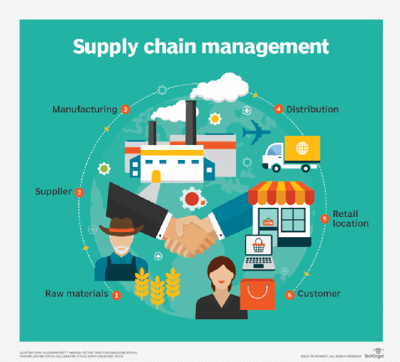

**Examples:**

## **1) Apple Inc.:**

Apple’s supply chain is widely recognized for its efficiency and innovation. Key aspects of Apple’s SCM include:

**A) Strong Supplier Relationships:** Apple maintains close partnerships with suppliers to ensure high-quality standards and reliable delivery schedules.

**B) Advanced Logistics:** It utilizes sophisticated logistics networks and real-time data to manage inventory and distribution effectively.

**C) Flexibility and Scalability:** Apple’s supply chain is designed to be flexible and scalable, allowing the company to quickly respond to changes in demand and market conditions.

## **2) Walmart:**

Walmart’s SCM is a benchmark for retail efficiency and cost management. Key elements of Walmart’s SCM include:

**A) Extensive Distribution Network:** This company operates one of the largest and most efficient distribution networks globally, ensuring timely delivery of products to stores.

**B) Advanced Data Analytics:** It uses big data and analytics to optimize inventory levels, forecast demand, and streamline replenishment processes.

**C) Supplier Collaboration:** It works closely with suppliers to reduce costs and improve product availability, using technologies like Electronic Data Interchange (EDI) for seamless communication and transactions.

In conclusion, effective Supply Chain Management is critical for achieving operational excellence, reducing costs, and enhancing customer satisfaction. By leveraging integration, efficiency strategies, advanced technologies, robust risk management, and sustainable practices, organizations can build resilient and competitive supply chains that meet the demands of the modern market.

**Mobility in Supply Chain**

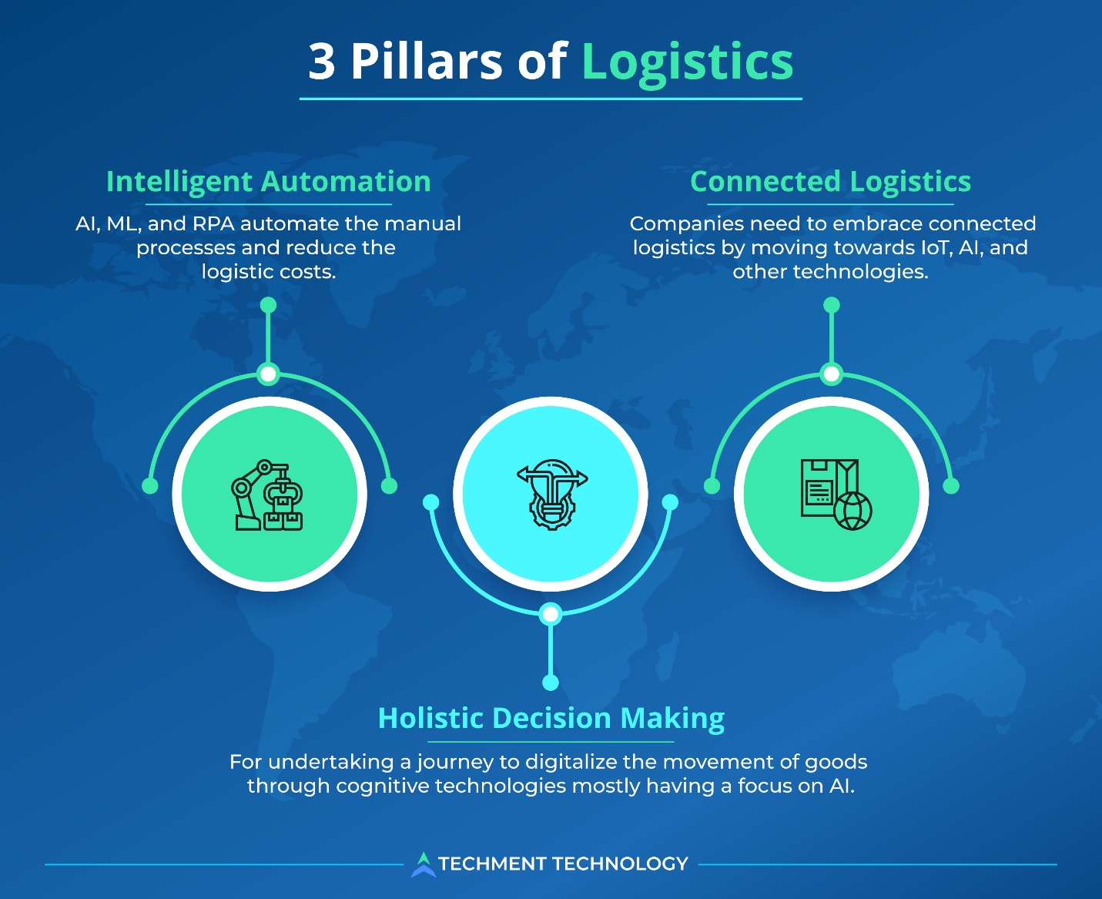

## **1. Overview:**

Mobility and supply chain engineering involves organizing transportation and supply networks, including trains, metros, buses, shared bikes, boats, terminals, warehouses, and trucks. Engineers work behind the scenes to optimize these systems and ensure smooth operations.

## **2. Levels of Transportation Systems:**

The systems operate on multiple levels: individual activities, company supply chains, and operational flows of vehicles and objects competing for resources in transportation infrastructures like roads, rails, and terminals. These systems are constantly evolving with new production methods, service concepts, and economic models.

## **3. Technological Innovations:**

The field is driven by technology that brings about constant innovation, such as e-commerce logistics, drone deliveries, and mobility as a service (e.g., autonomous taxis). Engineers need to manage and optimize these technologies to create sustainable and efficient transportation systems.

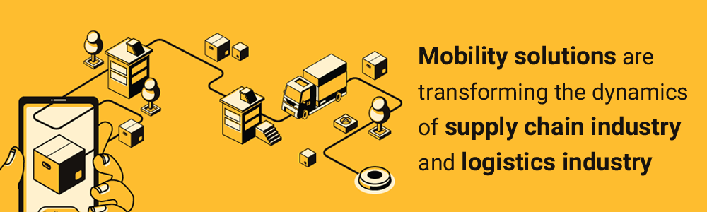

# **Reverse Logistics**

**Reverse logistics** is an essential operational procedure that adds value to the reverse flow of the supply chain. It involves the movement of products from customers back to the manufacturer. This process includes planning and executing the reverse flow of products in a cost-effective and efficient manner.

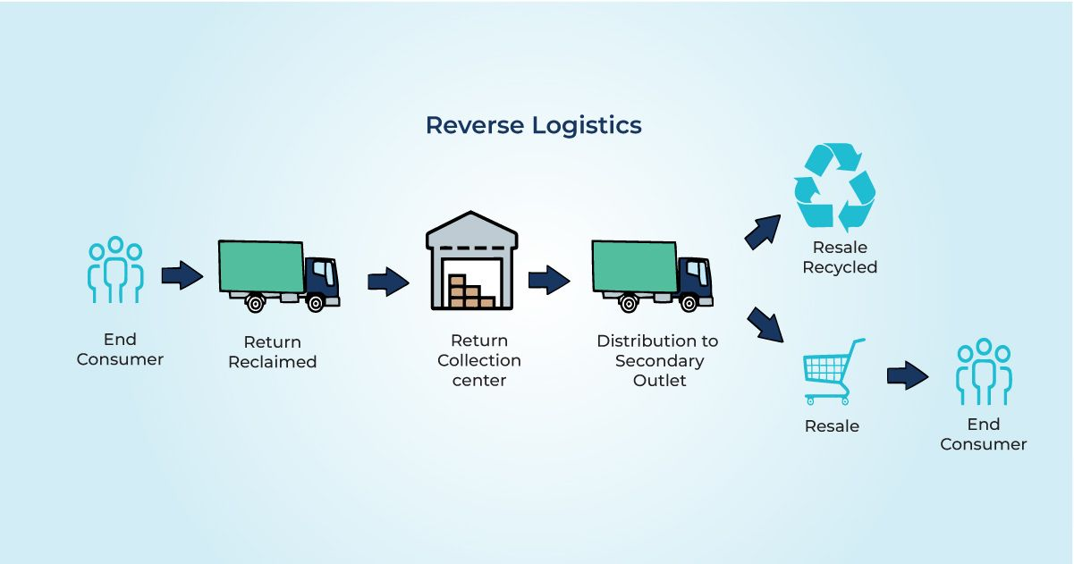

**Reasons for Returned Goods:**

1. **Refurbishing:** Repairing and restoring products to a like-new condition.
2. **Warranty Claims:** Handling products that are returned due to warranty issues.
3. **Remanufacturing:** Disassembling used products and rebuilding them with new or refurbished parts.
4. **Reuse of Packaging:** Returning and reusing packaging materials to reduce waste.

**Purposes of Returning Goods:**

**A) Reduce Waste:** Minimizing waste by reducing the number of returns through improved quality control and customer service.

**B) Reuse:** Extending the life cycle of products and packaging by reusing them.

**C) Recycle:** Processing returned goods to reclaim raw materials and reduce environmental impact.

**Rewards of Effective Reverse Logistics:**

**A) Increased Customer Satisfaction:** Providing efficient return processes enhances customer trust and satisfaction.

**B) Enhanced Brand Image:** Companies that manage returns well can improve their reputation and brand image.  
**C) Increased Loyalty:** Efficient reverse logistics can foster customer loyalty as customers feel confident in the return process.

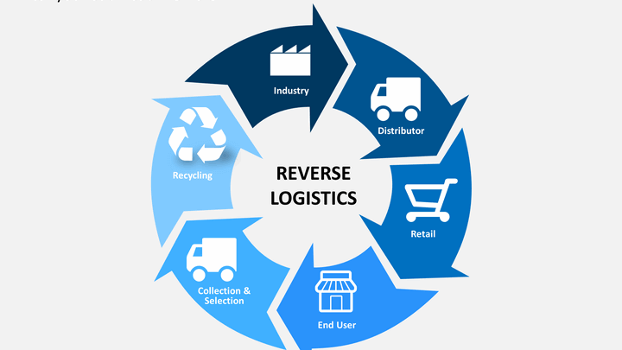

# **Collaborative Planning, Forecasting, and Replenishment (CPFR)**

**CPFR** is a strategic framework that involves multiple parties working together to collaboratively plan and fulfill customer demand. This approach was first introduced by **Walmart and Procter & Gamble (P&G).**

CPFR exemplifies how collaboration among various stakeholders in the supply chain can lead to significant improvements in efficiency, cost savings, and customer satisfaction.

**Stages:**

1. **Strategy & Planning**
2. **Demand & Supply Chain Management** 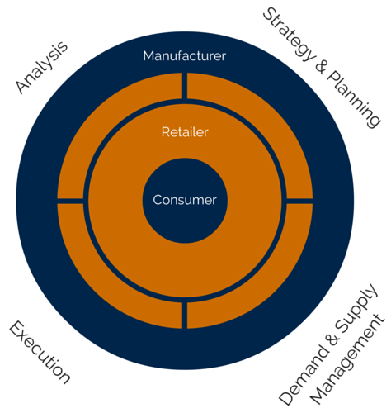
3. **Execution**
4. **Analysis**

**Key Players:**

1. **Consumer**
2. **Retailer**
3. **Manufacturer**

**Key Aspects of CPFR:**

1. **Collaborative Planning:** Multiple trading partners work together to plan production and inventory levels based on shared forecasts.
2. **Forecasting:** Jointly predicting customer demand to ensure that the right products are available at the right time.
3. **Replenishment:** Efficiently managing inventory to ensure timely restocking of products.

**Benefits of CPFR:**

1. **Efficient Inventory Movement:** It ensures that inventory is moved efficiently, in the right quantity, and at the right time to meet customer needs.
2. **Cost Reduction:** Collaborating with multiple trading partners can reduce the costs associated with inventory management and production.
3. **Improved Sales and Revenue:** By meeting customer demand more effectively, companies can improve sales and increase revenue.