|  |
| --- |
|  |
| COMPUTER PROJECT |
| **A Food Delivery App** |
|  |
| **By Sounak Mandal** |
|  |



Name : Sounak Mandal

Class : XI SC C

Roll No : 23

School : Birla High School

Session : 2017 - 2018

Hardware And Software Requirements

* SYSTEM : Microsoft Windows XP or more recent versions.
* PROCESSOR : Intel Core i5 processor.
* MINIMUM RAM SIZE : 4 MB
* MINIMUM HARD DISK SPACE : 25 MB

SOURCE CODE

#include<iostream.h>

#include<conio.h>

#include<ctype.h>

#include<stdio.h>

#include<math.h>

#include<string.h>

struct Customer

{

char name[50];

char address[100];

char mobile[50];

int distance;

char outlet[50];

char category[20][50];

char sub_category[20][50];

int quantity[20];

double price[20];

int number;

double gross;

double CGST;

double SGST;

double cess;

double discount;

double delivery_charge;

double net;

};

void Customer_Details(Customer &ob)

{

cout<<"\nPlease enter your credentials correctly"<<endl;

cout<<"\nEnter your name"<<endl;

gets(ob.name);

cout<<"\nEnter your address"<<endl;

gets(ob.address);

cout<<"\nEnter your mobile number"<<endl;

gets(ob.mobile);

clrscr();

}

void Outlet(Customer &ob)

{

int ch;

cout<<"We are happy to extend our delivery services"<<endl;

cout<<"We accept delivery orders from following outlets"<<endl;

cout<<"1. Dominos"<<endl;

cout<<"2. Pizza Hut"<<endl;

cout<<"3. Hayat"<<endl;

cout<<"4. Taj Bengal"<<endl;

cout<<"5. Wow Momo"<<endl;

cout<<"6. Hangout"<<endl;

cout<<"7. Kaidi Kitchen"<<endl;

cout<<"8. ITC"<<endl;

cout<<"\nEnter the option of the outlet ";

cin>>ch;

switch(ch)

{

case 1: strcpy(ob.outlet, "Dominos"); break;

case 2: strcpy(ob.outlet, "Pizza Hut"); break;

case 3: strcpy(ob.outlet, "Hayat"); break;

case 4: strcpy(ob.outlet, "Taj Bengal"); break;

case 5: strcpy(ob.outlet, "Wow Momo"); break;

case 6: strcpy(ob.outlet, "Hangout"); break;

case 7: strcpy(ob.outlet, "Kaidi Kitchen"); break;

case 8: strcpy(ob.outlet, "ITC"); break;

default:

cout<<"This restraurant is not in our list"<<endl;

cout<<"We will try to deliver the order"<<endl;

cout<<"Enter the name of the retraurant"<<endl;

gets(ob.outlet);

}

cout<<"Enter the distance of your place from outlet ";

cin>>ob.distance;

clrscr();

}

void Chicken(Customer &ob, int i)

{

int choice;

cout<<endl;

cout<<"1. Triple Treat"<<endl;

cout<<"2. Hot and Crispy Chicken"<<endl;

cout<<"3. Smoked and Grilled"<<endl;

cout<<"4. Chicken Bucket"<<endl;

cout<<"5. Chicken Fried Roll"<<endl;

cout<<"6. Mexican Special"<<endl;

cout<<"\nChoose any one of the following ";

cin>>choice;

switch(choice)

{

case 1:

strcpy(ob.sub_category[i],"Triple Treat");

ob.price[i] = 120;

break;

case 2:

strcpy(ob.sub_category[i],"Hot and Crispy Chicken");

ob.price[i] = 200;

break;

case 3:

strcpy(ob.sub_category[i],"Smoked and Grilled");

ob.price[i] = 250;

break;

case 4:

strcpy(ob.sub_category[i],"Chicken Bucket");

ob.price[i] = 350;

break;

case 5:

strcpy(ob.sub_category[i],"Chicken Fried Roll");

ob.price[i] = 100;

break;

case 6:

strcpy(ob.sub_category[i],"Mexican Special");

ob.price[i] = 180;

break;

}

strcpy(ob.category[i], "Chicken");

cout<<"Enter the quantity ";

cin>>ob.quantity[i];

}

void Burger(Customer &ob, int i)

{

int choice;

cout<<endl;

cout<<"1. Double Down Burgers"<<endl;

cout<<"2. 5 in 1 Special Treat"<<endl;

cout<<"3. Veg Masti"<<endl;

cout<<"4. Chicken Burger"<<endl;

cout<<"5. Chicken Zinger"<<endl;

cout<<"\nChoose any one of the following ";

cin>>choice;

switch(choice)

{

case 1:

strcpy(ob.sub_category[i],"Double Down Burgers");

ob.price[i] = 60;

break;

case 2:

strcpy(ob.sub_category[i],"5 in 1 Special Treat");

ob.price[i] = 150;

break;

case 3:

strcpy(ob.sub_category[i],"Veg Masti");

ob.price[i] = 40;

break;

case 4:

strcpy(ob.sub_category[i],"Chicken Burger");

ob.price[i] = 100;

break;

case 5:

strcpy(ob.sub_category[i],"Chicken Zinger");

ob.price[i] = 120;

break;

}

strcpy(ob.category[i], "Burger");

cout<<"Enter the quantity ";

cin>>ob.quantity[i];

}

void RiceBowls(Customer &ob, int i)

{

int choice;

cout<<endl;

cout<<"1. Smoky Rice Bowlz"<<endl;

cout<<"2. Chicken Rice Bowl"<<endl;

cout<<"3. 5 in 1 Rice Box"<<endl;

cout<<"4. Veg Rice Bowl"<<endl;

cout<<"\nChoose any one of the following ";

cin>>choice;

switch(choice)

{

case 1:

strcpy(ob.sub_category[i],"Smoky Rice Bowlz");

ob.price[i] = 400;

break;

case 2:

strcpy(ob.sub_category[i],"Chicken Rice Bowl");

ob.price[i] = 500;

break;

case 3:

strcpy(ob.sub_category[i],"5 in 1 Rice Box");

ob.price[i] = 500;

break;

case 4:

strcpy(ob.sub_category[i],"Veg Rice Bowl");

ob.price[i] = 200;

break;

}

strcpy(ob.category[i], "Rice Bowls");

cout<<"Enter the quantity ";

cin>>ob.quantity[i];

}

void Snacks(Customer &ob, int i)

{

int choice;

cout<<endl;

cout<<"1. Boneless Stripes"<<endl;

cout<<"2. Hot Chicken Wings"<<endl;

cout<<"3. Hot And Crispy Chicken"<<endl;

cout<<"4. Large Popcorn"<<endl;

cout<<"5. Veg Stripes"<<endl;

cout<<"6. Chicken Heaven"<<endl;

cout<<"\nChoose any one of the following ";

cin>>choice;

switch(choice)

{

case 1:

strcpy(ob.sub_category[i],"Boneless Stripes");

ob.price[i] = 120;

break;

case 2:

strcpy(ob.sub_category[i],"Hot Chicken Wings");

ob.price[i] = 175;

break;

case 3:

strcpy(ob.sub_category[i],"Hot And Crispy Chicken");

ob.price[i] = 120;

break;

case 4:

strcpy(ob.sub_category[i],"Large Popcorn");

ob.price[i] = 60;

break;

case 5:

strcpy(ob.sub_category[i],"Veg Stripes");

ob.price[i] = 75;

break;

case 6:

strcpy(ob.sub_category[i],"Chicken Heaven");

ob.price[i] = 190;

}

strcpy(ob.category[i], "Snacks");

cout<<"Enter the quantity ";

cin>>ob.quantity[i];

}

void Pizzas(Customer &ob, int i)

{

int choice;

cout<<endl;

cout<<"1. Chicken Hawaiian Pizza"<<endl;

cout<<"2. Chicken Fiestal"<<endl;

cout<<"3. Barbeque Chicken Pizza"<<endl;

cout<<"4. Zesty Chicken"<<endl;

cout<<"5. Seventh Heaven"<<endl;

cout<<"6. Chicken Golden Delight"<<endl;

cout<<"7. Veggie Pizza"<<endl;

cout<<"8. Delux Veggie"<<endl;

cout<<"9. Farmhouse"<<endl;

cout<<"\nChoose any one of the following ";

cin>>choice;

switch(choice)

{

case 1:

strcpy(ob.sub_category[i],"Chicken Hawaiian Pizza");

ob.price[i] = 350;

break;

case 2:

strcpy(ob.sub_category[i],"Chicken Fiestal");

ob.price[i] = 400;

break;

case 3:

strcpy(ob.sub_category[i],"Barbeque Chicken Pizza");

ob.price[i] = 450;

break;

case 4:

strcpy(ob.sub_category[i],"Zesty Chicken");

ob.price[i] = 450;

break;

case 5:

strcpy(ob.sub_category[i],"Seventh Heaven");

ob.price[i] = 500;

break;

case 6:

strcpy(ob.sub_category[i],"Chicken Golden Delight");

ob.price[i] = 600;

break;

case 7:

strcpy(ob.sub_category[i],"Veggie Pizza");

ob.price[i] = 300;

break;

case 8:

strcpy(ob.sub_category[i],"Delux Veggie");

ob.price[i] = 350;

break;

case 9:

strcpy(ob.sub_category[i],"Farmhouse");

ob.price[i] = 350;

break;

}

strcpy(ob.category[i], "Pizza");

cout<<"Enter the quantity ";

cin>>ob.quantity[i];

}

void FullMeals(Customer &ob, int i)

{

int choice;

cout<<endl;

cout<<"1. Fried Rice and Chilli Chicken"<<endl;

cout<<"2. Fried Rice with Prawn"<<endl;

cout<<"3. Fried Rice with Veg Delux"<<endl;

cout<<"4. Chicken Biriyani"<<endl;

cout<<"5. Mutton Biriyani"<<endl;

cout<<"6. Special Biriyani"<<endl;

cout<<"\nChoose any one of the following ";

cin>>choice;

switch(choice)

{

case 1:

strcpy(ob.sub_category[i],"Fried Rice and Chilli Chicken");

ob.price[i] = 500;

break;

case 2:

strcpy(ob.sub_category[i],"Fried Rice with Prawn");

ob.price[i] = 450;

break;

case 3:

strcpy(ob.sub_category[i],"Fried Rice with Veg Delux");

ob.price[i] = 400;

break;

case 4:

strcpy(ob.sub_category[i],"Chicken Biriyani");

ob.price[i] = 200;

break;

case 5:

strcpy(ob.sub_category[i],"Mutton Biriyani");

ob.price[i] = 400;

break;

case 6:

strcpy(ob.sub_category[i],"Special Biriyani");

ob.price[i] = 450;

break;

}

strcpy(ob.category[i], "Full Meals");

cout<<"Enter the quantity ";

cin>>ob.quantity[i];

}

void Beverages(Customer &ob, int i)

{

int choice;

cout<<endl;

cout<<"1. Choco Delight"<<endl;

cout<<"2. Choco Lash"<<endl;

cout<<"3. Strawberry Storm"<<endl;

cout<<"4. Alphonso Burst"<<endl;

cout<<"5. Cafe Cuba"<<endl;

cout<<"6. Red Bull"<<endl;

cout<<"7. Pepsi"<<endl;

cout<<"\nChoose any one of the following ";

cin>>choice;

switch(choice)

{

case 1:

strcpy(ob.sub_category[i],"Choco Delight");

ob.price[i] = 100;

break;

case 2:

strcpy(ob.sub_category[i],"Choco Lash");

ob.price[i] = 95;

break;

case 3:

strcpy(ob.sub_category[i],"Strawberry Storm");

ob.price[i] = 80;

break;

case 4:

strcpy(ob.sub_category[i],"Alphonso Burst");

ob.price[i] = 90;

break;

case 5:

strcpy(ob.sub_category[i],"Cafe Cuba");

ob.price[i] = 80;

break;

case 6:

strcpy(ob.sub_category[i],"Red Bull");

ob.price[i] = 50;

break;

case 7:

strcpy(ob.sub_category[i],"Pepsi");

ob.price[i] = 40;

break;

}

strcpy(ob.category[i], "Beverages");

cout<<"Enter the quantity ";

cin>>ob.quantity[i];

}

void PizzaSpecial(Customer &ob, int i)

{

int ch;

cout<<"\tMENU"<<endl;

cout<<"1. Burgers"<<endl;

cout<<"2. Snacks"<<endl;

cout<<"3. Pizzas"<<endl;

cout<<"4. Beverages"<<endl;

cout<<"\nEnter your choice ";

cin>>ch;

clrscr();

switch(ch)

{

case 1: Burger(ob,i); break;

case 2: Snacks(ob,i); break;

case 3: Pizzas(ob,i); break;

case 4: Beverages(ob,i);break;

}

}

void Some(Customer &ob, int i)

{

int ch;

cout<<"\tMENU"<<endl;

cout<<"1. Chicken"<<endl;

cout<<"2. Burgers"<<endl;

cout<<"3. Snacks"<<endl;

cout<<"4. Beverages"<<endl;

cout<<"\nEnter your choice ";

cin>>ch;

clrscr();

switch(ch)

{

case 1: Chicken(ob,i); break;

case 2: Burger(ob,i); break;

case 3: Snacks(ob,i); break;

case 4: Beverages(ob,i);break;

}

}

void All(Customer &ob, int i)

{

int ch;

cout<<"\tMENU"<<endl;

cout<<"1. Chicken"<<endl;

cout<<"2. Burgers"<<endl;

cout<<"3. Rice Bowls"<<endl;

cout<<"4. Snacks"<<endl;

cout<<"5. Pizzas"<<endl;

cout<<"6. Full Meals"<<endl;

cout<<"7. Beverages"<<endl;

cout<<"\nEnter your choice ";

cin>>ch;

clrscr();

switch(ch)

{

case 1: Chicken(ob,i); break;

case 2: Burger(ob,i); break;

case 3: RiceBowls(ob,i);break;

case 4: Snacks(ob,i); break;

case 5: Pizzas(ob,i); break;

case 6: FullMeals(ob,i);break;

case 7: Beverages(ob,i);break;

}

}

void Menu(Customer &ob)

{

char condition = '\0';

int i = 0;

ob.number = 0;

do

{

int ch;

if(strcmpi(ob.outlet, "Dominos") == 0)

PizzaSpecial(ob,i);

else if(strcmpi(ob.outlet, "Pizza Hut") == 0)

PizzaSpecial(ob,i);

else if(strcmpi(ob.outlet, "Hayat") == 0)

All(ob,i);

if(strcmpi(ob.outlet, "Taj Bengal") == 0)

All(ob,i);

if(strcmpi(ob.outlet, "Wow Momo") == 0)

Some(ob,i);

if(strcmpi(ob.outlet, "Hangout") == 0)

All(ob,i);

if(strcmpi(ob.outlet, "Kaidi Kitchen") == 0)

All(ob,i);

if(strcmpi(ob.outlet, "ITC") == 0)

All(ob,i);

i++;

ob.number++;

cout<<"\nYour order "<<i<<" has been accepted."<<endl;

cout<<"Do you want to order more?"<<endl;

cout<<"Enter Y is Yes and N if No :";

cin>>condition;

clrscr();

}

while(condition == 'y' || condition == 'Y');

}

double Delivery_Charge(double gross, int distance)

{

double delivery;

if(gross >= 2000)

{

if(distance <= 20)

delivery = 0;

else

delivery = (distance - 20) * 1;

}

else if(gross >= 400 && gross < 2000)

{

if(distance <= 5)

delivery = 0;

else

delivery = (distance - 5) * 2;

}

else

delivery = 3 * distance;

return delivery;

}

double Discount(double gross)

{

double discount;

if(gross <= 500)

discount = 0.05 * gross;

else if(gross <= 1500)

discount = 0.1 * gross;

else

discount = 0.15 * gross;

return discount;

}

void Calculate(Customer &ob)

{

for(int i = 0; i < ob.number; i++)

ob.gross += ob.price[i] * ob.quantity[i];

ob.delivery_charge = Delivery_Charge(ob.gross, ob.distance);

ob.SGST = 0.1 * ob.gross;

ob.CGST = 0.1 * ob.gross;

ob.cess = 0.02 * ob.gross;

ob.discount = Discount(ob.gross);

ob.net = ob.gross + ob.SGST + ob.CGST + ob.cess - ob.discount;

ob.net = ob.net + ob.delivery_charge;

}

void Bill(Customer &ob)

{

clrscr();

cout<<"Name : ";

puts(ob.name);

cout<<"Address : ";

puts(ob.address);

cout<<"Mobile Number : ";

puts(ob.mobile);

cout<<"\n"<<endl;

for(int i = 0; i < ob.number; i++)

{

cout<<i+1<<"."<<endl;

cout<<"Category : ";

puts(ob.category[i]);

cout<<"Sub Category : ";

puts(ob.sub_category[i]);

cout<<"Price : ";

cout<<ob.price[i]<<endl;

cout<<"Quantity : ";

cout<<ob.quantity[i];

cout<<"\n"<<endl;

}

cout<<"Gross Amount : "<<ob.gross<<endl;

cout<<"CGST : "<<ob.CGST<<endl;

cout<<"SGST : "<<ob.SGST<<endl;

cout<<"Cess : "<<ob.cess<<endl;

cout<<"Discount : "<<ob.discount<<endl;

cout<<"Delivery Charge : "<<ob.delivery_charge<<endl;

cout<<"Net Amount : "<<ob.net<<endl;

}

void Terms()

{

cout<<"Info About Service"<<endl;

cout<<"\nA. Delivery Charges"<<endl;

cout<<"1. Orders above Rs 2000 are free of delivery charge upto 20 KM"<<endl;

cout<<"2. For orders above Rs 2000 beyond 20 KM delivery charge is Rs 1 per KM above 20 KM"<<endl;

cout<<"3. Orders between Rs 400 and Rs 2000 are free of delivery charge upto 5 KM"<<endl;

cout<<"4. For orders between Rs 400 and Rs 2000 delivery charge is Rs 2 per KM above 2 KM"<<endl;

cout<<"5. For orders below Rs 400 delivery charge is Rs 3 per KM for any distance"<<endl;

cout<<"6. Delivery charge is calculated on gross amount"<<endl;

cout<<"\nB. Tax Rates"<<endl;

cout<<"The tax rates are as per the directives of gov of India"<<endl;

cout<<"1. Tax rates are calculated on gross amount"<<endl;

cout<<"2. SGST applicable at 10% of bill amount"<<endl;

cout<<"3. CGST applicable at 10% of bill amount"<<endl;

cout<<"4. Swacch Bharat Cess at 2% of bill amount"<<endl;

cout<<"\nC. Discount Rates"<<endl;

cout<<"1. For 500 and less discount rate is 5%"<<endl;

cout<<"2. For above 500 and less than 1500 discount rate is 10%"<<endl;

cout<<"3. For over 1500 discount rate is 15%"<<endl;

cout<<"Discount is calculated on gross amount"<<endl;

cout<<"\nD. Terms And Conditions"<<endl;

cout<<"1. We don't deliver food from other company"<<endl;

cout<<"2. The company doesn't take responsibility for delivery within fixed time"<<endl;

cout<<"3. There will be no return of order unless there is mixup of order"<<endl;

cout<<"For any queries contact 9074325784"<<endl;

clrscr();

}

void Feedback()

{

int a, b, c;

char feedback[50];

cout<<"Your Feedback is valuable to us"<<endl;

cout<<"\nRate the food(0-10) : ";

cin>>a;

cout<<"Rate our delivery(0-10) : ";

cin>>b;

cout<<"Rate our app interface(0-10) : ";

cin>>c;

if(a < 7 || b < 7 || c < 7)

{

cout<<"\nSorry for the inconvenience"<<endl;

cout<<"We would try to improve our service"<<endl;

}

else

cout<<"\nThank You"<<endl;

cout<<endl;

cout<<"Please enter your comment"<<endl;

gets(feedback);

clrscr();

}

void main()

{

clrscr();

Customer c;

Customer_Details(c);

Outlet(c);

Menu(c);

Calculate(c);

char p;

do

{

cout<<endl;

cout<<"Enter T to view Terms and Conditions"<<endl;

cout<<"Enter F to give Feedback"<<endl;

cout<<"Enter B to proceed to Bill"<<endl;

cout<<"Enter your choice ";

cin>>p;

if(p == 'T' || p == 't')

Terms();

else if(p == 'F' || p == 'f')

Feedback();

}

while(p != 'B' && p != 'b');

Bill(c);

getch();

}

Output

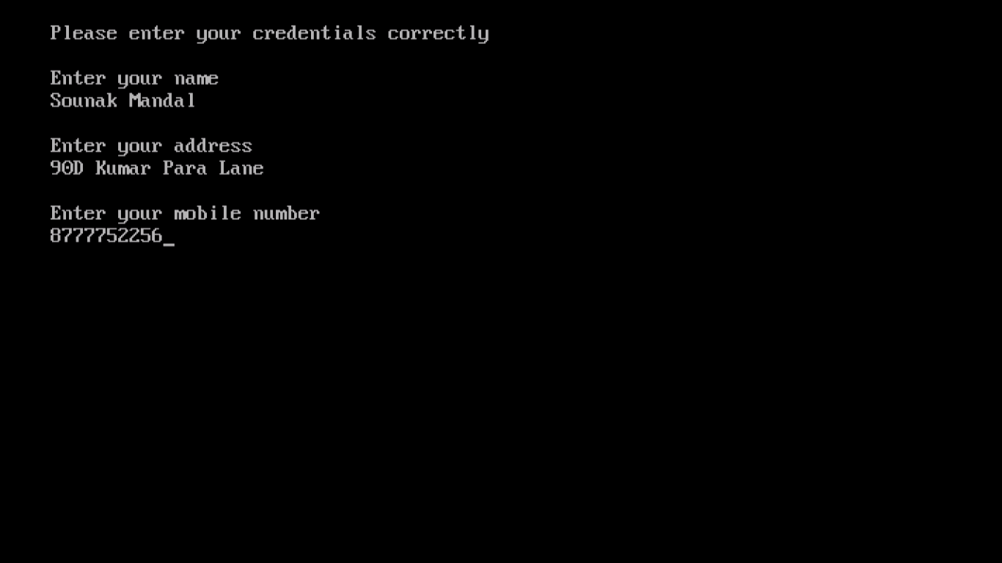

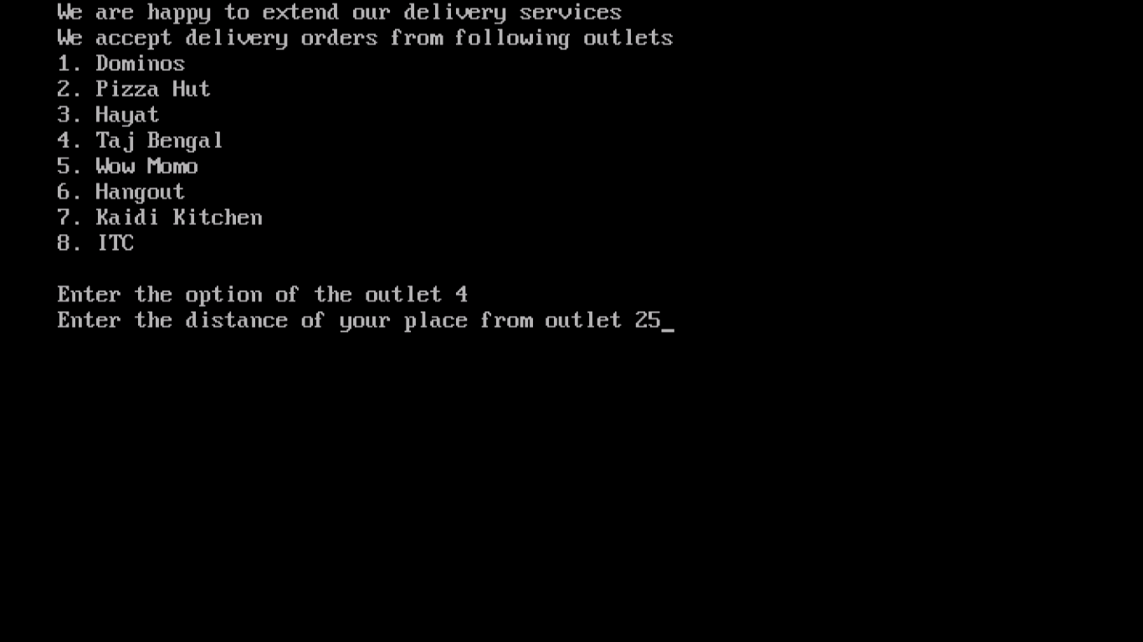

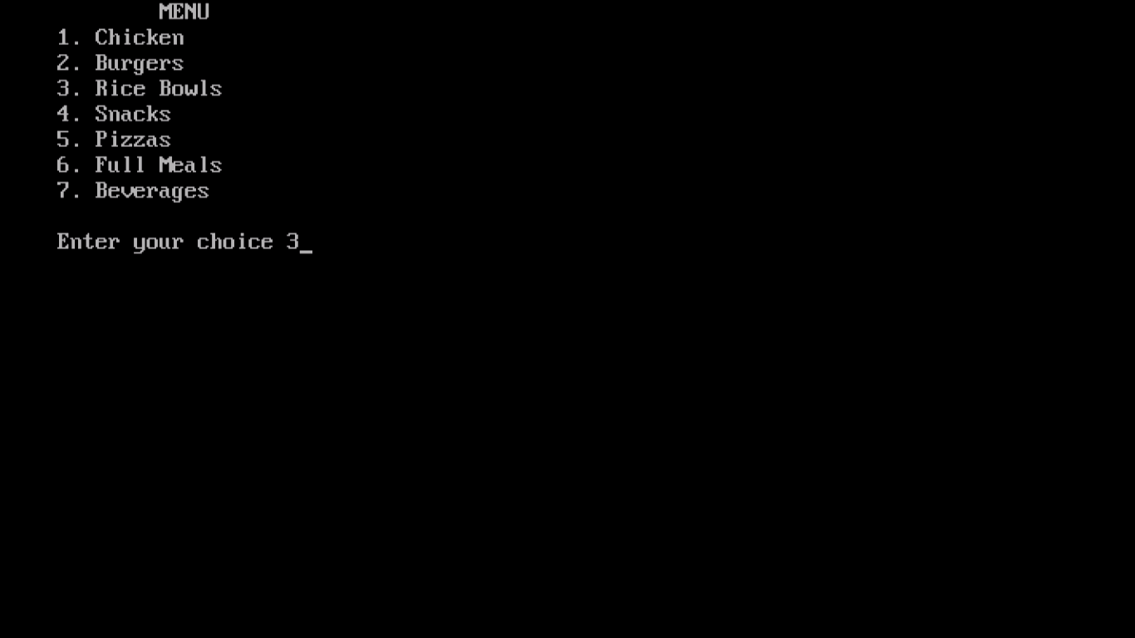

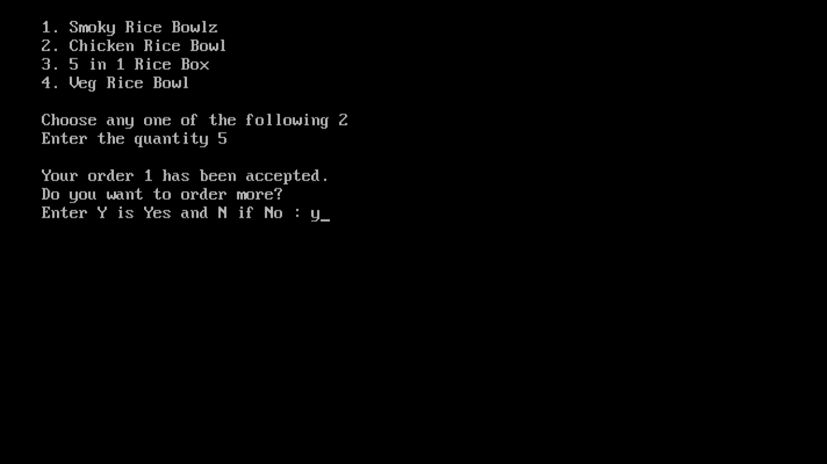

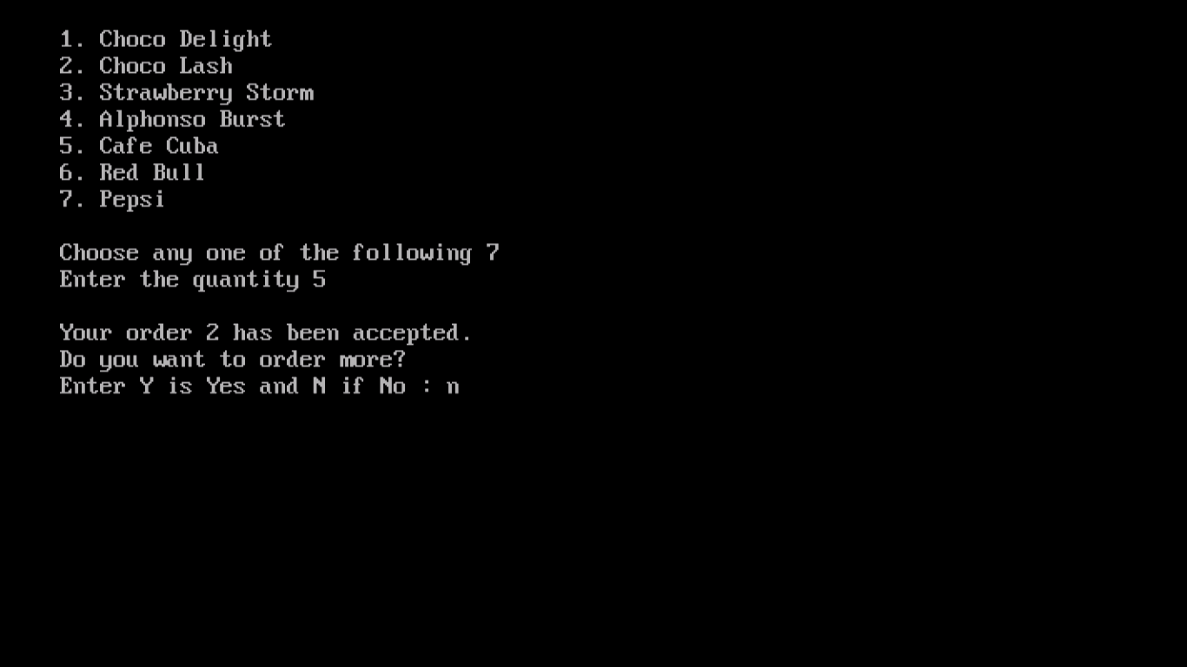

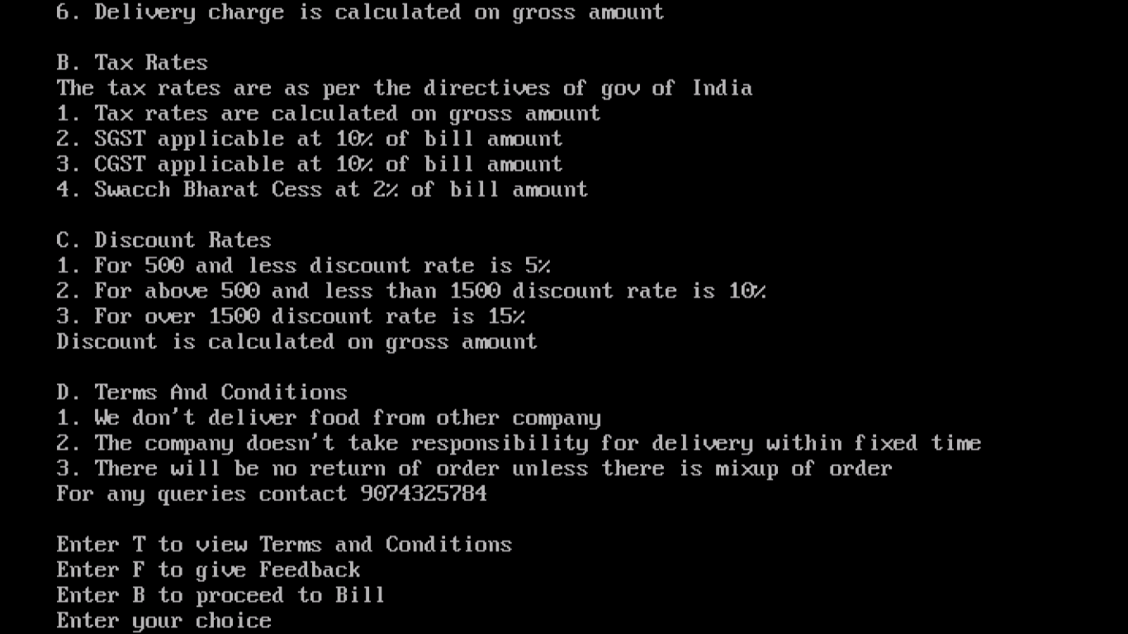

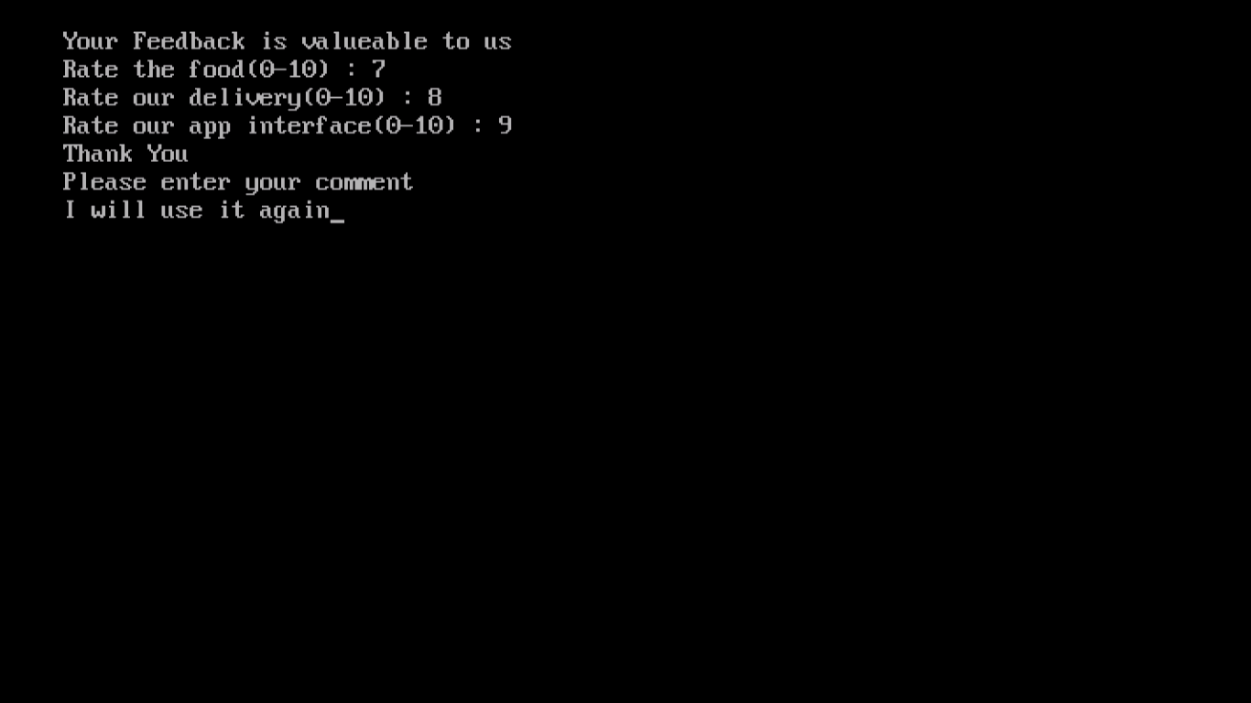

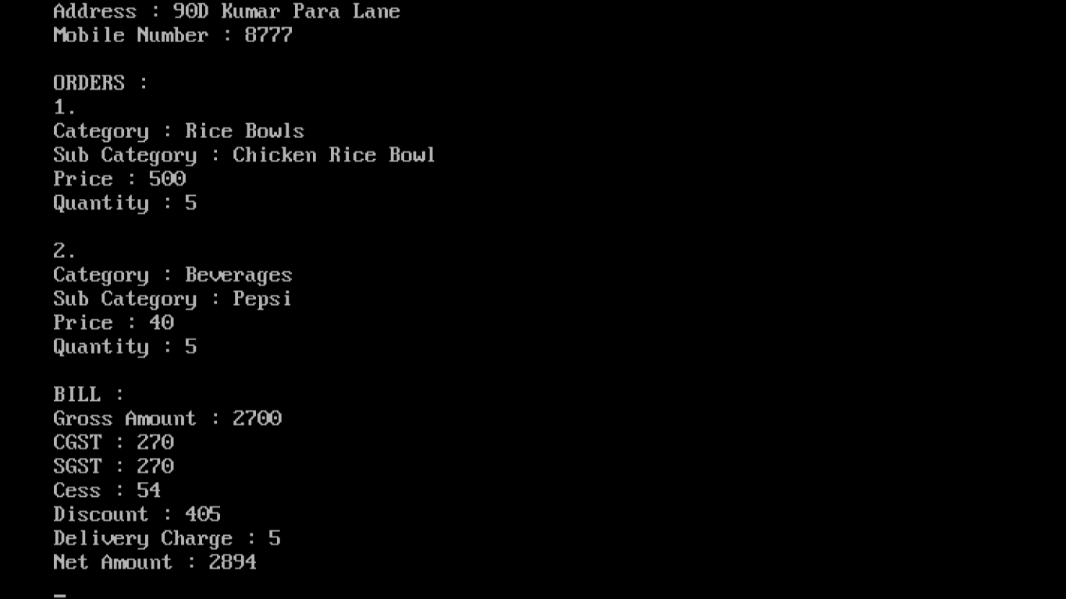

Acknowledgement

***The success and final outcome of the project required a lot of guidance and assistance from the group members and I am grateful to them for being with me all along to complete the project.***

***I am very grateful to my computer teacher Mrs. Anuja Datta who taught us the fundamentals of C++ and programming language with care. She was instrumental in guiding us in the right direction in the crucial stages of the completion of project.***

***I am thankful and fortunate to get constant assistance, encouragement and support from the teachers of Department of Computer Science who helped me in completing the project. I would like to extend my thanks and sincere regards to all my friends for their timely support.***

***I certify that I took the help of the following websites in the course of writing the program:-***

* [www.programiz.com](http://www.programiz.com)
* [www.github.com](http://www.github.com)
* [www.cplusplus.com](http://www.cplusplus.com)

***CERTIFICATE***

***This is to certify that Sounak Mandal has successfully completed his project in Computer Science, entitled “Food Delivery App” in the year 2017-2018 in BIRLA HIGH SCHOOL, Kolkata.***

***The program is complete and accurate to the best of my knowledge and satisfaction.***

_________________________

***Signature of Computer Teacher***

________________________

***Signature of Examiner***