Project : Enterprise Employee Performance & Workforce Analytics System Yash Pradhan
- One to One and One to Many:-
Departments CREATE API working POSTMAN :
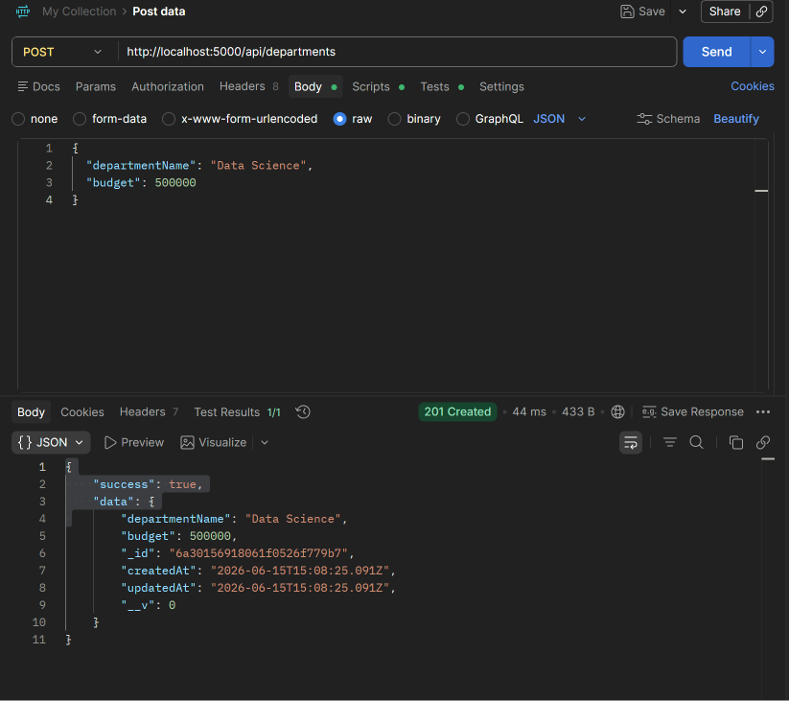
Employees CREATE API working POSTMAN:
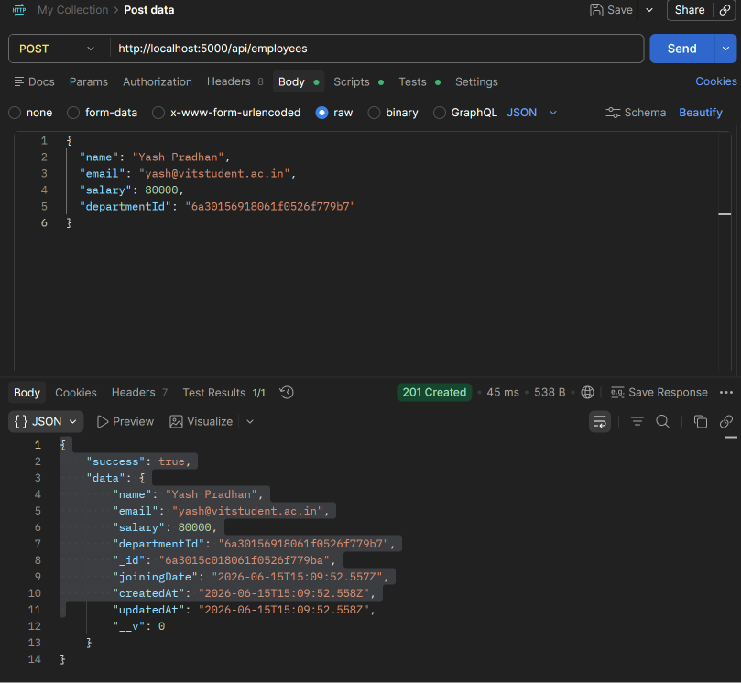
Departments READ API using POSTMAN GET:

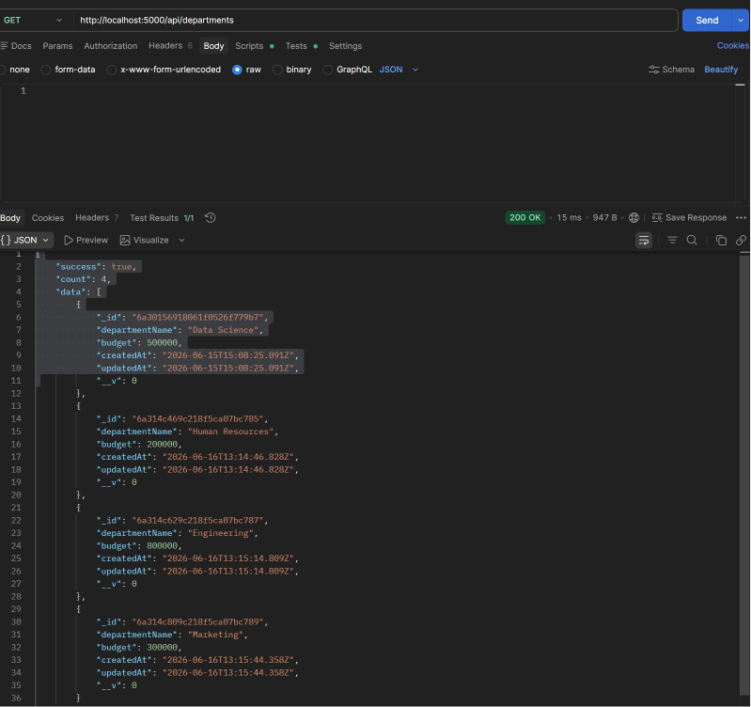

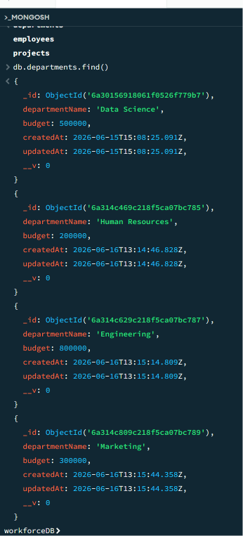
Employees READ API using POSTMAN GET:
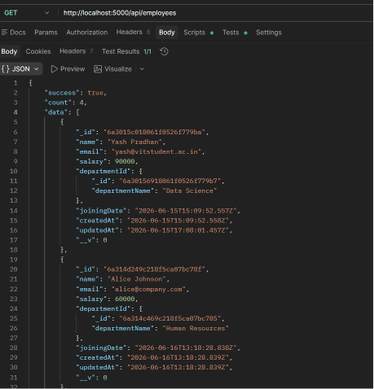

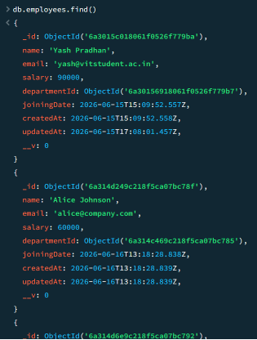
Employee UPDATE API working POSTMAN PUT:
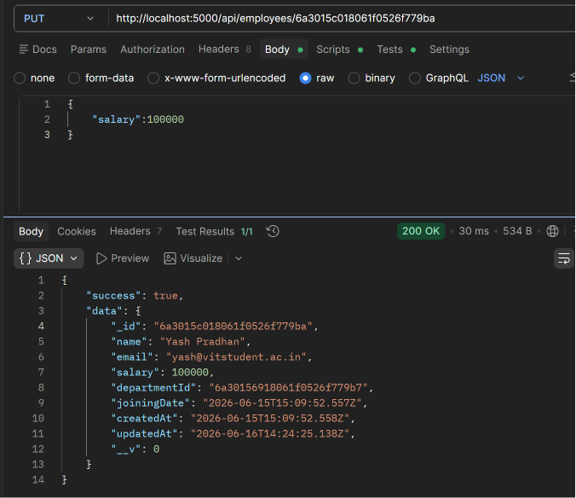

Relational Guard - Employee checks department ID POSTMAN :
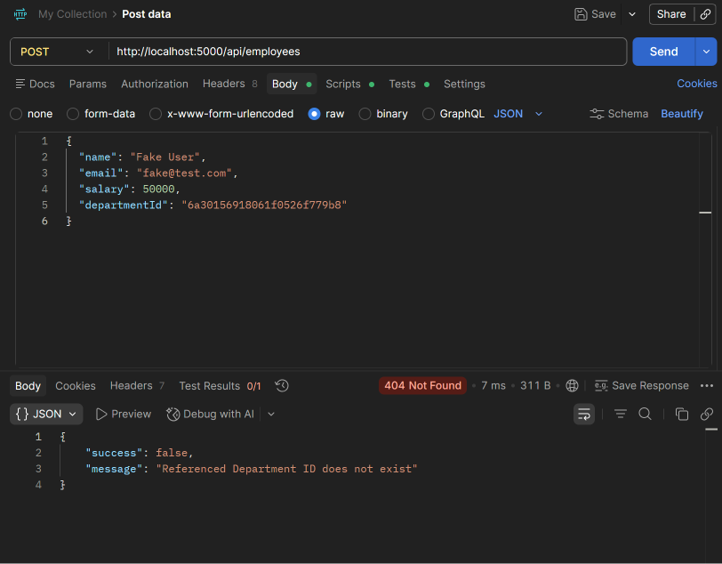

- Many to Many:-
Project CREATE API working POSTMAN :
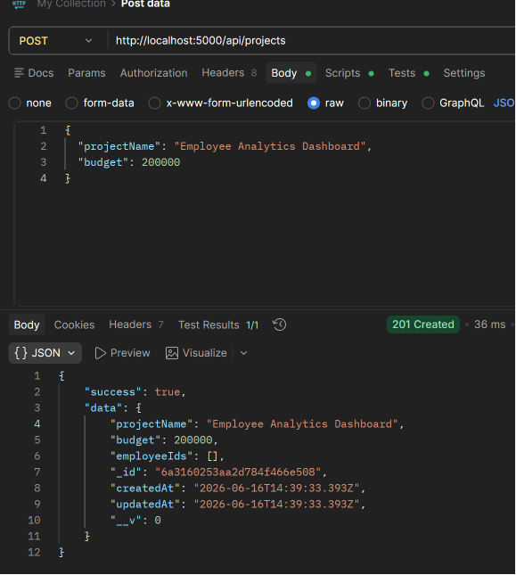
Project READ API working POSTMAN GET:
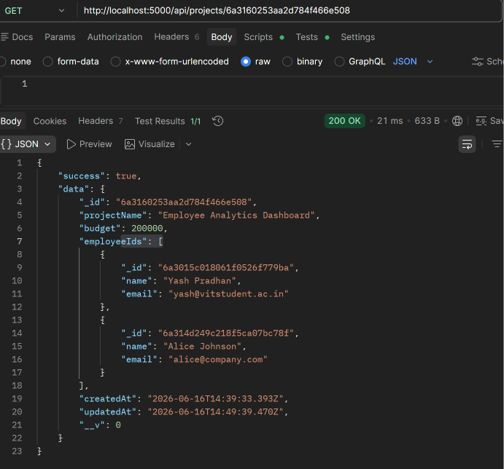

Projects UPDATE API working POSTMAN PUT:
