Yash Pradhan

Project :
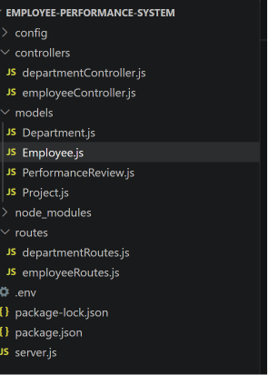

Departments CREATE API working POSTMAN:
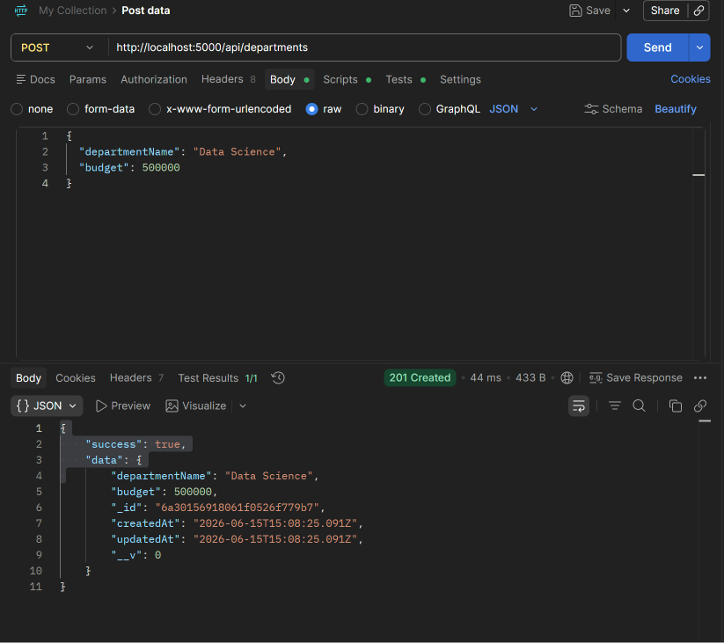
Employees CREATE API Working POSTMAN:
