ARIS Integration SDK 2.0

Contents

Purpose 2

Terminology 2

Development Requirements 2

SDK Contents 3

Diagnostics 3

Detecting an ARIS 3

Connecting to an ARIS 4

Commanding an ARIS 4

ARIS Acoustic Images 7

Receiving Acoustic Frames from an ARIS 15

Constructing Images from Acoustic Samples 17

Injecting ARIS Frame Header Data 17

Appendices 18

# Purpose

The ARIS Integration SDK is a software development kit for integrating ARIS sonar with an integrating partner’s own software. This SDK provides the technical knowledge and definitions necessary to integrate external software (your Controller) with ARIS.

## Exclusions and Dependencies

This SDK supports ARIS v2 and later; integration with ARIS 1.X is not supported by this SDK.

This SDK does not address the physical or electrical integration of an ARIS.

This SDK does not address the reading, visualization, or writing of .aris recording files. These topics are addressed by the [ARIS File SDK](https://github.com/SoundMetrics/aris-file-sdk).

This SDK does not support integrating an ARIS Defender; a Defender must be converted to an Explorer in order to successfully control it with your custom Controller.

# Terminology

**ARIS** – refers to the ARIS sonar, regardless of model.

**Controller** – the integrator’s software which controls the ARIS.

**Command Stream** – the TCP stream over which the Controller sends commands to the ARIS.

**Frame** – an assemblage of meta data and sample data that comprises a single, complete, static image. Each frame is assembled from multiple “frame parts.”

**Frame Stream** – the stream of acoustic frame data received from the sonar; this data is sent via UDP packets.

# Development Requirements

Communicating with ARIS requires the use of the TCP and UDP protocols over a TCP/IP network. The wire format of the message sent to and received from the ARIS is defined as Google Protocol Buffers. The messages are defined as .proto files (contained in this SDK) and can be used to generate message serialization/deserialization code in C, C++, Java, Python, and other programming languages.

**Note**: many of the field definitions in ARIS messages’ Protocol Buffer definitions are marked optional; this is designed to allow easier obsolescence of fields in the future. For commands sent to the ARIS no fields should be considered optional unless otherwise clearly annotated. For messages received from the ARIS, it should be assumed that all fields are indeed optional and their presence should be checked before use.

Certain critical implementations of code necessary to integrate with the ARIS are provided as C++ files. This code may depend on other libraries; see FrameStream Listener Reference Implementation and Reordering Frame Data.

# SDK Contents

## ARIS Integration SDK

This document provides an overview and technical detail of connecting to and controlling ARIS.

## Reference Code

This document contains references to source files contained in the source repository at

<https://github.com/SoundMetrics/aris-integration-sdk/>

## Protocol Buffer Files

These files are contained in common/protobuf/ which also contains .h header files for Microsoft Visual C++ (useful for warning suppression when compiling the generated protocol buffer code).

### FrameStream Implementation

The reference C++ implementation of a FrameStream listener is located in common/code/FrameStream/. This is discussed more in FrameStream Listener Reference Implementation below.

# Diagnostics

## Syslog

ARIS writes syslog entries to rotating syslog files. These files are located on the sonar in

/var/log/syslog/

The current syslog file may be followed with

tail -f /var/log/syslog/syslog

Login credentials for ssh access to syslog entries are available to qualified integration partners (please write [support@soundmetrics.com](mailto:support@soundmetrics.com)). Also, see Syslog Relay below.

## Syslog Relay

Upon a Controller successfully connecting to an ARIS, the ARIS will also relay its syslog messages to the Controller’s host on port 514 (syslog) via UDP. These syslog relay packets can also be observed with a network packet capture tool like Wireshark.

# Detecting an ARIS

Shortly after being powered on and booting up ARIS begins to broadcast “availability beacons” as UDP packets to port 56124; these beacons are sent at a 1-second interval and announce the presence of the sonar, along with various other information. The availability beacon is defined as the Availability message in file availability.proto.

## Availability Fields of Interest

serialNumber – never changes.

systemType – never changes.

connectionState – connection will be possible only when the connection state is AVAILABLE. If the state is BUSY your or another client already have an open connection to the ARIS.

cpuTemp – current CPU temperature.

powerDownReason – when the sonar determines it needs to power itself down (e.g., it’s over-temp) it populates this field and ensures another couple of beacons get out before powering down.

overTempLimitDegreesC – the maximum CPU operating temperature allowed

overTempLimitSeconds – the duration at which a continuing over-temp condition causes self-power down.

# Connecting to an ARIS

ARIS accepts connections from only one Controller at a time. If the Availability message’s connection state indicates BUSY a Controller will not be able to successfully connect.

To initiate a connection to an ARIS, open a Command Stream—a TCP stream to port 56888 on the ARIS. You may identify an ARIS by the serial number is in its availability beacon, and its IP address is that of the host from which the availability beacon’s UDP packet is received.

The Controller sends commands to control the ARIS as described in Commanding an ARIS, and receives acoustic frame data as described in Receiving Acoustic Frames from an ARIS.

The Controller closes the TCP stream described above to terminate the connection to the ARIS. The ARIS will no longer receive commands from the Controller and will cease to send acoustic frame data to the Controller.

See [connect-command](https://github.com/SoundMetrics/aris-integration-sdk/tree/master/sample-code/connect-command) for an example of how to connect to ARIS.

# Commanding an ARIS

Having opened a TCP stream to port 56888 on the ARIS, the Controller may send commands to the ARIS to control its behavior. The Controller should send a common initial series of commands in order to put the ARIS in a known state.

Commands are defined in common\protobuf\commands.proto. The Command message is a [tagged union](http://en.wikipedia.org/wiki/Tagged_union), in which the field named type is the tag and the CommandType enumeration defines the known message types. Each tag has an associated field that must be set; e.g., a message tagged SET_DATETIME requires that the dateTime field be set. Unrelated fields are ignored, depending on the message type.

Currently there is no acknowledgement from the ARIS that a command has been received.

See [connect-command](https://github.com/SoundMetrics/aris-integration-sdk/tree/master/sample-code/connect-command) for an example of how to send commands to ARIS.

## Message Framing

Commands to the ARIS over TCP must be properly framed in order for the ARIS to find command boundaries. Each command must be preceded by a 32-bit integer, in network order (e.g., htonl()), containing the serialized length of the command. This size prefix must be followed immediately by the serialized command. The Controller must not allow the size prefix and its associated command to be interrupted by another write to the socket.

**Suggestion**: size your “send buffer” to ‘length of serialized command’ + 4; populate the buffer with the command size followed by the serialized command; transmit the entire buffer in one write request. Your chosen protobuf library can calculate a message’s size before you write it to a buffer.

## Maintaining the Connection

In order to avoid zombie TCP connections, ARIS requires that the Controller periodically send a Ping message. The Controller should send a Ping once per second to maintain an active connection. ARIS will terminate an inactive connection.

## Initial Commands

The following commands should be sent on initial connection or re-connection, in this order:

1. SetFrameStreamReceiver (optional)
2. SetDateTime
3. SetAcousticSettings
4. SetSalinity
5. SetFocusPosition

SetFrameStreamReceiver and SetDateTime should be sent only once. Other commands may be sent as needed.

The ARIS will not send any frame data until valid acoustic settings are received in a SetAcousticSettings command.

## Commands

### SetDateTime

Sets the ARIS’ system clock. The date string must be in the format:

2014-Jan-31 23:58:15

The month name must be one of the following:

"Jan", "Feb", "Mar", "Apr", "May", "Jun",  
"Jul", "Aug", "Sep", "Oct", "Nov", "Dec"

### SetFrameStreamReceiver

Indicates the UDP port on which the Controller will receive Frame Stream packets and the IP address to which the packets will be sent. The Controller will likely already have opened the port and will use its own IP address. Assembly of the Frame Stream packets is covered in Receiving Acoustic Frames from an ARIS.

### SetFrameStreamSettings

Configures the frame stream. Not commonly used.

**Note**: inter-packet delay is seldom employed, but has been used to accommodate network configurations containing equipment that may not be able to keep up with the FrameStream UDP packets; e.g., a media converter with a small receive buffer.

See Acoustic Settings: Constraints and Limits.

### SetSalinity

Indicates the salinity of the water in which the ARIS rests; salinity affects the speed of sound in water and, therefore, distance measurements. The value passed for salinity must be one of the enumerated values: FRESH, BRACKISH, or SALTWATER. This value is remembered by the ARIS until it is powered down.

### SetTelephotoLens

Informs the ARIS that it has the telephoto lens mounted. Not commonly used.

### SetFocusPosition

Positions the focus lens. Focus is set by specifying the focus range, in meters, in field focusRange. Salinity affects the calculation for focus range, so be sure to use SetSalinity before SetFocusPosition.

**Note:** The focus distance was formerly specified in “focus units” which were specific to the ARIS model; that method is now obsolete, as is the field it used, named position.

### ForceFocus

Forces the lens focusing motor to move in a specific direction. Not commonly used.

### HomeFocus

Commands the lens focusing motor to move to home position. Not commonly used; this is automatically performed on power-up.

### SetRotatorMount

Indicates the type of mount employed with the attached optional AR2/AR3 rotator.

### SetRotatorVelocity

Sets the velocity for an axis of the attached AR2/AR3 rotator.

### SetRotatorAcceleration

Sets the acceleration for an axis of the attached AR2/AR3 rotator.

### SetRotatorPosition

Sets the position for an axis of the attached AR2/AR3 rotator.

### StopRotator

Stops rotator movement on the specified axis.

### Ping

Informs the ARIS that the Controller is still connected.

### SetAcousticSettings

The Controller requests specific acoustic settings for frame acquisition via SetAcousticSettings. ARIS will not return any acoustic data until valid acoustic settings are received. Valid values for SetAcousticSettings’ fields are described here; further knowledge required to combine settings successfully is described in Acoustic Settings: Constraints and Limits.

|  |  |  |
| --- | --- | --- |
| **Field Name** | **Units** | **Valid Range** |
| cookie | n/a | 1 – 0xFFFFFFFF; 0 is invalid |
| frameRate | frames/second | 1.0 – 15.0 |
| pingMode | n/a | 1, 3, 6, 9; system dependent |
| frequency | n/a | Low/High |
| samplesPerBeam | n/a | 128 – 4,096 |
| sampleStartDelay | µs | 930 – 60,000 |
| cyclePeriod | µs | 1,802 – 150,000 |
| samplePeriod | µs | 4 – 100 |
| pulseWidth | µs | 5 – 80; system dependent |
| enableTransmit | n/a | True/False |
| enable150Volts | n/a | True/False |
| receiverGain | dB | 0 – 24 |

Choosing appropriate values for these fields is discussed in depth in ARIS Acoustic Images.

# ARIS Acoustic Images

## Theory of Operation

ARIS creates images by transmitting acoustic energy and then detecting, or sampling, the energy reflected back from objects. Because we know the “time in flight” for each sample taken, we also know the range of the object that reflected the sample; this calculation depends on the speed of sound in water.

The near and far boundaries of the image are defined by the settings used to collect the image. While we discuss these boundaries in terms of physical distance, the ARIS is commanded in units of time (microseconds). Because sample collection occurs in units of whole microseconds, controlling the ARIS in units of time allows us to precisely know the range from which a sample was reflected.

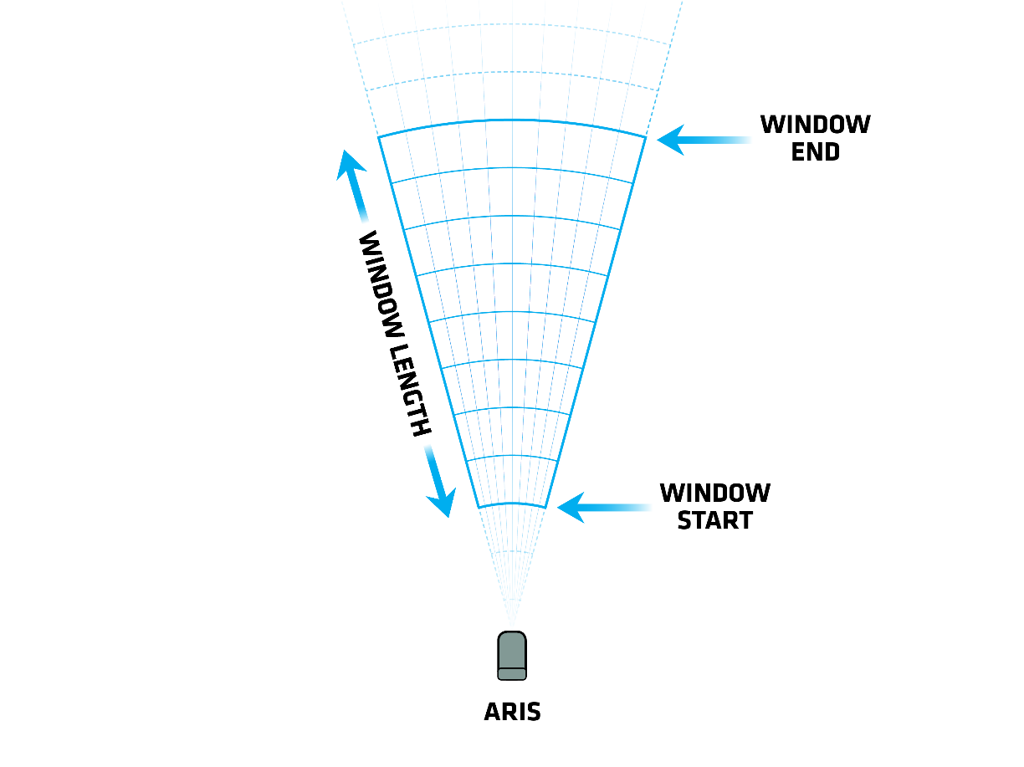

Figure

In order to calculate the range of a sample you need to know the speed of sound in water. The speed of sound, in turn, is approximated based on the water temperature, salinity, and depth. Temperature and salinity are the primary factors in determining the speed of sound in water. Water temperature and depth are provided by sensors onboard the ARIS. Salinity, however, is manually provided by the Controller by sending the SetSalinity command. Three acceptable salinity levels are pre-defined as fresh (0 ppt), brackish (15 ppt), and saltwater (35 ppt). (See protobuf definition file common\protobuf\commands.proto.)

## Perspective View

Three terms concerning distance and direction relative to the acoustic image are Down Range, Cross Range, and Perspective View. Down Range refers to distance away from the ARIS along the length of the image. Cross Range speaks to distance directly across the width of the wedge. Perspective View refers to viewing the image from directly above the imaged area.

The width of the acoustic image is a fan of narrow slices. Each beam from an ARIS produces a thin slice of the image from near to far along the Down Range axis.

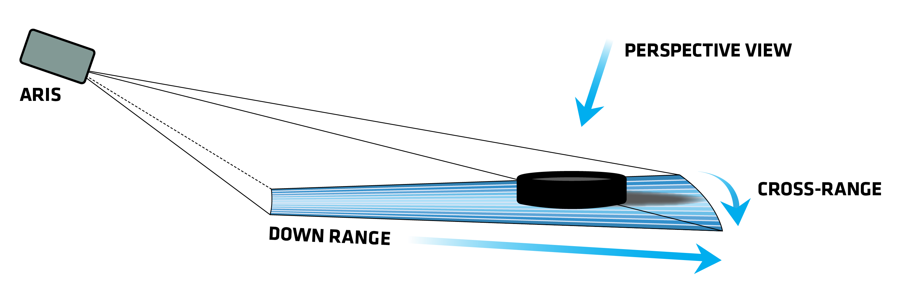

Figure

## Practical Considerations

### Water Temperature vs Range

Because water temperature changes over time, the calculated Window Start and Window Length (for constant acoustic settings) will also vary over time. For fixed window operations in which you don’t vary the acoustic settings, you may wish to select acoustic settings that work as expected over the range of operating conditions.

Some applications prefer or require a consistent image size over time (always the same sample count). Such applications should also consider selecting acoustic settings that work as expected over the range of operating conditions.

### Sample Storage Size

Sample storage size may be a consideration for applications. ARIS sample data is stored as one unsigned byte per sample with valid values of 0 – 255. (For more technical details, see Constructing Images from Acoustic Samples and the documents referenced there.) The size of each frame of data is a fixed header size plus the product of the beam count and sample count.

For example, an ARIS 3000 operating with 128 beams and 1000 samples produces a frame of 129KB. At a maximum of 15 frames per second this would produce frame data at a rate of approximately 9 GB per hour.

The .aris file format is documented at <https://github.com/SoundMetrics/aris-file-sdk>.

## Selecting Acoustic Settings

This section discusses how to select settings for the SetAcousticSettings message. Care must be taken to send valid acoustic settings to the ARIS. If your chosen settings exceed certain limits they may be constrained (adjusted) by the ARIS to fall within those limits. Invalid settings will be ignored.

In order to select appropriate acoustic settings, you’ll want to know your desired Window Start, Window End, and Window Length, where

Figure 1 above illustrates Window Start, Window End, and Window Length.

#### SetAcousticSettings Fields

cookie – The cookie is a monotonically increasing integer provided by the controller; the controller must increment this value every time this message is sent. The cookie is used by the controller to track application of acoustic settings. The acoustic frame header sent by the ARIS contains several fields (AppliedSettings, ConstrainedSettings, InvalidSettings) that indicate whether and how ARIS applied the settings requested by the Controller.

If the settings are considered good the cookie will appear in the AppliedSettings field. If the settings were constrained to respect certain limits the cookie will appear in the ConstrainedSettings field. If the settings were considered invalid the cookie will appear in the InvalidSettings field.

frequency – selects the transmit frequency of the sonar. Set to zero (0) for low frequency, one (1) for high frequency. Low frequency allows imaging at longer ranges; high frequency gives better image resolution at closer ranges.

|  |  |  |
| --- | --- | --- |
| **System Type** | **Low Frequency** | **High Frequency** |
| ARIS 1200 | 0.7 MHz | 1.2 MHz |
| ARIS 1800 | 1.1 MHz | 1.8 MHz |
| ARIS 3000 | 1.8 MHz | 3.0 MHz |

It is recommended to select frequency by the Window End value. If Window End exceeds (is larger than) the crossover in the table below, set the frequency Low; otherwise, set the frequency High. In water colder than 15°C, the crossover distance may need to be reduced, and conversely may be increased if warmer than 15°C

|  |  |
| --- | --- |
| **System Type** | **Crossover Distance (Window End)** |
| ARIS 1200 | 25 m |
| ARIS 1800 | 15 m |
| ARIS 3000 | 5 m |

pingMode – selects the total number of beams in a frame. For the ARIS 1800 and ARIS 3000, changing the ping mode allows a trade-off between better resolution (more beams) and higher frame rate (fewer beams).

|  |  |  |
| --- | --- | --- |
| **System Type** | **Ping Mode** | **Number of Beams** |
| ARIS 1200 | 1 | 48 |
| ARIS 1800 | 1 | 48 |
| ARIS 1800 | 3 | 96 |
| ARIS 3000 | 6 | 64 |
| ARIS 3000 | 9 | 128 |

sampleStartDelay – determined by Window Start, where sampling begins. The minimum value is 930 µs (~0.7 m); the maximum value is 60,000 µs (~45 m).

Note that sampleStartDelay field value must be an integer value in microseconds, so multiply by 106 and round to the nearest integer.

samplePeriod – Determined by the down-range resolution of samples. Because sample period is specified in an integral number of microseconds the down-range resolution is not infinitely adjustable (resolution is quantized).

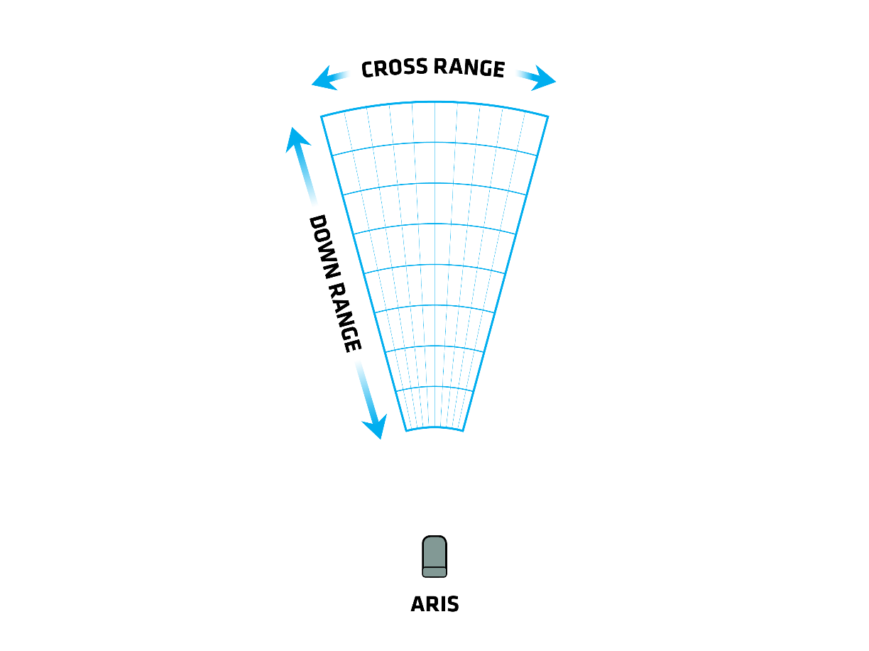

Figure

Sample period is typically selected to allow a cross-range to down-range aspect ratio of between 4:1 and 8:1, however you may wish to adjust the sample period based on storage needs: a smaller sample period gives a shorter down-range sample size, with more samples, and needs more storage space.

In order to select a sample period relative to the cross-range sample size, first calculate cross range resolution ( is given below):

Then, calculate down range resolution use the multiplier (given below):

The and factors are determined based on your ARIS system type and which ping mode you are using:

|  |  |  |  |
| --- | --- | --- | --- |
| **System Type** | **Ping Mode** | **Beam Spacing** | **N** |
| ARIS 1200 | 1 | 0.6° | 8 |
| ARIS 1800 | 1 | 0.6° | 8 |
| ARIS 1800 | 3 | 0.3° | 4 |
| ARIS 3000 | 6 | 0.5° | 8 |
| ARIS 3000 | 9 | 0.25° | 4 |

Finally, calculate sample period:

Note that samplePeriod field value must be an integer value in microseconds, so multiply by 106 and round to the nearest integer.

samplesPerBeam – having selected a sample period above, it is easy to calculate the number of samples in the sample window. Here is in microseconds.

cyclePeriod – the minimum time required to acquire the samples for a single ping.

This is the minimum value of cyclePeriod that allows for the fastest frameRate. Additional time may be added (within the constraints below) to correct for aliasing in the acoustic image, which will reduce the maximum possible frameRate.

frameRate – the number of frames acquired per second. Faster frame rates allow smoother image motion when the sonar or targets are moving, at the cost of more data transfer. The fastest allowable frame rates is:

|  |  |  |
| --- | --- | --- |
| **System Type** | **Ping Mode** | **Pings per Frame** |
| ARIS 1200 | 1 | 3 |
| ARIS 1800 | 1 | 3 |
| ARIS 1800 | 3 | 6 |
| ARIS 3000 | 6 | 4 |
| ARIS 3000 | 9 | 8 |

Currently ARIS is limited to a maximum of 15 frames per second.

pulseWidth – the duration of the transmitted energy pulse. Suggested values for transmit pulse width based on system type and frequency:

|  |  |  |
| --- | --- | --- |
| **System Type** | **Frequency** | **Modifier** |
| ARIS 1200 | LF | 1.0 |
| ARIS 1200 | HF | 1.0 |
| ARIS 1800 | LF | 1.0 |
| ARIS 1800 | HF | 1.5 |
| ARIS 3000 | LF | 1.5 |
| ARIS 3000 | HF | 2.0 |

receiverGain – relative receiver gain in dBs. Suggested initial values based on system type:

|  |  |
| --- | --- |
| **System Type** | **Receiver Gain** |
| ARIS 1200 | 20 |
| ARIS 1800 | 18 |
| ARIS 3000 | 12 |

enable150Volts – turns on 150V transmit circuit. You generally want this “on” (1).

enableTransmit – enables transmission of acoustic energy. You can turn this off to check for self-noise or look for external acoustic interference (other sonars, DVL, etc.).

This SDK contains two other resources for using correct acoustic settings:

* The appendix titled Example Acoustic Settings, which contains some baseline examples that are handy for making your first images during integration.
* The Excel spreadsheet “Integration SDK suggested settings.xlsx,” which provides some guided calculation of valid settings.

## Acoustic Settings: Validation and Constraints

### Validation

The following pseudo code illustrates how validation is performed by the ARIS; settings that fail these checks are considered invalid and are not applied.

pingModeConfigurations = // look-up table, ping mode is the key

    { { pingMode = 01u; channelCount =  48u; pingsPerFrame = 3u }

     { pingMode = 03u; channelCount =  96u; pingsPerFrame = 6u }

     { pingMode = 06u; channelCount =  64u; pingsPerFrame = 4u }

     { pingMode = 09u; channelCount = 128u; pingsPerFrame = 8u } }

// Valid input ranges:   
samplesPerBeamRange   = 128u ←→ 4096u

sampleStartDelayRange =  930u ←→ 60000u

cyclePeriodRange    = 1802u ←→ 150000u

samplePeriodRange    = 4u ←→   100u

pulseWidthRange    = 5u ←→   80u

receiverGainRange    = 0.0f ←→   24.0f

// Validate:

pingsPerFrame = pingModeConfigurations[pingMode].pingsPerFrame

framePeriod = uint32 (ceil (1000000.0f / frameRate)) // microseconds

adjustedCyclePeriod =

sampleStartDelay + (samplePeriod * samplesPerBeam) + 360u

isValid =   samplesPerBeam is in range samplesPerBeamRange

            && sampleStartDelay is in range sampleStartDelayRange

            && cyclePeriod is in range cyclePeriodRange

            && samplePeriod is in range samplePeriodRange

            && pulseWidth is in range pulseWidthRange

&& receiverGain is in range receiverGainRange

            && framePeriod > cyclePeriod * pingsPerFrame

            && cyclePeriod >= adjustedCyclePeriod

### Constraints

In order to protect certain components, ARIS limits the amount of energy allowed through them. The code below illustrates the steps taken by ARIS to limit energy by constraining the pulse with of the settings. If valid settings are supplied to the ARIS, this constraint is then supplied; if the settings are unchanged they are considered “valid,” otherwise “constrained.”

enum SystemType { ARIS1800 = 0, ARIS3000 = 1, ARIS1200 = 2 };

const float pulse_width_limits[3][2] = {

{ 40.0, 30.0 }, { 24.0, 16.0 }, { 80.0 , 60.0 }

// ARIS1800, ARIS3000, ARIS1200

};

const float energy_limits[3] = {

300.0, 240.0, 400.0 // ARIS1800, ARIS3000, ARIS1200

};

bool LimitPulseWidth(settings &settings)

{

const uint origPulseWidth = settings.pulse_width; // cycle count

const float actual = FreqSelToMHz(settings.acquisition.frequency_select);

// First limit pulse width by system type and frequency to ensure

// image quality

const auto freq = settings.acquisition.frequency_select;

const float maxPulseWidth = pulse_width_limits[_cfg.TheSystemType][freq];

// usecs

settings.pulse_width = min((uint)floor(maxPulseWidth * actual),

origPulseWidth);

// Then limit pulse with by total allowed energy for system type

const float fps = 1000000.0 / (float)settings.frame_period;

const float maxEnergy = energy_limits[_cfg.TheSystemType];

settings.pulse_width = min((uint)floor((maxEnergy * actual) / fps),

(uint)settings.pulse_width);

return settings.pulse_width != origPulseWidth;

}

float FreqSelToMHz(uint frequency)

{

float actual;

if (_cfg.TheSystemType == 1) { // ARIS3000

actual = (frequency == 0) ? 1.800f : 3.000f;

} else if (_cfg.TheSystemType == 2) { // ARIS1200

actual = (frequency == 0) ? 0.6923125f : 1.200f;

} else { // ARIS1800

actual = (frequency == 0) ? 1.1077f : 1.800f;

}

return actual;

}

# Receiving Acoustic Frames from an ARIS

ARIS uses a “Frame Stream” protocol to pass acoustic frame data to the Controller; the port on the controller used to receive the data is specified by the Controller in the SetFrameStreamReceiver command.

## Acoustic Frame Data

The final product of the Frame Stream protocol, a completely assembled frame of acoustic samples and associated metadata, is a 1024-byte Frame Header (described in the “015207 ARIS File SDK”; see “ArisFileSDK\ArisFileFormat\ARIS File Format DDF_05.xlsx”) followed by payload of acoustic samples whose length is ‘number of beams’ × ‘number of samples per beam.’

## Frame Stream Protocol

The Frame Stream protocol utilizes UDP to send packets containing acoustic frame data to the Controller. The wire format of each frame is a Google Protocol Buffer as defined by FramePart in protocols\ArisMessages\frame_stream.proto.

### Frame Parts

Each frame is sent as one or more FramePart messages. The first FramePart of a frame has a data_offset of 0, a non-zero total_data_size field, and its header field is populated with the Frame Header; its data field contains the initial bytes of the acoustic samples. Subsequent FramePart messages for the same frame have the same frame_index as the first FramePart and a larger data_offset value; the final FramePart of a frame is determined by the condition

data_offset + length-of(data) == total_data_size

Only the first FramePart contains the frame header.

**Note:** the frame header contained in the first FramePart of each frame is truncated to eliminate transmission of the unused tail-end portion of the structure. The implementer should pad the frame header to 1024 bytes for further manipulation and storage; this will ensure the frame header is forward-compatible as well as compatible with existing ARIS software.

### Frame Part Acknowledgements

Each FramePart received by the Controller should be acknowledged by sending a FramePartAck message to the ARIS. Presently, the ARIS will not re-send lost packets, but acknowledging the frame parts will support basic retries when that retry policy is implemented.

### Lost Frame Parts

Because the ARIS does not currently implement retries of lost packets the Controller may receive incomplete frames.

## FrameStream Listener Reference Implementation

Our FrameStream listener implementation is the canonical C++ example of how to receive and assemble frame parts sent by the sonar. It currently relies on the Boost libraries for asynchronous I/O and is not generalized for easy substitution of other libraries. See FrameStreamListener in common/code/FrameStream/.

## No retries

ARIS’ FrameStream sends frame parts over UDP, which is not a reliable protocol. ARIS does not presently resend missed frame parts, though the above FrameStream listener implementation does send acknowledgements to the ARIS in support of that future feature. It is the implementer’s choice whether to discard an incomplete frame or save it with some accounting for which parts are missing.

## Reordering Frame Data

Frame data delivered by the ARIS’ FrameStream is generally not in an order that’s appropriate for display or other usage—it is in the form received directly from the device rather than in a bitmap form. The frame header contains a field named ReorderedSamples, which is non-zero when the data has been properly re-ordered so it is useful for display.

When connecting your custom Controller directly to the ARIS you may see data that is not yet re-ordered, where ReorderedSamples is zero. In this case, you will need to re-order the data yourself.

The canonical C++ code to re-order the samples in a frame can be found in common/code/Reordering/; note that you should set frame header field ReorderedSamples to 1 after re-ordering the samples. There is also sample code in sample-code/reorder-frame.

# Constructing Images from Acoustic Samples

Please see [Constructing Images From Samples](https://github.com/SoundMetrics/aris-file-sdk/blob/master/docs/understanding-aris-data.md#constructing-images-from-samples) in the [ARIS File SDK](https://github.com/SoundMetrics/aris-integration-sdk/) for guidance on correctly constructing an image from the acoustic samples.

# Injecting ARIS Frame Header Data

A number of the frame header fields may be updated by your Controller or other software, including GPS coordinates. The file common/code/UpdateFrameHeader/ArisHeaderUpdate.h provides more information on what fields may be updated, how to create the update message, and sample functions for initializing and setting fields in an update message.

# Appendices

## Ports

|  |  |  |
| --- | --- | --- |
| **Port Number** | **Protocol** | **Description** |
| 56124 | UDP | ARIS broadcasts availability beacons to this port. See Detecting an ARIS. |
| 56888 | TCP | ARIS accepts a TCP connection from a Controller on this port; this initiates an ongoing dialog between the Controller and the ARIS. See Connecting to an ARIS, and Commanding an ARIS. |
| 700 | UDP | ARIS accepts platform header updates as described in Injecting ARIS Frame Header Data. See Injecting ARIS Frame Header Data. |

## Example Acoustic Settings

The following example settings are valid settings that will work with your ARIS Explorer 1200, 1800, or 3000; these should be helpful during your initial integration with the ARIS.

Please note that the frame rates listed are the maximum available for the selected acoustic settings, as discussed in Selecting Acoustic Settings.

### ARIS 1200

These acoustic settings are based on a sampling window from 4 – 24 meters in fresh water at 19°C. Recommended focus range is 14 meters.

|  |  |  |
| --- | --- | --- |
| **Field Name** | **Units** | **Value** |
| cookie | n/a | [you provide] |
| frameRate | frames/second | 10.0 |
| pingMode | n/a | 1 |
| frequency | n/a | 1 |
| samplesPerBeam | n/a | 1082 |
| sampleStartDelay | µs | 5408 |
| cyclePeriod | µs | 32,818 |
| samplePeriod | µs | 25 |
| pulseWidth | µs | 24 |
| enableTransmit | n/a | 1 |
| enable150Volts | n/a | 1 |
| receiverGain | dB | 20 |

### ARIS 1800

These acoustic settings are based on a sampling window from 1.5 – 7.5 meters in fresh water at 19°C. Recommended focus range is 4.5 meters.

|  |  |  |
| --- | --- | --- |
| **Field Name** | **Units** | **Value** |
| cookie | n/a | [you provide] |
| frameRate | frames/second | 15.0 |
| pingMode | n/a | 3 |
| frequency | n/a | 1 |
| samplesPerBeam | n/a | 1014 |
| sampleStartDelay | µs | 2028 |
| cyclePeriod | µs | 10500 |
| samplePeriod | µs | 8 |
| pulseWidth | µs | 11 |
| enableTransmit | n/a | 1 |
| enable150Volts | n/a | 1 |
| receiverGain | dB | 18 |

### ARIS 3000

These acoustic settings are based on a sampling window from 1.5 – 5.0 meters in fresh water at 19°C. Recommended focus range is 3.25 meters.

|  |  |  |
| --- | --- | --- |
| **Field Name** | **Units** | **Value** |
| cookie | n/a | [you provide] |
| frameRate | frames/second | 15.0 |
| pingMode | n/a | 9 |
| frequency | n/a | 1 |
| samplesPerBeam | n/a | 946 |
| sampleStartDelay | µs | 2028 |
| cyclePeriod | µs | 7118 |
| samplePeriod | µs | 5 |
| pulseWidth | µs | 10 |
| enableTransmit | n/a | 1 |
| enable150Volts | n/a | 1 |
| receiverGain | dB | 12 |

## Cycle Period & Sampling Terminology

|  |  |  |
| --- | --- | --- |
| Speed of Sound | SSPD | The velocity at which sound travels (in this case in water). |
| Sample Start Delay | SSD | The period of time that the sonar waits after transmit before sampling data. |
| Number of Samples | N | The number of samples to be taken for each beam. |
| Sample Period | SP | The time over which an individual sample is taken. |
| Window Start | WS | The distance at which the nearest sample is taken. This distance is  (the ping has to round trip, hence the divide by two). |
| Window Length | WL | This is the distance over which samples are taken. This distance is |
| Window End | WE | Window end, the farthest that we sample. |
| Cycle Period | CP | The minimum time it takes to complete one round of sampling. This can be derived from WE:  (multiply WE by two to get time of round trip distance) |
| Anti-Aliasing | AA | Time may be added to the cycle period in order to correct for aliasing in the acoustic image. |
| Adjusted Minimum Cycle Period | AMCP | The minimum cycle time necessary for data acquisition to go well. |