<?xml version="1.0"?><DocumentBlank xmlns:xsi="http://www.w3.org/2001/XMLSchema-instance" xmlns:xsd="http://www.w3.org/2001/XMLSchema"> <GraphicCharterDefinitionId>0</GraphicCharterDefinitionId> <TemplateBaseTypeId>0</TemplateBaseTypeId> <CompanyId>1</CompanyId> <ConfidentialId>0</ConfidentialId> <ConfidentialDescription /> <CountryId>0</CountryId> <PageSizeId>1</PageSizeId> <PageOrientationId>1</PageOrientationId> <PrePrintedStationary>false</PrePrintedStationary> <Project /> <Reference>20210208-150215-SD</Reference> <TemplateType>1</TemplateType> <CultureId>en-US</CultureId> <LanguageId>8</LanguageId> <Customer /> <DocumentDate>2023-02-24T08:25:50.5729981+05:30</DocumentDate> <FirstPageHeader /> <FirstPageSubHeader /> <FirstPageTitle_Blank /> <FirstPageSubtitle_Blank /> <Saved>false</Saved> <IsValid>true</IsValid> <FirstPageCover>false</FirstPageCover> <IsNew>false</IsNew> <Title /></DocumentBlank>

|  |  |  |  |  |
| --- | --- | --- | --- | --- |
|  |  |  |  | |
|  |  |  |  | |
|  |  | Puppet installation and configuration - AWS | | |
|  |  |  | | |
|  |  |  | | |
|  |  |  | |  |

Contents

1. Objective 3

2. Tools Used 3

3. Pre-requisites 3

4. Configuration steps 4

# Objective

The objective of this accelerator is to automate the installation and configuration of puppet master and agent in Ubuntu using terraform.

# Tools Used

* **Terraform -** Terraform is an infrastructure provisioning tool for building, changing, and versioning infrastructure safely and efficiently.

# Pre-requisites

* An AWS account with following access –
  + Amazon EC2
  + VPC, subnets, route tables
* Terraform version installed v1.1.1 or greater and the setup of terraform should be done. Link to download and setup terraform-

[**https://learn.hashicorp.com/terraform/getting-started/install.html**](https://learn.hashicorp.com/terraform/getting-started/install.html)

* AWS CLI should be installed and configured. Link to download and configure: -

[**https://awscli.amazonaws.com/AWSCLIV2.msi**](https://awscli.amazonaws.com/AWSCLIV2.msi)

* AWS VPC, subnets, and security groups should be pre-configured.
* Necessary ports should be open in the security groups for ec2 instances.

Puppet master:

* + Respective inbound ports are 22 for SSH,
  + 8140 for puppet agent to connect to puppet master instance,
  + 443 for HTTPS,
  + 80 for HTTP,

Puppet agent:

* + Respective inbound ports are 22 for SSH,
  + 443 for HTTPS,
  + 80 for HTTP

# Configuration steps

1. Clone/download the code of this accelerator to create the puppet master and agent ec2 instances.

**https://innersource.soprasteria.com/group-cloud-coe/puppet-accelerator**

1. Unzip the downloaded zip file.

* **ec2.tf** -: Creation of puppet agent and master instance which installs the agent and master prerequisites mentioned in the userdata template file.
* **variables.tf -:** Contains variables to be called by resources in other files.
* **agentuserdata.tmpl -:** Containsthe puppet commands for agent.
* **masteruserdata**.**tmpl** -: Containsthe puppet commands for master.

1. Change the necessary variables in **variables.tf** file to suit your requirements: -
   1. instance_master_type / instance_agent_type: Mention the instance type of ec2 to specify ram, vcpu, memory. Default is: t2.micro
   2. count: Number of puppet-master/puppet-agent instances you want to spin up.
   3. master_subnet_id / agent_subnet_id: Mention the subnet id you want to create your instance in.
   4. master_security_group_id / agent_security_group_id: Mention the security group id you want to associate your instance with.
   5. associate_public_ip_address_master / associate_public_ip_address_agent: Set to true if you want to access the instance publicly.
   6. master_ami / agent_ami / region: AMI’s are particular to a region which is by default set to us-east-2 i.e – Ohio. Change the ami according to the region you wish to create your instance in.
2. Open cmd **(run as administrator)** and run the command: -

cd <**path_to_the_sourcecode_folder**>

1. Run the following commands to setup the infrastructure: -

**terraform init**

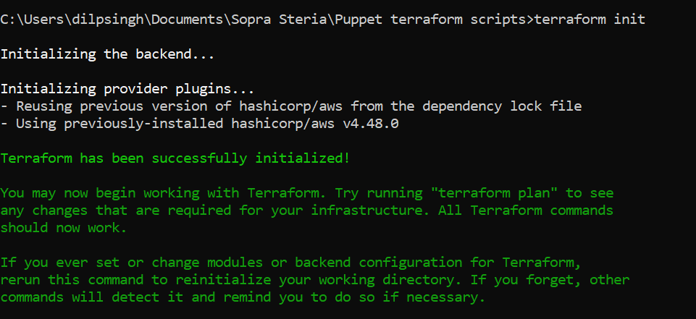

**terraform** **apply -auto-approve**

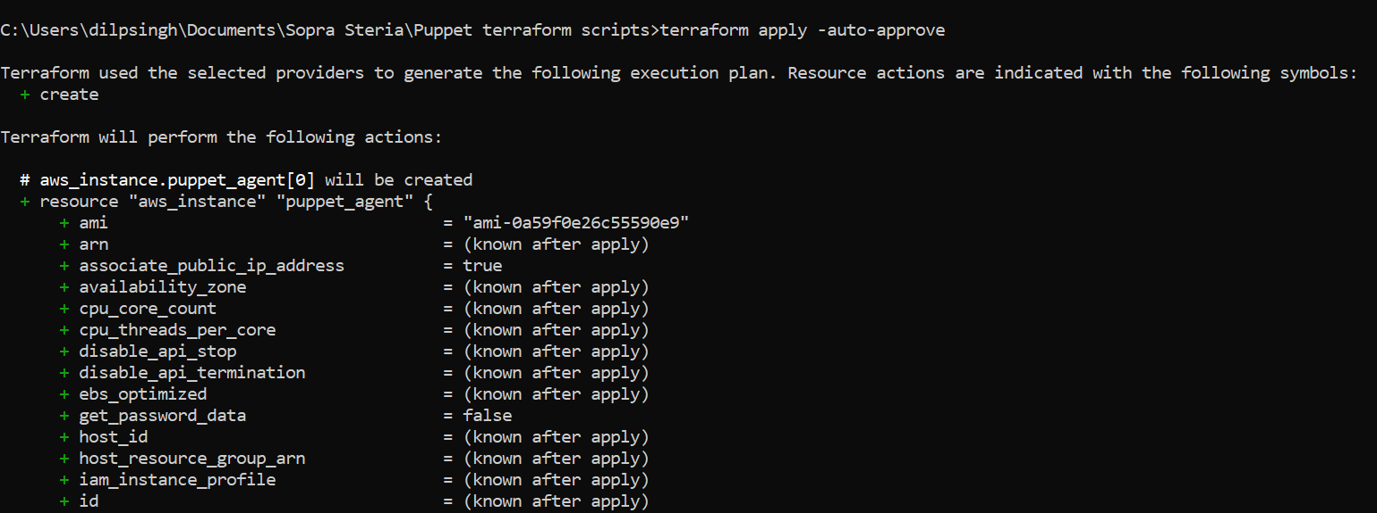

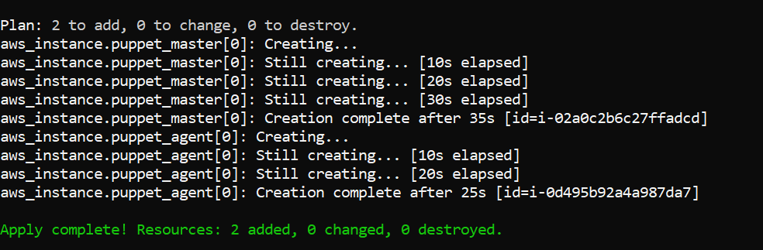

1. Login into the puppet-master instance using Putty and run the following command:

**sudo /opt/puppetlabs/bin/puppetserver ca sign --all**

1. Login into the puppet-agent instance using Putty and run the following command:

**sudo /opt/puppetlabs/bin/puppet agent --test**

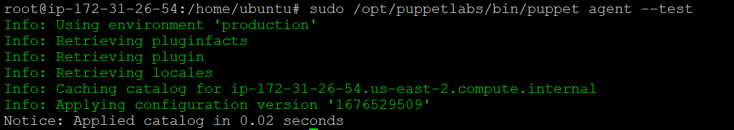The below output confirms that puppet is successfully installed, and master and agent is adequately configured.

1. Install apache module in puppet-master to verify puppet configuration is accomplished properly by running the below command:

**sudo /opt/puppetlabs/bin/puppet module install puppetlabs-apache**

The apache modules will be created in /etc/puppetlabs/code/environments/production/modules/.

1. Create a manifest file to run this apache module in the puppet-master instance with the below command:

**vi /etc/puppetlabs/code/environments/production/manifests/site.pp**

Now paste the below content and replace the <agent private ip dns name> from the output section from the terminal where terraform was run.

**node default { }**

**node '<agent private ip dns name>' {**

**include apache**

**}**

1. Run the below command to install apache in puppet agent:

**sudo /opt/puppetlabs/bin/puppet agent --test**

11. Verify the apache installation by copying the public ip of puppet agent server in the browser:

