*Original Article*

**Advanced Foams Production both in Terrestrial and Microgravity Conditions**

**M. Shoikhedbrod1*, I. Shoikhedbrod1**

*1R&D Department of Electromagnetic Impulse Inc., 21 Four Winds Drive, Unit 12, North York, Ontario, Canada.*

*michaelshoikhedbrod@bell.net

Received: 11 June 2025; Revised: 10 July 2025; Accepted: 08 August 2025; Published: 19 August 2025

**Abstract** **-** Advanced foams are characterized by a uniform distribution of gas filler in the molten foam material. Existing methods for producing foams do not allow for a uniform distribution of gas filler in the molten foam material. The use of such technologies leads to inefficient and unsafe foam production and to a radical change in the properties of the resulting foams for the worse. The article presents a new method for producing advance foams in terrestrial conditions, in which a uniform distribution of gas filler in the molten foam material is achieved using the vibroturbulation process, in which the role of the gas filler is played by hydrogen formed during the electrolysis of water, followed by its transformation due to the vibroturbulation process into microdispersed electrolytic hydrogen bubbles that uniformly saturate the molten foam material. The article also shows the production of advanced foams in microgravity conditions, using the peculiarity of the isotropic property of microgravity, as well as inertial forces that allow the gas filler - microdispersed electrolytic bubbles of hydrogen formed during the process of water electrolysis - to be evenly distributed in the foam.

**Keywords -** Foam materials processing, Process of vibroturbulization, Uniform saturation of thermoplastic, Hydrogen electrolytic gas bubbles, Electrolysis of water, Microgravity.

**1. Introduction**

Advanced foams are characterized by a uniform distribution of gas filler in the foam material [1-7]. Existing methods for producing foams use foaming of aqueous dispersions of foam materials by thermal decay of organic and inorganic substances contained in these materials; radiation decay of the foam material; foaming of foam material compositions by entering condensed hydrogen into the material under high-pressure conditions [1-3]. The use of such technologies leads to inefficient and potentially harmless foam production. In addition, the use of thermal decay and chemical foaming agents dramatically changes the properties of the material for the worse. The paper describes a new method of advanced foam production in terrestrial conditions, using the method of vibroturbulization, which allows the uniform distribution in the foam of a gas filler, formed by a water electrolysis process, and subsequent conversion of this gas filler due to the method of vibroturbulization into microdispersed electrolytic bubbles of hydrogen. The article also shows advanced foam production in microgravity conditions, using the feature of the isotropic property of microgravity, and inertial forces that allow uniform distribution in the foam of gas filler - microdispersed electrolytic bubbles of hydrogen, formed during the water electrolysis process. The novelty of the developed methods for obtaining advance foams consists in the fact that in terrestrial conditions, in contrast to existing methods, the process of vibroturbulation is used, which not only forms micro dispersed electrolytic bubbles of hydrogen from hydrogen, obtained in the process of water electrolysis (gas filler), but also saturates the molten foam material with them by mixing under the conditions of the regime parameters of the vibroturbulization process; under microgravity conditions, uniform saturation of the molten foam material with the gas filler - the same finely dispersed electrolytic bubbles, formed in the process of electrolysis under microgravity conditions, is carried out due to the inert force, injecting the gas filler into the molten foam material, and the isotropic property of microgravity uniformly saturates the molten foam material with this gas filler.

**2. Materials and Methods**

Advanced foams were processed in terrestrial conditions using polymers and resins: polyvinyl chloride PCHV-1, epoxy resin, and polyurethane PU-101. The processing of advanced foams in microgravity conditions was carried out on the model material, salol.

***2.1. Advanced Foams Production in Terrestrial Conditions***

Previously conducted theoretical and experimental studies of the method of vibroturbulation, showing that process is characterized by intensive mixing of liquids with different densities and air (gases), permitted to develop a completely new method for advanced foams production, in which the formation of a gas filler is achieved by electrolysis of water at a constant voltage of 10 V on the electrodes for 10 minutes. The conversion of the gas filler into microdispersed electrolytic gas bubbles of hydrogen with simultaneous uniform distribution of the foam polymer by them at its melting temperature of 60℃-130℃ is carried out using vibration in the vibroturbulization method mode (in the frequency range of 80-90 Hz with vibration acceleration of 150 m/c2) for 5minutes, followed by the production of advanced foam by cooling it. The use of water electrolysis to form gas filler, unlike known methods, results in the production of advanced foams in a safe and simple way, using neutral molecular hydrogen gas that does not affect the basic physical and mechanical properties of the thermoplastic polymer. The use of the vibroturbulization method for foaming a thermoplastic polymer allows for the simple and quick production of high-quality foams with uniform distribution of the microdispersed gas phase. A special installation, which differs significantly from existing devices in a better way, was developed by the authors at Electromagnetic Impulse Inc. for the experimental production of improved foams (Figure 1). The facility for the production of advanced foams works as follows:

At the initial state, the electromagnetic valves (9, 11) are closed, and valve (8) is opened. Through the branch pipe (6), the polymer material enters the heating chamber (1), which is filled with polymer material with a pre-calculated proportion since the ratio of the hydrogen gas and the melt of the polymer material in the chamber must correspond to the previously performed calculation. The chamber is heated to the melting temperature of the foam polymer, using the mobile induction heater.

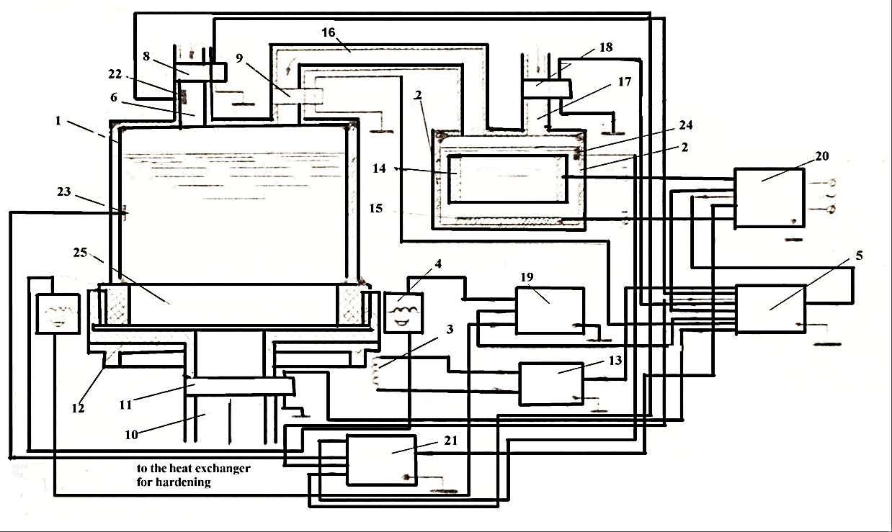

Fig. 1 Developed facility for the advanced foams production, which uses vibrations in the regime of vibroturbulation

The heating chamber content kept the temperature of the foam polymer melting, using the temperature-sensitive element (23), which, with the help of a mobile induction heater, stabilized the heat at the melting point of the thermoplastic polymer material. The automatic control unit (5) opens the valve (9) and supplies the voltage of direct current from the power unit (20) to the electrodes (14, 15) of the electrolytic camera with water (2). During the process of the electrolysis of water, the formation of neutral molecular hydrogen gas in the electrolytic cell (2) occurs, which, through a copper pipe (16), enters the heating chamber (1), where it displaces air contained in the chamber through the branch pipe (6).

The calculated hydrogen gas fills the above polymer melt area of the chamber; after the completion of the process of filling, from the chromatographic sensor (22) to the block of the analysis of work (21) the signal enters, as a result of which, using the unit of automatic control (5) the shutting of valves (8, 9) occurs. Simultaneously, the generator of high-frequency current (19) and sinusoidal wave oscillator (13) turned on, as a result of which, the saturation of the polymer melts by micro dispersed hydrogen gas bubbles, using the vibration in the regime of vibroturbulization, occurs.

With the aid of a temperature-sensitive element (23), the heat stabilization of the process of vibroturbulization occurs. After the equally saturated by microdispersed hydrogen gas bubbles of foam melt, the automatic control unit (5) turns off the generator of current of high frequency (19) and the sinusoidal wave oscillator (13), opens the valve (11) for the filling by the produced advanced foam melt material of the heat exchanger for the hardening.

Simultaneously, the valve (9) is opened, and the system comes to the initial state. Further processing is repeated many times. The heating chamber of the facility was made from molybdenum glass. A mobile induction heater was used to warm up the polymer material melt in the heating chamber. The vibrator, which is fixed on the basis of the heating chamber, was used to foam the heating chamber content in the regime of the vibroturbulation method. Advanced foam production was produced as follows:

The heating chamber was filled with the thermoplastic polymer material and heated by a mobile induction heater to the melting temperature of the foam polymer. The volume of the obtained melt in the chamber was - 80%. Under a voltage of 10V on the electrodes of the electrolytic camera with water, the electrolysis of water occurred, as a result of which the neutral molecular hydrogen gas was formed, which, through the copper tube, was given to the heating chamber with the melt of the thermoplastic polymer material, where it displaced above foam polymer melt air. After 10 minutes of complete filling by the hydrogen, the above thermoplastic polymer material’s melt air region (20%) occurred.

The heating chamber content kept the temperature of the thermoplastic polymer material melting, using the temperature-sensitive element (23), which, with the help of a mobile induction heater, stabilized the heat at the melting point of the thermoplastic polymer material. After this, the vibrator was turned on, supplying the vertical vibration to the heating chamber in the regime of the method of vibroturbulization in the previously calculated frequency diapason of the vibration of 80-90 Hz and the vibration acceleration of 150 m/sec2.

During 5 minutes, the formation of microdispersed hydrogen bubbles and intensive saturation by them of the melt of thermoplastic polymer material due to the sharp capture of the above molten thermoplastic polymer material by hydrogen gas and turbulent mixing of forming the gas-liquid mixture: the melt of thermoplastic polymer material + microdispersed hydrogen bubbles occurred. After the subsequent cooling of the foam melt in the heat exchanger to the temperature of solidification, equally saturated by microdispersed gas bubbles, advanced foam installations were produced.

***2.2. Advanced Foams Production in Microgravity Conditions***

To determine the possibility of using the electrolysis process and inertial forces to saturate foam with uniformly distributed microdispersed hydrogen bubbles in microgravity conditions, a special complex Physical and Chemical Studies of Microgravity (PChSM) was developed as part of the “PION” set for further use of the entire complex as a whole on board the International Space Station. Figure 2 shows the base of the “PChSM” set, which was installed on the rails of the “PION” set and connected to the power unit and video measuring unit of the “PION” set. In the center of the basis was a special mechanism for attaching and fixing ampoules on it, in which the production of advanced foams with uniformly saturated microdispersed hydrogen bubbles was carried out in microgravity conditions. The dimensions of the platform were: width - 116 mm, height - 116 mm, and depth - 54 mm.In specially designed ampoules, foams with a uniform distribution of microdispersed hydrogen bubbles were obtained.

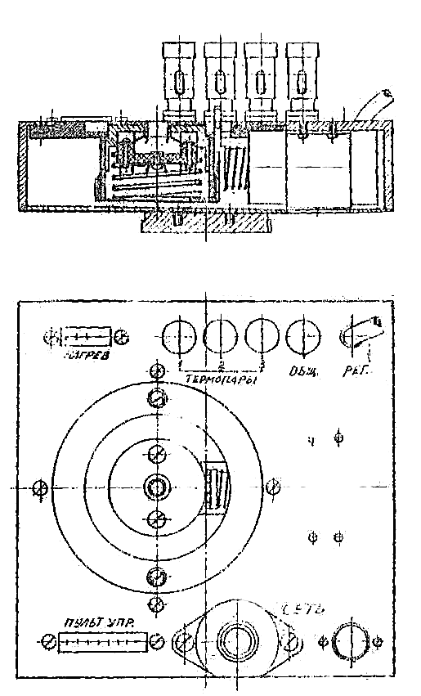

**Fig. 2 Basic platform of system “PChSM”, fixed on the set of the equipment “PION” and connected to the power unit, video and the measuring unit of the complete set of equipment “PION”**

The essence of the process for obtaining advanced foam, saturated with microdispersed hydrogen bubbles from a thermoplastic melt in ampoules under microgravity conditions is to use the electrolysis process to obtain negatively charged microdispersed electrolytic hydrogen bubbles, which are formed under microgravity conditions due to the action of an increasing electrostatic repulsive force of negatively charged microdispersed electrolytic hydrogen bubbles from a negatively charged cathode under these conditions, and inertial forces for injecting the formed electrolytic hydrogen bubbles through a small gap connecting the electrolytic chamber with the chamber for melting the model foam material, into the melt of the model foam material.

The uniform distribution of microdispersed hydrogen bubbles in the melt of the model material in microgravity conditions occurred because of the unique property of microgravity - its isotropism. Figure 3 presents the construction of an ampule for processing advanced foam materials with equally distributed microdispersed hydrogen gas bubbles.

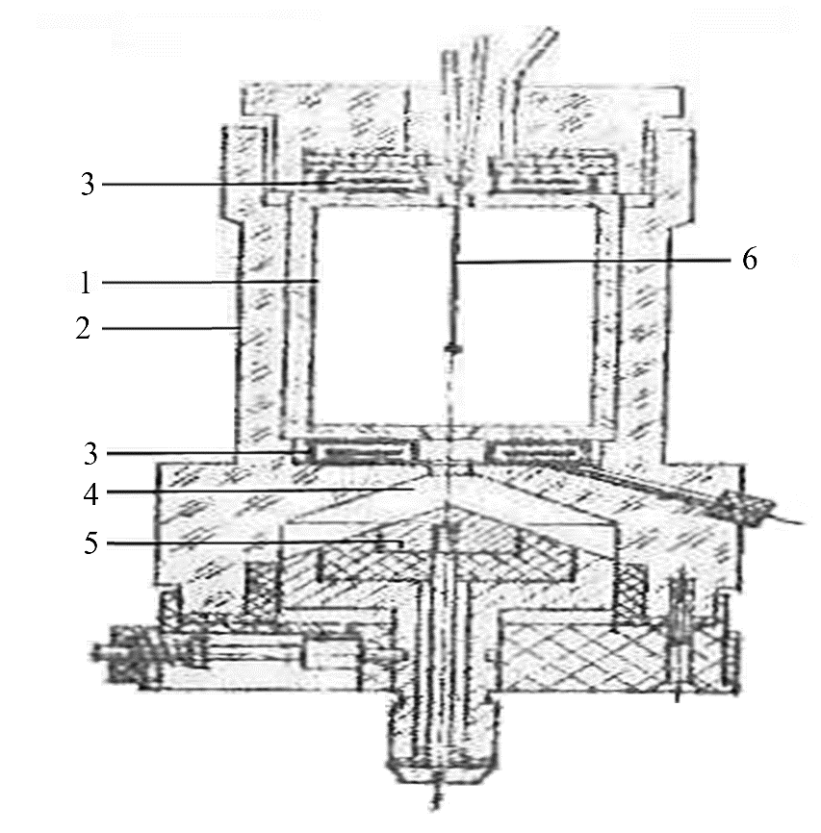

**Fig. 3 Construction of an ampule for processing of the foam materials with an equal distribution of the gas phase**

Here - (1) the glass camera from the molybdenum glass for the melting of model material, which contains a thermocouple - (6) for maintaining the necessary temperature in the camera, connected through the small gap with the electrolytic camera - (4). All working parts of the ampule are “dressed” in the plastic jacket - (2) for the isolation of the processes taking place in the camera processes, with the purpose of ensuring the safety of conducting processing of advanced foam materials by the operator-cosmonauts in the space station.

From above and from below the camera, for the melting of model material, the heating elements in the form of tablets (3) were arranged. An electrostatic camera was supplied by the piston in the form of a plug (5) with two electrodes to form the electrolytic bubbles inside the camera, and these bubbles were injected through the small gap into the camera for the melting of the model material.

The ampoule’s design provided a simple replacement of the inner chamber with the obtained advanced foam material, with a new inner chamber for the production of a new foam material. The heating temperature was 20℃ -100℃. The temperature distribution inside the model material was recorded using a chromel-copel thermocouple, placed in the middle of the inner chamber with the melt of the model material.

**3. Results and Discussions**

***3.1. Experimental Advanced Foams Production in Terrestrial Conditions***

The results of experimental production of advanced foams are presented in Figure 1 with the following polymers and resins: polyvinyl chloride PCHV-1, epoxy resin, and polyurethane PU-101. The experimental production of advanced foams was carried out on the set, presented in Figure 1, with the following polymers and resins: polyvinyl chloride PCHV-1, epoxy resin, and polyurethane PU-101. Tables 1 and 2 show the regime parameters of the production and the physical mechanical properties of the produced polyvinylchloride PCHV-1 foam, as well as their comparison with the known methods of foam polymer production. Tables 3 and 4 give results for the case of epoxy resin. Tables 5 and 6 give results for the case of polyurethane PU-101.

Table 1. Regime parameters of the process of production and the physical and mechanical properties of the produced polyvinylchloride foam, PCHV-1. Melting point - 60℃, time - 4 minutes, vibration acceleration – 150 m/sec2.

|  |  |  |  |  |  |
| --- | --- | --- | --- | --- | --- |
| **Frequency (Hz)** | **Volume weight (Kg/m3)** | **Diameter of cells (mm)** | **Strength with the compression, (Мn/m2), σ** | **Water Absorption, (%)** | **Dielectric constant, (ε)** |
| 50 | 130 | 0.2 | 0.4 | 2.5 | 1.1 |
| 60 | 110 | 0.15 | 0.6 | 2.3 | 1.2 |
| 70 | 80 | 0.1 | 0.8 | 2.1 | 1.5 |
| 80 | 70 | 0.02 | 0.9 | 2.0 | 1.9 |
| 90 | 75 | 0.02 | 1.0 | 1.9 | 1.8 |
| 100 | 90 | 0.09 | 0.8 | 2.0 | 1.3 |
| 110 | 115 | 0.1 | 0.7 | 2.2 | 1.2 |
| 120 | 120 | 0.15 | 0.45 | 2.4 | 1.1 |

**Table 2. Comparison of the physical and mechanical properties of polyvinylchloride foam PCHV-1, produced by the developed method, with the known methods**

|  |  |  |  |  |  |  |
| --- | --- | --- | --- | --- | --- | --- |
|  | **Time of process (min)** | **Volume weight (Kg/m3)** | **Ε** | **Diameter of cells (mm)** | **σ,**  **Мn/m2** | **Water absorption,**  **(%)** |
| Developed method | 4 | 0.02 | 1.9 | 0.02 | 1.0 | 1.9 |
| Known methods | 30 – 40 | 0.2 | 1.1 | 0.1 | 0.4 | 2.5 |

**Table 3. Regime parameters of the process of production and the physical and mechanical properties of the produced epoxy foam resin. Melting point - 110℃, time - 5 minutes, vibration acceleration – 150 m/sec2.**

|  |  |  |  |  |  |
| --- | --- | --- | --- | --- | --- |
| **Frequency (Hz)** | **Volume weight (Kg/m3)** | **Diameter of cells (mm)** | **Strength with the compression, (Мn/m2), σ** | **Water absorption (%)** | **Dielectric constant,**  **(ε)** |
| 50 | 220 | 0.3 | 1.2 | 2.3 | 1.0 |
| 60 | 170 | 0.2 | 1.9 | 2.0 | 1.2 |
| 70 | 110 | 0.1 | 2.0 | 1.8 | 1.7 |
| 80 | 90 | 0.02 | 2.5 | 1.3 | 2.0 |
| 90 | 85 | 0.01 | 2.3 | 1.1 | 1.9 |
| 100 | 100 | 0.2 | 1.9 | 1.5 | 1.6 |
| 110 | 190 | 0.4 | 1.5 | 2.1 | 1.5 |
| 120 | 200 | 0.5 | 1.0 | 2.4 | 1.4 |

**Table 4. Comparison of the physical and mechanical properties of foam epoxy resin, produced by the developed method, with the known methods**

|  |  |  |  |  |  |  |
| --- | --- | --- | --- | --- | --- | --- |
|  | **Time of process (min)** | **Volume weight (Kg/m3)** | **Ε** | **Diameter of cells (mm)** | **σ,**  **Мn/m2** | **Water absorption,**  **(%)** |
| **Developed method** | 5 | 85 | 2.0 | 0.02 | 2.5 | 1.3 |
| **Known methods** | 30 - 40 | 220 | 1.0 | 0.3 | 1.2 | 2.3 |

**Table 5. Regime parameters of the process of production and the physical and Mechanical properties of the produced polyurethane foam PU-101. Melting point - 130℃, time - 5 minutes, vibration acceleration – 150 m/sec2.**

|  |  |  |  |  |  |
| --- | --- | --- | --- | --- | --- |
| **Frequency (Hz)** | **Volume weight (Kg/m3)** | **Diameter of cells (mm)** | **Strength with the compression, (Мn/m2), σ** | **Water absorption (%)** | **Dielectric constant,**  **(ε)** |
| 50 | 300 | 0.3 | 1 | 0.7 | 1.0 |
| 60 | 200 | 0.2 | 1.2 | 0.6 | 1.2 |
| 70 | 100 | 0.1 | 1.4 | 0.5 | 1.7 |
| 80 | 50 | 0.02 | 2.0 | 0.2 | 2.0 |
| 90 | 49 | 0.01 | 1.9 | 0.2 | 1.9 |
| 100 | 200 | 0.2 | 1.5 | 0.6 | 1.6 |
| 110 | 250 | 0.4 | 1.0 | 0.7 | 1.5 |
| 120 | 300 | 0.5 | 0.9 | 0.8 | 1.4 |

**Table 6. Comparison of the physical and mechanical properties of polyurethane foam PU-101, produced by the developed method, with the known methods**

|  |  |  |  |  |  |  |
| --- | --- | --- | --- | --- | --- | --- |
|  | **Time of process (min)** | **Volume weight (Kg/m3)** | **Ε** | **Diameter of cells (mm)** | **σ,**  **Мn/m2** | **Water absorption,**  **(%)** |
| **Developed method** | 5 | 50 | 2.0 | 0.02 | 2.0 | 0.2 |
| **Known methods** | 300 - 360 | 250 | 1.1 | 5.0 | 1.0 | 0.3 |

The obtained results permitted the conclusion that the use of a process of Vibroturbulation in the production of foam permits high-quality, stable foams with mechanical strength and uniform distribution of the microdispersed gas bubbles. The use of a vibroturbulation process does not require the application of expensive gases and chemical solvents, which have an adverse effect on the properties of the produced foams. The method of foam production with high physical and mechanical properties using the effect of vibroturbulation is technologically simple and requires low time expenditures for producing the foams.

***3.2. Experimental Advanced Foams Production in Microgravity Conditions***

Practical production of advanced foams with uniform distribution of microdispersed electrolytic hydrogen bubbles in microgravity conditions, as part of pre-flight tests, was carried out on Earth and in conditions of short-term weightlessness on board the Il-76K flying laboratory. Practical tests of producing advanced foams were carried out on a specially developed complex by the authors in Electromagnetic Impulse Inc.. “PChSM” complex (physical and chemical studies of microgravity) as part of the “PION” complex for further use of the entire complex as a whole on board the International Space Station. Pre-flight tests of producing promising foams in microgravity conditions included the following stages and actions of the astronaut operator: a) preparing the “PChSM” installation for operation - the control panel was connected to the platform via the “panel contact” connector; the platform was connected to the power source and video measurement of the “PION” installation (“network”, REG); the ampoule was inserted and secured on the platform; the ampoule heating elements were connected to the platform via the “heating” connector, and the ampoule thermocouple was connected to the “thermocouple” terminal, b) obtaining foamed material - power was turned on using the “network” toggle switch on the remote control (the presence of power in the network was indicated by the operation of the indicator lamp); the glass chamber of the ampoule was preheated using the “TOP HEATING” toggle switch; as the model material melted, the electrolysis process took place and video measuring of set “PION” simultaneously switched on; after the formation of the sufficiency of electrolytic hydrogen gas bubbles in the electrolytic chamber, by pressing the “GAS” button on the remote control, the electromagnetic mechanism of the piston trigger was activated, which introduced the resulting gas-liquid mixture into the molten model material through the gap between the chambers; the “Electric” and “TOP HEATING” toggle switches were switched off; after the resulting foam had solidified, the video measurement of the “PION” installation was switched off, c) the “PChSM” installation was dismantled - the “PChSM” installation was dismantled in the reverse order of preparing the “PChSM” installation for operation.

Pre-flight tests of practical production of advancedfoams on Earth, as well as in short-term weightlessness conditions, conducted on board of the Il-76K flying laboratory, established that the “PChSM” system allows for the production of advanced foams with uniform distribution of microdispersed gaseous hydrogen, bubbled, using the process of electrolysis and inertial forces, which allows for experiments to be conducted as part of the “PION” system on board the International Space Station (ISS).

**4. Conclusion**

Method and facility, using the vibroturbulation method, allowing uniform distribution of thermoplastic at its melting temperature with a gas filler, formed during the water electrolysis process, and the subsequent conversion of this gas filler during the vibroturbulation method into microdispersed electrolytic bubbles of hydrogen, permit the production of advanced foams with a uniform distribution of electrolytic bubbles of hydrogen inside under terrestrial conditions. The obtained results of the experimental production of advanced foams allowed concluding that the use of vibroturbulation and electrolysis processes in the production of advanced foams ensures the production of high-quality, stable in mechanical strength and uniformly saturated with microdispersed hydrogen bubbles advanced foams. The vibroturbulation method does not require the use of expensive gases and chemical solvents, which negatively affect the properties of the resulting foams. The method of advanced foams production, using the effect of vibroturbulization, is technologically simple and requires little time to obtain foams.

The developed method and system “PChSM”, using the isotropic microgravity property and inertial forces, permitted advanced foam with uniformly distributed gas filler - microdispersed electrolytic bubbles of hydrogen, formed during the water electrolysis process, in the foam material melt production in microgravity conditions. The pre-flight tests of practical production of advanced foams on Earth and under short-term weightlessness conditions, conducted on board the IL-76K flying laboratory, established that the system “PChSM” permits to obtain advanced foams with the uniform distribution of microdispersed hydrogen gas bubbled, using the process of electrolysis and inertial forces that permits the conducting of the experiments as part of system “PION” on board of International Space Station (ISS).

**References**

1. A.A. Berlin, and F.A. Shutov, *Chemistry and Technology of the Gas Filled High Polymers*, Moscow: Naika, 1980. [[Google Scholar](https://scholar.google.com/scholar?hl=en&as_sdt=0%2C5&q=Chemistry+and+technology+of+gas-filled+high+polymers&btnG=)]
2. Khalyapov R.R., and Utekhin S.V., “The Method of Obtaining the Elastic Foam Producing Agent,” *Patent 2197505*, 2003**.**
3. Trefilov S.V., and Trefilov A.V., “The Method of Obtaining the Super-Lightweight Organomineral Foam Producing Agent,” *Patent 2160287*, 2000.
4. Y. Conde et al., “Replication Processing of Highly Porous Materials,” *Advanced Engineering Materials*, vol. 8, no. 9, pp. 795 -803, 2006. [[CrossRef](https://doi.org/10.1002/adem.200600077)] [[Google Scholar](https://scholar.google.com/scholar?hl=en&as_sdt=0%2C5&q=Goodall+R.Replication+processing+of+Highly+Porous+Materials.&btnG=)] [[Publisher Link](https://advanced.onlinelibrary.wiley.com/doi/10.1002/adem.200600077)]
5. Rajiv Mahajan, and William J. Koros, “Factors Controlling Successful Formation of Mixed-Matrix Gas Separation Materials,” *Industrial & Engineering Chemistry Research*, vol. 39, no. 8, pp. 2692-2696, 2000. [[CrossRef](https://doi.org/10.1021/ie990799r)] [[Google Scholar](https://scholar.google.com/scholar?hl=en&as_sdt=0%2C5&q=Controlling+Successful+Formation+of+Mixed-Matrix+Gas+Separation+++++++++Materials&btnG=)] [[Publisher Link](https://pubs.acs.org/doi/10.1021/ie990799r)]
6. Linnéa Andersson, and Lennart Bergström, “Gas-Filled Microspheres as an Expandable Sacrificial Template for Direct Casting of Complex-Shaped Macroporous Ceramics,” *Journal of the European Ceramic Society*, vol. 28, no. 15, pp. 2815-2821, 2008. [[CrossRef](https://doi.org/10.1016/j.jeurceramsoc.2008.04.020)] [[Google Scholar](https://scholar.google.com/scholar?hl=en&as_sdt=0%2C5&q=Gas-filled+microspheres+as+an+expandable+sacrificial+template+for+direct+casting+of+complex-shaped+macroporous+ceramics&btnG=)] [[Publisher Link](https://www.sciencedirect.com/science/article/abs/pii/S0955221908002148?via%3Dihub)]
7. Shih-Jung Liu, Ming-Jen Lin, and Yi-Chuan Wu, “An Experimental Study of the Water-Assisted Injection Molding of Glass Fiber Filled Poly-Butylene-Terephthalate (PBT) Composites,” *Composites Science and Technology*, vol. 67, no. 7-8, pp. 1415-1424, 2007. [[CrossRef](https://doi.org/10.1016/j.compscitech.2006.09.016)] [[Google Scholar](https://scholar.google.com/scholar?q=An+experimental++study+of+the+water-assisted+injection+molding+++++++++of+glass+fiber+filled+poly-butylene-terephthalate+(PBT)++composites&hl=en&as_sdt=0,5)] [[Publisher Link](https://www.sciencedirect.com/science/article/abs/pii/S0266353806003666?via%3Dihub)]