*Original Article*

**Live Virtual Machine Pre-copy Migration Algorithm for Fault Isolation in Cloud Based Computing Systems**

**S.Veerapandi1, R.Surendiran2, K.Alagarsamy3**

1Department of Computer Science, MannarThirumalaiNaicker College, Madurai,

2School of Information Science, Annai College of Arts and Science, Kumbakonam, India,

3 School of Information Technology, Madurai Kamaraj University, Madurai,

surendiranmca@gmail.com

Received: 26 May 2022; Revised: 25 June 2022; Accepted: 05 July 2022; Published: 15 July 2022;

**Abstract -**Live Virtual Machine migration techniques are using broadly for fault isolation in cloud based computing systems. Live Replatforming & Refactoring is an important technique for assisting elastic management of virtualized assets. Virtual computer migration is happened transparently with different host’s migration. The efficiency of virtual Live Replatforming & Refactoring is dependent on the workload running in the migrated virtual machines. Here scientific prediction of Live Replatforming& Refactoring migration is the challenging problem. We can apply the training techniques on the data sets and generate the model. Those all models are going to predict best live virtual machine migration pattern and this will helpful for improve the performance to provide better services and power consumption solutions. In this paper mainly focus on reduce the down time and minimal influence of E2E application efficiency.

**Keywords -** Live Virtual machine migration, Fault tolerance, Training and prediction techniques, High availability and reliability.

**1. Introduction**

Virtualization technologies are mainly utilizes in data centers and will get the benefits of efficiency and fault isolation, flexible migration. Live Replatforming& Refactoring migration is one of the emerging technologies now a days. This techniques mainly for fault isolation and load balancing. Traditional Live Replatforming& Refactoring migration techniques are not cope to handle the heavy workloads information. We have studied extensively the live migration techniques in this paper and propose the best technique to improve the performance and reduces the down time and improves the end-to-end performance. We have proposed the live virtual machine migration technique in this paper. We have implement the virtual machine pre-copy algorithm

Below are the previous studies details of migration performance. Monitoring mechanism of dirty pages and memory and network congestion. We present the live virtual pre-copy migration algorithm is able to accomplish the nominal downtime and increases the application end to end performance.

**2. Literature Survey**

This section represents few of work done by researchers. There are countless research spikes at fault isolation field for the high availability and reliability. This survey mainly discussed the types of letdowns and numerous techniques used for discovery, control and recovery from failures. We may observe the different types of failures in cloud computing like omission, hardware, software, Network, Response, and miscellaneous failures and designed reactive and proactive fault isolation techniques to overcome the fault tolerance issues.

There is a technique called fault masking. It is correcting the faults immediately when any kind of hardware redundancy. This approach is execute the redundant functions and able to remove the fault errors. It is not able identify the hidden faults information. The system is not aware of identify the hidden faults. Then the other authors are interested in reliability and high availability assessment used the reproduction technique. The reproduction technique is replicate the tasks in all the available virtual machines. It defines the alive of VM time and task status. System decides which virtual machine is the finest based on the above two attributes details. The best virtual machine is satisfies the requirement of high availability. When the task fails in all the virtual machines, needs new virtual machine to backward recovery to the task. The same task needs to be rerun in the new virtual machine. This approach is required huge storage device and more availability of nodes to add when miscarriage continue and waste in resource utilization.

Author presented another technique as a resubmission technique. This technique is tolerating the faults. It is having two modules, one is processing module and other one is executor module. The processing module is begins to prepare the task and copy the same task in all the virtual machines. Now the next executor module is run the task on all the virtual machines. If its complete the task correctly and then system starts the next task. When it fails the task to execution and then the tasks submitted again in all the virtual machines with a new set of parameters. The research is utilizes the extra resources and excess of time due to repeating the tasks execution.

Author presented another technique as a checkpoint/restart mechanism with replication mechanism. This kind of fault-tolerant system ensure to provide the reliability and continuity of services. Checkpoint file is collect the high failure rate information. This check pointing file is used to progress to provide the high consistency and availability. The checkpoint/restart mechanism helps for the proactive fault tolerance to recover from the fault. It decreases the time consumed to recover the faults and also reduces the amount of energy used up and above your head.

Author presented another technique to enhance the consistency of cloud services through fault-based mechanism. This approach is having these steps. 1. Discovery of virtual machine failure because of greater response time. 2. While executing the tasks find the checkpoints periodically 3. Find the optimal goal barrier to restart failed tasks. This will gives the solution reducing the execution time and growing reliability also reduces the energy consumption.

Author introduces the model to design a fault isolation scheduling algorithm to increases the reliability requirements with least resources. This approach will present a high availability and low firing storage architecture for a cloud computing system. Author presents the many other reactive approaches like restart, retry, replay and so on. When retry is performed and it is detecting the faults and applied the retry mechanism to recover from the effect of fault. This retry mechanism is activates the certain time period. If the fault remain longer than the retry period and then it will considered the permanent fault. We would identify the fault node and replace the same to overcome the permanent fault issue. When it fault is disappears with in the time period that we can considering as a transient failure and it is working normal functioning This approaches will reduces the most of the faults with in the less time and reduces the energy consumption.

Author presents the proactive approaches, it can be reduces the failure rates within the cloud and also increases the capacity and throughput. There is a technique called job migration. It will do the job migration into another machine when the failure occurrence is happened. This approach also will helpful on the consumption on the energy levels.

The author proposed Fault tolerant recovery agent system. It is having four types of agents for recovery purpose. These recovery agents is performs the roll back recovery after occurenance of any failure. It collects the data the failure and recovery information. This system is helpful maintain the consistent state from the failures.

**3. Proposed System**

In this segment we present the detail our contribution to fault isolation problem. We develop the green cloud architecture which aims maninly on the reduce data center power consumption and will give the gurantee to the users on the performance wise and also it enables the online monitoring environment for the live virtual machine pre-copy migration and virtual machine employement optimization. Here we are designing the hierarchical architecture in the data centers locations for the easiness of administration. Thiscategorized architecture of data centers mainly designed for fault tolerance in routing and storage.

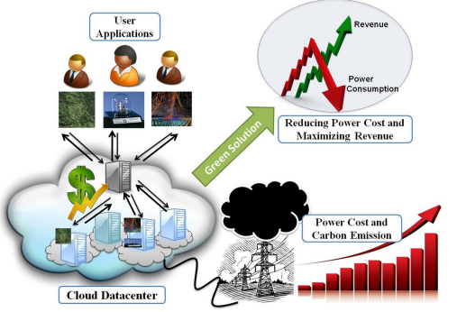

**Fig. 1 Gree cloud architecture for reducing power cost and maximuzing revenue**

The VM migration is mainly for elastic and energetic resource management while enabling fault management and lesser maintenance cost. It helps in the improvement in virtualization technology has run to significant reduction in VM overhead and also increases the energy efficiency in cloud architecture. the greencloud architecture make the cloud green for the both the user and provider. Here VM migration is called as a Live Migration. Now a days live migration technique is the most important technology. It will empower the virtual machines to moved between hosts with no downtime and live migration technique enables to respond in such a way that extraordinary resource utilization by moving virtual machines to hosts. With the help of this VM migration approach will get the high levels of efficiency even in during hard periods also.

***3.1.Setups for Live Migration***

Live migration setups has been in beween of the two hyper virtual machines hosts. Here virtual machine memory is copied in both the hyper v-hosts. Bost the v-hosts can share access to use whenever required.

* Configuration file created and available in the destination server.
* Birthplace memory is copied in the target server
* Altered memory pages on both home VM and target VM
* the above process will continue till to reduces the number of pages
* May be VM is stopped on the source node
* Ultimate memory state will copied from home VM to target
* Virtual Machine may be restarted in destination
* Address determination protocol is used to modernize the network routing tables

***3.2. Configurations Steps for Live Migration***

Developers can use SCORCH cloud alignment model to paradigm a catalog of arrangement options that are available on the virtual machines. Here configure the auto scaling queue configuration optimization technique in all the virtual machines. There is a possibility to add or remove the virtual machines based on the requirement. in this configuration developers designed the energy model that specifies the power ingestion required to run a VM configuration. Developers also designes the cost model that specifies cost to run the VM configuration These all the models will gives the optimization solution in the form of energy efficiency and reduce the cost.

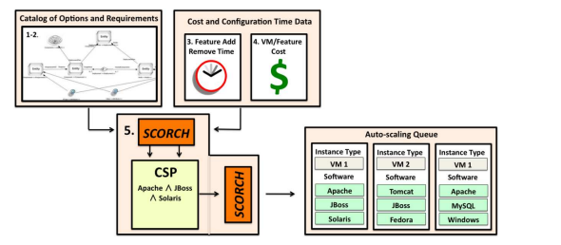

**Fig. 2 SCORCH engine**

***3.3. Deployment of VM Migration***

VM migration needs when a physical host machine needs maintenance or for n update or when a virtual machine must be switched to a different host.This VM migration process transfers the VM memory, network connectivity and storage information. A Virtual machine can be moved on the physical server to other in the VM migration process. This process will happening while running continuously without evident effects from the point of view of the end users. Major advance this VM migration is memory of the virtual machine is iteratively copied to the destination without ending its execution. Here in this approach there is a halt time is 50 to 300 ms for the synchornization of all the virtual machines to start executing as its for final target and providing an impression of seamless migration. Tradational VM migration tools is stops the running virtual machines during the migration process and this helps to overcome the failures and achieves the service level agreements gurantees. This kind of virtual machine migration process will takes us to reduces the energy consumption and also response time sensitive computing.

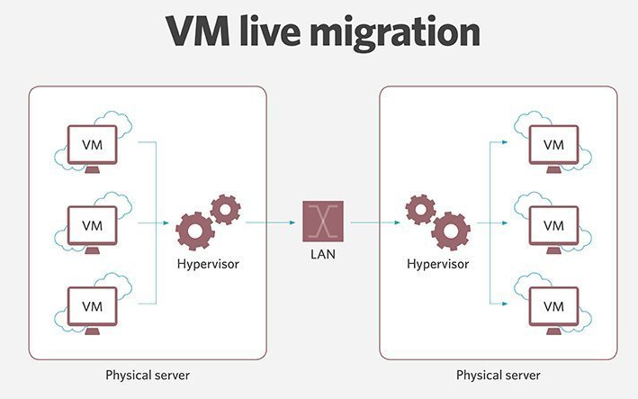

**Fig. 3 Live migration architecture**

Live migration is mainly uses virtualization process. This Virtualization process will helps an entire virtual machine to be moved with a running operating system. Live migration will gives the results like low disruption fault management, load balancing and short level system maintenance. This kind of combination of virutalization and migration eases systems management for the cluster admin. the live migration process will taken care of transferring the data in the another virtual machines memory to the target physical machine. if all the data is transferred, an operational resource consisting of CPU, memory and storage is created on the target machine. So that process will start for execution process. the above entire VM migration process causes is having the minimal downtime only and it is not possible to avoid the downtime while doing the VM migration process.

*3.3.1. Live Migration Steps*

*Premigration and Construction*

the Target host should be preselected for migration process and virtual machine is active on the clinet for process. the hyperviosr is having duplicates the memory pages from the source file to destination file.

*Reservation*

Migration request is passed from one host to other host. Target host is reserves the virtual machine container of the required size. This resources are not ready to secure, virtual machine will run on the source host only without facing any issues.

*Iterative Pre-Copy Process*

Iterative pre-copy process migration contains two steps. Those steps are iterative push phase and stop and copy phase. It will take care of all pages from host A are transferred to host B. in other subsequent iterations only pages are altered duing the transfer process will be considered.

*Stop and Copy Mechanism*

When we can observe the OS instances are failure in Host A & may observe the network traffic here. System needs to take care of network load using redirection to Host B. We could see finally failure copy information in both the Host A & B. Host A considered a primary and this way migration can be resumed from A when in case of any failure.

*Synchornous Communcation*

Host B confirms to Host A that has acknowledged the consistent OS image. Host A acknowledges this message and this becomes the commitment of movement process. Now here Host A is discards the OS image of Virtual machine and host B converts primary host.

*Activation*

Now the Virtual machine is start running from Host B. Post migration codes are going to attached to the Host B like device drivers and IP addresses information. Operations can be resume from Host B.the all the above 6 steps comes under migration process when any failures are occures any of the Hosts.

Live migration ensures the consistent VM image is available atleast one of the Virtual machine host. One host is in risk and resume the process from other Host B.

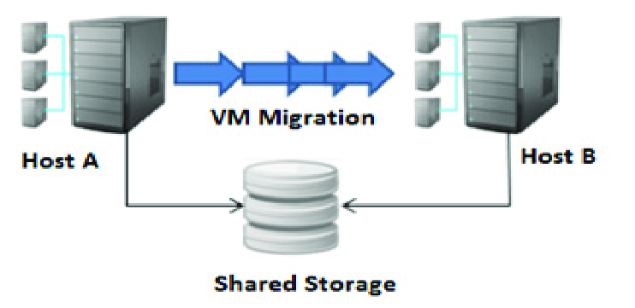

**Fig. 4 Live virtual machine migration process**

***3.4.Virtual Machine Live Migration Pre-Copy Algorithm***

In this procedure makes use of function named failure gaurd, which uses the set of all possible routes and bandwidth volume of failed path to decide which path readdress the subflow.

* Initialize the availability of paths with Virtual machines and bandwidth capacity
* Compute the total volume of all possible paths of virtual machines
* Identify the minimum bandwidth path
* Finally display the all optimal paths information
* Copy VM image in the destination Host
* Invoke the failure protection where index is a set returened by the function failure gaurd and copy the information same OS image to new active Host
* Again start executing the 1 to 4 steps for finding the optimal paths without any delay
* Close the combination with minimum number of paths
* Return the index results with optimal virtual machines path and
* New Virtual machine will start continue to availability of services.

**4. Experimental Results**

Live migration dataset is having 50000+ samples and is gathered in one year. the dataset is targeted to train using some mining techniques and generate the model. the training model is going to helpful for Live virtual computer migration. Live virtual computer migration involves memory transmission from home virtual machine to destination virtual machine. Memory usage structure of virtual machines is highly impact the rectical of Live Virtual computer Migration. Live virtual machine pre-copy migration algorithm is designed with best feature set of features. This feature set is useful to achieve the SLAs of services in a data center. When we can use the best feature set in live migration process will save power consumption and provide the better services to customers. We can reuse the best feature set information for more power consumption results.

The dataset contains application workloads to train the migration model. the above statistical image contains Virtual machine Size, page dirty rate, working set size, modified words per page and CPU utiliztion of Virtual machine. It is complete analysis depends on the various workloads are having the dataset information. We have various workloads information for different various migration algorithms. we experiment to reproduce the cluster status. we migrate the same VM with the different migration algorithms. it is highly depends on the workloads and also used the machine learned model to guide to select finest migration algorithm for a given workload. Here we main identify the best Live virtual machine migration algorithm using the training and prediction.

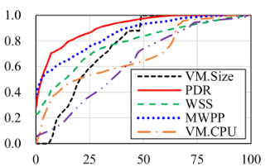

**Fig. 5 Performance metrics**

The above figure represent the memory update patterns. According to memory update pattern observe the reduced downtime. Reduced downtime leads to show utilization of power consumption is less. This kind of live migration approach is reduces the number of retransmissions and this will helps to improve the performance.

**5. Conclusion**

This paper main aims at enhancing the highligh availability and fault tolerance of cloud services using live virtual machine pre-copy algorithm. in this approach identify failure virtual machine with due to complext response time and then place the check points preiodically while executing the tasks. the evalution outcome using the genuine time dataset shows the proposed algorithm gives a healthier fault accepting solution decreasing the execution time and energy consumption and increasing the high availability and reliability. Coming up work includes to emerging the fault isolation machanisms using additional reactive and proactive techniques.

The future work mainly utilize the all resources without waste used the workflow tasks as an alternative of independent tasks.

**References**

1. Jayadivya S K et al., ”Fault-Tolerant Workflow Scheduling Based on Replication and Resubmission of Tasks in Cloud Computing,” *International Journal of Computer Science and Engineering*, vol. 4, no. 6, pp. 996-1006, 2012. [[Google Scholar](https://scholar.google.com/scholar?hl=en&as_sdt=0%2C5&q=Fault-Tolerant+Workflow+Scheduling+Based+on+Replication+and+Resubmission+of+Tasks+inCloud+Computing&btnG=)] [[Publisher Link](http://www.enggjournals.com/ijcse/issue.html?issue=20120406)]
2. Sheheryar Malik, and Fabrice Huet, ”Adaptive Fault Tolerance in Real-Time Cloud Computing,” *IEEE World Congress on Services*, 2011. [[CrossRef](http://doi.org/10.1109/SERVICES.2011.108)] [[Google Scholar](https://scholar.google.com/scholar?hl=en&as_sdt=0%2C5&q=Adaptive+Fault+Tolerance+in+Real-Time+Cloud+Computing&btnG=)] [[Publisher Link](https://ieeexplore.ieee.org/document/6012725)]
3. R. Surendiran, "Secure Software Framework for Process Improvement," *SSRG International Journal of Computer Science and Engineering*, vol. 3, no. 12, pp. 19-25, 2016. [[CrossRef](https://doi.org/10.14445/23488387/IJCSE-V3I12P105)] [[Google Scholar](https://scholar.google.com/scholar?hl=en&as_sdt=0%2C5&q=Secure+Software+Framework+for+Process+Improvement&btnG=)] [[Publisher Link](https://www.internationaljournalssrg.org/IJCSE/paper-details?Id=191)]
4. Jing Mei et al., “Fault-Tolerant Dynamic Rescheduling for Heterogeneous Computing Systems,” *Journal of Grid Computing*, pp. 507-525, 2015. [[CrossRef](https://doi.org/10.1007/s10723-015-9331-1)] [[Google Scholar](https://scholar.google.com/scholar?hl=en&as_sdt=0%2C5&q=Fault-Tolerant+Dynamic+Rescheduling+for+Heterogeneous+Computing+Systems&btnG=)] [[Publisher Link](https://link.springer.com/article/10.1007/s10723-015-9331-1)]
5. Laiping Zhao, and Kouichi Sakurai, ”A Reliability Analysis Based Scheduling Algorithm inthe Heterogeneous System,” *IPSJ SIG Technical Report*, 2010. [[Google Scholar](https://scholar.google.com/scholar?hl=en&as_sdt=0%2C5&q=A+Reliability+Analysis+Based+Scheduling+Algorithm+inthe+Heterogeneous+System&btnG=)]
6. Qingqing Feng et al., ”Magicube: High Reliability and Low Redundancy Storage Architecture for Cloud Computing,” *IEEE Seventh International Conference on Networking, Architecture, and Storage*, pp. 89-93, 2012. [[CrossRef](https://doi.org/10.1109/NAS.2012.15)] [[Google Scholar](https://scholar.google.com/scholar?hl=en&as_sdt=0%2C5&q=Magicube%3A%E2%80%9D+High+Reliability+and+Low+Redundancy+Storage+Architecture+for+Cloud+Computing&btnG=)] [[Publisher Link](https://ieeexplore.ieee.org/document/6310880)]
7. Anjali D.Meshram, A.S.Sambare, and S.D.Zade, “Fault Tolerance Model for Reliable Cloud Computing,” *International Journal on Recent and Innovation Trends in Computing and Communication*, vol. 1, no. 6, pp. 600-603, 2013. [[CrossRef](https://doi.org/10.17762/ijritcc.v1i7.2827)] [[Google Scholar](https://scholar.google.com/scholar?hl=en&as_sdt=0%2C5&q=Fault+Tolerance+Model+for+Reliable+Cloud+Computing&btnG=)] [[Publisher Link](https://ijritcc.org/index.php/ijritcc/article/view/2827)]
8. Chaonan Wang et al., ”Processing Time Analysis of Cloud Services With Re-Trying Fault Tolerance Technique,” *First IEEE International Conference on Communications in China*, pp. 63-67, 2012. [[CrossRef](https://doi.org/10.1109/ICCChina.2012.6356962)] [[Google Scholar](https://scholar.google.com/scholar?hl=en&as_sdt=0%2C5&q=Processing+Time+Analysis+of+Cloud+Services+With+Re-Trying+Fault+Tolerance+Technique&btnG=)] [[Publisher Link](https://ieeexplore.ieee.org/document/6356962)]
9. Mohammed El Mehdi Diouri, Olivier Gl¨Uck, and Laurent Lefevre, ” ECOFIT: A Framework to Estimate Energy Consumption of Fault Tolerance Protocols for HPC Applications,” *13th IEEE/ACM International Symposium on Cluster, Cloud, and Grid Computing*, 2013. [[CrossRef](https://doi.org/10.1109/CCGrid.2013.80)] [[Google Scholar](https://scholar.google.com/scholar?hl=en&as_sdt=0%2C5&q=A+Framework+to+Estimate+Energy+Consumption+of+Fault+Tolerance+Protocols+for+Hpc+Applications&btnG=)] [[Publisher Link](https://ieeexplore.ieee.org/document/6546134)]
10. Harpreet Kaur, and Amritpal AL Kaur, ”A Survey on Fault Tolerance Techniques in Cloud Computing,” *International Journal of Science, Engineering and Technology*, 2015. [[Google Scholar](https://scholar.google.com/scholar?hl=en&as_sdt=0%2C5&q=A+Survey+on+Fault+Tolerance+Techniques+in+Cloud+Computing&btnG=)] [[Publisher Link](https://www.ijset.in/volume-3-issue-2-mar-apr-2015/)]
11. Anju Bala, and Inderveerchana, ”Fault Tolerance- Challenges, Techniques, and Implementation in Cloud Computing,” *International Journal of Computer Science Issues*, vol. 9, no. 1, 2012. [[Google Scholar](https://scholar.google.com/scholar?hl=en&as_sdt=0%2C5&q=Fault+Tolerance-+Challenges%2C+Techniques%2C+and+Implementation+in+Cloud+Computing%2C&btnG=)] [[Publisher Link](https://www.ijcsi.org/articles/Fault-tolerance-challenges-techniques-and-implementation-in-cloud-computing.php)]
12. P. Latchoumy, and P. Sheik Abdul Khader, ”Survey on Fault Tolerance in Grid Computing,” *International Journal of Computer Science Issues*, vol. 2, no. 4, 2011. [[Google Scholar](https://scholar.google.com/scholar?hl=en&as_sdt=0%2C5&q=Survey+on+Fault+Tolerance+in+Grid+Computing&btnG=)] [[Publisher Link](https://airccse.org/journal/ijcses/current2011.html)]
13. R. Surendiran, and K. Duraisamy, “An Approach in Semantic Web Information Retrieval,” *SSRG International Journal of Electronics and Communication Engineering*, vol. 1, no. 1, pp. 17-21, 2014. [[CrossRef](https://doi.org/10.14445/23488549/IJECE-V1I1P105)] [[Google Scholar](https://scholar.google.com/scholar?hl=en&as_sdt=0%2C5&q=An+Approach+in+Semantic+Web+Information+Retrieval%2C&btnG=)] [[Publisher Link](http://www.internationaljournalssrg.org/IJECE/paper-details?Id=5)]
14. Amal Ganesh, M. Sandhya, and Sharmila Shankar, ”A Study on Fault Tolerance Methods in Cloud Computing,” *IEEE International Advance Computing Conference (IACC),* pp. 844-849, 2014. [[CrossRef](https://doi.org/10.1109/IAdCC.2014.6779432)] [[Google Scholar](https://scholar.google.com/scholar?hl=en&as_sdt=0%2C5&q=A+Study+on+Fault+Tolerance+Methods+in+Cloud+Computing&btnG=)] [[Publisher Link](https://ieeexplore.ieee.org/document/6779432)]
15. Daeyong Jung et al., ”*VM Migration for Fault Tolerance in Spot Instance Based Cloud Computing,*” *International Conference on Grid and Pervasive Computing*, pp. 142-151, 2013. [[CrossRef](https://doi.org/10.1007/978-3-642-38027-3_15)] [[Google Scholar](https://scholar.google.com/scholar?hl=en&as_sdt=0%2C5&q=Vm+Migration+for+Fault+Tolerance+in+Spot+Instance+Based+Cloud+Computing&btnG=)] [[Publisher Link](https://link.springer.com/chapter/10.1007/978-3-642-38027-3_15)]
16. Qi Zhang, Lu Cheng, and Raouf Boutaba, ”Cloud Computing: State-of-Theart and Research Challenges,” *Journal of Internet Services and Applications*, pp. 7-18, 2010. [[CrossRef](https://doi.org/10.1007/s13174-010-0007-6)] [[Google Scholar](https://scholar.google.com/scholar?hl=en&as_sdt=0%2C5&q=Cloud+computing%3A+state-of-the-art+and+research+challenges&btnG=)] [[Publisher Link](https://jisajournal.springeropen.com/articles/10.1007/s13174-010-0007-6)]
17. Harpreet Kaur, and Amritpal Kaur, “A Survey on Fault Tolerance Techniques in Cloud Computing,” *International Journal of Science, Engineering, and Technology*, 2015. [[Google Scholar](https://scholar.google.com/scholar?hl=en&as_sdt=0%2C5&q=A+Survey+on+Fault+Tolerance+Techniques+in+Cloud+Computing&btnG=)]
18. P. Sunilgavaskar, and Ch D.V Subbarao, ”A Survey of Distributed Fault Tolerance Strategies,” *International Journal of Advanced Research in Computer and Communication Engineering*, vol. 2, no. 11, 2013. [[Google Scholar](https://scholar.google.com/scholar?q=A+Survey+of+Distributed+Fault+Tolerance+Strategies&hl=en&as_sdt=0,5)] [[Publisher Link](https://ijarcce.com/recent-issue-november-2013/)]
19. V. Subburaj et al., “DDos Defense Mechanism By Applying Stamps Using Cryptography,” *International Journal of Computer Applications*, vol. 1, no. 6, pp. 48-52, 2010. [[Google Scholar](https://scholar.google.com/scholar?hl=en&as_sdt=0%2C5&q=Ddos+Defense+Mechanism+By+Applying+Stamps+Using+Cryptography&btnG=)]
20. Virendra Singh Kushwah, Sandip Kumar Goyal, and Priusha Narwariya, “A Survey on Various Fault Tolerant Approaches for Cloud Environment During Load Balancing,” *International Journal of Computer Networking, Wireless and Mobile Communications*, vol. 4, no. 6, pp. 25-34, 2014. [[Google Scholar](https://scholar.google.com/scholar?hl=en&as_sdt=0%2C5&q=A+Survey+on+Various+Fault+Tolerant+Approaches+for+Cloud+Environment+During+Load+Balancing&btnG=)] [[Publisher Link](http://www.tjprc.org/view_paper.php?id=4278)]
21. R. Surendiran, "Development of Multi Criteria Recommender System," *SSRG International Journal of Economics and Management Studies*, vol. 4, no. 1, pp.31-35, 2017. [[CrossRef](https://doi.org/10.14445/23939125/IJEMS-V4I1P106)] [[Google Scholar](https://scholar.google.com/scholar?hl=en&as_sdt=0%2C5&q=Development+of+Multi+Criteria+Recommender+System&btnG=)] [[Publisher Link](https://www.internationaljournalssrg.org/IJEMS/paper-details?Id=730)]
22. G. Gayathri, and R. Latha, ”Implementing A Fault Tolerance Enabled Load Balancing Algorithm in the Cloud Computing Environment,” *International Journal of Engineering Development and Research*, 2017. [[Google Scholar](https://scholar.google.com/scholar?hl=en&as_sdt=0%2C5&q=Implementing+A+Fault+Tolerance+Enabled+Load+Balancing+Algorithm+in+the+Cloud+Computing+Environment&btnG=)] [[Publisher Link](https://www.ijedr.org/viewfull.php?&p_id=IJEDR1701039)]
23. Jialei Liu et al., “Using Proactive Fault-Tolerance Approach to Enhance Cloud Service Reliability,” *IEEE Transaction on Cloud Computing*, vol. 6, no. 4, pp. 1191-1202, 2018. [[CrossRef](https://doi.org/10.1109/TCC.2016.2567392)] [[Google Scholar](https://scholar.google.com/scholar?hl=en&as_sdt=0%2C5&q=Using+Proactive+Fault-Tolerance+Approach+to+Enhance+Cloud+Service+Reliability&btnG=)] [[Publisher Link](https://ieeexplore.ieee.org/document/7469864)]
24. Alain Techana, Laurent Broto, and Daniel Hagimont, ”Fault Tolerance Approaches in Cloud Computing Infrastructures,” *The Eight International Conference on Autonomic and Autonomous System*, 2012. [[Google Scholar](https://scholar.google.com/scholar?hl=en&as_sdt=0%2C5&q=Fault+Tolerance+Approaches+in+Cloud+Computing+Infrastructures&btnG=)]
25. Saurabh Kumar Garg, and Rajkumar Buyya, ”Network Cloudsim: Modelling Parallel Applications in Cloud Simulations,” *Fourth IEEE International Conference on Utility and Cloud Computing*, 2011. [[CrossRef](https://doi.org/10.1109/UCC.2011.24)] [[Google Scholar](https://scholar.google.com/scholar?hl=en&as_sdt=0%2C5&q=Network+Cloudsim%3A+Modelling+Parallel+Applications+in+Cloud+Simulations&btnG=)] [[Publisher Link](https://ieeexplore.ieee.org/abstract/document/6123487)]
26. Rodrigo N. Calheiros et al., ”Cloudsim: A Toolkit for Modeling and Simulation of Cloud Computing Environments andEvaluation of Resource Provisioning Algorithms,” *Journal of Software: Practice and Experience*, vol. 41, no. 1, pp. 23-50, 2010. [[CrossRef](https://doi.org/10.1002/spe.995)] [[Google Scholar](https://scholar.google.com/scholar?hl=en&as_sdt=0%2C5&q=Cloudsim%3A+A+Toolkit+for+Modeling+and+Simulation+of+Cloud+Computing+Environments+andEvaluation+of+Resource+Provisioning+Algorithms&btnG=)] [[Publisher Link](https://onlinelibrary.wiley.com/doi/10.1002/spe.995)]