MAHARANI’S SCIENCE COLLEGE FOR WOMEN
JLB ROAD, MYSORE – 570005
DEPARTMENT OF COMPUTER SCIENCE


PROJECT REPORT ON
FUSION OF CONVENTIONAL AND DEEP LEARNING METHODS FOR OFFFLINE
SIGNATURE VERIFICATION
6th semester BCA Project
Submitted By
Prarthana M.K [U01AG23S0187]

Lavanya Y.S [U01AG23S0184]

Geetha G.S [U01AG23S0107]

Divya M.R [U01AG23S0266]


To the University of Mysore in partial fulfillment for award of the degree of
BACHELOR OF COMPUTER APPLICATION (BCA)
UNDER THE GUIDANCE OF
Mrs.BHAVANI S D
Department of Computer Science Maharani’s Science College for Women, Mysore

MAY-2026
MAHARANI’S SCIENCE COLLEGE FOR WOMEN
JLB ROAD, MYSURU-5700015
DEPARTMENT OF COMPUTER SCIENCE

CERTIFICATE

This is to certify that Prarthana M K [U01AG23S0187], Lavanya Y S [U01AG23S0184], Geetha G S[U01AG23S0107], and Divya M R [U01AG23S0266], 6th semester Bachelor of computer Application (BCA) students of this institution have successfully completed the project work entitled “FUSION OF CONVENTIONAL AND DEEP LEARNING METHODS FOR OFFFLINE SIGNATURE VERIFICATION ", in partial fulfillment of the requirement of the award of Bachelor of Computer Application (BCA) degree of University of Mysore. They worked under my guidance and supervision.

DECLARATION
We hereby declare that the project work entitled "FUSION OF CONVENTIONAL AND DEEP LEARNING METHODS FOR OFFFLINE SIGNATURE VERIFICATION ", in partial fulfillment of the curriculam prescribed for the award of the degree of Bachelor of Computer Application (BCA) is recorded of a project work carried out by us under the guidance of Mrs Bhavani S. D., Department of Computer Science, MSCW, Mysuru.

We further declare that the work reported in this project has not been submitted either in part or full, for the award of any degree or diploma in this institution or any other institution or University.

Date:

Place: Mysore

PRARTHANA M K [U01AG23S0187]

LAVANYA Y S [U01AG23S0184]

GEETHA G S [U01AG23S0107]

DIVYA M R [U01AG23S0266]

ACKNOWLEDGEMENT

We are immensely grateful and take this opportunity to express our deep gratitude and indebtedness to our project guide Mrs. Bhavani S D ,MSCW, for her inspiring guidance , support and valuable suggestion throughout our project work.

We express our gratitude to Dr. Sheela T, Head of the Computer Science
Department of Maharani’s science College for Women, for giving us an opportunity to carry out our project.

We are very thankful to Dr Abdul Rahiman, Principal of MSCW, Mysore, for providing infrastructure and support.

We would also like to thank all teaching and non-teaching staff of our department who directly or indirectly contributed in the accomplishment of this task.

Our sincere thanks to all our friends and family members who have patiently extended all sort of help for accomplishing this undertaking.

PRARTHANA M K [U01AG23S0187]

LAVANYA Y S [U01AG23S0184]

GEETHA G S [U01AG23S0107]

DIVYA M R [U01AG23S0266]

ABSTRACT

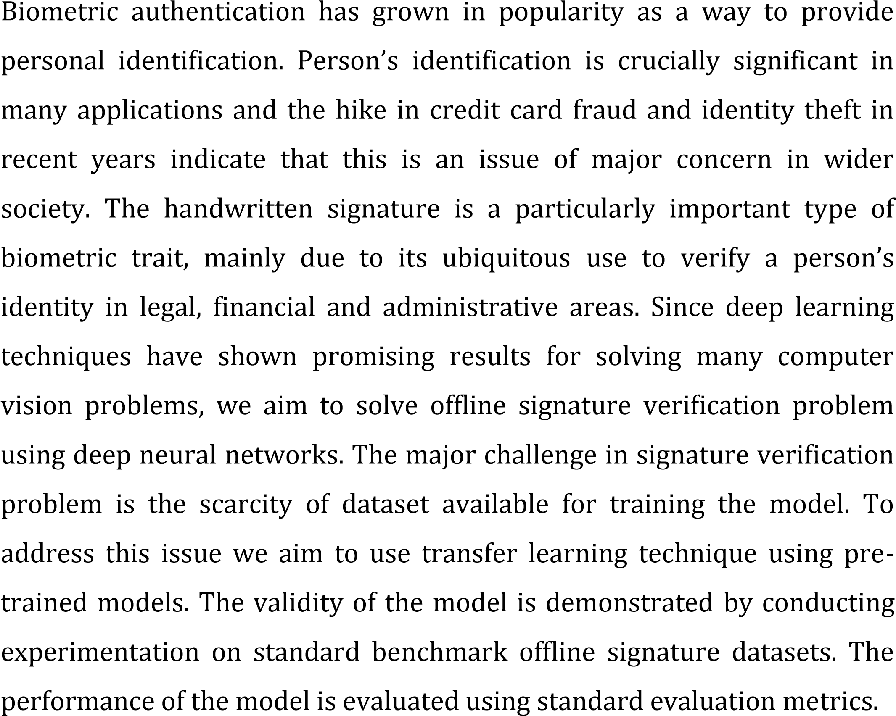

TABLE OF CONTENTS
CHAPTERS | CONTENT | PAGE NUMBERS
1 | Introduction | 7-23
1.0 | Introduction | 7-10
1.1 | Conventional authentication modes
1.1.1 | Password
1.1.2 | Pin
1.1.3 | Token
1.1.4 | Pattern
1.1.5 | Captcha
1.2 | Introduction to Biometric | 10-15
1.2.1 | Strengths of biometric
1.2.2 | Biometric classification
1.2.3 | Physiological
1.2.4 | Behavioural
1.2.5 | Characteristics of biometric
1.3 | Signature biometric traits | 15-19
1.3.1 | Categories
1.3.2 | Offline signature
1.3.3 | Online signature
1.4 | Architecture of signature verification | 20-23
1.4.1 | Image acquisition
1.4.2 | Image Pre-processing
1.4.3 | Feature extraction
1.4.4 | Model Training
1.4.5 | Decision making
2 | Review of Literature | 24-30
2.0 | Introduction
3 | Proposed model | 31-35
3.0 | Introduction
3.1 | Architecture of proposed model
4 | Experimentation and Result | 39-43
4.0 | Introduction
4.1 | Libraries used
4.2 | Training and testing
4.3 | Datasets
4.4 | Experimentation Details and Results
5 | conclusion | 43

CHAPTER-1

1.INTRODUCTION
Information security plays a vital role in protecting data from unauthorized access. Authentication is a process of verifying the identity of a user before granting access to systems or resources.
In today's digital world, ensuring secure authentication is important for individuals as well as organizations. Traditional methods such as passwords and PINs are widely used, but they have limitations like being easily forgotten or hacked.
Biometric authentication provides a more secure alternative by using unique characteristics of individuals. Among various biometric techniques, signature verification is one of the most commonly accepted methods due to its legal validity.
This project introduces a hybrid approach, combining conventional techniques and deep learning models to improve the accuracy of offline signature verification systems

NEED FOR AUTHENTICATION
- It ensures that only authorized users can access sensitive information.
- It protects data from unauthorized access and misuse.
- It maintains confidentiality, integrity, and availability of data.
- It helps in preventing identity theft and fraud.
- It is essential for secure communication and transactions.

1.1 CONVENTIONAL AUTHENTICATION MODES
Conventional authentication methods verify user identity using predefined credentials .
- PASSWORD
- PIN
- TOKEN/BADGE
- PATTERN
- CAPTCHA

1.1.1 PASSWORD
A password is a combination of characters used to authenticate a user.
Advantages:
- Easy to use and implement
- Cost-effective
- Widely accepted
Disadvantages:
- Can be hacked or stolen
- Difficult to remember strong passwords
- Requires frequent updates

1.1.2 PIN (Personal Identification Number)
A PIN is a numeric code used for authentication.
Advantages:
- Simple and quick to use
- User-friendly
- Low cost
Disadvantages:
- Limited security
- Vulnerable to guessing and attacks

1.1.3 TOKEN
A token is a physical or digital object used for authentication.
Advantages:
- More secure than passwords
- Prevents unauthorized access
Disadvantages:
- Additional cost
- Can be lost or stolen

1.1.4 PATTERN
Pattern-based authentication uses graphical patterns.
Advantages:
- Easy to remember
- Convenient
Disadvantages:
- Limited complexity
- Can be guessed
1.2 INTRODUCTION TO BIOMETRICS
Biometrics refers to identifying individuals using unique physical or behavioral characteristics.
Examples include:
- Fingerprint
- Face recognition
- Iris
- Signature
Biometric systems capture these characteristics and compare them for authentication.

1.2.1 STRENGTHS OF BIOMETRICS

- Unique Identification: Biometrics rely on individual physical or behavioral characteristics, ensuring each person has a unique identifier.

- Convenience: Users do not need to remember passwords or carry physical tokens, improving user experience and reducing the risk of forgotten credentials.

- Real-time Authentication: Biometric systems can provide instantaneous authentication, enabling swift access to devices, systems, or physical spaces.

- Reduced Fraud: Biometric technology helps prevent identity theft and fraud by ensuring that only authorized individuals can access sensitive information or facilities.

- Accuracy: Advanced biometric systems offer high levels of accuracy in identifying individuals, reducing the risk of false positives or negatives.

- Versatility: Biometric technology can be applied across various industries and use cases, from law enforcement and border control to healthcare and finance.
.

1.2.2 BIOMETRIC IS CLASSIFIED INTO TWO TYPES

- Physiological biometric
- Behavioural biometric

1.2.3 PHYSIOLOGICAL BIOMETRIC
Physiological biometrics refers to the branch of biometrics that involves the measurement and analysis of physical characteristics of individuals. These characteristics are unique to each person and are typically difficult to alter or replicate.

- Fingerprint Recognition: Fingerprint recognition involves capturing the unique patterns found on the surface of an individual's fingertips.

- Iris Recognition: Iris recognition relies on the unique patterns within the iris of the eye. The intricate patterns and colors of the iris are captured using specialized cameras.

- Facial Recognition: It can identify individuals by comparing facial features such as the distance between the eyes, nose shape, and jawline.

- Hand Geometry: Hand geometry biometrics measures various physical characteristics of the hand, including the size and shape of the palm, length and width of the fingers, and the geometry of the knuckles.

ADVANTAGES

- Uniqueness: Physiological biometrics, such as fingerprints and iris patterns, are inherently unique to each individual, making them highly reliable for accurate identification.

- Non-Transferable: Unlike passwords or tokens, physiological traits are inseparable from the individual, reducing the risk of unauthorized access due to theft or sharing.

- Convenience: Physiological biometrics eliminate the need for users to remember passwords or carry physical tokens, streamlining the authentication process and enhancing user experience.

- Speed and Efficiency: Biometric authentication can be performed quickly and efficiently, enabling swift access to devices, systems, or physical spaces.

DISADVANTAGES

- Inability to Change: Unlike passwords or PINs, which can be changed if compromised, biometric traits are permanent and cannot be altered. If a biometric template is compromised, the individual's biometric data is compromised for life.

- Privacy Concerns: Collecting and storing biometric data may raise privacy concerns among individuals, as it involves capturing and storing unique physical characteristics that are inherently personal and sensitive.

- Accuracy Issues: While physiological biometrics generally offer high accuracy, certain factors such as poor image quality, variations in environmental conditions, or physical changes over time (such as aging or injury) can affect the accuracy of biometric systems.

1.2.4 BEHAVIOURAL BIOMETRIC
Behavioral biometrics refers to the field of biometric authentication that analyzes patterns of behavior or actions unique to individuals for verification purposes.

ADVANTAGES

- Real-time Monitoring: Behavioral biometrics can provide continuous authentication by monitoring user behavior throughout a session, not just at login.

- Reduced Risk of Session Hijacking: Continuous monitoring helps to detect and prevent unauthorized access during a session.

- Non-Intrusive: Behavioral biometrics are generally non-intrusive and do not require active participation from the user after initial setup.

- Seamless Experience: Users can be authenticated in the background without interrupting their normal activities.

DISADVANTAGES

- Data Sensitivity: Behavioral data can reveal sensitive information about a person's habits and routines, raising privacy concerns.

- Data Storage and Security: Storing and protecting large amounts of behavioral data can pose security risks.

- Inconsistent Behavior: User behavior can vary due to fatigue, stress, illness, or other factors, potentially leading to authentication errors.

- False Positives/Negatives: High variability in behavior can result in false positives (incorrectly identifying someone as the legitimate user) or false negatives (failing to recognize the legitimate user).

DIFFERENCES BETWEEN PHYSIOLOGICAL AND BEHAVIOURAL BIOMETRIC

PHYSIOLOGICAL BIOMETRIC |  | BEHAVIOURAL BIOMETRIC
• Involves the measurement and analysis of physical human characteristics. | • | Involves the measurement and analysis of patterns in human activity and behavior.
• Fingerprints, facial recognition, iris scans, DNA, hand geometry. | • | Keystroke dynamics, voice recognition, gait analysis, signature dynamics, mouse movement patterns.
• Static and typically unchanging over time. | • | Dynamic and can change based on mood, health, and other external factors.
• Often requires direct physical interaction with a sensor (e.g., placing a finger on a scanner). | • | Typically involves monitoring activity over time (e.g., typing on a keyboard).
• Generally stable throughout a person's life, with minimal changes. | • | Subject to variation and may need continuous updating.
• Higher privacy concerns due to the uniqueness and unchangeability of the data (e.g., fingerprints). | • | Potentially lower privacy concerns but still significant due to the tracking of activities.

1.2.5 CHARACTERISTICS OF BIOMETRICS
- Uniqueness: Biometric authentication uses unique biological characteristics that are specific to each individual.
- Permanence: Biometric characteristics are permanent and do not change over time.
- Universality: Each person should have a unique characteristic.
- Collectability: Easy to collect and can be captured using verity of devices and technologies.
- Acceptability: Biometric authentication is widely accepted and used in a verity of settings.
- Integration: Easy to embedded in an application.
- Performance: Biometric authentication is fast and efficien

1.3 SIGNATURE BIOMETRIC TRAITS

Signature is a result of neuro-motor activities and it is widely accepted authentication means from ancient times. It is the symbol of consent. signature is a unique mark, symbol, or writing that serves as a person's official endorsement, authentication, or approval of a document, contract, or transaction. Signatures are commonly used in various contexts, such as legal agreements, financial transactions, official documents, and personal correspondence.
A signature can take many forms, including handwritten cursive script, printed names, initials, seals, stamps, or even digital signatures. The primary purpose of a signature is to provide evidence of the signer's intent to agree to the contents of the document or to verify their identity.

ADVANTAGES OF SIGNATURE BIOMETRIC TRAITS

- Authentication: They provide evidence that the person who signed the document intended to agree to its contents or authorize a particular action.

- Legal Validity: They help establish the authenticity and validity of contracts, agreements, and other legal documents, making them legally binding.

- Personalization: Signatures add a personal touch to documents, making them uniquely identifiable to the signer.

- Versatility: Signatures can be used in various formats, including handwritten, digital, or even electronic signatures, making them adaptable to different technological platforms and workflows.

TYPES OF SIGNATURE
- Offline signature
- Online signature

1.3.1 OFFLINE SIGNATURE
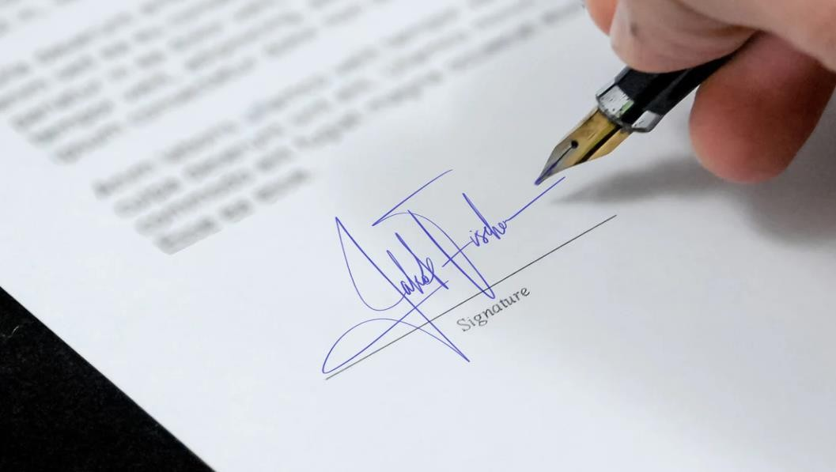

Offline signatures are when you write your name by hand on a real paper. They're like old-fashioned autographs, showing that you agree with something. These signatures are important and real in legal situations. They make things official without needing a computer or phone. Even though we have fancy technology, offline signatures are still used a lot. Sometimes it's tricky because you need to send papers by mail or meet in person. Each person's signature looks different, like their own special handwriting. Even though we can do things digitally, offline signatures are still a big deal. They show trust and make things official, just like they always have.
Verifying the authenticity of a handwritten signature can be challenging and often necessitates forensic analysis. The process is also time-consuming and inefficient, especially for transactions requiring multiple signatures, and contributes to environmental concerns due to paper usage. Additionally, offline signatures are limited in their applicability for remote transactions,
necessitating physical presence and document handling. Despite these drawbacks, offline signatures remain a prevalent method of authentication due to their simplicity and established legal acceptance.

ADVANTAGES:

- Offline signatures are legally recognized in many jurisdictions, carrying the same validity as digital signatures in official documents and contracts.

- They are universally accepted across various industries and cultures, making them accessible and familiar to people worldwide.

- Offline signatures create a personal connection between individuals, as they are handwritten and unique to each signer.

- Offline signatures are easy to understand and use, requiring minimal training or technical expertise.

DISADVANTAGES:

- Handwritten signatures are susceptible to forgery.

- Physical documents with offline signatures can be altered or tampered.

- Offline signatures may require physical exchange or mailing of documents, leading to delays and added costs, particularly in remote or international transactions.

- Printing and mailing physical documents for offline signatures contribute to paper waste and carbon emissions, impacting the environment.

- People's signatures can vary over time or in different circumstances, leading to inconsistencies

1.3.2 ONLINE SIGNATURE



An online signature, also known as a digital signature, is a way to sign documents electronically. It allows you to sign papers without printing them out or using a pen. You can create your signature using a computer or smartphone and add it to documents with just a few clicks. Online signatures are fast and convenient, saving time and reducing paperwork. They're secure too, often using encryption to protect your signature from being tampered with. Many businesses and organizations use online signatures because they're legally binding and accepted worldwide. They're also ecofriendly, as they reduce the need for printing and paper. Overall, online signatures make signing documents easier, faster, and more efficient in today's digital age.
They significantly streamline workflows by enabling remote signing, reducing the need for physical document handling and accelerating transaction times. Security features like encryption and multifactor authentication enhance the protection against forgery and unauthorized access. Additionally, online signatures support environmental sustainability by minimizing paper use and associated waste. However, their adoption requires users to have access to the necessary technology and can raise concerns about digital security and privacy. Despite these challenges, the growing reliance on digital transactions and remote work environments has made online signatures an essential tool for modern business operations, providing a seamless and secure signing experience.

ADVANTAGES:

- Online signatures allow you to sign documents from anywhere with an internet connection.

- Documents can be signed and processed instantly, reducing turnaround times and streamlining workflows.

- Online signatures enable remote signing, making it easier for individuals to sign documents, especially when parties are located in different locations.

- Online signature solutions provide an audit trail that records each step of the signing process.

- Online signature platforms can integrate with other digital tools and systems.

DISADVANTAGES:

- Online signature platforms may experience technical glitches or downtime, leading to delays or disruptions in the signing process.

- Online signatures rely on internet connectivity and digital devices, making them inaccessible in areas with poor internet .

- While online signatures employ encryption and authentication measures, they are still vulnerable to cybersecurity

- Some jurisdictions may have specific requirements or regulations regarding the use of online signatures, leading to legal uncertainties or disputes.

- Verifying the identity of signatories in online transactions can be challenging, as digital signatures may not provide the same level of certainty as physical signatures.

1.4 ARCHITECTURE OF SIGNATURE VERIFICATION

Any signature verification is a two class pattern verification problem of deciding whether the given signature is genuine or forgery.

1.4.1 IMAGE ACQUISITION: Image acquisition in offline signature verification is a critical step that involves capturing a high-quality digital image of the handwritten signature. The process relies on highresolution scanners, digital cameras, or smartphone cameras to ensure clarity and detail. Proper image acquisition is essential for accurate feature extraction, reliable verification, and effective forgery detection in offline signature authentication systems.
1.4.2 IMAGE PREPROCESSING: Image preprocessing in offline signature verification involves enhancing the captured signature image to improve its quality and suitability for analysis. This step is crucial for accurate feature extraction and verification. Key preprocessing techniques include:
- Grayscale → removes color, keeps intensity
- Binarization → converts image to black & white
- Noise removal → cleans the image
1.4.3 FEATURE EXTRACTION: Feature extraction involves extraction of suitable features for discriminating genuine and forgery signatures. The extracted features should be their values among genuine signatures should be close to each other and sufficiently different for discriminating forgeries from genuine signatures for a writer. Extraction of suitable features not only enhance the performance of a system but also reduces the time required to verify a signature.

1.4.4 MODEL TRAINING: Model training in offline signature verification involves developing algorithms to accurately differentiate between genuine and forged signatures. The process begins with collecting a comprehensive dataset of signature samples, both authentic and forged, ensuring diversity to account for variations in handwriting and forgery techniques. Preprocessing these samples is crucial, applying noise reduction, binarization, normalization, and segmentation to maintain consistency. Feature extraction follows, identifying static features like geometric properties and pixel distribution, and dynamic features if available, such as stroke pressure and timing. Feature selection then narrows down to the most relevant attributes, using techniques like Principal Component Analysis (PCA) to reduce dimensionality and enhance model efficiency. The refined features are used to train machine learning models, which are iteratively improved through validation and testing to achieve high accuracy in signature verification. This rigorous training process ensures that the final model can reliably distinguish between genuine signatures and forgeries, contributing to robust offline signature verification systems.

1.4.5 FUSION TRAINING: Fusion training enhances the performance of offline signature verification by combining the strengths of conventional and deep learning methods, resulting in a more accurate and robust system.

1.4.6 DECISION MAKING: After estimating the similarity between a test signature and a reference signature, the estimated similarity is compared with a pre-defined threshold. The predefined threshold may be fixed as a common to all writers or may be fixed for each writer individually. The common threshold is derived from the training signature of all writers while the writer dependent threshold is derived from the training signature of individual writers. These two thresholds are empirically fixed during training and the thresholds are used to
discriminate a genuine and a forgery sample during verification. Depending on the outcome of the matching process, the decision on the acceptance or rejection of a test signature is taken.
PERFORMANCE MEASURE:
The performance of automatic signature verification system is measured by two errorrates namely False acceptance rate (FAR) and False rejection rate (FRR).
- FRR refers to percentage of original signature by mistake rejected as a forgery.
- FAR refers to percentage of forgery samples by mistake accepted as original signature.

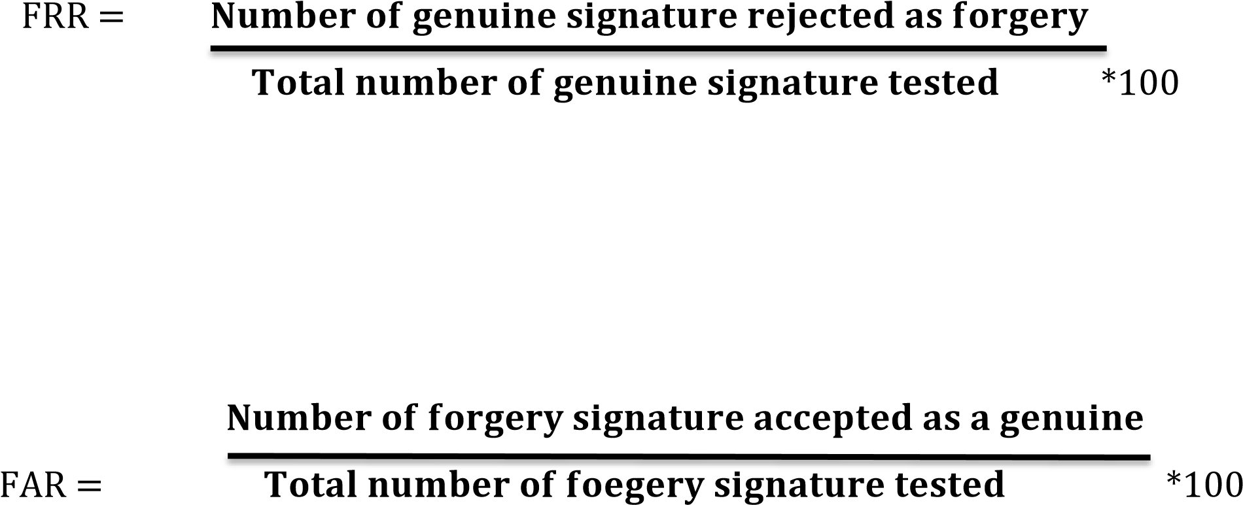
- The object of any automatic verification system is to gain a considerably lower FAR and FRR but these two errors are inversely related to each other the increase in FAR result is decreasing in FRR and vice versa.
- The threshold at which FAR and FRR are almost equal is called equal error threshold and the error rate at the corresponding threshold is called Equal Error Rate (ERR).
- ERR is calculated by means of Receiver Operating Characteristics Curve (ROC) which is a plot of FAR and FRR against varying threshold.
- The average of FAR and FRR which is generally called Average Error Rate (AER). It is also used as an Evaluation Measure.
Average error rate = 𝑭𝑨𝑹+𝑭𝑹𝑹

2
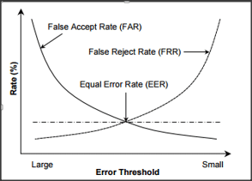

2.REVIEW OF LITERATURE

2.0 Introduction

Offline signature verification is a challenging research problem due to its wide application in many areas like, banking sector, healthcare, education etc. A significant amount of research work has been carried out during the last few decades on offline signature verification.

Researches have proposed many models for offline signature verification using different set of features, different pre-processing techniques, different classifiers etc. Further to reduce the error rather many fusion based approaches also have been proposed. In this chapter a brief research work carried out has been presented focusing on the work carried out during last decades. Some of the major works are presented below.

Hybrid User-Independent and User-Dependent Offline Signature Verification with a Two-Channel CNN Mustafa Berkay YILMAZ et al.(2018)
Signature verification task needs relevant signature representations to achieve low error rates. Many signature representations have been proposed so far. In this work we propose a hybrid userindependent/dependent offline sig nature verification technique with a two-channel convolutional neural network (CNN) both for verification and feature extraction. Signature pairs are input to the CNN as two channels of one image, where the first channel always represents a reference signature and the second channel represents a query signature. We decrease the image size through the network by keeping the convolution stride parameter large enough. Global average pooling is applied to decrease the dimensionality to 200 at the end of locally connected layers. We utilize the CNN as a feature extractor and report 4.13% equal error rate (EER) considering 12 reference signatures with the proposed 200-dimensional representation, compared to 3.66% of a recently proposed technique with 2048-dimensional representation using the same experimental protocol. When the two methods are combined at score level, more than 50% improvement (1.76% EER) is achieved demonstrating the complementarity of them. Sensitivity of the model to gray-level and binary images is investigated in detail. One model is trained using gray-level images and the other is trained using binary images. It is shown that the availability of gray-level information in train and test data decreases the EER e.g. from 11.86% to 4.13%.

Handwritten signature verification using shallow convolutional neural network Anamika Jain et al.(2020)
Handwritten signatures are an undeniable and unique way to prove the identity of per sons. Owing to the simplicity and uniqueness, it finds an essential place in the area of behavioral biometric. Signatures are the most widely accepted biometric trait by law enforcement agencies/personnel for verification purposes, especially in financial institutions, legal transactions, etc. and hence secured authentication becomes imperative. In the era of a digital age, numerous transactions are taking place, where handwritten signature verification is required by the agencies, e.g., banks, etc. In such scenarios, the process of signature verification, besides being accurate and secure, should be very fast, i.e., the real-time verification can be done. In this paper, we have proposed a convolutional neural network-based language-independent shallow architecture (sCNN(Shallow Convolutional Neural Network)) for signature verification. The proposed architecture is very simple but extremely efficient in terms of accuracy. A custom shallow convolution neural network is used to automatically learn the features of signature from the provided training data. Another contribution of the research work, which is the handwritten signature data collection for 137 subjects and 467 subjects, which are named as CVBLSig-V1 and CVBLSig-V2 respectively, has been reported in this paper. The performance of the proposed architecture has been evaluated on publicly available datasets, i.e., MCYT-75, MCYT-100, and GPDS, as well as CVBLSig-V1 and CVBLSig-V2. The performance was also compared with state of the art reported methods and shown improved, while considering the accuracy and equal error rate (EER) as performance metrics.

Offline Signature Verification Using Convolutional Neural Network S V Bonde et al.(2020)
Offline handwritten signature verification is widely used important form of biometrics. It is a challenging task due to time-variant nature of signature. To address the above difficulty, a new approach is proposed in this paper to compute the features of signatures. The proposed approach is divided into two parts: 1) writer-independent approach, 2) writer-dependent approach. Writerindependent approach is utilized for fine-tuning of VGG16 convolutional neural network (CNN). In writer dependent approach, this fine-tuned CNN is utilized to extract the features from the signature. The signature is passed through this fine-tuned CNN and the vector obtained at first fully connected layer (after last convolutional layer) is used as feature vector. To obtain the accurate features for classification of signatures, the pixels of thinned signature image are replaced by their Gaussian Weighting Based Tangent Angle (GWBTA) in both writer-independent and writer-dependent approach. The computed features which are obtained in writer-dependent approach are fed to Support Vector Machine (SVM) classifier to classify the signature into genuine or forgery class. The performance results obtained on different databases of offline handwritten signatures confirms the validity of proposed methodology for offline signature verification.

Offline Handwritten Signature Verification And Recognition Based On Deep Transfer
Learning Using Convolutional Neural Networks Atefeh Foroozandeh et al.(2020)
Recently, deep convolutional neural networks have been successfully applied in different fields of computer vision and pattern recognition. Offline handwritten signature is one of the most important biometrics applied in banking systems, administrative and financial applications, which is a challenging task and still hard. The aim of this study is to review of the presented signature verification/recognition methods based on the convolutional neural networks and also evaluate the performance of some prominent available deep convolutional neural networks in offline handwritten signature verification/recognition as feature extractor using transfer learning. This is done using four pre trained models as the most used general models in computer vision tasks including VGG16, VGG19, ResNet50, and InceptionV3 and also two pre-trained models especially presented for signature processing tasks including SigNet and SigNet F. Experiments have been conducted using two benchmark signature datasets: GPDS Synthetic signature dataset and MCYT 75 as Latin signature datasets, and two Persian datasets: UTSig and FUM-PHSD. Obtained experimental results, in comparison with literature, verify the effectiveness of the models: VGG16 and SigNet for signature verification and the superiority of VGG16 in signature recognition task.

Offline Handwritten Sig nature Verification Luiz G. Hafemann1 et al. (2019)
The area of Handwritten Signature Verification has been broadly researched in the last decades, but remains an open research problem. The objective of signature verification systems is to discriminate if a given signature is genuine (produced by the claimed individual), or a forgery (produced by an impostor). This has demonstrated to be a challenging task, in particular in the offline (static) scenario, that uses images of scanned signatures, where the dynamic information about the signing process is not available. Many advancements have been proposed in the literature in the last 5-10 years, most notably the application of Deep Learning methods to learn feature representations from signature images. In this paper, we present how the problem has been handled in the past few decades, analyze the recent advancements in the field, and the potential directions for future research.

Offline Signature Verification Using Image Processing. In E3S Web of Conferences Shaik, B., et al. (2023).

A person's signature is merely a handwritten sign that closely resembles his/her name, frequently stylized and distinctive, and that expresses the person's identity, intent, and consent. Two types of verifications are present. They are online signature verification and offline signature verification. Generally, Offline Signature verification is less efficient and slower process compare to online verification when come to the situation having larger number of documents and files to verify with in less time. Over the years, many researchers have developed so many methods for signature verifications to help the people or organizations to find whether the signature of a particular person is forged or genuine. To overcome this problems: In this paper we introduced a simple method to improve the verification of the signature in Image Processing using Convolution Neural Networks(CNN).

Signature Verification it is used to authenticate various kinds of documents, including cheques, draughts, certificates, approvals, letters, and other legal ones, such verification is crucial for preventing document forgery and falsification. Previously, to verify a signature, it was manually checked against copies of real signatures. This straightforward approach might not be sufficient given that forgery and signature fraud techniques are becoming more sophisticated as a result of Omproving technology.

verification system achieved the state-of-the-art results on MCYT database, while it reached the second-best verification result on GPDS.

Deep learning-based data augmentation method and signature verification system for offline handwritten signature. Pattern Analysis and Applications, Yapıcı, M. M. et al. (2021).
Offline handwritten signature verification is a challenging pattern recognition task. One of the most significant limitations of the handwritten signature verification problem is inadequate data for training phases. Due to this limitation, deep learning methods that have obtained the state-of-the-art results in many areas achieve quite unsuccessful results when applied to signature verification. In this study, a new use of Cycle-GAN is proposed as a data augmentation method to address the Inadequate data problem on signature verification. We also propose a novel signature verification system based on Caps-Net. The proposed data augmentation method is tested on four different convolutional neural network (CNN) methods, VGG16, VGG19, ResNet50, and DenseNet121, which are widely used in the literature. The method has provided a significant contribution to all mentioned CNN methods' success. The proposed data augmentation method has the best effect on the DenseNet121. We also tested our data augmentation method with the proposed signature verification system on two widely used databases GPDS and MCYT. Compared to other studies, our

A multi-dimensional review on handwritten signature verification: strengths and gaps S.D Bhavani et.al. (2023)
A handwritten signature is the most widely accepted method to authenticate an individual in banking, financial, business transactions, cheque processing, access control, and e-busi ness due to its simplicity and distinctiveness. Many automated systems have been created to predict the authenticity of a signature. However, barely a few review papers provide a summary of the existing research on deep learning-based signature verification systems. An attempt is made to bring out the strengths and find gaps in handwritten signature veri f ication in various dimensions considering both online and offline signatures. The primary objective of this comprehensive study is to present the most recent deep learning-based models for signature verification systems by putting emphasis on five different aspects: datasets, preprocessing techniques, feature extraction methods, machine learning-based verification models, and performance evaluation metrics. This review includes publica tions on both offline and online signature verification systems published between 2017 and 2022. This systematic review has discovered that recently, the deep learning-based neural network accomplished the most encouraging results for signature verification systems on public datasets.
Features selection for offline handwritten signature verification: state of the art

Anwar Yahya Ebrahim et.al. (2018)

This research comes out with an in-depth review of widely used techniques to handwritten signature verification based, feature selection techniques. The focus of this research is to explore best features selection criteria for signature verification to avoid forgery. This paper further present pros and cons of local and global features selection techniques, reported in the state of art. Experiments are conducted on benchmark databases for signature verification systems (GPDS). Results are tested using two standard protocols; GPDS and the program for rate estimation and feature selection. The current precision of the signature verification techniques reported in state of art are compared on benchmark database and possible solutions are suggested to improve the accuracy. As the equal error rate is an important factor for evaluating the signature verification's accuracy, the results show that the feature selection methods have successfully contributed toward efficient signature verification.

Text feature Extraction baesd on deep Learning : a review H Liang et.al.(2017)
Selection of text feature item is a basic and important matter for text mining and information retrieval. Traditional methods of feature extraction require handcrafted features. To hand-design, an effective feature is a lengthy process, but aiming at new applications, deep learning enables to acquire new effective feature representation from training data. As a new feature extraction method, deep learning has made achievements in text mining. The major difference between deep learning and conventional methods is that deep learning automatically learns features from big data, instead of adopting handcrafted features, which mainly depends on priori knowledge of designers and is highly impossible to take the advantage of big data. Deep learning can automatically learn feature representation from big data, including millions of parameters. This thesis outlines the common methods used in text feature extraction first, and then expands frequently used deep learning methods in text feature extraction and its applications, and forecasts the application of deep learning in feature extraction.

Give CHAPTER-3
PROPOSED MODEL

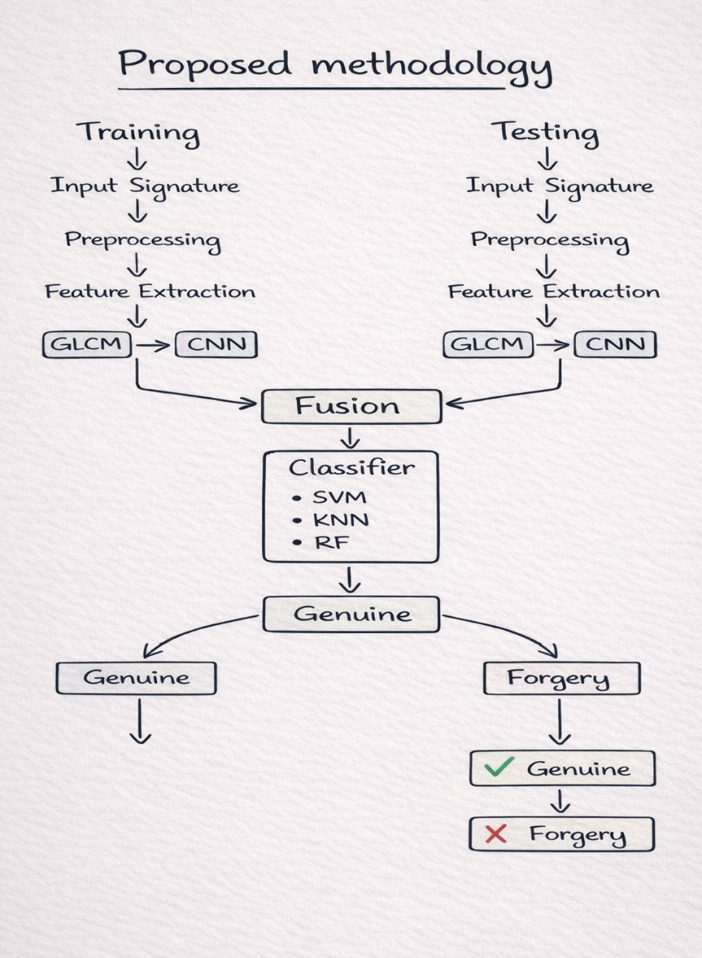

3.0 INTRODUCTION
The proposed system focuses on offline signature verification using a fusion of conventional and deep learning methods. The main objective is to improve the accuracy and reliability of signature verification by combining handcrafted features with automatically learned features.
Offline signature verification is a challenging task because signatures vary even for the same person and skilled forgeries are difficult to detect. To overcome these challenges, the proposed method integrates GLCM-based feature extraction (conventional) and CNN-based feature extraction (deep learning).
The extracted features are fused and then classified using machine learning algorithms such as SVM, KNN, and Random Forest.

3.1 OVERALL SYSTEM ARCHITECTURE
The system consists of two main phases:
1. Training Phase
2. Testing Phase
Both phases follow similar steps:
- Input Signature
- Preprocessing
- Feature Extraction
- Fusion
- Classification
(Based on your diagram + architecture in PDF )

3.2 TRAINING PHASE
The training phase is used to train the model using labeled signature data (genuine and forged).
Steps:
1. Input Signature
- Signature images are collected from the dataset
- Includes both genuine and forged samples

2. Preprocessing
Preprocessing improves the quality of the signature image.
- Grayscale conversion → removes color information
- Binarization → converts image to black and white
- Noise removal → removes unwanted disturbances
- Normalization → resizes images to uniform size
These steps ensure that the image is clean and suitable for feature extraction.

3. Feature Extraction
Feature extraction is performed using two methods:

(a) GLCM (Gray Level Co-occurrence Matrix)
GLCM is a texture-based feature extraction method.
- It analyzes the spatial relationship between pixels
- Captures texture information of the signature
Features extracted using GLCM:
- Contrast
- Correlation
- Energy
- Homogeneity
Advantages:
- Captures texture details
- Simple and effective

(b) CNN (Convolutional Neural Network)
CNN is a deep learning model used to extract features automatically.
- Input image is passed through multiple layers
- Learns edges, shapes, and complex patterns
CNN layers include:
- Convolution layer
- Pooling layer
- Fully connected layer
Advantages:
- High accuracy
- Captures complex signature patterns

3.3 FEATURE FUSION
- Features obtained from GLCM and CNN are combined
- This is called feature-level fusion
Process:
- GLCM features → vector A
- CNN features → vector B
- Fusion → Combined vector (A + B)
Purpose:
- Combine strengths of both methods
- Improve performance

3.4 CLASSIFICATION
After fusion, the combined features are given to classifiers.
Classifiers used:
SVM (Support Vector Machine)
- Separates genuine and forged signatures using a hyperplane
- High accuracy
KNN (K-Nearest Neighbor)
- Classifies based on nearest neighbors
- Simple and effective
Random Forest (RF)
- Uses multiple decision trees
- Provides better generalization
The classifier predicts whether a signature is:Genuine or Forgery

3.5 TESTING PHASE
The testing phase evaluates the trained model.
Steps:
- Input test signature
- Preprocessing
- Feature extraction (GLCM + CNN)
- Feature fusion
- Classification
The system compares the test signature with trained data and outputs the result.

3.6 WORKING FLOW SUMMARY
- Input signature image
- Apply preprocessing techniques
- Extract features using:
  - GLCM (conventional)
  - CNN (deep learning)
- Combine features (fusion)
- Train classifier
- Predict output (genuine/forgery)

3.7 ADVANTAGES OF PROPOSED SYSTEM
- Improved accuracy compared to single method
- Better detection of skilled forgeries
- Combines both traditional and modern techniques
- More robust and reliable

3.8 CONCLUSION OF METHODOLOGY
The proposed methodology effectively integrates conventional and deep learning techniques for offline signature verification. By combining GLCM-based texture features with CNN-based deep features, the system achieves higher accuracy and better performance. The use of multiple classifiers further enhances the reliability of the system

CHAPTER-4
EXPERIMENTATION AND RESULTS

4.0 Introduction
This chapter presents the experimental setup, implementation details, datasets used, and performance evaluation of the proposed system. The main objective of this experimentation is to analyze the effectiveness of the fusion-based offline signature verification system, which combines conventional feature extraction techniques with deep learning models.
The system is evaluated based on its ability to correctly classify signatures as genuine or forged. Various performance metrics such as accuracy, False Acceptance Rate (FAR), and False Rejection Rate (FRR) are used to measure the effectiveness of the model

LIBRARIES USED
- Numpy
- Panda
- Open CV
- OS
- Tensorflow.keras

NUMPY:
NumPy, short for Numerical Python, is a fundamental library in the Python ecosystem for numerical computing. It provides support for arrays, matrices, and a wide range of mathematical functions to operate on these data structures. Central to NumPy is the ndarray, a powerful n-dimensional array object that forms the backbone of most scientific computations in Python. With its ability to handle large datasets efficiently, NumPy enables high-performance operations that are crucial for scientific and engineering applications. It supports broadcasting, a feature that allows arithmetic operations on arrays of different shapes, simplifying code and improving readability.

OPEN CV:
Open CV, or Open Source Computer Vision Library, is an open-source software library designed for real-time computer vision and image processing. Developed by Intel and now maintained by the open-source community, Open CV provides a comprehensive suite of tools and functions to handle various computer vision tasks, including image recognition, face detection, object tracking, and more. One of Open CV's core strengths is its ability to perform efficient image manipulation and transformation, supporting a wide array of image formats and enabling operations like filtering, warping, and color conversion. The library also includes powerful machine learning algorithms, facilitating the development of sophisticated applications such as gesture recognition, augmented reality, and autonomous vehicle navigation. Open CV's extensive functionality is accessible through its well-documented API, which supports multiple programming languages including C++, Python.

OS:
The os library in Python is a versatile module that allows developers to perform operating system-dependent tasks within their Python programs. It provides functions for file and directory manipulation, such as reading, writing, and deleting files, as well as creating and removing directories. The module also facilitates interaction with the system's environment variables, enabling scripts to adapt to different configurations dynamically. Additionally, os supports process management, allowing for the execution of system commands and spawning of new processes. The os.path submodule offers utilities to handle and manipulate file paths in a cross-platform manner. With its comprehensive range of functionalities, the os library is essential for tasks involving system-level operations, making it a fundamental tool for automation, file management, and system administration in Python. Its integration into Python's standard library ensures accessibility and ease of use for both novice and experienced developers.

TensorFlow:
TensorFlow is an open-source library developed by Google for numerical computation and machine learning, particularly deep learning. It provides a flexible ecosystem of tools, libraries, and community resources that enable researchers and developers to build and deploy machine learning powered applications. TensorFlow's core feature is its use of data flow graphs, where nodes represent operations and edges represent tersors, making it highly efficient for large-scale machine learning tasks. It supports various high-level APIs like Keras, simplifying the creation and training of neural networks. TensorFlow is highly scalable, capable of running on CPUs, GPUs, and TPUs across desktops, clusters, mobile, and edge devices. Its extensive documentation and active commanity support foster Innovation and collaboration With its robust performance and flexibility, TensorFlow is widely used in academia and industry for a broad range of applications, from image and speech recognition to natural language processing and autonomous driving.

We have imported VGG16 model from keras Application .VGG 16 model consist of 16 layers where we have fine tuned the top 3 layers and remaining 13 layers has been used as it is. While fine tuning we have used hyper parameters such as for Loss function we have used binary cross entropy, for optimizer we have used adam optimizer.
To train the model we have used fit function .Before fitting the model we have used early stopping where this consist of some of the parameters such as for monitor we have used validation loss, for min delta we have given 0, for patience we have given 3 and for verbose we have given 0 for implimentation purpose.

4.1 TRAINING AND TESTING
For training and testing purpose we have split the data into 2 parts i.e training and testing The training dataset is further divided into training and validating . therefore we have used fit function to train the model . Once the model is trained and validate we will get the validation accuracy. In testing phase to evaluate the model we have used predict function . As for calculating the result we have used different metrices such as accuracy ,ERR, FRR, FAR. And finally we are printing the confusion matrix .

TABLE SHOWS THE NUMBER OF IMAGES USED TO TRAIN AND TEST THE MODEL FOR VARIOUS TRAIN:TEST SPLIT RATIOS

DATASETS | 70:30 | 60:40 | 80:20
CEDAR
BHsig
TABLE SHOWS THE RESULTS ODTAINED FOR CEDAR DATASET

EPOCHS | 60:40 | 70:30 | 80:20
5 | 92.11% | 94% | 95.54%
10 | 94% | 96.23% | 97%
15 | 96% | 98.24% | 98.88%

TABLE SHOWS THE RESULTS ODTAINED FOR BHsig DATASET
EPOCHS | 60:40 | 70:30 | 80:20
5 | 93.43% | 96.52% | 97%
10 | 95.77% | 97.43% | 98%
15 | 97.56% | 98% | 98.89%

TABLE SHOWS THE CONFUSION MATRIX
[[293
104]

GENUINE FORGERY
 |  |  | 
 |  |  | 

GENUINE

FORGERY

➢
➢
➢
➢

TABLE SHOWS THE EVALUATION MATRICS FOR 5 EPOCHS
DATASET | FRR | FAR
CEDAR
BHsig

CHAPTER 5
CONCLUSION

In this project, a fusion-based approach for offline signature verification has been proposed and implemented. The system combines conventional feature extraction techniques with deep learning models to improve the accuracy and reliability of signature verification.
Offline signature verification is a challenging problem due to variations in handwriting and the presence of skilled forgeries. Traditional methods alone are not sufficient to capture complex patterns, while deep learning methods require large datasets and high computational power.
The proposed system successfully integrates both approaches to overcome their individual limitations. Conventional features provide structural information, while deep learning models extract high-level features. The fusion of these features results in improved performance.
The experimental results demonstrate that the proposed method achieves better accuracy and lower error rates compared to individual methods. The system is capable of effectively distinguishing between genuine and forged signatures.



➢
➢
.
➢
➢
➢
➢
➢
➢
➢

➢ 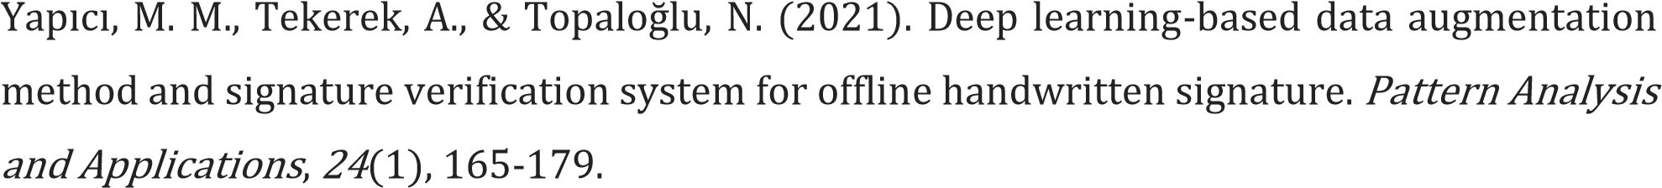

➢

➢ 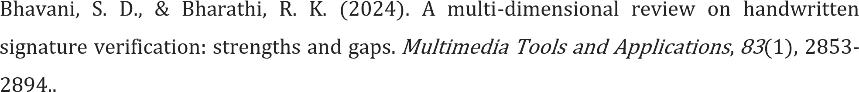

➢

➢ 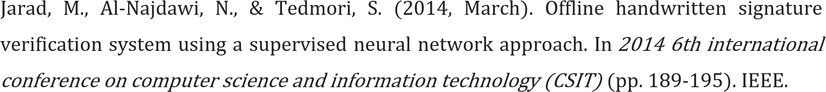

➢

➢

➢ 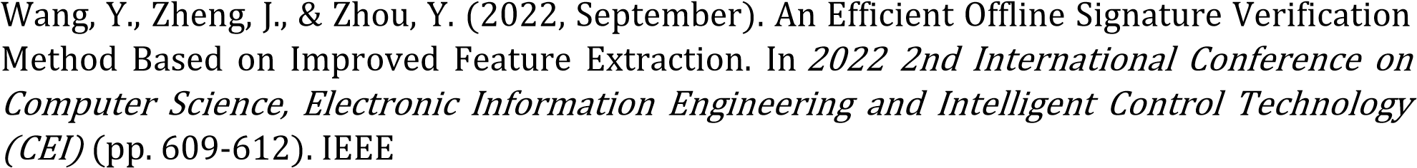

➢

➢

- Alsuhimat, F. M., & Mohamad, F. S. (2023). A Hybrid Method of Feature Extraction for Signatures Verification Using CNN and HOG a Multi-Classification Approach. IEEE Access, 11, 21873-21882.

- Zhou, Y., Zheng, J., Hu, H., & Wang, Y. (2021). Handwritten signature verification method based on improved combined features. Applied Sciences, 11(13), 5867.

- Hashim, Z., Mohsin, H., & Alkhayyat, A. (2024). Signature verification based on proposed fast hyper deep neural network. Int J Artif Intell, 13(1), 961-973.

- Chandra, S., & Maheskar, S. (2016, March). Offline signature verification based on geometric feature extraction using artificial neural network. In 2016 3rd international conference on
recent advances in information technology (RAIT) (pp. 410-414). IEEE.

- Chandra, S., & Maheshkar, S. (2017). Verification of static signature pattern based on random subspace, REP tree and bagging. Multimedia Tools and Applications, 76, 1913919171.

