CHAPTER 1
INTRODUCTION
  - Project Overview
In the course of recent years, distributed computing has encountered huge turn of events. Increasingly more cloud suppliers have gotten on board with the cloud fleeting trend, and they midway deal with an assortment ofassets like equipment and programming and convey them over the web as administrations to clients on request.On account of extraordinary properties like versatility, adaptability, clearly limitless computational force, and you pay for a service before you use estimating model, shared estimating can lessen the prerequisite of customersfor huge capital costs for equipment important to send administration and the human costs to work it. One hugesegment of circulated processing is pay-as you-use, which contains two ramifications. To start with, as indicatedby the client asset request like CPU, memory, and so forth, the actual machines are powerfully fragmented utilizing virtualization innovations and given to clients as virtual machines , and clients pay as per the measure of assets they really burned-through. Second, the VMs can be progressively designated and deallocatedwhenever, and clients should pay dependent on how long the assets are really utilized. By the by, thecompensation as-you-use evaluating model is by and by simply applied because of the outrageous intricacy in observing and inspecting asset utilization, and cloud suppliers for the most part receive an hourly charging plan;as such, the Billing Time Unit assembly of the cloud suppliers is 60 minutes. Accordingly, the clients should pay for the assets constantly regardless of whether they don't really use the apportioned assets in the entire charging skyline. This prompts a misuse of assets and raises the expense of clients somewhat. Also, practically all cloud suppliers give two fundamental: On Demand and Reserved examples. With request cal possibility, clients pays for process limit by each hour relying upon which examples they run, and suggested for the applications with momentary jobs. Held Instances give clients a huge contrasted with an appeal case valuing. yet, clients should lease occurrences for extensive stretches, e.g., from a half year to quite a long while, as per the present ideas offered by genuine cloud suppliers. Clearly, this markdown can't be delighted in by the momentary clients. Due to over two reasons, the momentary clients consistently should pay huge than suppliers should payment.
1.2 Objective
Our objective is to establish the refined and user-friendly automation software to help the users who are searching for information on cloud space, Rerent cloud space and also upload data files over cloud . this project ensures to user to rerent the unused cloud space and allow the recover the money throught renting cloud spaces to others the following are some of the objectives of our project.
The main objectives of the project are as mentioned below
- To create a web portal to manage the users and cloud server by logging into this portal.
- To allow a user to register on this portal to buy cloud space for his business
- To create a Dashboard for the users (owner/user) to view & manage the cloud space and other services like upload file and manage files details. View cloud usage details through graph.
- Providing the cloud broker to view and manage the whole portal of profit maximization through consolidated tickets reporting tool and also monitor the reviews details through various security layers and get monthly reports etc.,
- To provide a view of all the uploaded file details which are available in cloud space.
- To provide a mechanism which allow users to re rent the un used cloud space supporting maximized usage of cloud space.
- To provide cloud sharing and paying options.
- To provide cloud server with allocation and deallocation features.
- A detailed graph which consists of cloud usage ie., total cloud space, used space, free space and rented space pie graph.
1.3 Project Scope
With regards to project arranging, characterizing the venture extension is the most basic advance. In the event that in the event that we start the task without knowing what we should convey toward the finish to the customer and what the limits of the undertaking are, there is somewhat chance for progress. In the task scope definition, the components inside the degree and out of the extension are obvious to unmistakably get what will be the region under the venture control. On the off chance that we didn't work really hard in project scope definition, project scope the executives during the undertaking execution is practically outlandish. Extension alludes to a venture's limits: it figures out what work will be finished during the undertaking lifecycle. This incorporates distinguishing the work that will not be remembered for the current round of item/administration improvement. During the arranging interaction, yields are made to catch and characterize the work that should be finished. The controlling and observing cycle is worried about overseeing extension. Recording, following, and supporting/objecting project changes. At last, the end measures incorporate a review of venture expectations and survey the results against the first arrangement.
Degree is about item extension and venture scope. Undertaking degree incorporates business prerequisites, project necessities and conveyance necessities. Item scope incorporates mechanical prerequisites, security necessities and execution prerequisites. The principle motivation behind the degree definition is to unmistakably depict the limits of my venture. To characterize the extent of a venture, it is important to initially build up the undertaking goals. The goal of a venture might be to deliver another item, make another assistance to give inside the association, or foster another piece of programming. There are large numbers of the targets that could be fundamental to a given undertaking - and it is the job of the task supervisor to see that their group or project workers convey an outcome that meets the predefined capacities and highlights.
The work and assets that go into the formation of the item or administration are basically the things that outline the extent of the task. The extent of the task traces the destinations of the venture and the objectives that should be met to accomplish an agreeable outcome. Each undertaking designer ought to see how to characterize the task extension and there are a few stages that can be followed while doing this. To characterize a venture scope, we should initially recognize the accompanying things:

- Project targets
- Goals
- Sub-stages
- Tasks
- Resources
- Budget
- Schedule

Whenever we have set up these things, we should explain the impediments or boundaries of the project and plainly recognize any perspectives that are not to be incorporated. In indicating what will and won't be incorporated, the task scope should clarify to the partners, senior administration and colleagues included, what item or administration will be conveyed. This venture is proposed to learn and utilize the incredible current advances of web improvement and executing the prerequisites under the extent of this task.

CHAPTER 2
LITERATURE SURVEY
Writing study is the main advance in programming improvement measure. Prior to fostering the device, it is important to decide the time factor, economy and friends strength. When these things are fulfilled, the subsequent stages are to figure out which working framework and language can be utilized for fostering the apparatus. When the software engineers begin fabricating the apparatus the developers need part of outer help. This help can be gotten from senior software engineers, from book or from sites. Prior to building the framework the above thought is considered for fostering the proposed framework.
The subjects of writing studies are chosen so they support the task. The principle objective of a writing overview is to accumulate a reason for the functional work and to show that the understudy knows about existing writing and examination on the point. It isn't keen to re-develop the wheel, i.e., one needs to realize what has effectively been finished.
We have done the review on the visit arranging and booking site and criticism the board webpage applications across different destinations and we have additionally gone over couple of sites in regards to the administration of input and appraisals. We could see one thing normal in this load of locales for example site visit plan just permit client to book visit designs instead of lodging appointments. Such sort of site doesn't permit client to pick lodging, same way not many inn booking applications and site doesn't uphold for shrewd arranging of visits We needed to improve these product applications by building our own product with more modules which are talked about in the underneath sections.
We initially surfed through couple of locales on the most proficient method to plan a site front-end which had models portraying the working and utilizing these models in the sites, we needed to create and execute this load of thoughts all in all to foster our task's (UI). We planned it more, making it look more appealing and snappy with the assistance of few website architecture situated sites.

After the front-end (UI) was created, we had not many disarrays in connecting these fields onto the information base for which we looked for the working of the back-finish of modules close by the ones we were thought at the organization which we found in the sites over the web. Practically all the shopping site that we run over permit with not many impediments that we are attempting to fix.

CHAPTER 3
SYSTEM ANALYSIS
3.1 Introduction
Framework Analysis is an itemized investigation of the different tasks performed by a framework and their connections inside and outside of the framework. Here the key inquiry is-what all issues exist in the current framework? How should be dealt with tackle the issue? Investigation starts when client or administrator starts an investigation of the program utilizing existing framework. The accomplishment of the framework relies generally upon how obviously the issue is characterized, completely examined and appropriately helped out through the decision of arrangement. A decent investigation model ought to give the instrument of issue understanding as well as the casing work of arrangement. Consequently it ought to be concentrated completely by gathering information about the framework.
3.2 Existing System
Many potential recent trade rules for selecting statistic facilities are related to the design of the analytics centers, current execution load, and so on. The above pricing business research focused on how to manage the economy for each transaction. Because there are so many cloud vendors with excellent capabilities, it might be difficult for clients to choose the right one.
Disadvantages of the Existing System:
- Current existing system of cloud broker are not centralized.
- Multiple cloud server is not allowed in existing systems
- User cannot re rent the cloud that is allocated to the user for certain period.
- Re rent cancellation process is difficult to handle

3.3 Proposed System
To help cloud clients, a cloud merchant component is utilized to change the heterogeneous cloud market into an item like assistance. The cloud intermediary has been concentrated according to alternate points of view. To start with, the cloud agent was concentrated as a scheduler between cloud suppliers and clients. It alludes to two principle viewpoints: assisting clients with choosing the most fitting cloud supplier and assisting suppliers with settling on choices on asset portion. Thus, the planning components are needed to upgrade the determination of cloud merchant or position of VMs among numerous server farms of a cloud to diminish the expenses of VM arrangement or fulfill other execution limitations, for example, reaction time, processing limit, etc. To accomplish the various destinations, many related cloud specialist arrangements have been proposed
- the service provider needs to take advantage of the cost difference between restrained and now on VMs by purchasing the reserved VMs for a low cost and distributing them including on VMs for a lesser price when compared to cloud providers' VMs.

- Second, compared to cloud providers, the cloud broker has a shorter billing cycle. The energy consumption can be efficiently enhanced and client requests may be met at a lower cost by implementing the two ways.

- Because the cloud broker's major benefit in attracting clients is its cheaper pricing as compared to external clouds, the costs will almost definitely impact the request arrival rate, affecting revenue as a result .

3.4 Feasibility Study
Feasibility study is an important phase in requirements engineering process. An estimate is made of whether the identified user needs may be satisfied using current software and hardware technologies. The study will decide if the proposed system will be cost effective and if it can be developed given existing budgetary constraints. Feasibility study should be relatively cheap and quick. The result should inform the decision of whether to go ahead with a more detailed analysis.
A feasibility analysis is performed to choose the system that meets the performance requirements at least cost. During product engineering, I concentrated attention on three main areas of interest. Three essential considerations are involved in the feasibility analysis are.
- Operational Feasibility.
- Technical Feasibility.
- Economic Feasibility.

3.4.1 Operational Feasibility
The proposed project is beneficial because it can be turned into an information system that will meet the organizations operating requirements. Product will be developed without a real time study of any specific process in any organization. There could be performance related issues which are not addressed at this point of development taking into consideration the efforts and costs.
3.4.2 Technical Feasibility
Technical Feasibility concentrates on the existing computer system and to what extent it can support the proposed system. For example, if the current computer is operating at 80% capacity, then running another application could overload the system or require additional hardware. This involves financial considerations to accommodate technical enhancements.
3.4.3 Economic Feasibility
Economic Feasibility is the most frequently used method for evaluating the effectiveness of a mobile user system which is more commonly known as cost-benefit analysis. The procedure is to determine the benefits and savings that are expected from a mobile user system and compare them with costs. The application is easy to use and does not require any expenditure on other software’s.

CHAPTER 4

REQUIREMENT SPECIFICATION

4.1 Introduction
Software Requirement Specification is the starting point of the software development activity. It includes an introduction that gives the purpose, scope and an overview of the system. This needs requirement by talking to the people and understanding their needs. It also includes a general description of the product perspective, product function and certain user characteristics of the system. It also specifies the overall functional requirements, performance requirements and design constraints. The SRS is a means of translating the idea in the mind of the clients (the input), into a formal document (the output of the requirement phase). The Software Requirement Specification document is organized in such a manner that it aids validation and system design.

4.2 Software Requirement Specification
Software requirement specification is a document which will capture the requirements of the end user and communicates to the development team. Requirement document consists of requirements, functional and non-functional specification. A brief set of requirements are given below:

Functional Requirements
Functional requirements define the fundamental actions that system must perform. The functional requirements for the system are divided into these main categories.
- Registration: Anonymous user can register this portal but admin are approvers. Registration contains email-id, password, name, phone no., city, address details, gender, DOB, nationality and which are to be filled. Authenticated user can login with the registered email-id and password and suppose that user has forgotten the password, he can request a new password through the mail notification or contact with admin.

- Dashboard: This feature allows both the users, cloud servers and the admin to view the overview of the whole portal which displays every detail that can be accessed and viewed; summary, cloud space details, cloud space rent request details, file upload details, space usage graphs, activations and deactivation of user and cloud servers, user rented details etc.

- Upload File: This feature is simple which provide the users to upload the file details to the database which are displayed at cloud space details pages. User can upload file if he has sufficient cloud space in his account. User are also allowed to delete the uploaded files
- Request Cloud Details: This feature is a highlight as it provides a platform to the users to request cloud space for his or her business usage. The user can decide the whether to re rent the unused space through cloud broker for his profit and sufficient cloud usage.

- Cloud Re Rent Details: This feature provides users to re rent unused cloud space that he brought for his or her business usage. The user can decide the whether to re rent the unused space through cloud broker for his profit and sufficient cloud usage.

- Cloud Request Details: This feature allows the cloud server to view and manage the cloud space rent request along with the complete details of the individual cloud request. It contains details like user name, Space size, virtual Machines, price, and other details etc.

- View Cloud usage details: This functionality allow users to view his current cloud usage details. A graph will be generated on values like used space, free space and rented spaces. It also provides users to view all uploaded files in his cloud and allow to delete uploaded file in this page

- Activate and Deactivate users and owner: This feature allow cloud broker to authentic the registered users and owners by sending OTP to register email id, also if users is not valid admin can deactivate or delete the users

- Cloud space request forward: This feature allow cloud broker to forward cloud space request to cloud server to allocate cloud space for users

4.2.2 Non-functional Requirements

Non Functional requirements define the needs in terms of performance, logical database requirements, design constraints, standard compliance, reliability, availability, security, maintainability.

- Efficiency: It utilizes scarce resources: CPU cycles, disk space, and memory,
- Security: The system can be accessed only by authorized users. Hence a full fledge security is provided to the user’s data. No unauthorized users can modify the data present in the system. The user information is also kept confidential and will not be disclosed to any third party, if third party try to access this portal automatically send a message to admin.
- Reliability: The web portal is required to be reliable as this would be used on a daily basis. Hence reliability plays a major role.
- Maintainability: Maintenance should not consume more time because this portal is expected to run every day. Hence long maintenance time cannot be afforded.
- Usability: The portal will be available all the time to view the data or to use any other functionality provided by it.
- Portability: The portal is developed to perform on PHP and it is expected to run in all versions of windows, Linux, UNIX and Ubuntu.

  - Hardware Requirements
Processor : Intel Core-i3 or higher
Processor speed : 1.73GHz or higher
RAM : 2GB RAM
Hard Disk : 160GB
4.4 Software Requirements
The project would be developed on a XAMPP3 (Linux, Apache, MySQL, PHP) \WAMP (Windows, apache, MySQL, PHP) based environment. An MVC based powerful content management framework would be used as a platform over which the proposed system would be built.
Server Environment:
OS : Windows based system
Web Server : Apache with related modules
Programming Language : PHP 5.x
Database : MySQL 5.x
Development Environment:
OS :Windows Desktop, XAMPP
IDE : Notepad ++
Server : Windows Server
Web Technologies: HTML, CSS, Bootstrap
Programming Languages: PHP 5.x, JavaScript, Java Query
Back End : MySQL
Templating : Bootstrap
Client : Any modern browsers such as Firefox, GoogleChrome
Operating System: Windows XP onwards.
RAM: 2 GB of RAM, 500 GB hard disk.
Client Requirements: A Typical Desktop / Laptop with a modern browser and a good internet connection.

CHAPTER 5
SYSTEM DESIGN
5.1 Introduction
Design is the first step in moving from problem domain to the solution Manager. Design is essentially the bridge between requirements specification and the final solution. The goal of design process is to produce a model or representation of a system, which can be used later to build that system. The produced model is called the “Design of the System”. It is a plan for a solution for the system. The system design is the most creative and challenging phase of the system development life cycle. It is an approach for the creation of the proposed system, which still helps the system coding. It provides the understanding and procedural details necessary for implementing the system. A number of subsystems are to be identified which constitutes the whole system. In this phase the data organization is to be discussed, in which the output formats are to be designed. The system design is composed of several steps. Here the emphasis is on translating the performance requirements in to the design specification.
5.2 Input Design
In the input design, user-originated inputs are converted into a computer-based system format. It also includes determining the record media, method of input, speed of capture and entry on to the screen. Online data entry accepts commands and data through a keyboard. The major approach to input design is the menu and the prompt design. In each alternative, the user’s options are predefined. The data flow diagram indicates logical data flow, data stores, source and destination. Input data are collected and organized into a group of similar data once identified input media are selected for processing.

In this software, importance is given to develop Graphical User Interface (GUI), which is an important factor in developing efficient and user friendly software. For inputting user data, attractive forms are designed. User can also select the desired options from the menu, which provides all possible facilities. Also the important input format is designed in such a way that accidental errors are avoided. The user has to input only just the minimum data required, which also helps in avoiding the errors that the users may make. Accurate designing of the input format is very important in developing efficient software. The goal of input design is to make entry as easy, logical and free from errors.

5.3 Output Design
In the output design, the emphasis is on producing a hard copy of the information requested or displaying the output on the PMS screen in a predetermined format. Two of the most output media today are printers and the screen. Most users now access their reports from either a hard copy or screen display. Computer’s output is the most important and direct source of information to the user, efficient, logical, output design should improve the systems relations with the user and help in decision-making.
As the outputs are the most important source of information to the user, better design should improve the systems relations and also should help in decision-making. The output device’s capability, print quality, response time requirements etc should also be considered, form design elaborates the way the output is presented and layout available for capturing information. It’s very helpful to produce the clear, accurate and speedy information for end users.
5.4 Requirement Analysis and Specification:
The main aim of this phase is to understand the exact requirements of the customer and to document them properly.
- Requirement Collection: We collected the requirement from Spritz Interactive Technologies Ltd., Bangalore which is required for the Client.
- Analysis: We analyzed the client requirements and we decided to take up project through the company and they suggested us to this project for client use and gave us a sketch of blue print on our project.
- Design: The goal of design phase is to transform the requirements specified in the SRS document into a structure that is suitable for implementation in some programming
language. In technical terms, during the design phase the software architecture is derived from SRS document. We have to design this project using HTML and CSS.
- Coding & Implementation: Once design is complete, goal of the coding phase is to translate the design of the system into code in a given programming language. For a given design, the aim in this phase is to implement the design in the best possible manner. We have coded the design using PHP, Java Script and Java Query and we even used Bootstrap to develop the project.
- Testing: Testing is the major quality control measure employed during software development. Its basic function is to detect errors in the software.
- Maintenance: Maintenance is not a part of software development. It is an extremely important activity in the life of software product. Maintenance involves performing any one or more of the following kinds of activities:
  - Correcting errors that were not discovered during the product phase. This is called corrective maintenance.
  - Improving the implementation of the system, and enhancing the functionalities of the system according to the customer’s requirements. This is called perfective maintenance.
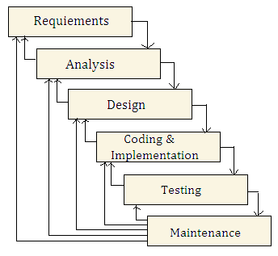
Fig: 5.1 Iterative Waterfall Model

5.5 Architecture Design
Architecture is the conceptual design and fundamental operational structure of asystem. It's a blueprint and functional description of requirements and design implementation for our project as shown in Fig. 5.3.
Most web application architecture uses Smart Disk in present days and are designed based on the generic client server architecture. This 3 tiered structure has its advantages of distributing the processing of the system to the client machines in the presentation layer. The presentation tier manages all interactions with the user. Client machines process user input, send requests to the server, and show the results of these requests to the user. The application tier housing the web processes the requests of all clients. It is the actual web application that performs all functionality specific to the web application though it does not store the persistent data itself. Whenever it needs data it contacts the database server. The database tier contains the database management system that manages all persistent data.
The representation bellow adequately represents the architecture of SmartDesk. It parallels the generic 3 tier architecture where MySQL forms the database layer, Apache and PHP services constituting the application layer and the web-browsers of the clients representing the presentation layer. WAMP (Windows, Apache, MySQL, PHP/Perl/Python), the open source resource has been strategically packaged to match the 3-tier architecture ruling out the need to manage the system components separately.
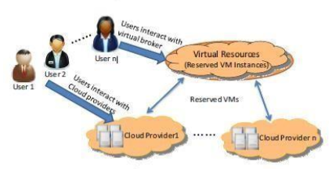
Fig. 5.3 Architecture Diagram
5.6 Modules Specification
- Cloud Broker Module
- Cloud Server Module
- User Module

Cloud Broker: In this portal, cloud broker has the full authority of the web-portal. He can add authenticated user and approve the anonymous user registered. He can also delete or deactivate authenticated user, can forward cloud space request to activated cloud servers Later, takes the re rent request and sent same details as adds to all users. Re-rent allocation process is carried out by cloud broker, user queries and questionnaires are responded back through given mail by the cloud broker

This module provides following sub functions to the cloud broker
- Login.
- Active Users and Cloud Servers.
- Deactivate Users and Cloud Servers.
- View Cloud Space Request and forward to Cloud Servers.
- View Re Rent Details and Create Adds
- View Users and Cloud Servers.
- View users Questionnaires and Queries.
- Respond to users Queries

User Module:
User Module: A user is who request for cloud for cloud broker and user cloud space for his business. This User Module provide users to get register to this project and allow registered user to request for cloud space from cloud broker. User can also request broker for re rent his cloud space in which the cloud space not being used. Once users purchase a cloud can upload his business related file as along as he has space to upload. This module allow user to view his cloud space details ie., user used space, free space, and rented space through a pie graph.
This module provides following sub functionalities to the owners
- Registrations.
- Login
- Cloud Space Request
- Cloud Space Rent Request
- Upload file
- View Cloud Space Details
- View Rented Details

Cloud Server: It maintains the total information related to the unique user’s cloud request forwarded by the cloud broker and then allow cloud server to allocate the cloud space for each requested users. The module also allows the cloud servers to delete or confirm the space rent request and also provide cloud server to view all users under his cloud.
This module provides following sub functionalities to the owners
- Registrations.
- Login
- View Cloud Request
- View Rented Details
- Cancel Rented Space

5.7 Data Flow Diagrams
Dataflow diagram is one of the most important modeling tools. It is used to model the system components. These components are the system process, an external entity that interacts with the system, uses the data and the information flows in the system. DFD shows the information moves thought the system and how it is modified by a series of transformations. It is graphical technique that depicts information flow and that is applied as data moves from input to output. DFD is also known as bubble chart. DFD may be used to represent the system at any level of abstraction DFD’S may be partitioned into levels that represents increasing information flow and functional details.
A data flow diagram is a graphic description of portion of a system. It consists of data flows, process, sources, destinations and data stores all are described through the use of easily understandable symbols. An entire system can be described from the view point of the data it processes with just a few symbols. Data flow diagrams powerful enough to show parallel activities. Data flow diagrams describes the system independently of how it is actually implemented, that is, they show what takes place, rather than how an activity is accomplished.
Advantages:
- Users easily understand these simple notations.
- Users can make suggestions for modifications.
- If analysis wants to review the overall system late, they use the higher level over view diagrams.
To construct a Data Flow Diagram, we use,
- Arrow
- Circles
- Open End Box
- Squares
An arrow identifies the data flow in motion. It is a pipeline through which information is flown like the rectangle in the flowchart. A circle stands for process that converts data into information. An open-ended box represents a data store, data at rest or a temporary repository of data. A square defines a source or destination of system data.
Six rules for constructing a Data Flow Diagram
- Arrows should not cross each other.
- Squares, circles and files must bear names.
- Decomposed data flow squares and circles can have same names.
- Choose meaningful names for data flow
- Draw all data flows around the outside of the diagram.
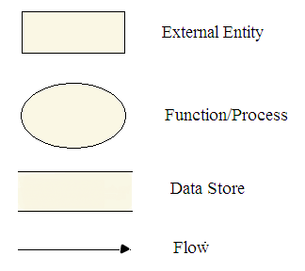
- Function Symbol: A function symbol is represented using a rounded rectangle or Circle. It may also be represented using a circle. This symbol is called a Process.
  - Data Store: An open rectangle represents a data store. Data store is a place where the data resides. It is generally used for transactions and the data can also be manipulated.
  - Data Flow Symbol: A directed arrow is used as a data flow symbol. A data flow symbol represents the data flow occurring between two processes or between an external entity and a process in the direction of the data flow arrow.
  - External Entity Symbol: A rectangle represents an external entity. The external entities are essentially those physical entities which are external to the software system and interact with the system by inputting the data to the system or by consuming the data produced by the system.

5.7.1 Context Data Flow Diagram
It is common practice to draw a Context-level Data Flow Diagram first, which shows the interaction between the system and external agents which acts as data sources and links. On Context Diagram (also known as ‘Level 0 DFD’) the system’s interactions with the outside world are modeled purely in terms of data flows across the system boundary. The Context Diagram shows the entire system as a single process, to produce a Level 1 DFD as shown below.
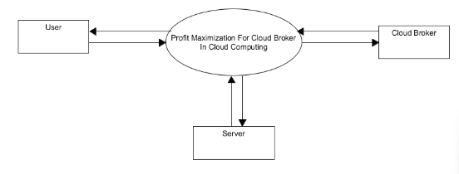
Fig: Context flow diagram

Modules Involved
- Cloud Broker Module
- Cloud Server
- User Module

5.7.2.1 Level 1: Cloud Broker Module
The Level 1 DFD shows how the system is divided into sub-system (process), each of which deals with one or more of the data flows to or from an external agent, and which together provide all of the functionality of the system as a whole. It also identifies internal data storage that must be present in order of the system to do its job, and shows the flow of data between the various parts of the system.
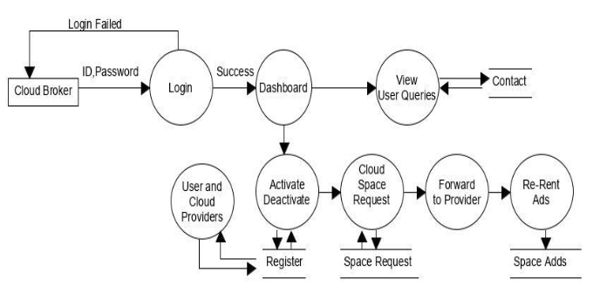

Fig: DFD admin module

5.7.2.2 Level 2: Cloud Server
This level is the next step of Level 1 DFD where it deepens the flow of data from the sub-systems giving us the flow of data into more sub-systems whose data are being held by the database. In our system, the head of institution holds the Level 2 DFD as show below. 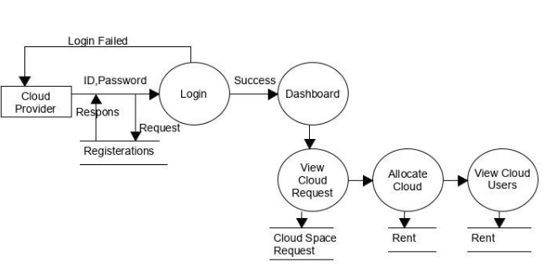
Fig: DFD Cloud Server module
5.7.2.4 Level 3: User Section
The Level 3 DFD shows how the system is divided into sub-system (processes), each of which deals with more & more data flows to or from an latter DFD, and which together provide all of the functionality of the system as a whole. This Level 3 DFD deepens the flow of data into their final states giving us the flow of data into the final sub-systems. In our system, the user module holds the Level 3 DFD as
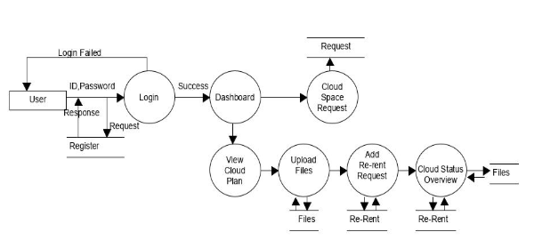
Fig: DFD User module

5.8 Use Case Diagram
A use case diagram in the Unified Modeling Language (UML) is a type of behavioral diagram defined by and created from a Use-case analysis. Its purpose is to present a graphical overview of the functionality provided by system in terms of actors, their goals (represented as use cases), and any dependencies those use cases.
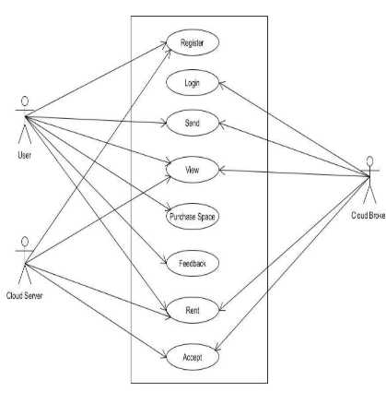
Fig: Use Case

The main purpose of use case diagram is to show what system functions are performed for which actor. Rules of the actors in the system can be depicted. Interaction among actors is not shown on the use case diagram. If this interaction is essential to a coherent description of the desired behavior, perhaps the system or use case boundaries should be re-examined. Alternatively, interaction among actors can be part of the assumptions used in the use case.

5.9 Sequence Diagram
A sequence diagram in Unified Modeling Language (UML) is a kind of interaction diagram that shows how processes operate with one another and in what order. It is a construct of a Message Sequence Chart. A sequence diagram shows, as parallel vertical lines (lifelines), different processes or objects that live simultaneously, and, as horizontal arrows, the messages exchanged between them, in the order in which they occur. This allows the specification of simple runtime scenarios in a graphical manner.
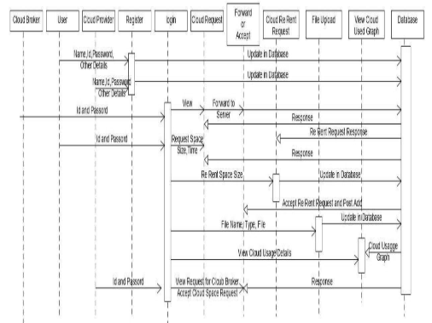
5.10 Data Base Design Structure
The Data base design involves 8 main tables which are mentioned below,
- Registration
- Files
- rent
- request
- user_queries

Data Table below contains the User Registrations. This table used under User Module, Cloud Broker Module
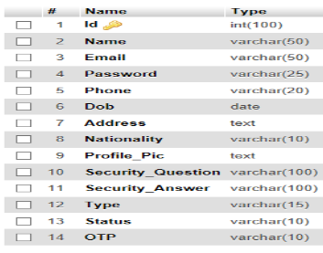

Data Table below contains cloud space re rent request details. This table used under User Module, Cloud broker Module
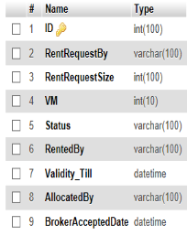

Data Table below contains the Contact details. This table used under Admin Module
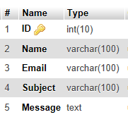

Data Table below contains the Cloud space details. This table used under User Module and cloud broker module
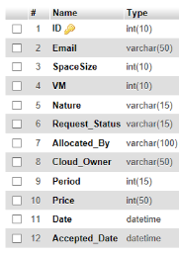

5.11 E-R Diagram
An entity-relationship (ER) diagram is a specialized graphic that illustrates the interrelationships between entities in a database. ER diagrams often use symbols to represent three different types of information. Entity relationship diagramming uses a standard set of symbols to represent each of these defined data groups and then proceeds by establishing the relationships between them.

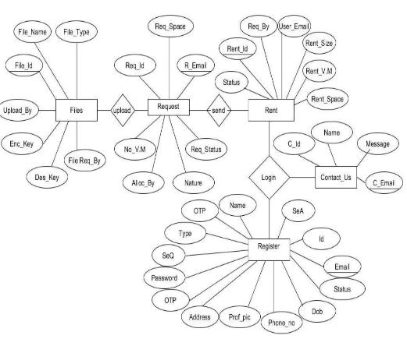
Fig: E-R Diagram

5.12 Activity Diagram
An activity diagram visually presents a series of actions or flow of control in a system similar to a flowchart or a data flow diagram. Activity diagrams are often used in business process modeling. They can also describe the steps in a use case diagram. Activities modeled can be sequential and concurrent. In both cases an activity diagram will have a beginning (an initial state) and an end (a final state).
Initial State or Start Point: A small filled circle followed by an arrow represents the initial action state or the start point for any activity diagram. For activity diagram using swimlanes, make sure the start point is placed in the top left corner of the first column.
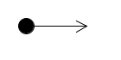
Activity or Action State: An action state represents the non-interruptible action of objects. You can draw an action state in Smart Draw using a rectangle with rounded corners.
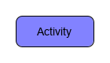
Action Flow: Action flows, also called edges and paths, illustrate the transitions from one action state to another. They are usually drawn with an arrowed line.
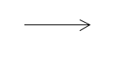

Object Flow: Object flow refers to the creation and modification of objects by activities. An object flow arrow from an action to an object means that the action creates or influences the object. An object flow arrow from an object to an action indicates that the action state uses the object.

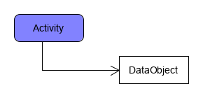
Decisions and Branching
A diamond represents a decision with alternate paths. When an activity requires a decision prior to moving on to the next activity, add a diamond between the two activities. The outgoing alternates should be labeled with a condition or guard expression. You can also label one of the paths "else."

Decision symbol - Activity diagram
Guards: In UML, guards are a statement written next to a decision diamond that must be true before moving next to the next activity. These are not essential, but are useful when a specific answer, such as "Yes, three labels are printed," is needed before moving forward.
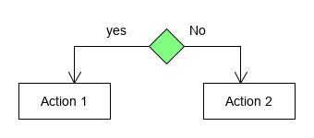
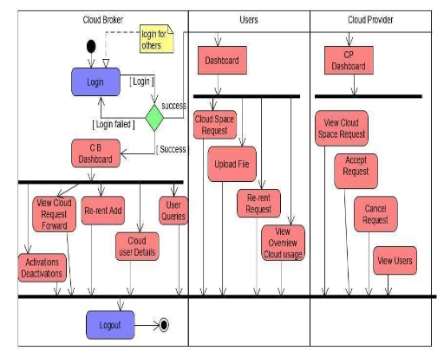
Fig: Activity Diagram
CHAPTER-6
SOFTWARE ENVIRONMENT
6.1 HTML (Hyper Text Mark-up Language)
It is a core technology markup language of the Internet used for structuring and presenting content for the World Wide Web. This is the final and complete fifth revision of the HTML standard of the World Wide Web Consortium (W3C) since October 2014. Its core aims have been to improve the language with support for the latest multimedia while keeping it easily readable by humans and consistently understood by computers and devices (web browsers, parsers, etc.). HTML5 is a response to the fact that the HTML and XHTML in common use on the World Wide Web are a mixture of features introduced by various specifications, along with those introduced by software products such as web browsers, those established by common practice. It was also an attempt to define a single markup language that can be written in either HTML or XHTML.
It includes detailed processing models and extends, improves and rationalizes the markup available for document and also introduces markup and application programming interfaces (APIs) for complex web applications. For the same reasons, HTML5 is also a potential candidate for cross-platform mobile applications. Many features of HTML5 have been built with the consideration of being able to run on low-powered devices such as smart-phones and tablets.
The HTML5 syntax is no longer based on SGML despite the similarity of its markup. It has, however, been designed to be backward compatible with common parsing of older versions of HTML. It comes with a new introductory line that looks like an SGML document type declaration, <!DOCTYPE HTML>, which triggers the standards-compliant rendering mode
  - CSS (Cascading style sheets)
It is a style sheet language used for describing the look and formatting of a document written in a markup language. While most often used to change the style of web pages and user interfaces written in HTML, CSS is used. Along with HTML and JavaScript, CSS is a cornerstone technology used by most websites to create visually engaging web pages, user interfaces for web applications, and user interfaces for many mobile applications.
CSS is designed primarily to enable the separation of document content from document presentation, including elements such as the layout, colors, and fonts. This separation can improve content accessibility, provide more flexibility and control in the specification of presentation characteristics, enable multiple HTML pages to share formatting by specifying the relevant CSS, and reduce complexity and repetition in the structural content, such as semantically insignificant tables that were widely used to format pages before consistent CSS rendering was available in all major browsers. CSS makes it possible to separate presentation instructions from the HTML content in a separate file or style section of the HTML file.
It can be used to display the web page differently depending on the screen size or device on which it is being viewed. While the author of a web page typically links to a CSS file within the markup file, readers can specify a different style sheet, such as a CSS file stored on their own computer, to override the one the author has specified. If the author or the reader did not link the document to a style sheet, the default style of the browser will be applied.
Another advantage of CSS is that aesthetic changes to the graphic design of a document (or hundreds of documents) can be applied quickly and easily, by editing a few lines in one file, rather than by a laborious (and thus expensive) process of crawling over every document line by line, changing markup.
CSS3 is an upgraded version of the CSS language that has been split into "modules". It contains the "old CSS specification". In addition, new modules are added
Some of the most important CSS3 modules are:
  - Selectors
  - Box Model
  - Backgrounds and Borders
  - Image Values and Replaced Content
  - Text Effects
  - Multiple Column Layout
  - User Interface

  - PHP (Hypertext Pre-Processor)
It is a server-side scripting language created in 1995 and designed for web development but also used as a general-purpose programming language. Originally created by Rasmus Lerdorf in 1994, the reference implementation of PHP (powered by the Zend Engine) is now produced by The PHP Group. While PHP originally stood for Personal Home Page, it now stands for PHP: Hypertext Preprocessor, which is a recursive backronym.
PHP code can be simply mixed with HTML code, or it can be used in combination with various templating engines and web frameworks. PHP code is usually processed by a PHP interpreter, which is usually implemented as a web server's native module or a Common Gateway Interface (CGI) executable. After the PHP code is interpreted and executed, the web server sends resulting output to its client, usually in form of a part of the generated web page; for example, PHP code can generate a web page's HTML code, an image, or some other data. PHP has also evolved to include a command-line interface (CLI) capability and can be used in stand-alone graphical applications.
The canonical PHP interpreter, powered by the Zend Engine, is free software released under the PHP License. PHP has been widely ported and can be deployed on most web servers on almost every operating system and platform, free of charge.
Despite its popularity, no written specification or standard existed for the PHP language until 2014, leaving the canonical PHP interpreter as a normal standard. Since 2014, there is ongoing work on creating a formal PHP specification.
  - JAVA Script
It is a dynamic programming language. It is most commonly used as part of web browsers, whose implementations allow client-side scripts to interact with the user, control the bowser, communicate asynchronously, and alter the document content that is displayed. JavaScript also considered an "assembly language of the web" – a compile target of source-to-source compilers – for making client side web applications, using other programming languages, supported by all major browsers without plug-ins. It is also used in server-side network programming with runtime environments, game development and the creation of desktop and mobile applications. It is also classified as a prototype-based scripting language with dynamic typing and first-class functions. This mix of features makes it a multi-paradigm language, a web-design supporting language, supporting object-oriented and an imperative programming language.
Despite some naming, syntactic, and standard library similarities, JavaScript and Java are otherwise unrelated and have very different semantics. The syntax of JavaScript is actually derived from C, while the semantics and design are influenced by the Self-Scheme programming languages.
JavaScript is also used in environments that are not web-based, such as PDF documents, site-specific browsers, and desktop widgets. Newer and faster JavaScript virtual machines (VMs) and platforms built upon them have also increased the popularity of JavaScript for server-side web applications. On the client side, JavaScript has been traditionally implemented as an interpreted language, but more recent browsers perform just-in-time compilation.
  - MySQL
MySQL pronounced either "My S-Q-L" or "My Sequel,” is the world's second most widely used relational database management system (RDBMS) and most widely used open-source RDBMS. It is named after co-founder Widenius's daughter, named My. The SQL acronym stands for Structured Query Language.
MySQL is a popular choice of database for use in web applications, and is a central component of the widely used XAMPP3 open source web application software stack. XAMPP3 is an acronym for "Linux, Apache, MySQL ,Perl/PHP/Python.
The applications which make use of the MySQL databases include: TYPO3, MODx, Joomla, WordPress, phpBB, MyBB, Drupal and other software. MySQL is also used in many high-profile, large-scale websites, including Google (though not for searches), Facebook, Twitter, Flickr, and YouTube.
MySQL ships with no GUI tools to administer MySQL databases or manage data contained within the databases. Users may use the included command line tools, or use MySQL "front-ends", desktop software and web applications that create and manage MySQL databases, build database structures, back up data, inspect status, and work with data records. The official set of MySQL front-end tools, MySQL Workbench is actively developed by Oracle, and is freely available for use.
  - PhpMyAdmin
PhpMyAdmin is a free software tool written in PHP, intended to handle the administration of MySQL over the Web. PhpMyAdmin supports a wide range of operations on MySQL, MariaDB and Drizzle. Frequently used operations (managing databases, tables, columns, relations, indexes, users, permissions, etc) can be performed via the user interface, while you still have the ability to directly execute any SQL statement.

CHAPTER 7
SYSTEM IMPLEMENTATION

Implementation is the stage of the project when the theoretical design is turned out into a working system. Thus it can be considered to be the most critical stage in achieving a successful new system and in giving the user, confidence that the new system will work and be effective.The implementation stage involves careful planning, investigation of the existing system and it’s constraints on implementation, designing of methods to achieve changeover and evaluation of changeover methods.
7.1Configuration and Installation
- WAMP or XAMP should be should be installed.
- Bootstrap should be installed.

  - Pseudo code
    - Cloud Broker
- Login:
- Enter ID and Password
- Dashboard
- END
- Activate :
- Check details
- If details are valid
Send OTP
Else
Cancel Registration
- END
- Deactivate:
- Check details
- If details are valid
- Deactivate User or owner
- END

- Cloud Space Rent Request Details:
- Select Space rent request Details
- View the Information
- Click forward to cloud server
Successfully forwarded to servers
Else
Failed to update
- Add Re rent ads:
- Select add re-rent ads
- View re rent ads request Information
- Click create ads
Successfully updated in Database
Else
Failed to update

- Feedback :
- Check the queries from the users
- Respond back with necessary information to the Users
- END

- View Users rent details:
- Check the rented user details
- information to the Users displayed
- END

    - Cloud Server
- Login:
1. Enter User ID and Password
2.View cloud space request
3.allocate the space
4. Deallocate the space
5. view rented user Details
6.END

- Allocated Space Details
1. Select the user space request
2. view the details using table view
3. click on allocate space button
4. END

- Deallocate space Details
1. Select the user space request
2. view the details using table view
3. click on deallocate space button
4. END

View rented user Details
1. Select rented user details
2. view details
3. If allocated confirm mail sent
4.Successful, insert into database
Else
Cancel the booking
5. END

7.2.3 User
- Registration:
1. Fill the User Registration Form
2. Click Register Button
3. If Registration Successful, insert into database
Redirect to Login page
Else
Registration Failed
Re-enter the fields
4. END
- Login:
1. Enter User ID and Password
2. View Space ads Details
3. Request cloud space request details
4. Upload files
5. View re rent ads
6. End
- Request cloud space
1. login and select request space
2. Select number of cloud space required
3. Fill number of year or time durations
4. Select submit
5. view confirmations pages
6. End

- View rented space details
1. login and select view rented space
2. Select the View rented
3. view details
4. End

- Upload file
1. login and upload file
2. Select the file to upload
3. Fill details
4. if success files saved in cloud Dates
5. else
6. Not update in cloud

- Re rent Ads
1. login in and select re rent ads
2. Select the number of size of cloud space to re rent
3. click on submit
4. end

CHAPTER 8
TESTING
Testing is the process, which reflects the strengths and weakness of the application. It is done by evaluating the functioning of the application including the case of ease response, suitability of information formats, level of utilization and overall reliability. Also testing is the process of executing the program with explicit intension of finding errors, verifications of all validation are done during testing.
  - Objectives of Testing

- Testing is the process of executing a program with the intent of finding an error.
- A good test case is one that has a high probability of finding y the yet undiscovered error.
- A successful test is one that uncovers the yet undiscovered errors
Testing is vital to the success of the system. System testing makes a logical assumption that all parts of the systems are correct.

Software Testing is an empirical investigation conducted to provide stakeholders with information about the quality of the product or service under test, with respect to the context in which it is intended to operate. Software Testing also provides an objective, independent view of the software to allow the business to appreciate and understand the risks at implementation of the software. Test techniques include, but are not limited to, the process of executing a program or application with the intent of finding software bugs. It can also be stated as the process of validating and verifying that a software program/application/product meets the business and technical requirements that guided its design and development, so that it works as expected and can be implemented with the same characteristics.

Software Testing, depending on the testing method employed, can be implemented at any time in the development process, however the most test effort is employed after the requirements have been defined and coding process has been completed.
There are basically two important types of testing:
1. Unit Testing
2. Integration Testing
3. System Testing
4. Black Box Testing
5. White Box Testing

8.1.1 Unit Testing
In unit testing application developer tests the system. The whole application is made up of different modules. Unit testing focuses on each sub module independent of one another, to locate errors. This enables the programmer to detect errors. While testing the module the concept of trace and breakpoints are applied at different stages of testing. The unit testing of this project was done in each and every module with certain test data to ensure that the program works accurately. The unit testing was carried out successfully.
8.1.2 Integration Testing
Integrated testing is to test the system as a whole. That is to test the system when allthe modules and its sub modules are integrated. This testing is done to ensure that all the modules, which works correctly when independent, works without any discrepancies when integrated. System testing ensures that the related modules work together to achieve the main objective of the application.
The project was tested with all its modules integrated and ensured that there were no errors. Samples of data were keyed into the application. It has been seen the application is working perfectly, to the satisfactory of the user.

8.1.3 System Testing
System testing can be defined in many ways but a simple definition is that the validationsucceeds when the system function in a manner that reasonably expected by the user. Validation testing provides the final assurance that the system meets all the functional, behavioral and performance requirements.

The project was tested with all its modules and ensured that there were no errors. It has been seen that the system is working perfectly, to the satisfaction of the user meeting all the requirement of user.

8.1.4 Black Box Testing
Black box testing is an approach to testing where the tests are derived fromt he program or component specification. The system is a “black box “whose behavior can only be determined by studying its inputs and the related outputs. Black box is only concerned with the functionality and not the implementation of the software.
8.1.5 White Box Testing
White box testing (a.k.a. clear box testing, glass box testing, a transparent box testingor structural testing) uses an internal perspective of the system to design test cases based on internal structure. It requires programming skills to identify all paths through the software. The tester chooses test case inputs to exercise paths through the Code and determines the appropriate outputs. In electrical hardware testing, every node in a circuit may be probed and measured. Since the tests are based on the actual implementation, if the implementation changes the tests probably will need to change, too.

8.2 Need for Testing
System testing is expensive. For some large systems such as Real Time systems with complex non functional constants, half of the budget may be spent on testing. Careful planning is needed to get most out of testing and to Control testing costs.
Test Planning is concerned with setting out standards, for the testing process, rather than describing product tests. Errors may occur at the very inception of the process where the objectives may be imperfectly specified, as well as later design and development stages.
After the source Code was generated, the application was tested to un-cover as many errors as possible. The tests were conducted to: Examine the internal Logic of application components/ Elements. Below table describes the test scenarios of Product Management System.

  - Test Cases

Sl. No. | Scenario | Action | Expected Result | Actual Result | Status
1. | Cloud Broker:  login | - enter the username and Password  - click on the login button | System should allow Cloud Broker to the Cloud Broker Dashboard page | As expected | OK
2. | Cloud Server: Register | - Enter all the fields in the form.  - Click on Submit button | System should insert all the fields into database, Login page should appear. | As expected | OK
3. | Cloud Server:  If already registered | - Enter all the fields in the form.  - Click on Submit Button | Error message saying Username already exists,  Redirect to Login page | As expected | OK
4. | Cloud Server: login | - enter the username and password  - click on the login button | System should allow Admin to the Cloud Server Dashboard  Page | As expected | OK
5. | Cloud Server: Login Fail | - Enter the username and password  - click on the login button | Error message saying mismatch of Username &password,  Redirect to Login Page | As expected | OK
6. | Cloud Server:  Forgotten Password | - Answer a security question  - Click on Next button | Page displaying Password fetched from the database. | As expected | OK
7. | Cloud Space Request:  Check if any | - Select Cloud Space Request and Select user to allocate Space | Message box displaying “Cloud Space Allocated successful” | As expected | OK
8. | View Rented Details : | - Select View Rented button | Table with All the Users allocated under Cloud Server will get Display | As expected | OK
9. | Cancel Space Rent: | - Click on Cancel Space Rent button  - Select the user and Cancel button | Selected User Cloud Space gets deleted (deallocation). | As expected | OK
10. | Owner: Logout | - Click on Logout button | Page is redirected to Home page of the project. | As expected | OK
11. | User: Register | - Enter all the fields in the form.  - Click on Submit button | System should insert all the fields into database, Login page should appear. | As expected | OK
12. | User:  If already | - Enter all the fields in the form. | Error message saying Username | As expected | OK
13. | User:  Login | - Enter the username and password  - click on the login button | System should allow Admin to the Tenant Dashboard  Page | As expected | OK
14. | User:  Cloud Space Request | - Enter into the fields of the form  - Click on Submit button | Request sent to cloud broker for allocation | As expected | OK
15. | User:  Cloud Space Rent Request | - Enter all total Space for re rent  - Click on submit | Re rent Request sent to Cloud Broker . | As expected | OK
16. | User: Upload File | - Enter all the required Field and select file to upload  - Click on submit | File gets upload in Database and Used space, Free space is updated in View cloud Space page | As expected | OK
17. | User:  View Cloud Space Details | - Select View Cloud Space Details | Displays the Cloud Space details , Cloud Used space, Rented space, Free space of the user | As expected | OK
18. | User: Logout | - Click on Logout button | Page is redirected to Home page of the Project. | As expected | OK

CHAPTER 9
SCREENSHOTS
Put Screenshots

CONCLUSION
In profit maximization project, we attention on the income maximization trouble of cloud brokers.
A cloud broking is an intercessor stuff among cloud service companies and customers, which buys particular times from companies for lengthy duration of time and outsources them as with appeal VM for a lower charge with respect to what the data provider vendors rate for the equal VMs.
Because of the least service rating in compare with the public clouds, the dealers can shop heap cost for customers. This undertaking attempts to guide cloud agents on the way to configure the digital useful resource platform and way to price their service such that they are able to obtain the maximal profit.
To solve this issue, of paying extra cash despite the fact that cloud area is not in use and the digital aid platform is modeled and a profit maximization trouble is constructed in which many profit affecting elements are analyzed based at the allocation and re lease providers, in addition to the relationship between servers and consumers is maintained.

FUTURE ENHANCEMENTS
The future enhancements to this portal include the following:
- The Application intends to provide SMS MONITORING SERVICES for students and users regarding review rating scheduled time.
- We can add the video conferencing feature for the head of institution with other faculties.
- This portal can be made to use by companies who need to purchase hardware and
software products.

REFERENCE

- Websites :-
- http://www.w3schools.com/
- http://www.php.net/
- https://www.academia.edu/
- http://www.mysql.com/

