INTRODUCTION

  - Overview Of The System:

Psychological stress is becoming a threat to people’s health nowadays. With the rapid pace of life, more and more people are feeling stressed. According to a worldwide survey reported by New business in 2010, over half of the population have experienced an appreciable rise in stress over the last two years. Though stress itself is non-clinical and common in our life, excessive and chronic stress can be rather harmful to people’s physical and mental health. According to existing research works, long-term stress has been found to be related to many diseases, e.g., clinical depressions, insomnia etc.. Moreover, according to Chinese Center for Disease Control and Prevention, suicide has become the top cause of death among Chinese youth, and excessive stress is considered to be a major factor of suicide. All these reveal that the rapid increase of stress has become a great challenge to human health and life quality. Thus, there is significant importance to detect stress before it turns into severe problems. Traditional psychological stress detection is mainly based on face-to face interviews, self-report questionnaires or wearable sensors. However, traditional methods are actually reactive, which are usually labor-consuming, time-costing and hysteretic.

Purpose

The main purpose of this project is to know the stress level of users in social networks.

  - Scope Of The Project :

When it comes to project planning, defining the project scope is the most critical step. In case if we start the project without knowing what we are supposed to be delivering at the end to the client and what the boundaries of the project are, there is a little chance for success. In the project scope definition, the elements within the scope and out of the scope are well defined in order to clearly understand what will be the area under the project control. If we didn’t do a good job in project scope definition, project scope management during the project execution is almost impossible. Scope refers to a project’s boundaries: it determines what work will be completed during the project lifecycle. This includes identifying the work that won’t be included in the current round of product/service development. During the planning process, outputs are created to capture and define the work that needs to be completed. The controlling and monitoring process is concerned with managing scope. Documenting, tracking, and approving/ disapproving project changes. Finally, the closing processes include an audit of project deliverables and assess the outcomes against the original plan.
Scope is about product scope and project scope. Project scope includes business requirements, project requirements and delivery requirements. Product scope includes technological requirements, security requirements and performance requirements. The main purpose of the scope definition is to clearly describe the boundaries of my project. In order to define the scope of a project, it is necessary to first establish the project objectives. The objective of a project may be to produce a new product, create a new service to provide within the organization, or develop a new bit of software. There are many of the objectives that could be central to a given project - and it is the role of the project manager to see that their team or contractors deliver a result that meets the specified functions and features.
The work and resources that go into the creation of the product or service are essentially the things that frame the scope of the project. The scope of the project outlines the objectives of the project and the goals that need to be met to achieve a satisfactory result. Every project developer should understand how to define the project scope and there are some steps that can be followed when doing this. To define a project scope, we must first identify the following things:
- Project objectives
- Goals
- Sub-phases
- Tasks
- Resources
- Budget
- Schedule
Once we have established these things, we will need to clarify the limitations or parameters of the project and clearly identify any aspects that are not to be included. In specifying what will and will not be included, the project scope must make clear to the stakeholders, senior management and team members involved, what product or service will be delivered. This project is intended to learn and use the powerful modern technologies of web development and implementing the requirements under the scope of this project.The scope of this project is to create an application which enhances the mental status of a end-users.

2.1 Introduction:
Every Software development requires the survey process. The Survey process is needed to get the requirement for the software. The Survey also consists of studying the present system and also studying about the tools needed for the development of the software. A proper understanding of the tools is very much essential. Following is an extract of the information of the material collected during literature survey.
Yuan Zhang, Jie Tang, Jimeng Sun, Yiran Chen, and Jinghai Rao have introduced study a novel problem of emotion prediction in social networks. A method referred to as Mood cast for modeling and predicting emotion dynamics in the social network. Each user’s emotion status and the prediction performance is better than several baseline methods for emotion prediction. It is used to due to the limited number of participants. For model learning, it uses a Metropolis-Hastings algorithm to obtain an approximate solution. Experimental results on two different real social networks demonstrate that the proposed approach can effectively model each user’s emotion status and the prediction performance is better than several baseline methods for emotion prediction.
Dan C Ciresan, Ueli Meier, Jonathan Masci, Luca Maria Gambardella,furgen Schmidhuberhave introduced an new deep CNN architecture, MaxMin-CNN, to better encode both positive and negative filter detections in the net. We propose to adjust the standard convolutional square of CNN keeping in mind the end goal to exchange more data layer after layer while keeping some invariance inside the system.Our fundamental thought is to abuse both positive and negative high scores got in the convolution maps.This conduct is acquired by altering the customary enactment work venture before pooling1.Time required for this is more. It is time consuming process.

2.2 Overview Of The HTML, CSS And JAVASCRIPT:
HTML (Hyper Text Mark-up Language)
It is a core technology markup language of the Internet used for structuring and presenting content for the World Wide Web. This is the final and complete fifth revision of the HTML standard of the World Wide Web Consortium (W3C) since October 2014. Its core aims have been to improve the language with support for the latest multimedia while keeping it easily readable by humans and consistently understood by computers and devices (web browsers, parsers, etc.). HTML5 is a response to the fact that the HTML and XHTML in common use on the World Wide Web are a mixture of features introduced by various specifications, along with those introduced by software products such as web browsers, those established by common practice. It was also an attempt to define a single markup language that can be written in either HTML or XHTML.
It includes detailed processing models and extends, improves and rationalizes the markup available for document and also introduces markup and application programming interfaces (APIs) for complex web applications. For the same reasons, HTML5 is also a potentia candidate for cross-platform mobile applications. Many features of HTML5 have been built with the consideration of being able to run on low-powered devices such as smart-phones and tablets.
The HTML5 syntax is no longer based on SGML despite the similarity of its markup. It has, however, been designed to be backward compatible with common parsing of older versions of HTML. It comes with a new introductory line that looks like an SGML document type declaration, <!DOCTYPE HTML>, which triggers the standards-compliant rendering mode.

CSS (Cascading style sheets)
It is a style sheet language used for describing the look and formatting of a document written in a markup language. While most often used to change the style of web pages and user interfaces written in HTML, CSS is used. Along with HTML and JavaScript, CSS is a cornerstone technology used by most websites to create visually engaging web pages, user interfaces for web applications, and user interfaces for many mobile applications.
CSS is designed primarily to enable the separation of document content from document presentation, including elements such as the layout, colors, and fonts. This separation can improve content accessibility, provide more flexibility and control in the specification of presentation characteristics, enable multiple HTML pages to share formatting by specifying the relevant CSS, and reduce complexity and repetition in the structural content, such as semantically insignificant tables that were widely used to format pages before consistent CSS rendering was available in all major browsers. CSS makes it possible to separate presentation instructions from the HTML content in a separate file or style section of the HTML file.
It can be used to display the web page differently depending on the screen size or device on which it is being viewed. While the author of a web page typically links to a CSS file within the markup file, readers can specify a different style sheet, such as a CSS file stored on their own computer, to override the one the author has specified. If the author or the reader did not link the document to a style sheet, the default style of the browser will be applied.
Another advantage of CSS is that aesthetic changes to the graphic design of a document (or hundreds of documents) can be applied quickly and easily, by editing a few lines in one file, rather than by a laborious (and thus expensive) process of crawling over every document line by line, changing markup.
CSS3 is an upgraded version of the CSS language that has been split into "modules". It contains the "old CSS specification". In addition, new modules are added.
Some of the most important CSS3 modules are:
  - Selectors
  - Box Model
  - Backgrounds and Borders
  - Image Values and Replaced Content
  - Text Effects
  - Multiple Column Layout
  - User Interface
JAVA Script
- It is a dynamic programming language. It is most commonly used as part of web browsers, whose implementations allow client-side scripts to interact with the user, control the browser, communicate asynchronously, and alter the document content that is displayed. JavaScript also considered an "assembly language of the web" – a compile target of source-to-source compilers – for making client side web applications, using other programming languages, supported by all major browsers without plug-ins.
- It is also used in server-side network programming with runtime environments, game development and the creation of desktop and mobile applications. It is also classified as a prototype-based scripting language with dynamic typing and first-class functions. This mix of features makes it a multi-paradigm language, a web-design supporting language, supporting object-oriented and an imperative programming language.
- Despite some naming, syntactic, and standard library similarities, JavaScript and Java are otherwise unrelated and have very different semantics. The syntax of JavaScript is actually derived from C, while the semantics and design are influenced by the Self-Scheme programming languages.
- JavaScript is also used in environments that are not web-based, such as PDF documents, site-specific browsers, and desktop widgets. Newer and faster JavaScript virtual machines (VMs) and platforms built upon them have also increased the popularity of JavaScript for server-side web applications. On the client side, JavaScript has been traditionally implemented as an interpreted language, but more recent browsers perform just-in-time compilation.
2.3 Overview Of The PHP:
PHP (Hypertext Pre-Processor)
It is a server-side scripting language created in 1995 and designed for web development but also used as a general-purpose programming language. Originally created by Rasmus Lerdorf in 1994, the reference implementation of PHP (powered by the Zend Engine) is now produced by The PHP Group. While PHP originally stood for Personal Home Page, it now stands for PHP: Hypertext Preprocessor, which is a recursive backronym.
PHP code can be simply mixed with HTML code, or it can be used in combination with various templating engines and web frameworks. PHP code is usually processed by a PHP interpreter, which is usually implemented as a web server's native module or a Commo Gateway Interface (CGI) executable. After the PHP code is interpreted and executed, the web server sends resulting output to its client, usually in form of a part of the generated web page; for example, PHP code can generate a web page's HTML code, an image, or some other data. PHP has also evolved to include a command-line interface (CLI) capability and can be used in stand-alone graphical applications.
The canonical PHP interpreter, powered by the Zend Engine, is free software released under the PHP License. PHP has been widely ported and can be deployed on most web servers on almost every operating system and platform, free of charge.
Despite its popularity, no written specification or standard existed for the PHP language until 2014, leaving the canonical PHP interpreter as a normal standard. Since 2014, there is ongoing work on creating a formal PHP specification.
2.4 Back End:
MySQL
MySQL pronounced either "My S-Q-L" or "My Sequel,” is the world's second most widely used relational database management system (RDBMS) and most widely used open-source RDBMS. It is named after co-founder Widenius's daughter, named My. The SQL acronym stands for Structured Query Language.
MySQL is a popular choice of database for use in web applications, and is a central component of the widely used LAMP open source web application software stack. LAMP is an acronym for "Linux, Apache, MySQL,Perl/PHP/Python.
The applications which make use of the MySQL databases include: TYPO3, MODx, Joomla, WordPress, phpBB, MyBB, Drupal and other software. MySQL is also used in many high-profile, large-scale websites, including Google (though not searches), Facebook, Twitter, Flickr, and YouTube.
MySQL ships with no GUI tools to administer MySQL databases or manage data contained within the databases. Users may use the included command line tools, or use MySQL "front-ends", desktop software and web applications that create and manage MySQL databases, build database structures, back up data, inspect status, and work with data records. The official set of MySQL front-end tools, MySQL Workbench is actively developed by Oracle, and is freely available for use.
2.5 Server:
PhpMyAdmin
PhpMyAdmin is a free software tool written in PHP, intended to handle the administration of MySQL over the Web. PhpMyAdmdein supports a wide range of operations on MySQL, MariaDB and Drizzle. Frequently used operations (managing databases, tables, columns, relations, indexes, users, permissions, etc) can be performed via the user interface, while you still have the ability to directly execute any SQL statement.

3.1 Introduction:
System Analysis is a detailed study of the various operations performed by a system and their relationships within and outside of the system. Here the key question is-what all problems exist in the present system? What must be done to solve the problem? Analysis begins when user or admin begins a study of the program using existing system. The success of the system depends largely on how clearly the problem is defined, thoroughly investigated and properly carried out through the choice of solution. A good analysis model should provide not only the mechanism of problem understanding but also the frame work of solution. Thus it should be studied thoroughly by collecting data about the system.
3.2 Existing System:
Psychological stress detection is related to the topics of sentiment analysis and emotion detection. Research on tweet-level emotion detection in social networks. Computer-aided detection, analysis, and application of emotion, especially in social networks, have drawn much attention in recent years. Relationships between psychological stress and personality traits can be an interesting issue to consider. For example, providing evidence that daily stress can be reliably recognized based on behavioral metrics from users mobile phone activity.
Disadvantages:
- More Time Consuming.

3.3 Proposed System:
We proposed a hybrid model which combines the factor graph model (FGM) with a convolution neural network (CNN). In this work, we also discovered several intriguing phenomena of stress. We found that the number of social structures of sparse connection (i.e. with no delta connections) of stressed users is around 14% higher than that of non-stressed users, indicating that the social structure of stressed users’ friends tend to be less connected and less complicated than that of non-stressed users. These phenomena could be useful references for future related studies.
Advantages:
- Less Time Consuming.
- Can Be Easily Analyzed.

3.4 Feasiblity Study:
The feasibility of the project is analyzed in this phase and business proposal is put forth with a very general plan for the project and some cost estimates. During system analysis the feasibility study of the proposed system is to be carried out. This is to ensure that the proposed system is not a burden to the company. For feasibility analysis, some understanding of the major requirements for the system is essential.
Three key considerations involved in the feasibility analysis are
- ECONOMICAL FEASIBILITY
- TECHNICAL FEASIBILITY
- SOCIAL FEASIBILITY
Economical Feasibility:
This study is carried out to check the economic impact that the system will have on the organization. The amount of fund that the company can pour into the research and development of the system is limited. The expenditures must be justified. Thus the developed system as well within the budget and this was achieved because most of the technologies used are freely available. Only the customized products had to be purchased.
Technical Feasibility:
This study is carried out to check the technical feasibility, that is, the technical requirements of the system. Any system developed must not have a high demand on the available technical resources. This will lead to high demands on the available technical resources. This will lead to high demands being placed on the client. The developed system must have a modest requirement, as only minimal or null changes are required for implementing this system.
Social Feasibility:
The aspect of study is to check the level of acceptance of the system by the user. This includes the process of training the user to use the system efficiently. The user must not feel threatened by the system, instead must accept it as a necessity. The level of acceptance by the users solely depends on the methods that are employed to educate the user about the system and to make him familiar with it. His level of confidence must be raised so that he is also able to make some constructive criticism, which is welcomed, as he is the final user of the system.

4.1 Software Specification:
The project would be developed on a WAMP (Windows, apache, MySQL, PHP) based environment
Server Side:
OS: Windows based system
Web Server: Apache with related modules
Programming Language: PHP 5.x
Database: MySQL 5.x
Development Side:
OS: Windows Desktop, XAMPP/WAMP installation.
IDE: Notepad ++
Server: Windows Server
Web Technologies: HTML, CSS, Bootstrap
Programming / Scripting Languages: PHP 5.x, JavaScript, Java Query
Back End: MySQL
Templating: Bootstrap
Operating System: Windows XP onwards.
RAM: 1 GB of RAM, 500 GB hard disk.

Client Side:
OS: A Typical Desktop / Laptop with a modern browser and a good internet connection.
Web Browser: Chrome, Mozilla Fire Fox, Microsoft Edge.
4.2 Hardware Specification:
Server Side:
Processor : Intel core i3
Hard Disk : 500 GB.
RAM : 2 GB.

Development side:
Processor : Intel core i3
Hard Disk : 500 GB.
RAM : 2 GB.
Client Side:
Processor : Intel core i3
Hard Disk : 500 GB.
RAM : 2 G
5.1 Introduction:
Software Requirement Specification (SRS) is the starting point of the software development activity. It is a complete description of the behavior of a system which is to be developed. The SRS document enlists all necessary requirements for project development. To derive the requirements we need to have clear and thorough understanding of the product which is to be developed. This is prepared after detailed communication with project team and the customer.
A Software Requirement Specification is a comprehensive description of the intended purpose and environment for software under development. The SRS fully describes what the software will do and how it will be expected to perform.
A Software Requirement Specification minimizes the time and effort required by developers to achieve desired goals and also minimizes the development cost. A good SRS defines how an application will interact with system hardware, other programs and human users in a wide variety of real-world situations.
5.2 Characteristics:
Characteristics of Software Requirement Specification:
- Correct - An SRS is correct if, and only if, every requirement stated therein is one that the software shall meet. Traceability makes this procedure easier and less prone to error.
- Unambiguous - An SRS is unambiguous if, and only if, every requirement stated therein has only one interpretation. As a minimum, this requires that each characteristic of the final product be described using a single unique term.
- Verifiable – It is verifiable if there exists some finite cost-effective process with which a person or machine check whether software product meets requirements.
- Consistent - Consistency refers to internal consistency. If an SRS does not agree with some higher-level document, such as a system requirements specification, then it is not correct. An SRS is internally consistent if, and only if, no subset of individual requirements described in it conflict.
- Modifiable – System Requirement Specification is said to be modifiable if its structure and style are such that any changes to the requirements can be made easily, completely and consistently while retaining the structure and style.
- Traceable – System Requirement Specification is said to be traceable if the origin of each of its requirements is clear and it facilitates the referencing of each requirement in future enhancement.
- Stability – System Requirement Specification is ranked for importance or stability if each requirement in it has an identifier to indicate either the importance or stability of that particular requirement.
5.3 Communication Interfaces:
The communication interface for our project is Webpages, which provides interface for the faculty and the admin.
Functional Requirements
This section gives the list of Functional and non-functional requirements which are applicable to this System. Functional requirements are nothing but the services provided by the system to its end user.
Functional requirements capture the intended behavior of the system. This behavior may be expressed as services, tasks or functions the system is required to perform. Functional Requirements should include.
Non-Functional Requirements
Non-functional requirements are requirements that specify criteria that can be used to judge the operation of a system, rather than specific behaviors.
They are contrasted with functional requirements that define specific behavior or function. The plan for implementing functional requirements is detailed in system design. The plan for implementing non- functional requirements is detailed in the system architecture because, they are usually architecturally significant requirements.
Software Quality Attributes
The Quality of the System is maintained in such a way so that it can be very user friendly.
The software quality attributes are assumed as under:
- Accurate and hence reliable.
- Secured.
- Fast speed.

6.1 Introduction:
Design is the first step in moving from problem domain to the solution Manager. Design is essentially the bridge between requirements specification and the final solution. The goal of design process is to produce a model or representation of a system, which can be used later to build that system. The produced model is called the “Design of the System”. It is a plan for a solution for the system. The system design is the most creative and challenging phase of the system development life cycle. It is an approach for the creation of the proposed system, which still helps the system coding. It provides the understanding and procedural details necessary for implementing the system. A number of subsystems are to be identified which constitutes the whole system. In this phase the data organization is to be discussed, in which the output formats are to be designed. The system design is composed of several steps. Here the emphasis is on translating the performance requirements in to the design specification.
Requirement Analysis and Specification:
The main aim of this phase is to understand the exact requirements of the customer and to document them properly.
- Requirement Collection: We collected the requirement from Spritz Interactive Technologies Ltd., Bangalore which is required for the Client.
- Analysis: We analyzed the client requirements and we decided to take up project through the company and they suggested us to this project for client use and gave us a sketch of blue print on our project.
- Design: The goal of design phase is to transform the requirements specified in the SRS document into a structure that is suitable for implementation in some programming language. In technical terms, during the design phase the software architecture is derived from SRS document. We have to design this project using HTML and CSS.
- Coding & Implementation: Once design is complete, goal of the coding phase is to translate the design of the system into code in a given programming language. For a given design, the aim in this phase is to implement the design in the best possible manner. We have coded the design using PHP, Java Script and Java Query and we even used Bootstrap to develop the project.
- Testing: Testing is the major quality control measure employed during software development. Its basic function is to detect errors in the software.
- Maintenance: Maintenance is not a part of software development. It is an extremely important activity in the life of software product. Maintenance involves performing any one or more of the following kinds of activities:
- Correcting errors that were not discovered during the product phase. This is called corrective maintenance.
- Improving the implementation of the system, and enhancing the functionalities of the system according to the customer’s requirements. This is called perfective maintenance.
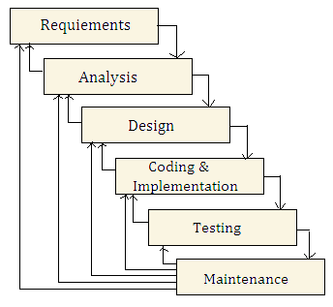
Figure: Iterative Waterfall Model

Architecture Design:
In data mining architecture, database or data warehouse is treated as an information retrieval component of data mining system using integration. All the features of database or data warehouse are used to perform data mining tasks. This architecture provides system scalability, high performance, integrated information.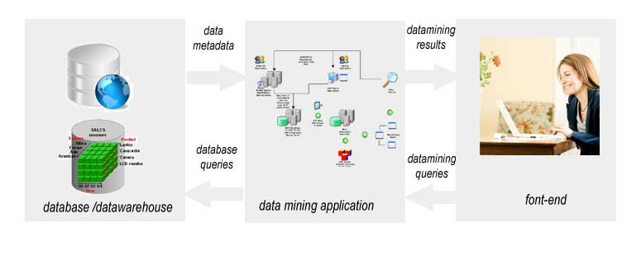
There are three tiers in the tight-coupling data mining architecture:
- Data layer: as mentioned above, data layer can be a database and/or data warehouse systems. This layer is an interface for all data sources. Data mining results are stored in data layer so it can be presented to end-user in the form of reports or another kind of visualization.
- Data mining application layer is used to retrieve data from the database. Some transformation routine can be performed here to transform data into the desired format. Then data is processed using various data mining algorithms.
- Front-end layer provides an intuitive and friendly user interface for end-user to interact with data mining system. Data mining result presented in visualization form to the user in the front-end layer.
System Architecture
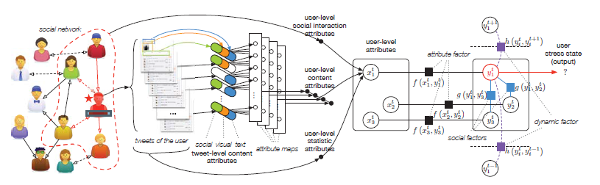
Figure: System Architecture

6.2 DFD:
Data Flow Diagram
The DFD is also called as bubble chart. It is a simple graphical formalism that can be used to represent a system in terms of the input data to the system, various processing carried out on these data, and the output data is generated by the system.
Level 0
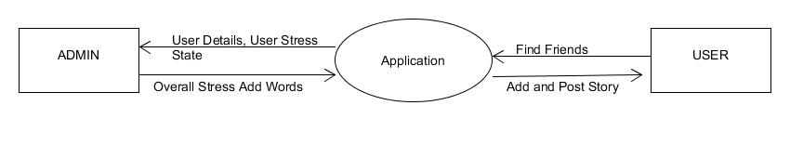
Admin Level 1
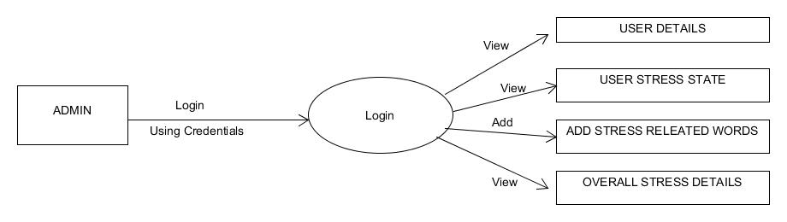

User level 1
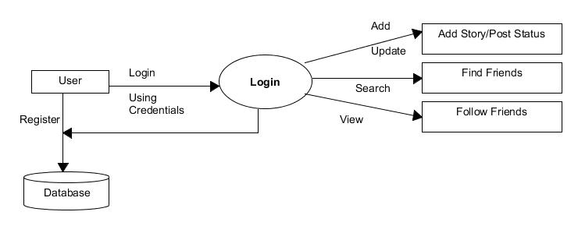

Use Case Diagram
Use case diagram is a graph of actors, a set of use cases enclosed by a system boundary, communication associations between the actor and the use case. The use case diagram describes how a system interacts with outside actors; each use case represents a piece of functionality that a system provides to its users. A use case is known as an ellipse containing the name of the use case and an actor is shown as a stick figure with the name of the actor below the figure.

The use cases are used during the analysis phase of a project to identify and partition system functionality. They separate the system into actors and use case. Actors represent roles that are played by user of the system. Those users can be humans, other computers, pieces of hardware, or even other software systems.
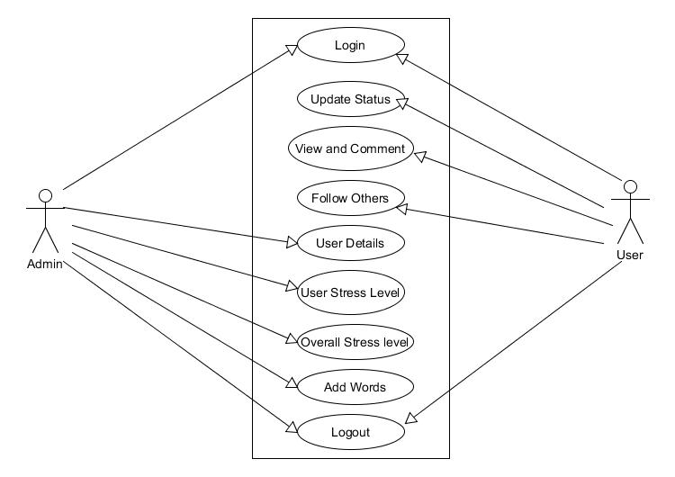
Entity-Relationship Diagram
Entity Relationship Diagram depicts the various relationships among entities, considering each objective as entity. Entity relationships are described by their dependence on each other, as well as the extent of the relationship between the data stores. It depicts the relationship between data objects. The ER diagram is a notation that is used to conduct the data modeling activity.
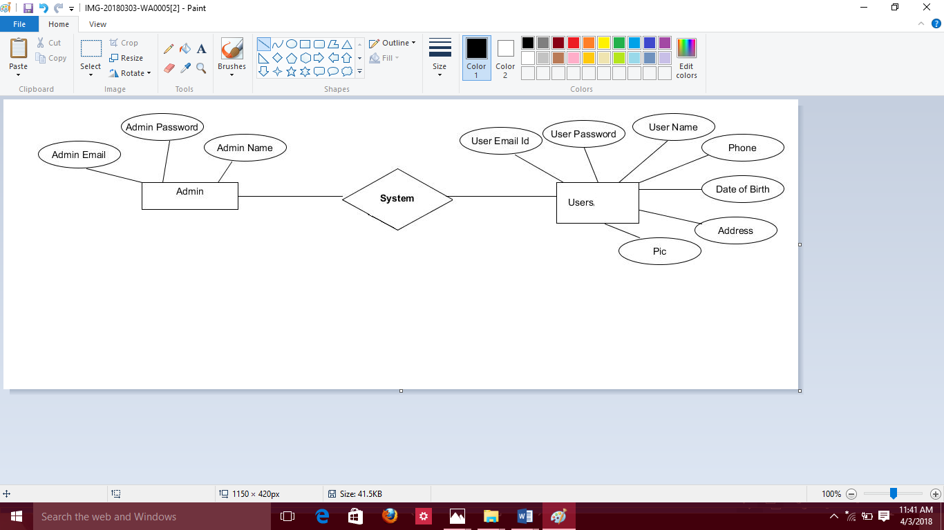

The Symbols used in this E-R Diagram are-

SI.NO | NAME | SYMBOL | DESCRIPTION
1 | Entity |  | Entity is a “thing” in the real world with an independent existence. It is an elementary basic building block of storing information about business process.
2 | Relationships |  | A relationship is a named connection or association between entities or used to relate to two or more entities with some common attributes or meaningful interaction between the objects.
3 | Attributes |  | Attributes are the properties of the entities and the relationships are the description of the entity. Attributes are elementary pieces of information attached to an entity.
4 | Key attributes |  | An entity type usually has an attribute whose values are distinct for each individual entity in the collection. Such an attribute is called key attribute.
Sequence Diagram:
A sequence diagram in Unified Modeling Language (UML) is a kind of interaction diagram that shows how processes operate with one another and in what order. It is a construct of a Message Sequence Chart. A sequence diagram shows, as parallel vertical lines (lifelines), different processes or objects that live simultaneously, and, as horizontal arrows, the messages exchanged between them, in the order in which they occur. This allows the specification of simple runtime scenarios in a graphical manner.

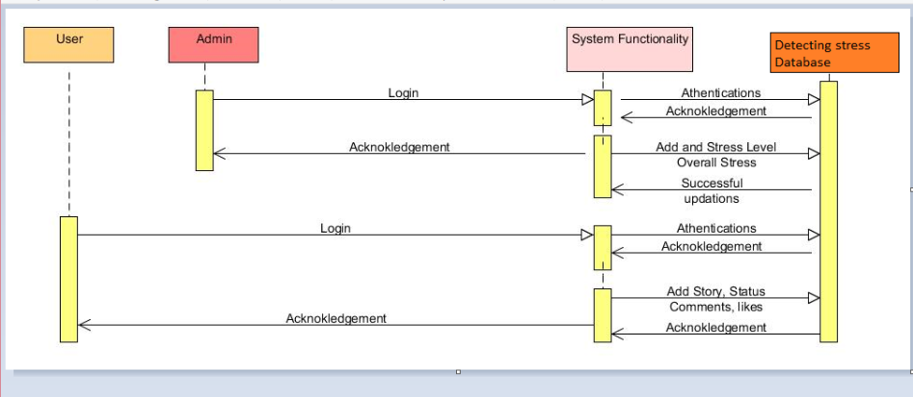

Data Base Design Structure:
- User like
- User comments
- Stress Dictionary
- Story
- Status
- Sign in
- Overall Stress
- Friend Request
- Contact Us
- Data table below contains the user like details. This table comes under User Module.
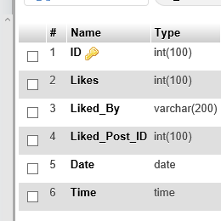

Data table below contains the user comments.This table comes under User Module.

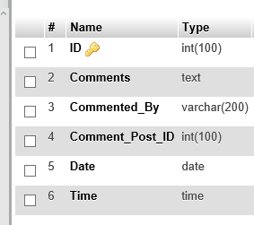
Data table below contains the stress dictionary.This table comes under Admin Module

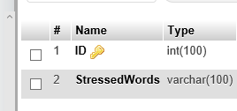

Data table below contains the story.This table comes under User Module

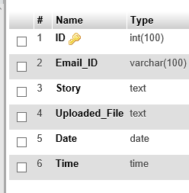

Data table below contains the status.This table comes under User Module

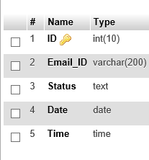

Data table below contains the overall stress.This table comes under Admin Module

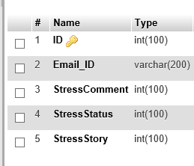

Data table below contains the sign in.This table comes under User Module

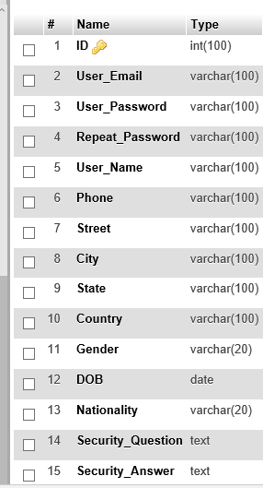
Data table below contains the Friend request.This table comes under User Module

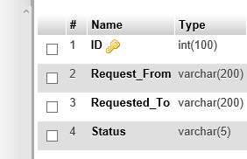

Data table below contains the Contact us.This table comes under Admin Module

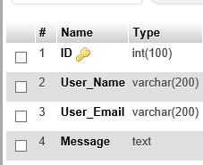

7.1 System Implementation:
Implementation is the process of converting a new or a revised system design into an operational one. The objective is to put the new or revised system that has been tested into operation while holding costs, risks, and personal irritation to the minimum. A critical aspect of the implementation process is to ensure that there will be no disrupting the functioning of the organization. The best method for gaining control while implanting any new system would be to use well planned test for testing all new programs. Before production files are used to test live data, text files must be created on the old system, copied over to the new system, and used for the initial test of each program.
Another factor to be considered in the implementation phase is the acquisition of the hardware and software. Once the software is developed for the system and testing is carried out, it is then the process of making the newly designed system fully operational and consistent in performance.
Implementation is the most crucial stage in achieving a successful system and giving the user’s confidence that the new system is workable and effective. Implementation of a modified application to replace an existing one. This type of conversation is relatively easy to handle, provide there are no major changes in the system.
7.2 Implementation Steps:
There are three major types of implementation are there but the following are proposed for the project.

Parallel Conversion type of Implementation
In this type of implementation both the current system and the proposed system run in parallel. This happens till the user gets the complete confidence on the proposed system and hence cuts of the current system.
Phase - in method of implementation
In this type of implementation, the proposed system is introduced phase-by-phase. This reduces the risk of uncertainty of proposed system.
Each program is tested individually at the time of development using the data and has verified that this program linked together in the way specified in the programs specification, the computer system and its environment is tested to the satisfaction of the user. The system that has been developed is accepted and proved to be satisfactory for the user. And so the system is going to be implemented very soon. A simple operating procedure is included so that the user can understand the different functions clearly and quickly.
Initially as a first step the executable form of the application is to be created and loaded in the common server machine which is accessible to the entire user and the server is to be connected to a network. The final stage is to document the entire system which provides components and the operating procedures of the system.
Implementation is the stage of the project when the theoretical design is turned out into a working system. Thus it can be considered to be the most critical stage in achieving a successful new system and in giving the user, confidence that the new system will work and be effective.
The implementation stage involves careful planning, investigation of the existing system and it’s constraints on implementation, designing of methods to achieve changeover and evaluation of changeover methods.
Implementation is the process of converting a new system design into operation. It is the phase that focuses on user training, site preparation and file conversion for installing a candidate system. The important factor that should be considered here is that the conversion should not disrupt the functioning of the organization.
Pseudo code
Admin
- Login:
- Enter User ID and Password
- User Registration
- Respond to User
- END
- User Registration:
- Check details
- If details are valid
Send acceptance notification
Else
Cancel Registration
- END

- Detecting User Stress:
- Detect user stress
- Detect overall user stress
- Generate a overall stress graph
- END
User
- Registration:
1. Fill the User Registration Form
2. Click Register Button
3. If Registration Successful, insert into database
Redirect to Login page
Else
Registration Failed
Re-enter the fields
4. END
- Login:
1. Enter User ID and Password
2. Upload/View photos
3. Send Friend Request
4. Accept Friend Request
5. Interactions with Friends
6. END
- Upload Status/Post pics
1. Upload Status/Post
2. Click Upload Status/Post Button
3. If Upload Successful, insert into database
Else
Error in Uploading
Re-Upload the Status/Post
4. END

- User comment
1. View the Status/Post
2. Upload the Status/Post
3. Click on the Comments Box
4. Send a comments
5. END
- Password Change
1. Click Change Password
2. Type Old Password
3. Type New Password
4. Click Update
5. END

8.1 Introduction:
Before actually implementing the new system into operations, a test run of the system is done removing all the bugs, if any. It is an important phase of a successful system. After codifying the whole programs of the system, a test plan should be developed and run on a given set of test data. The output of the test run should match the expected results.
System testing is expensive. For some large systems such as Real time systems with complex non-functional constant, half of the budget may be spent on testing. Careful planning is needed to get most out of testing and to control the testing costs.
Software testing is a critical element of software quality assurance and represents the ultimate review of specification, design and coding.
The overall objective of event based testing is to find the maximum number of errors with a minimum effort. In event based testing the view of testing broadens to include the review of both analysis models.
The first state of testing is a form of formal technical reviews of event relationship and models, design models and resulting source code.
8.2 Testing Methodologies:
There are several types of testing strategies. They are as follows:
- Unit Testing.
- Integration Testing.
- Regression Testing.
- System Testing.
- Validation Testing.
- Acceptance Testing.
Unit Testing:
When the programs have been coded and compiled and brought to working conditions, they must be individually tested with the prepared test data. Any undesirable happening must be noted and debugged (error corrections). Unit testing focuses on the smallest unit of the software design, the software component or module. Unit testing is a white box oriented testing.
Integration Testing:
Integration testing is a logical extension of the unit testing. Here when all the modules are integrated to form a single application is tested. In this testing, two units that have already been tested are combined into a component and the interfaces between them are tested.
Regression Testing:
Whenever we modify the implementation part with in the program then we should also do regression testing. We can do so by returning existing tests against the modified code to determine whether the changes break anything that worked prior to the change and by writing new tests wherever necessary.
System Testing:
The sub-systems are integrated to make up the system. This process is concerned with finding errors that result from unanticipated interactions between sub-systems and sub-System interface problems. It is also concerned with validating that the system meets its functional and non-functional requirements and testing the emergent system properties.
Validation Testing:
Validation testing is the step where requirements established as a part of the software requirements analysis, are validated against the software already been constructed. This test provides the final assurance that the software meets all the functional, behavioral and performance requirement and the errors that are discovered during the testing. Deviation or errors discovered at this project is corrected in prior to completion of the project with the help of user by negotiating to establish a method for resolving deficiencies.
Acceptance Testing:
A test performed by an end user or system owner to verify that the delivered software functions correctly and meets requirements. Usually these tests are derived from use cases of the particular iteration to be tested. The testing process is similar to that of component testing.
Black Box Testing:
Black box testing is an approach to testing where the tests are derived from the program or component specification. The system is a “black box “whose behavior can only be determined by studying its inputs and the related outputs. Black box is only concerned with the functionality and not the implementation of the software.

White Box Testing:
White box testing (clear box testing, glass box testing, a transparent box testing or structural testing) uses an internal perspective of the system to design test cases based on internal structure. It requires programming skills to identify all paths through the software. The tester chooses test case inputs to exercise paths through the Code and determines the appropriate outputs. In electrical hardware testing, every node in a circuit may be probed and measured. Since the tests are based on the actual implementation, if the implementation changes the tests probably will need to change, too.
8.3 Test Cases:
A Test case (TC) is a set of test inputs, executions and expected results developed for a particular objective.
- Test cases should satisfy the following criteria.
- Reasonable probability of catching an error.
- Does interesting things.
- Doesn’t do unnecessary things.
- Neither too simple nor too complex.
- Not redundant with other tests.
- Allows isolation and identification of errors.

Need for Testing:
System testing is expensive. For some large systems such as Real Time systems with complex nonfunctional constants, half of the budget may be spent on testing. Careful planning is needed to get most out of testing and to Control testing costs.
Test Planning is concerned with setting out standards, for the testing process, rather than describing product tests. Errors may occur at the very inception of the process where the objectives may be imperfectly specified, as well as later design and development stages.
After the source Code was generated, the application was tested to un-cover as many errors as possible. The tests were conducted to: Examine the internal Logic of application components.
Test Cases
Test Case Number | Testing Scenario | Expected result | Result
 | REGISTRATION TESTING
TC – 01 | Clicking submit without entering details | Alert "Please fill all details" | Pass
TC – 02 | Clicking submit without entering Username | Alert "Please fill Username" | Pass
TC – 03 | Clicking submit without entering password | Alert "Please fill Password" | Pass
TC – 04 | Clicking submit without entering email id | Alert "Please fill email id" | Pass
TC – 05 | Clicking submit without entering phone number | Alert "Please fill contact number" | Pass
TC – 06 | Clicking submit entering confirm password data which is not matching with password data | Alert "Password and Confirm Password do not match" | Pass
 | LOGIN TESTING
TC – 07 | Clicking submit without entering login details | Alert "Please enter the username and password" | Pass
TC – 08 | Clicking submit without entering password | Alert "Please enter the password" | Pass
TC – 09 | Clicking submit without entering Username | Alert "Please enter the Username" | Pass
TC – 10 | Clicking submit entering wrong Username | Alert "Invalid User" | Pass
TC – 11 | Clicking submit entering wrong password | Alert "Invalid User" | Pass
TC – 12 | Clicking submit entering wrong Username and password | Alert "Invalid User" | Pass

Detecting Stress Based On Social Interactions In Social Networks have two major modules

- Admin Module
- Owner Module

- Home Page

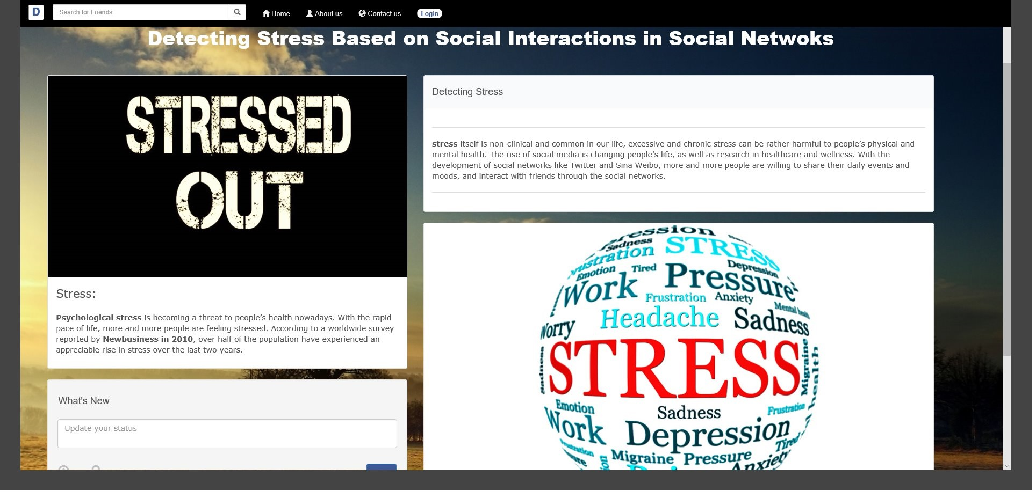

- About Page

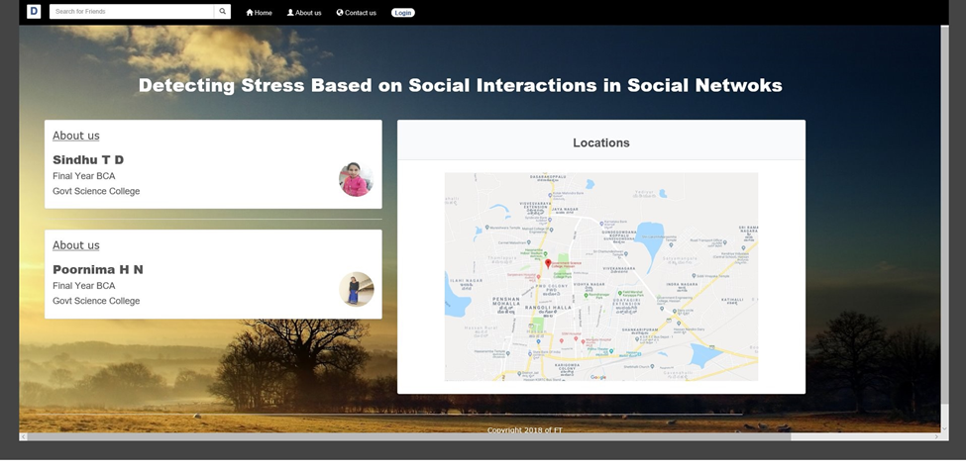

- Admin Dashboard

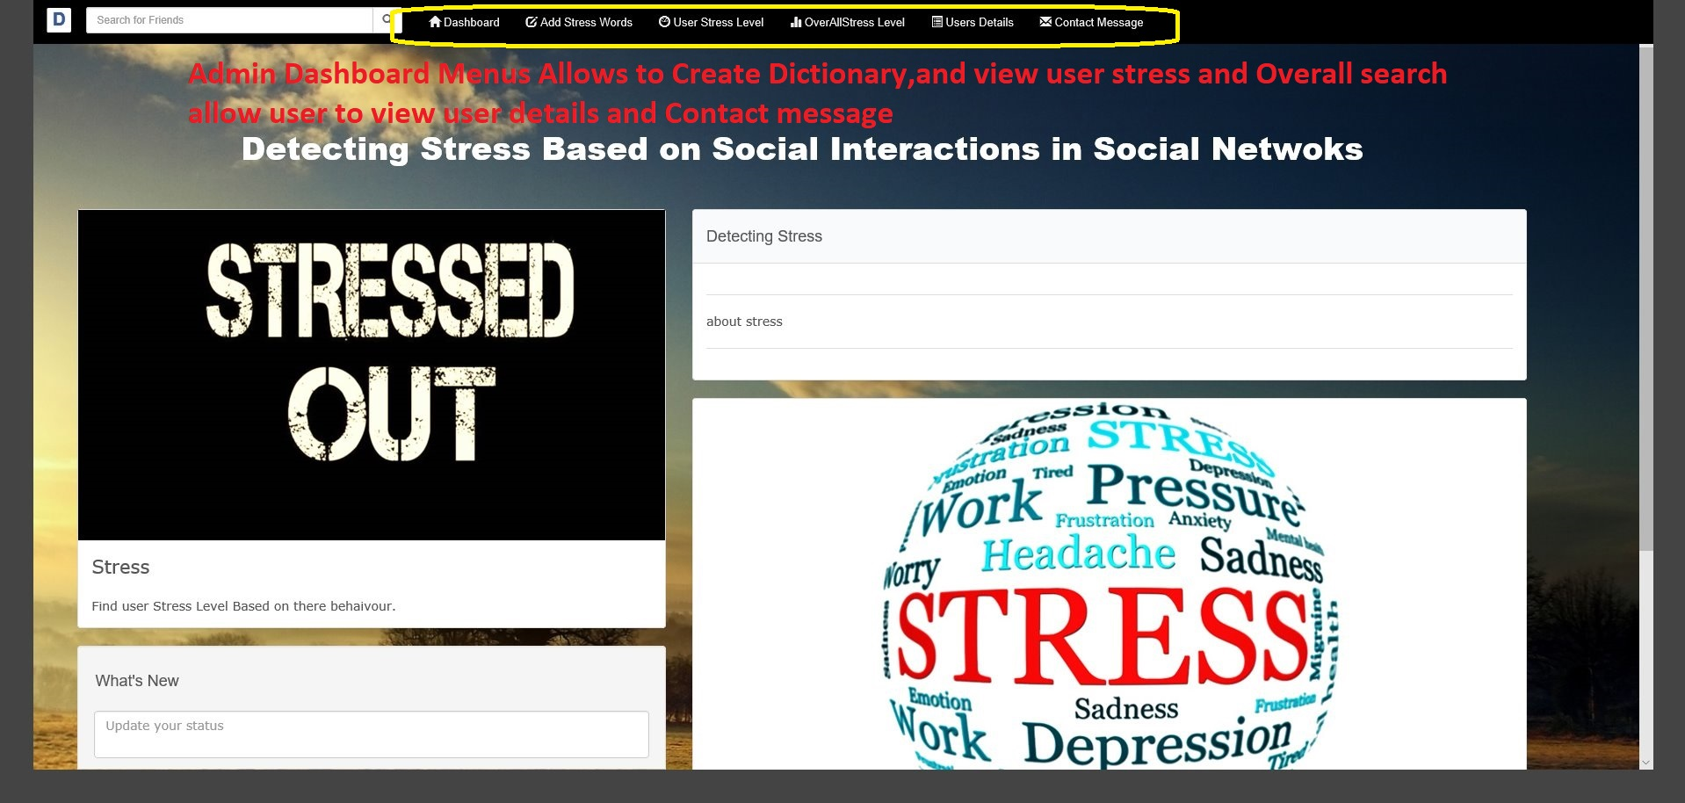

- Admin and User Login

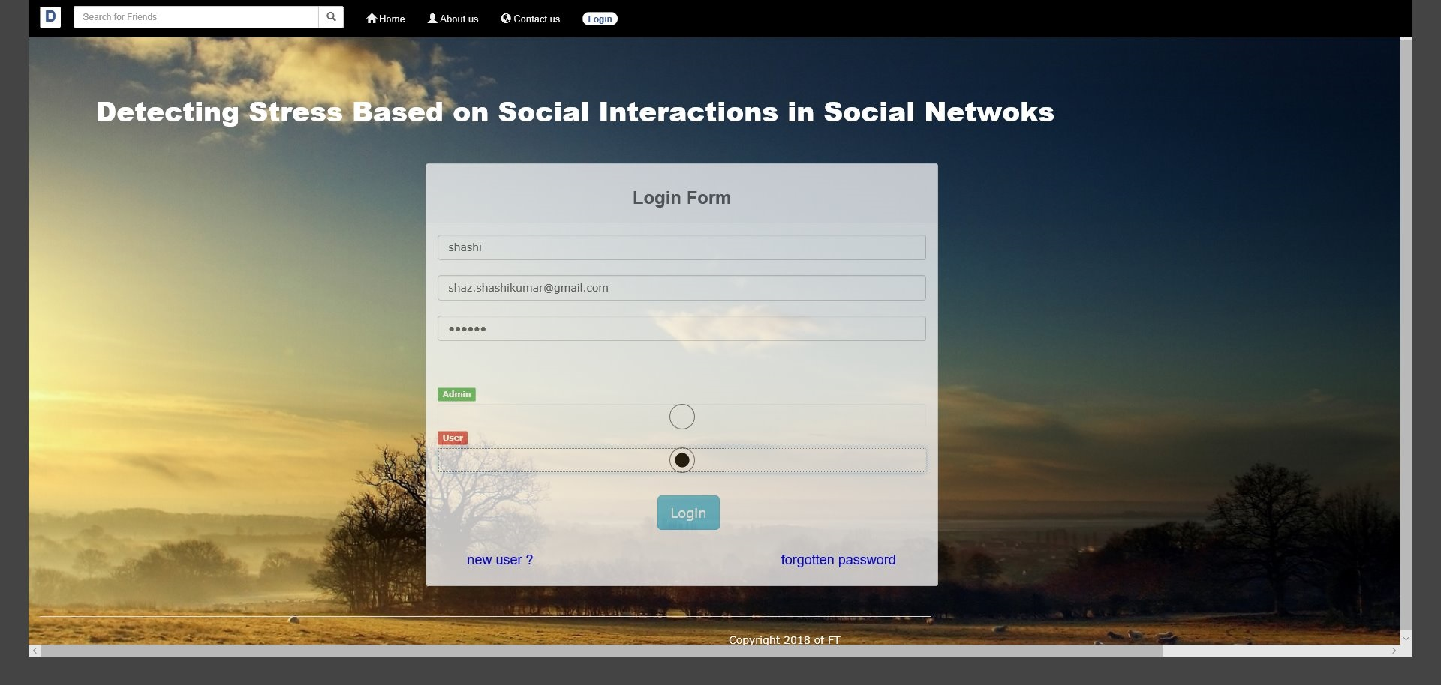

- User Dash Board

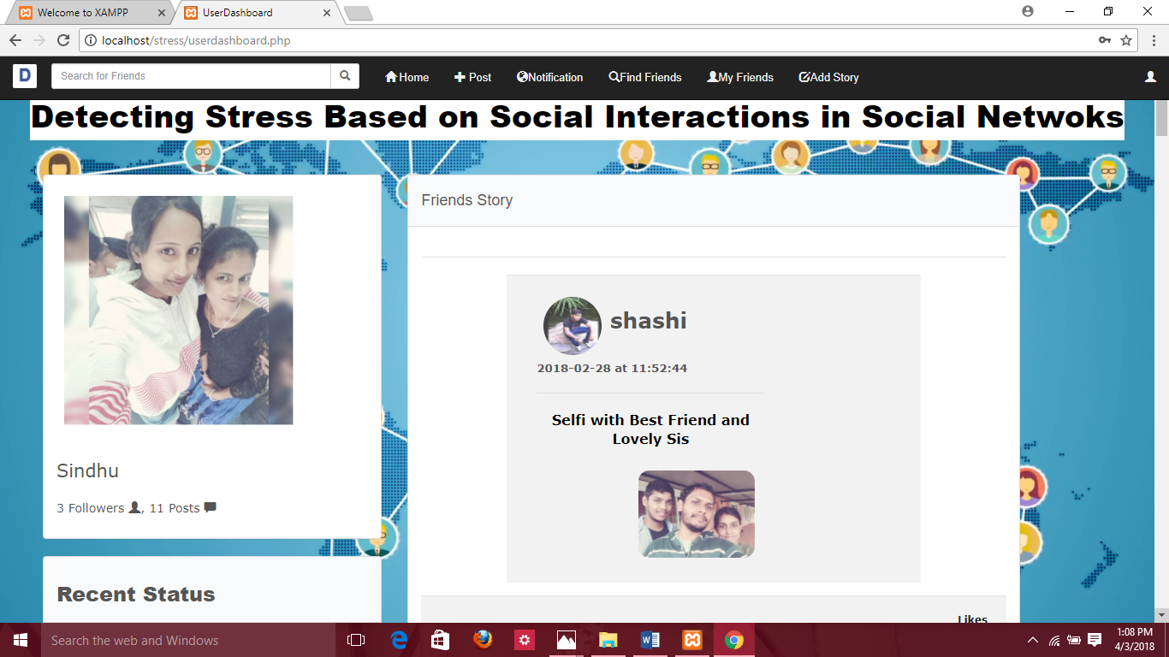

- User Details

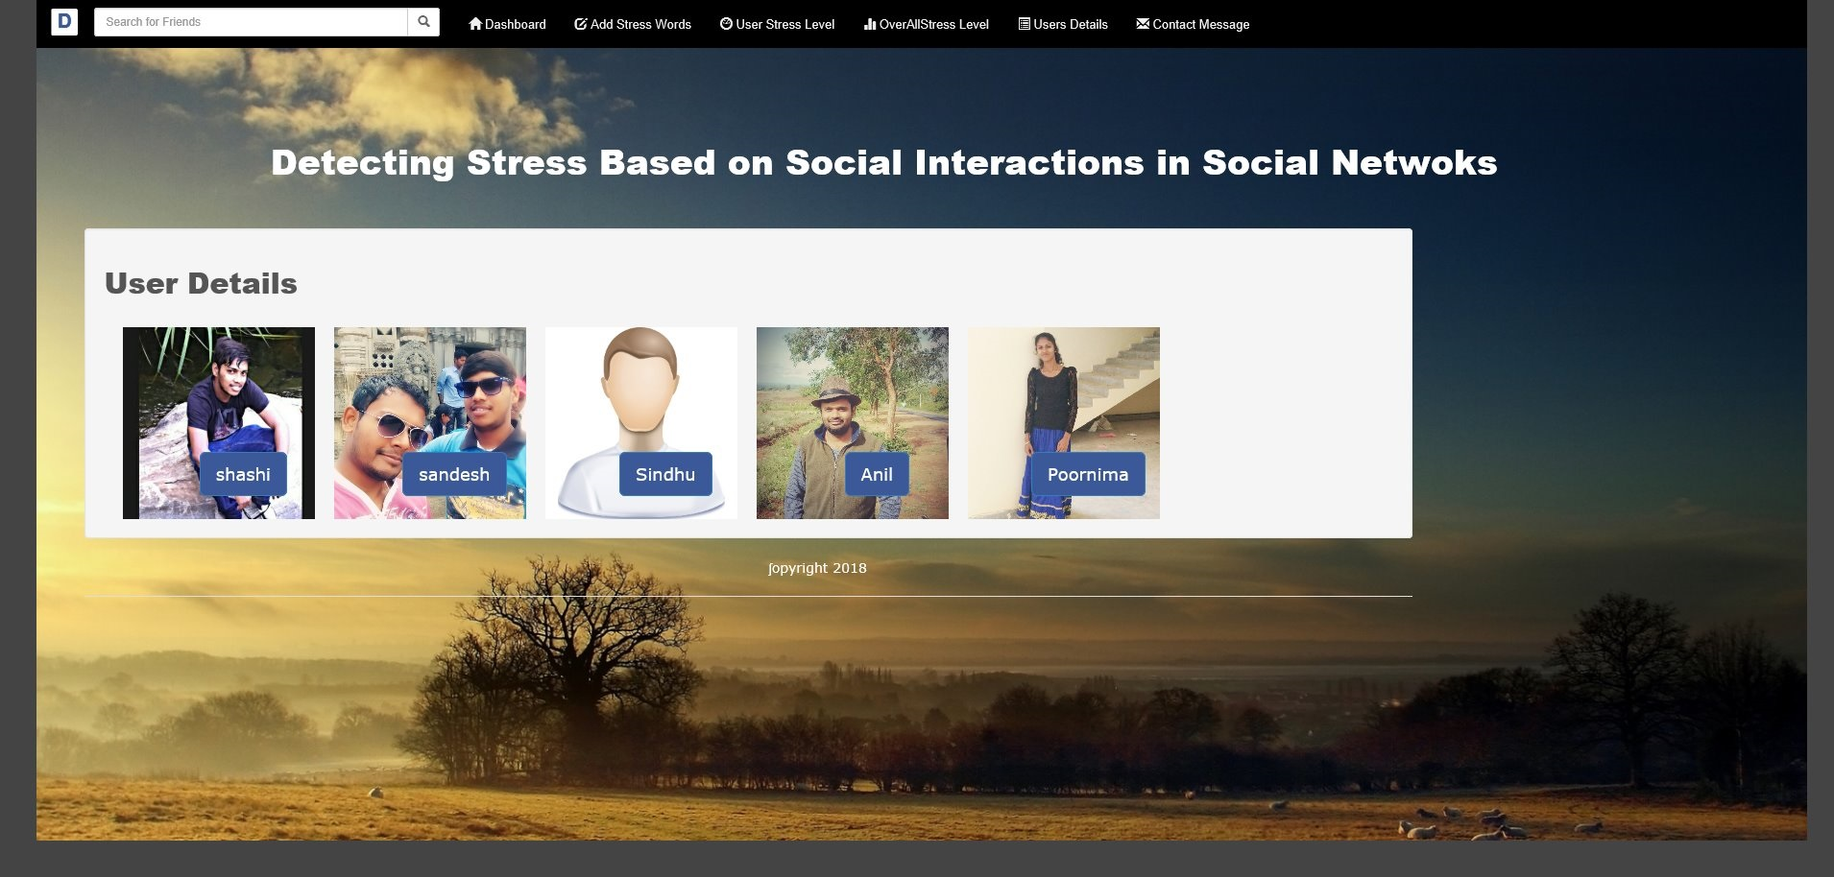

- User Stress Level

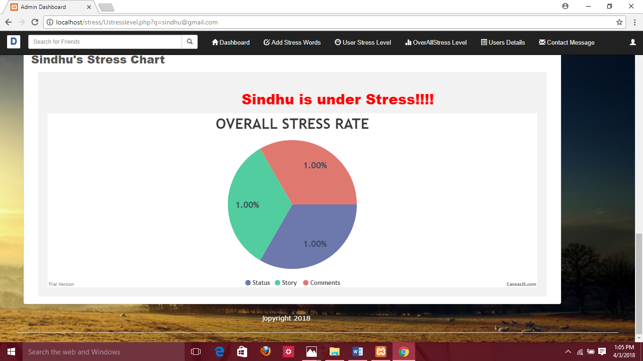

- Users Overall Stress Level

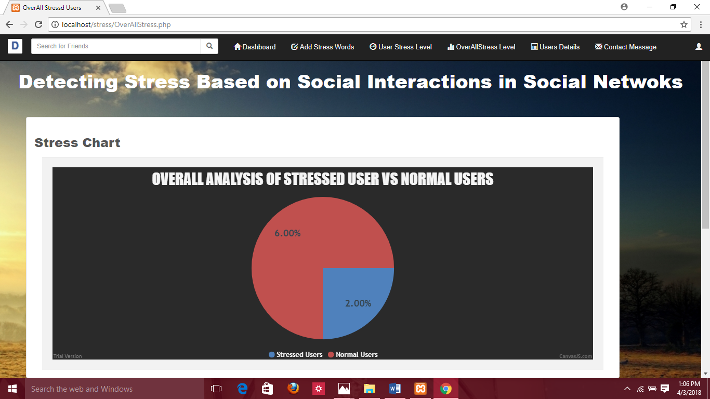

CONCLUSION
In this, we presented a framework for detecting users’ psychological stress states from users’ weekly social media data, leveraging tweets’ content as well as users’ social interactions. Employing real-world social media data as the basis, we studied the correlation between user’ psychological stress states and their social interaction behaviors. To fully leverage both content and social interaction information of users’ tweets, we proposed a hybrid model which combines the factor graph model (FGM) with a convolutional neural network (CNN). In this work, we also discovered several intriguing phenomena of stress. We found that the number of social structures of sparse connection (i.e. with no delta connections) of stressed users is around 14% higher than that of non-stressed users, indicating that the social structure of stressed users’ friends tend to be less connected and less complicated than that of non-stressed users. These phenomena could be useful references for future related studies.

FUTURE ENHANCEMENT

The developed website is just a start up website. Now we use this website only for user interactions and detecting stress user and overall stress user. In future we can find the stress user and send a message to that user to come out the stress.

BIBLIOGRAPHY
References:
Golnoosh Farnadi, Geetha Sitaraman, Shanu Sushmita, Fabio Celli, Michal Kosinski, David Stillwell, Sergio Davalos, Marie Francine Moens, and Martine De Cock. Computational personality recognition in social media. User Modeling and User-
Adapted Interaction, pages 1–34, 2016.
H. Lin, J. Jia, Q. Guo, Y. Xue, Q. Li, J Huang, L. Cai, and L. Feng. User-level psychological stress detection from social media using deep neural network. In Proceedings of ACM Int. Conference on Multimedia, 2014.

Ben Verhoeven, Walter Daelemans, and Barbara Plank. Twisty: A multilingual twitter stylometry corpus for gender and personality profiling. In Proceedings of the Tenth International Conference on Language Resources and Evaluation LREC, pages 1632–1637, 2016.

Johannes Gettinger and Sabine T. Koeszegi. More than Words: The Effect of Emoticons in Electronic Negotiations.

