Visualisation & Analysis ( B111 Group)
Loading and Preparing the Data
I loaded the dataset into R and selected the two variables we needed. I also removed any missing values just to avoid errors when plotting or running the correlation test. After this, the dataset had 157 valid rows, which is the number used in the analysis.

Histogram of Happiness Score
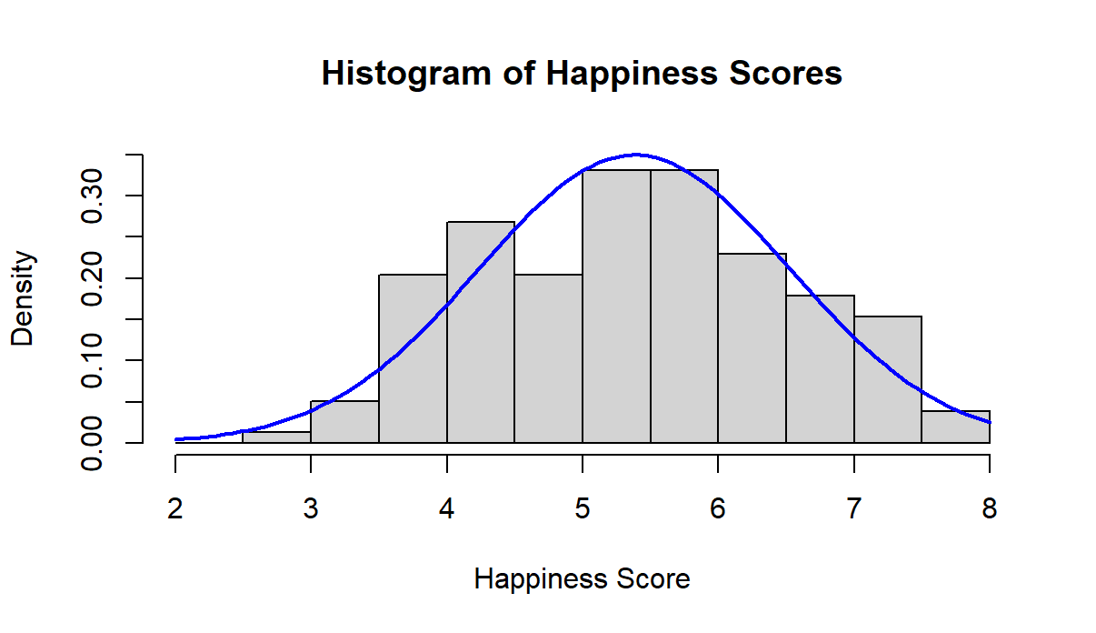
I created a histogram of the Happiness Score to check the distribution. The shape looked roughly like a bell curve, and when I added the normal curve on top, it matched pretty well. This suggests that the data is close to normally distributed.
Because of this, it was appropriate to use the Pearson correlation test later on. The histogram also shows that most countries have medium to high happiness scores.

Scatterplot: GDP vs Happiness
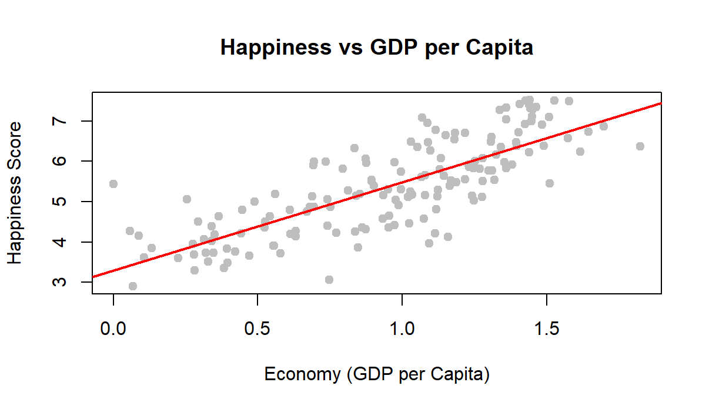
Created scatterplot with GDP on the x-axis and Happiness Score on the y-axis. Each point represents a country.
The points clearly go upward, which means that higher GDP is generally linked to higher happiness. I also added a straight trendline to make the pattern easier to see.

Pearson Correlation Test
Finally, I ran the Pearson correlation test on the two variables. The results I got were:
Pearson's product-moment correlation

data: Cleaned_Happiness and Cleaned_GDP
t = 16.059, df = 155, p-value < 2.2e-16
alternative hypothesis: true correlation is not equal to 0
95 percent confidence interval:
0.7232138 0.8426452
sample estimates:
cor
0.790322

r = 0.79 (shows strong positive relationship)
p-value < 2.2e-16 (basically zero)
N = 157 countries
Since the p-value is extremely small, we reject the null hypothesis. This means the relationship between GDP and Happiness is statistically significant and not due to chance. Overall, this shows that countries with higher GDP per capita tend to have higher happiness levels in this dataset.

The histogram showed the data was normal enough.The scatterplot showed a clear positive pattern.Pearson test confirmed a strong, significant correlation. Conclusion is that richer countries in this dataset are generally happier.

