MILDSTONE 1

Name : Soundarya Lakshmi S

Employee Id : 761152

Mail Id : SoundaryaLakshmi.SundaraRajan@cognizant.com

Location : Siruseri,Chennai

1. Schema Diagram

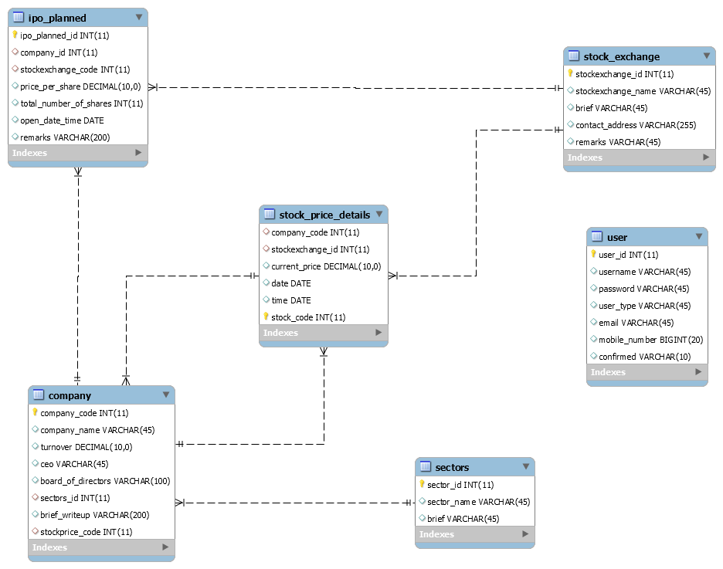

2) HTML Screens

2.1 Admin Login Page



2.2 User Login Page

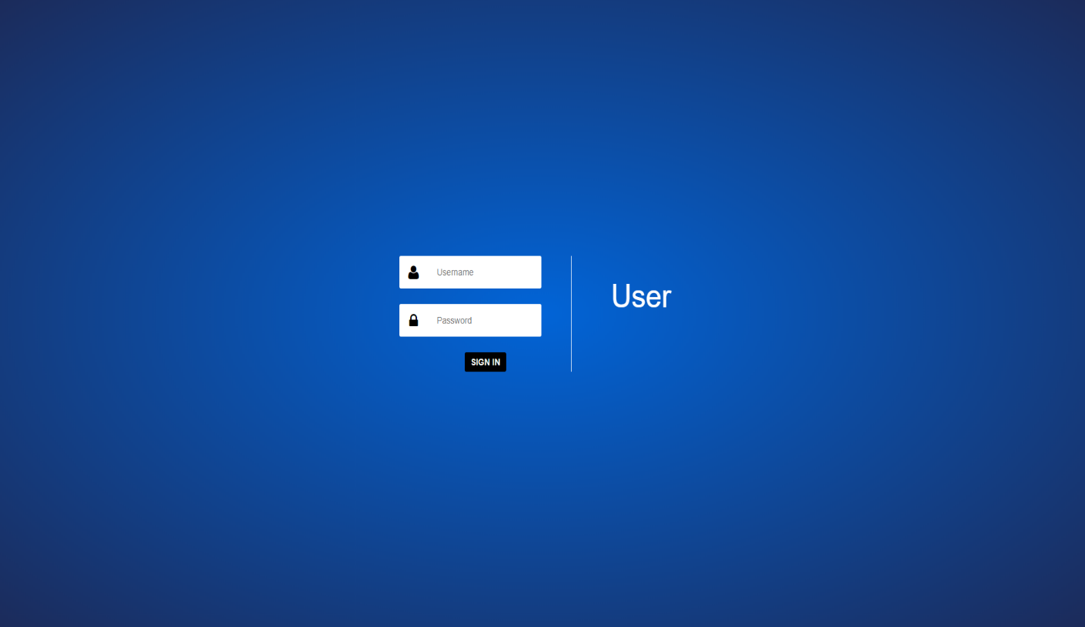

2.3 Admin Landing Page

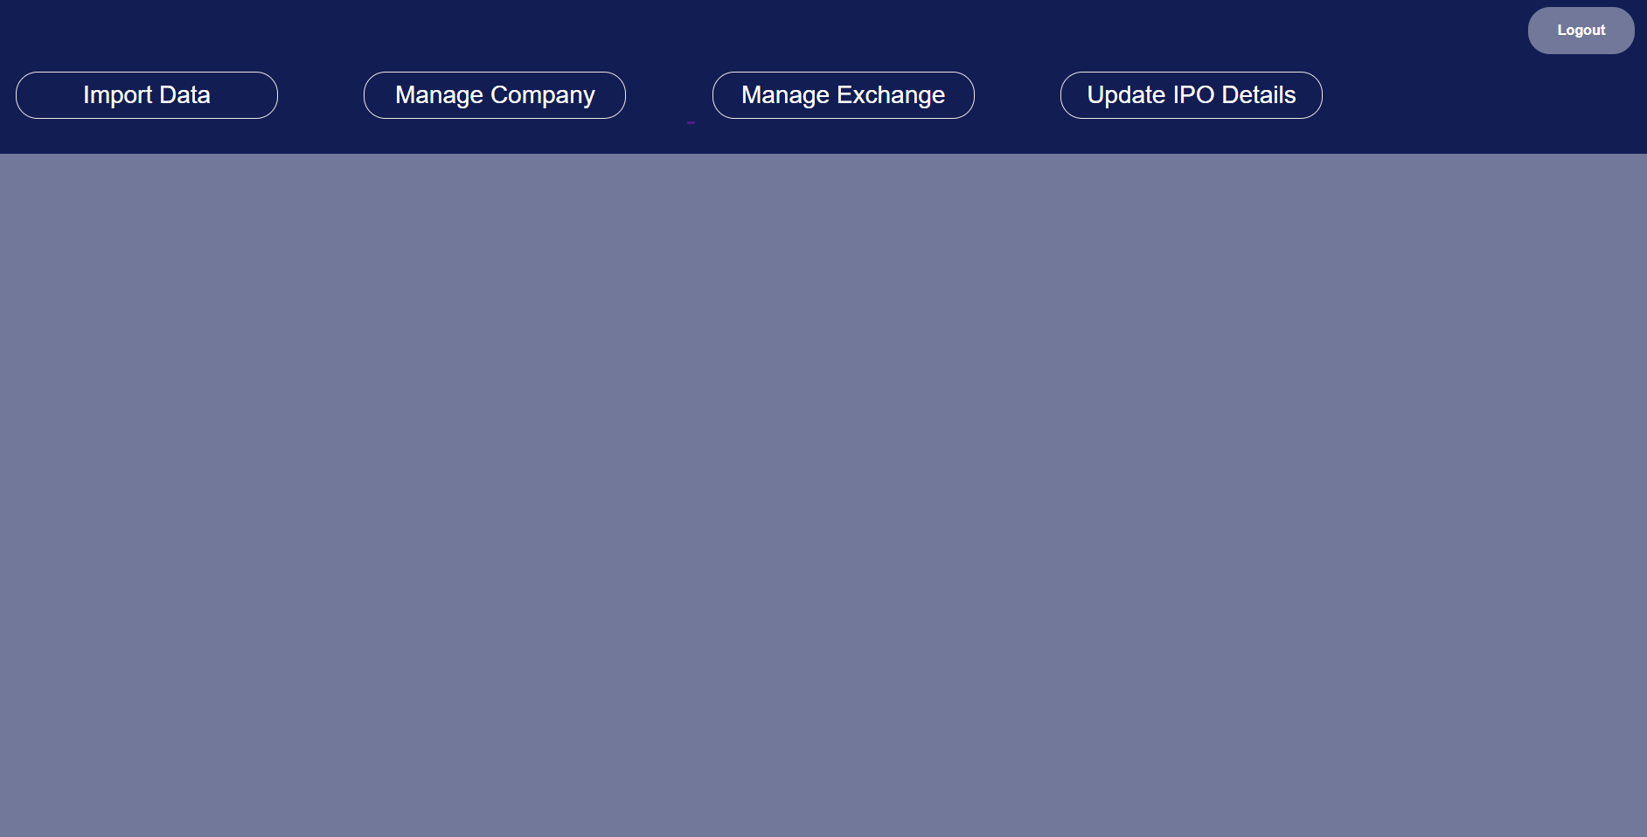

2.4 Import Data

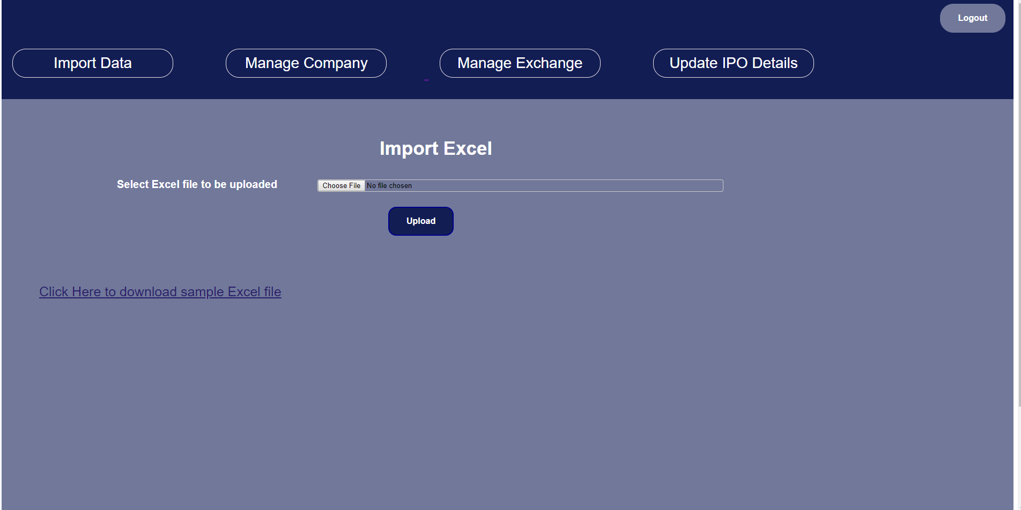

2.5 Summary of Upload

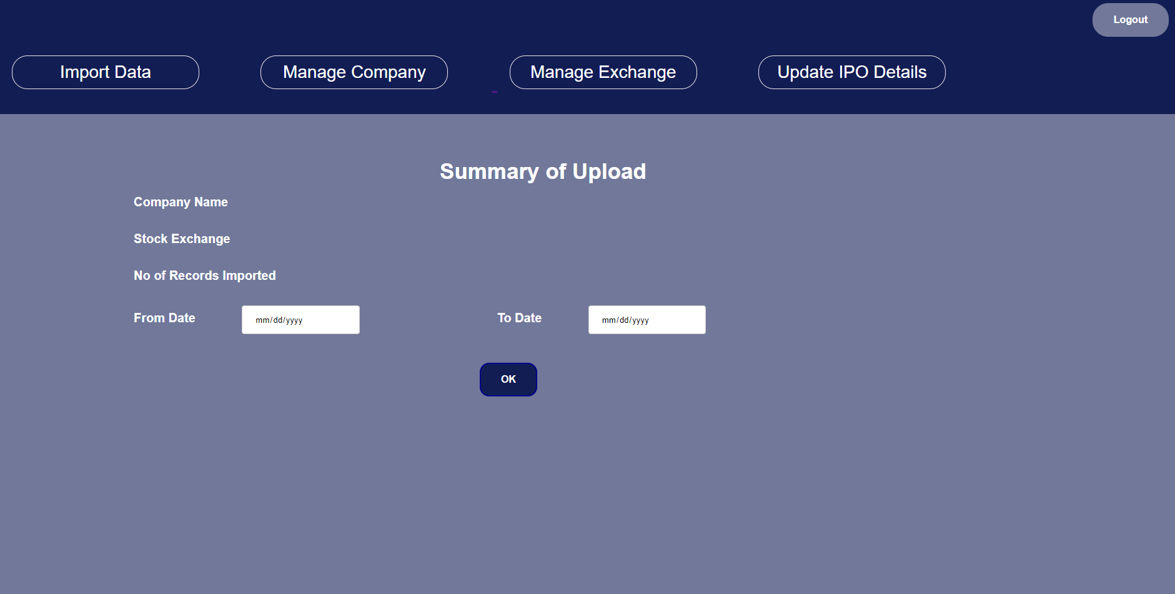

2.5 Manage Company

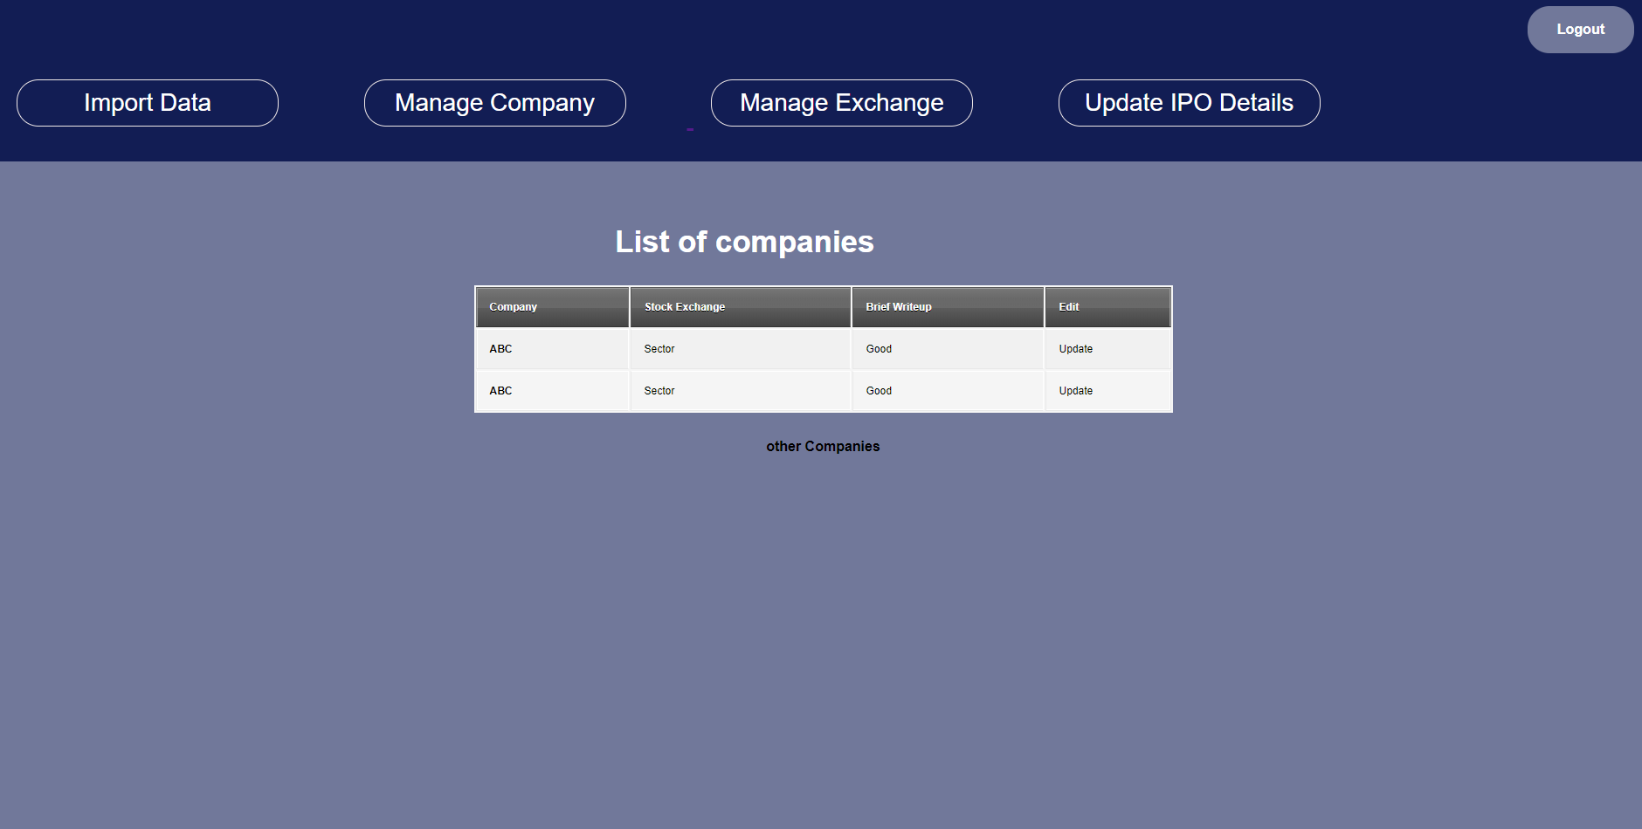

2.6 Create Company

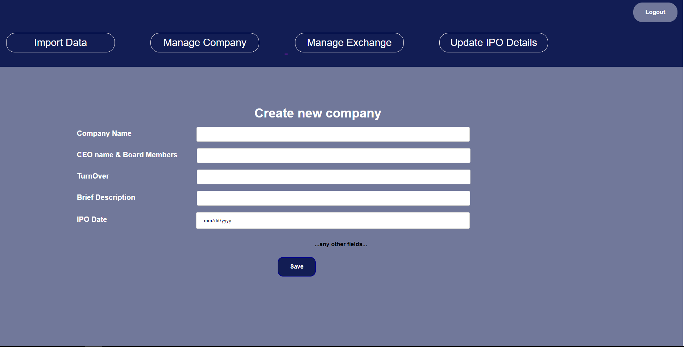

2.7 User Landing Page

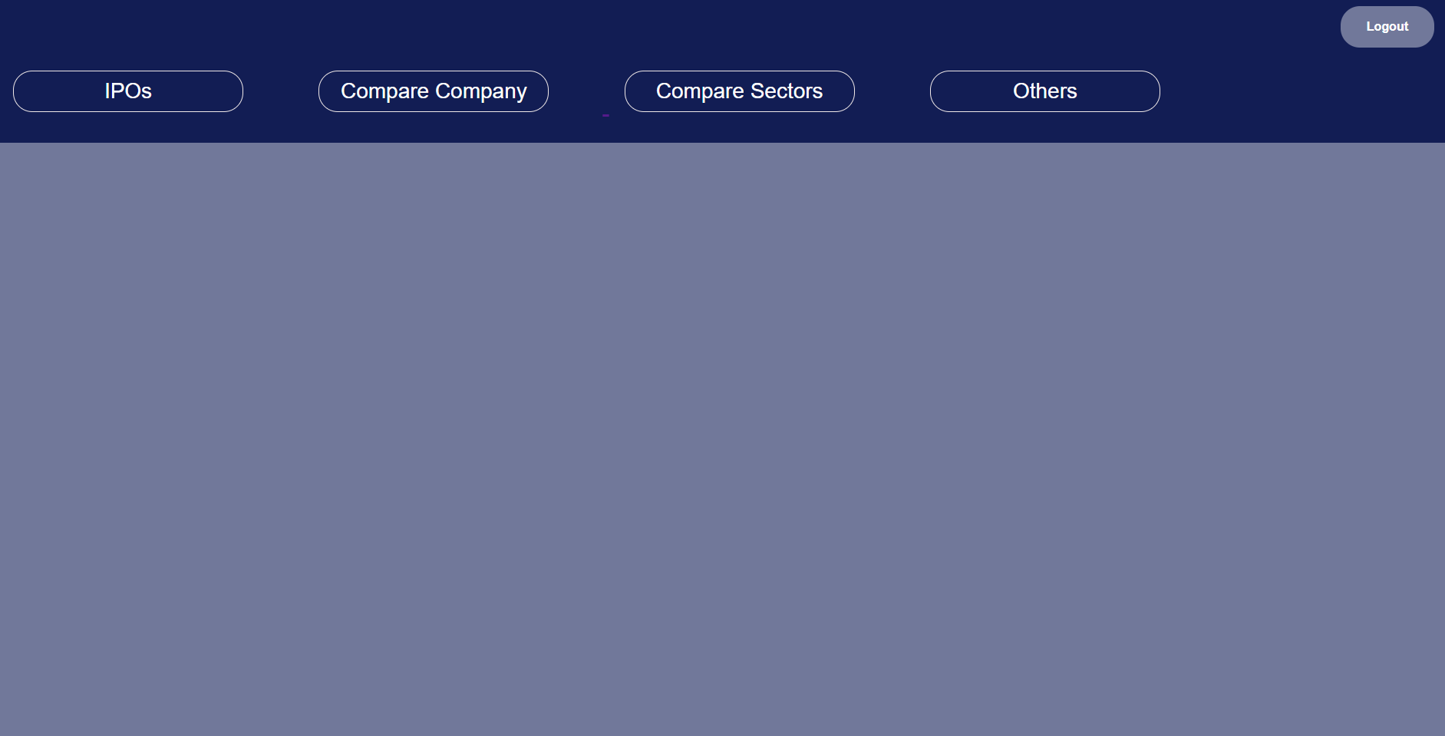

2.8 Compare Company

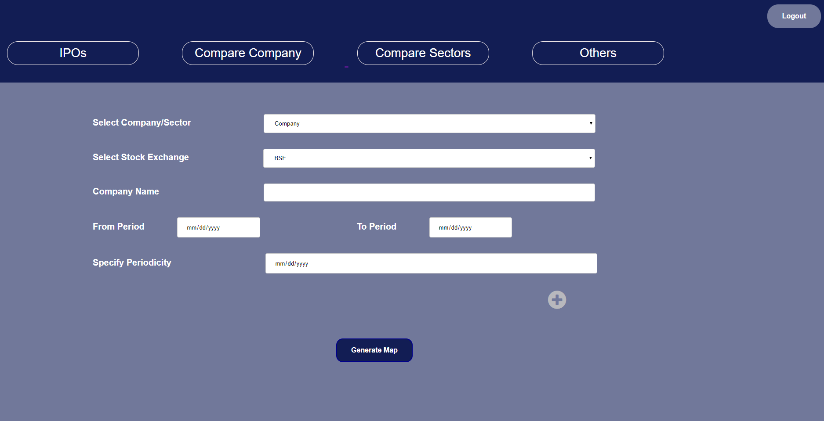

2.9 companyList.jsp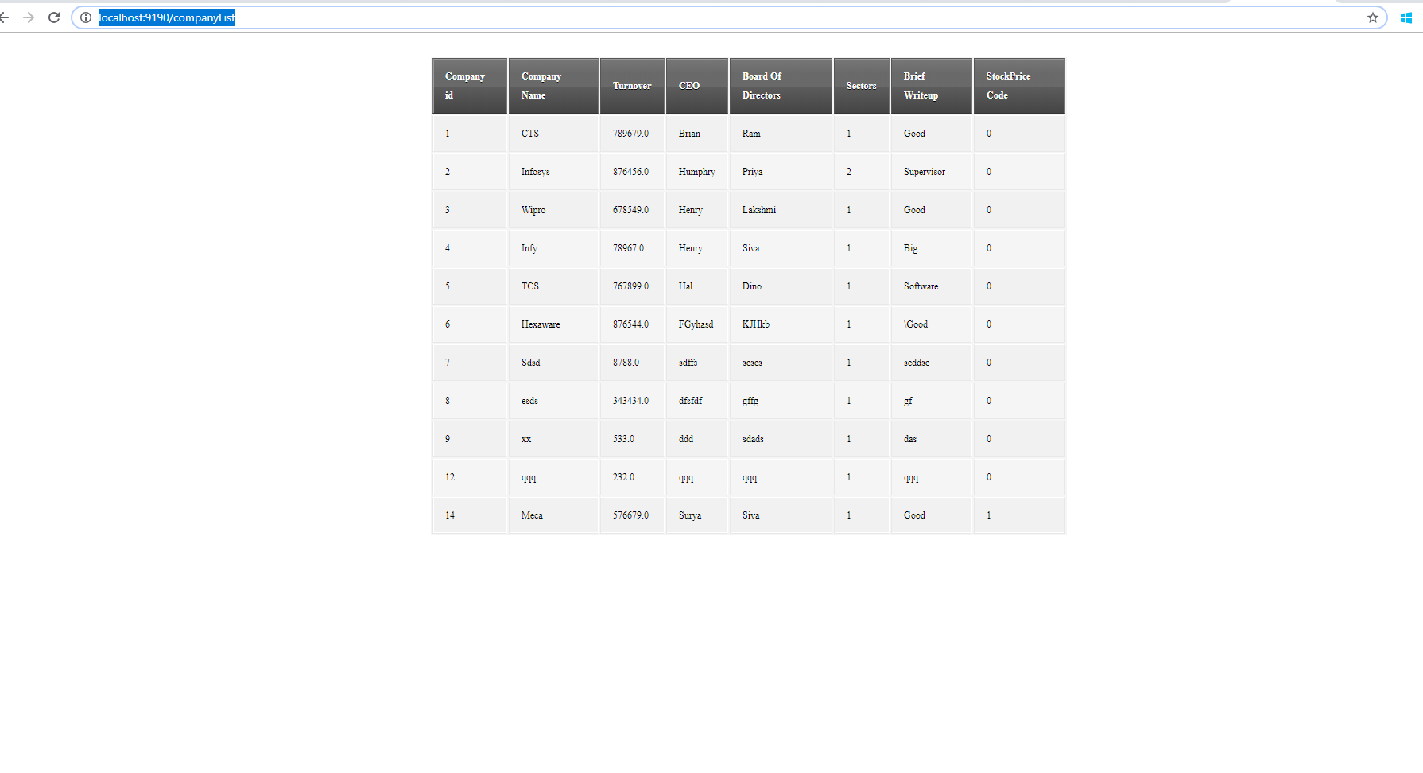

3) Github link

<https://github.com/Soundarya34/StockExchangeSpringBoot>