MILDSTONE 2

Name : Soundarya Lakshmi S

Employee Id : 761152

Mail Id : SoundaryaLakshmi.SundaraRajan@cognizant.com

Location : Siruseri , Chennai

JSP Screens

2.1 Register Company Page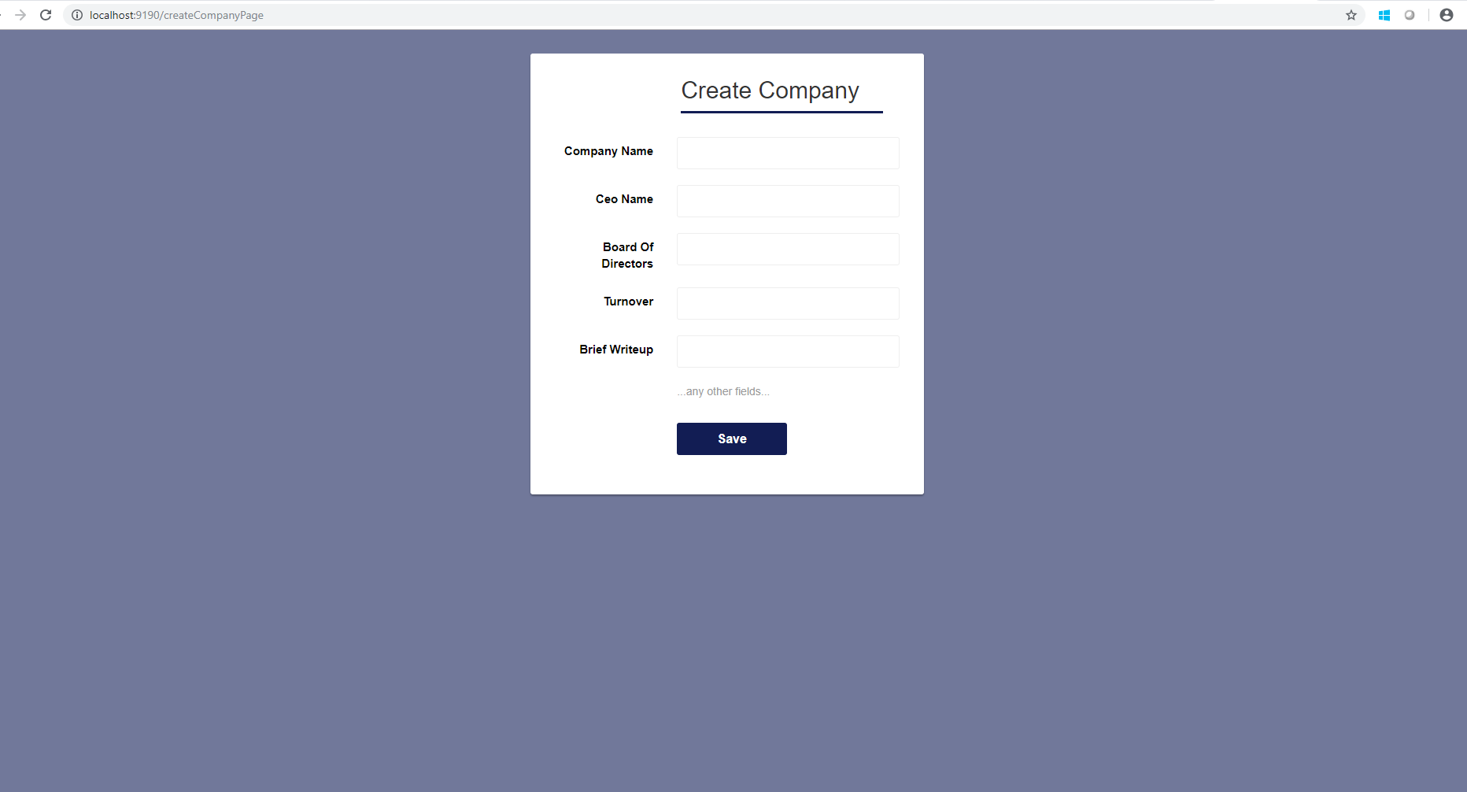2.2 Display Company List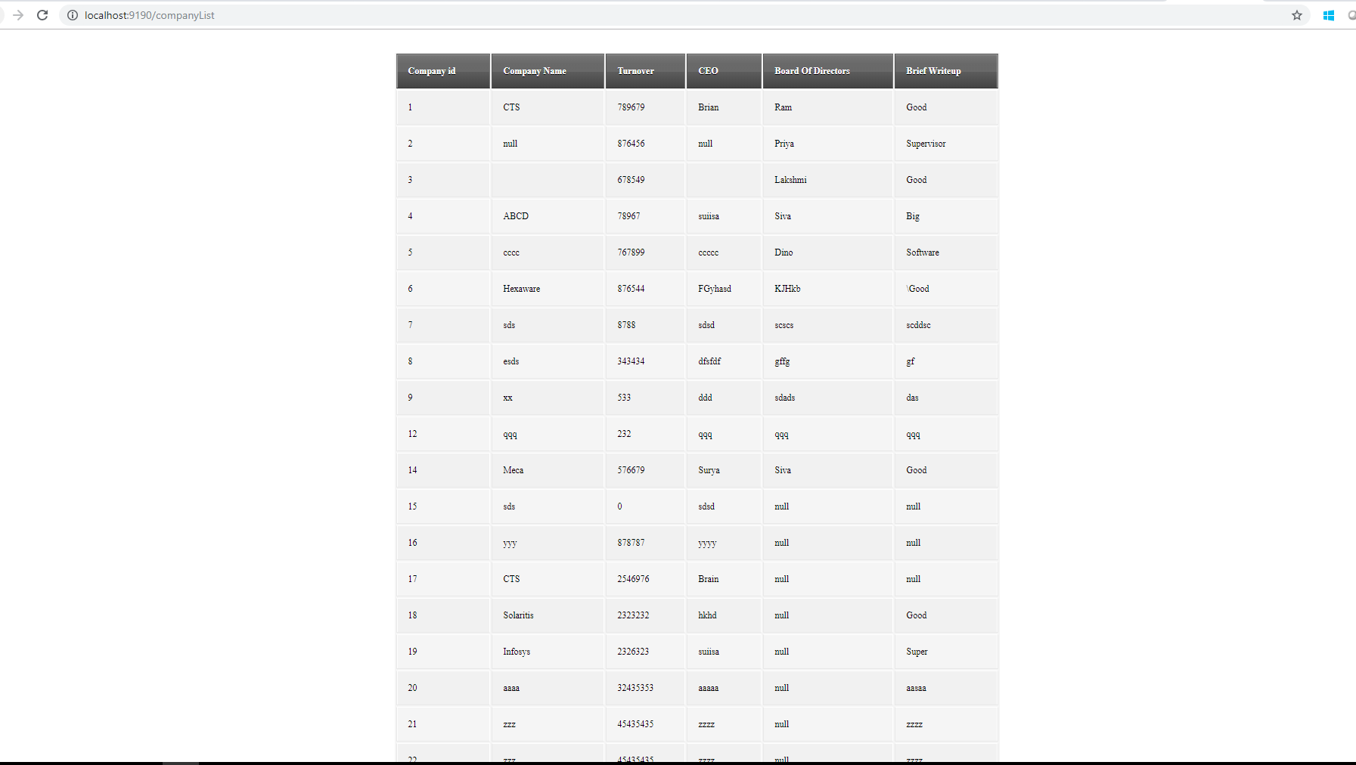

2.3 Register Stock Page

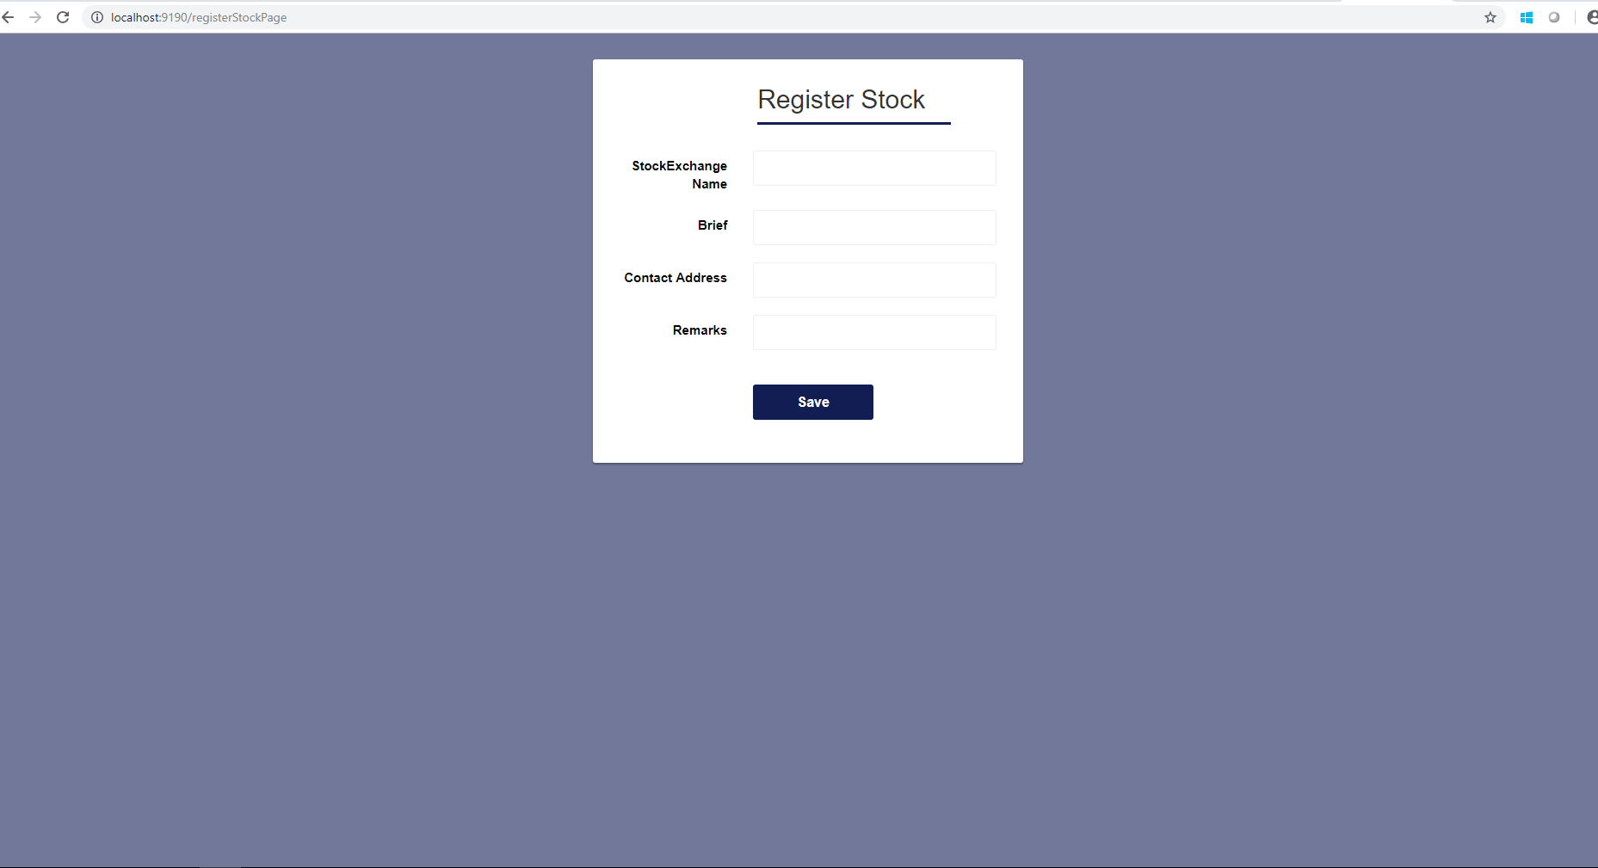

2.4 Display Stock List

