**CASE STUDY PROJECT OUTPUT SCREENSHOTS:**

**CONSOLE OUTPUT:**

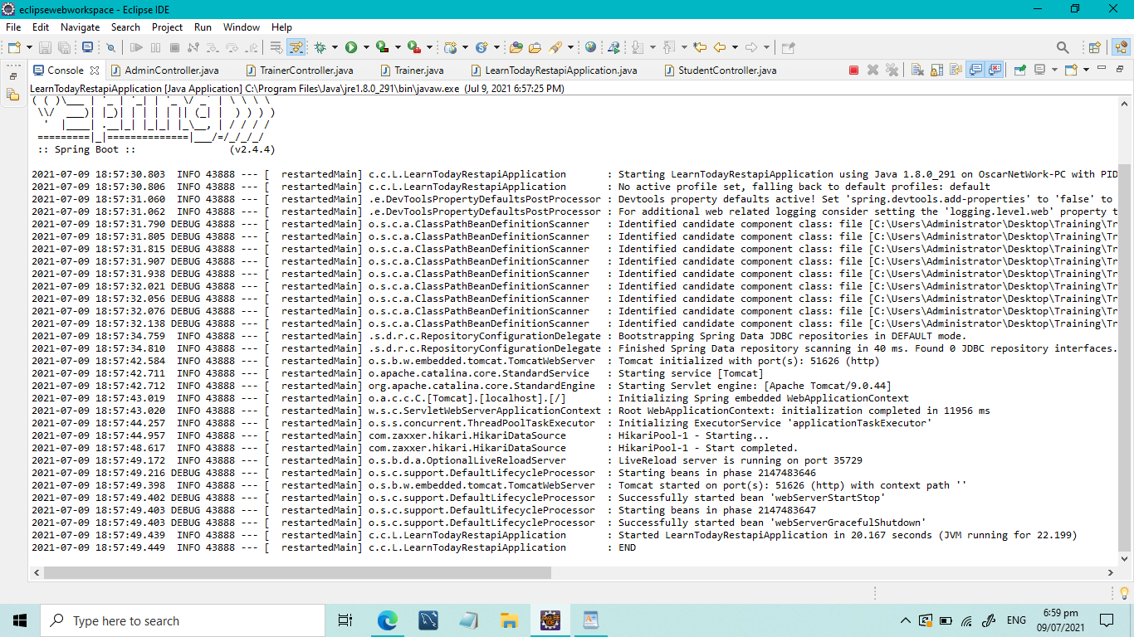

**ADMIN CONTROLLER:(GET MAPPING):GET ALL COURSES**

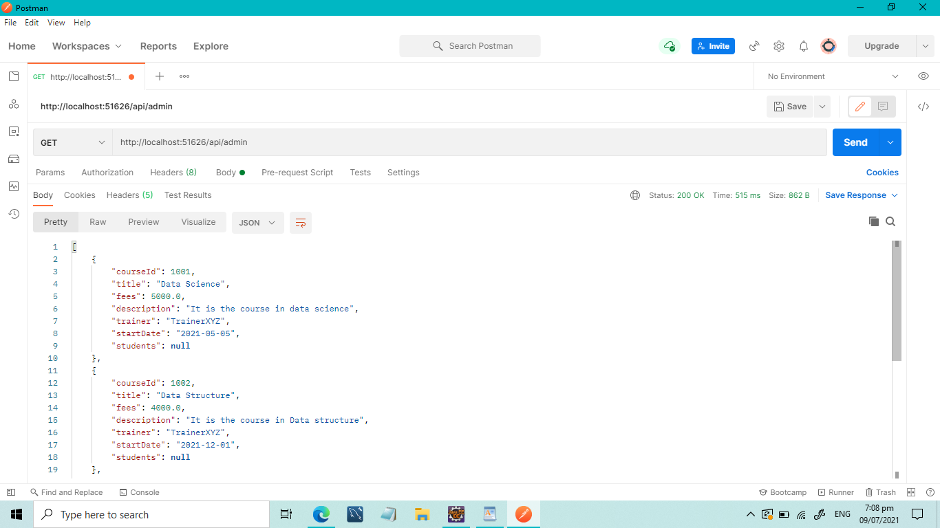

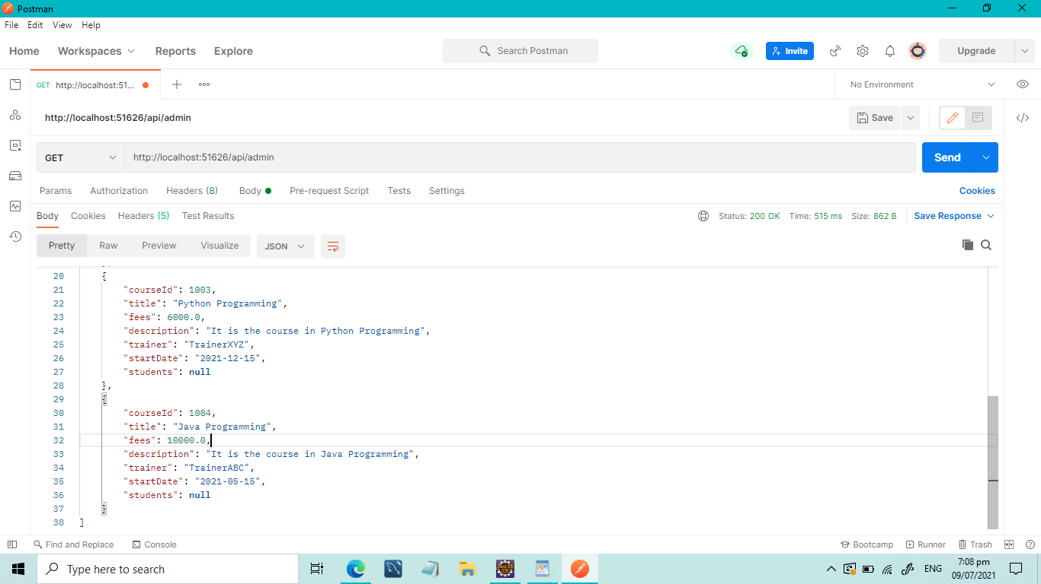

**ADMIN CONTROLLER (GET MAPPING):GET COURSE BY ID**

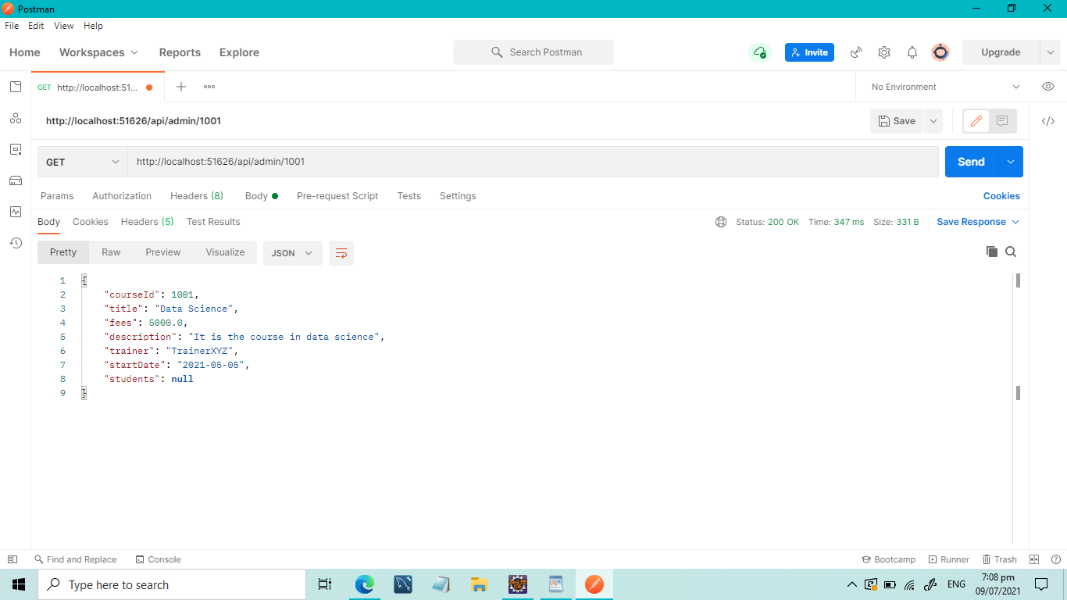

**STUDENT CONTROLLER(GET COURSES):**

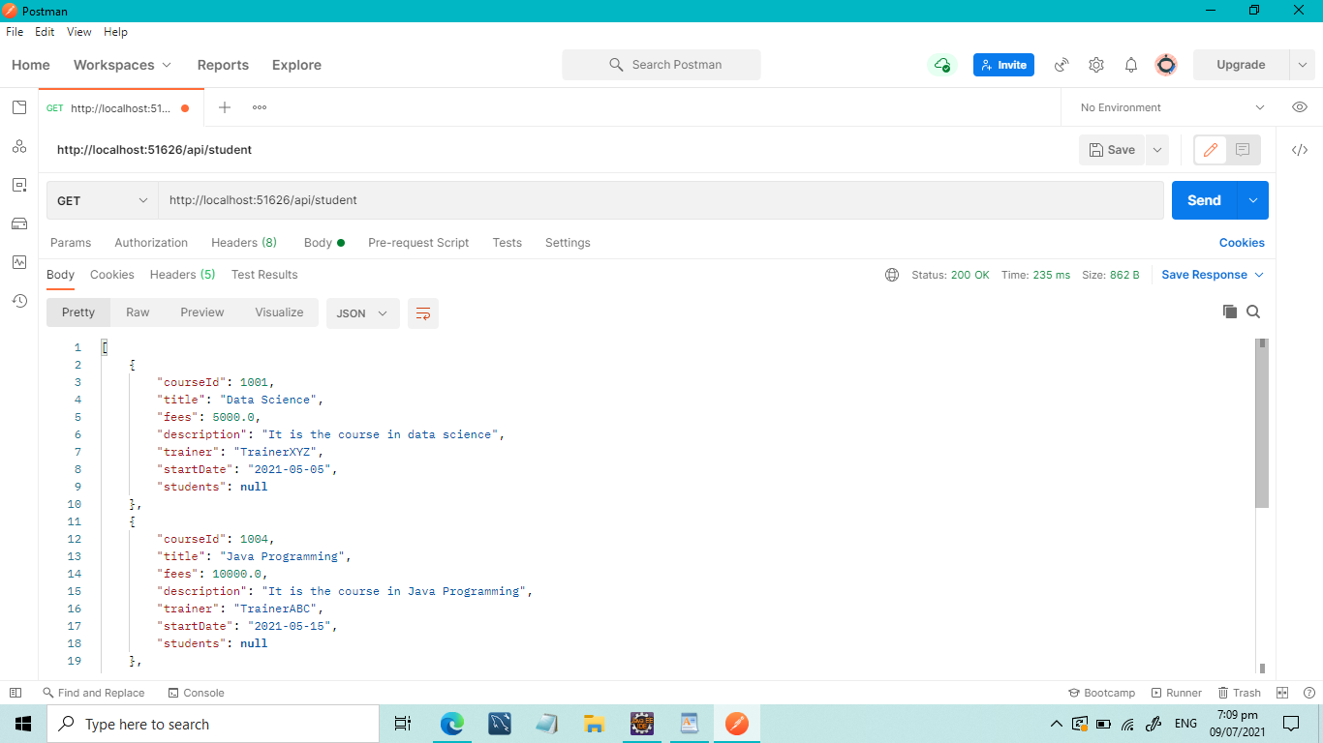

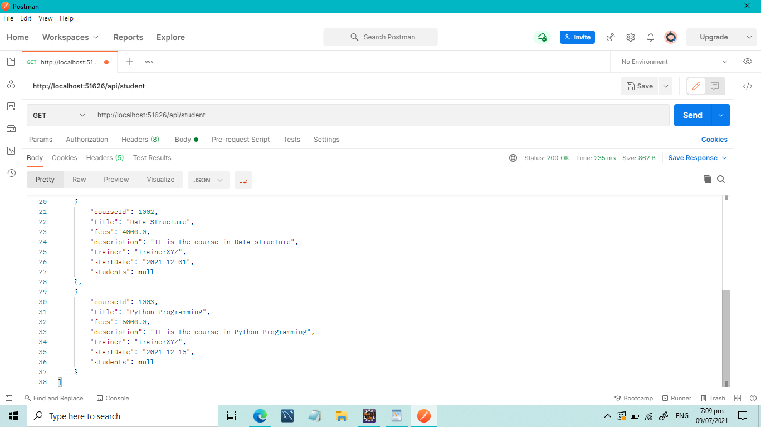

**STUDENT CONTROLLER (POST STUDENT DETAILS IN TABLE)**

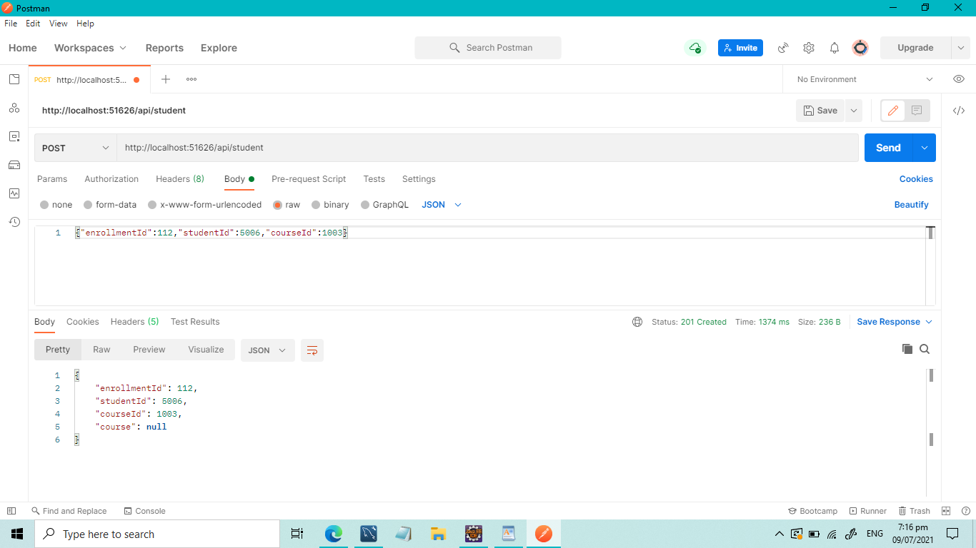

**SQL :BEFORE EXECUTING PREVIOUS STEP:**

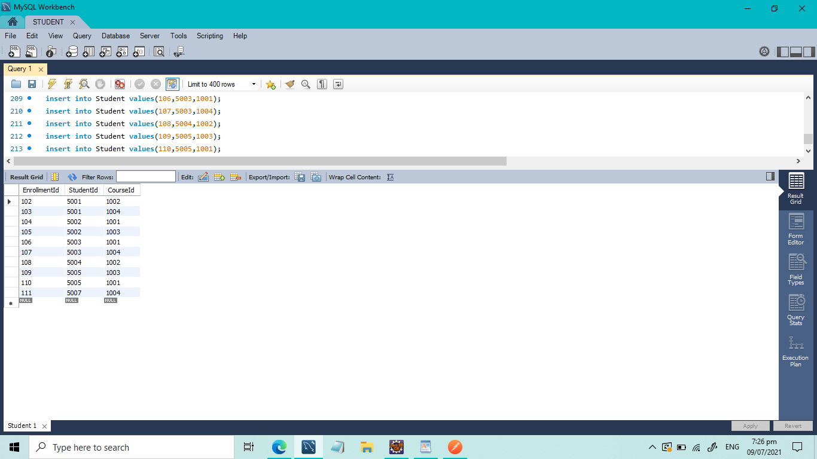

**SQL:AFTER POSTING STUDENT DETAILS:**

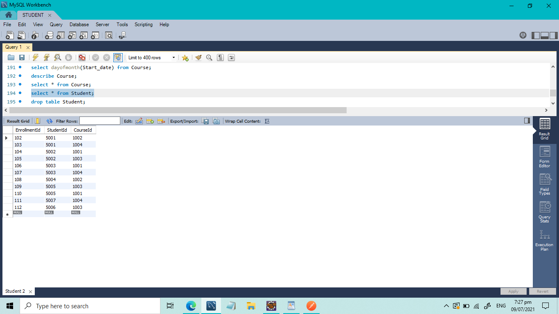

**STUDENT CONTROLLER:DELETING STUDENT RECORD BY ID:**

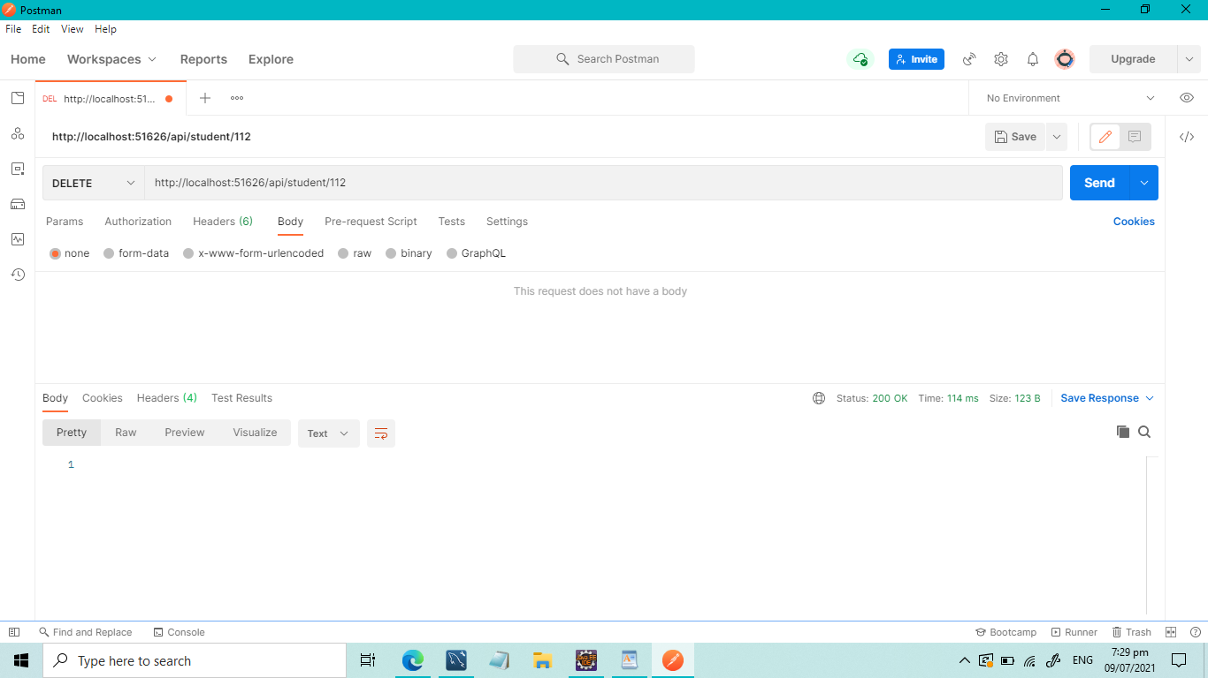

**SQL AFTER EXECUTING ABOVE STEP:**

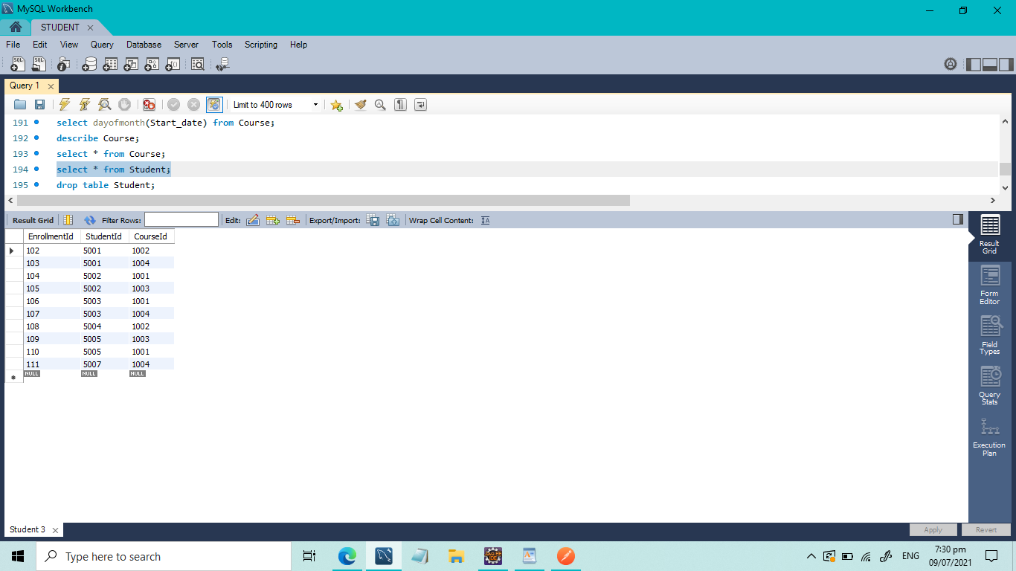

**TRAINER CONTROLLER :POSTING TRAINER ID:**

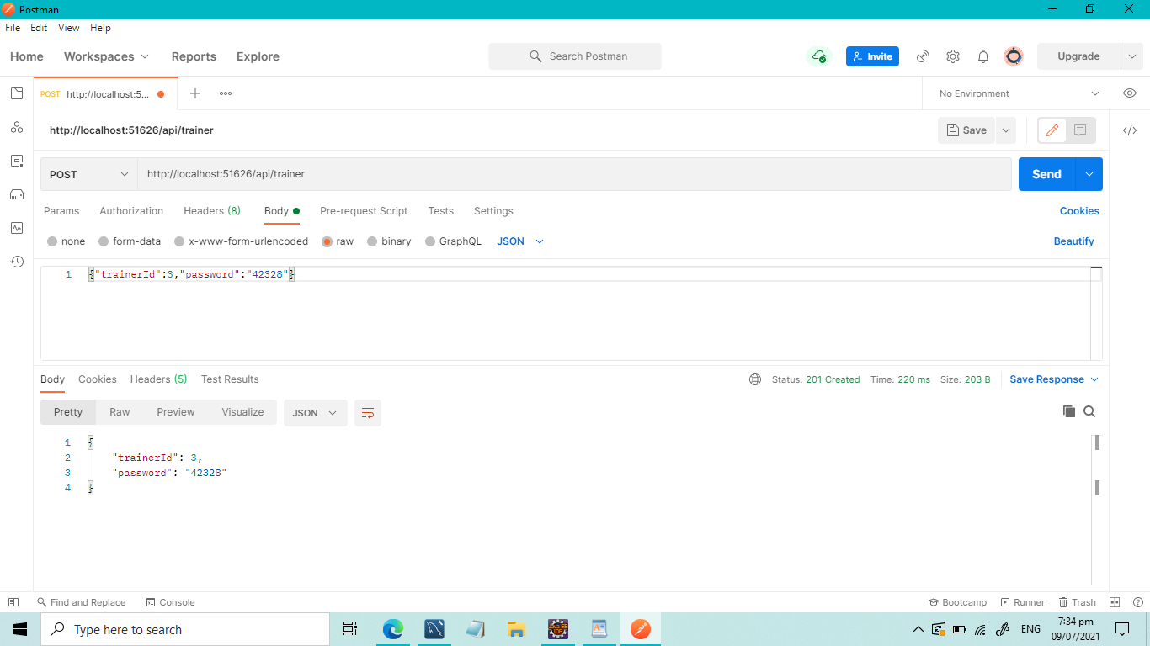

**SQL AFTER POSTING TRAINER DETAILS:**

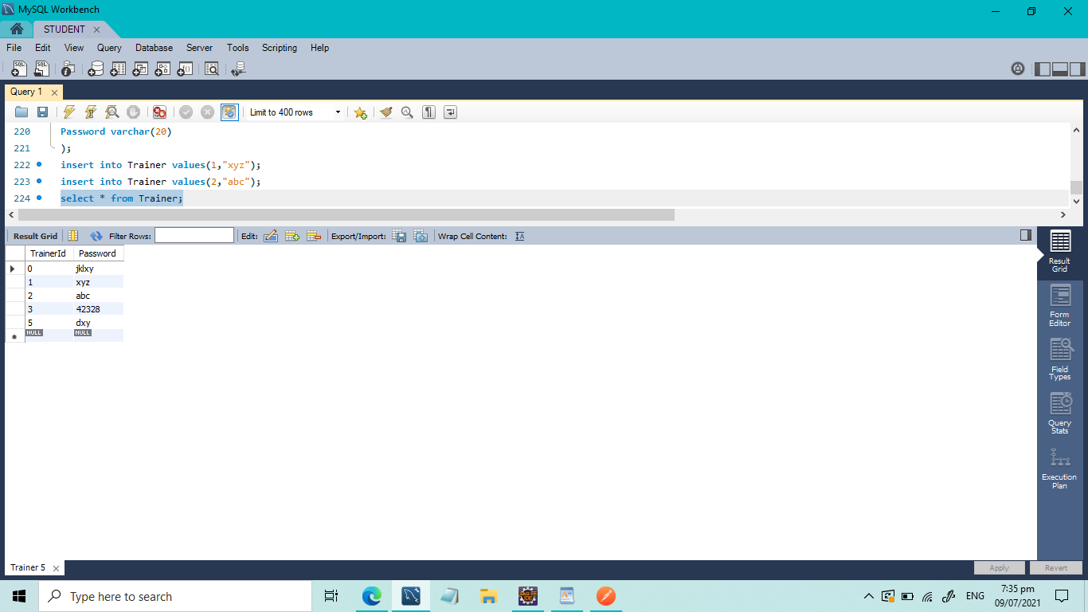

**TRAINER CONTROLLER :CHANGING PASSWORD USING PUT MAPPING:**

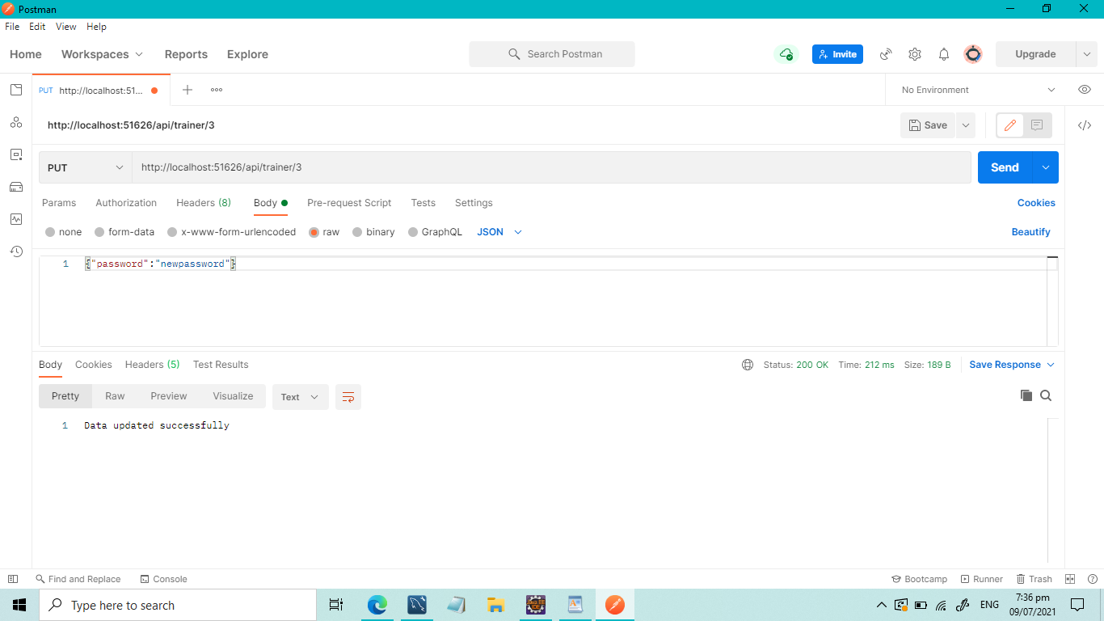

**SQL AFTER CHANGING THE PASSWORD FOR TRAINER ID 3:**

