Reverse KT Document

Thanks to all the members for parting their knowledge during the KT sessions
Anusha
Papulugari Rajitha
K Panimalar
TK Sushma
Sowmya

Soundarya K
Emp Id: 443606

Code preparation ----> first step

delivery through dmt and ftp
Create code_db where we need to paste db and code folder
Code_db will be uploaded to console.

if dmt
go to this pc-->cast share instance--->source code delivery ---> create folder called code db save all the folder that has been shared

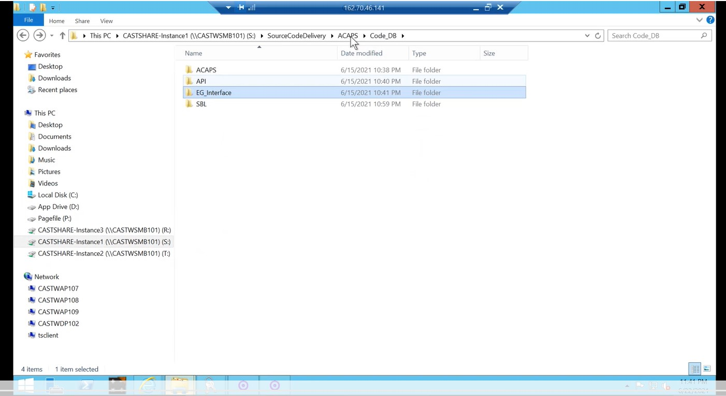
Through FTP:
If code delivered through ftp login to 70 server-d drive-castftps-groupinfracheck the names
If we don’t know the grp infra check in cup portal
Then copy and paste the code in source code delivery with app name .

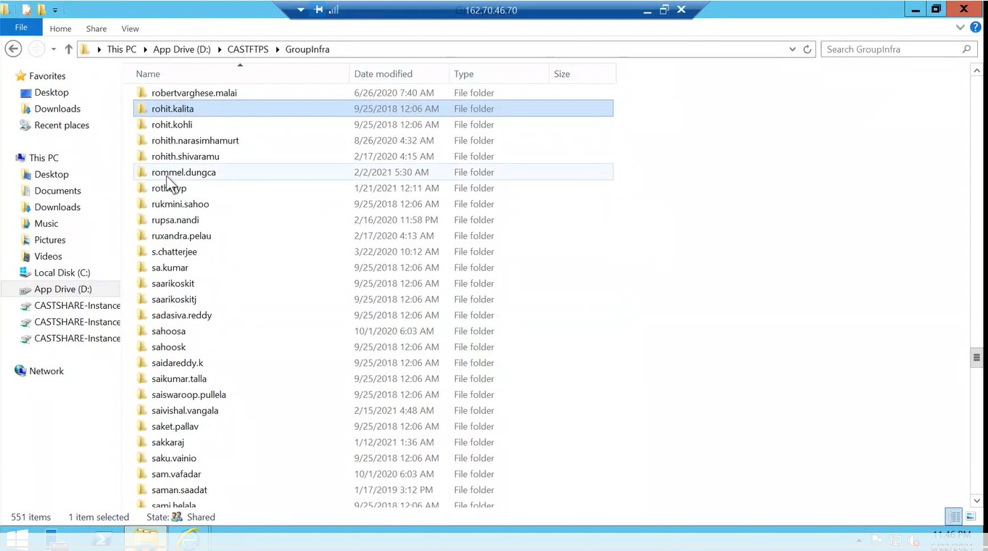

Cup portal-users-add/edit usrs-paste the email id of the user
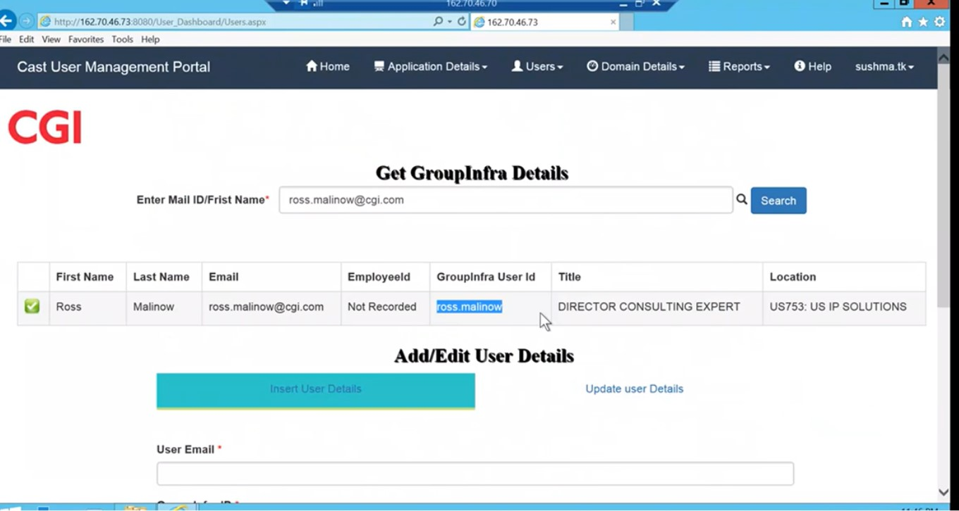

Code delivered through DMT :
Three drives AICP1,2,3
If aicp1- go to S drive- dmt delivery data folder-- copy index file to desktop to avoid data corruption
Inside index file check the app name
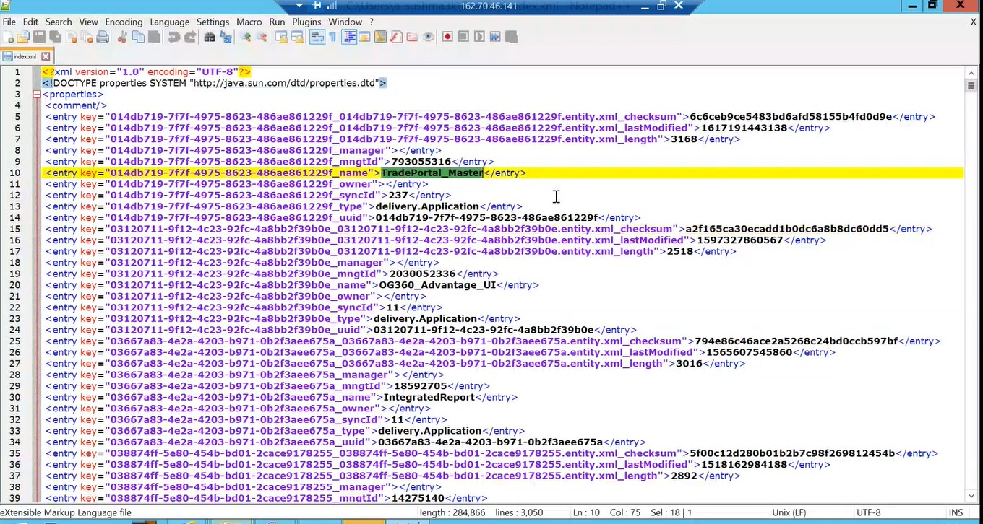

Copy paste app name in FIND and get the app ID
Copy the app id and find in dmt delivery-data folder

Right click and click edit with notepad++ in index file
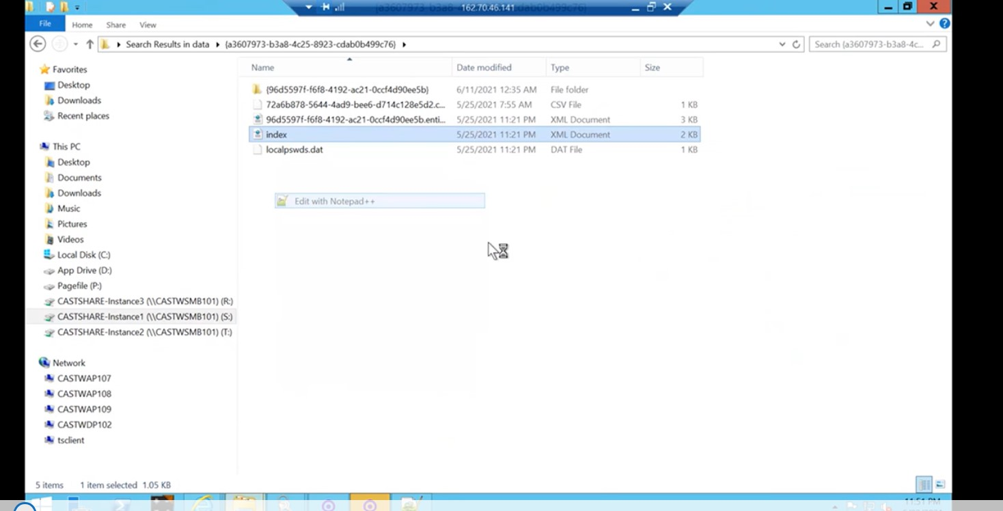
Check the version provided

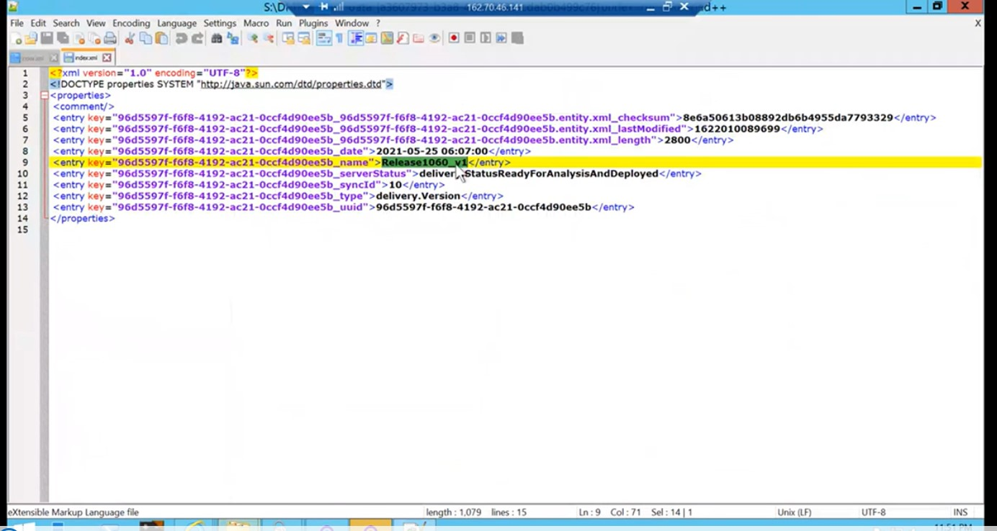

Click the another folder
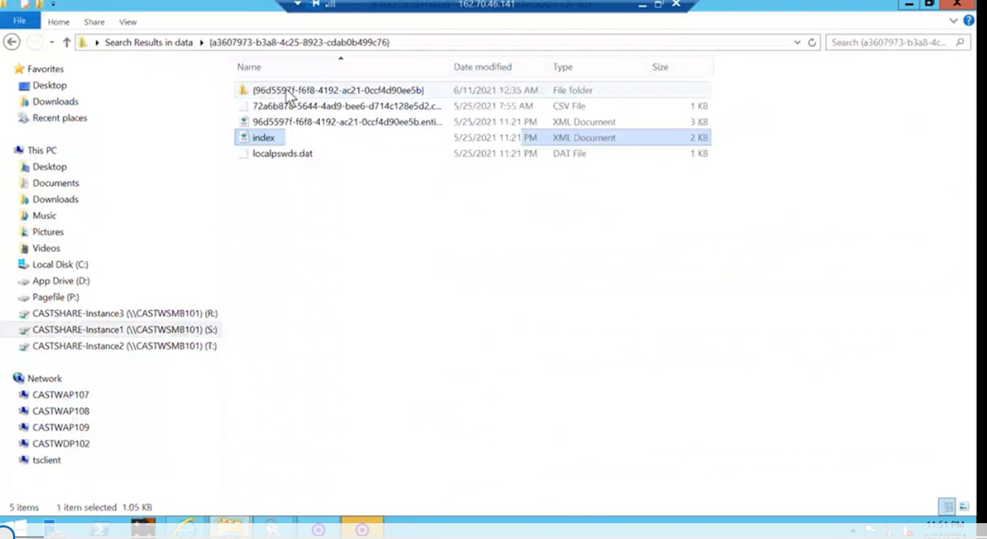

Inside that 2 folders r present to find the name of those two -click right index and edit with notepad++
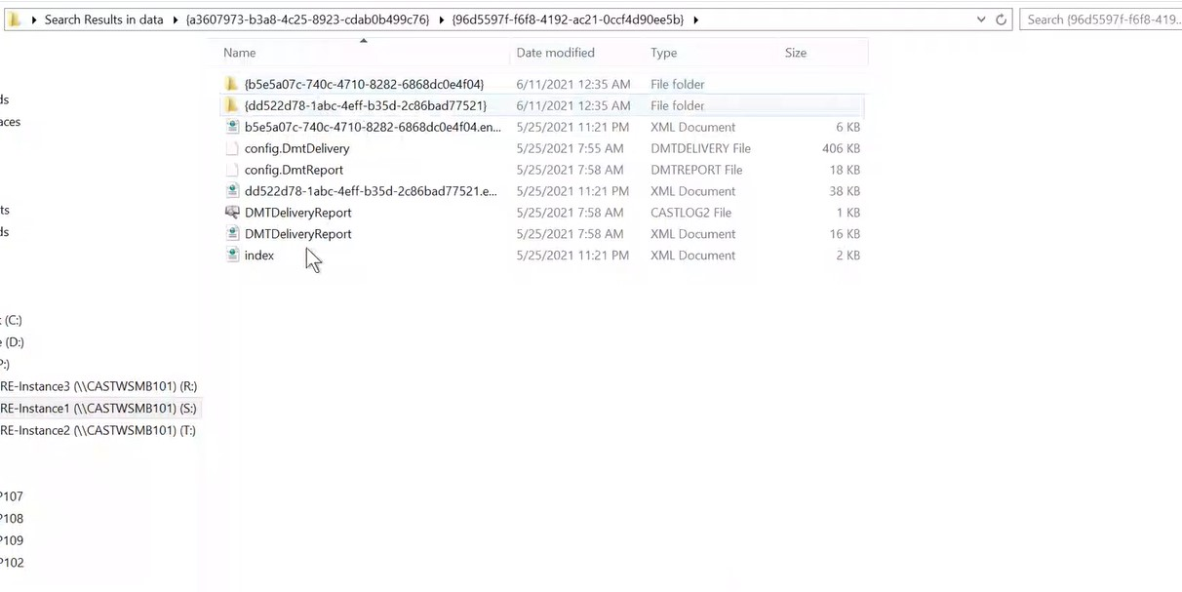

Check the db ID and search in the folder
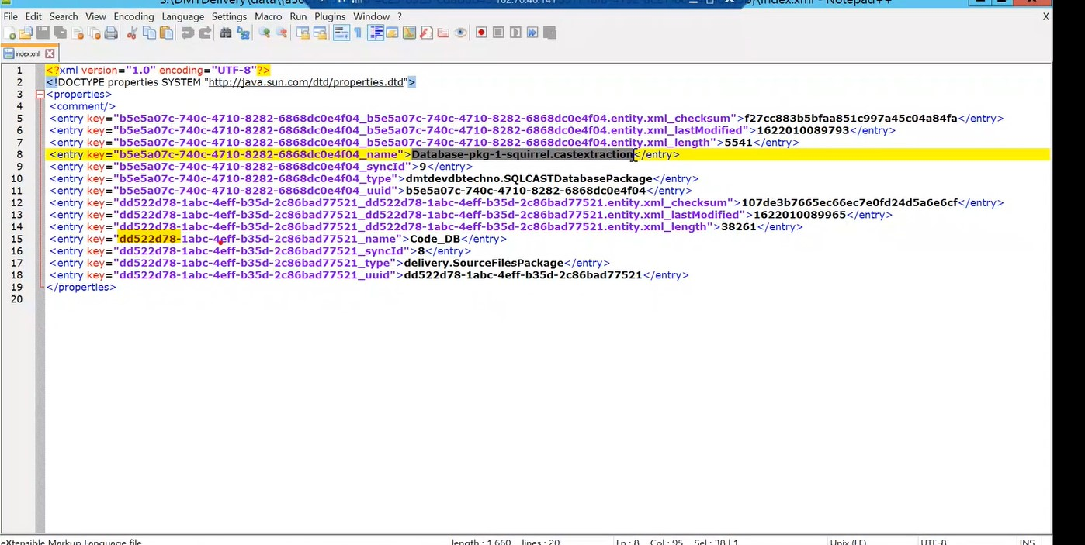
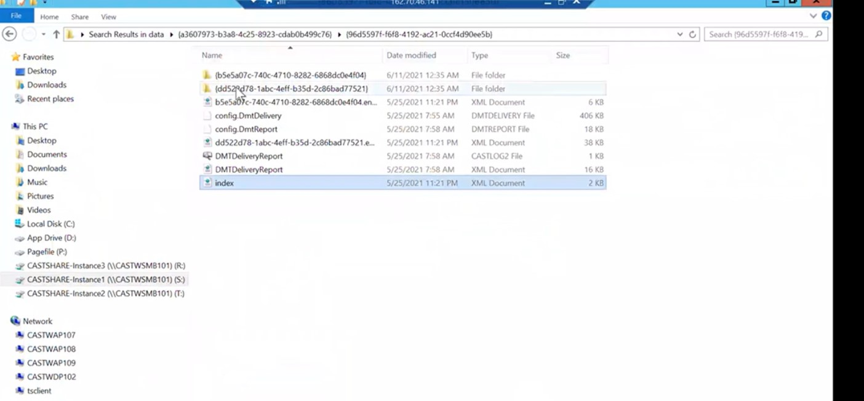

Inside the folder copy source_castsoursepackage and paste it in app folder created in S drive and extract it by creating a folder called original code

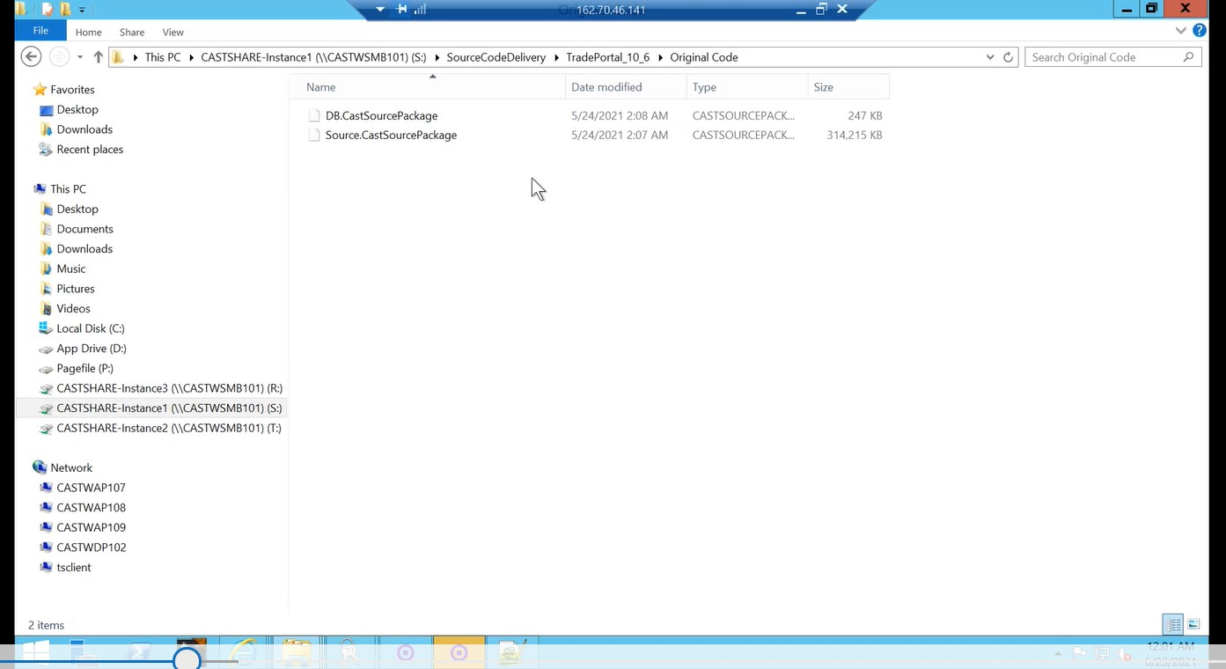

Right click on source_castsoursepackage--7zip-extract to sources
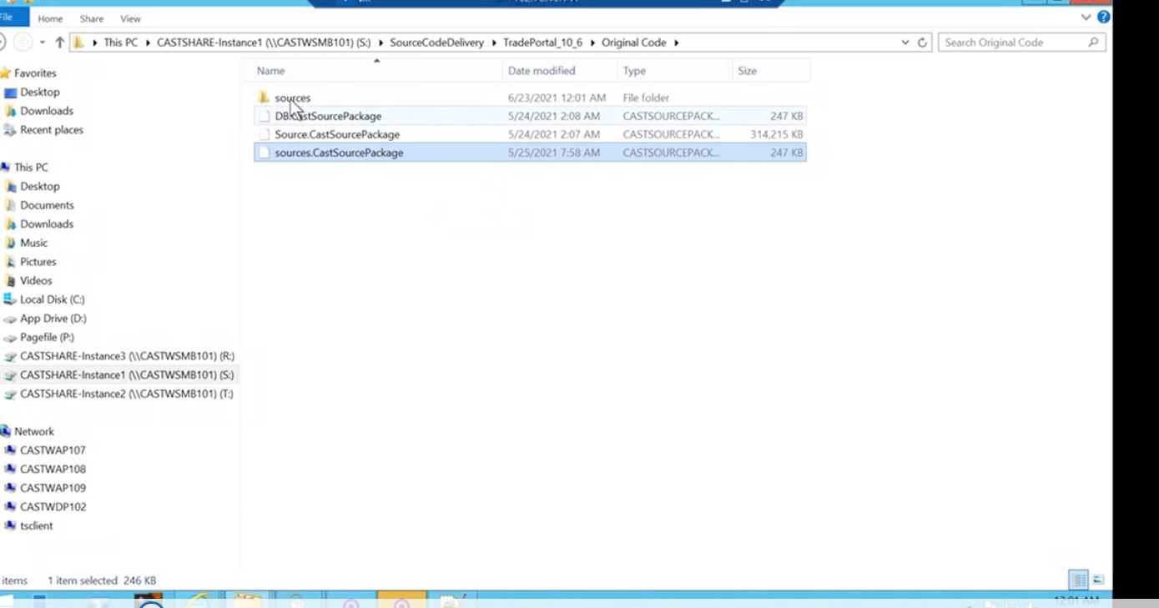
Click on sources click on either 1 or meta folder
1-for sourse
Meta-database

Copy and paste in code_db folder
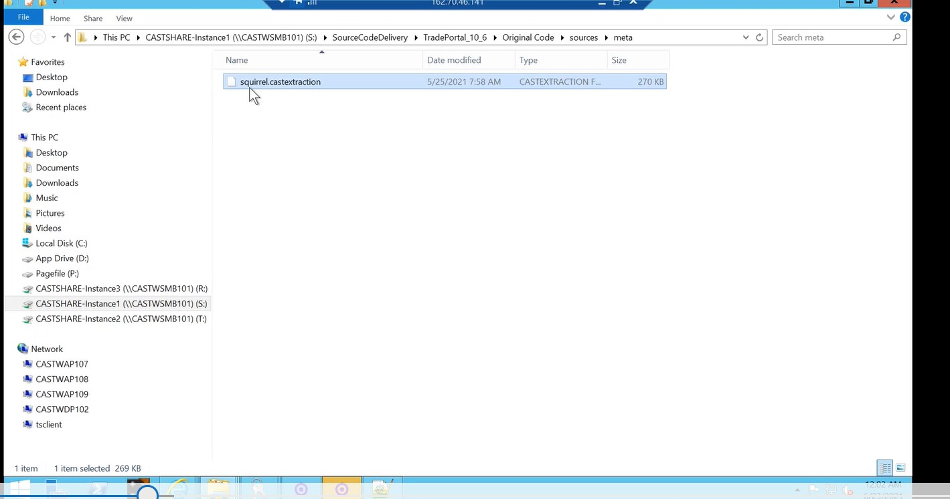

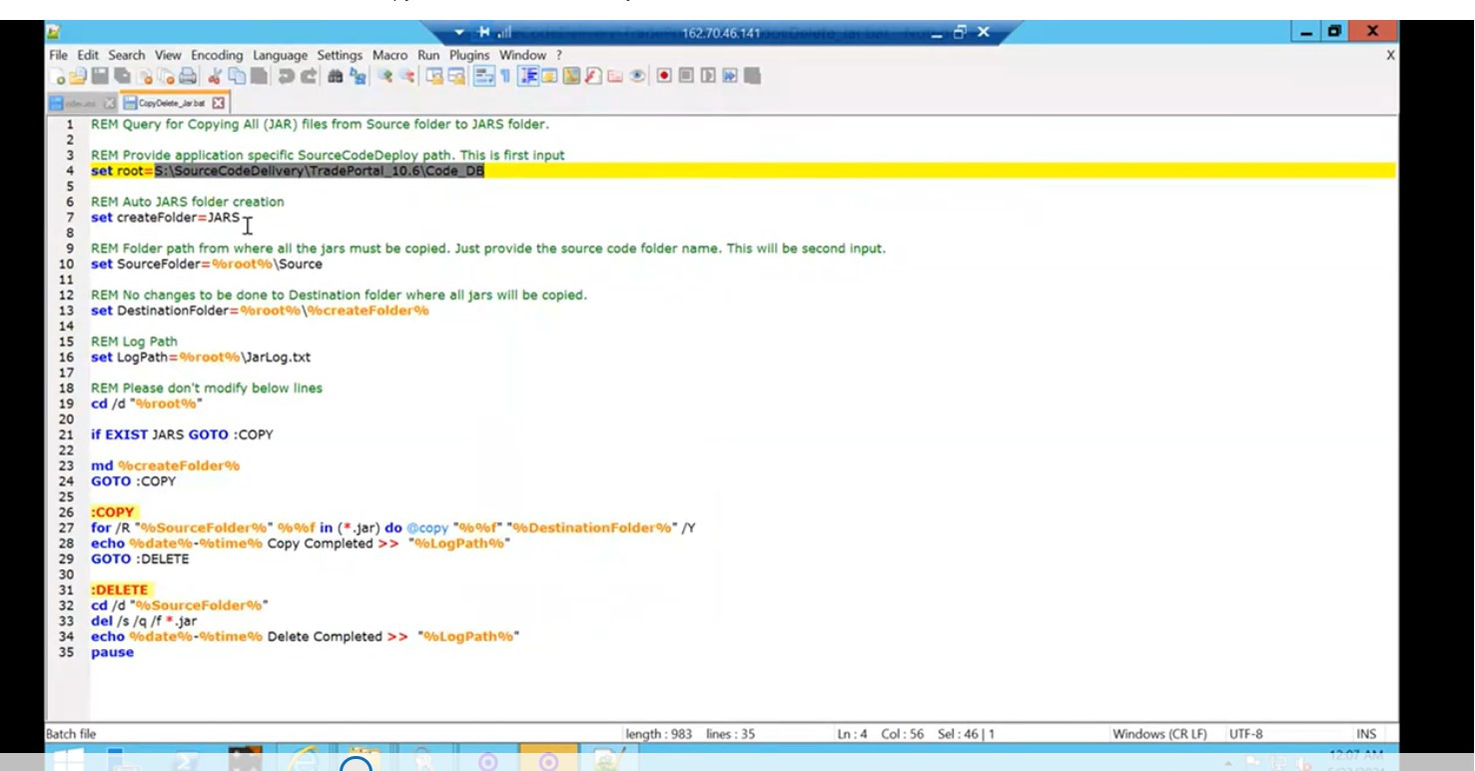

Introduction to CAST
CAST AIP is static source code analyzer for quality measurement of the source code. The quality measurement is based on weather the application code follows the industry standard rules defined in the CAST AIP. The Current Version of CAST AIP is 8.3.26.1.
With CAST AIP we can
- Calculate the code quality of an application
- Calculate the Function points of an application

3.Cast components

3.1.Server Manager
Server manager is used to for creating Schema's for the application
There are three schemas for an application
1.”local“ also known as Knowledge Base
2.”Mngt“ also known as CAST-MS Base
3.”Central“ also known as Central Base
3.2.Cast Management Studio(CMS)
CMS tool is the heart of CAST AIP application analysis process, the complete analysis of the application is done here. The functionalities that are done in CMS is
1.Adding new application
2.Accepting source code for delivery
3.Dependency management
4.Analysis configuration
5.Assesment model
6.User Input security
7.Analysis of application and publishing snapshot in health dashboard
Also rescan of an application is done in CMS

3.3.Enlighten
Enlighten is used for pictorially analyzing the application Transactions and validating them.
These transactions are links between the Application Layers from end point to end point.
3.4.Transaction Configuration Center(TCC)
TCC is used for configuring the transaction details in order to get the function point analysis of the application.
The following parameters of a transaction can be configured in TCC:
1.Entry point
2.End point
3.5.Extention Downloader
Extension downloader downloads the Plugins for Frameworks for a technology.
3.6.PostgreSQL
It is the Database to store Applications in the form of Schemas
SURVEY FORMS:
Filled by application team before source code delivery
Cast User Management Dashboard or Cast user Portal (CUP)
Users of the application and the application details collected from the survey form are stored and updated in the CAST User Portal for queries and future reference.
And also registering the application for administration purposes.
Used to:
1.Add/register application in the portal to maintain application information for reference
2.Add users in the portal to maintain user information to contact
3.Map dashboards to users

Steps in CUP
1.Click add/copy to Add users
2.Fill out Application details from survey form
- Fill out other details not mentioned in survey forms like
- Status – onboarding
- ADG Database – “central_schema_name”
- AICP – 1,2,3
- Port
- Database Server – DB1(142), DB2(148)
3.Add Users
- Click on user Tab
- Search for user in GroupInfra details and based on search results
- Add the user details
4.Mapping Users to Applications
Select users/Mapping users to Applicatons in CUP
Select the Application Name, User, Role
Select AAD access and AED access base on User roles
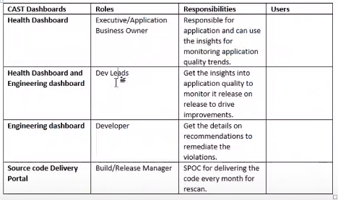

Step 2 : Code sanitization
- Run the above file
Give the code_db path in above filethen double click and run
- Go the code_db check for duplicate files

- In sql file -check the syntax
copy the code _db path -open notepad++-ctrl+f--provide the path
Check create table, create procedure or create index

*.* in code_db --- > groupby-typeright click collapse all grp

If we have JAR files
Right click copy delete jar and edit with notepad++- provide code_db path it will automatically copies and paste the jar files

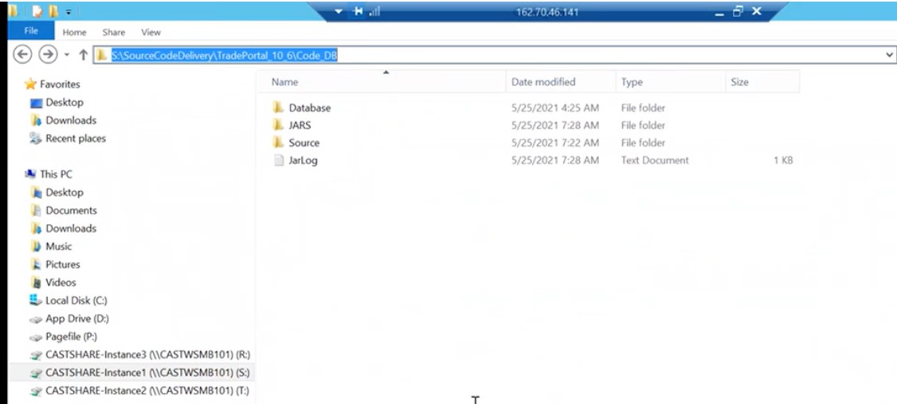

3) Adding application in aip console
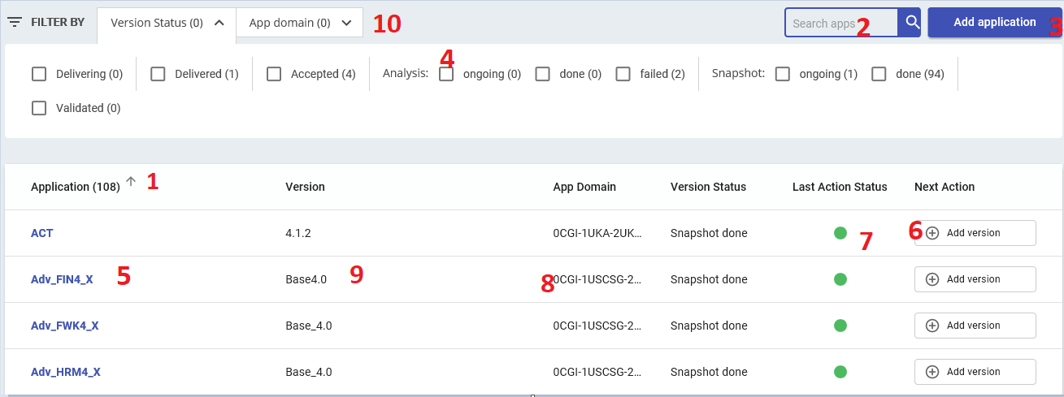
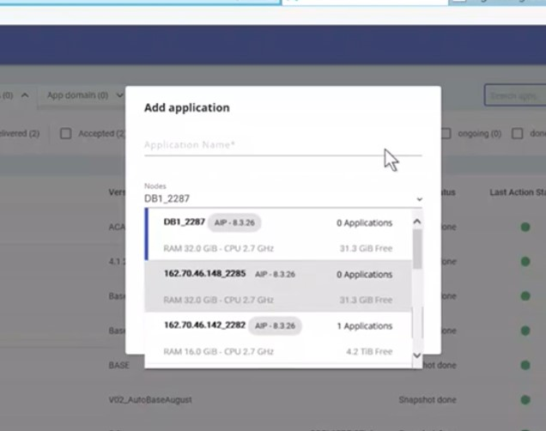

In Logs we can check the status of wht all we did
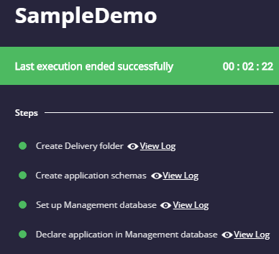

Adding version
-Step 1 form , related application
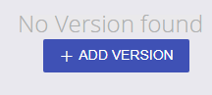
- add source code path (Code_DB)
- add version
- version date will be automatically updated
- Uncheck generate snapshot
- add exclusion rules use regex() if needed next
REGEX TO ADD IN AIP CONSOLE
^.*(.cache|.gif|.png|.pdf|.doc|.exe|thumbs.db|.ico|.otf|.txt|.ttf|.xlsx)$
^.*(.png|.jpg|.exe|.bat)$
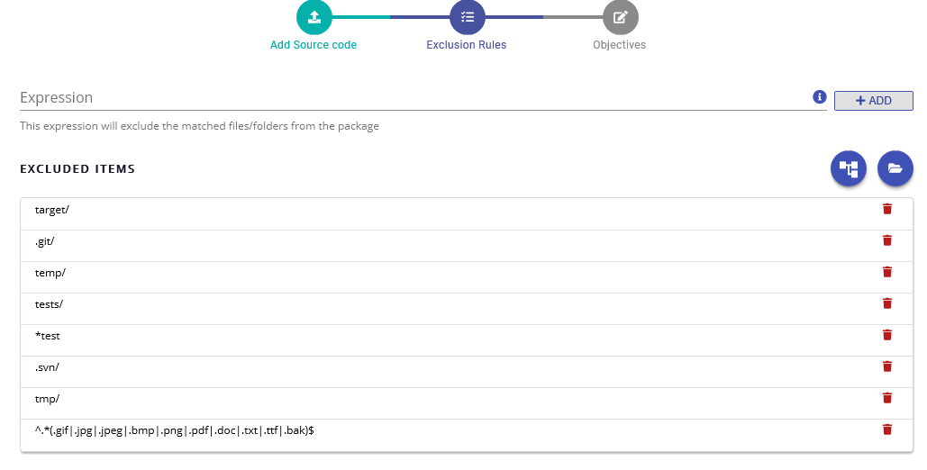
Version reports
When clicking on application version we can see the files in the application along with the alerts.
These are

- missing file references
- missing container references
- missing project references
- JAR alerts for Java application
If the mandatory references like java files, sql files are missing we need to send user the DMT alert report by running DMT alert report script.
DMT Alert report:
- Run DMT alert report from Delivery Manager Tool to generate the DMT alert report excel to send to user.
- After user updates code, add the new source by adding version
- Accept the version (will also accept delivery)
Adding extensions:
- Extensions are used for the analysis of the application. We have to add the extensions the version based on the technology.
- We add extensions and versions to the available extensions by using the confluence page for versions.
Confluence link:
https://proactionca.ent.cgi.com/confluence/login.action?os_destination=%2Fpages%2Fviewpage.action%3FspaceKey%3DCAST%26title%3DCAST%2BAIP%2BUniversal%2BAnalyzers&permissionViolation=true
- Also some mandatory extensions like TCC(transaction calibration KIT),8 mandatory (starts with FE)
- Also need to be added these are used for post analysis reports.
Importing version:
Go to version and import :
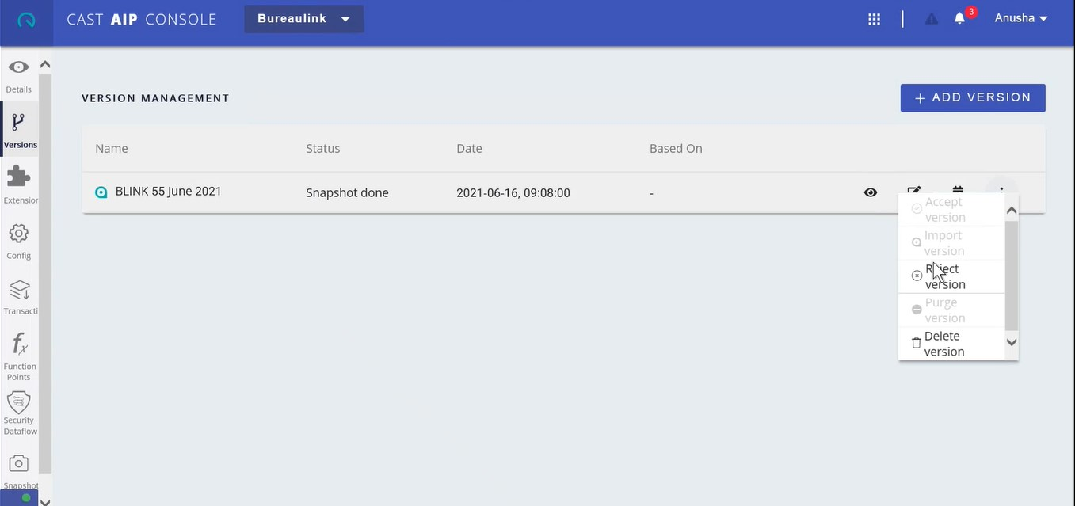
.Configuration
The configuration of the analysis is done under Configuration tab. It has several tab for each configuration.
Tabs:
Analysis
Here the technologies in the application are listed where we can add dependencies and analysis units for each technology. Dependencies and Analysis units are preconfigured here we need to validate and add them if required.
steps
Select technology(java,.net,..)
- Select dependency
- Add dependency if needed from all analysis units of java/.net to all analysis units of java/.net
along with java/.net to sql(DB)
- Check analysis units for repetitions and delete unnecessary analysis units
Select Univeral Technology
- Select dependency
- add dependency in the flow FrontEnd(HTML) to JAVA/.NET
Analysis (for java)- from .pom or .project (if dotnet)-.csproj
Select technology(java)
- class path
- Class root folder set path to Code_DB Folder
- Archive folder select path to JARS Folder
- versions remain same
Frameworks
- look for frameworks used in code
- search in notepad++ using the keys "spring, hibernate ..." (found in pom.xml)
- if the keys and versions are available select the version.
- if wsdl/wsdd files are present select "Axis WSDD.java"
Duplicates can be removed by checking the path if 2 analysis units has same path
Click on the analysis unit -- main file-- copy the path and search in and check for the availability of java files
Under Classpath definition- if source_db is not available click + and add as root folder add the connect package
Similarly for archieve folder add jars
Similarly confirm the technologies used by searching in notepad++ : 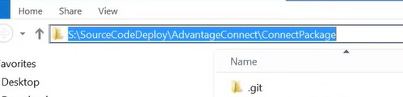
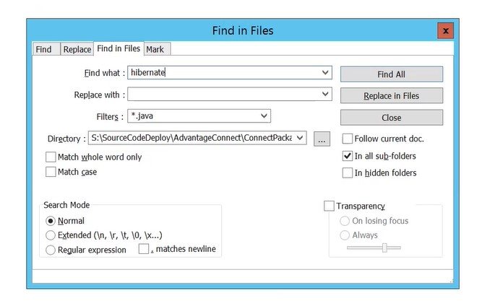
Check for webservices in overview tab and added it if its used
In dependencies add jave to sql if not added
FOR DOTNET: only dependency needs to be added if Html5 is used add ua to all analysis unit
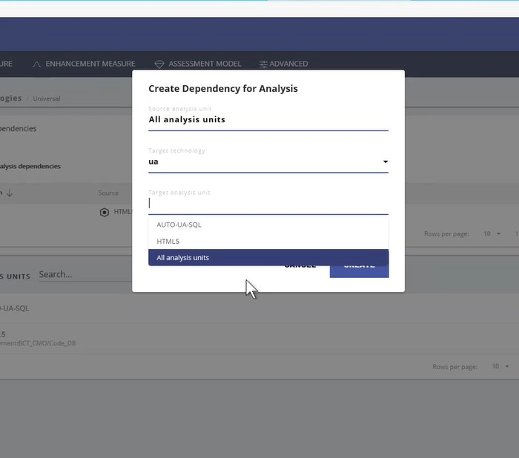

Module
Here we have to add module for source code and DB
select none(Manual creation) in type and click (+) add module
a.Source code module:
- Give module name as SourceCode
- add source code analysis units
- create
b.DB module:
- Give module name as DB
- add DB analysis units
- create
Enhancement Measure
It is a tab for the objectives selected, do not change it
Assesment model
For configuration of assessment model we need to open CMS

Post Analysis Activities:
step1.
Check log for warnings and errors, errors are not accepted at all.

12.1. Consistency check
Here we check weather all the files delivered are analyzed or not by comparing between source code delivered, sorce code deployed.
done in two ways
1.Compare the count of files between delivered files(file explorer) and postgres (PGAdmin)
2.Completeness report
We can download completeness report from AIP console.
Go to details/overview/reports and download FERV Result Validation report, completeness report.
If there is a mismatch between Analysis report (postgres) and deploy/DMT we need to justify why they are not included. See the un-analyzed files from result validation report and find what type of files are un-analyzed.

Peer Review Documents
We have to Create the following 4 documents to submit for the peer review
1.completeness_report_AppName.xlsx
2.CGI_CAST_onboarding_checklist_AppName.xlsx
3.Consistency Check Between Analysis Input andOutput.xlsx
4.Result Validation Report

Create consistency check b/w Analysis Input and Output document
1. Getting Screen shots from DMT
- open DMT tool from CMS (click truck icon on delivery Accepted version window)
- In DMT go to packages Files on your local system
- take screen shots with snipping tool
- put it under "DMT-" heading

2. Creating source code deploy excel
- go to source code deploy folder/code_DB/App_Name
- open cmd and run
dir /a:a/s/b/o:n >listFiles.csv
- this will create listFiles.csv file
- copy this file and open it with excel on your local machine
- in excel
- Name first column as "Files Deployed", second column as "File Extension" by inserting new row
- put this in the next cell of file name
=RIGHT(A2,LEN(A2)-FIND("|",SUBSTITUTE(A2,".","|",LEN(A2)-LEN(SUBSTITUTE(A2,".","")))))
- go to insert and new pivot table (select new sheet)
- drag and drop Files deployed in Rows and (In the left pane) File Extension on values
- put it under "Deploy-" heading

3. Getting Screen shot from Postgres, put it under "Postgres-" heading

- login to CAST DB server (142 | 148) //99 in india server
- Open PG Admin from C:drive/ProgramFiles/Cast/CastStorageService3/PGAdmin4/Runtime/PGAdmin4
- Create Server
- General CSS_2281
- Connection Give Host Address, Port, User_Name, Pwd
- Go to port/database/postgres/schemas/App_Name_local
- right click on App_Name_local and select Querry Tool
- and run the below querry
set search_path=<local schema name>;
select substring(p.path from '\.([a-z]+)$') ext, count(*) from (select distinct path from RefPath where path like '%SourceCodeDeploy%') p group by ext;
- take a screenshot of the ouput

Review Dynamic Links
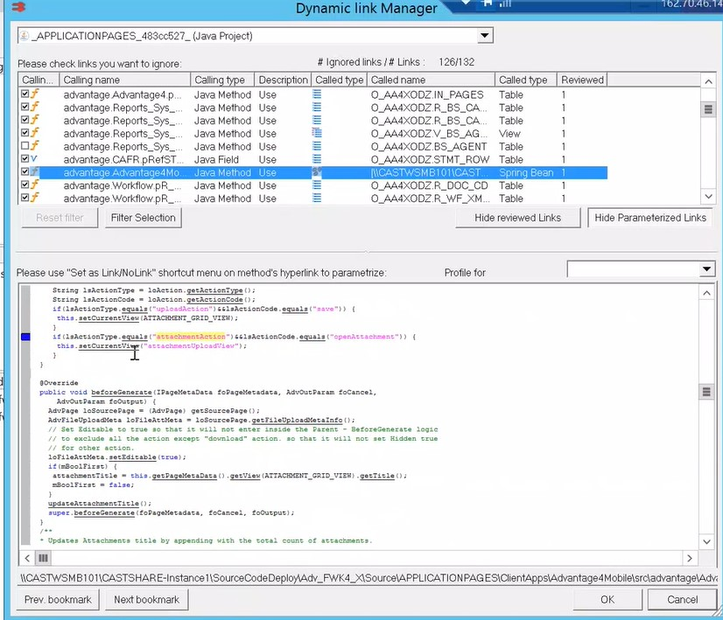
Automated Process:
S drive-- Share Folder --- DLM Configuration--XML Document
To get the caller and calling type execute the query in postgres
set search_path = fom_local;
select * from ctv_object_types where type_description like '%'
Generates caller and calling type :
Raw string declaration:
12.3. TCC
TCC stands for Transaction Configuration Center. TCC is used for configuring the details of transactions.
These are
1.Configuring the entry points
2.Configuring the end points
Function points or Functional size :
Function points is the number of functionality implemented in the application. The Artifacts (objects) in valid transactions contribute to the Function points of the application.
Definitions related to TCC:
Function points are mainly two types
1.Automated function points - functional size of current analysis
2.Enhanced Function points - functional size relative to previous and current versions

Transactions are of two types -
1.Transaction Function - architechtural flow from entry point to end point(ui to DB).
2.Data function - objects in the data base (tables).

Entry point:
It is the entry of dataflow in the application.
For web application the entry point is the "UI files" and for Stand alone Application the entry point is "Web services or a Business Class File".
Configuring Entry point:
Some of the entry points can be diselected as they are unecessary like (header,footer in JSP)

End point:
It is the last object that is called in a transaction. Generally End points are database object like tables and out of the application calls like web calls.

Note: Sometimes based on the requirement we have assign the persistence layer as end points when the data base tables cannot be part of the application source code.

Note : while configuring end point set contribution to 1 for valid end point
Note: In JSP
always prefer HTML JSP files over Efile

12.4. Enlighten
It is a tool for impact analysis, tracing the transactions in the application, validating the transactions.
It allows us to view a pictorial representation of the dynamic links between the objects in the application.
Functions of Enlighten:
Impact Analysis:
It is finding out what a missed link in a transaction does to the transaction flow.
Tracing out transactions
Analyzing the impact of reviewed DLM’s on TCC i.e. transactions.
Note: All CAST sub tools TCC, Enlighten ... are connected through the management (mngt) schema.
Transaction: the link or path from entry point (UI) to end point (DB | external_link )

Enlighten navigation and shortcuts :
1.Edit/find object in Knowledgebase opens search window (ctrl+Shift+F)
2.search for the object by its name + right click on object + view adds object to the work space
3.F12 get code information of the object
4.F11 get object information of the object
5.Ctrl+B locate object in object browser

Steps in Enlighten:
- We open the Enlighten once we have noted down the valid and invalid transaction functions from TCC.
- We note the name of Endpoint object name (table) or Entry point object name from the invalid transactions
- Search the object in Knowledge base and put in your view
- Pull the called or calling object into the view to form the transaction

12.5. SMELL TEST
There Are Five factors to test for smell test
1.Artifact Coverage
2.DLM Review
3.Emty Transaction ratio
4.FP to Class Ratio
5.Transaction KIT applied
To pass the smell test all the query results from PGAdmin should give green

Results Publishing:
Publishing Results to Engineering Dashboard (AED consolidation)
- Go to 160.70.46.68 server

- Go to C:drive/ProgramFiles/Apache Software Foundation/Tomcat8.5_Tomcat8_Engineering<X> (x= 1,2,3 based on aplication is in AICP1,AICP2,AICP3 respectively)
- ... /webaps/CAST-Engineering<X>/WEB-INF/domains.properties
- edit the file domains.properties file with notepad ++
- enter new line and make new entry
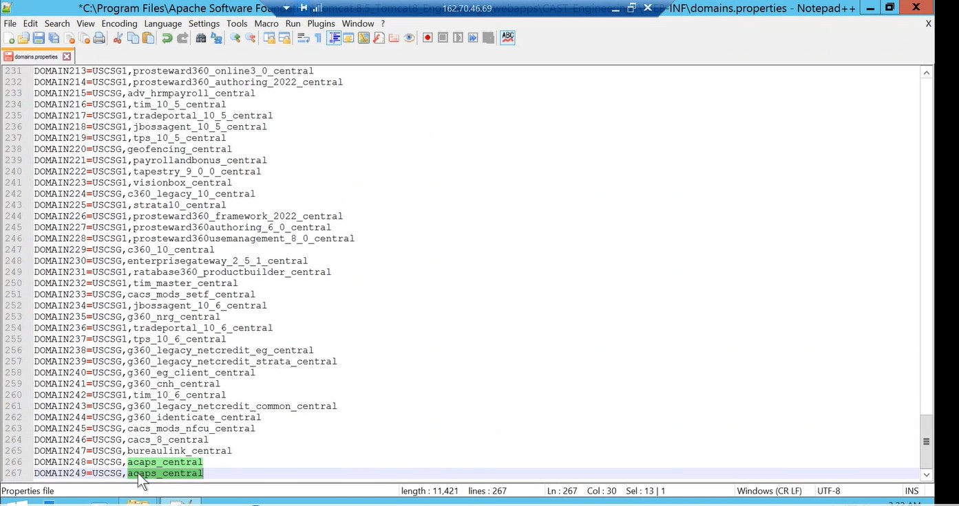
- "SL.NO DOMAIN<APP_NO>=<DOMAIN_NAME>,<APP_NAME>"

- Eg: 201 DOMAIN200=USCSG,myjavaapp

- Here DOMAIN_NAME is the country name like USCSG
- Save the file

- Go to 160.70.46.69 server
- Go to C:drive/ProgramFiles/Apache Software Foundation/Tomcat8.5_Tomcat8_Engineering<X> (x= 1,2,3 based on aplication is in AICP1,AICP2,AICP3 respectively)
- ... /webaps/CAST-Engineering<X>/WEB-INF/domains.properties
- edit the file domains.properties file with notepad ++
- enter new line and make new entry
- "SL.NO DOMAIN<APP_NO>=<DOMAIN_NAME>,<APP_NAME>"
And finally save the file, when the AED and AAD servers restart the dashboards will add the applications.
- Go to C:drive/ProgramFiles/Apache Software Foundation/Tomcat8.5_Tomcat8_Engineering<X> (x= 1,2,3 based on aplication is in AICP1,AICP2,AICP3 respectively)
... /webaps/CAST-Engineering<X>/meta-inf/context

Action Plan
Action plan is given to the user in order to improve the code quality health factors.
Steps for Action plan
- Go back Production server
- Open Action Plan Optimizer tool from the server
- C:drive/programfiles/cast/8.3/cast-actionplanoptimizer
- open Application
- Go to Detailed Simulation tab
Note: if score is greater than 3 no need to give action plan, the simulation grades must always be greater than original grade.
Education plan

- open engineering dashboard
- Click on action plans tile
- identify the rules and items
- click educate button for each item
- enter comment as continuous improvement
- select complexity = HIGH
- click educate symbol

BACKUP
CHECKLIST:
All peer- review documents
S-share-onboardingappchecklistsave with peer review document.

Application Backup
- get the entire code (Code_DB) folder from source code deploy folder and AdvisorExperience_AX
- Go to S:drive/share/rescan backup
- select folder(148 or 142) based on application/port
- and create folder with version name inside that create two folders"Code" and “Schema”
- put code in CODE folder
SCHEMA:
CONSOLE
Admin centerview details-backup
Go to the respective server
D\NODE\AIPNODE or AIPNODE2\DATA--BACKUP
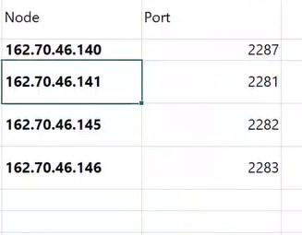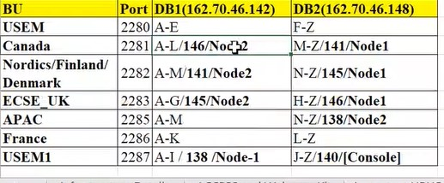
POSTGRES
- got to 148 server
- open PGadmin4 tool
- select the server and port of the application by providing password "CastAIP"
- select databases/postgres/schemas/
- select each of the Schema(central , mngt , local) rightclick and back up
- provide the path as Backup folder path/schemaname.backup
- S:/share/Rescan_Backup/<AppName>/<V1.0>/<Schema>/<Appname_local.backup>
- select format as Tar
- click backup
Action plan backup:
Create a folder with application name in sshare-actionplanstimulator
Go to ccast-8.3-actionplanoptimiser
TCC Backup:
Create a folder
SshareTCC-BACKUP
Q&A SESSION IN KT:
- Method to identify Technology in AIP Console: Security data flow
- Use of CSV: To Update and to get results of view
- Use of Importing Assessment: when any changes done in assessment model(rules) we need to import the assessment to get all the rules reflected.
- Adding job in CMS: Click add new cast knowledge base
- Use of CUP: Used for getting details and giving access to users

