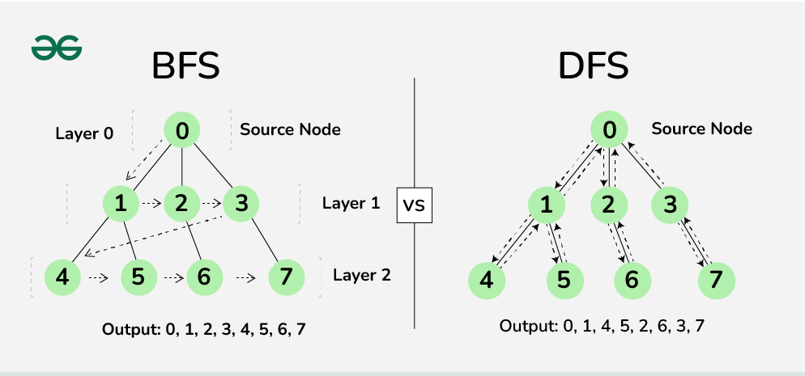
DFS:
def dfs(graph, start):
# Initialize the stack with the starting node
stack = [start]
visited = set() # To keep track of visited nodes

while stack:
# Pop a node from the stack
node = stack.pop()

# If the node has not been visited
if node not in visited:
visited.add(node) # Mark it as visited
print(node, end=" ") # Process the node (just print it)

# Add all unvisited neighbors to the stack
for neighbor in graph[node]:
if neighbor not in visited:
stack.append(neighbor)

# Example usage:
graph = {
0: [1, 2],
1: [0, 3, 4],
2: [0, 5],
3: [1],
4: [1],
5: [2]
}

# Start DFS from node 0
dfs(graph, 0)

THE GRAPH IS:
0

1 2

3 4 5

OUTPUT:
0 2 5 1 4 3

BFS:
from collections import deque

def bfs(graph, start):
# Initialize the queue with the starting node
queue = deque([start])
visited = set() # To keep track of visited nodes

while queue:
# Dequeue a node from the front of the queue
node = queue.popleft()

# If the node has not been visited
if node not in visited:
visited.add(node) # Mark it as visited
print(node, end=" ") # (here we just print it)

# Add all unvisited neighbors to the queue
for neighbor in graph[node]:
if neighbor not in visited:
queue.append(neighbor)

# Example usage:
graph = {
0: [1, 2],
1: [0, 3, 4],
2: [0, 5],
3: [1],
4: [1],
5: [2]
}

# Start BFS from node 0
bfs(graph, 0)

THE GRAPH IS:
0
1 2

3 4 5

OUTPUT:
0 1 2 3 4 5

Parameter | DFS | BFS
Data Structure | Stack | Queue
Approach | begins at the root node and proceeds through the nodes as far as possible until we reach the node with no unvisited nearby nodes. | first walk through all nodes on the same level before moving on to the next level.
Conceptual Difference | builds the tree sub-tree by sub-tree. | builds the tree level by level.
Concept used | LIFO (Last In First Out). | FIFO (First In First Out)
Suitable when | solutions away from source. | searching vertices closer to the given source.
Applications | 1.Pathfinding and Navigation  2.Game AI(Chess or Tic-Tac-Toe)  3.Topological Sorting  4.solve constraint satisfaction problems like the N-Queens problem, Sudoku, and puzzles  5.Artificial Neural Networks  6.Web Crawlers | 1.Shortest Path Algorithms  2.Social Network Analysis  3.Search and Recommendation Systems  4.Web Crawlers  5.Network Broadcasting  6.Tree Traversal

Why we use stack in DFS?
The most recently added node is the first to be explored. In DFS, this is crucial because it allows the algorithm to explore as deep as possible down one branch before backtracking to explore other branches.

Why we use stack in BFS?
The nodes that are added first will be explored first. BFS requires this order because it explores all nodes at the present depth level before moving on to the nodes at the next level.

