Soundbite Teams App Deployment

# Download the Teams Application Package

Before you can deploy the Soundbite Teams App, you will need to acquire the solution package. This package is a zip file that can be found at our GitHub site:

<https://github.com/Soundbite-ai/api>

Please navigate to the site, look for the section titled Microsoft Teams App, and download the appropriate version of the Soundbite Teams App package. If you need help determining the appropriate version and environment, please contact support.

**Helpful Tip**: Please make sure to save the package file to a location on your computer that you can easily find later. Alternatively, you can save it to a location that is difficult to find, but that will make things more difficult later on when you need to find it.

# Upload Soundbite Teams App Package to Your Teams Store

You must upload the Soundbite Teams App package to your Teams Store to make it available to users. To do this, navigate to your [Microsoft Teams Administration Center](https://admin.teams.microsoft.com/dashboard). On the left-hand navigation menu, you should see an option for **Teams Apps**. Click to expand this menu item. You should then see a child item named **Manage Apps**. Click on the **Manage Apps** menu item.

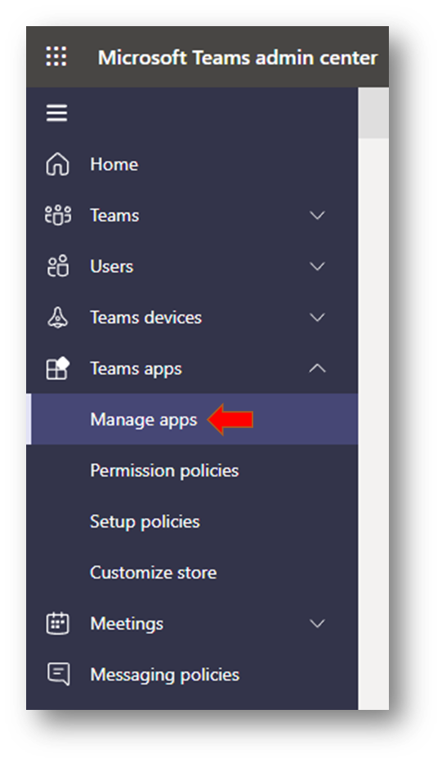

This should take you to the Manage App screen that shows you all the application that are available to your organization. On this screen, click the **Upload** button.

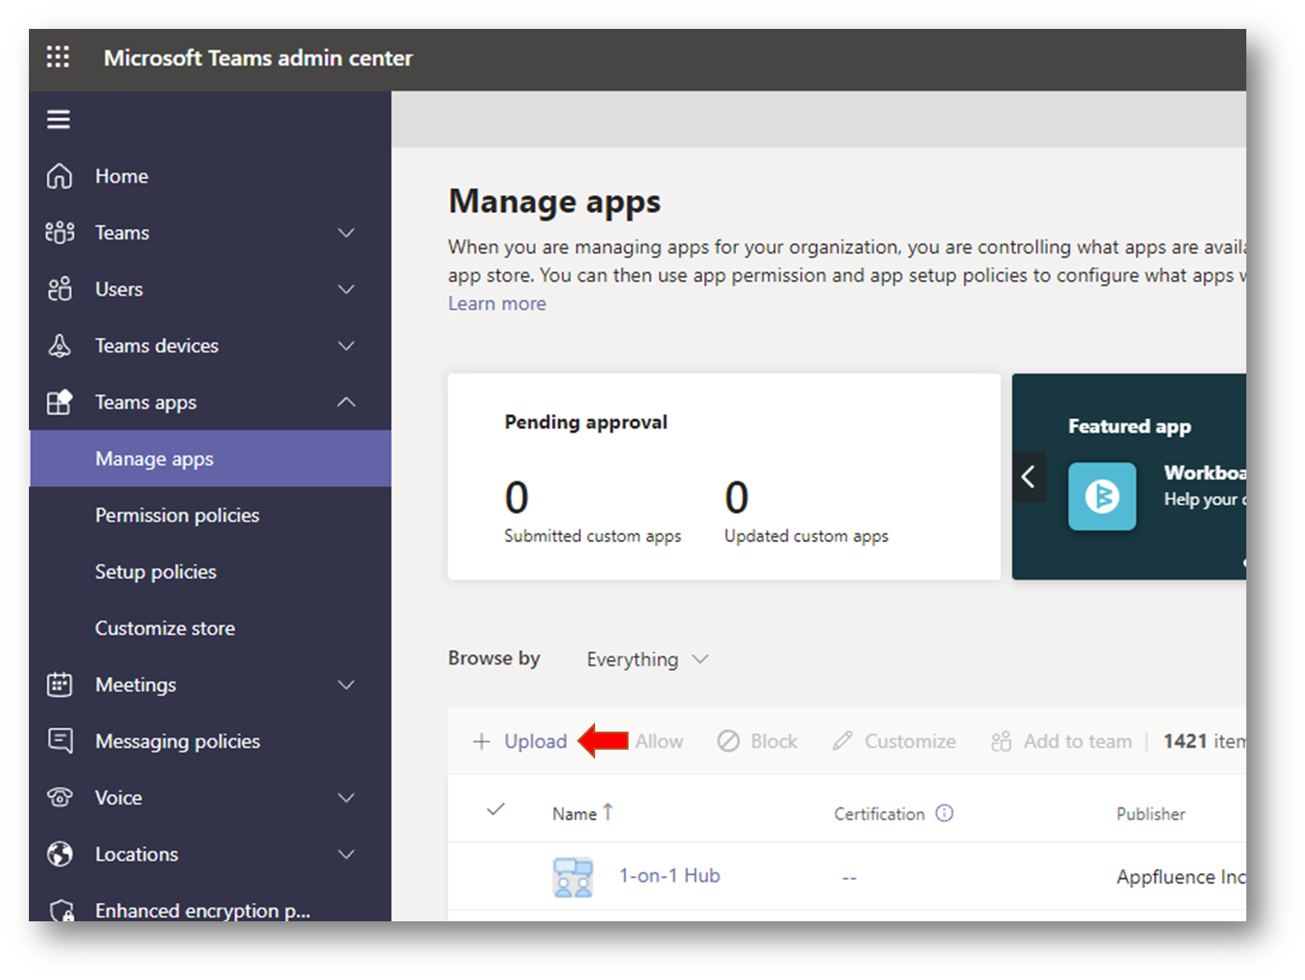

Now that you have clicked the upload button, you will be presented with a highly informative dialog that informs you that you are about to upload something. Having been duly informed that clicking the upload button does in fact lead to uploading, you will then be required to click another upload button before you can actually upload. Go ahead and click the second **Upload** button.

After clicking the second upload button you should see a file picker dialog. This is where you will need to locate the Soundbite Teams App package that you downloaded earlier. If you opted to save the file to an easy to find location, it should be easy to find. If it is difficult to find, then please know we expressly recommended against putting it in a difficult to find location. File pickers vary from system to system and browser to browser, but generally you will need to select the file and click OK. When you do, the Soundbite Teams App package will be uploaded and should appear in your list of available packages for users after the upload is complete. Please note that this only makes the package available, and does not automatically deploy the package to users in your organization.

# Deploying Soundbite Package to Users Automatically

You can deploy Soundbite to users automatically using Setup Policies in the [Microsoft Teams Administration Center](https://admin.teams.microsoft.com/dashboard). On the left-hand navigation menu, you should see an option for **Teams Apps**. Click to expand this menu item. You should then see a child item named **Setup policies**. Click on the **Setup policies** menu item.

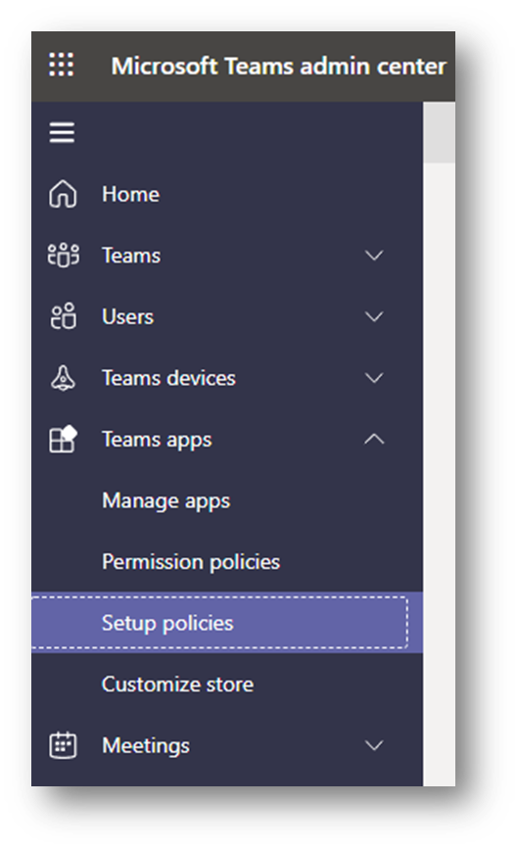

This takes you to the App setup policies. By default, Teams has two policies named FirstLineWorker and Global (Org-wide default). Your organization may also have additional setup policies. Each setup policy is associated with a group of users. If you want to deploy Soundbite across your organization, then you will need to configure the **Global (Org-wide default)** setup policy. If you want to limit the deployment of Soundbite to a select group of people, you will need to select an existing setup policy that represents those people or create a new setup policy for that select group. When you have determined the setup policy to configure, click on the setup policy name.

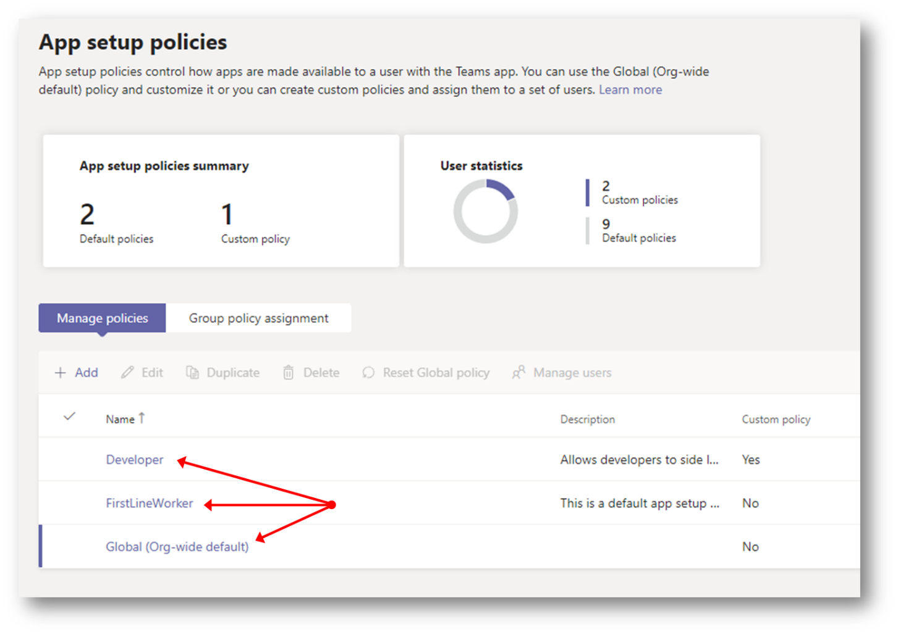

This takes you to the setup policy configuration page. There are two key sections to this page, the **Installed Apps** and **Pinned Apps**. Installed apps allows you to define which Teams applications are automatically installed for the users in the setup policy. You can click the **+ Add** button to add Soundbite to the list of installed applications. This will install Soundbite for those users, which alleviates them from manually installing the app.

Automatically installing the app does not make the app readily visible to end-users. That is where the second section, Pinned Apps, comes into play. Pinned Apps are prominently displayed on the Teams App bar. The Teams App bar is the bar that appears on the left side of the Teams screen with icons showing the various activities you can do in Teams. We **HIGHLY RECOMMEND** adding the Soundbite Teams app to the list of pinned application to help better engage people in your enterprise. The position of Soundbite in the list of pinned apps corresponds to the order the apps are displayed on the Teams App bar.