1. Introduction:
1.1. Overview
This company is about the profit that can be earned by the pure quantity of sweets sold to customers
1.2 purpose:
- This project is been done with the help of Zoho
- Books where Sweets sold can be prepared with the pictorial representation
2. Problem Definition and Design Thinking:
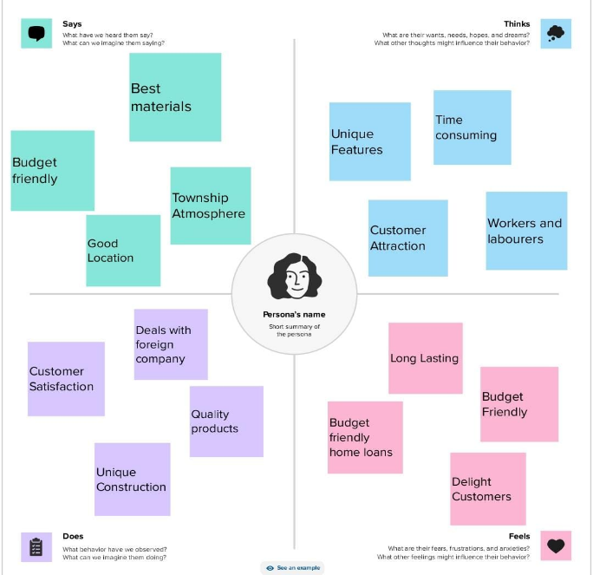
2.1 Empathy map

2.2 Ideation and brainstorming map
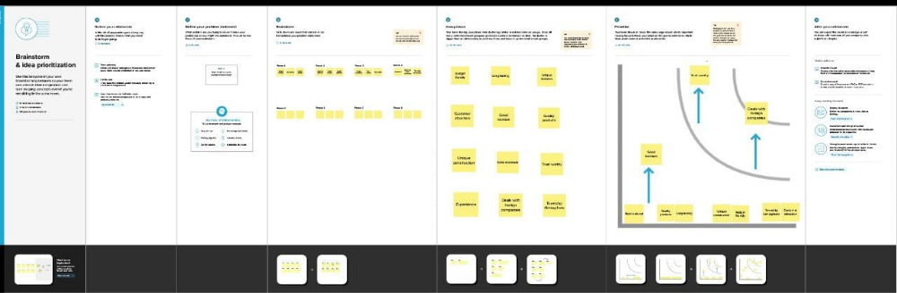

3. Result
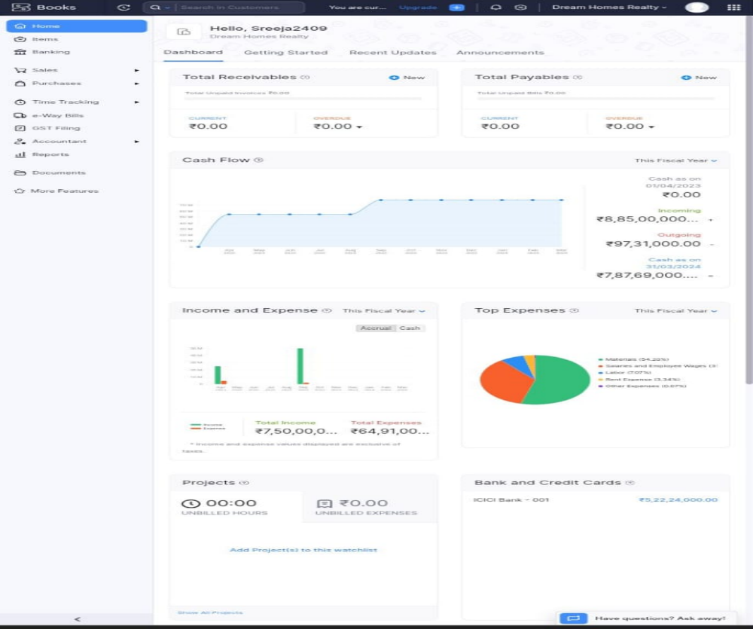
4 Advantages and Advantage
Advantages
- In olden days, sweets are being used as medicine
- There are many benefit of eating Sweets Some Sweets are conbin vitamins antioxidants and fibrer, and it helps from lack of nutrient
Disadvantage
- Eating too much Sweets can cause illness
5. Applications
Any time of sweet to order their of dealers. Into can order our sweets as bulk of small quantities

6. Conclusion
In this project we had used Zoho books as the application for preparing the financial reports of Keerthi Sweets and also we had created each and every needed items, purchases, sales and also banking entries with the help of the application Zoho books
7. future scope.
we provide best sweet scrive with no artificial colours and mostly we sold the Sweets at the day. when that all can be Produced, sell to customer with reasonable. and satisfactionable price of of them.

