

|  |  |
| --- | --- |
| **Date** | **21th April 2023** |
| **Team ID** | **NM2023TMID33413** |
| **Project Name** | **Vehicle Management System Using Salesforce** |
| **Team Leader** | **SOUNDHARYA.A** |
| **Team Member** | **RATHNA.M** |
| **SHARMILA.S** |
| **SRIVITHYA.D** |

**1 INTRODUCTION**

* 1. **Overview**

Vehicle management is an application where a customers details are stored in order to choose cars,bikes and commercial vehicles for travel with in the city.The data which is stored here is further used to remind them if any offers are provided during the seasons and updates regarding vehicles are sent to them in the form of messages and mails.

**1.2 Purpose**

A management system is a software system _or platform_that serves to manage commercial fleets of vehicles ,such as cars,vans or trucks _or even heavy equipment _to ensure they ‘re utilized safely ,efficiently and professionally ,while making sure they are well maintained and high_performing.

# 2 PROBLEM DEFINITION & DESING THINKING

* 1. **Empathy Map**

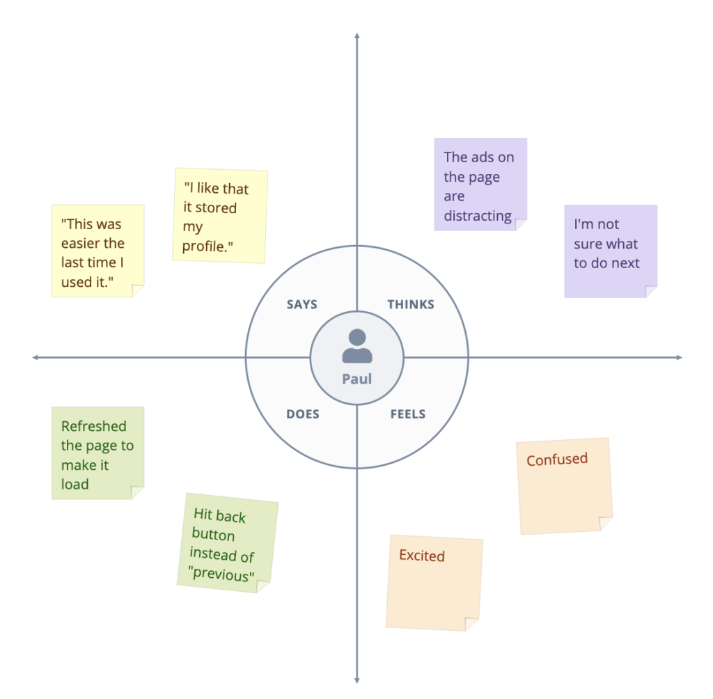

* 1. **Ideation & Brainstorming Map**

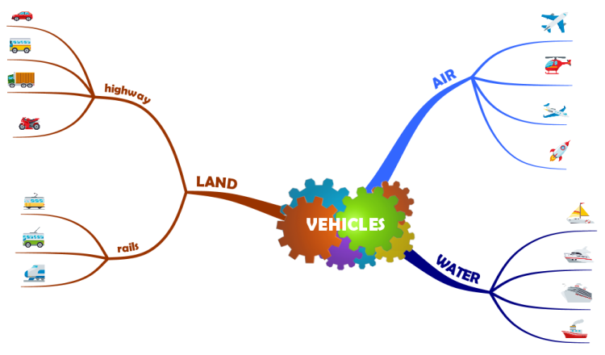

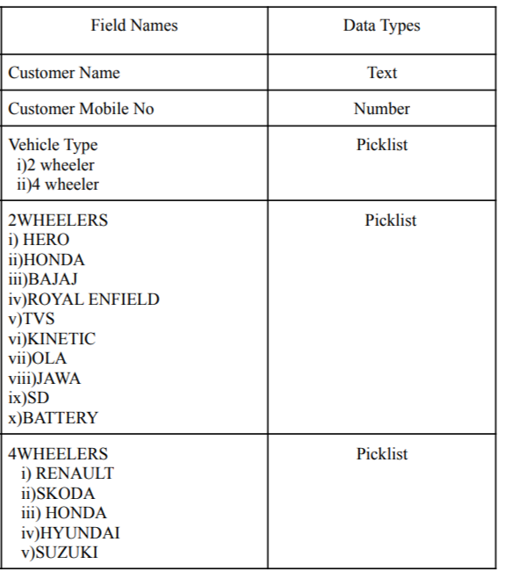

# 3 RESULT

**3.1 Data Type**

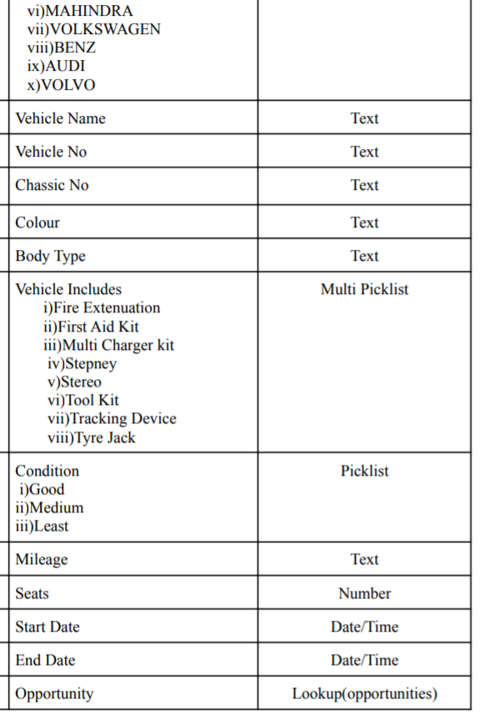

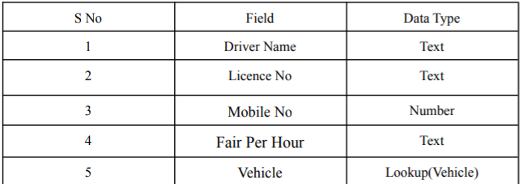

* 1. **Activity & Screenshot**

**Milestone:1**

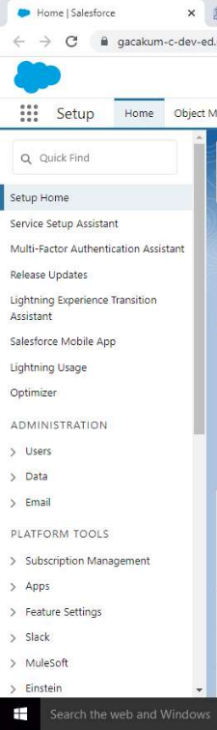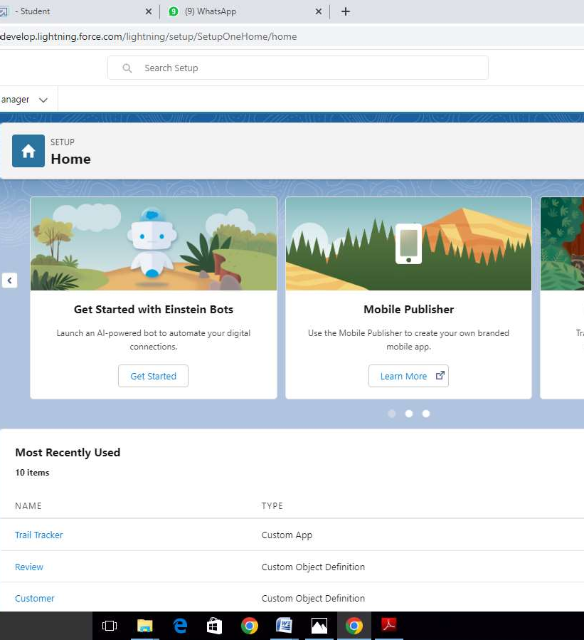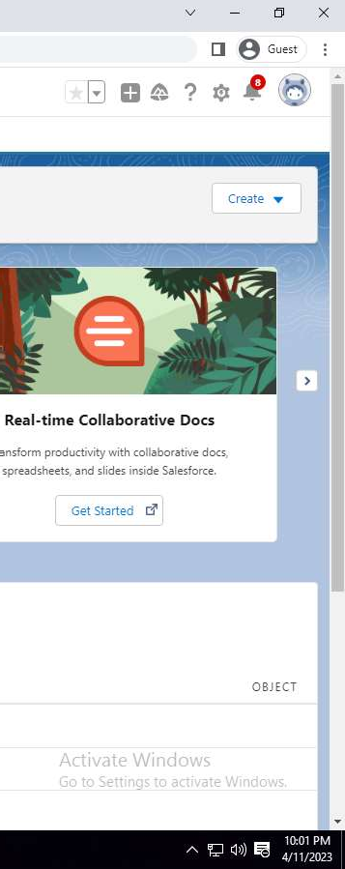

**Creation of Salesforce Account.**

Milestone 2:

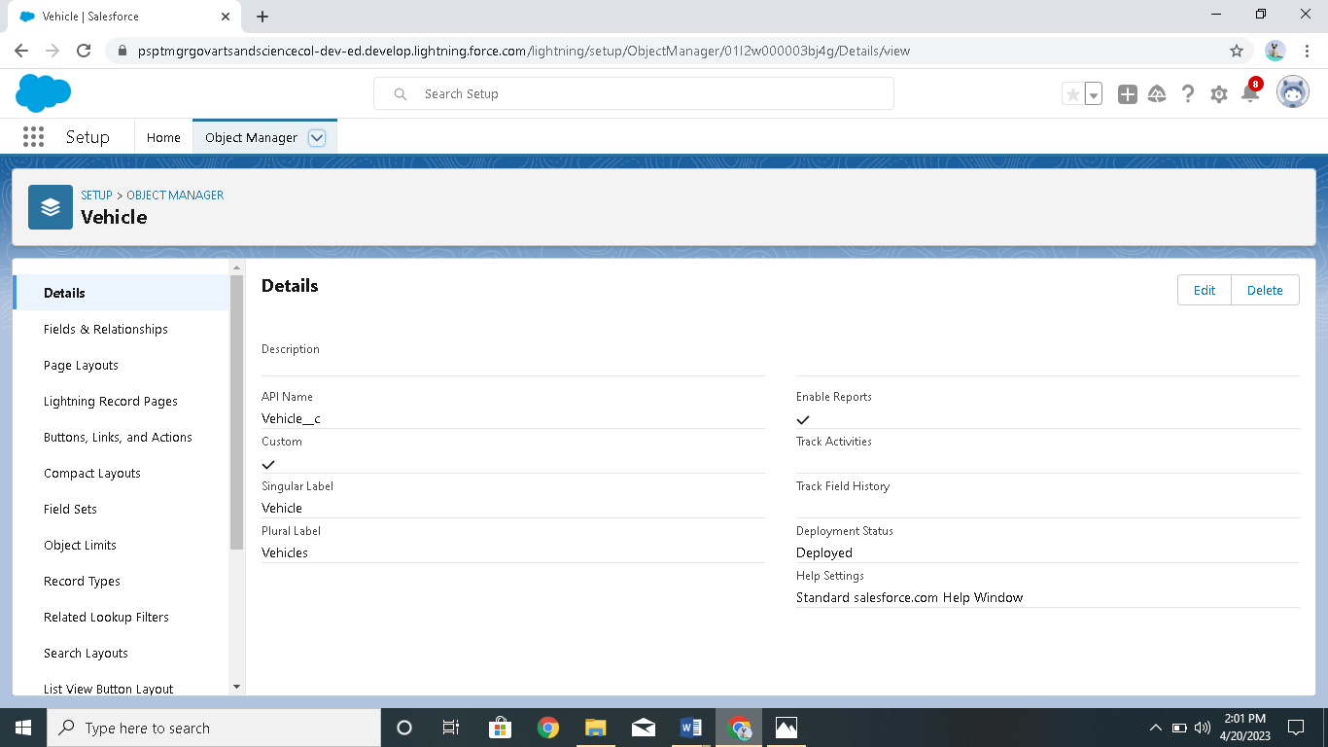

Creation of objects(Vehicles,Driver)

Milestone 3:

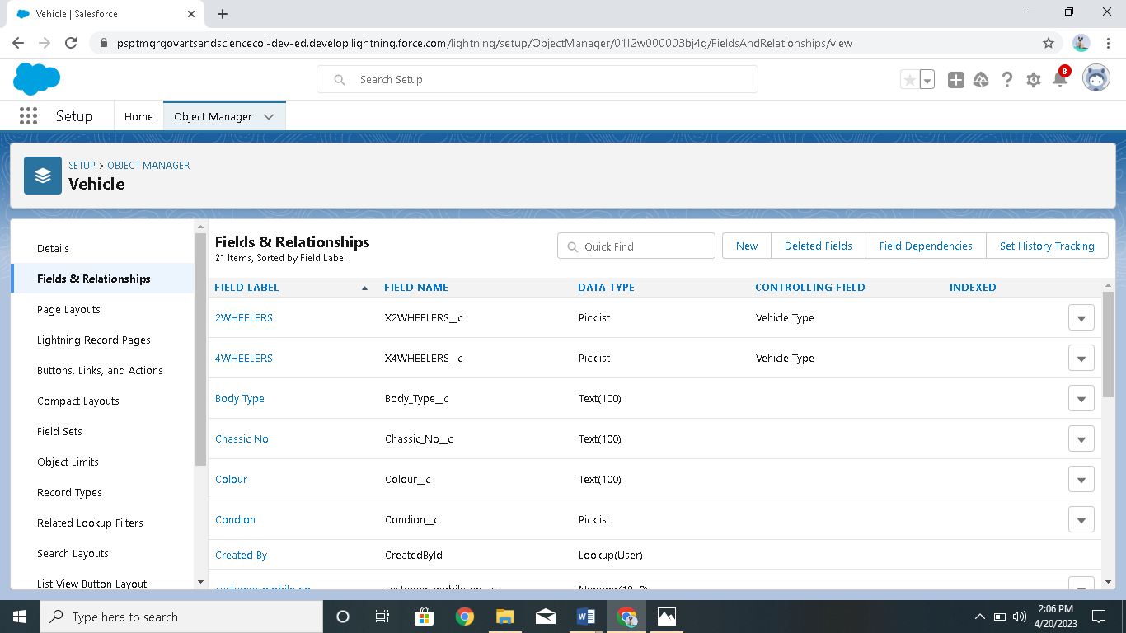

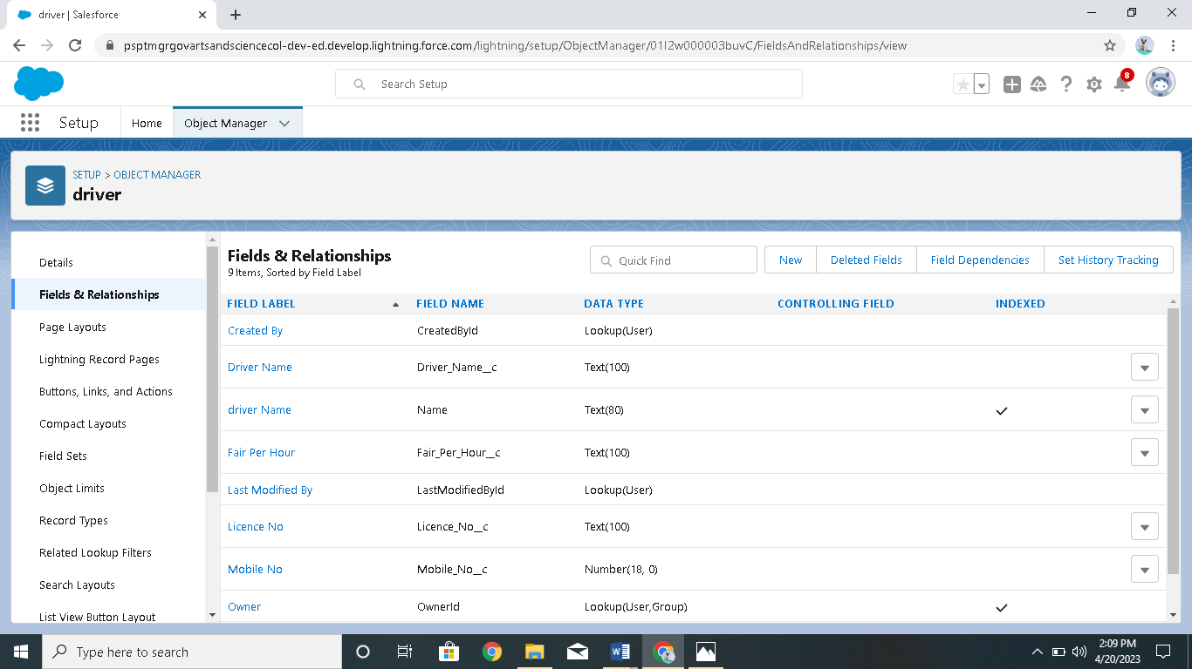

Creation of fields in vehicle & driver objects

Milestone 4 :

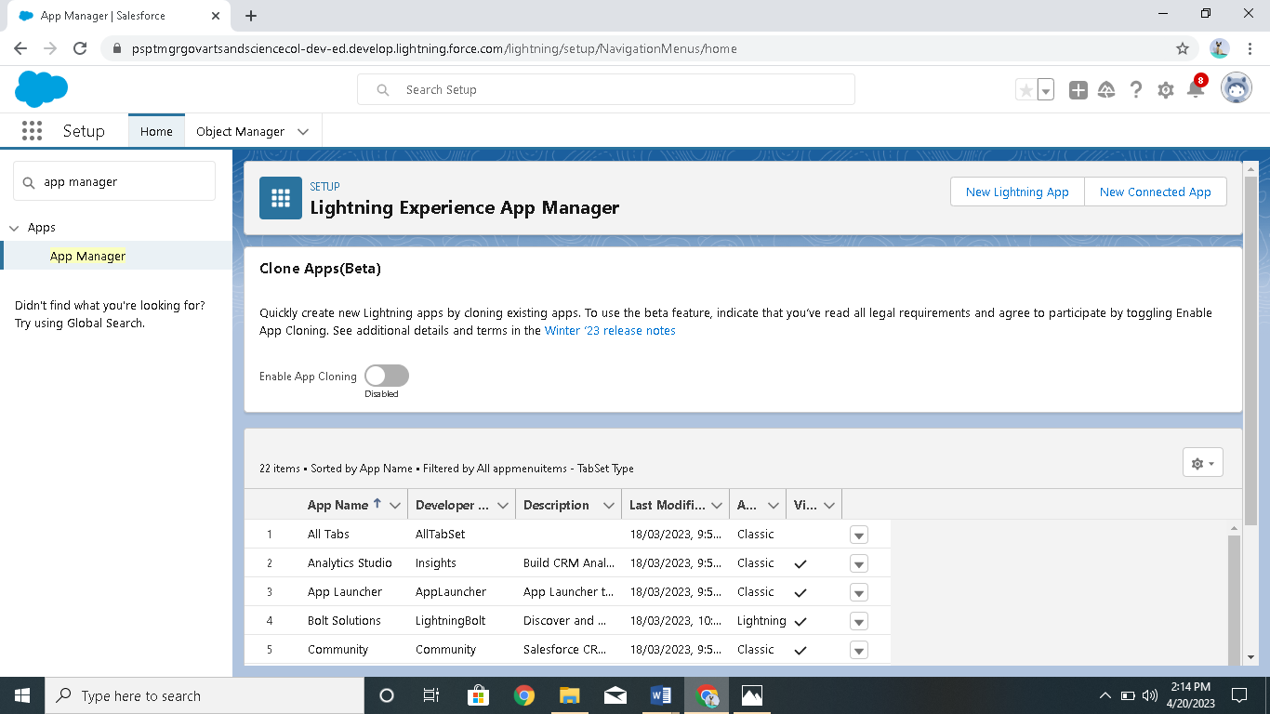

Creation of vehicle management construction app

Milestone 5:

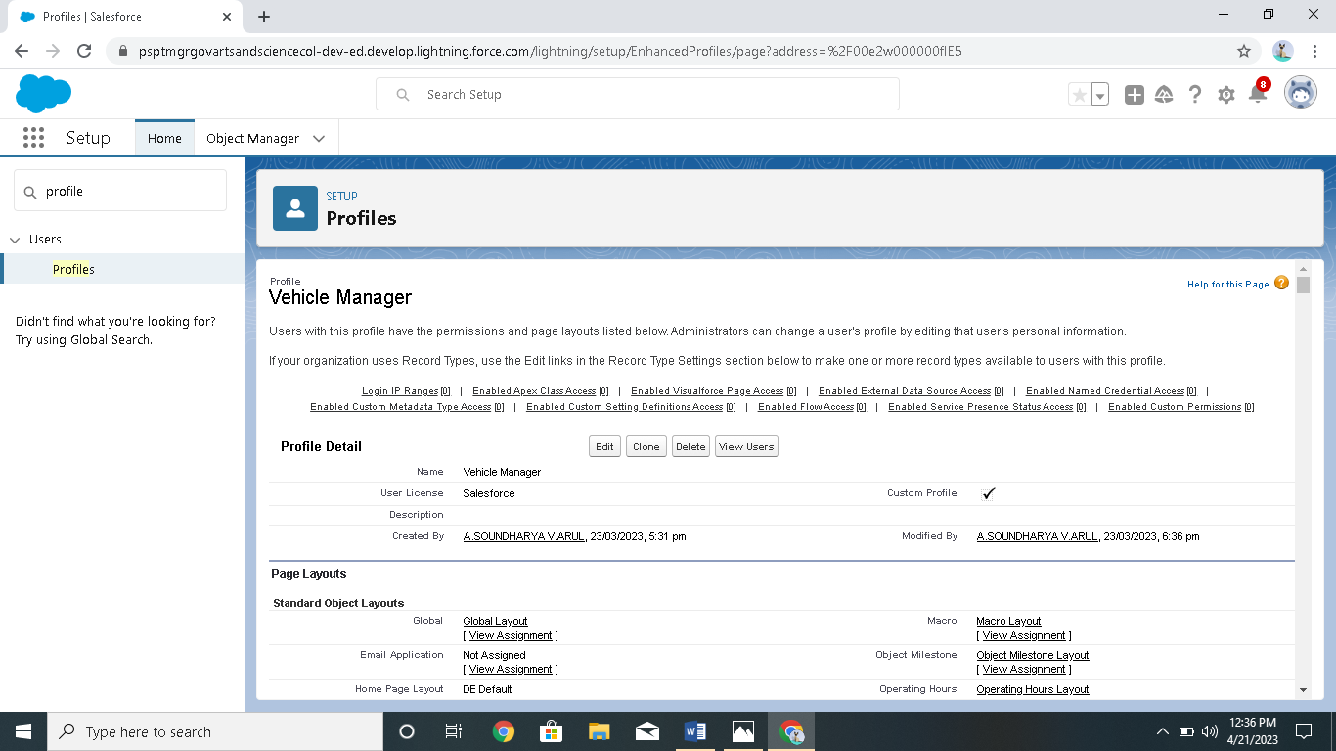

Creation of vehicle manager profile

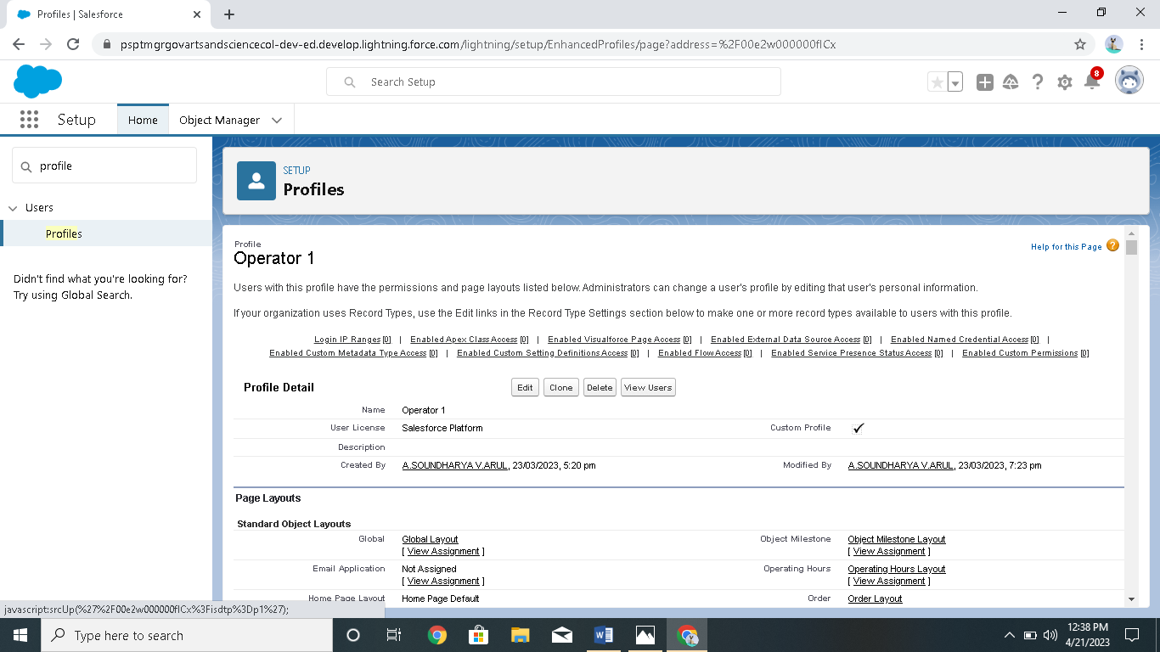

Creation of operator 1 profile

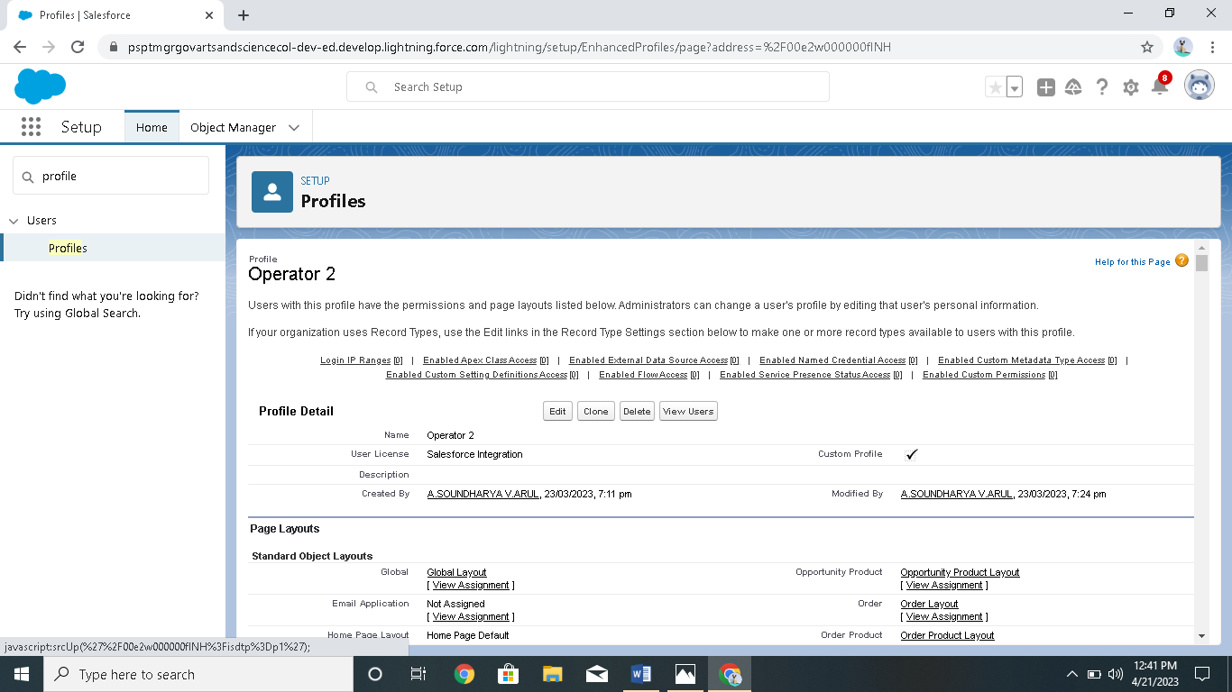

Creation of operator 2profile

**Milestone:6**

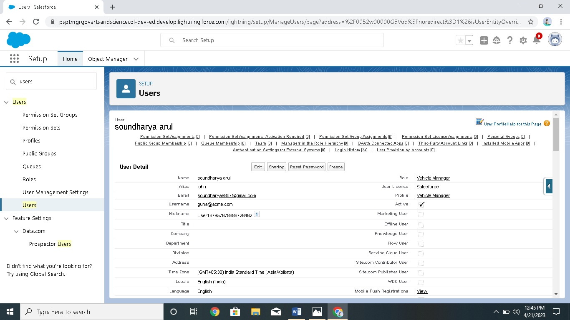

Creation of user( soundharya arul)

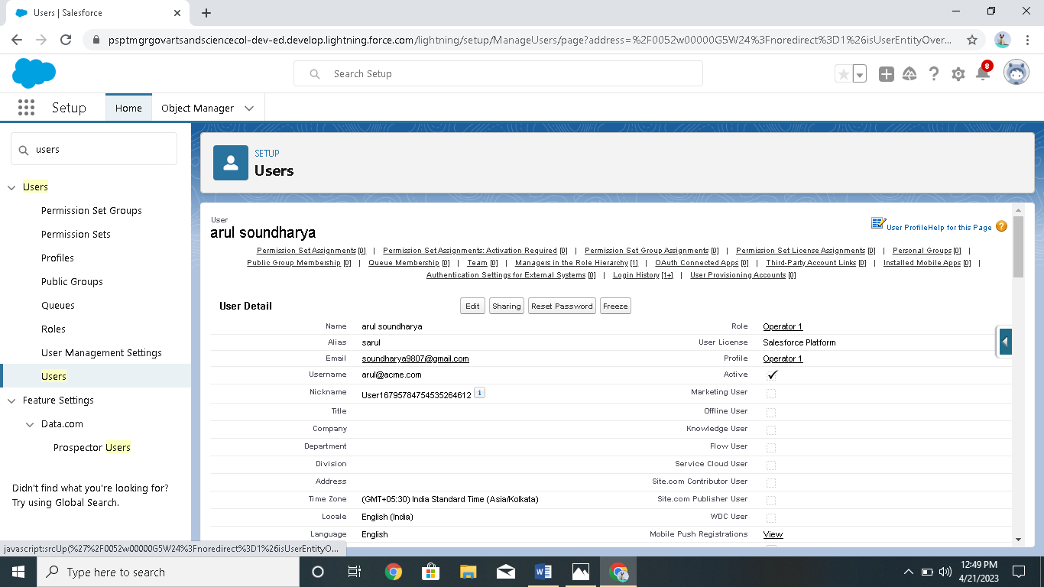

Creation of user( arul soundharya)

Milestone 7:

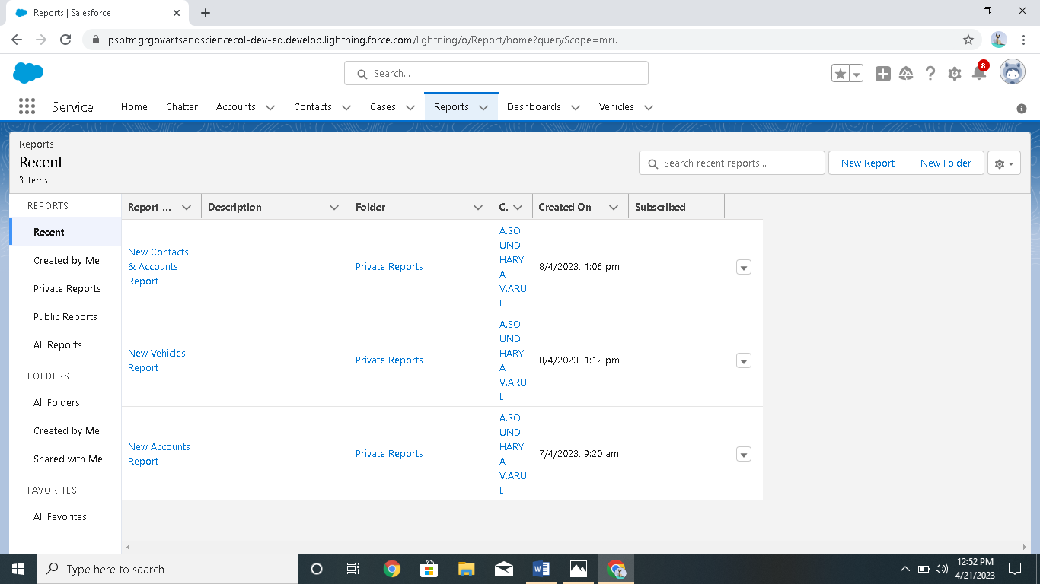

Creation of reports(vehicle,contact,account)

**Milestone:8**

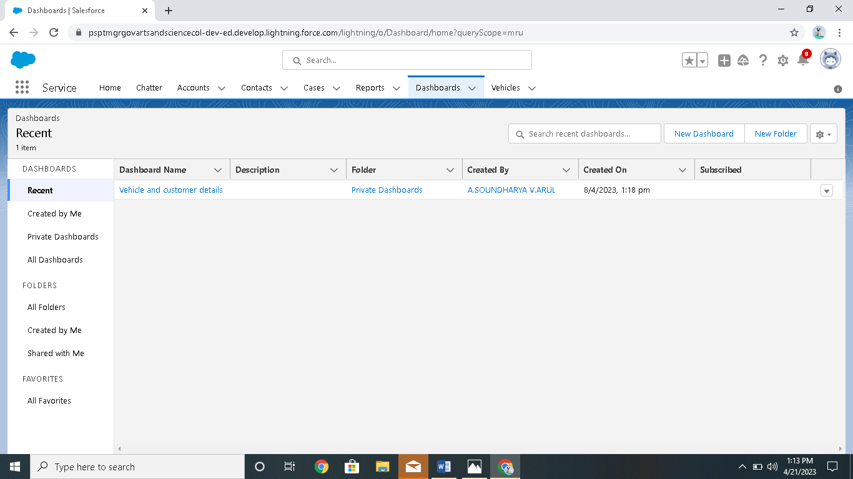

Creation of dashboards

# 4 TRAILHEAD PROFILE PUBLIC URL

Team Lead -https://trailblazer.me/id/souna19

Team member 1 -https://trailblazer.me/id/rrathna5

Team member 2 -https://trailblazer.me/id/ssharmila33

Team member 3 -https://trailblazer.me/id/srivd2

# 5 ADVANTAGES & DISADVANTAGES

* Duplication of the vehicle data is avoided .
* As vehicle number is already stored in the master therefore human mistakes can be avoided.

* Timely alerts ensure that penalties are avoided.

# 6 APPLICATIONS

* Location wise user wise alert list can be configured .
* Daily /weekly/monthly alerts can be set for the upcoming renewal of documents..
* Vehicle master captures all the information related to vehicles number ,controlling location and so on.

# 7 CONCULUSION

* Our project is only humble venture to satify the needs to manage their project work .several user friendly coding have also adopted.This package shall prove to be a powerful package in satifing all the requirements of the school..

# 8 FUTURE SCOPE

We can add printer in future .we can give more advance software for vehicle management system

Including more facilities .we will host the platform on onlion servers to make it accessible worldwide.