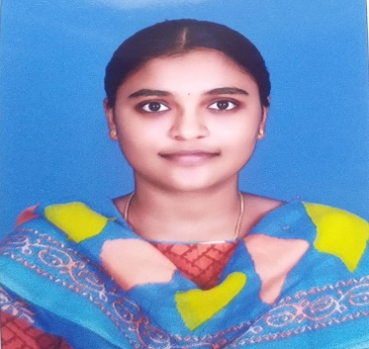

SOUNDHARYALAKSHMI .M

Contact : 8667713431

Address :2/84, Eaststreet, Thottampatti, Palladam(tk), Tiruppur District,641667.

Email : [soundaryalakshmi41@gmail.com](mailto:soundaryalakshmi41@gmail.com)

Linkedin : <https://www.linkedin.com/in/soundarya-lakshmi-21b275249>

**CAREER OBJECTIVE**

Looking forward for an opportunity in a organization where I can learn new skills, expand my knowledge, and leverage my learnings.

**ACADEMIC CREDENTIALS:**

|  |  |  |  |
| --- | --- | --- | --- |
| **COURSE** | **INSTITUTION** | **YEAR OF PASSING** | **CGPA/PERCENTAGE** |
| BE - Electronics and communication | Karpagam Academy of Higher Education, Coimbatore. | 2021-2025 | CGPA: 8.3(Upto 3 rd sem) |
| HSC | Kannamal National Matric Hr.Sec School, Palladam | 2021 | 80.8% |
| SSLC | Kannamal National Matric Hr.Sec School, Palladam | 2019 | 78.8% |

**PROJECT**

* TITLE: **Traffic Signal System Using Microcontroller**
* DESRIPTION: The project on Traffic signal system using microcontroller required tools like motion sensor, Arduino and Zigbee Technology. This is all about the traffic signals system.

**INTERNSHIP**

* Undergone a internship VLSI DESIGN conducted by Sevael Technologies, Chennai, India. ( 2022).

**CERTIFICATION**

* Certified in Introducton to Python, by Infosys.
* Certified in Introduction to C by SoloLearn.
* Certified in Data analysis with Python by IBM.
* Certified in Introduction of Artificial Intelligence, march 23,2022 by Infosys.

**TECHNICAL SKILLS**

* C programming
* Python
* Computer-aided design
* Embedded c
* Python programming
* HTML

**AREA OF INTEREST**

* Designing
* Testing electronics equipment
* Editing

**LANGUAGES KNOWN**

* Tamil
* English

**DECLARATION**

I hereby declare that the information started above is true to the best of my knowledge.

[SOUNDHARYALAKSHMI M]