Problem 1: Plugin manager

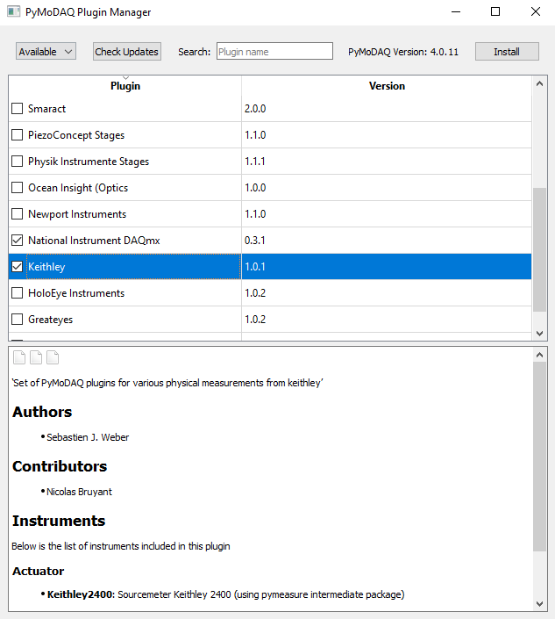 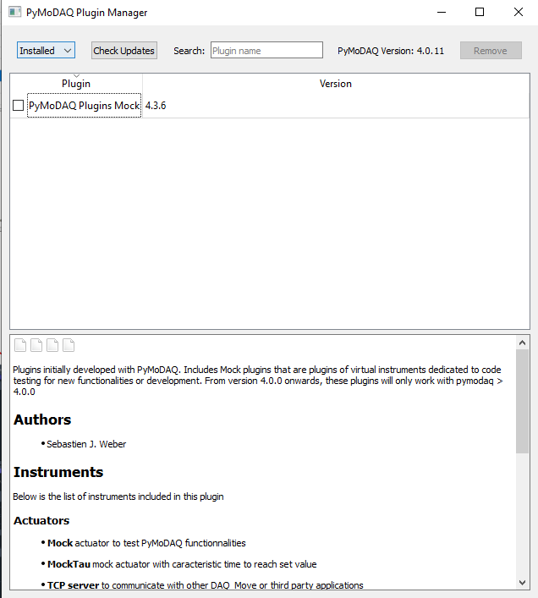 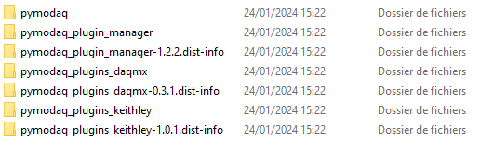

When installing plugins from the plugin manager, installation process occurs but once the plugin manager closed and restarted, they never appear.

Checking directly in the directory “my_env\Lib\site-packages”, they have been installed successfully.

After few researches, it looks like the json file is not up to date and have not been update since a while.

Problem 2 : Daq_viewer presets (test with keithley 2700)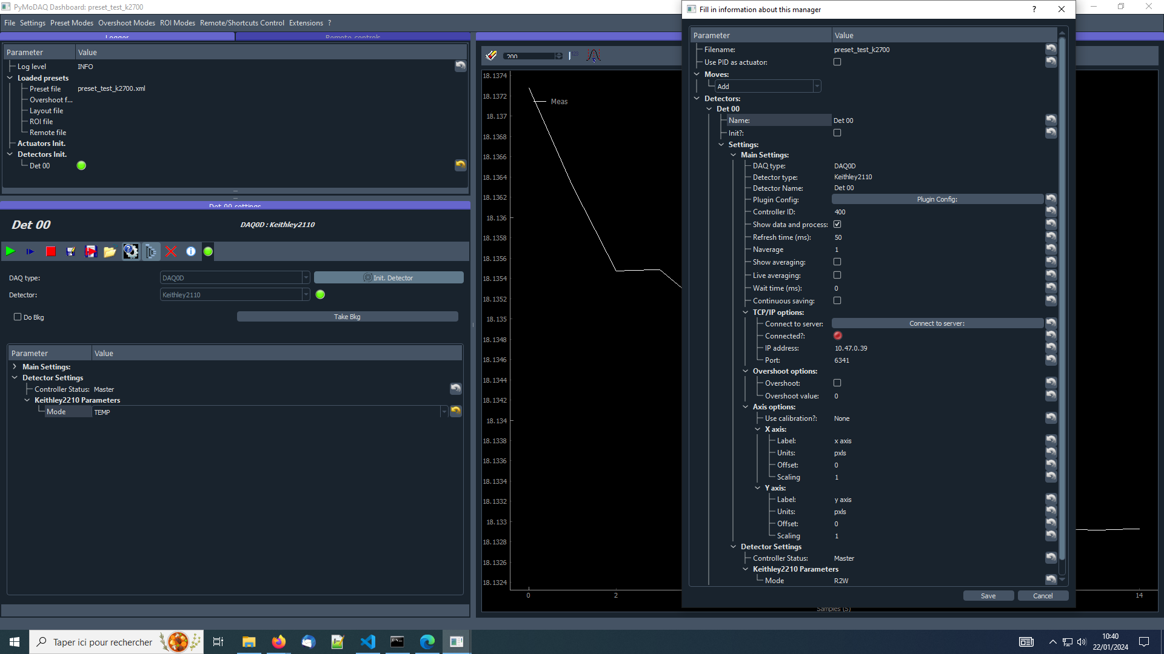

After having modified a bit the Keithley 2210 plugin to match our keithley 2700 instructions, we created a preset to fit our instrument acquisition parameters. Grabbed data are well displayed through the daq viewer, but when using the dashboard and our preset, it appears the initialization is having troubles, indeed if Detectors>Det00>Init ?: is ticked, Initialization fail and pymodaq is killed, going through these errors:

>INFO:pymodaq.dashboard:Preset file: C:\ProgramData\.pymodaq\preset_configs\preset_test_k2700.xml has been loaded

>INFO:pymodaq.pymodaq.daq_viewer.Det 00:tuple index out of range

>INFO:pymodaq.pymodaq.daq_viewer.Det 00:tuple index out of range

>INFO:pymodaq.pymodaq.daq_viewer.Det 00:tuple index out of range

>INFO:pymodaq.pymodaq.daq_viewer.Det 00:tuple index out of range

>QThread: Destroyed while thread is still running