Module 3 : PL/SQL
By Soupal Ghosh

Schema :
CREATE TABLE Customers(
CustomerID INT PRIMARY KEY,
Name VARCHAR(100),
DOB DATE,
Balance INT,
IsVIP CHAR(1),
LastModified DATE
);

CREATE TABLE Accounts(
AccountID INT PRIMARY KEY,
CustomerID INT,
AccountType VARCHAR(20),
Balance INT,
LastModified DATE,
FOREIGN KEY(CustomerID) REFERENCES Customers(CustomerID)
);

CREATE TABLE Transactions(
TransactionID INT PRIMARY KEY,
AccountID INT,
TransactionDate DATE,
Amount INT,
TransactionType VARCHAR(20),
FOREIGN KEY(AccountID) REFERENCES Accounts(AccountID)
);

CREATE TABLE Loans(
LoanID INT PRIMARY KEY,
CustomerID INT,
LoanAmount INT,
InterestRate INT,
StartDate DATE,
EndDate DATE,
FOREIGN KEY(CustomerID) REFERENCES Customers(CustomerID)
);

CREATE TABLE Employees(
EmployeeID INT PRIMARY KEY,
Name VARCHAR(100),
Position VARCHAR(50),
Salary INT,
Department VARCHAR(50),
HireDate DATE
);

CREATE TABLE AuditLog(
LogID INT PRIMARY KEY,
TransactionID INT,
LogDate DATE,
Action VARCHAR(100)
);
INSERT INTO Customers VALUES
(1,'John Doe','1950-05-15',12000,'N','2024-01-01');

INSERT INTO Customers VALUES
(2,'Jane Smith','1990-07-20',1500,'N','2024-01-01');

INSERT INTO Customers VALUES
(3,'Robert King','1948-03-10',20000,'N','2024-01-01');

INSERT INTO Customers VALUES
(4,'Alice White','1988-09-25',8000,'N','2024-01-01');

INSERT INTO Customers VALUES
(5,'David Green','1962-12-18',11000,'N','2024-01-01');

INSERT INTO Accounts VALUES
(101,1,'Savings',10000,'2024-01-01');

INSERT INTO Accounts VALUES
(102,2,'Checking',5000,'2024-01-01');

INSERT INTO Accounts VALUES
(103,3,'Savings',15000,'2024-01-01');

INSERT INTO Accounts VALUES
(104,4,'Checking',8000,'2024-01-01');

INSERT INTO Accounts VALUES
(105,5,'Savings',12000,'2024-01-01');

INSERT INTO Transactions VALUES
(1,101,'2024-03-10',500,'Deposit');

INSERT INTO Transactions VALUES
(2,102,'2024-03-12',300,'Withdrawal');

INSERT INTO Transactions VALUES
(3,103,'2024-03-15',1000,'Deposit');

INSERT INTO Transactions VALUES
(4,104,'2024-03-18',400,'Withdrawal');

INSERT INTO Transactions VALUES
(5,105,'2024-03-20',700,'Deposit');

INSERT INTO Loans VALUES
(1,1,50000,8,'2024-01-01','2029-01-01');

INSERT INTO Loans VALUES
(2,3,70000,9,'2024-02-01','2029-02-01');

INSERT INTO Loans VALUES
(3,4,30000,10,'2024-03-01','2029-03-01');

INSERT INTO Loans VALUES
(4,5,45000,7,'2024-04-01','2029-04-01');

INSERT INTO Employees VALUES
(1,'Alice Johnson','Manager',70000,'HR','2015-06-15');

INSERT INTO Employees VALUES
(2,'Bob Brown','Developer',60000,'IT','2017-03-20');

INSERT INTO Employees VALUES
(3,'Charlie Lee','Analyst',55000,'Finance','2018-09-12');

INSERT INTO Employees VALUES
(4,'Diana Scott','Clerk',40000,'HR','2020-01-10');

INSERT INTO Employees VALUES
(5,'Edward Smith','Developer',65000,'IT','2019-07-05');

INSERT INTO AuditLog VALUES
(1,1,'2024-03-10','Transaction Added');

INSERT INTO AuditLog VALUES
(2,2,'2024-03-12','Transaction Added');
SELECT * FROM Customers;

SELECT * FROM Accounts;

SELECT * FROM Transactions;

SELECT * FROM Loans;

SELECT * FROM Employees;

SELECT * FROM AuditLog;
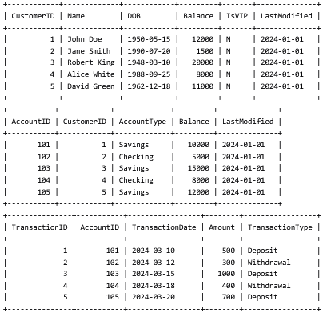
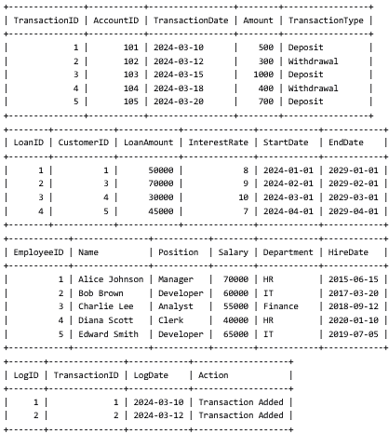

Ex1:
DELIMITER $$

CREATE PROCEDURE DiscountInterest()
BEGIN
DECLARE done INT DEFAULT 0;
DECLARE c_id INT;
DECLARE c_dob DATE;
DECLARE age INT;

DECLARE cur CURSOR FOR
SELECT CustomerID, DOB FROM Customers;

DECLARE CONTINUE HANDLER FOR NOT FOUND SET done = 1;

OPEN cur;

read_loop: LOOP

FETCH cur INTO c_id, c_dob;

IF done = 1 THEN
LEAVE read_loop;
END IF;

SET age = YEAR(CURDATE()) - YEAR(c_dob);

IF age > 60 THEN

UPDATE Loans
SET InterestRate = InterestRate - 1
WHERE CustomerID = c_id;

END IF;

END LOOP;

CLOSE cur;

SELECT 'Interest Updated' AS Message;

END$$

DELIMITER ;

CALL DiscountInterest();

SELECT * FROM Loans;

DELIMITER $$

CREATE PROCEDURE MakeVIP()
BEGIN

DECLARE done INT DEFAULT 0;
DECLARE cid INT;
DECLARE bal INT;

DECLARE cur CURSOR FOR
SELECT CustomerID,Balance
FROM Customers;

DECLARE CONTINUE HANDLER FOR NOT FOUND SET done=1;

OPEN cur;

abc: LOOP

FETCH cur INTO cid,bal;

IF done=1 THEN
LEAVE abc;
END IF;

IF bal>10000 THEN

UPDATE Customers
SET IsVIP='Y'
WHERE CustomerID=cid;

END IF;

END LOOP;

CLOSE cur;

SELECT 'VIP Updated' AS Message;

END$$

DELIMITER ;

CALL MakeVIP();

SELECT * FROM Customers;
DELIMITER $$

CREATE PROCEDURE LoanReminder()
BEGIN

DECLARE done INT DEFAULT 0;

DECLARE cid INT;
DECLARE lid INT;
DECLARE edate DATE;

DECLARE cur CURSOR FOR

SELECT LoanID,
CustomerID,
EndDate
FROM Loans
WHERE EndDate BETWEEN CURDATE()
AND DATE_ADD(CURDATE(),INTERVAL 30 DAY);

DECLARE CONTINUE HANDLER FOR NOT FOUND SET done=1;

OPEN cur;

xyz: LOOP

FETCH cur INTO lid,cid,edate;

IF done=1 THEN
LEAVE xyz;
END IF;

SELECT CONCAT('Reminder : Loan ',
lid,
' of Customer ',
cid,
' is due on ',
edate) AS Reminder;

END LOOP;

CLOSE cur;

END$$
DELIMITER ;
CALL LoanReminder();

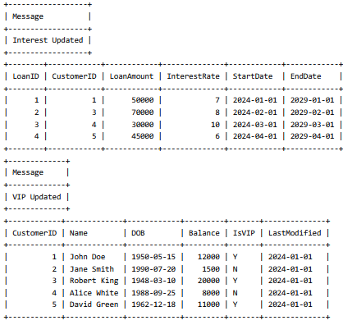
Ex2:

DELIMITER $$

CREATE PROCEDURE SafeTransferFunds(
IN fromAcc INT,
IN toAcc INT,
IN amt INT
)
BEGIN

DECLARE bal INT;

DECLARE EXIT HANDLER FOR SQLEXCEPTION
BEGIN
ROLLBACK;
SELECT 'Transaction Failed' AS Message;
END;

START TRANSACTION;

SELECT Balance
INTO bal
FROM Accounts
WHERE AccountID = fromAcc;

IF bal >= amt THEN

UPDATE Accounts
SET Balance = Balance - amt
WHERE AccountID = fromAcc;

UPDATE Accounts
SET Balance = Balance + amt
WHERE AccountID = toAcc;

COMMIT;

SELECT 'Transfer Successful' AS Message;

ELSE

ROLLBACK;

SELECT 'Insufficient Balance' AS Message;

END IF;

END$$

DELIMITER ;

CALL SafeTransferFunds(101,102,500);

SELECT * FROM Accounts;

DELIMITER $$

CREATE PROCEDURE UpdateSalary(
IN emp INT,
IN percent INT
)
BEGIN

DECLARE cnt INT;

SELECT COUNT(*)
INTO cnt
FROM Employees
WHERE EmployeeID = emp;

IF cnt = 0 THEN

SELECT 'Employee Not Found' AS Message;

ELSE

UPDATE Employees
SET Salary = Salary + (Salary * percent / 100)
WHERE EmployeeID = emp;

SELECT 'Salary Updated' AS Message;

END IF;

END$$

DELIMITER ;

CALL UpdateSalary(2,10);

SELECT * FROM Employees;

DELIMITER $$

CREATE PROCEDURE AddNewCustomer(

IN cid INT,
IN cname VARCHAR(100),
IN dob DATE,
IN bal INT

)
BEGIN

DECLARE cnt INT;

SELECT COUNT(*)
INTO cnt
FROM Customers
WHERE CustomerID = cid;

IF cnt > 0 THEN

SELECT 'Customer Already Exists' AS Message;

ELSE

INSERT INTO Customers
VALUES
(
cid,
cname,
dob,
bal,
'N',
'2024-01-01'
);
SELECT 'Customer Added Successfully' AS Message;

END IF;
END$$
DELIMITER ;

CALL AddNewCustomer(
6,
'Rahul Sharma',
'1998-08-15',
9000
);

SELECT * FROM Customers;
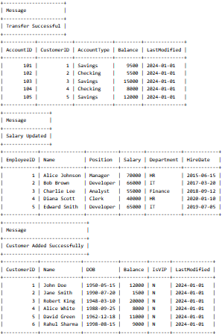
Ex3:
DELIMITER $$

CREATE PROCEDURE ProcessMonthlyInterest()
BEGIN

UPDATE Accounts
SET Balance = Balance + (Balance * 1 / 100)
WHERE AccountType = 'Savings';

SELECT 'Monthly Interest Added' AS Message;

END$$

DELIMITER ;

CALL ProcessMonthlyInterest();

SELECT * FROM Accounts;

DELIMITER $$

CREATE PROCEDURE UpdateEmployeeBonus(
IN dept VARCHAR(50),
IN bonus INT
)
BEGIN

UPDATE Employees
SET Salary = Salary + (Salary * bonus / 100)
WHERE Department = dept;

SELECT 'Bonus Added' AS Message;

END$$

DELIMITER ;

CALL UpdateEmployeeBonus('IT',10);

SELECT * FROM Employees;

DELIMITER $$

CREATE PROCEDURE TransferFunds(
IN fromAcc INT,
IN toAcc INT,
IN amt INT
)
BEGIN
DECLARE bal INT;
SELECT Balance
INTO bal
FROM Accounts
WHERE AccountID = fromAcc;
IF bal >= amt THEN
UPDATE Accounts
SET Balance = Balance - amt
WHERE AccountID = fromAcc;
UPDATE Accounts
SET Balance = Balance + amt
WHERE AccountID = toAcc;
SELECT 'Money Transferred' AS Message;
ELSE
SELECT 'Not Enough Balance' AS Message;
END IF;
END$$
DELIMITER ;

CALL TransferFunds(103,104,1000);

SELECT * FROM Accounts;
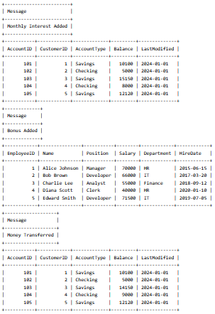

Ex4:

DELIMITER $$

CREATE FUNCTION CalculateAge(dob DATE)
RETURNS INT
DETERMINISTIC
BEGIN

RETURN YEAR(CURDATE()) - YEAR(dob);

END$$

DELIMITER ;

SELECT CalculateAge('1990-07-20') AS Age;

DELIMITER $$

CREATE FUNCTION CalculateMonthlyInstallment(
loanAmount INT,
rate INT,
years INT
)
RETURNS DECIMAL(10,2)
DETERMINISTIC
BEGIN

DECLARE total DECIMAL(10,2);

SET total = loanAmount +
(loanAmount * rate * years / 100);

RETURN total / (years * 12);

END$$

DELIMITER ;

SELECT CalculateMonthlyInstallment(100000,8,5) AS Monthly_Installment;

DELIMITER $$

CREATE FUNCTION HasSufficientBalance(
acc INT,
amt INT
)
RETURNS VARCHAR(10)
DETERMINISTIC
BEGIN

DECLARE bal INT;

SELECT Balance
INTO bal
FROM Accounts
WHERE AccountID = acc;

IF bal >= amt THEN
RETURN 'YES';
ELSE
RETURN 'NO';
END IF;

END$$

DELIMITER ;

SELECT HasSufficientBalance(101,5000) AS Result;

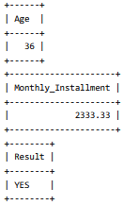
Ex5:
DELIMITER $$

CREATE TRIGGER LogTransaction
AFTER INSERT
ON Transactions
FOR EACH ROW
BEGIN

DECLARE nextID INT;

SELECT IFNULL(MAX(LogID),0) + 1
INTO nextID
FROM AuditLog;

INSERT INTO AuditLog
VALUES
(
nextID,
NEW.TransactionID,
CURDATE(),
'Transaction Added'
);

END$$

DELIMITER ;
INSERT INTO Transactions
VALUES
(
6,
101,
'2024-06-15',
500,
'Deposit'
);

SELECT * FROM AuditLog;
