DAY 2 RESEARCH NOTE
Fat Tails and Distributional Differences Between Bitcoin and SPY
Souparneya Chakrabarti

Abstract
This study examines whether Bitcoin exhibits heavier tail behavior than a major equity benchmark (SPY). Using daily log returns from 2014 onward, I compare the two assets through a range of statistical and distributional diagnostics, including histograms, Gaussian quantile–quantile plots, extreme-return frequency analysis, and tail index estimation via the Hill estimator. The analysis shows that Bitcoin’s return distribution is fundamentally more heavy-tailed, jump-prone, and structurally non-Gaussian than SPY’s. These properties cannot be explained solely by higher volatility; they arise from endogenous features of cryptocurrency market microstructure. The findings illustrate that Bitcoin behaves not as a scaled-up equity index, but as an asset class with its own distinctive statistical structure.

1. Introduction
It is common in informal discussions of financial markets to hear that cryptocurrency returns resemble equity returns but with higher volatility. This line of reasoning carries an implicit assumption: that the distributions are similar in shape and differ primarily in scale. If this were true, then normalizing Bitcoin’s returns by their standard deviation should produce a distribution with the same essential characteristics as SPY. Many conventional risk-management tools, especially those derived from Gaussian or near-Gaussian assumptions, rely on precisely this type of reasoning.
However, cryptocurrency markets differ from equity markets in several fundamental ways. They lack centralized regulation, trade continuously across fragmented exchanges, and make heavy use of derivatives such as perpetual futures that impose nonlinear funding dynamics on spot prices. These structural differences raise the question of whether Bitcoin returns actually follow the same statistical patterns as equities—or whether the comparison itself is flawed.
To examine this, I analyze the empirical distribution of daily log returns for SPY and BTC-USD from 2014 to the present. My aim is to determine whether Bitcoin’s return distribution can reasonably be modeled using the same theoretical assumptions as SPY’s, or whether the two assets belong to fundamentally different statistical regimes.

2. Mathematical Framework and Data Construction
Daily adjusted closing prices were obtained from Yahoo Finance, and log returns were computed using the standard transformation
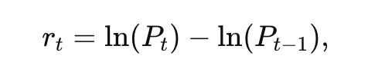
which ensures additivity over time and relative scale invariance. These returns were then standardized via z-scores
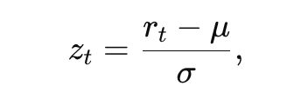
making it possible to compare extreme events across assets with different volatility levels and to evaluate how frequently returns exceed thresholds implied by a Gaussian distribution.
Several statistical quantities were computed, including sample skewness, which measures the asymmetry of the distribution, and excess kurtosis, which measures the heaviness of the tails relative to a normal distribution. A Gaussian probability density function with the same mean and variance served as a benchmark for comparison in histogram overlays.
To examine the match between empirical and theoretical distributions more formally, I generated quantile–quantile (QQ) plots, which compare the empirical quantiles
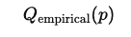
to quantiles of the standard normal distribution
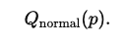
Deviations from the diagonal line indicate discrepancies from Gaussianity, especially in the tails.
The frequency of extreme standardized returns—those exceeding three, four, or five standard deviations in absolute value—was recorded and compared to Gaussian expectations. Under a true normal distribution, observations beyond five standard deviations should be astronomically rare. Finally, to quantify tail thickness directly, I applied the Hill estimator to the largest absolute return observations.
The estimator
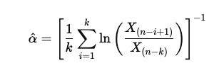
provides a statistical measure of the power-law tail index α. A smaller α corresponds to slower tail decay and therefore heavier tails. Together, these mathematical tools offer a comprehensive description of how each asset behaves in its extreme regions.

3. Empirical Findings
The empirical histograms immediately reveal qualitative differences between the two assets. Bitcoin’s distribution is sharply peaked around zero, yet its tails extend far beyond what a Gaussian curve—with matching mean and variance—can accommodate. This combination of a tight central mass and disproportionate tail weight is characteristic of leptokurtic distributions. SPY, by contrast, displays a much more compact histogram. Although SPY still deviates from normality, its distribution does so with moderation: the Gaussian curve approximates the center reasonably well, and the tails diverge only gently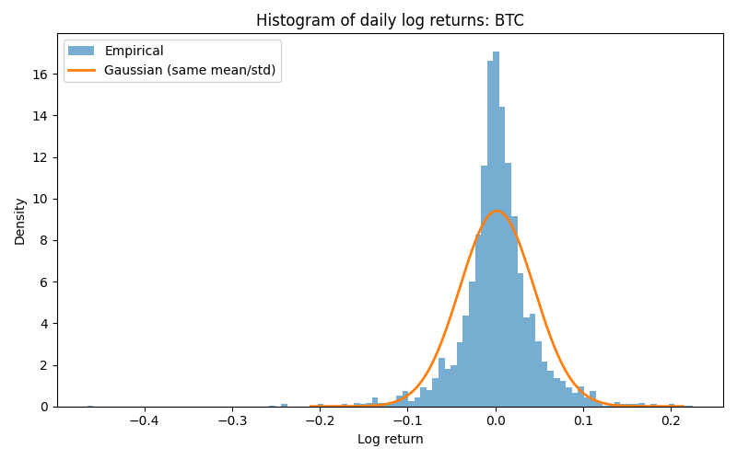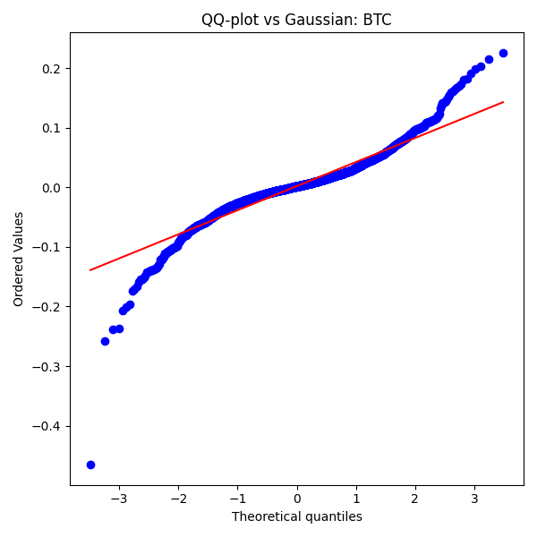
The contrast becomes even more pronounced in the QQ plots. For SPY, the QQ plot shows a modest upward curvature at the extremes, indicating heavier-than-Gaussian tails, but the departures are consistent with what is typically found in equity index data. Bitcoin’s QQ plot, however, shows dramatic divergence from the diagonal reference line. The extreme quantiles, both positive and negative, lift away sharply, indicating that Bitcoin’s largest returns—whether crashes or short squeezes—vastly exceed those predicted by a normal distribution. The center of the distribution also shows irregular curvature, reflecting the mixture of calm periods interspersed with volatility bursts that characterize cryptocurrency markets.
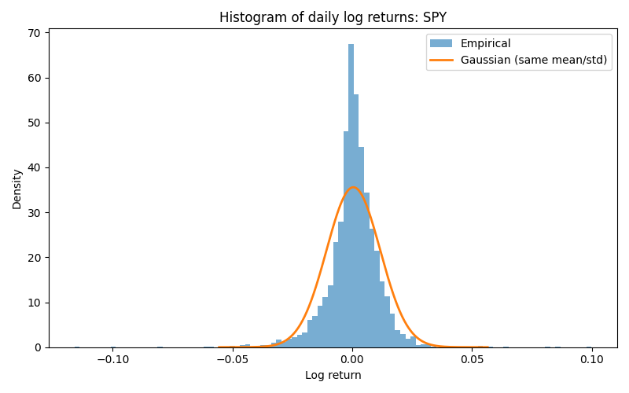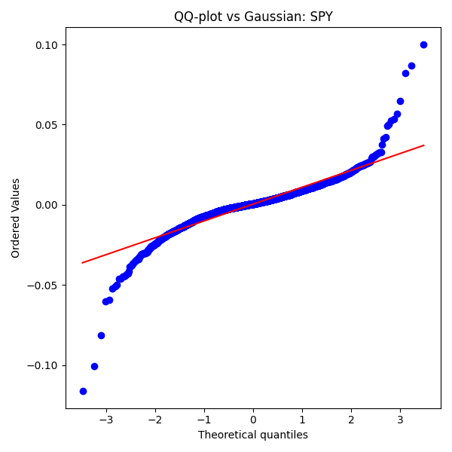
These visual patterns are supported by quantitative measures. Bitcoin produces extreme standardized returns with a frequency far greater than would be expected under a Gaussian model. Events exceeding three standard deviations occur regularly; events beyond four or five standard deviations, which should be effectively nonexistent under a normal distribution, appear multiple times over the sample period. SPY, in contrast, produces only a very small number of such events, consistent with a mildly heavy-tailed but largely stable process.

Hill tail index estimation confirms the heavy-tailed nature of Bitcoin returns. Bitcoin’s estimated α is substantially lower than that of SPY, implying that its tails decay according to a power-law distribution rather than a Gaussian one. This means that the probability of extreme outcomes decreases slowly rather than exponentially. From a mathematical standpoint, this is the signature of a system that generates extreme events not as rare exceptions but as inherent features of its dynamics.

4. Interpretation
The empirical and mathematical evidence together show that Bitcoin’s return distribution cannot be understood as simply a high-volatility version of the equity market. Even after standardization, the shape of Bitcoin’s distribution differs fundamentally from that of SPY. The dominance of heavy tails, the frequency of extreme events, and the curvature of the QQ plot all indicate that Bitcoin’s returns follow a distribution with qualitatively different behavior.
The reasons for this difference arise not only from higher volatility but from the structure of cryptocurrency markets themselves. Bitcoin trades across fragmented exchanges with uneven liquidity depth, making sudden jumps more likely when large orders interact with thin order books. The prevalence of derivatives—especially perpetual futures with funding payments—creates feedback loops that can amplify price movements, particularly when large segments of positions are forced into liquidation. Because the market operates continuously, without the dampening effects of closing auctions or overnight price limits, periods of stress can escalate unchecked. These features generate endogenous sources of tail risk, meaning that large price movements can occur even in the absence of major external news.
SPY, by contrast, benefits from deep institutional liquidity, circuit breakers, concentrated trading venues, and highly efficient market-making systems. These characteristics help absorb shocks and limit the magnitude of discontinuous price movements, producing tails that, while heavier than Gaussian, remain relatively tame compared to those of Bitcoin.

5. Conclusion
This analysis demonstrates that Bitcoin’s return distribution exhibits substantially heavier tails and more extreme behavior than SPY’s. These differences cannot be attributed merely to volatility scaling; they reflect distinct underlying dynamics. Bitcoin’s heavy-tailed behavior is intrinsic to its market structure, driven by liquidity fragmentation, leverage-driven cascades, and microstructural discontinuities. SPY, meanwhile, maintains the more moderate tail behavior expected of a mature, liquid equity index.
The findings imply that traditional risk-management methods—especially those based on Gaussian assumptions—are inadequate for modeling Bitcoin. Power-law distributions, jump-diffusion models, regime-switching volatility, and Extreme Value Theory provide more realistic frameworks for capturing the nature of its tail risk. Understanding these distinctions is essential for designing robust trading strategies, stress tests, and risk controls in cryptocurrency markets.

