**KLE Society's**

**KLE Technological University**



**Open Ended Activity Report**

**On**

**ORGAN DONATION MANAGEMENT SYSTEM**

**Database Management System(15ECSC208)**

**Database Applications Lab(15ECSP204)**

**Submitted By**

**NAME ROLLNO USN**

**Sahana Kubsad 218 01FE19BCS091**

**Sneha Sangeet 219 01FE19BCS092**

**Samarth H 221 01FE19BCS094**

**Sourabh Kumar 228 01FE19BCS102**

**TEAM NUMBER: B1_06**

**Faculty In-charge:Sunitha Hiremath**

**SCHOOL OF COMPUTER SCIENCE & ENGINEERING**

**HUBLI – 580 031 (India)**

**Academic year 2020-21**

**TITLE**

**ORGAN DONATION MANAGEMENT SYSTEM**

**(B1 BATCH)**

**CONTENTS**

1. **Introduction**

1.1 Problem Description

1.2 Problem Statement

1. **Objectives**

2.1 Main objectives

2.2 Data Collection

2.3 Implementation

1. **Requirements**

3.1 Data Requirements

3.2 Functional Requirements

3.3 Functionalities

**4. Data Design**

4.1 Entities

4.2 Attributes

4.3 Relations

4.4 Cardinality Ratios

4.5 Data Dictionary

**5. Design Phase**

5.1 ER Diagram

5.2 Relational Schema

5.3 Normalization

**6. Functionalities**

**7. Tech Stack**

**8.Implementation**

**9.Database**

1. **INTRODUCTION**

**1. 1 Problem Description**

The person who requires an organ transplantation (Recipient) due to organ failure/damage and the person who wants to donate(donor) should register himself under the organization by an authorised staff so that he/she is considered as potential candidate for transplantation. While you may be referred to a transplant center or program, you may also want to make sure that it meets your needs. Consider its location, compatibility with your insurance program, and financial arrangements. The list of Organs donated by the donor is maintained. Organ Availability is checked .If that is required by the recipient and all criteria pertaining to the transplant matches then the recipient is a suitable transplant candidate and the organ will be procured(transacted) to the recipient.The data pertaining to procurement is maintained(which organ and when was it procured). and the transplant procedure is continued.

**1.2 Problem Statement**

Creating the database system for maintaining information about the client(donor, patient),organs available, organization and show the statistics of how many organs and how many of each type have been successfully transplanted during organ transplantation.

**Organ Transplantation Organizations in India:**

* MOHAN foundation (Multi Organ Harvesting Aid Network) NGO
* Postgraduate Institute of Medical Education and Research,Chandigarh
* Narayana Health City (Bengaluru,Jaipur,Kolkata)
* Manipal Hospitals,Bengaluru,Karnataka

1. **OBJECTIVES**

**2.1 MAIN OBJECTIVES**

Our database is for a single organization where in it will consist of all the information related to client (patient, donor) and check for organ available whenever required and these details will not be made public.It provides the list of government organizations where organ transplantation is done for easy identification for the client.Easy registration is done and the registration through authorised staff so that the recipient /donor is genuine.Ease of maintaining the details related to organ transplantation process.

**2.2 DATA COLLECTION**

The database is for the single organization .The client(recipient/donor) needs to be registered by an authorised staff where the details of staff is maintained as well as the details of client is also recorded by the staff.The information about the client’s(donor/recipient) insurance is required. Whenever a donor donates the organ data pertaining to that will be maintained. Whenever the request for organ donation is made by the recipient ,the organ available list will be checked and then based on organ availability i.e. if available it is transacted to the recipient and the details regarding that is maintained(to keep track of how many and which organs are donated).Then at the end of we will be producing the statistical data regarding how many transplantations took place, how many transplantations of which organ particularly, how many of them were not successfully transplanted(wasted).

**2.3 IMPLEMENTATION**

In our project we will use RDBMS for Database,Django for backend and HTML and CSS ,Django for the front end part. To implement this application, we will be using the following technology:

1. SQL — SQL is used for creating and maintaining the database
2. MySQL Server — MySQL is a open source, feature-rich database mainly developed by oracle
3. HTML, CSS — HTML is used to develop forms and pages to get the data and develop a interactive web interface along with CSS
4. Django - Django used to render web pages and develop backend.
5. **REQUIREMENTS**

**3.1 DATA REQUIREMENTS**

* **Client:** Client name.date of birth,organ requested,organ donated,contact , type(donor/recipient), address ,blood group, medical record,**insurance**,**staff**,**procured**
* **Organ Available:** Organ name, date, time,**procured**
* **Procured:** Procured time, procured date**,** description, **staff**
* **Staffs:** Staff name.designation,contact,salary ,address,email
* **Insurance**: Company name, Insurance type,amount,date insured,company contact,**client**

**3.2 FUNCTIONAL REQUIREMENTS**

**Administrator**

* Insert values in the table
* Alter the tables
* Delete the tables or values
* Edit the tables or values

**Normal user**

* View information about any government organization where organ transplantation takes place
* Registration can be under government approved organization
* Can register himself if in need of an organ or want to be a donor

**3.3 FUNCTIONALITIES**

The organ transplantation database is maintained for a single organization and the organ transplantation is done for the registered clients based on need and availability of organs.Its functionalities include :

1. Organizations Staff will register clients(donor,patient).
2. List of available organs seen by patient.
3. Patients can request organs.
4. Patients can procure organs.
5. Donation and procurement process will be inspected and verified by organization staff.
6. Donors can enlist for organ donation.

**4. DATA DESIGN**

**4.1 ENTITIES**

1. CLIENT
2. STAFFS
3. ORGAN AVAILABLE
4. PROCURED
5. INSURANCE

**4.2 ATTRIBUTES**

**1.CLIENT**

1. CLIENT_ID
2. Name
3. Dob
4. Type
5. Email
6. Contact
7. Address
8. Medical History
9. Blood Group
10. Organ Donated
11. Organ Requested

**2.STAFFS**

1. STAFF_ID
2. Staff_name
3. Staff_designation
4. Staff_contact
5. Staff_email
6. Staff_address
7. Staff_salary
8. Client_ID(foreign key)

**3. INSURANCE**

1. INSURANCE_COMPANY_ID
2. Insurance_type
3. Amount
4. Date-in
5. Company_contact
6. Client_ID(foreign key)

**4. PROCURED**

1. PROCURED_ID
2. Procured_date
3. Procured_time
4. Procurement_desc
5. Staff_id (foreign key)

**5.ORGAN_AVAILABLE**

1. ORGAN_ID
2. Organ_name
3. Date_time
4. Client_ID
5. Procured_ID(foreign key)

**4.3 RELATIONSHIP**

1.**Registers** : Client is registered by a staff

2.**Donated_by** : Organ available is donated_by the Client(donor)

3.**Used_in** : Organ available is used in procured

4.**Insured** : Client is insured by Insurance

5.**Performed_by** : Procurement performed by staffs

6.**Procured_by :** Procured to the recipient

**4.4 CARDINALITY RATIOS**

1.**Registers** : Many to one

2.**Donated_by** : Many to one

3.**Used_in** : One to one

4.**Insured** : One to one

5.**Performed_by** : One to one

6..**Procured_by :** One to One

**4.5 DATA DICTIONARY**

|  |  |  |  |  |  |
| --- | --- | --- | --- | --- | --- |
| **Object (Entity)** | **Name (Attribute)** | **Type**  **(Data type)** | **Description** | **Primary Key** | **Foreign Key** |
| CLIENT | Client_ID | Integer | Unique Identification number for the client. | Yes | No |
|  | Client_Name | String | The name of the client. | No | No |
|  | Client_Type | String | It will tell if the client is a donor or recipient. | No | No |
|  | Client_Contact | Integer(long) | The phone number of the client. | No | No |
|  | Client_Email | String | The email address of the client. | No | No |
|  | Client_Medical_record | String | The medical history of the client. | No | No |
|  | Client_Address | String | The address of the client. | No | No |
|  | Client_dob | Date | The date of birth of the client. | No | No |
|  | Client_blood_group | String | The blood group of the client. | No | No |
|  | Organ_Requested | String | The name of the organ requested by the donor. | No | No |
|  | Organ_Donated | String | The name of the organ donated by the recipient. | No | No |
|  | Staff_ID | String | Unique Identification number for the staff. | No | Yes |
|  | Insurance_ID | String | Unique Identification number for the Insurance Company. | No | Yes |
|  | Procured_ID | String | Unique Identification number for the procurement done. | No | Yes |
| STAFFS | Staff_ID | String | Unique Identification number for the staff. | Yes | No |
|  | Staff_designation | String | The designation of the staff | No | No |
|  | Staff_contact | Integer(long) | The phone number of the staff. | No | No |
|  | Staff_email | String | The email address of the staff. | No | No |
|  | Staff_address | String | The address of the staff. | No | No |
|  | Staff_salary | Integer | The salary of the address. | No | No |
| PROCURED | Procured_ID | String | Unique Identification number for the procurement done. | Yes | No |
|  | Procured_date | Date | The date of the procurement | No | No |
|  | Procured_time | String | The time of the procurement. | No | No |
|  | Procured_desc | String | Description about the procurement. | No | No |
|  | Staff_ID | String | Unique Identification number for the staff. | No | Yes |
| ORGAN  AVAILABLE | Organ_ID | String | Unique Identification number for the organ. | Yes | No |
|  | Organ  name | String | The name of the organ available. | No | No |
|  | Date_time | String | The date and time of the organ donated. | No | No |
|  | Client_ID | Integer | Unique Identification number for the client. | No | Yes |
|  | Procured_ID | String | Unique Identification number for the procurement. | No | Yes |
| INSURANCE | Insurance_ID | String | Unique Identification number for the Insurance Company. | Yes | No |
|  | Insurance_company_name | String | The name of the insurance company. | No | No |
|  | Company_contact | Integer(long) | The phone number of the insurance company. | No | No |
|  | Insurance_Type | String | The type of the insurance claimed. | No | No |
|  | Date_in | Date | The date on which the insurance was claimed. | No | No |
|  | Amount | Float | The amount claimed by the client from the insurance company. | No | No |

**5. DESIGN PHASE**

**5.1 ER DIAGRAM**

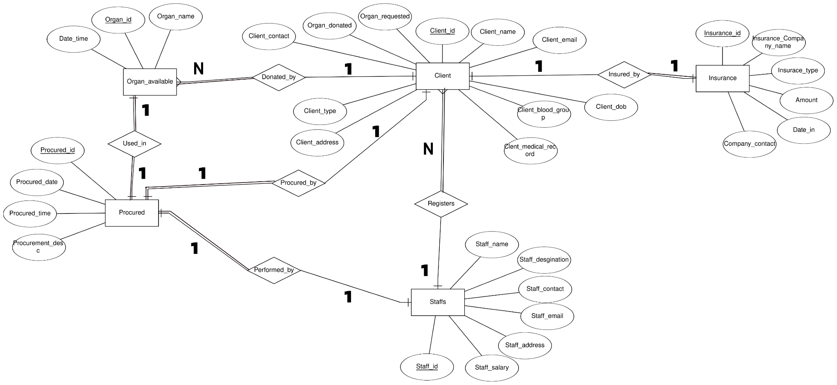

**ER DIAGRAM DESCRIPTION**

**Staff** registers **clients** , (client can be donor or recipient), only some **staff** are authorized to register. And only a few staff (Organization head) are allowed to access all data. One staff member can register more than one client.

Registered donor (client), if successfully donates the organ then the organ will be displayed in **Organ_Available** via **Donated_By** which is visible to Recipient and Recipient can request for the available organ.We assumed that one donor can donate more than one organ at a time.

Registered recipient (client), if requested organ is available then recipient can procure organ, this transplant details will be displayed in **Procured** via relationship **Procured_By.**

**Organ_Available** is related to **Procured** via **Used_in** relation. Organs used in transplantation will be removed from **Organ_Available.** We assumed one recipient can procure only one organ at a time.

Every client (donor, recipient) has medical insurance stored in **Insurance** related to **Client** via **Insured_By.** We assumed every client has single medical insurance. This insurance amount will be taken into consideration for transplantation fees,

**Procured** contains details of successful transaction/transplantation done. We assumed only staff can handle one procurement process at a time.

**5.2 RELATIONAL SCHEMA**

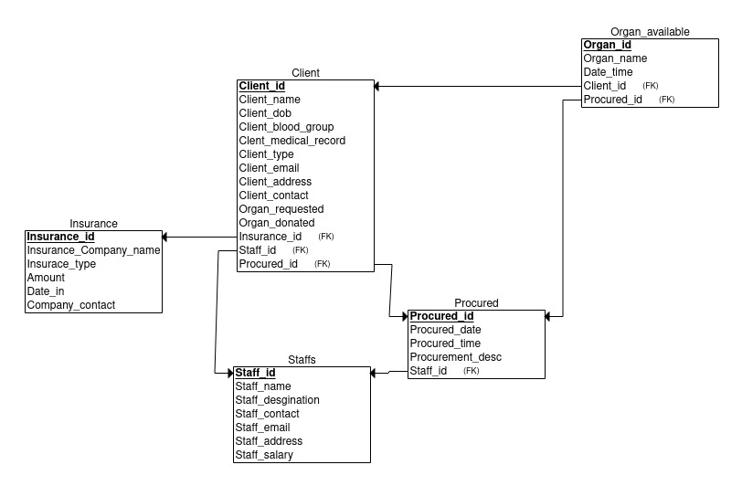

Before normalization, the relational schema has 5 tables.

**5.3 NORMALIZATION**

**Normalized Relational Schema**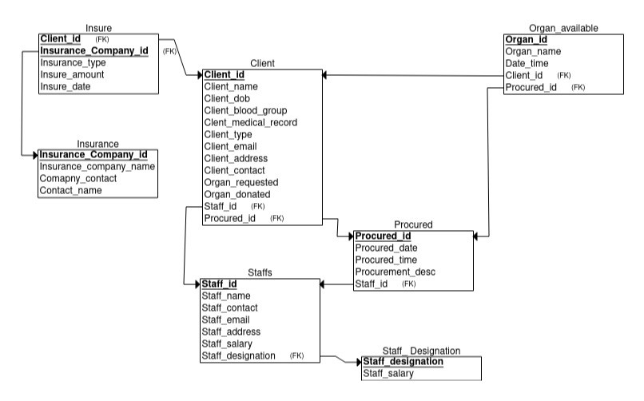

* **Client**(Client_ID,Client_dob,Client_blood_group,Client_name,Organ_donated,Organ_requested,Client_contact,Client_email,Client_address,Client_type,Client_medical_record)
  + The relation is in 1NF as it does not contain any multi-valued or composite attributes.
  + The relation is in 2NF as it is in First Normal Form and it has no partial dependency
  + The relation is in 3NF as there is no transitive dependency for the non-prime attributes

* **Organ Available**(Organ_id,Organ_name,Date_time)
* The relation is in 1NF as it does not contain any multi-valued or composite attributes.
  + The relation is in 2NF as it is in First Normal Form and it has no partial dependency.
  + The relation is in 3NF as there is no transitive dependency for the non-prime attributes
* **PROCURED** (Procured_id,Procured_Date,Procured_time,Procured_desc)
  + The relation is in 1NF as it does not contain any multi-valued or composite attributes.
  + The relation is in 2NF as it is in First Normal Form and it has no partial dependency.
  + The relation is in 3NF as there is no transitive dependency for the non-prime attributes
* **STAFFS**(Staff_id,Staff_Name,Staff_email,Staff_contact,Staff_address,Staff_salary,Staff_desgination)
  + The relation is in 1NF as it does not contain any multi-valued or composite attributes.
  + The relation is in 2NF as it is in First Normal Form and it has no partial dependency.
  + The relation is not in 3NF as there is transitive dependency for the non-prime attributes.
  + **(Staff_salary,Staff_designation)🡪(Staff_id) & (Staff_salary)**

**🡪(Staff_designation).**

* **INSURANCE**(Insurance_ID,,Company_Name,Company_Contact,Insurance_type,Insured_Date,insured_Amount)
  + The relation is in 1NF as it does not contain any multi-valued or composite attributes.
  + The relation is in 2NF as it is in First Normal Form and it has no partial dependency.
  + The relation is not in 3NF as there is transitive dependency for the non-prime attributes.
  + **(Company_Name,Company_contact)🡪(Insurance_ID)&(Company_contact)🡪(Company_name)**

**TABLES(after normalization):** Seven tables identified are-

1. CLIENT
2. STAFFS
3. JOB DESIGNATION
4. ORGAN AVAILABLE
5. PROCURED
6. INSURE
7. INSURANCE

**6.FUNCTIONALITIES**

1.Add client

2.Display client

3.Add organ

4,Display organ available

5.Match recipient with organ

6.Print bill

7.Add staff

8.Display staff

**7.TECH STACK**

1.Frontend Angular

2.Django(Backend)

3.Mysql(Database)

4.API

**8.IMPLEMENTATION**

**8.1 Login**

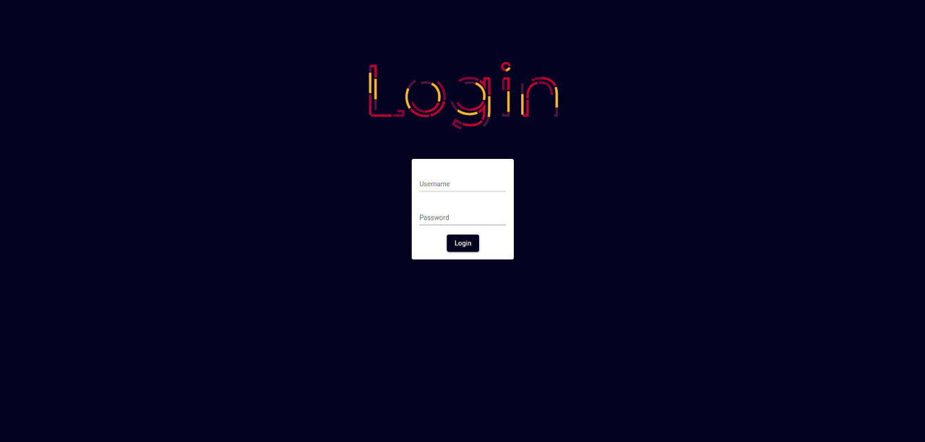

**8.2** **Dashboard**

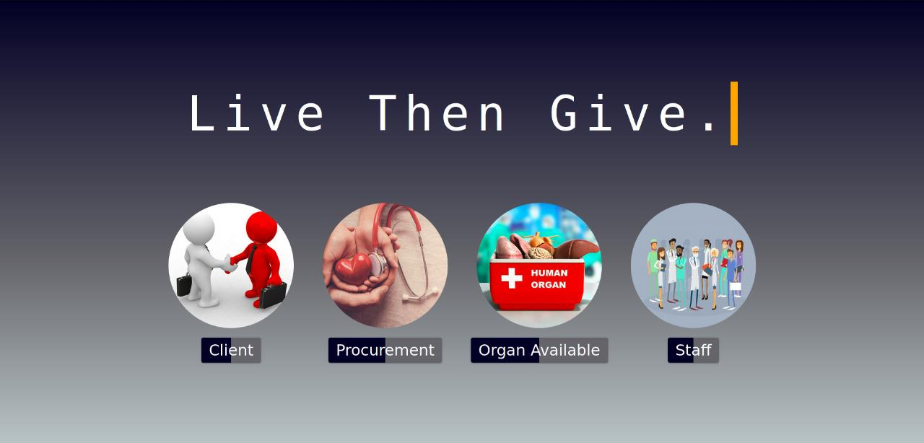

**8.3 Add Client**

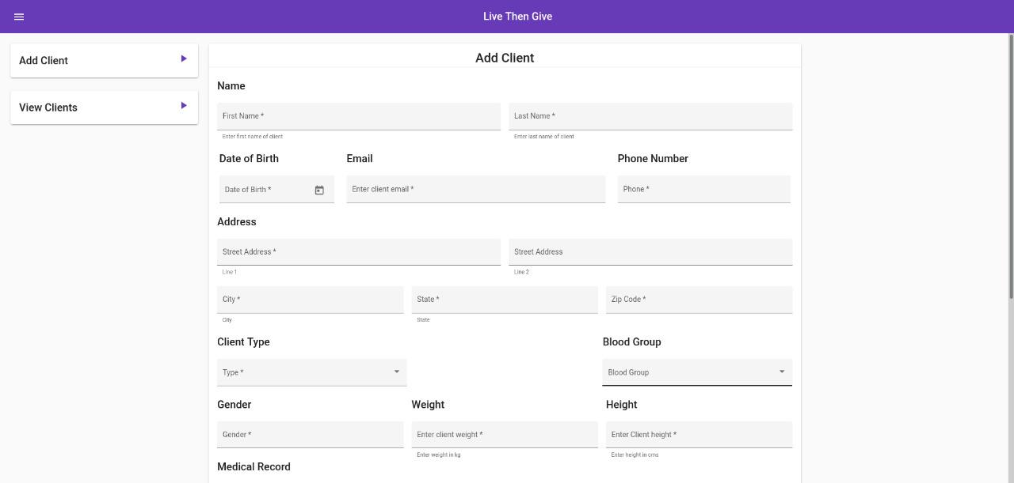

**8.4 Display Client**

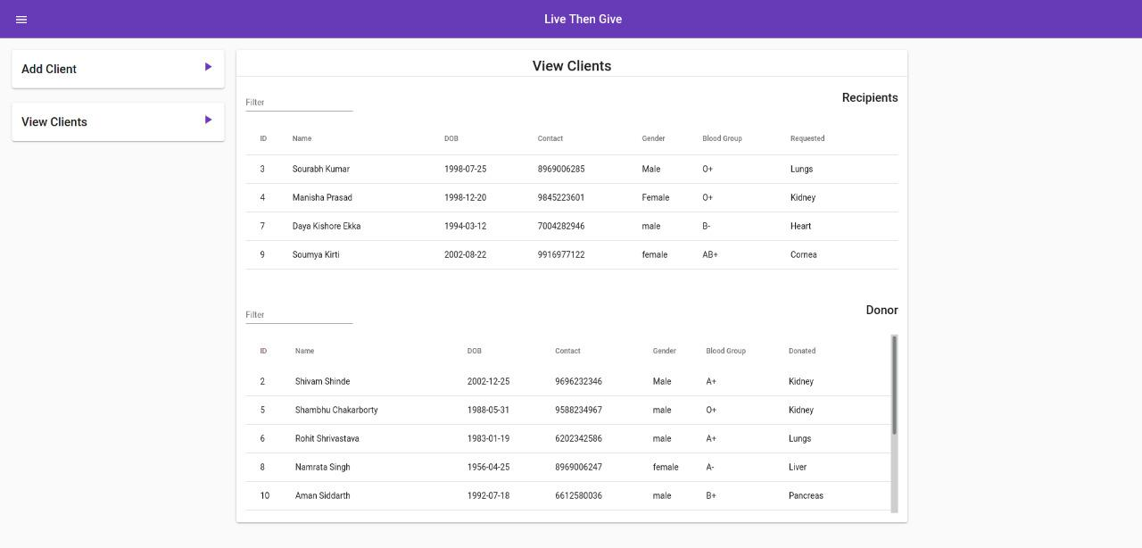

**8.5 Organ Available**

**8.5.1 Add** **Organ Available**

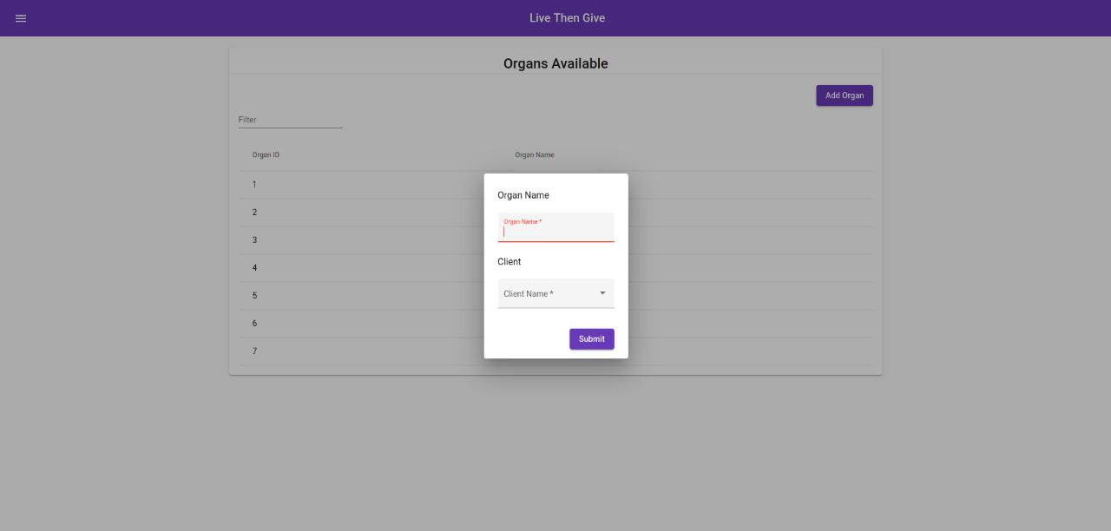

**8.5.2 Display** **Organ Available**

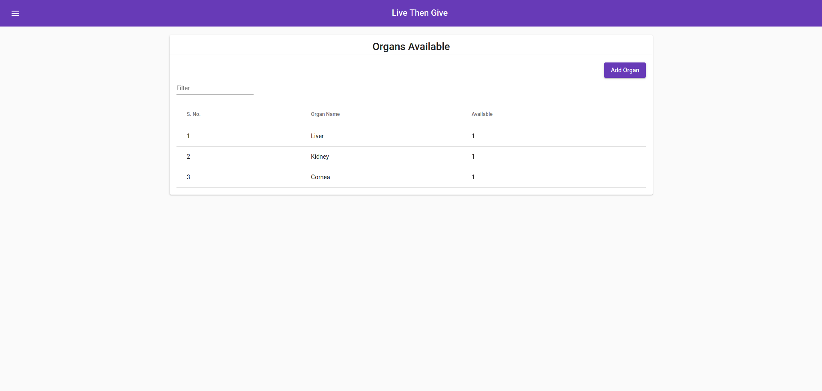

**8.6 Procurement**

1) Display recipient and match if it's available

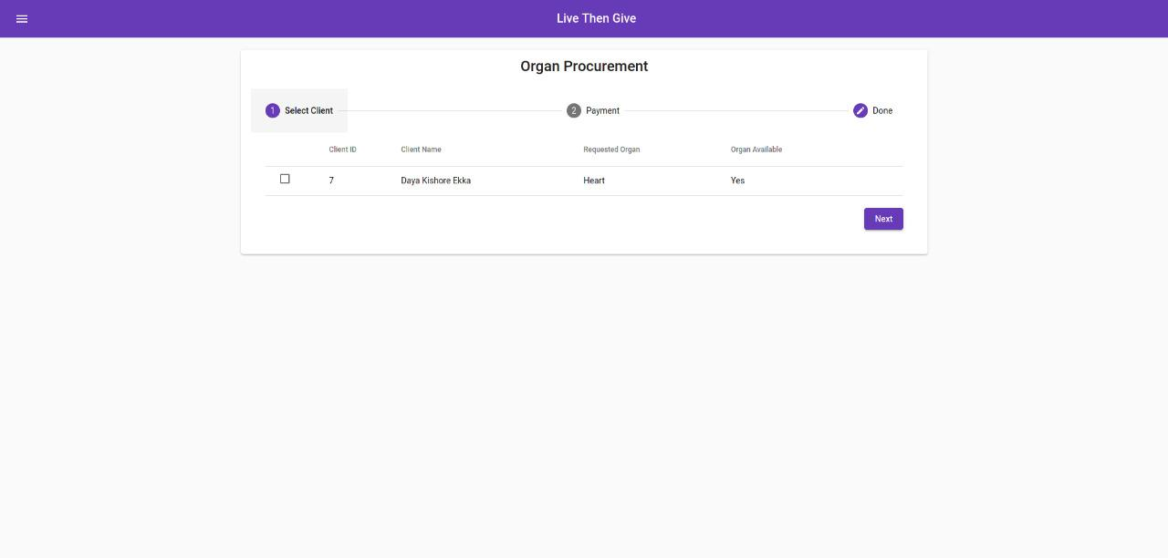

2) Fill the procurement details

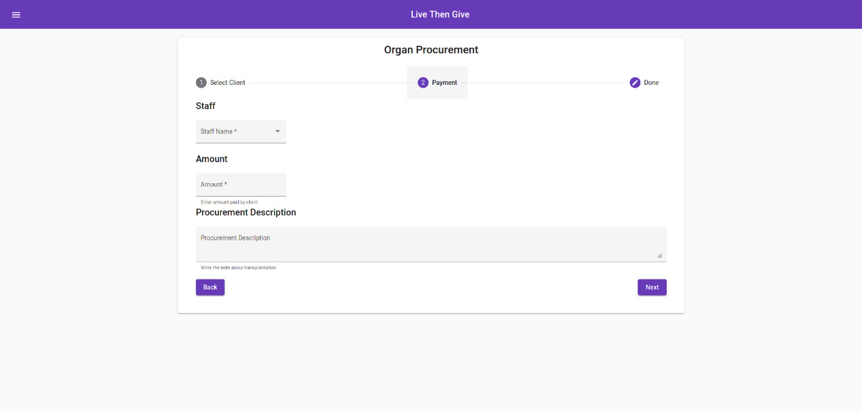

3) Review of filled details

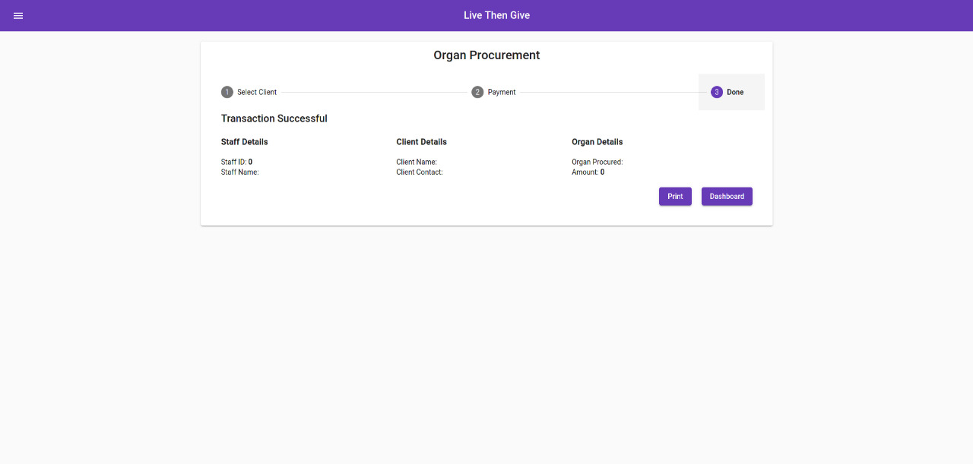

4) Printing the Bill

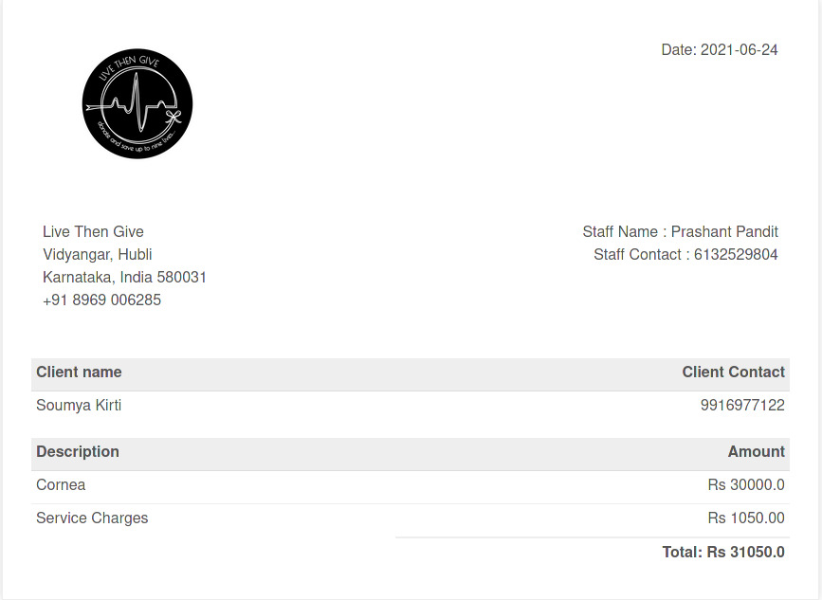

**8.7 Staff**

**8.7.1 Add Staff**

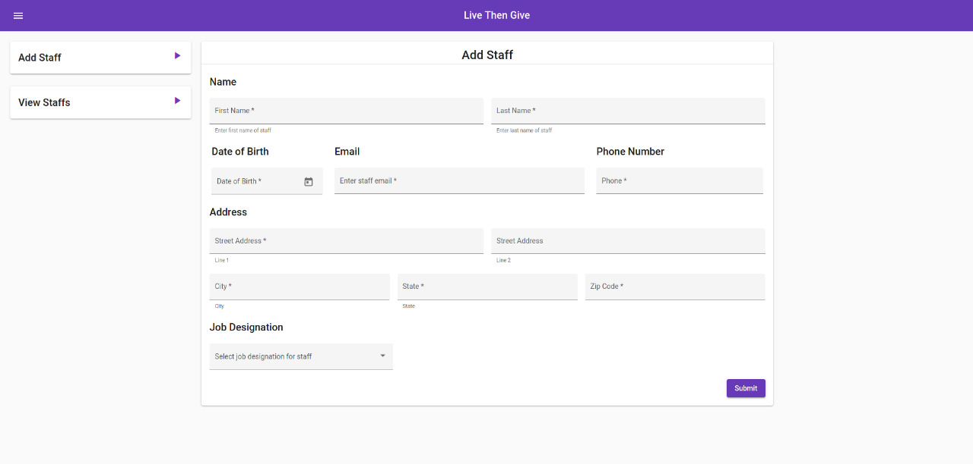

**8.7.2 Display Staff**

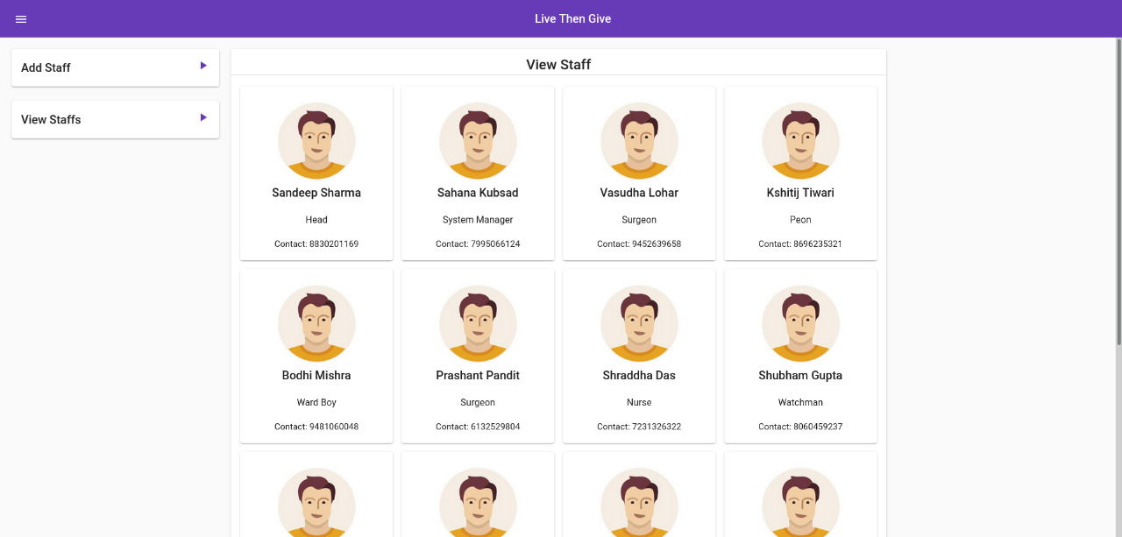

**9.DATABASE**

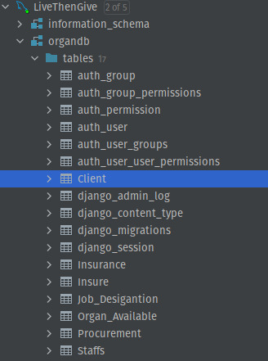

**9.1 Client**

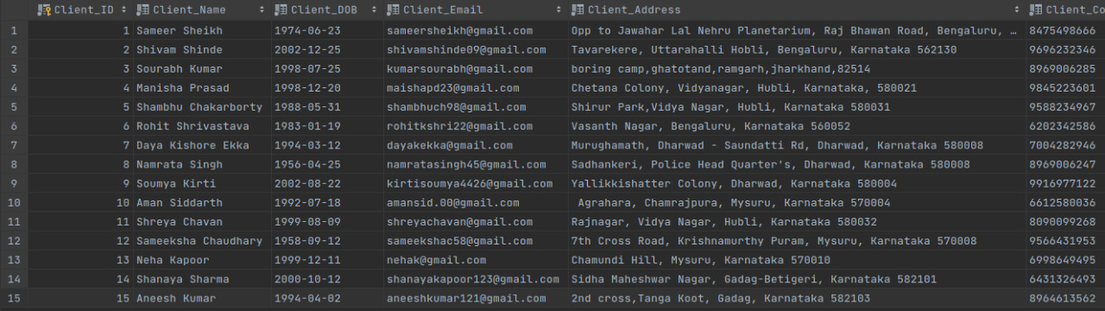

**9.2 Organ Available**

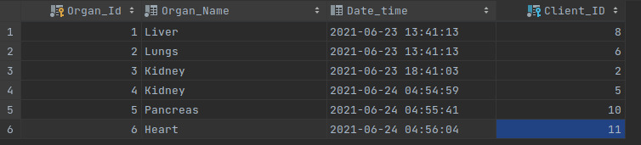

**9.3 Procurement**



**9.4 Insure**

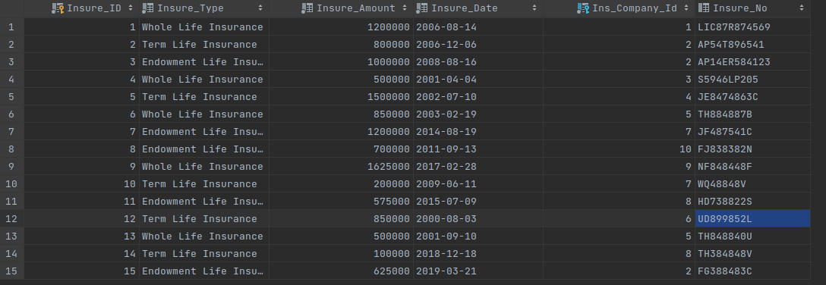

**9.5 Staffs**

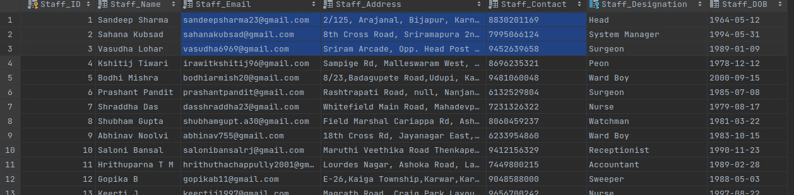

**9.6 Job Designation**

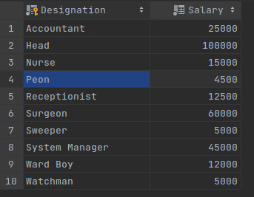

**References:**

**1.** [**https://www.organdonor.gov/about/process/transplant-process.html**](https://www.organdonor.gov/about/process/transplant-process.html)

**2.** [**https://en.wikipedia.org/wiki/Organ_donation_in_India**](https://en.wikipedia.org/wiki/Organ_donation_in_India)

**3.**[**https://journals.lww.com/transplantjournal/abstract/2018/07001/implementation_of_a_quality_management_system_on.1249.aspx**](https://journals.lww.com/transplantjournal/abstract/2018/07001/implementation_of_a_quality_management_system_on.1249.aspx)

**4.**[**https://www.internationaljournalssrg.org/uploads/specialissuepdf/ICIMCEH-2020/2020/CSE/P105.pdf**](https://www.internationaljournalssrg.org/uploads/specialissuepdf/ICIMCEH-2020/2020/CSE/P105.pdf)