**Assignment No 13**

**Problem Statement:**

Create a WorkMail for your organization.

**Solution:**

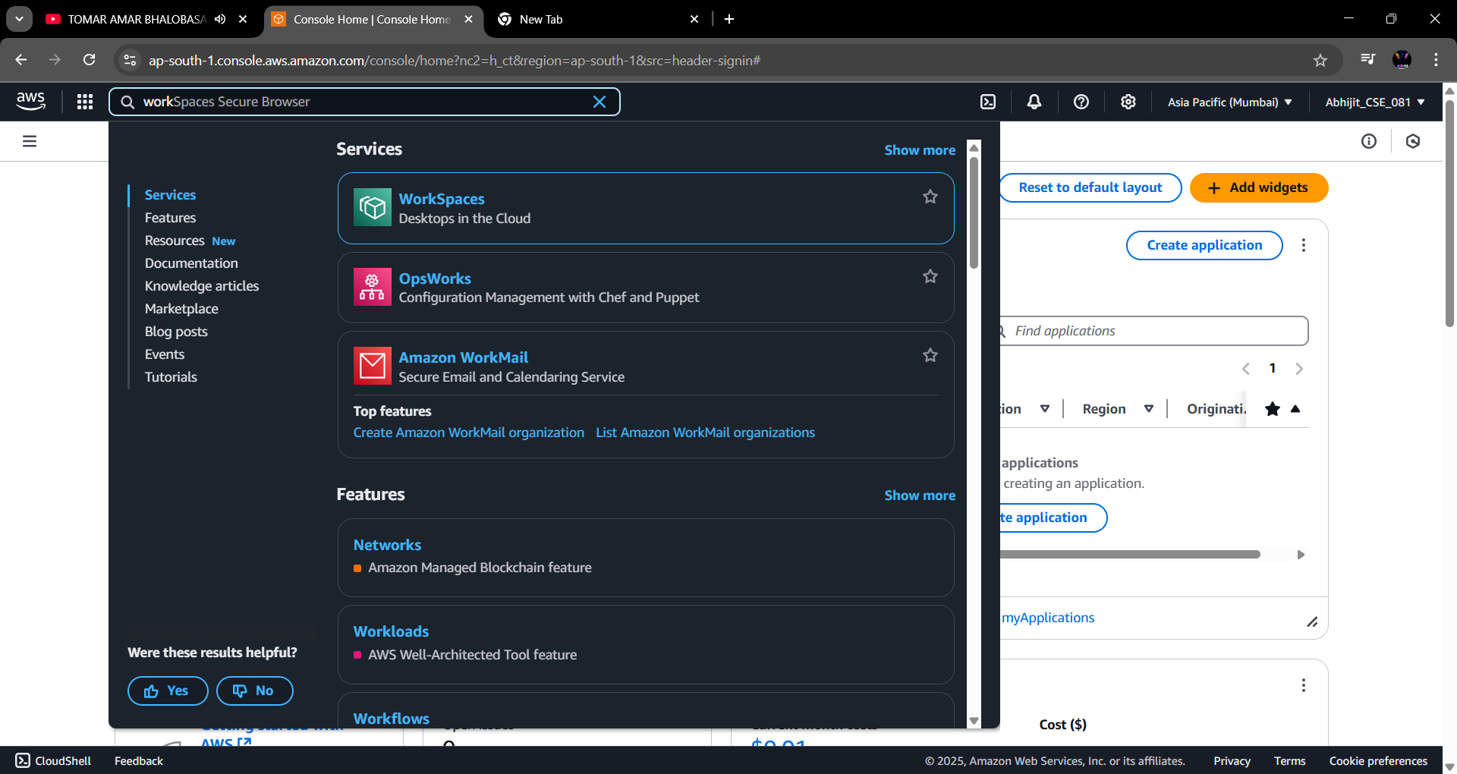**Step 1:** Search for **“Amazon WorkMail”** in the search bar & open it.

**Step 2:** Click on **“Create Organization”**.

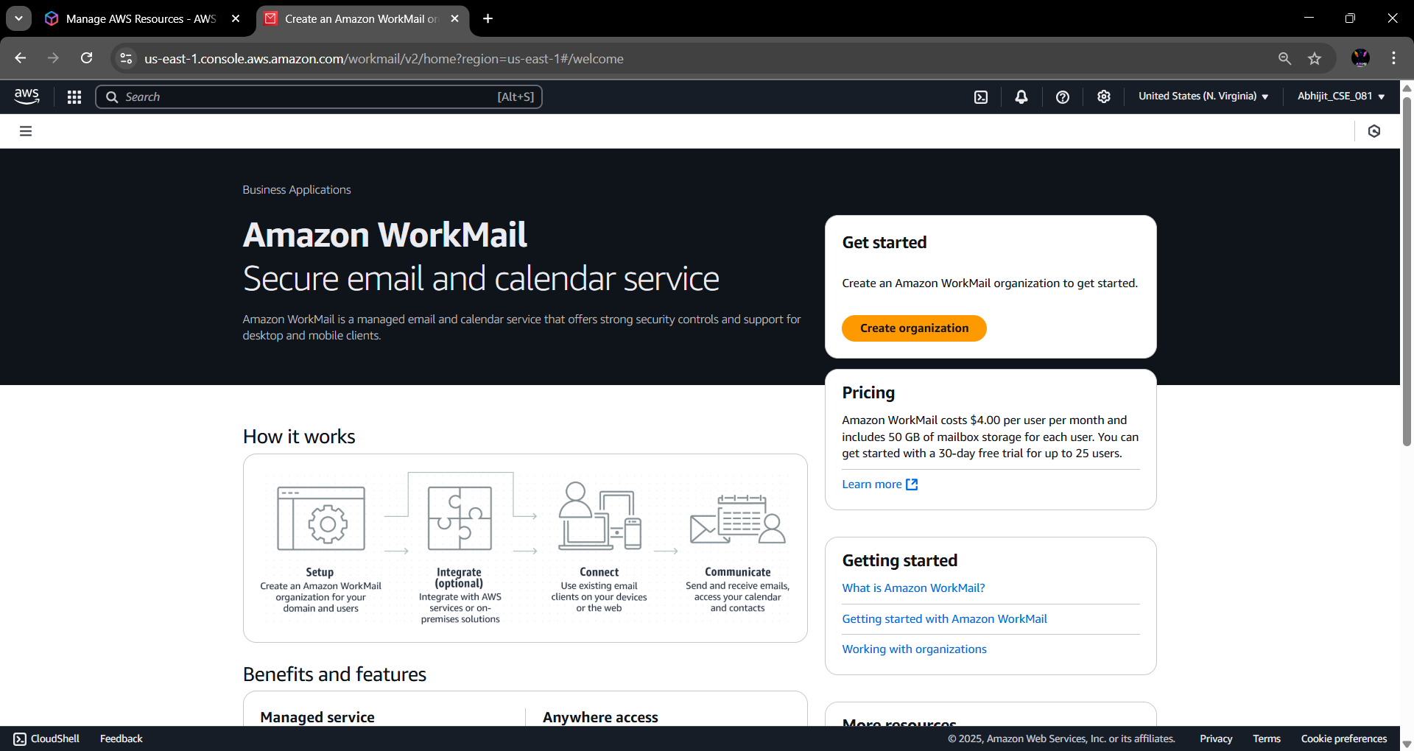

**Step 3:** Under Organization settings select **“Free Test Domain”**. Give the organization name under alias. Then click on **“Create Organization”**.

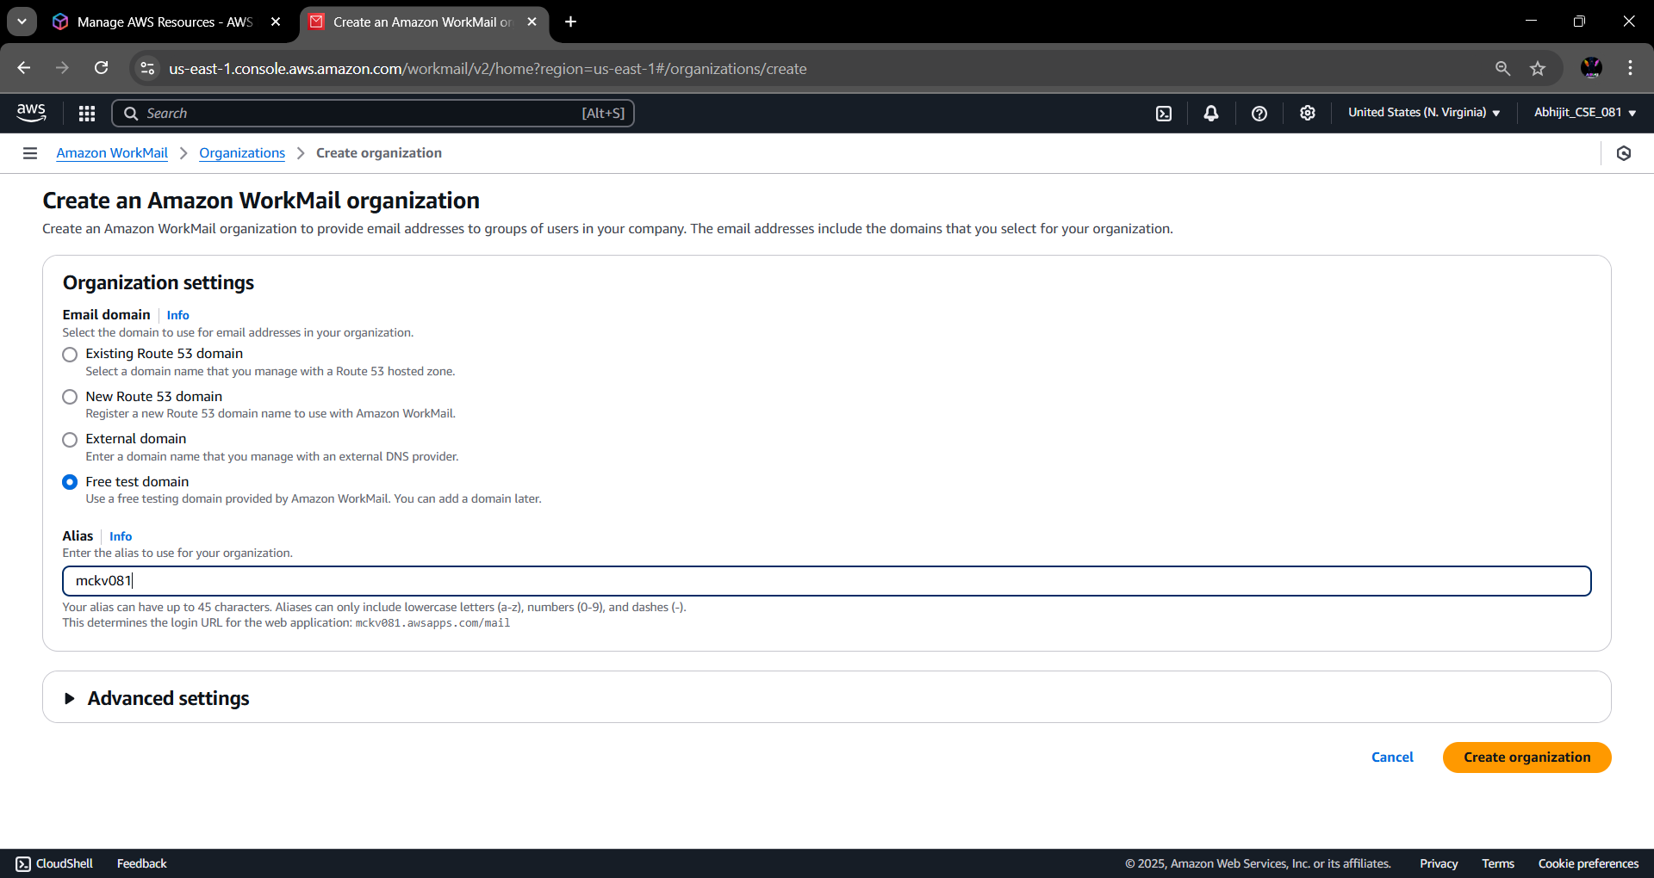

**Step 4:** The organization is created successfully. Click on the organization name to enter into it.

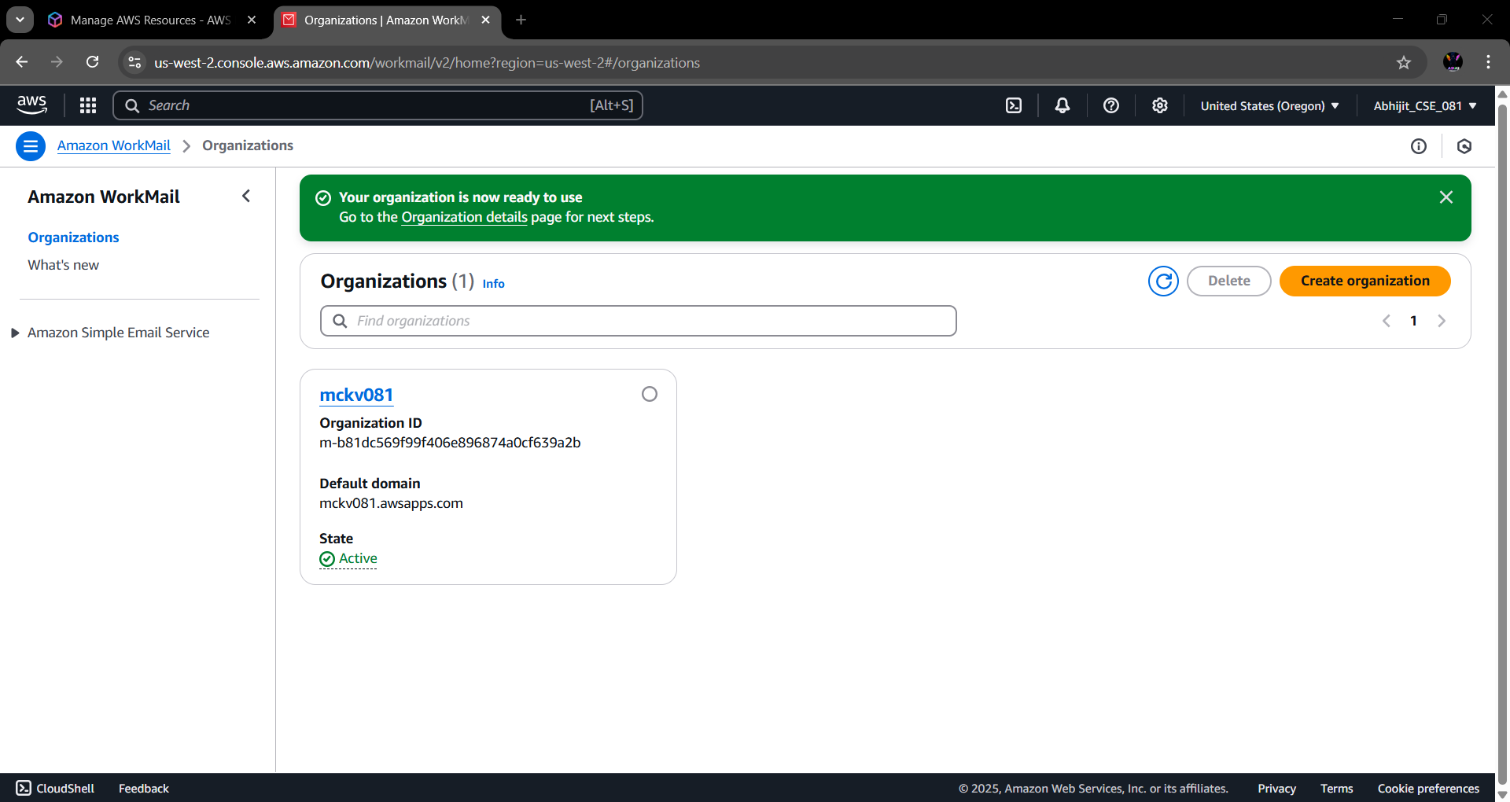**Step 5:** From the left side menu, go to the **“Users”** option under Organization.

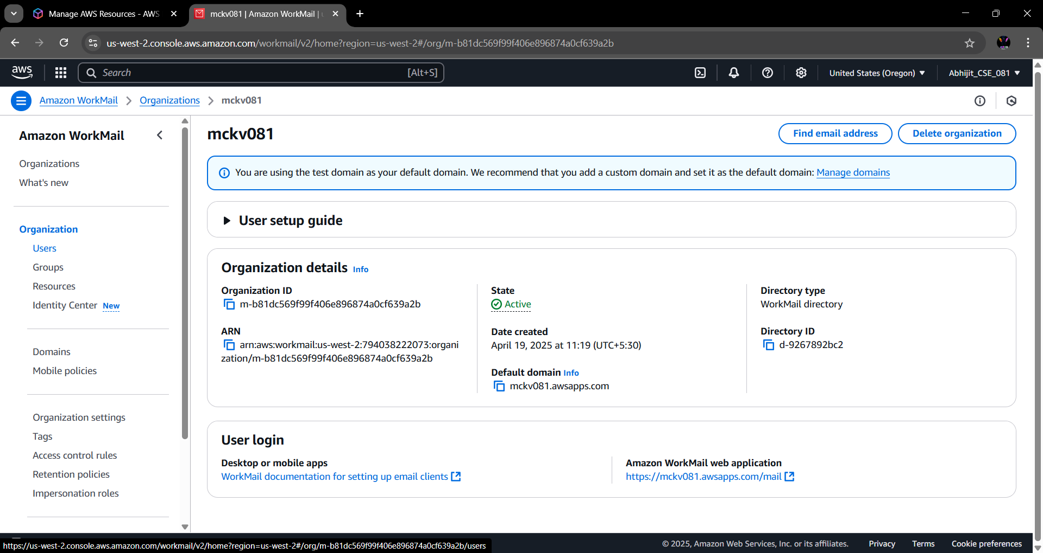

**Step 6:** Click on **“Add User”** button.

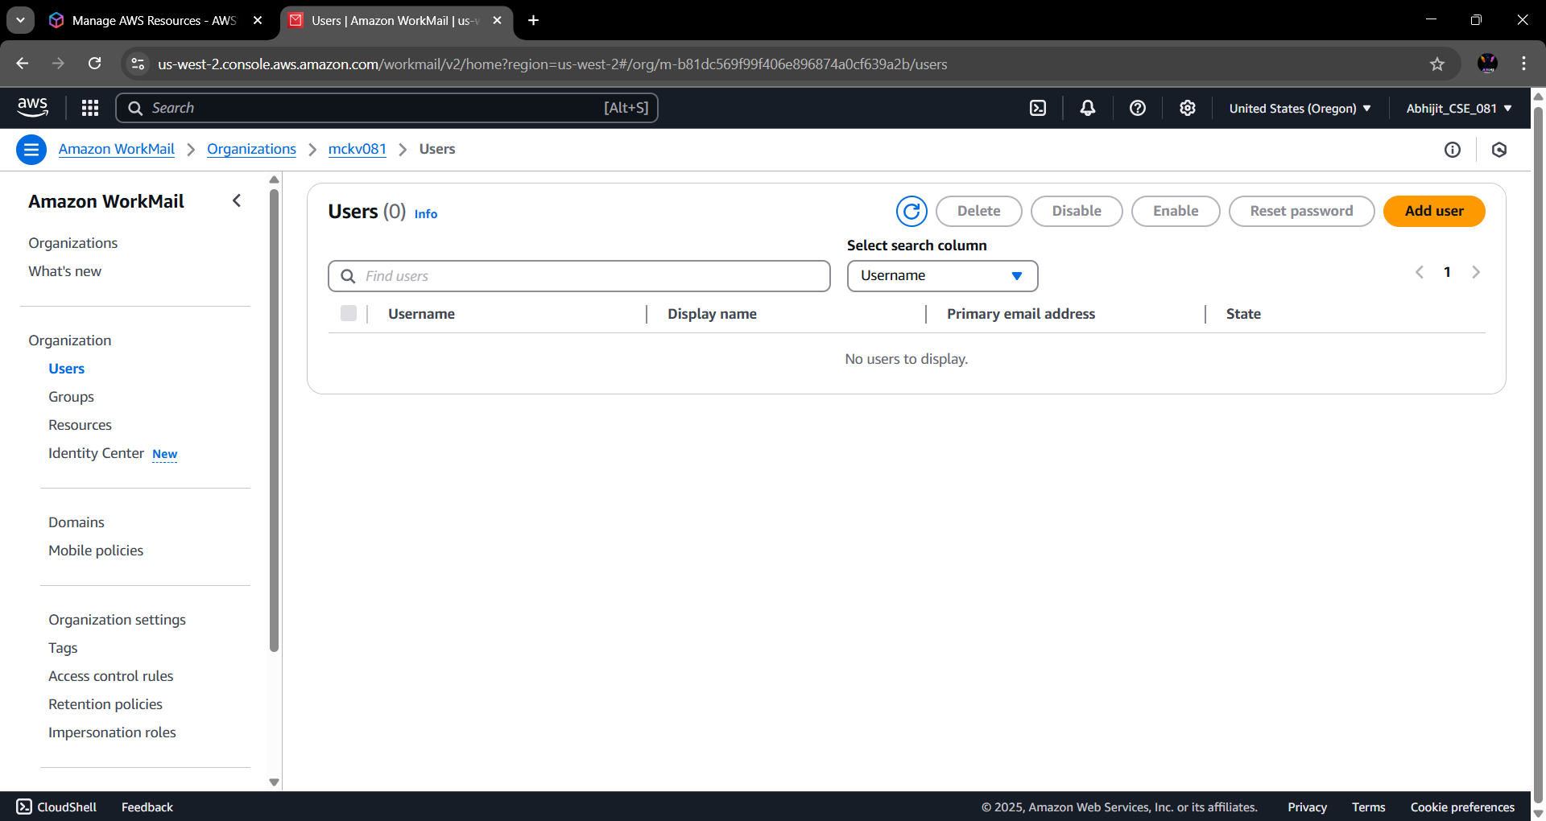

**Step 7:** Fill basic user details.

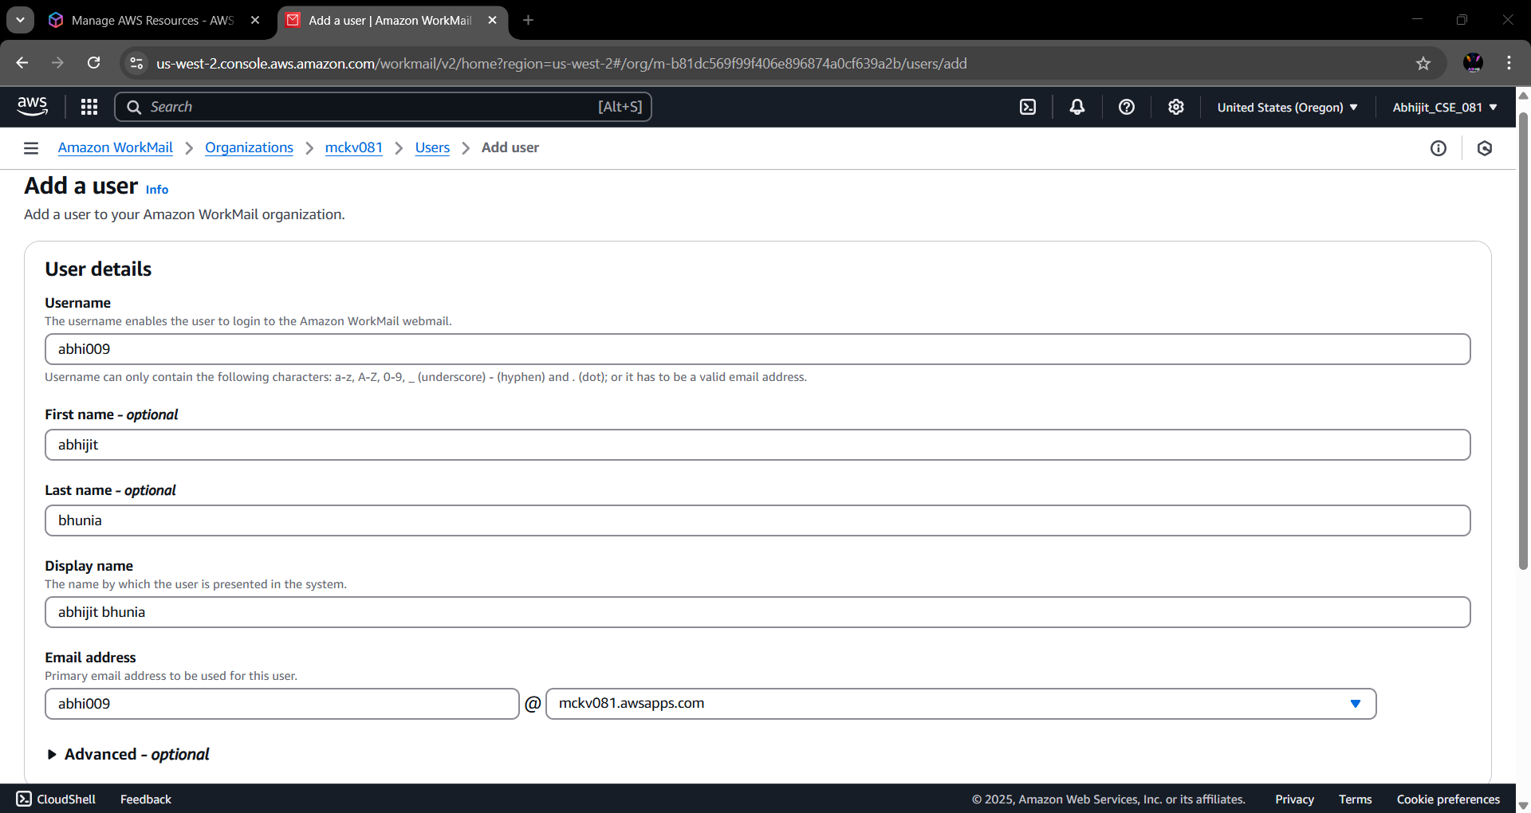

**Step 8:** Set up a password. Then click on **“Add User”**.

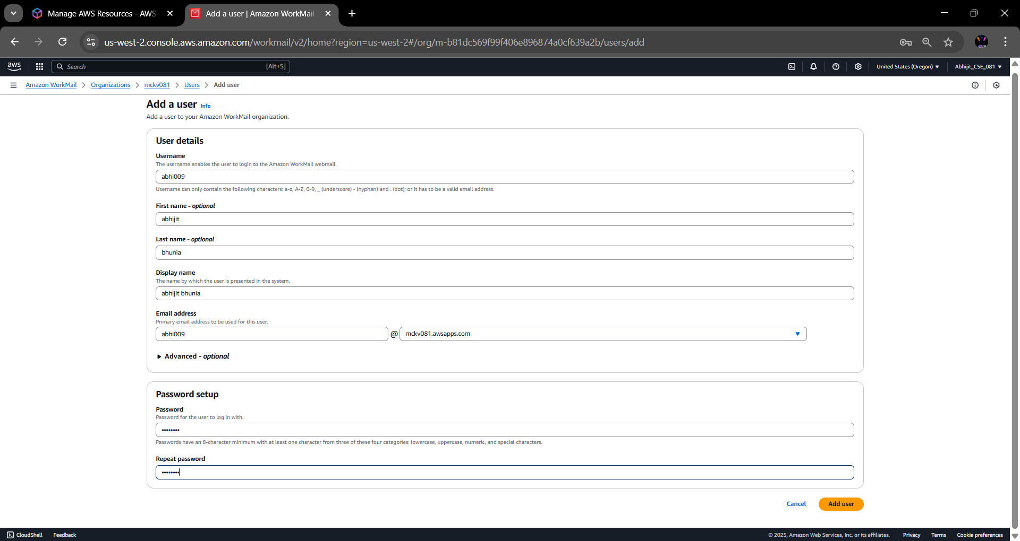

**Step 9:** The user is successfully created. Now, go back enter into Organization.

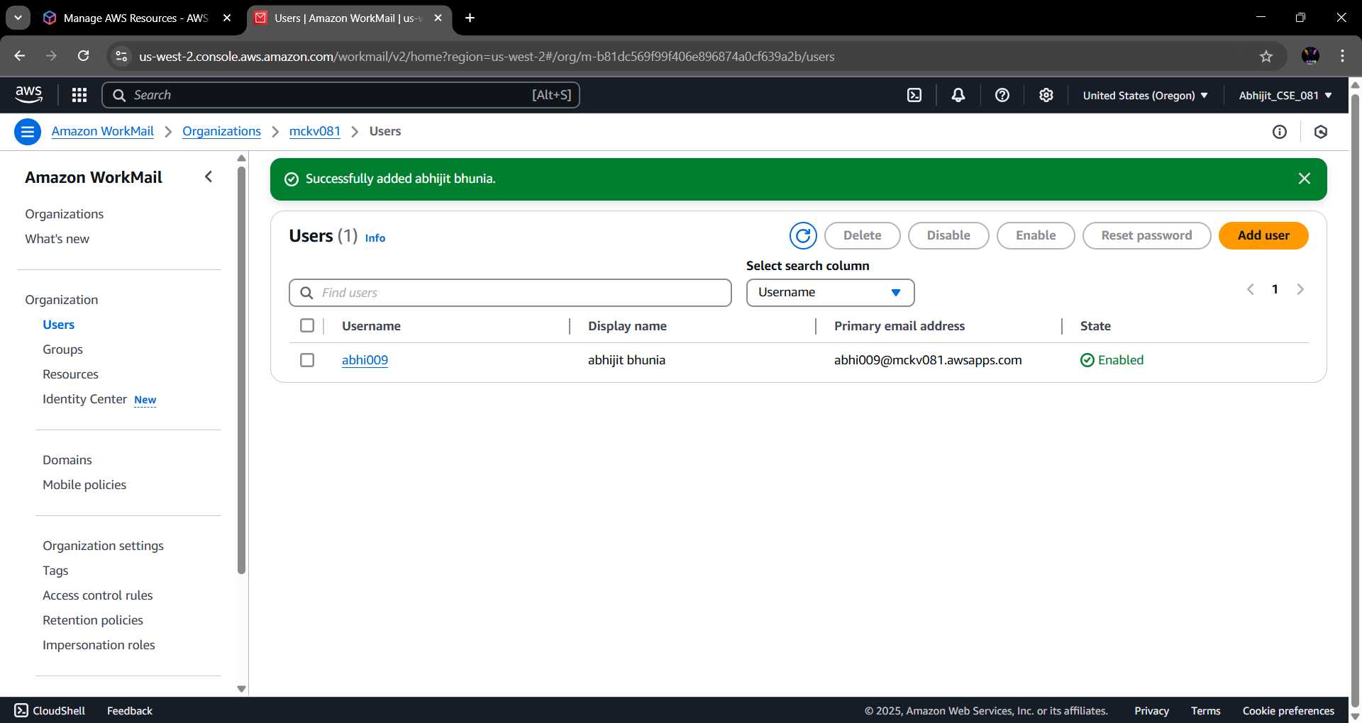

**Step 10:** From the bottom of the screen, click on the **“Amazon WorkMail Web Application”** link.

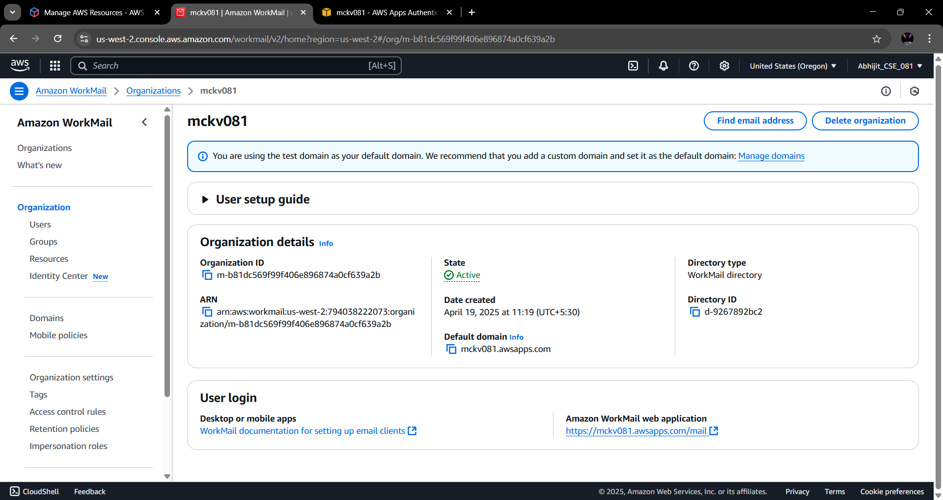

**Step 11:** Login into the Amazon WorkMail with ‘User Name’ and ‘Password’.

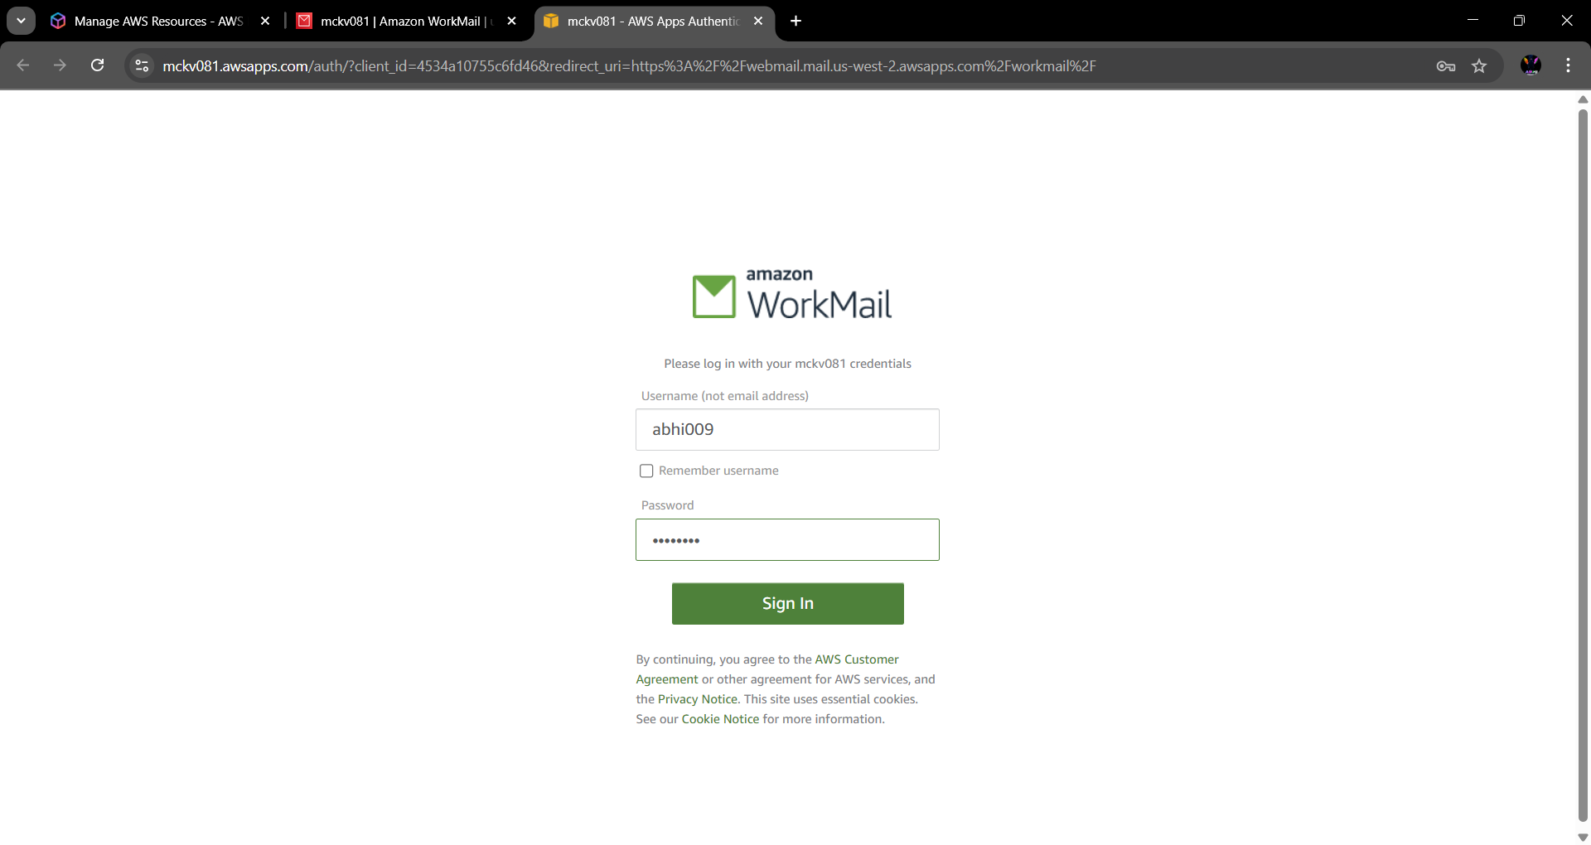

**Step 12:** In AWS WorkMail, click on ‘New item’ section choose ‘New Email’. Composed A new workmail with ‘Receiver Email Address’ and write something in the mail body. Finally click on ‘Send’ option.

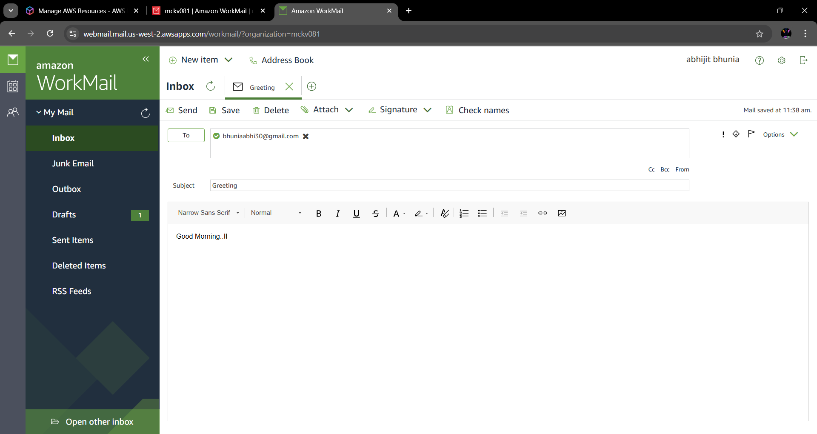

**Step 13:** Now in Receiver end workmail is received successfully.

