Assignment-3

**PROBLEM STATEMENT:**

Create IAM user and give full access to S3.

**Solution:**

1. From AWS console search for IAM and click on it.

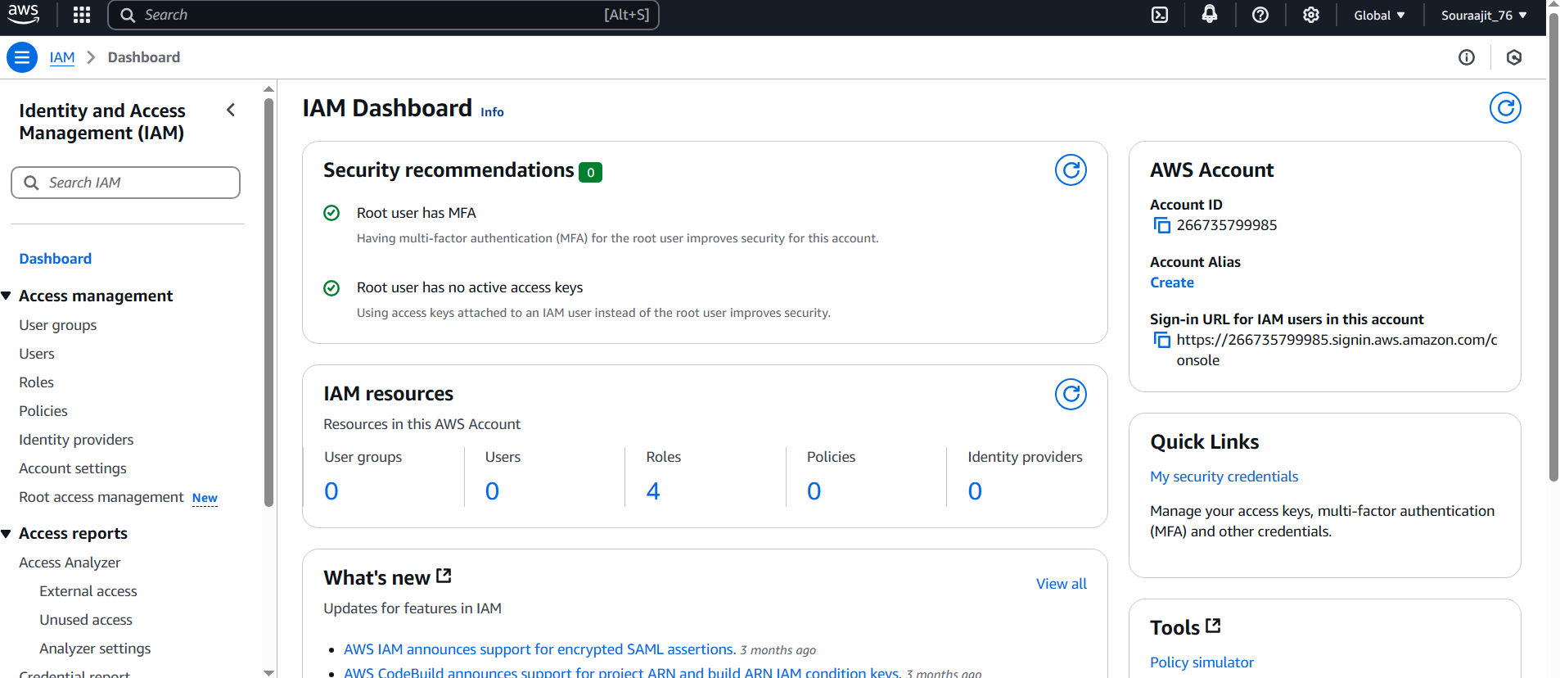

2.Under IAM resources click on ‘Users’.

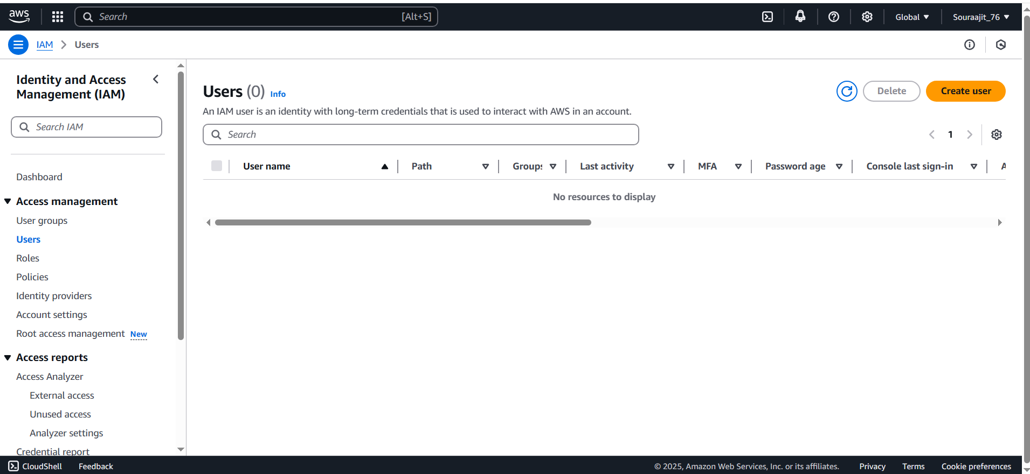

3.Click on ‘Create User’. Provide User details (name, password, etc.) and click on “Next” to proceed.

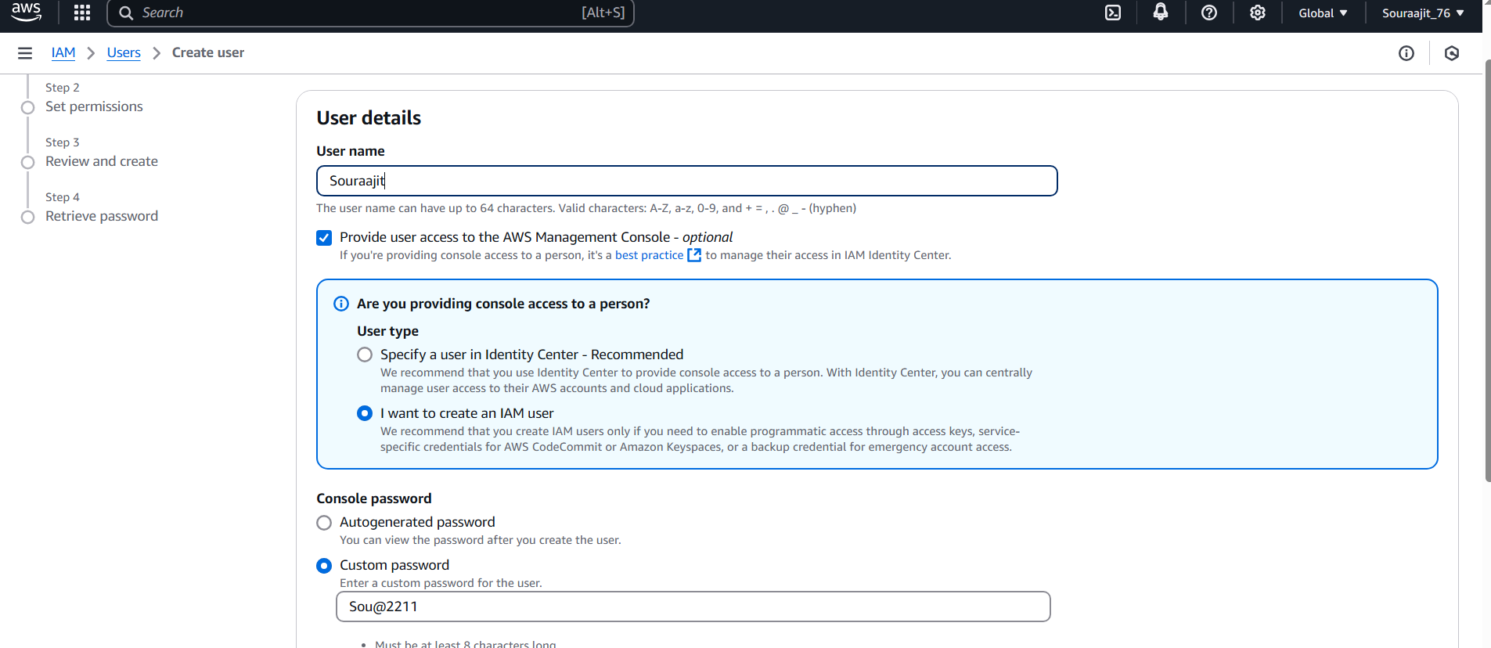

4.Under ‘Permissions options’, click on ‘Add user to group’ and go to ‘Create group’.

To ‘Create user group’, first provide ‘User group name’, then from permission policies search for s3 and select full access of the particular permission we want to give to that group. Then click on “Create User Group”.

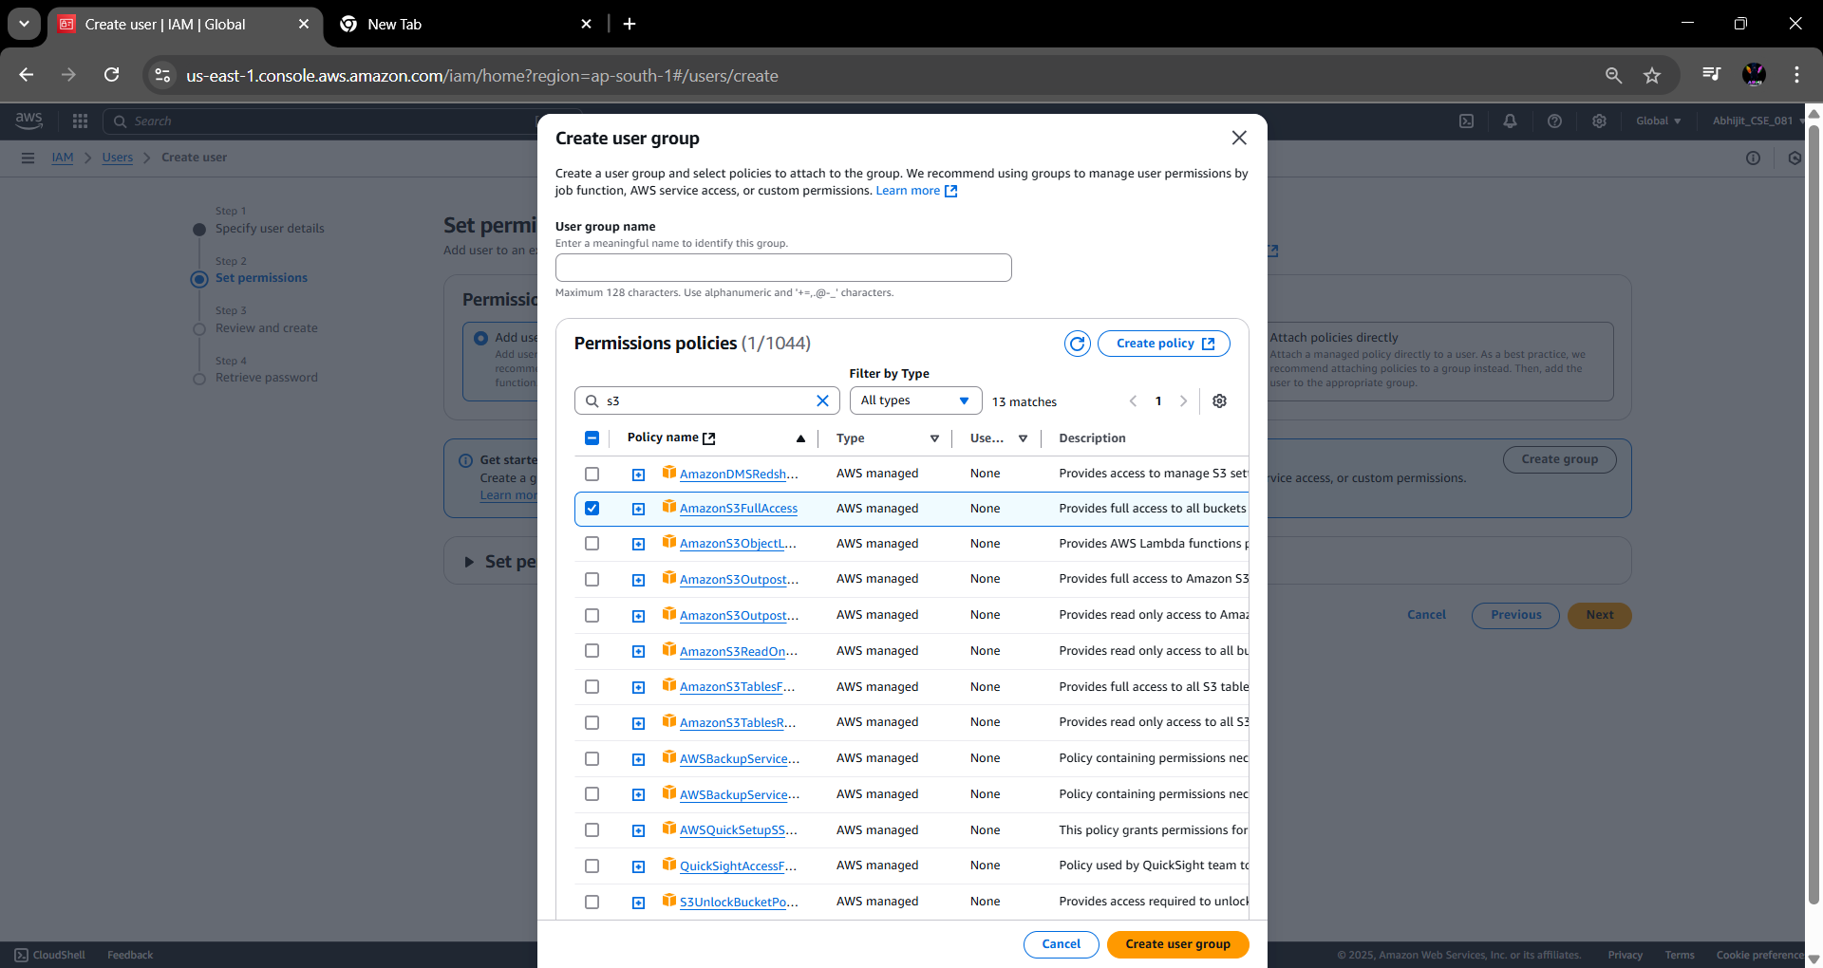

5.The group is successfully created. Tick the checkbox of the created group in ‘User groups’, so that our IAM user is connected to this group and gets the required permission. Then click on ‘Next’.

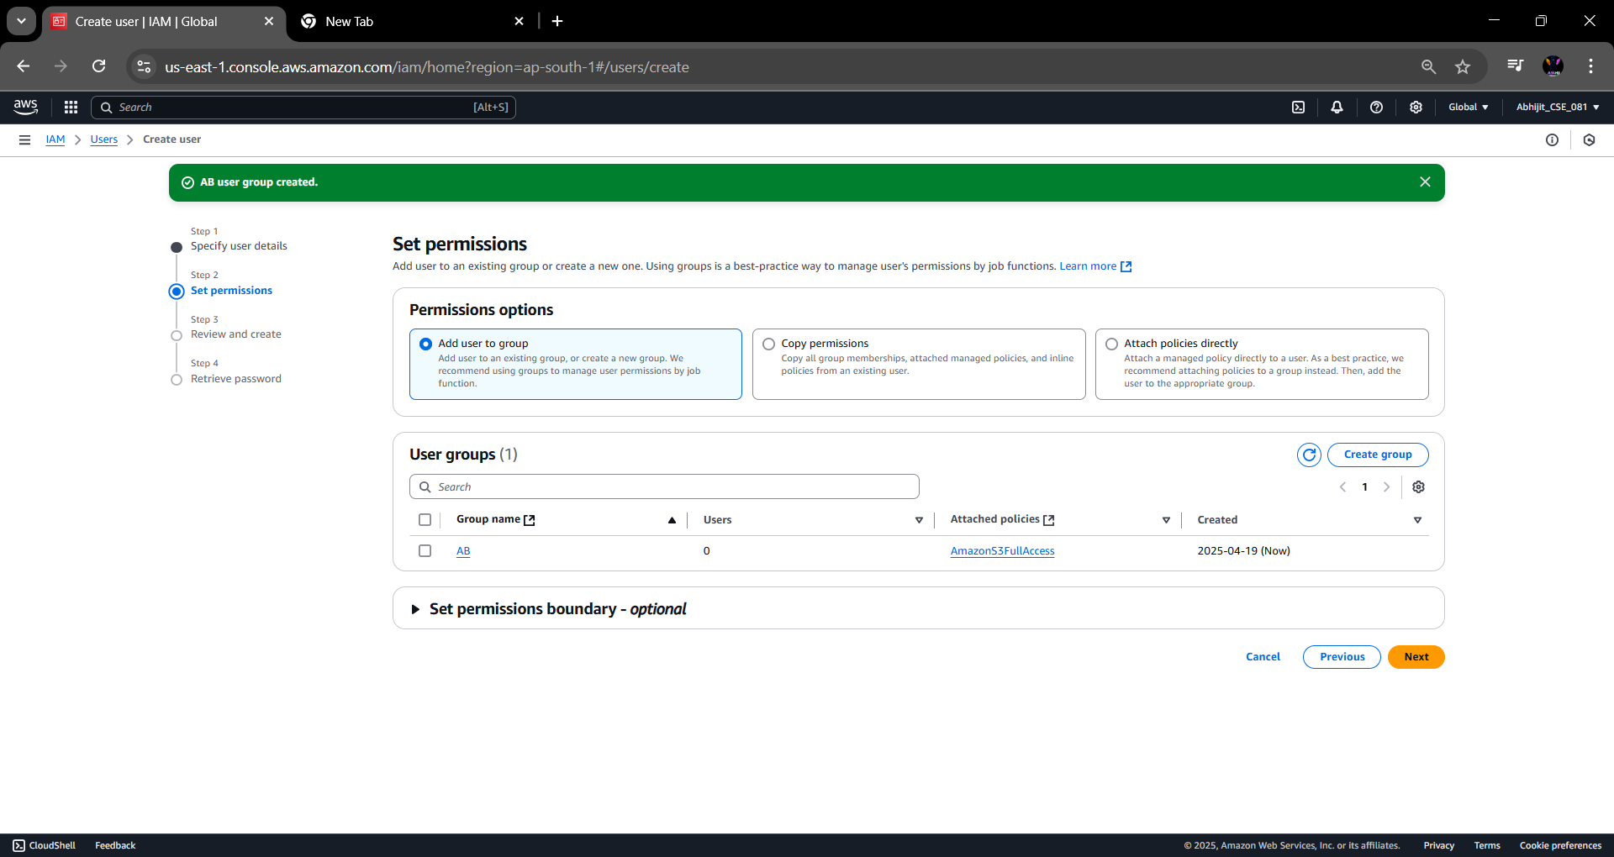

6.Under ‘Review and create’, click on ‘Create user’ to create our IAM user

7.IAM user is created successfully.

