**Assignment No: 09**

**Deploy a project from GitHub to EC2.**

**Solution:**

**Step 1:**  Upload required files to GitHub

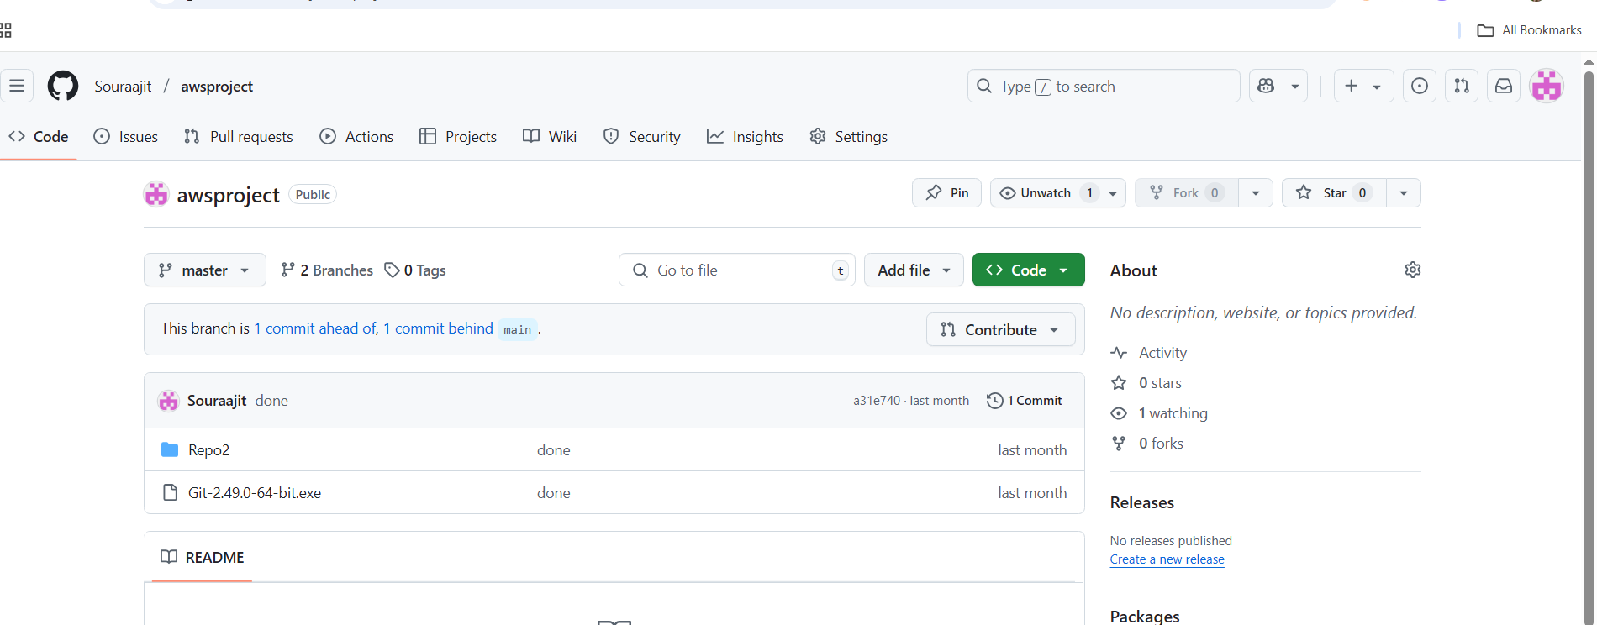

**Step 2:**

Log into AWS and open EC2. Click on launch instance. Give a name to the instance and select the operating system as Ubuntu.

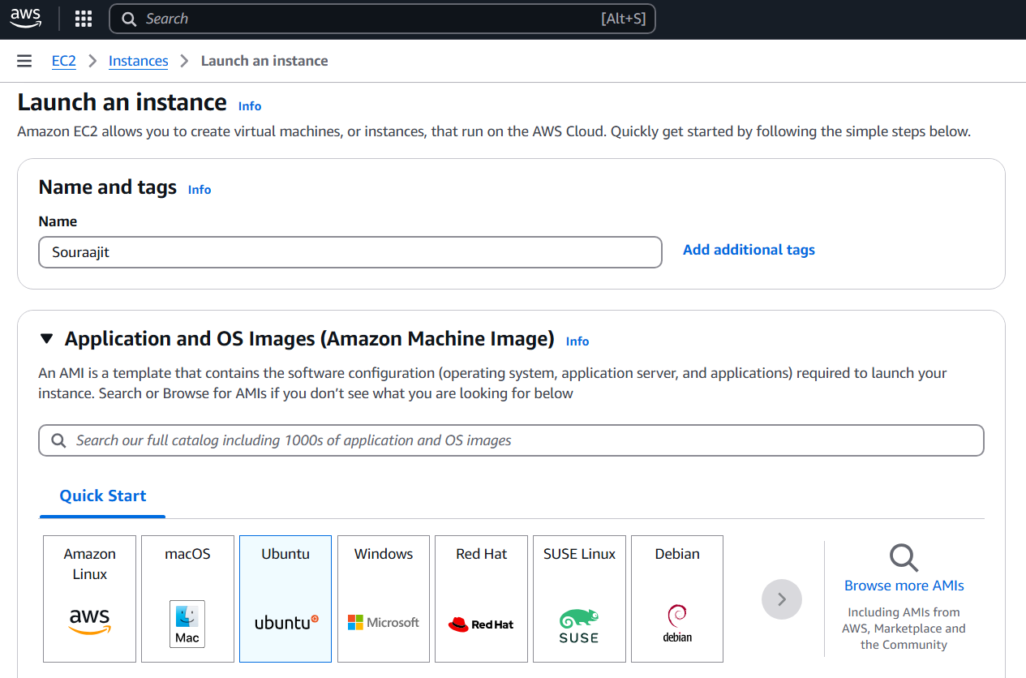

**Step 3:** Create Key Pair.

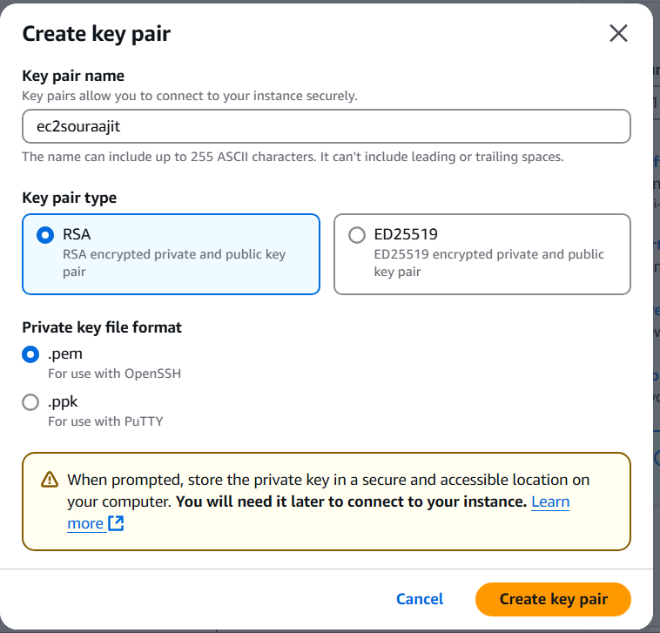

**Step 4:** Check the 3 boxes to allow SSH, HTTP and HTTPS traffics and click launch instance.

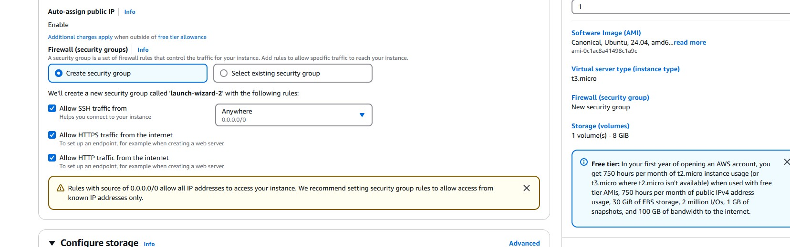

**Step 5:** Open instances and click of the instance Id of the instance. Copy the IPv4 address.

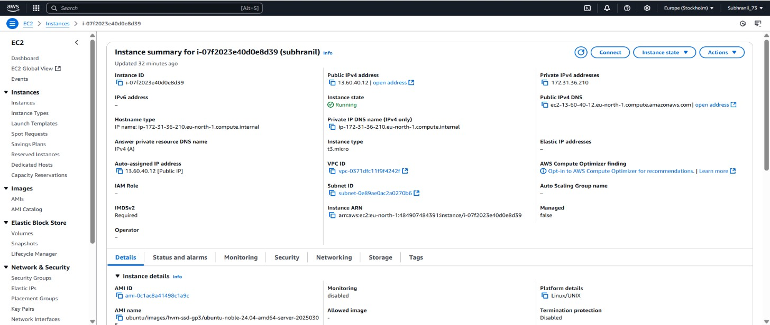

**Step 6:** Open Bitwise SSH Client and paste the IP address in host and set up authentication using the key pair then login and after logging in open new terminal window.

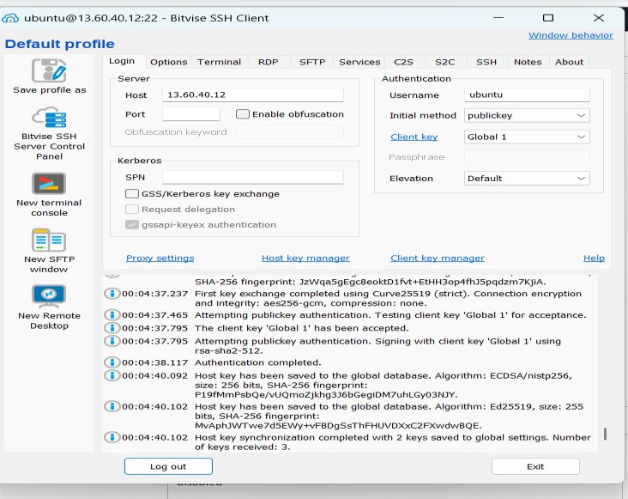

**Step 7:** Then Execute command sudo apt-get update and sudo apt-get upgrade in the Bitvise SSH Client Terminal.

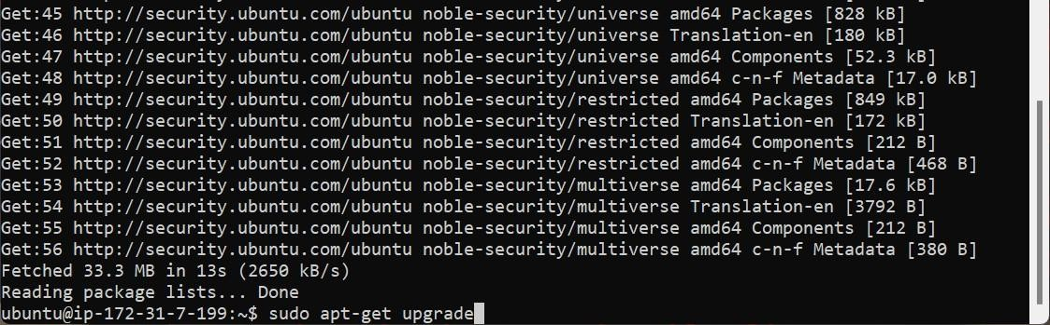

**Step 8:** Now Execute sudo apt -get install nginx Cmd for setting up the web server.

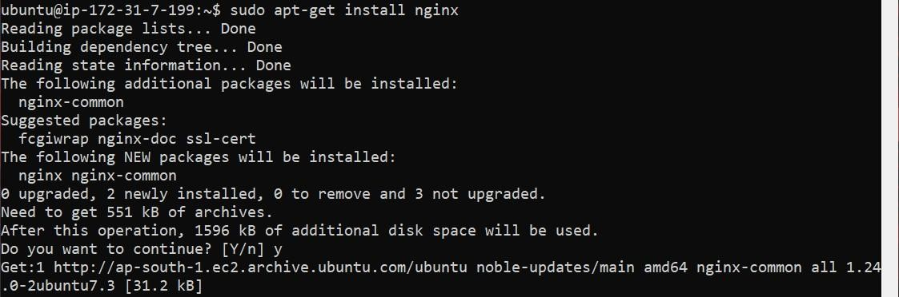

**Step 9:** After that, then open the directory that is cloned using command cd name of the directory. Then install NodeJS using commands curl:https://deb.nodesource.com/setup_18.x | sudo -E bash – and sudo apt-get install nodejs.

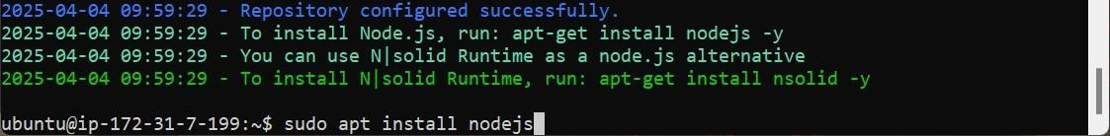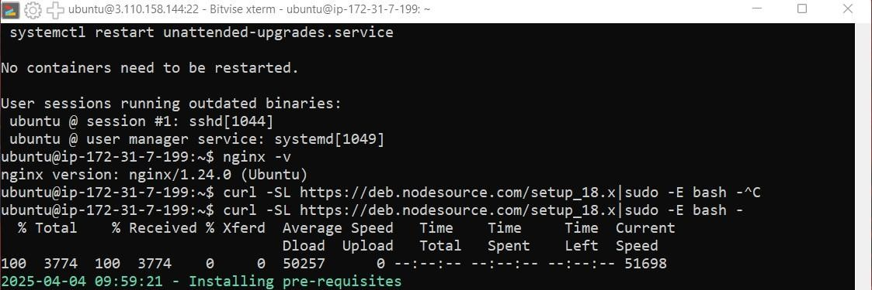

**Step 10:** Now clone the GitHub repository from GitHub using command git clone paste the link of the repository.

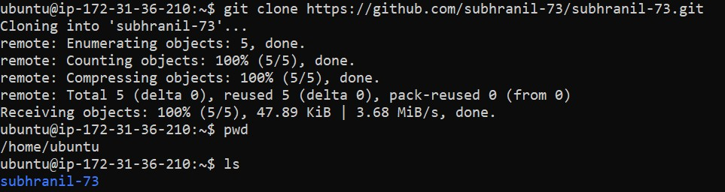

**Step 11:** After installing nodejs use npm install command to install required dependencies.

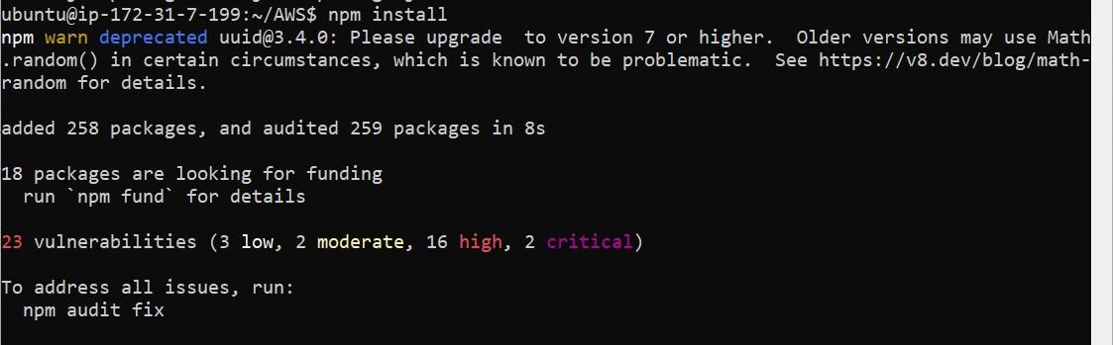

**Step 12:** Now open AWS and open the current instance then scroll down and go to security Section. Then click on the link in security groups then click on edit inbound rules.

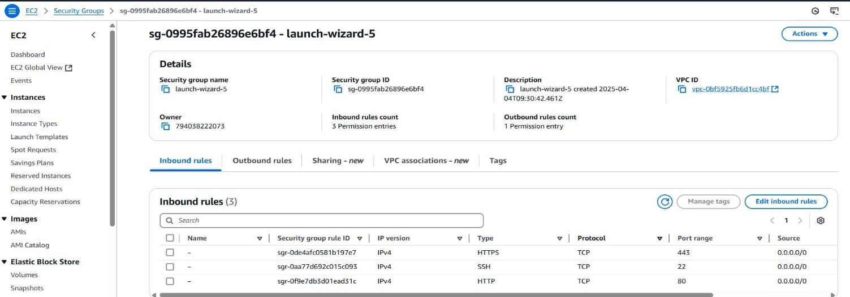

**Step 13:** Click on add rule and select the type of new rule custom TCP Port range 4000 source 0.0.0.0 or anywhere then click on save rule.

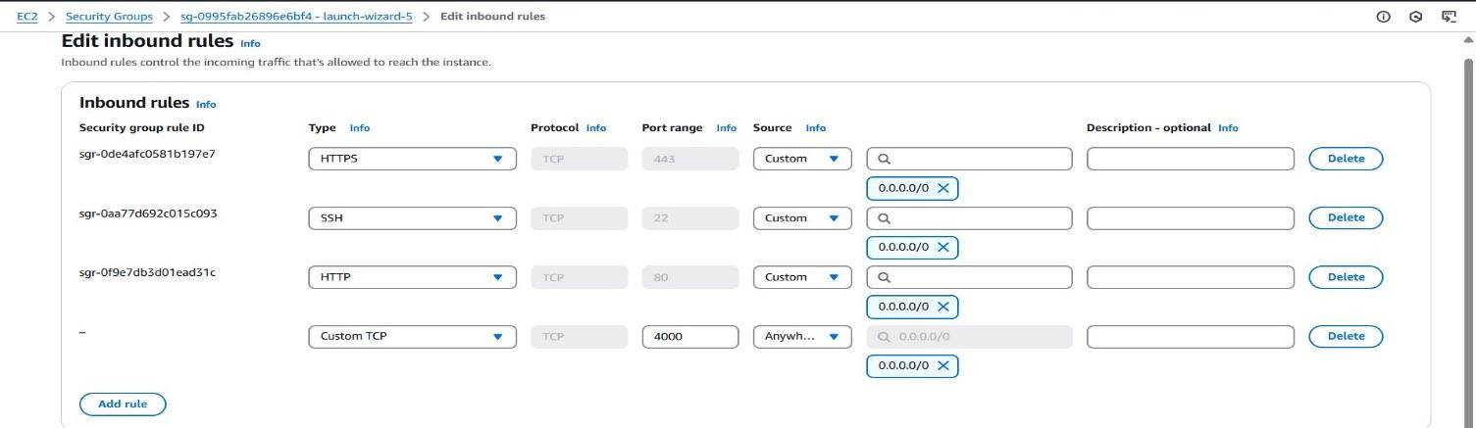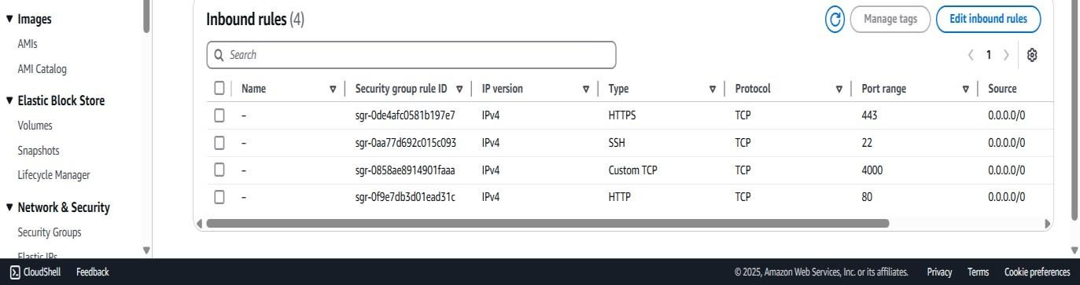

**Step 14:** Open the Bitvise SSH Client terminal console and start the server using command node index.js

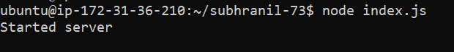

**Step 15:** Now copy the IPv4 address of the instance and paste it on web browser.

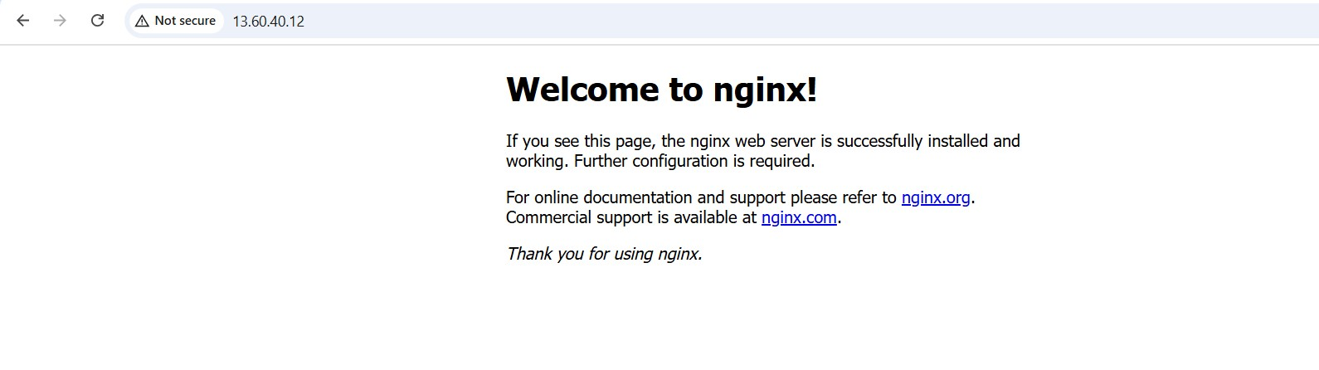

**Step 16:** Then, put the port like this IP address: Port (51.20.132.245:4000)

