**IDE :** Eclipse

**Project :** Java Project

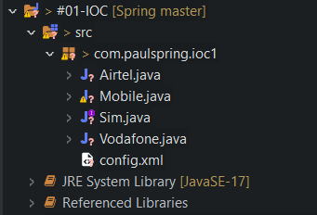

**Spring Jar Files Download :** https://repo.spring.io/ui/native/release/org/springframework/spring/