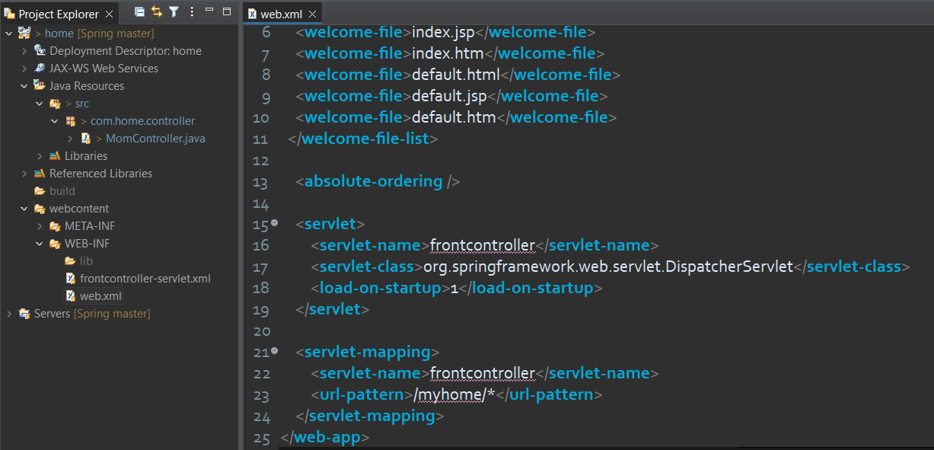

So far we have learnt that there is configuration file should be present in the folder **WEB-INF** for Instantiate **Front Controller.** And the file name should be Front Controller name appends with -servlet.

So can we change this default behavior ?

Answer is Yes!

**Step 1 :** Change your front controller configuration file name to **config.xml**

**Step 2 :** Now we just have to add the following code inside the <servlet> tag of **web.xml**

<**servlet**>

<**servlet-name**>frontcontroller</**servlet-name**>

<**servlet-class**>org.springframework.web.servlet.DispatcherServlet</**servlet-class**>

<**init-param**>

<**param-name**>contextConfigLocation</**param-name**>

<**param-value**>/WEB-INF/config.xml</**param-value**>

</**init-param**>

<**load-on-startup**>1</**load-on-startup**>

</**servlet**>

