**Step 1 :** Create new **dynamic web project** with following steps :

1. Give the project name as **home** and hit next.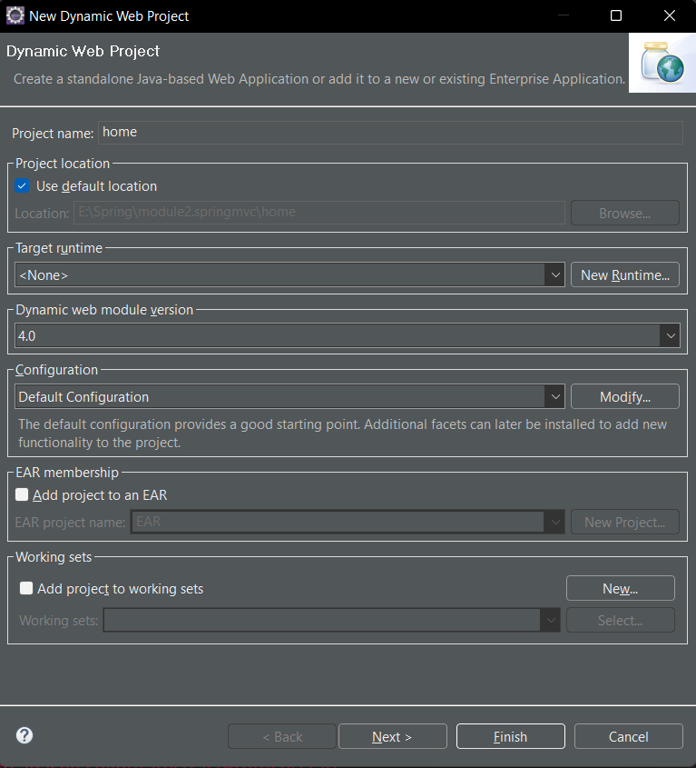
2. As a second step you will the following Dialogue box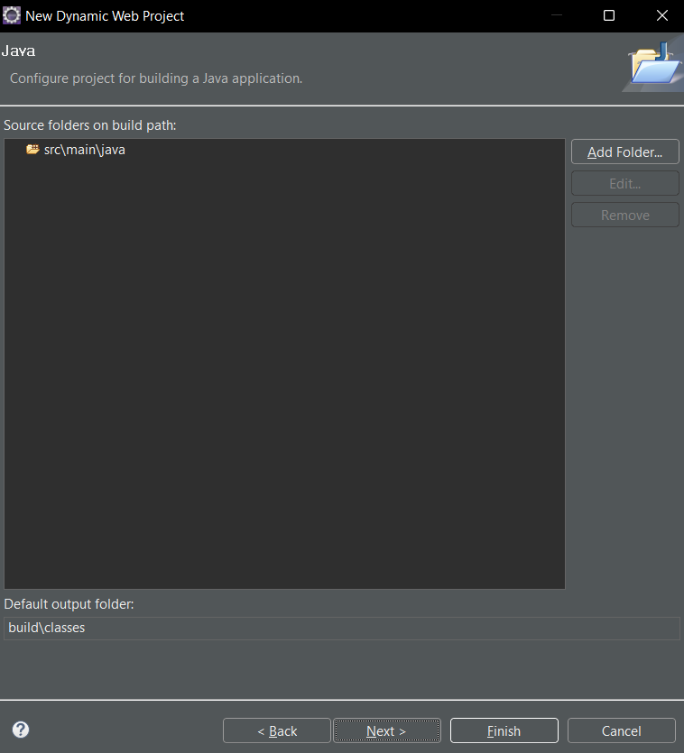

Select and delete the default source folder i.e. **src\main\java** and then add new folder with name only **src** like below :

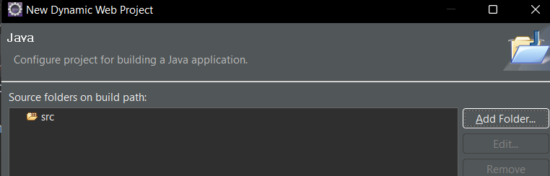

And press next button.

1. Now you have arrived at the last configuration page and pop up will be like below :

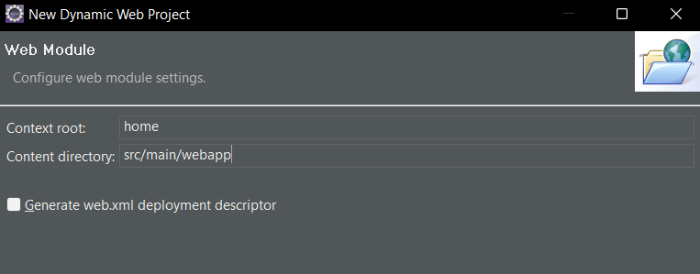

You need to change the name of your Content directory from **src/main/webapp** to **webcontent**

And carefully check the **generate web.xml** **deployment descriptor** and press **finish.**

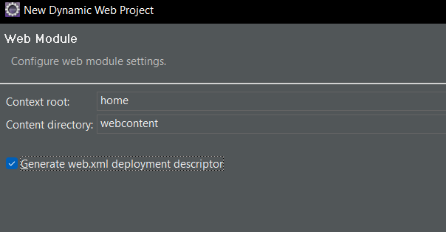

**Step 2 :** Add all the spring libraries into your project classpath using below path :

Right click on project -> Build Path -> Configure Build Path -> Libraries -> Select Classpath

-> Add External Jar

Or

Copy all the spring .jar file and paste them into **webcontent/WEB-INF/lib** folder of your project.

**Step 3 :** Configure Tomcat :

As our project is web project and is going to run on browser so it is mandatory to have a Server layer in our project.

We are going to use Tomcat 9. If you haven’t downloaded the tomcat follow the below link :

* <https://tomcat.apache.org/download-90.cgi>
* 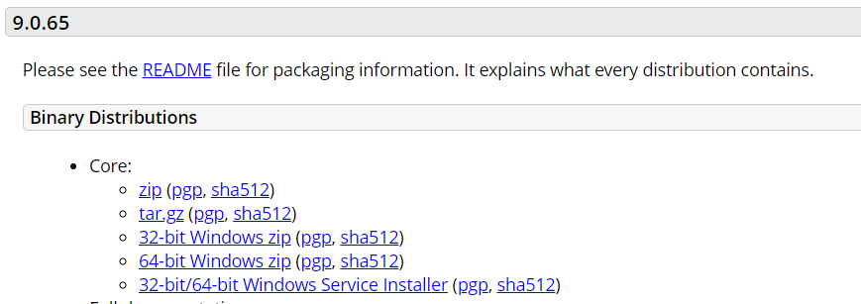

And then click on zip.

* Once the zip has downloaded bring it into your D: or E: derive and extract it using the option **extract here**.
* Rename it with the name **Tomcat-9**

Now come back to your eclipse and follow the below path :

Window -> Show view -> Server -> Right click Inside Server Window -> New -> Server -> Apache -> Tomcat 9 -> Next -> Browse Tomcat Installation Directory (Just select the folder Tomcat-9) -> Finish