Till now, we were working with only static jsp pages. But what if we want data from user through our webpage.

Let’s create a full fledge application with receiving data from user,

**Step 1 :**

Here is our **web.xml**

<?**xml** version=*"1.0"* encoding=*"UTF-8"*?>

<**web-app** xmlns:xsi=*"http://www.w3.org/2001/XMLSchema-instance"* xmlns=*"http://xmlns.jcp.org/xml/ns/javaee"* xsi:schemaLocation=*"http://xmlns.jcp.org/xml/ns/javaee http://xmlns.jcp.org/xml/ns/javaee/web-app_4_0.xsd"* id=*"WebApp_ID"* version=*"4.0"*>

<**display-name**>home</**display-name**>

<**welcome-file-list**>

<**welcome-file**>index.html</**welcome-file**>

<**welcome-file**>index.jsp</**welcome-file**>

<**welcome-file**>index.htm</**welcome-file**>

<**welcome-file**>default.html</**welcome-file**>

<**welcome-file**>default.jsp</**welcome-file**>

<**welcome-file**>default.htm</**welcome-file**>

</**welcome-file-list**>

<**absolute-ordering** />

<**servlet**>

<**servlet-name**>frontcontroller</**servlet-name**>

<**servlet-class**>org.springframework.web.servlet.DispatcherServlet</**servlet-class**>

<**init-param**>

<**param-name**>contextConfigLocation</**param-name**>

<**param-value**>/WEB-INF/config.xml</**param-value**>

</**init-param**>

<**load-on-startup**>1</**load-on-startup**>

</**servlet**>

<**servlet-mapping**>

<**servlet-name**>frontcontroller</**servlet-name**>

<**url-pattern**>/myhome/*</**url-pattern**>

</**servlet-mapping**>

</**web-app**>

**Step 2 :**

Here is our **config.xml.** In this file, we have configure our ViewResolver and <component-scan> tag.

<**beans** xmlns=*"http://www.springframework.org/schema/beans"*

xmlns:xsi=*"http://www.w3.org/2001/XMLSchema-instance"*

xmlns:context=*"http://www.springframework.org/schema/context"*

xmlns:mvc=*"http://www.springframework.org/schema/mvc"*

xsi:schemaLocation=*"http://www.springframework.org/schema/beans*

*http://www.springframework.org/schema/beans/spring-beans.xsd*

*http://www.springframework.org/schema/mvc*

*http://www.springframework.org/schema/mvc/spring-mvc.xsd*

*http://www.springframework.org/schema/context*

*https://www.springframework.org/schema/context/spring-context.xsd "*>

<**context:component-scan** base-package=*"com.home.controller"* />

<**bean** class=*"org.springframework.web.servlet.view.InternalResourceViewResolver"*>

<**property** name=*"prefix"* value=*"/WEB-INF/views/"*/>

<**property** name=*"suffix"* value=*".jsp"*/>

</**bean**>

</**beans**>

**Step 3 :**

We have a project called **home,** when we run this project it shows **404 error code** for default home url i.e. [**http://localhost:1714/home/**](http://localhost:1714/home/)

Why ?

It is because spring looks for default welcome file which is mentioned in **web.xml**

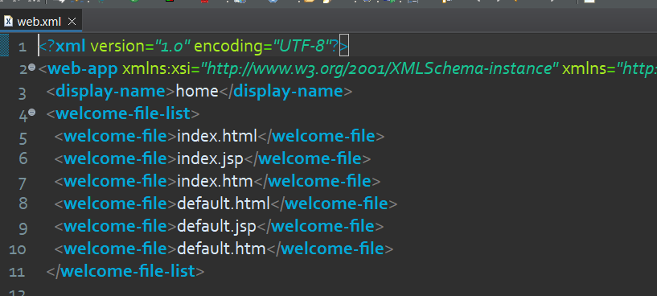

To remove this error let’s create a **index.html** file into our **webcontent** directory

**index.html :**

<!**DOCTYPE** html>

<**html**>

<**head**>

<**meta** charset=*"ISO-8859-1"*>

<**title**>Insert title here</**title**>

</**head**>

<**body**>

<**h1**>Welcome to homepage</**h1**>

<**p**> <**a** href=*"/home/myhome/mother/sugar"* >click here</**a**> to take sugar </**p**>

</**body**>

</**html**>

**Step 4 :**

If we ever hit the above anchor text it will request for the url */home/myhome/mother/sugar* which is handled by our below Controller :

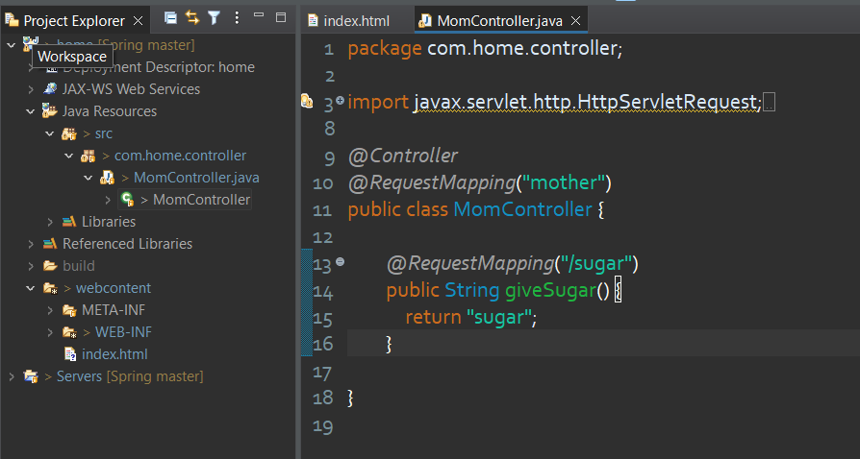

**Step 5 :**

*/home/myhome/mother/sugar* this url mapped with **giveSugar()** method and this method is returning the view name “sugar”. So it’s time to create a View called **sugar.jsp.**

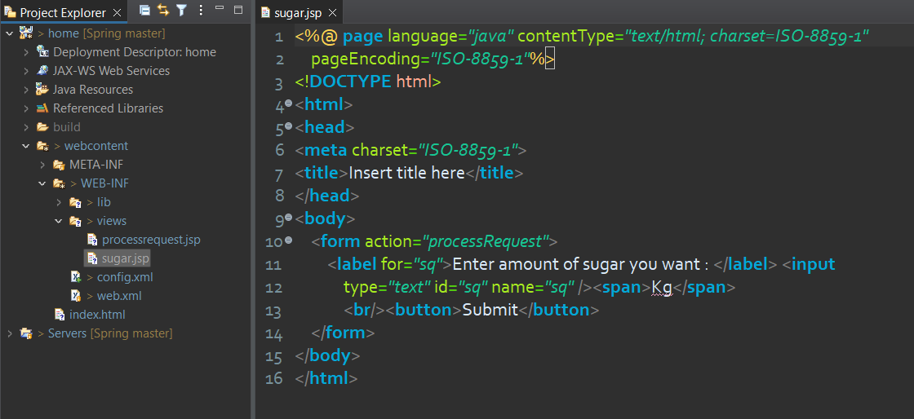

**Step 6 :**

Inside **sugar.jsp** we are asking for amount the sugar. As the user, enter amount and hit the submit button immediately a request will fire with below url :

<http://localhost:1714/home/myhome/mother/processRequest?sq=20>

as you can see url containing the request for “/processRequest” mapping. Now we need to create one more method into our controller for handle this request.

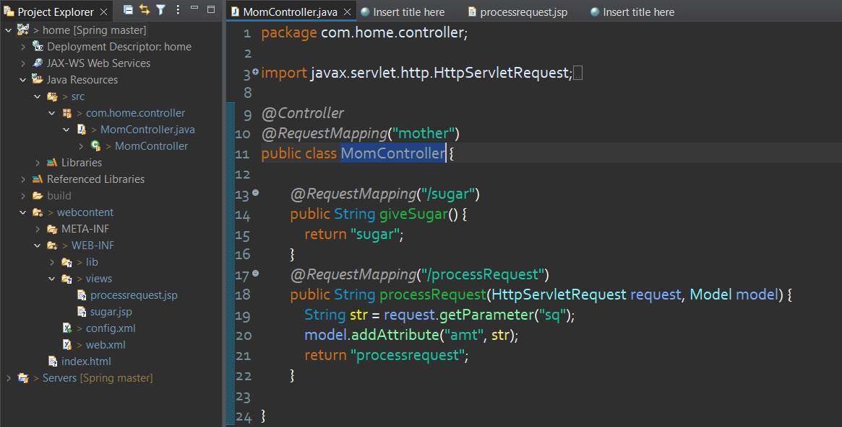

**processRequest()** method receiving two important arguments

* **HttpServletRequest**
* **Model**

We have already learnt previously about **Model**.

Let’s explore ,

If you know JEE servlets, you already know about this.

**HttpServletRequest** is an interface. Whatever request is coming to any url, if the request containing data in the form of query string (Key-Value pair). This Key-Value pairs is maintained by this interface.

To access this data this interface has a method called **getParameter(String).**

Now suppose, we have input tag as below :

<**input** type=*"text"* id=*"sq"* name=*"sq"* />

This input data is maintained be like :

Key : Value of **name** attribute

Value : Value of **value** attribute

To access the data of this input tag we need to pass the Key i.e. value of **name** attribute to the **getParameter()** method then this method will return the corresponding value associated to this key.

**Step 6 :**

This **processRequest()** returning a name of View i.e. **processrequest**. But we haven’t make it yet. Let’s make it,

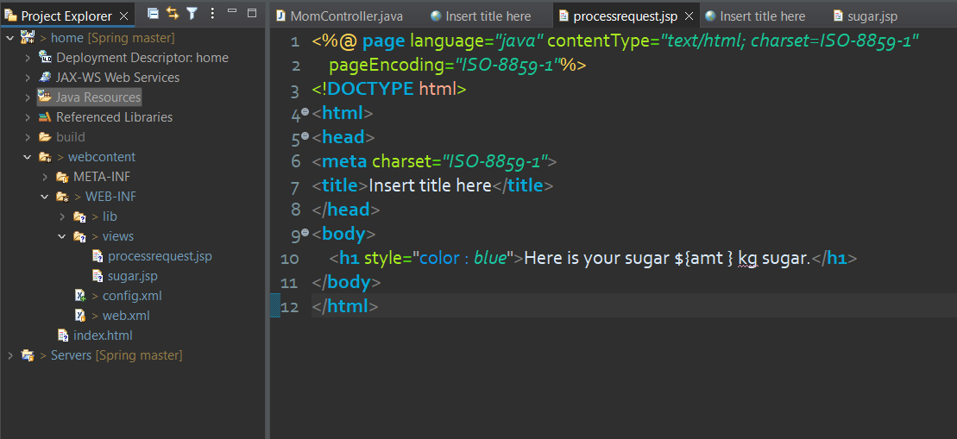

This is the final View of our Application. We you have successfully reach the final webpage, Congratulations !