**CODE**

**from tkinter import *  
  
def click(event):  
 global scvalue  
 text = event.widget.cget("text")  
 print(text)  
 if text == "=":  
 if scvalue.get().isdigit():  
 value= int(scvalue.get())  
 else:  
 try:  
 value= eval(screen.get())  
 except Exception as e:  
 print(e)  
 value=("Error")  
  
  
  
 scvalue.set(value)  
 screen.update()  
  
  
  
 elif text =="C":  
 scvalue.set("")  
 screen.update()  
  
 else:  
 scvalue.set(scvalue.get()+ text)  
 screen.update()  
  
  
  
root = Tk()  
root.geometry("361x381+500+200")  
root.title("Calculator")  
  
scvalue = StringVar()  
scvalue.set("")  
screen = Entry(root,bd=29,bg="powder blue",justify="right", textvar=scvalue, font="lucida 40 bold")  
screen.grid(row=2,columnspan=4)  
  
screen.pack(fill=X, ipadx=8, pady=10, padx=10)  
f= Frame(root,bg="grey")  
b= Button(f, text="(",padx=25,pady=18, font="lucida 25 bold",bd=9,height=1,width=2)  
b.pack(side= LEFT ,padx=10 ,pady=5)  
b.bind("<Button-1>",click)  
b= Button(f, text=")",padx=25,pady=18, font="lucida 25 bold",bd=9,height=1,width=2)  
b.pack(side= LEFT, padx=10 ,pady=5)  
b.bind("<Button-1>",click)  
b= Button(f, text="%",padx=25,pady=18, font="lucida 25 bold",bd=9,height=1,width=2)  
b.pack(side= LEFT ,padx=10 ,pady=5)  
b.bind("<Button-1>",click)  
b= Button(f, text="C",padx=25,pady=18, font="lucida 25 bold",bd=9,height=1,width=2)  
b.pack(side= LEFT ,padx=10 ,pady=5)  
b.bind("<Button-1>",click)  
f.pack()  
f= Frame(root,bg="grey")  
b= Button(f, text="7",padx=25,pady=18, font="lucida 25 bold",bd=9,height=1,width=2)  
b.pack(side= LEFT, padx=10 ,pady=5)  
b.bind("<Button-1>",click)  
b= Button(f, text="8",padx=25,pady=18, font="lucida 25 bold",bd=9,height=1,width=2)  
b.pack(side= LEFT ,padx=10 ,pady=5)  
b.bind("<Button-1>",click)  
b= Button(f, text="9",padx=25,pady=18, font="lucida 25 bold",bd=9,height=1,width=2)  
b.pack(side= LEFT ,padx=10 ,pady=5)  
b.bind("<Button-1>",click)  
b= Button(f, text="/",padx=22,pady=18, font="lucida 31 bold",bd=9,height=1,width=2)  
b.pack(side= LEFT, padx=10 ,pady=5)  
b.bind("<Button-1>",click)  
f.pack()  
f= Frame(root,bg="grey")  
b= Button(f, text="4",padx=25,pady=18, font="lucida 25 bold",bd=9,height=1,width=2)  
b.pack(side= LEFT, padx=10 ,pady=5)  
b.bind("<Button-1>",click)  
b= Button(f, text="5",padx=25,pady=18, font="lucida 25 bold",bd=9,height=1,width=2)  
b.pack(side= LEFT ,padx=10 ,pady=5)  
b.bind("<Button-1>",click)  
b= Button(f, text="6",padx=25,pady=18, font="lucida 25 bold",bd=9,height=1,width=2)  
b.pack(side= LEFT ,padx=10 ,pady=5)  
b.bind("<Button-1>",click)  
b= Button(f, text="*",padx=25,pady=18, font="lucida 25 bold",bd=9,height=1,width=2)  
b.pack(side= LEFT, padx=10 ,pady=5)  
b.bind("<Button-1>",click)  
f.pack()  
f= Frame(root,bg="grey")  
b= Button(f, text="1",padx=25,pady=18, font="lucida 25 bold",bd=9,height=1,width=2)  
b.pack(side= LEFT, padx=10 ,pady=5)  
b.bind("<Button-1>",click)  
b= Button(f, text="2",padx=25,pady=18, font="lucida 25 bold",bd=9,height=1,width=2)  
b.pack(side= LEFT ,padx=10 ,pady=5)  
b.bind("<Button-1>",click)  
b= Button(f, text="3",padx=25,pady=18, font="lucida 25 bold",bd=9,height=1,width=2)  
b.pack(side= LEFT ,padx=10 ,pady=5)  
b.bind("<Button-1>",click)  
b= Button(f, text="-",padx=25,pady=18, font="lucida 25 bold",bd=9,height=1,width=2)  
b.pack(side= LEFT, padx=10 ,pady=5)  
b.bind("<Button-1>",click)  
f.pack()  
f= Frame(root,bg="grey")  
b= Button(f, text="0",padx=25,pady=18, font="lucida 25 bold",bd=9,height=1,width=2)  
b.pack(side= LEFT ,padx=10 ,pady=5)  
b.bind("<Button-1>",click)  
b= Button(f, text=".",padx=25,pady=18, font="lucida 25 bold",bd=9,height=1,width=2)  
b.pack(side= LEFT ,padx=10 ,pady=5)  
b.bind("<Button-1>",click)  
b= Button(f, text="=",padx=25,pady=18, font="lucida 25 bold",bd=9,height=1,width=2)  
b.pack(side= LEFT, padx=10 ,pady=5)  
b.bind("<Button-1>",click)  
b= Button(f, text="+",padx=25,pady=18, font="lucida 25 bold",bd=9,height=1,width=2)  
b.pack(side= LEFT ,padx=10 ,pady=5)  
b.bind("<Button-1>",click)  
f.pack()  
  
  
  
root.mainloop()**

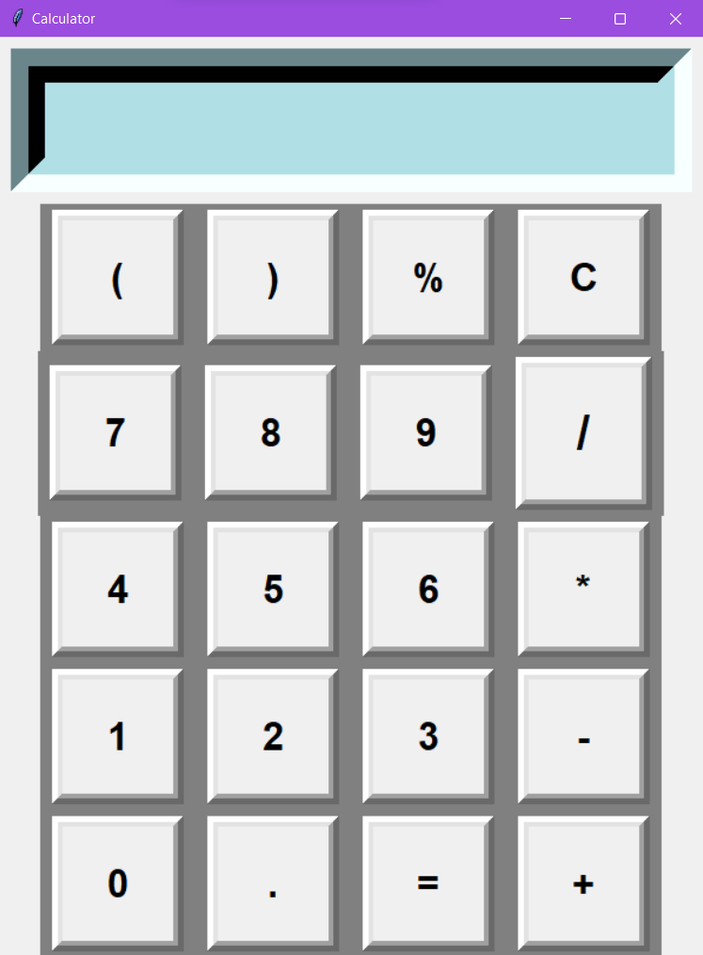

**addition**

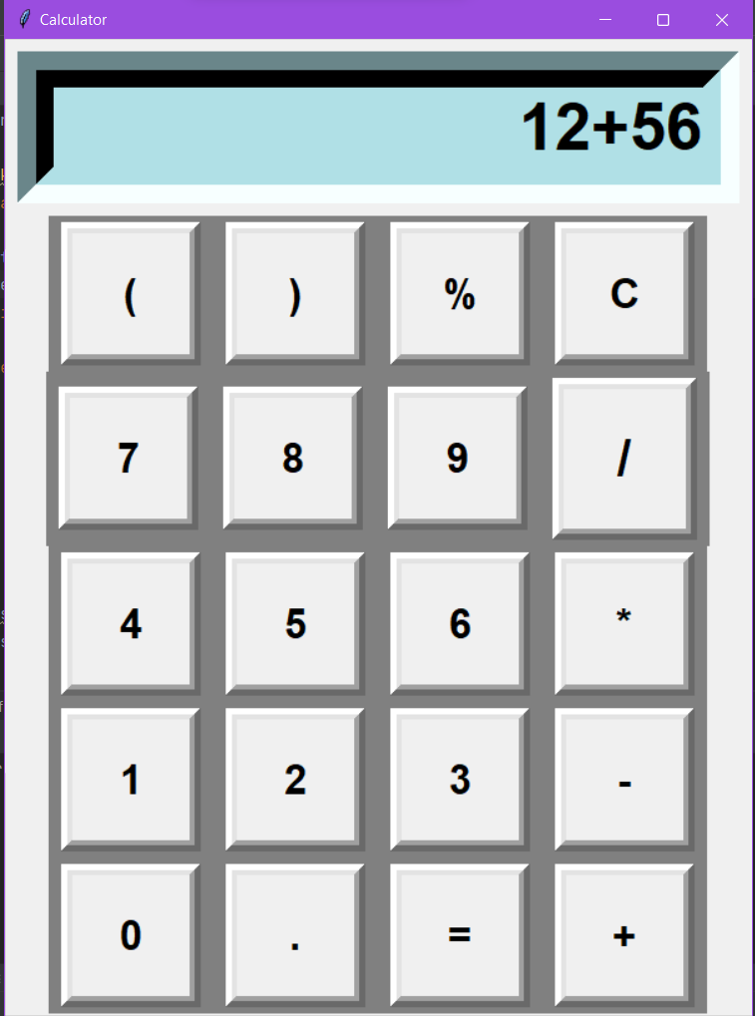

**Output:**

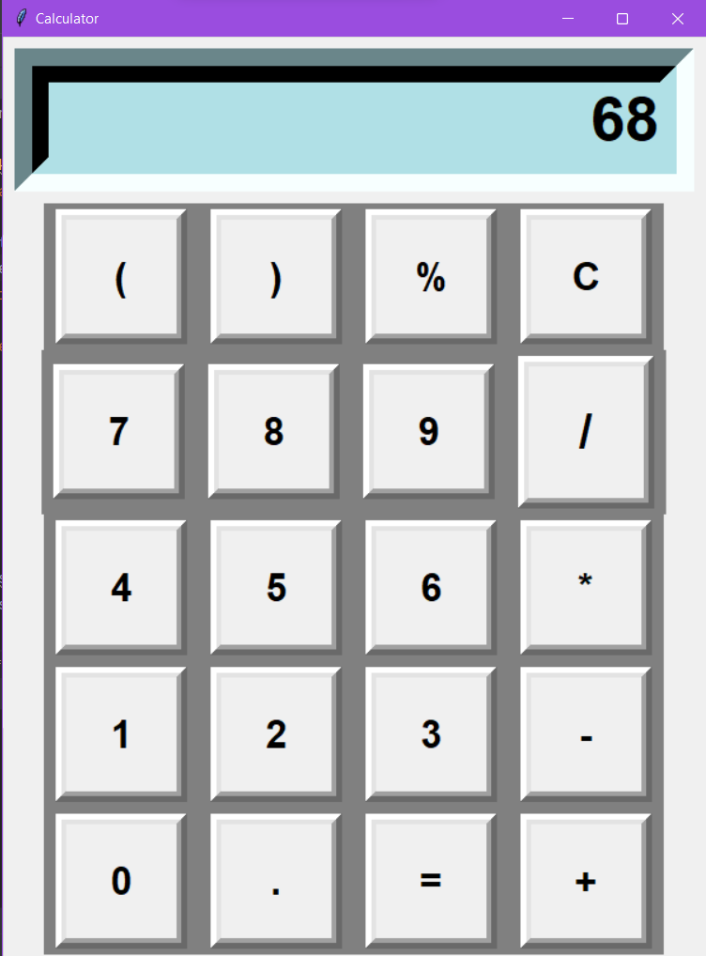

**Substation**

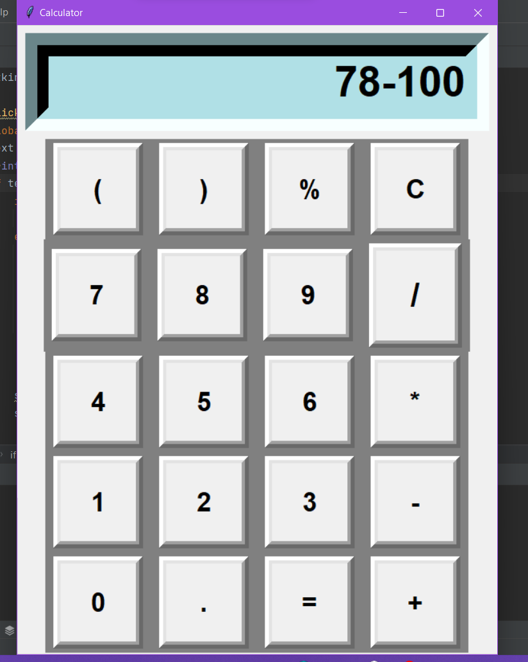

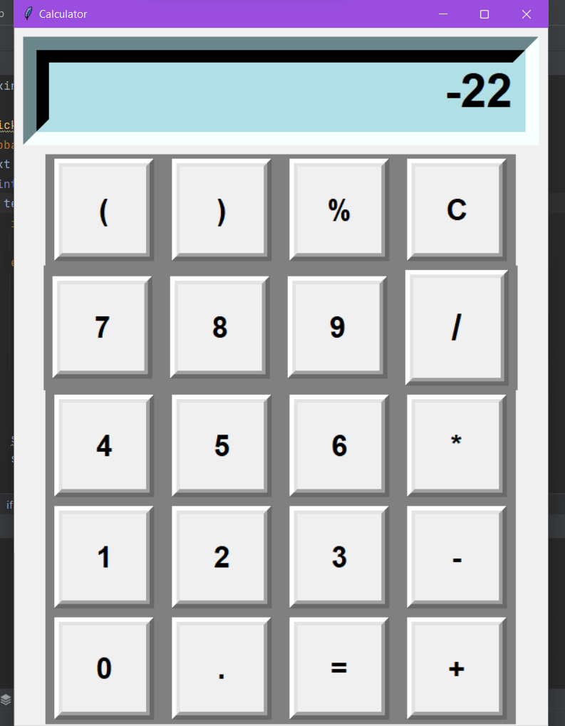

**error**

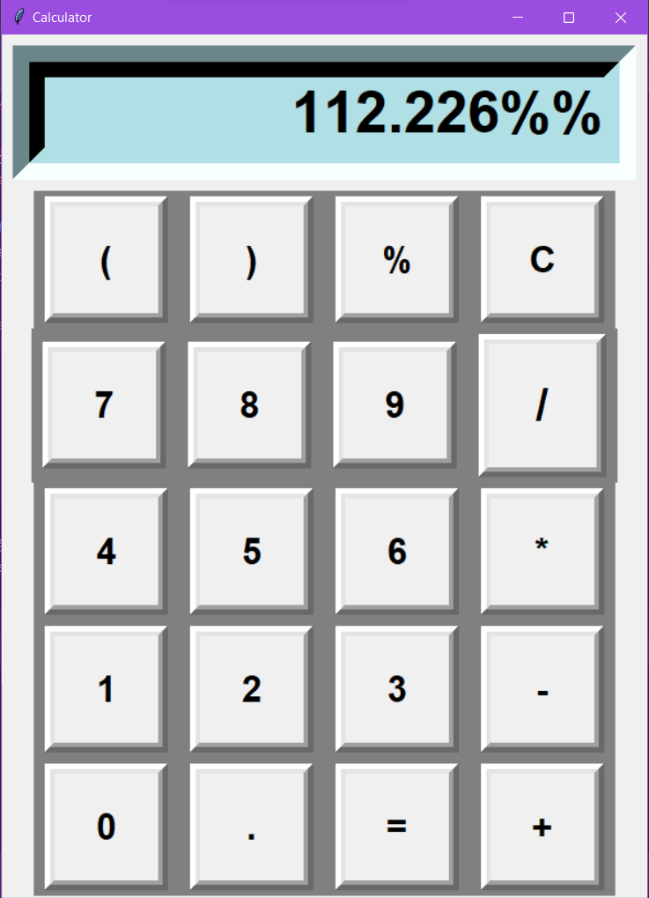

**OUTPUT:**

