## *CLINIC WEBSITE*

PROJECT NAME =CLINIC WEBSITE

LANGUAGE USED = PYTHON

TOOLS IN USE = DJANGO FRAMEWORK

MEMBERS=HIMANSHU, ANKIT, SOURABH, SURAJ

***OBJECTIVE-***

As it is clear from the name of the Project that the objective of our project is to book online appointment of the patients that are coming to the clinic and maintain the record of the previous as well as the new patients in the database.

* Provide ease to patients for booking online appointments
* Helps to maintain patients database

***Scope-***

It is the aim of our website to provide the ease to the customers that is patients as well as to the clinic by keeping database of patient’s safe and booking online appointments for the proper and smooth functioning of the clinic as well as making patients satisfy by our service.

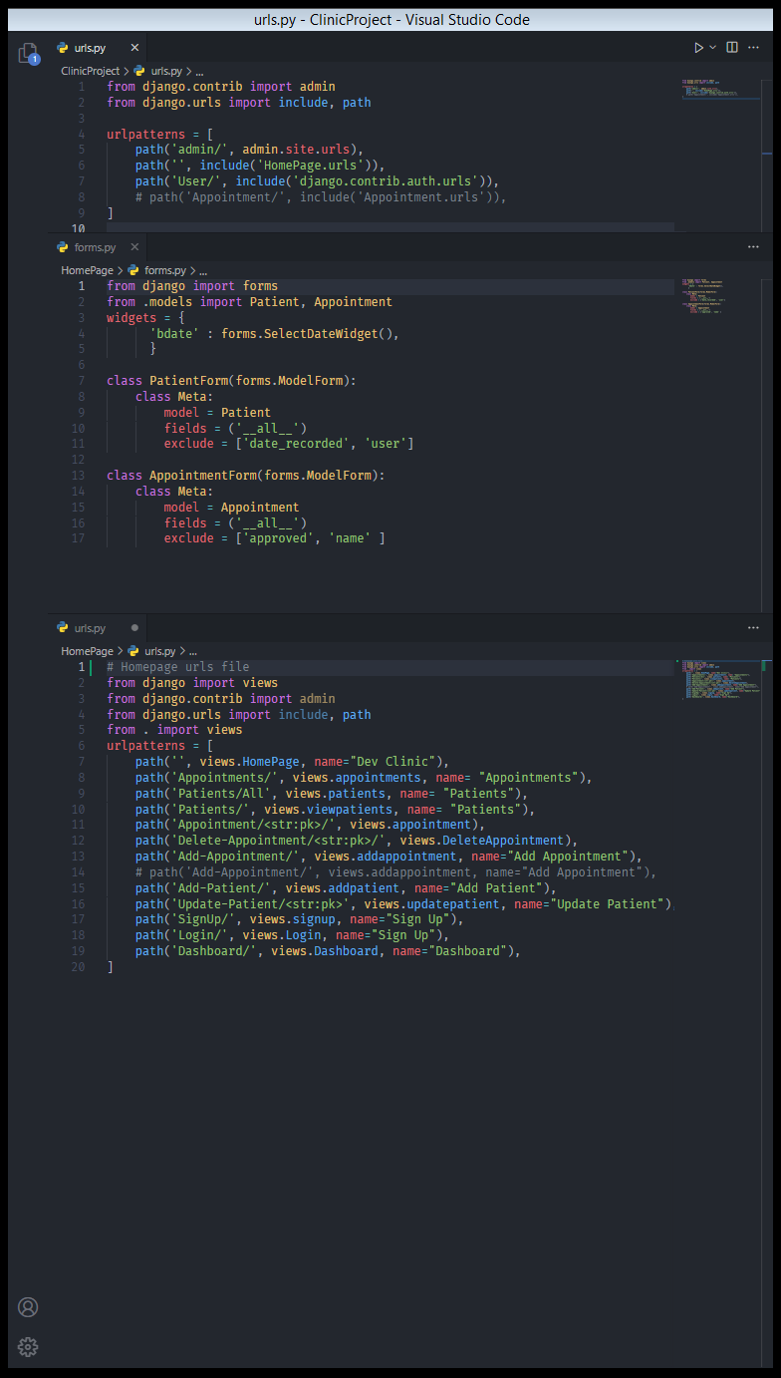

.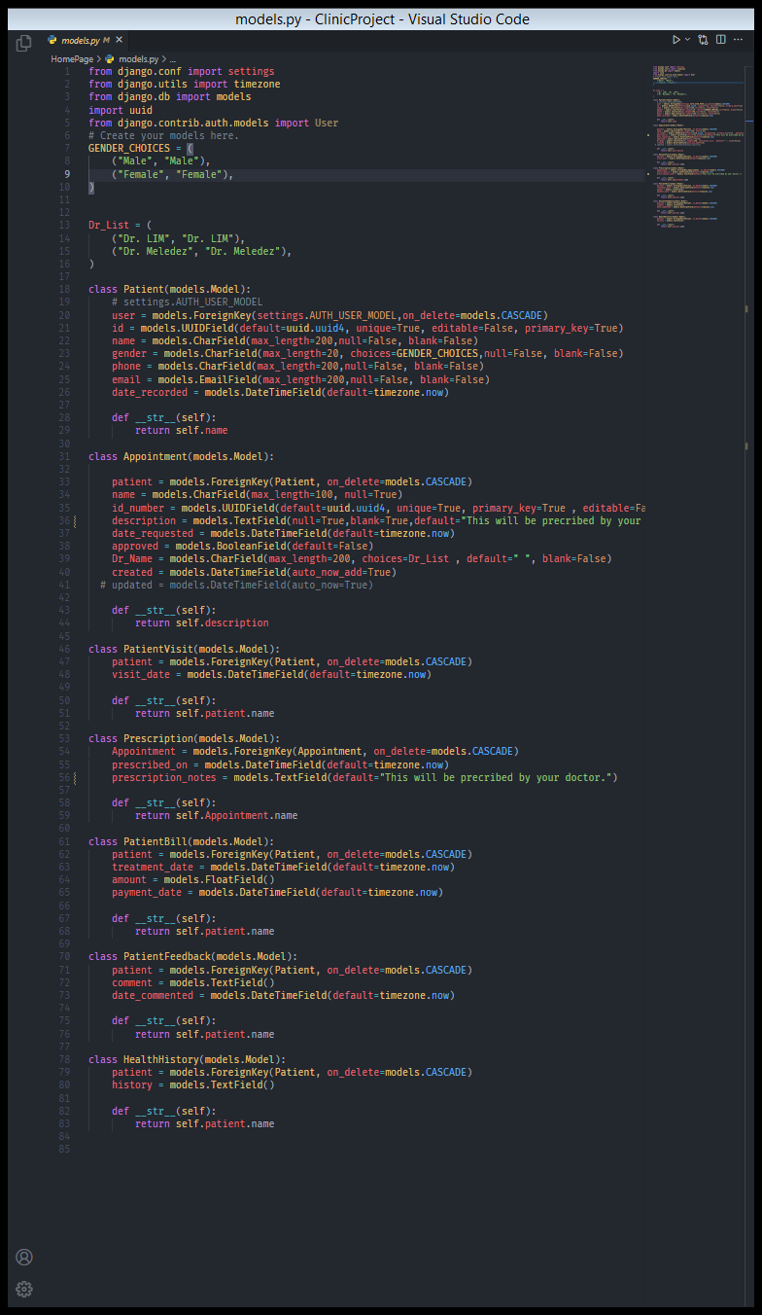

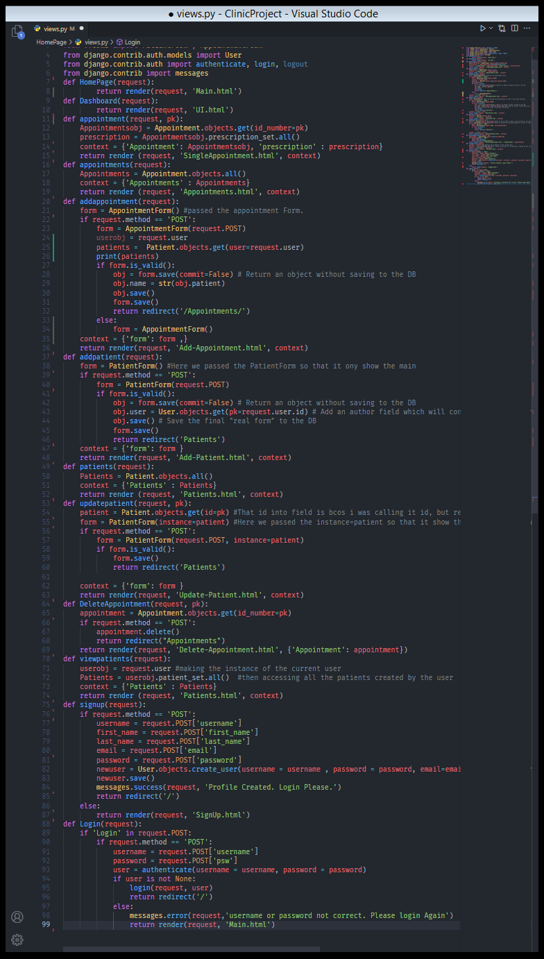

**Html And Css Part**

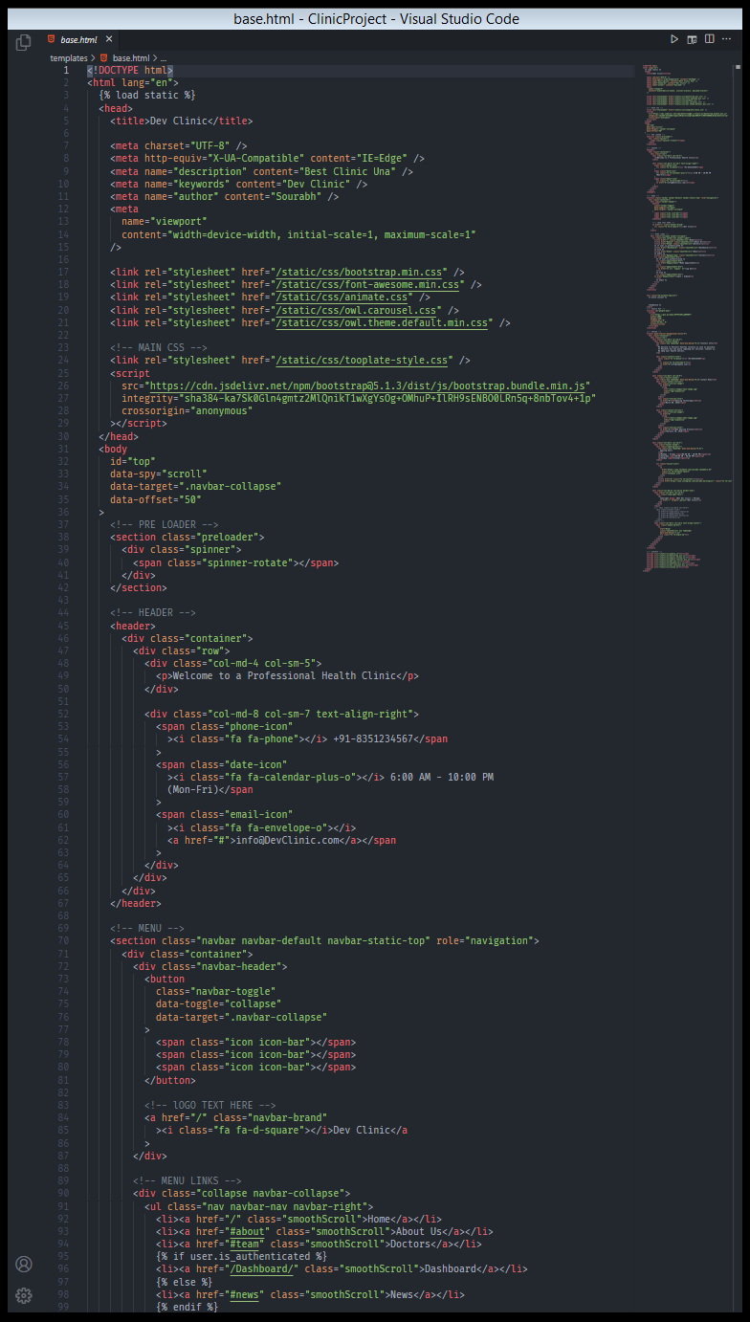

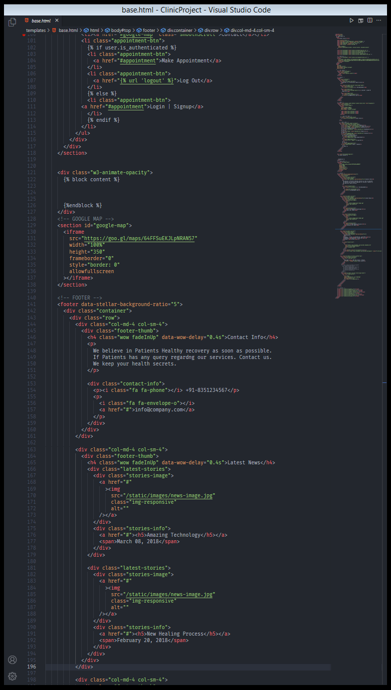

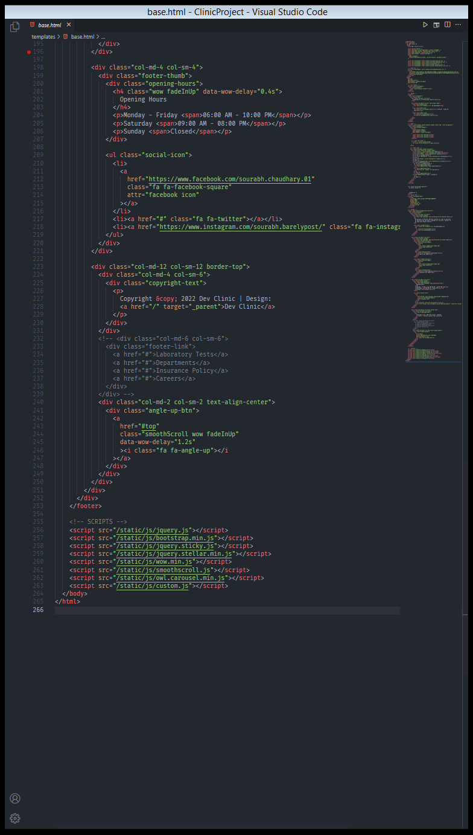

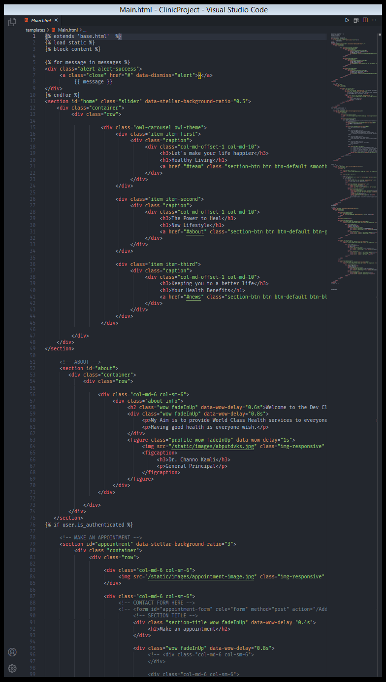

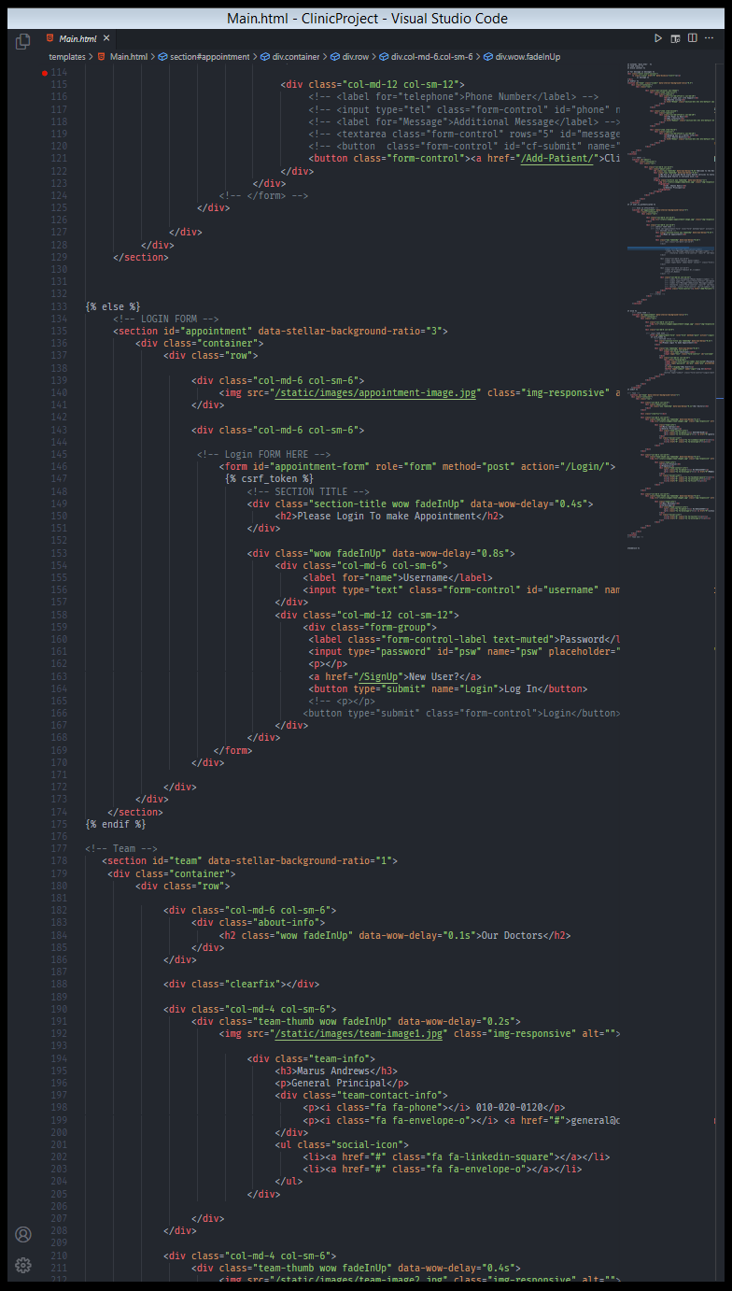

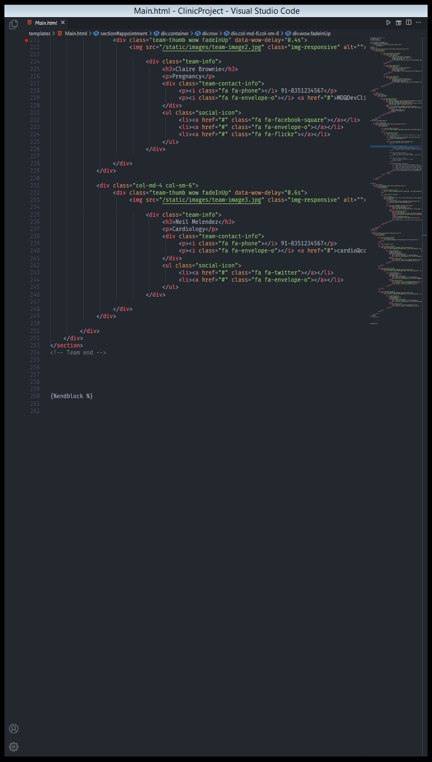

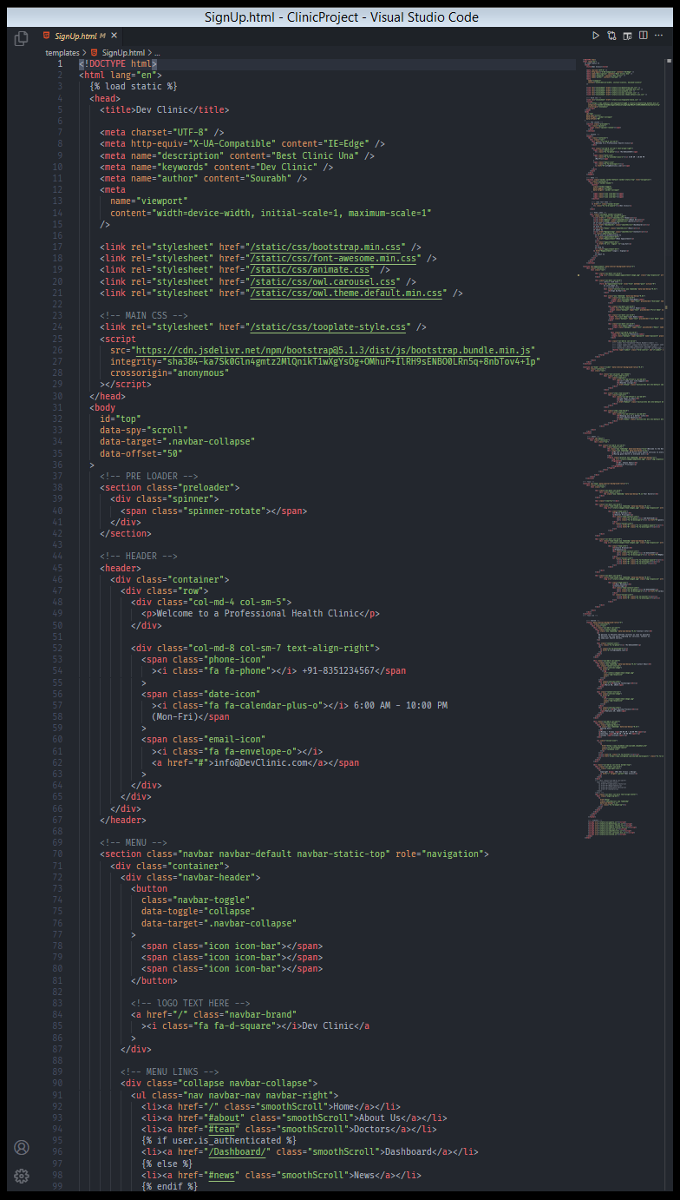

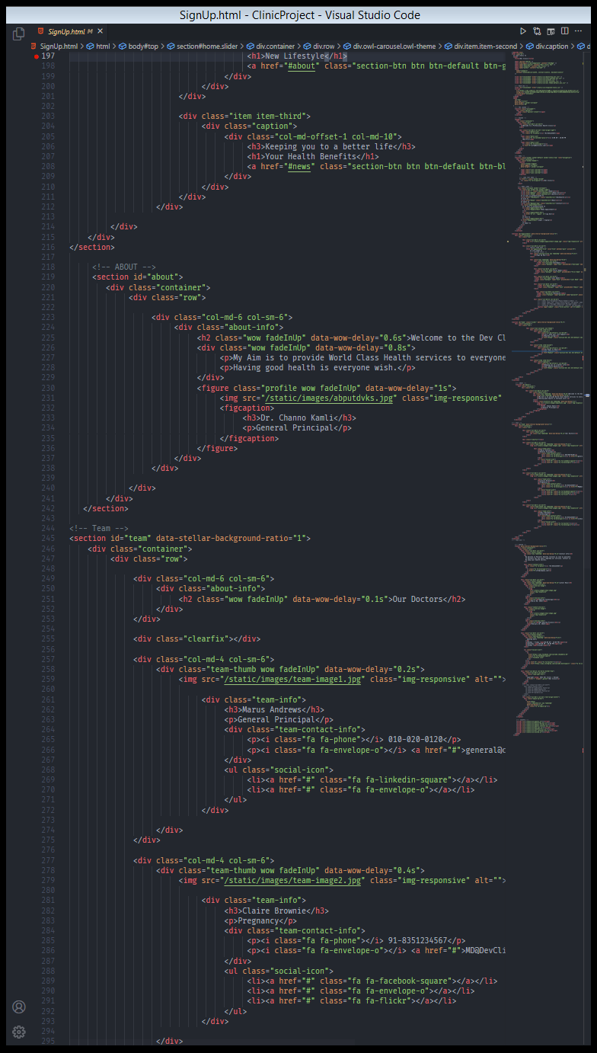

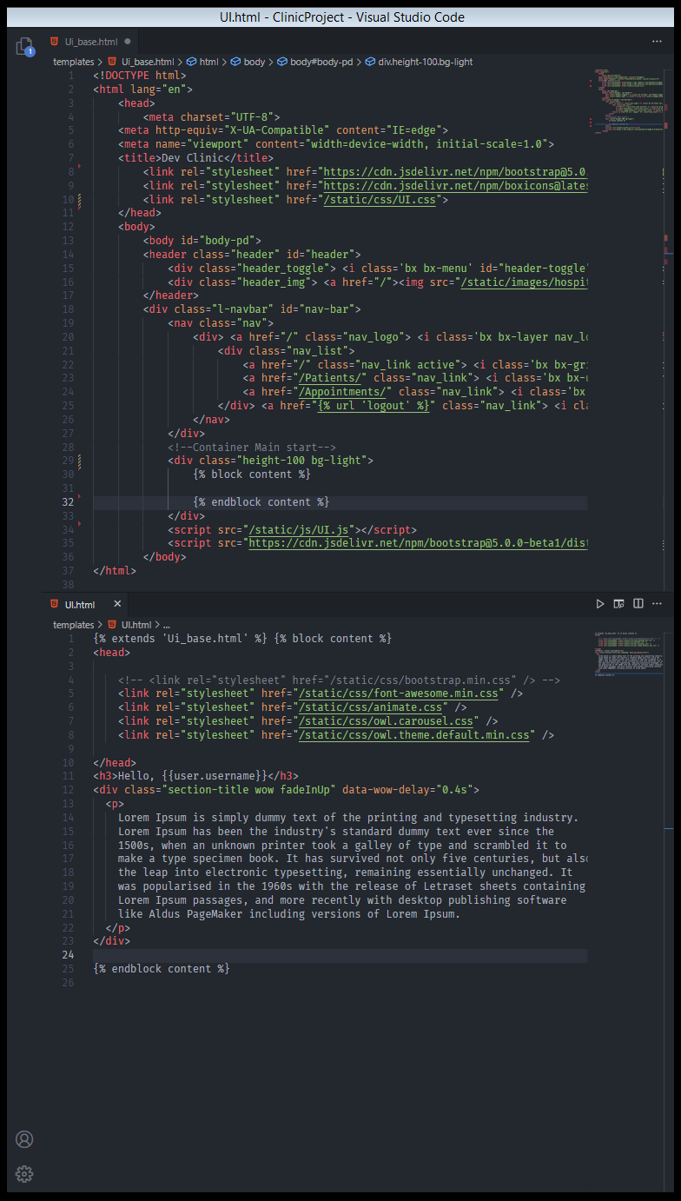

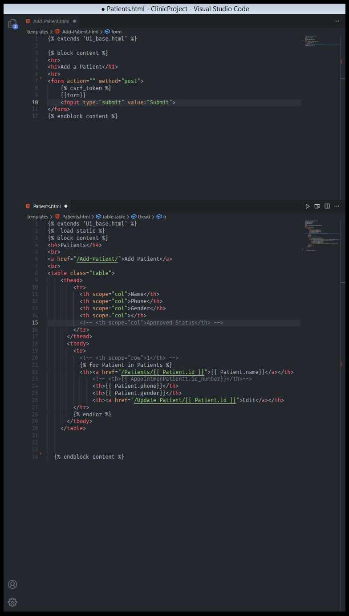

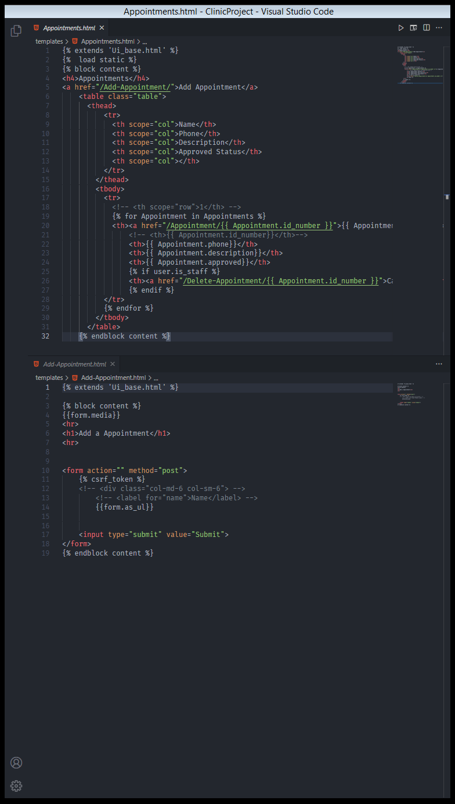

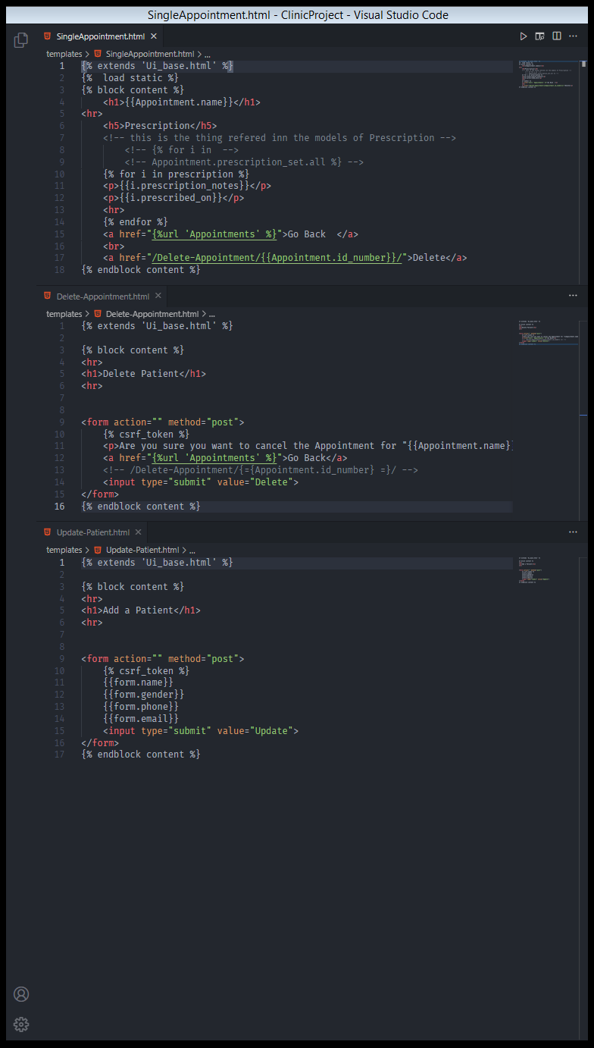36