**TECHNO INDIA GROUP PUBLIC SCHOOL,HOOGHLY**

**SESSION : 2024-2025**

**CLASS :NURSERY**

**SUBJECT :**

**Name : ____________________________________________SEC.___________Roll_________**

**Change Capital letters to Small letters**

|  |
| --- |
|  |
|  |
|  |

A

|  |
| --- |
|  |
|  |
|  |

C

|  |
| --- |
|  |
|  |
|  |

K

|  |
| --- |
|  |
|  |
|  |

Q

|  |
| --- |
|  |
|  |
|  |

R

|  |
| --- |
|  |
|  |
|  |

T

**TECHNO INDIA GROUP PUBLIC SCHOOL,HOOGHLY**

**SESSION : 2024-2025**

**CLASS :NURSERY**

**SUBJECT :**

**Name : ____________________________________________SEC.___________Roll_________**

**Change Small letters to Capital letters**

|  |
| --- |
|  |
|  |
|  |

a

|  |
| --- |
|  |
|  |
|  |

n

|  |
| --- |
|  |
|  |
|  |

m

|  |
| --- |
|  |
|  |
|  |

d

|  |
| --- |
|  |
|  |
|  |

e

|  |
| --- |
|  |
|  |
|  |

t

**TECHNO INDIA GROUP PUBLIC SCHOOL,HOOGHLY**

**SESSION : 2024-2025**

**CLASS :NURSERY**

**SUBJECT :**

**Name : ____________________________________________SEC.___________Roll_________**

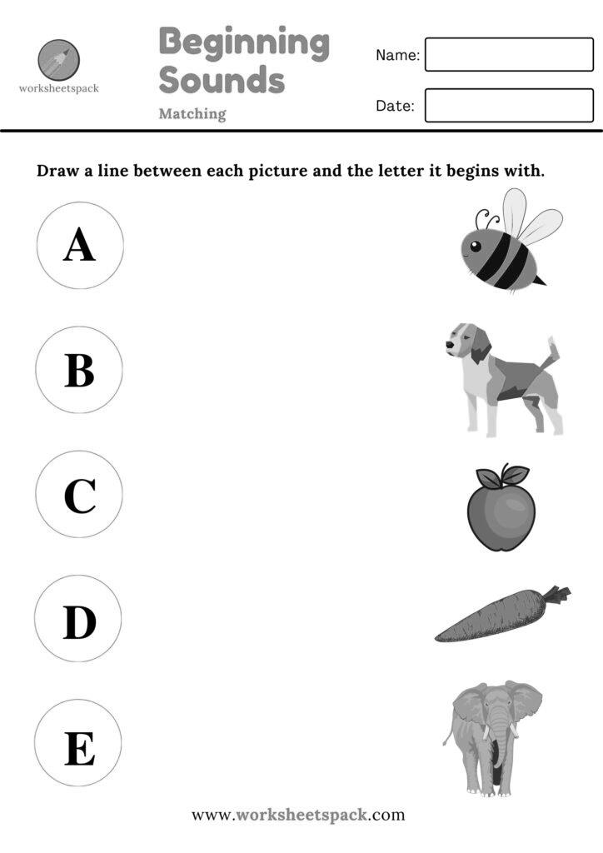

**TECHNO INDIA GROUP PUBLIC SCHOOL,HOOGHLY**

**SESSION : 2024-2025**

**CLASS :NURSERY**

**SUBJECT :**

**Name : ____________________________________________SEC.___________Roll_________**

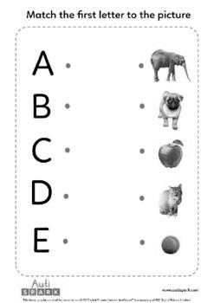

**TECHNO INDIA GROUP PUBLIC SCHOOL,HOOGHLY**

**SESSION : 2024-2025**

**CLASS :NURSERY**

**SUBJECT :**

**Name : ____________________________________________SEC.___________Roll_________**

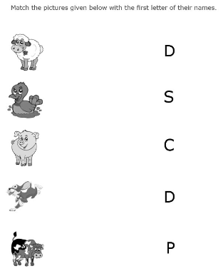

**TECHNO INDIA GROUP PUBLIC SCHOOL,HOOGHLY**

**SESSION : 2024-2025**

**CLASS :NURSERY**

**SUBJECT :**

**Name : ____________________________________________SEC.___________Roll_________**

1. Write From M – V

|  |  |  |  |  |
| --- | --- | --- | --- | --- |
|  |  |  |  |  |
|  |  |  |  |  |
|  |  |  |  |  |

|  |  |  |  |  |
| --- | --- | --- | --- | --- |
|  |  |  |  |  |
|  |  |  |  |  |
|  |  |  |  |  |

1. Write From (a – j)

|  |  |  |  |  |
| --- | --- | --- | --- | --- |
|  |  |  |  |  |
|  |  |  |  |  |
|  |  |  |  |  |

|  |  |  |  |  |
| --- | --- | --- | --- | --- |
|  |  |  |  |  |
|  |  |  |  |  |
|  |  |  |  |  |

**TECHNO INDIA GROUP PUBLIC SCHOOL,HOOGHLY**

**SESSION : 2024-2025**

**CLASS :NURSERY**

**SUBJECT :**

**Name : ____________________________________________SEC.___________Roll_________**

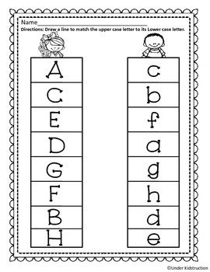

**Missing Alphabets**

C____ E____G____I____K_____M____O____

m____o____q____s____u_____w____y____

**TECHNO INDIA GROUP PUBLIC SCHOOL,HOOGHLY**

**SESSION : 2024-2025**

**CLASS :NURSERY**

**SUBJECT :**

**Name : ____________________________________________SEC.___________Roll_________**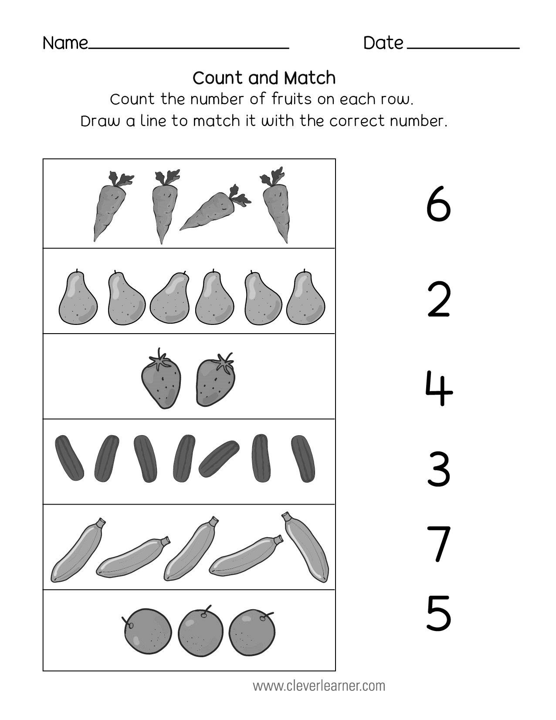

**TECHNO INDIA GROUP PUBLIC SCHOOL,HOOGHLY**

**SESSION : 2024-2025**

**CLASS :NURSERY**

**SUBJECT :**

**Name : ____________________________________________SEC.___________Roll_________**

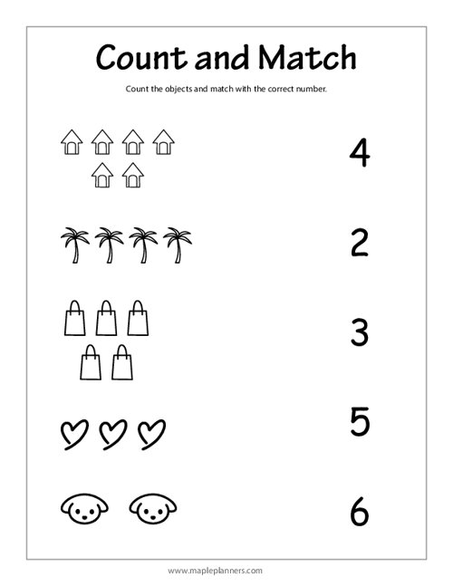

**TECHNO INDIA GROUP PUBLIC SCHOOL,HOOGHLY**

**SESSION : 2024-2025**

**CLASS :NURSERY**

**SUBJECT :**

**Name : ____________________________________________SEC.___________Roll_________**

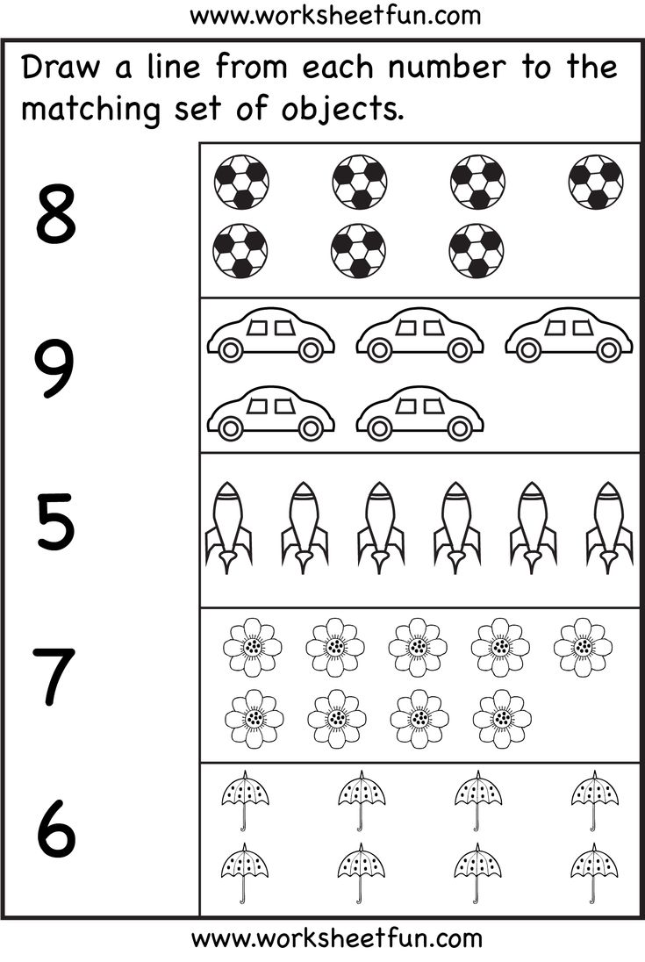

**TECHNO INDIA GROUP PUBLIC SCHOOL,HOOGHLY**

**SESSION : 2024-2025**

**CLASS :NURSERY**

**SUBJECT :**

**Name : ____________________________________________SEC.___________Roll_________**

Write Numbers from 21 to 30

|  |  |
| --- | --- |
| T | O |
|  |  |
|  |  |
|  |  |
|  |  |
|  |  |
|  |  |
|  |  |
|  |  |
|  |  |
|  |  |

**TECHNO INDIA GROUP PUBLIC SCHOOL,HOOGHLY**

**SESSION : 2024-2025**

**CLASS :NURSERY**

**SUBJECT :**

**Name : ____________________________________________SEC.___________Roll_________**

Write Back count from 20 to 01

|  |  |  |  |  |
| --- | --- | --- | --- | --- |
| T | O | X | T | O |
|  |  |  |  |  |
|  |  |  |  |  |
|  |  |  |  |  |
|  |  |  |  |  |
|  |  |  |  |  |
|  |  |  |  |  |
|  |  |  |  |  |
|  |  |  |  |  |
|  |  |  |  |  |
|  |  |  |  |  |

**TECHNO INDIA GROUP PUBLIC SCHOOL,HOOGHLY**

**SESSION : 2024-2025**

**CLASS :NURSERY**

**SUBJECT :**

**Name : ____________________________________________SEC.___________Roll_________**

**Count and Write**

|  |  |
| --- | --- |
|  |  |
| Cartoon of a duck Royalty Free Vector Image - VectorStockCartoon of a duck Royalty Free Vector Image - VectorStockCartoon of a duck Royalty Free Vector Image - VectorStock |  |
| Cartoon Fish Images - Free Download on FreepikCartoon Fish Images - Free Download on FreepikCartoon Fish Images - Free Download on FreepikCartoon Fish Images - Free Download on Freepik |  |
| 141,900+ Cartoon Sun Stock Photos, Pictures & Royalty-Free Images - iStock  | Cartoon sun with sunglasses, Cartoon sun rise, Cartoon sun sunglasses141,900+ Cartoon Sun Stock Photos, Pictures & Royalty-Free Images - iStock  | Cartoon sun with sunglasses, Cartoon sun rise, Cartoon sun sunglasses141,900+ Cartoon Sun Stock Photos, Pictures & Royalty-Free Images - iStock  | Cartoon sun with sunglasses, Cartoon sun rise, Cartoon sun sunglasses141,900+ Cartoon Sun Stock Photos, Pictures & Royalty-Free Images - iStock  | Cartoon sun with sunglasses, Cartoon sun rise, Cartoon sun sunglasses141,900+ Cartoon Sun Stock Photos, Pictures & Royalty-Free Images - iStock  | Cartoon sun with sunglasses, Cartoon sun rise, Cartoon sun sunglasses141,900+ Cartoon Sun Stock Photos, Pictures & Royalty-Free Images - iStock  | Cartoon sun with sunglasses, Cartoon sun rise, Cartoon sun sunglasses141,900+ Cartoon Sun Stock Photos, Pictures & Royalty-Free Images - iStock  | Cartoon sun with sunglasses, Cartoon sun rise, Cartoon sun sunglasses141,900+ Cartoon Sun Stock Photos, Pictures & Royalty-Free Images - iStock  | Cartoon sun with sunglasses, Cartoon sun rise, Cartoon sun sunglasses141,900+ Cartoon Sun Stock Photos, Pictures & Royalty-Free Images - iStock  | Cartoon sun with sunglasses, Cartoon sun rise, Cartoon sun sunglasses141,900+ Cartoon Sun Stock Photos, Pictures & Royalty-Free Images - iStock  | Cartoon sun with sunglasses, Cartoon sun rise, Cartoon sun sunglasses141,900+ Cartoon Sun Stock Photos, Pictures & Royalty-Free Images - iStock  | Cartoon sun with sunglasses, Cartoon sun rise, Cartoon sun sunglasses |  |
| Cartoon Star Stock Illustrations – 378,347 Cartoon Star ...Cartoon Star Stock Illustrations – 378,347 Cartoon Star ...Cartoon Star Stock Illustrations – 378,347 Cartoon Star ...Cartoon Star Stock Illustrations – 378,347 Cartoon Star ...Cartoon Star Stock Illustrations – 378,347 Cartoon Star ...Cartoon Star Stock Illustrations – 378,347 Cartoon Star ...Cartoon Star Stock Illustrations – 378,347 Cartoon Star ...Cartoon Star Stock Illustrations – 378,347 Cartoon Star ...Cartoon Star Stock Illustrations – 378,347 Cartoon Star ...Cartoon Star Stock Illustrations – 378,347 Cartoon Star ...Cartoon Star Stock Illustrations – 378,347 Cartoon Star ...Cartoon Star Stock Illustrations – 378,347 Cartoon Star ...Cartoon Star Stock Illustrations – 378,347 Cartoon Star ...Cartoon Star Stock Illustrations – 378,347 Cartoon Star ... |  |

**TECHNO INDIA GROUP PUBLIC SCHOOL,HOOGHLY**

**SESSION : 2024-2025**

**CLASS :NURSERY**

**SUBJECT : English Skill**

**Name : ____________________________________________SEC.___________Roll_________**

|  |
| --- |
|  |
|  |
|  |

1)

|  |
| --- |
|  |
|  |
|  |

2)

|  |
| --- |
|  |
|  |
|  |

3)

|  |
| --- |
|  |
|  |
|  |

4)

|  |
| --- |
|  |
|  |
|  |

5)

|  |
| --- |
|  |
|  |
|  |

6)

|  |
| --- |
|  |
|  |
|  |

7)

|  |
| --- |
|  |
|  |
|  |

8)

**TECHNO INDIA GROUP PUBLIC SCHOOL,HOOGHLY**

**SESSION : 2024-2025**

**CLASS :NURSERY**

**SUBJECT : English Skill**

**Name : ____________________________________________SEC.___________Roll_________**

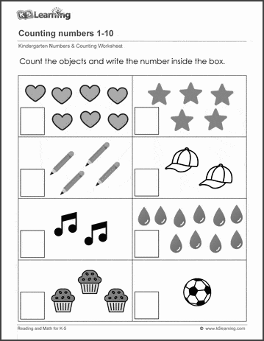

**TECHNO INDIA GROUP PUBLIC SCHOOL,HOOGHLY**

**SESSION : 2024-2025**

**CLASS :NURSERY**

**SUBJECT : English Skill**

**Name : ____________________________________________SEC.___________Roll_________**

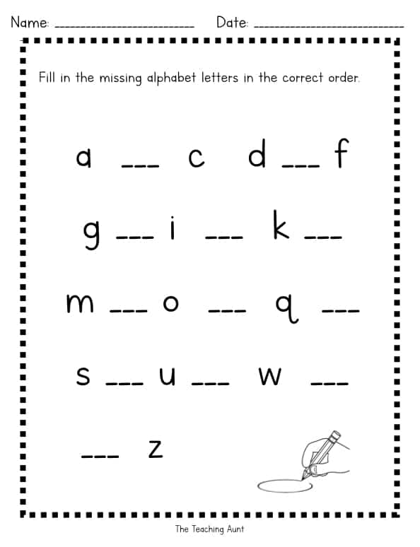

**TECHNO INDIA GROUP PUBLIC SCHOOL,HOOGHLY**

**SESSION : 2024-2025**

**CLASS :NURSERY**

**SUBJECT :**

Write Missing Numbers

|  |  |  |  |  |  |  |  |
| --- | --- | --- | --- | --- | --- | --- | --- |
| 1 | __ | 3 | __ | __ | 6 | __ | 8 |
| 9 | __ | __ | 12 | __ | __ | 15 | __ |

Write Missing Alphabets

|  |  |  |  |  |  |
| --- | --- | --- | --- | --- | --- |
| a |  | c |  | e |  |
| g |  | i |  | k |  |

**TECHNO INDIA GROUP PUBLIC SCHOOL,HOOGHLY**

**SESSION : 2024-2025**

**CLASS :NURSERY**

**SUBJECT : Math**

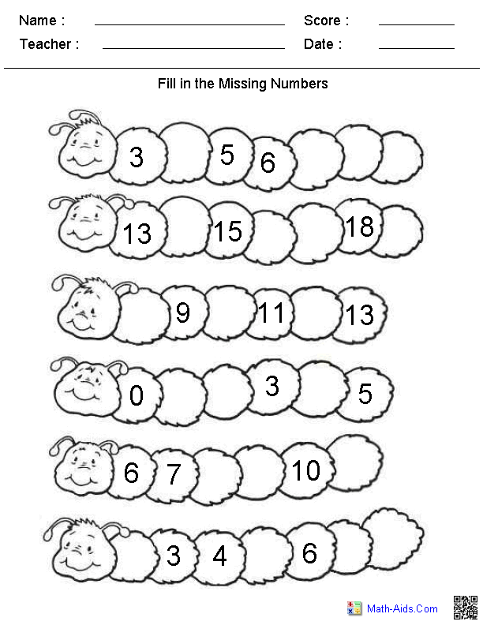

**TECHNO INDIA GROUP PUBLIC SCHOOL,HOOGHLY**

**SESSION : 2024-2025**

**CLASS :NURSERY**

**SUBJECT : Math**

