**Edge Computing Laboratory**

**Lab Assignment 10**

**Name:** Sourabh Karmakar

**Class:** TY AIEC Batch C

**Enrollment No:** MITU22BTCS0851

**Roll No:** 22231152

### Title

Study of Transfer Learning (Images) on Edge Computing Devices

**Objective:** Build a project to apply Transfer Learning of MobileNetV1 & V2 architectures trained on an ImageNet dataset

**Tasks:**

|  |  |
| --- | --- |
| ● | Understand Transfer learning |
| ● | Understanding of MobileNetV1 & V2 Architectures |
| ● | Configure Edge Impulse for Object Detection |
| ● | Apply a pre-trained network for you to fine-tune your specific application |
| ● | Building and Training a Model |
| ● | Deploy on Edge Computing Devices |

### Introduction

Edge Impulse is a development platform for machine learning on edge devices, targeted at developers who want to create intelligent device solutions. The " Camera "sensor reading equivalent in Edge Impulse would typically involve creating a simple machine learning model that can run on an edge device, like classifying sensor data or recognizing a basic pattern.

### Materials Required

• Nano BLE Sense Board

Theory

GPIO (General Purpose Input/Output) pins on the Raspberry Pi are used for interfacing with other electronic components. BCM numbering refers to the pin numbers in the Broadcom SOC channel, which is a more consistent way to refer to the GPIO pins across different versions of the

Here’s a high-level overview of steps you'd follow to create a "Hello World" project on Edge Impulse:

**Steps to Configure the Edge Impulse:**

1. Create an Account and New Project:
   * + Sign up for an Edge Impulse account.
     + Create a new project from the dashboard.
2. Connect a Device:
   * + You can use a supported development board or your smartphone as a sensor device.
     + Follow the instructions to connect your device to your Edge Impulse project.
3. Collect Data:

Use the Edge Impulse mobile app or the Web interface to collect data from the onboard sensors.

* + For a "Hello World" project, you could collect accelerometer data, for instance.

1. Create an Impulse:
   * Go to the 'Create impulse' page.
   * Add a processing block (e.g., time-series data) and a learning block (e.g., classification).
   * Save the impulse, which defines the machine learning pipeline.
2. Design a Neural Network:
   * Navigate to the 'NN Classifier' under the 'Learning blocks'.
   * Design a simple neural network. Edge Impulse provides a default architecture that works well for most basic tasks.
3. Train the Model:
   * Click on the 'Start training' button to train your machine learning model with the collected data.
4. Test the Model:
   * Once the model is trained, you can test its performance with new data in the 'Model Testing' tab.
5. Deploy the Model:
   * Go to the 'Deployment' tab.
   * Select the deployment method that suits your edge device (e.g., Arduino library, WebAssembly, container, etc.).
   * Follow the instructions to deploy the model to your device.
6. Run Inference:
   * With the model deployed, run inference on the edge device to see it classifying data in real-time.
7. Monitor:
   * You can monitor the performance of your device through the Edge Impulse studio.

Screenshots:

Dataset image

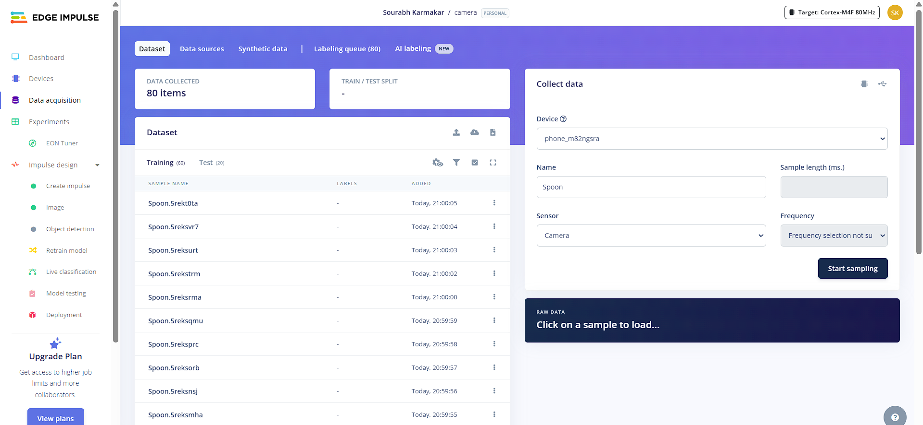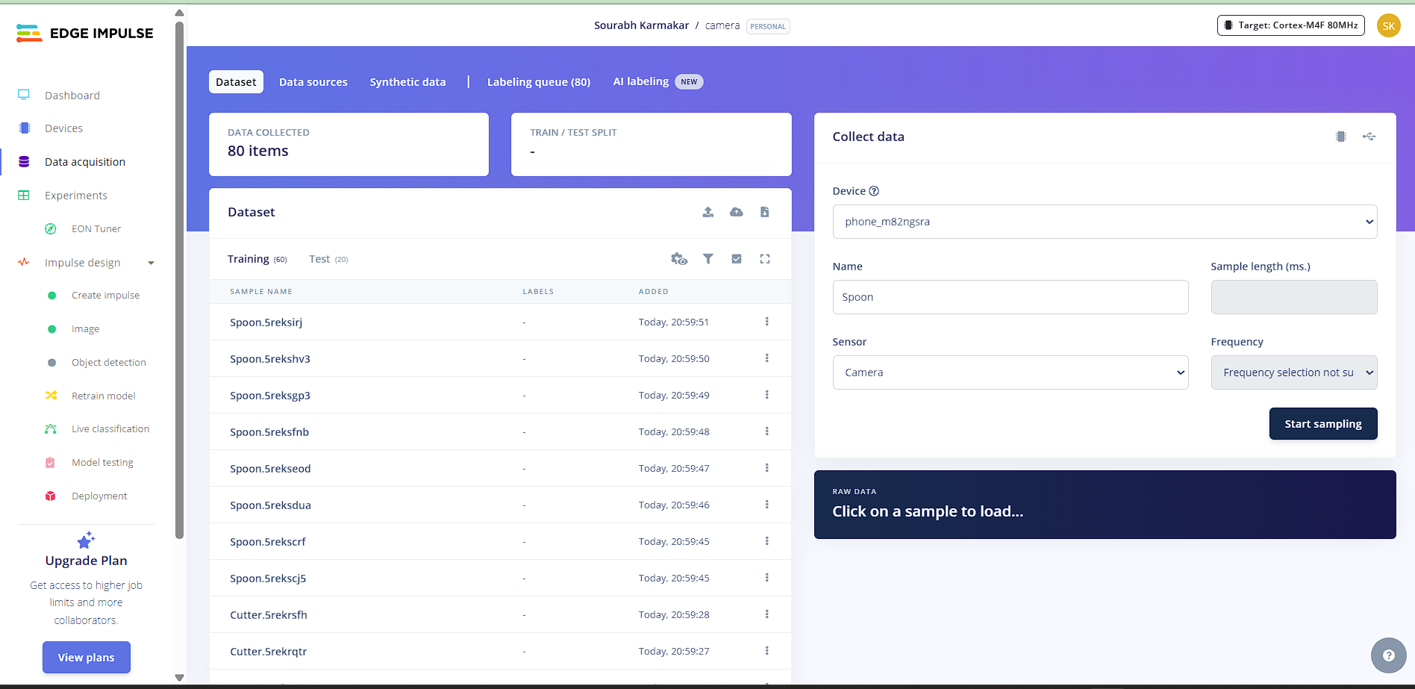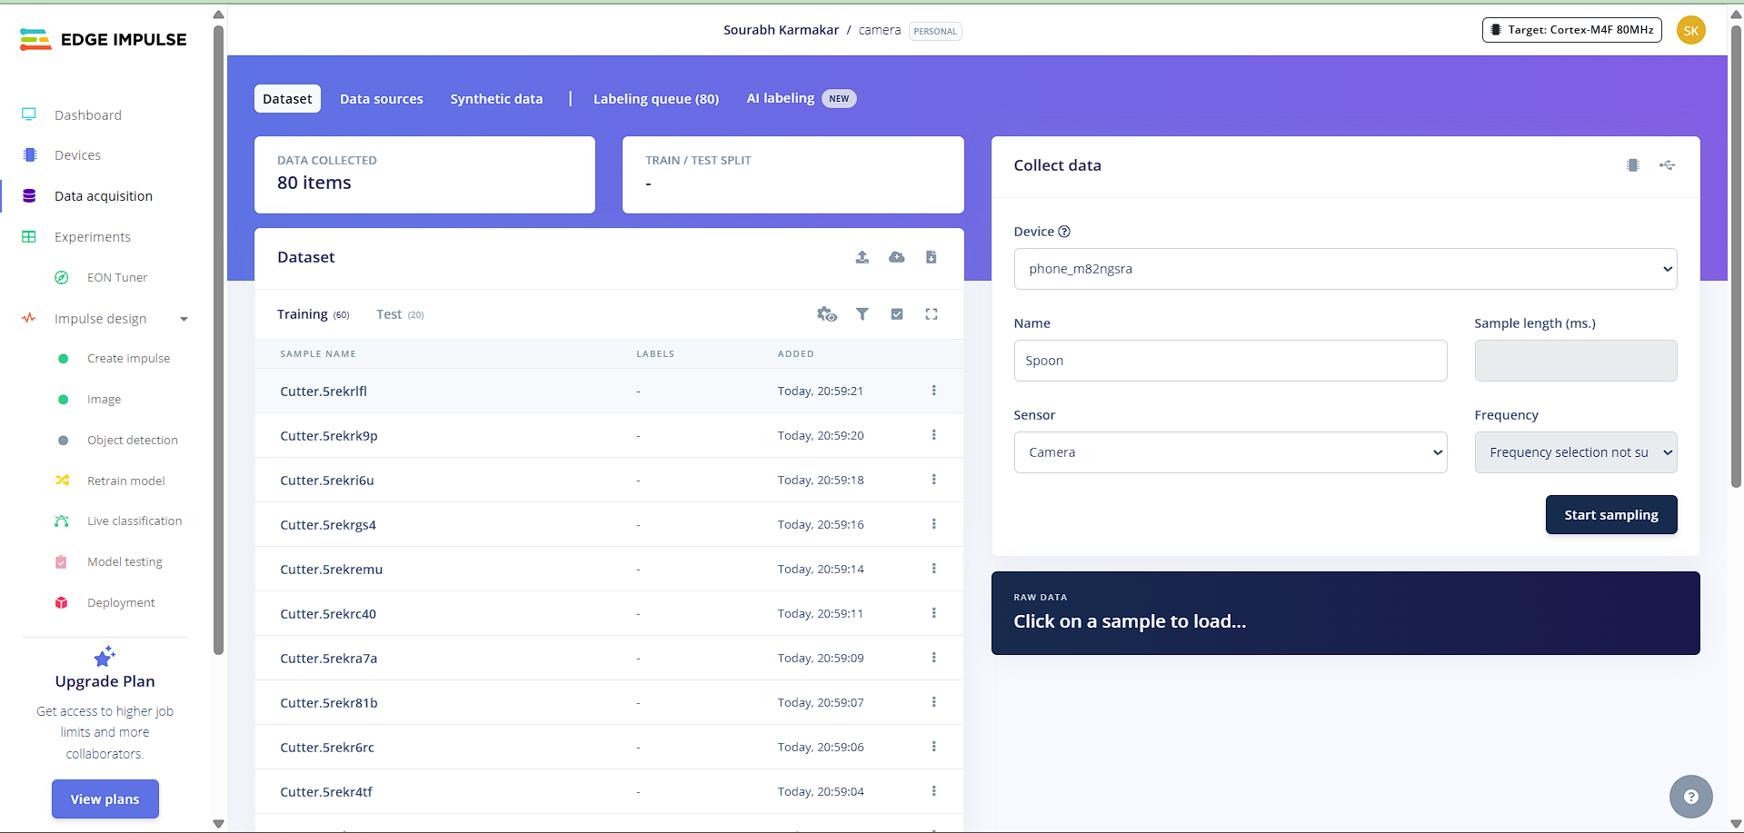

Feature extraction - Image

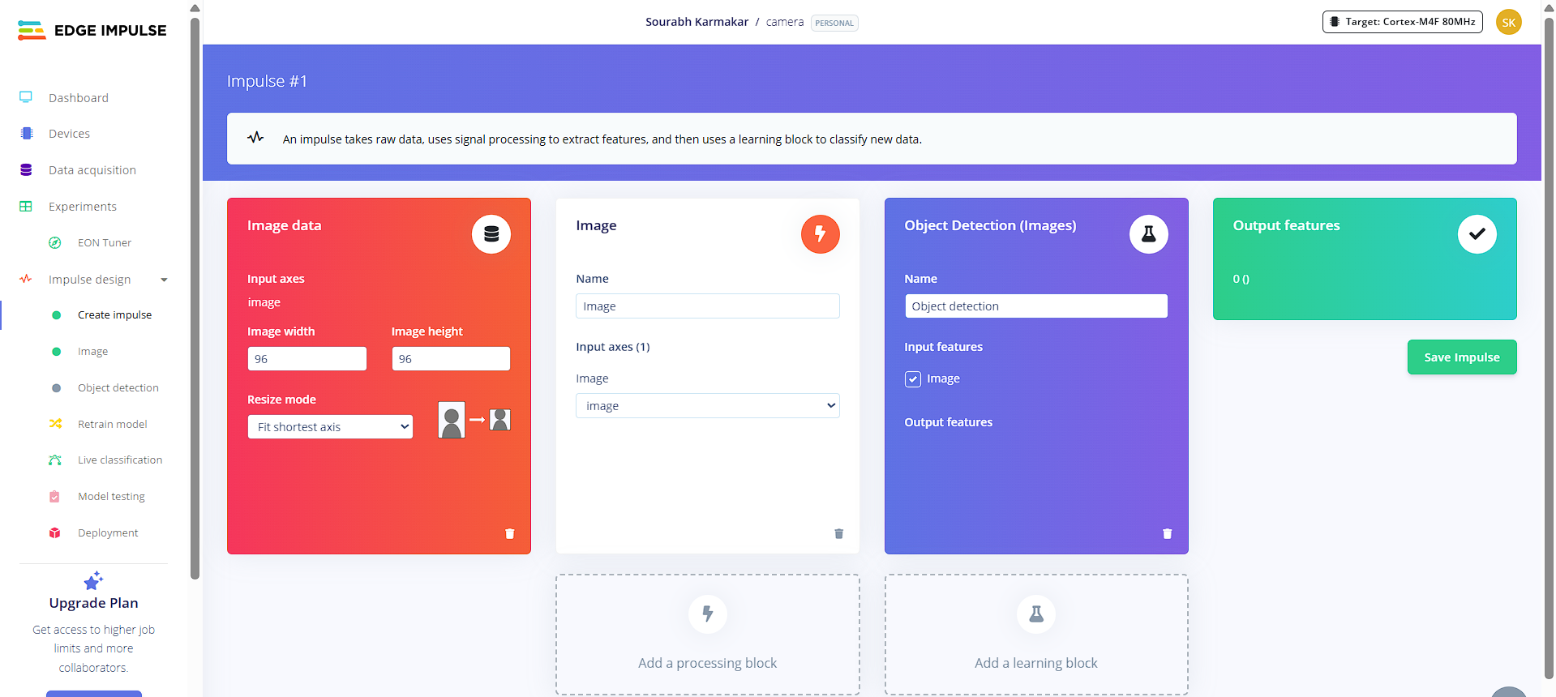

Accuracy / Loss image

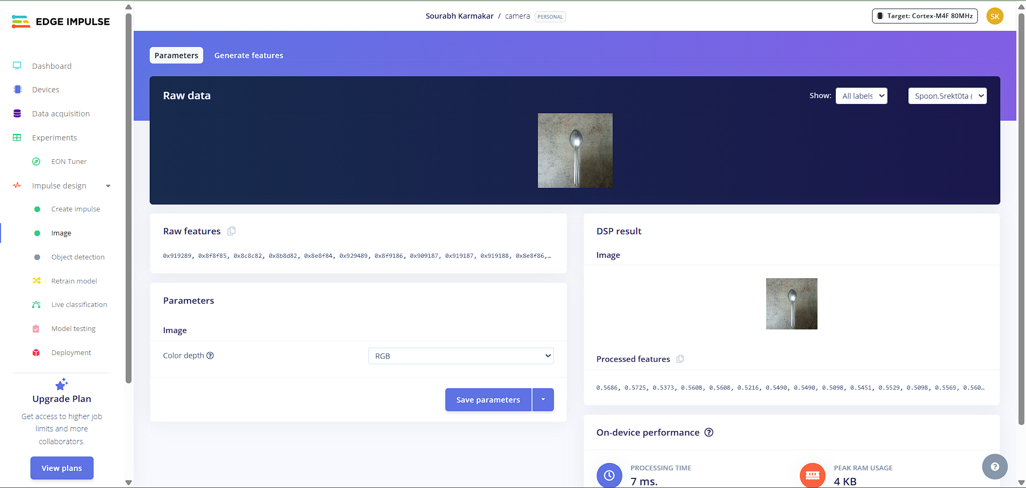

1. Validation Result – Image

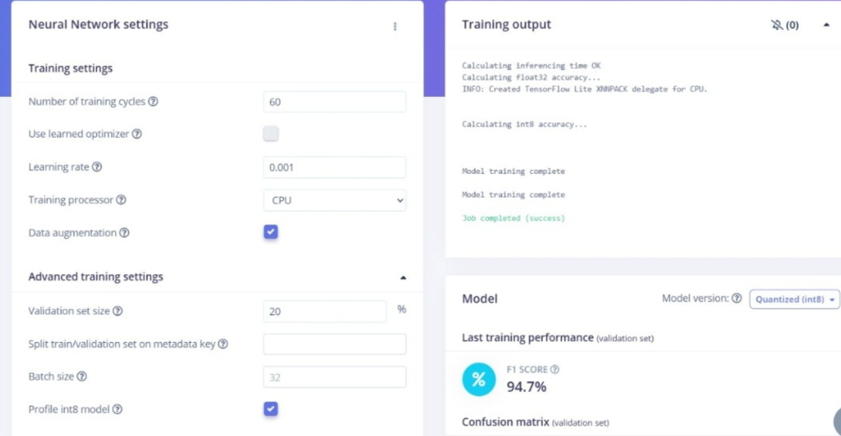

● **Conclusion:** Understood of MobileNetV1 & V2 Architectures and custom training on new dataset for edge devices.