PROJECT REPORT
AttendSense
Intelligent AI Attendance and Analytics Dashboard
Face and voice recognition attendance with teacher and student portals, QR-code joining, a teacher review step and an analytics dashboard. This report records everything done, from the requirements to a tested, deployable codebase,, and explains the code module by module.
Author: Sourabh
Repository: github.com/Sourabh16/Intelligent-AI-Attendance-and-Analytics-Dashboard
Date: 5 October 2026
Stack: Python 3.11 · Streamlit 1.65 · dlib 20 · Resemblyzer · Supabase (Postgres) · Altair · Vercel

Contents

(If the table of contents is empty, right-click it in Word and choose Update Field.)

1. Executive summary
Calling a roll takes 5-10 minutes of every class, and paper registers make it hard to see who is falling behind. The goal of this project was an attendance system that marks a whole class from one classroom photo or one voice recording, with separate teacher and student portals, joining by QR code, and an analytics dashboard. It also had to be accurate, secure with biometric data, and honest about uncertainty.
The result, AttendSense, is a Streamlit application backed by Supabase Postgres, plus a static landing page for Vercel. In numbers:
Measure | Value
Application code | about 2,900 lines of Python across 22 modules
Automated tests | 55 (unit, database-contract and headless UI tests), all passing
Database | 6 tables, 1 view, 1 transactional function, row-level security on every table
Backends | Supabase in production; identical SQLite schema for local use and tests
Recognition | dlib 128-d face embeddings; Resemblyzer 256-d voice embeddings
Accounts needed | GitHub (done), Supabase, Streamlit Community Cloud, Vercel (all free tiers)

The main design decisions:
- Recognition only compares against students enrolled in the subject, uses three enrollment photos per student, and assigns each face to at most one student. Uncertain faces are flagged for the teacher instead of guessed.
- Student sign-in is a 1:1 check with liveness: roll number, then a front photo, then a head-turned photo. Searching the whole school for a face would let a look-alike, or a printed photo, sign in as someone else.
- Nothing is saved without teacher review. The result is an editable table; past classes can be corrected; every save is atomic.
- A real analytics dashboard: trends, heatmap, weekday profile, defaulters, the 75% calculator, and Excel export.
- Security and privacy: row-level security, server-only database key, bcrypt, login throttling, consent, templates instead of photos, and self-service deletion.
- Engineering: 55 tests, CI, pinned dependencies, a local mode needing no accounts, and a demo-data generator.

2. Problem statement and design goals

2.1 Requirements
Who | Needs to
Teacher | create subjects; let students join without typing long lists; take attendance in seconds from a photo or a roll-call recording; correct mistakes; see who is below the attendance target; export records
Student | register once; sign in securely; join a class from a QR code; see their percentage and exactly how many classes they need to attend (or can miss)
Institution | trustworthy records that are safe to store: biometric data protected, consent recorded, deletion possible

2.2 Pitfalls a simple design falls into
Before writing code, I listed the ways a straightforward face-and-voice attendance app goes wrong, and designed each one out:
Pitfall | Consequence | How AttendSense avoids it
Logging students in by searching all faces (1:N), no liveness | A look-alike or a printed photo signs in as someone else | Roll number + 1:1 face check + head-turn liveness (section 12.4)
One enrollment photo per student | Fragile under different lighting, angle or glasses | Three guided photos, checked for consistency (section 12.4)
One classifier trained over every student | Faces match students from other classes; retraining on every sign-up | Closed-set nearest-sample matching, no training step (section 6.3)
No one-to-one constraint | Two faces in one photo both marked as the same student | Greedy most-confident-first assignment (section 6.4)
Guessing when two students look alike | Silent wrong marks | 'Needs review' status; teacher decides (section 6.4)
Using the subject code as the join code | Two teachers' CS101 collide | Separate random join code, pausable and regenerable (section 10.3)
Server clock for timestamps; a class = rows sharing a time | UTC times on the cloud; fragile class counting | UTC stored, IST shown; explicit sessions table (section 10.1)
Saving rows one by one | A failure leaves half a class saved | One atomic database function (section 10.1)
Saving AI output directly | No way to fix mistakes | Editable review before saving; past classes correctable (section 8)
Database open to the public API key | Biometric data exposed if the key leaks | Row-level security, secret key only on the server (section 10.2)
Storing photos and audio | Privacy risk | Only numeric templates kept; consent and deletion (section 10.4)

2.3 What has to be prepared in advance
- Supabase account: hosts the Postgres database. Free tier. Free projects pause after about a week without activity, so open the dashboard before a demo.
- Streamlit Community Cloud account (sign in with GitHub): hosts the app itself.
- Vercel account (sign in with GitHub): only for the landing page. Vercel cannot run this app. Streamlit needs a long-running server with WebSockets, and dlib + PyTorch are far beyond Vercel's ~250 MB serverless function size.
- Local tools: Python 3.11 (managed with uv), a webcam and microphone, and 3-5 volunteers who consent to test recognition.

3. Build log: what was done, in order
- Wrote down the requirements and the pitfalls to design out (section 2).
- Created the project folder and a Python 3.11 virtual environment with uv (3.11 has the most reliable prebuilt wheels for dlib and Resemblyzer). Installed every dependency and smoke-tested the models: dlib 20.0.1 loads its three models; Resemblyzer returns a unit-length 256-d embedding; Streamlit 1.65.0.
- Wrote config.py so every threshold lives in one place.
- Wrote the pure-logic layer core/ (face, voice, attendance draft, analytics, security) with no Streamlit dependency, so it can be unit-tested.
- Designed the database (supabase/schema.sql) and the Repository interface with two implementations: Supabase and SQLite.
- Wrote services.py (cached models, photo and selfie workflows) and the UI: home, teacher portal (auth, take attendance, subjects, analytics), student portal (auth with liveness, registration, dashboard, privacy).
- Pinned dependencies, including CPU-only PyTorch on Linux.
- Wrote 55 tests. Testing found and fixed a real algorithm flaw (section 6.4) and two test-harness issues.
- Wrote a demo-data generator, ran the app in a browser, and fixed three UI issues found there (section 14.1).
- Built the static landing page and checked it on desktop and mobile widths.
- Added CI, .gitignore, README and this report.

4. Architecture
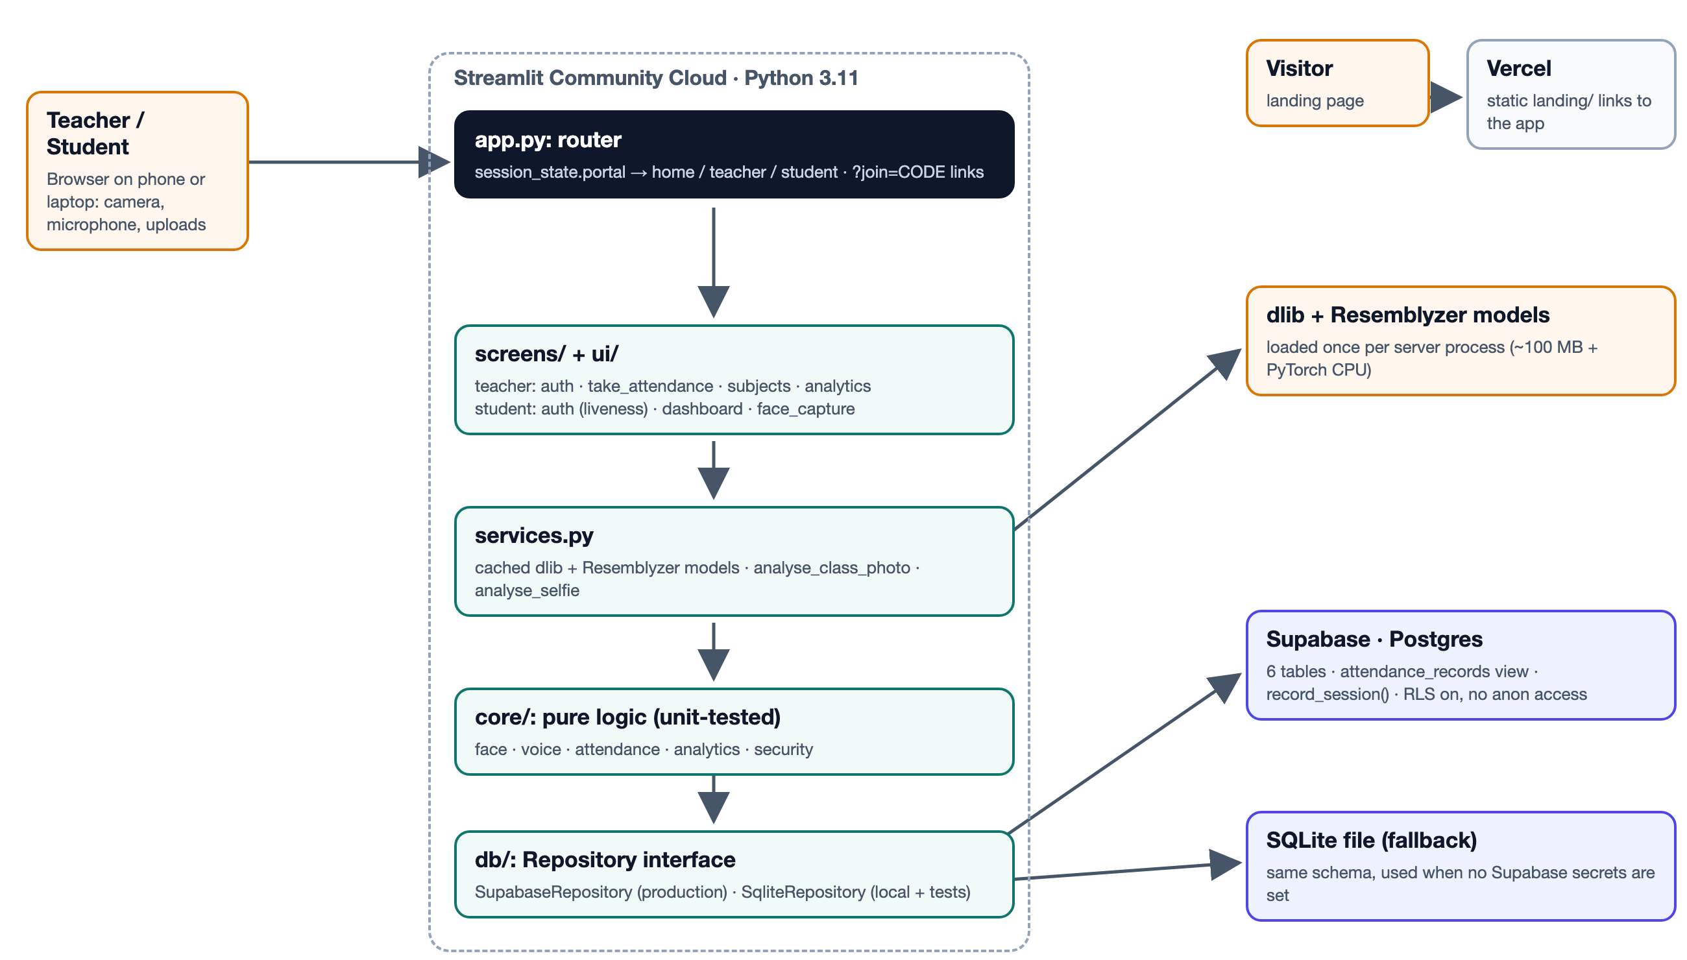
Figure 1. System architecture
The app is layered so that each layer only talks to the one below it:
Layer | Responsibility | Depends on Streamlit?
app.py | Page setup, picks the backend, handles ?join= links, routes to a portal | yes
screens/, ui/ | Everything the user sees: forms, tables, charts, dialogs | yes
services.py | Loads the ML models once (st.cache_resource) and runs the photo/selfie workflows | yes (caching only)
core/ | All algorithms and business rules | no: plain Python, unit-tested
db/ | Data access behind one interface; Supabase or SQLite | only the factory

This separation is why the project can have 55 fast tests: the hard parts (matching, analytics, the 75% arithmetic, security rules, the database contract) are tested without a browser, camera or cloud account.

4.1 Repository layout
app/
app.py entry point + router
requirements.txt pinned runtime dependencies
packages.txt apt packages for Streamlit Cloud (libsndfile, ffmpeg)
.streamlit/config.toml theme
.streamlit/secrets.toml.example
src/
config.py all thresholds and settings
services.py cached models + recognition workflows
core/ face.py voice.py attendance.py analytics.py security.py
db/ base.py sqlite_repo.py supabase_repo.py __init__.py (get_repo)
screens/ home.py
teacher/ main.py auth.py take_attendance.py subjects.py analytics.py common.py
student/ main.py auth.py dashboard.py face_capture.py
ui/components.py theme CSS + shared widgets
supabase/schema.sql database schema
landing/ static site for Vercel
scripts/seed_demo.py demo semester generator
tests/ 55 tests
.github/workflows/ci.yml lint + tests on every push

5. Configuration: src/config.py
Every tunable number is a named constant in one file, with a comment explaining it. Secrets (Supabase URL and key, public app URL) are read from Streamlit secrets first, then environment variables.
Setting | Value | Meaning
FACE_MATCH_THRESHOLD | 0.50 | Max embedding distance to call a face a match. dlib's default is 0.6; we are stricter because a false "present" is worse than a false "absent" (the teacher can tick a missed student).
FACE_AMBIGUITY_MARGIN | 0.04 | If the runner-up student is within this of the best, the face is 'needs review'.
FACE_DUPLICATE_THRESHOLD | 0.42 | A new registration this close to an existing student is refused.
FACE_ENROLL_CONSISTENCY | 0.55 | The three enrollment photos must all be within this of each other.
FACE_UPSAMPLE_CLASSROOM | 2 | Detector upsampling for classroom photos (finds small faces).
LIVENESS_TURN_MIN_OFFSET | 0.15 | Required change in head-turn estimate between login photos.
VOICE_MATCH_THRESHOLD | 0.72 | Min cosine similarity for a voice match (stricter than the commonly used 0.65).
DEFAULT_TARGET_PCT | 75 | Default attendance target; editable per subject.
MAX_LOGIN_ATTEMPTS / LOCKOUT | 5 / 60 s | Login throttling.
TIMEZONE | Asia/Kolkata | Times are stored in UTC and displayed in IST.

6. Face recognition: core/face.py
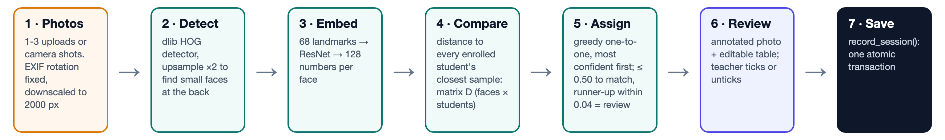
Figure 2. Photo attendance pipeline

6.1 Loading images safely
Phone photos are often stored sideways with an EXIF 'rotate' tag. Without honouring it, faces are detected lying on their side, or not at all. Very large photos are downscaled to keep detection fast.
core/face.py: load_image
def load_image(data: bytes, max_side: int = config.MAX_IMAGE_SIDE) -> np.ndarray:
"""Decode an uploaded image into an RGB uint8 array.

Applies the EXIF rotation (phone photos are often stored sideways) and
downscales very large photos so detection stays fast.
"""
img = Image.open(io.BytesIO(data))
img = ImageOps.exif_transpose(img).convert("RGB")
if max(img.size) > max_side:
img.thumbnail((max_side, max_side))
return np.ascontiguousarray(np.asarray(img, dtype=np.uint8))

6.2 Detection and embeddings
dlib's HOG detector finds face rectangles. For each one, a 68-point landmark predictor finds the eyes, nose and jaw. A ResNet network then turns the aligned face into 128 numbers, the *embedding*. Two photos of the same person produce embeddings that are close together (Euclidean distance usually below 0.6). The landmarks are kept too, for the liveness check. jitters > 1 averages several slightly distorted copies of the face; it is used for enrollment selfies.
core/face.py: detect_faces
def detect_faces(
image: np.ndarray, models: FaceModels, upsample: int = 1, jitters: int = 1
) -> list[DetectedFace]:
"""Find every face and compute its 128-d embedding and landmarks.

`jitters` > 1 re-samples the face with small distortions and averages the
embeddings: slower, slightly more robust. Used for enrollment selfies.
"""
faces = []
for rect in models.detector(image, upsample):
shape = models.predictor(image, rect)
emb = np.asarray(models.encoder.compute_face_descriptor(image, shape, jitters))
pts = np.array([(p.x, p.y) for p in shape.parts()], dtype=float)
box = (max(rect.left(), 0), max(rect.top(), 0), rect.right(), rect.bottom())
faces.append(DetectedFace(box=box, embedding=emb, landmarks=pts))
return faces

6.3 Comparing faces with students
Each student has several enrollment embeddings. The distance from a face to a student is the distance to that student's closest sample, so a face turned to the left is compared with the left-turned enrollment photo. The result is a matrix D with one row per face and one column per student.
core/face.py: distance_matrix (vectorised with NumPy broadcasting)
def distance_matrix(
embeddings: Sequence[Embedding], gallery: Gallery
) -> tuple[np.ndarray, list[int]]:
"""Euclidean distance from each face to each student's *closest* sample.

Returns (D, student_ids) where D has shape (n_faces, n_students).
"""
student_ids = [sid for sid, samples in gallery.items() if len(samples) > 0]
n_faces = len(embeddings)
if n_faces == 0 or not student_ids:
return np.zeros((n_faces, len(student_ids))), student_ids
faces = np.asarray(embeddings, dtype=float) # (F, 128)
D = np.empty((n_faces, len(student_ids)))
for j, sid in enumerate(student_ids):
samples = np.asarray(gallery[sid], dtype=float) # (k, 128)
dists = np.linalg.norm(faces[:, None, :] - samples[None, :, :], axis=2)
D[:, j] = dists.min(axis=1)
return D, student_ids

Crucially, the gallery passed in contains only students enrolled in the subject being marked (closed-set recognition). A common alternative is to train one classifier (for example an SVM) over every student in the database; then a face can match someone from another class, and every new sign-up forces a full retrain. With nearest-neighbour matching there is no training step at all: a new student is usable immediately.

6.4 One face, one student: greedy assignment
In a classroom photo two different faces can both look most like the same student. Without a constraint, that student would be counted twice and the real second person missed. The first implementation used the Hungarian algorithm (scipy.optimize.linear_sum_assignment), the textbook optimal assignment. A unit test exposed a flaw:
 | Student 1 | Student 2
Face 1 | 0.05 (near-certain) | 0.30
Face 2 | 0.10 | 0.45

Hungarian minimises the total distance: Face 1 → Student 2 and Face 2 → Student 1 costs 0.30 + 0.10 = 0.40, which beats the intuitive 0.05 + 0.45 = 0.50. So it hands a near-certain face to the wrong student to make the sum smaller. The fix is greedy assignment, most confident pair first: take the smallest remaining distance whose face and student are both free, and repeat. Face 1 gets Student 1 (0.05), then Face 2 gets Student 2 (0.45, still under the threshold).
core/face.py: assign_greedy
def assign_greedy(D: np.ndarray, threshold: float) -> dict[int, int]:
"""One-to-one face -> student assignment, most confident pair first.

Repeatedly takes the smallest remaining distance whose face and student
are both still free. Unlike the Hungarian algorithm (which minimises the
*total* distance) this never gives a near-certain face to the wrong
student just to make the sum smaller.
"""
pairs = sorted((D[i, j], i, j) for i in range(D.shape[0]) for j in range(D.shape[1]) if D[i, j] <= threshold)
used_faces: set[int] = set()
used_students: set[int] = set()
assigned: dict[int, int] = {}
for _, i, j in pairs:
if i not in used_faces and j not in used_students:
assigned[i] = j
used_faces.add(i)
used_students.add(j)
return assigned

core/face.py: match_faces
def match_faces(
embeddings: Sequence[Embedding],
gallery: Gallery,
threshold: float = config.FACE_MATCH_THRESHOLD,
margin: float = config.FACE_AMBIGUITY_MARGIN,
) -> list[FaceMatch]:
"""Assign faces to students one-to-one.

* Pairs further apart than `threshold` are never assigned.
* A face whose runner-up student is within `margin` of its best is marked
"ambiguous": shown to the teacher but not auto-marked present.
"""
D, sids = distance_matrix(embeddings, gallery)
n_faces = len(embeddings)
if not sids:
return [FaceMatch(i, None, float("inf"), "unknown") for i in range(n_faces)]

assigned = assign_greedy(D, threshold)
results = []
for i in range(n_faces):
if i not in assigned:
j = int(D[i].argmin())
results.append(FaceMatch(i, None, float(D[i, j]), "unknown"))
continue
j = assigned[i]
d = float(D[i, j])
others = np.delete(D[i], j)
ambiguous = others.size > 0 and float(others.min()) - d < margin
results.append(FaceMatch(i, sids[j], d, "ambiguous" if ambiguous else "matched"))
return results

Each face ends with one of three statuses:
- matched: assigned and clearly better than the runner-up; auto-marked present.
- ambiguous: assigned, but another student is within 0.04. It is shown with a '?' and listed for the teacher; not auto-marked.
- unknown: nobody within the threshold (often a visitor or an unenrolled student).
core/face.py: FaceMatch.confidence: a 0..1 display score
@property
def confidence(self) -> float:
"""0..1 score for display: 1 at distance 0, 0 at the threshold."""
if not np.isfinite(self.distance):
return 0.0
return float(max(0.0, 1.0 - self.distance / config.FACE_MATCH_THRESHOLD))

6.5 1:1 verification and the head-turn estimate
Login doesn't search the whole school. It checks one claimed identity: is this face within the threshold of *this* student's samples?
core/face.py: verify_face
def verify_face(
embedding: Embedding,
samples: Sequence[Sequence[float]],
threshold: float = config.FACE_MATCH_THRESHOLD,
) -> tuple[bool, float]:
"""1:1 check: is this face the owner of `samples`? Used for student login."""
if not samples:
return False, float("inf")
d = float(np.linalg.norm(np.asarray(samples) - embedding, axis=1).min())
return d <= threshold, d

For liveness we estimate how far the head is turned from three landmarks: the left jaw (0), the right jaw (16) and the nose tip (30). Looking straight at the camera, the nose sits near the middle of the jaw, giving an offset of about 0. Turning the head moves the nose towards one side, giving roughly ±0.2 or more. The sign is ignored because some browsers mirror the camera image and some don't.
core/face.py: head_turn_offset
def head_turn_offset(landmarks: np.ndarray) -> float:
"""Signed horizontal head-turn estimate from landmarks.

The nose tip's position across the jaw width: 0 when looking straight at
the camera, about +-0.2 or more when the head is clearly turned. The sign
is not used because browser cameras may or may not mirror the image.
"""
left = landmarks[_JAW_LEFT, 0]
right = landmarks[_JAW_RIGHT, 0]
width = right - left
if width <= 0:
return 0.0
return float((landmarks[_NOSE_TIP, 0] - left) / width - 0.5)

Finally, annotate() draws a green, amber or red box and the name on every face, so the teacher can see exactly what the AI decided.

7. Voice recognition: core/voice.py
The teacher records the class while each student says "present". The recording is cut wherever there is silence; each spoken piece becomes a 256-number Resemblyzer embedding; each piece is compared with the voice profiles of students enrolled in the subject.
core/voice.py: split_segments: drop pieces shorter than 0.6 s (coughs, desk noise)
def split_segments(
audio: np.ndarray,
sr: int = config.VOICE_SAMPLE_RATE,
top_db: float = config.VOICE_SILENCE_TOP_DB,
min_seconds: float = config.VOICE_MIN_SEGMENT_SECONDS,
) -> list[tuple[int, int]]:
"""Sample ranges of the non-silent parts, dropping very short blips."""
import librosa

if audio.size == 0:
return []
intervals = librosa.effects.split(audio, top_db=top_db)
return [(int(s), int(e)) for s, e in intervals if (e - s) >= min_seconds * sr]

Resemblyzer embeddings are L2-normalised (length 1), so the dot product equals cosine similarity: 1.0 means identical and unrelated voices typically score 0.5-0.7. The best student must reach 0.72 and beat the runner-up by 0.03.
core/voice.py: match_embedding
def match_embedding(
embedding: np.ndarray,
profiles: Mapping[int, Sequence[float]],
threshold: float = config.VOICE_MATCH_THRESHOLD,
margin: float = config.VOICE_AMBIGUITY_MARGIN,
) -> tuple[int | None, float, bool]:
"""Best student for one voice segment.

Returns (student_id or None, similarity, ambiguous). Below `threshold`
nobody is returned; within `margin` of the runner-up the match is
flagged ambiguous.
"""
ids = [sid for sid, p in profiles.items() if p is not None and len(p) > 0]
if not ids:
return None, 0.0, False
P = np.asarray([profiles[s] for s in ids], dtype=float)
sims = P @ np.asarray(embedding, dtype=float)
order = np.argsort(sims)[::-1]
best = float(sims[order[0]])
if best < threshold:
return None, best, False
ambiguous = len(order) > 1 and best - float(sims[order[1]]) < margin
return ids[int(order[0])], best, ambiguous

Unlike faces, one student may legitimately produce several segments (they say "present, ma'am"), so voice matching is not one-to-one. Instead, each student's strongest unambiguous segment is kept:
core/voice.py: best_per_student
def best_per_student(matches: Sequence[SegmentMatch]) -> dict[int, SegmentMatch]:
"""Keep each student's strongest unambiguous segment.

A student who speaks twice (or coughs) only needs to be recognised once.
"""
best: dict[int, SegmentMatch] = {}
for m in matches:
if m.student_id is None or m.ambiguous:
continue
if m.student_id not in best or m.similarity > best[m.student_id].similarity:
best[m.student_id] = m
return best

8. From recognition to a saved class: core/attendance.py
A teacher may analyse two photos and a voice recording for the same class. All results merge into one draft: a student is present if any source recognised them, and the draft keeps the strongest evidence and where it came from ("Photo 1, Photo 2").
core/attendance.py: merge_hit
def merge_hit(hits: dict[int, Hit], student_id: int, source: str, confidence: float, evidence: str) -> None:
"""Record that `student_id` was recognised; keep the best confidence."""
h = hits.get(student_id)
if h is None:
hits[student_id] = Hit(source, confidence, [evidence])
return
h.evidence.append(evidence)
if confidence > h.confidence:
h.source, h.confidence = source, confidence

The draft becomes an editable table (st.data_editor). When the teacher saves, every row whose tick-box was changed is recorded with source = manual and no confidence. The database therefore always shows which marks came from AI and which from a human.
core/attendance.py: rows_from_draft
def rows_from_draft(original: pd.DataFrame, edited: pd.DataFrame) -> list[dict]:
"""Attendance rows to save. A changed tick-box becomes a manual mark."""
before = original.set_index("student_id")["present"].to_dict()
out = []
for r in edited.itertuples(index=False):
changed = bool(r.present) != bool(before.get(r.student_id, False))
source = "manual" if changed or pd.isna(r.confidence) else r.source
out.append({
"student_id": int(r.student_id),
"status": "present" if r.present else "absent",
"source": source,
"confidence": None if source == "manual" or pd.isna(r.confidence) else float(r.confidence),
})
return out

core/attendance.py: session_method: face, voice, manual or mixed
def session_method(sources_used: set[str]) -> str:
"""'face', 'voice', 'manual' or 'mixed' for the sessions table."""
sources_used = sources_used - {"manual"} or {"manual"}
return sources_used.pop() if len(sources_used) == 1 else "mixed"

9. Analytics: core/analytics.py
Every dashboard, export and student card works on one flat table with one row per (class, student), read from the attendance_records view. records_frame() converts times from UTC to IST and adds a boolean present column.

9.1 The 75% arithmetic
Let a = classes attended, t = classes held, T = target (e.g. 0.75).
Classes needed: the smallest k such that (a + k) / (t + k) ≥ T. Rearranging: a + k ≥ T·t + T·k, so k(1 − T) ≥ T·t − a, so k = ⌈(T·t − a) / (1 − T)⌉. Example: 6 of 10 at 75% gives k = ⌈(7.5 − 6)/0.25⌉ = 6, and indeed 12/16 = 75%.
Classes that can be missed: the largest m such that a / (t + m) ≥ T, so m = ⌊a/T − t⌋. Example: 9 of 10 gives m = ⌊12 − 10⌋ = 2, and 9/12 = 75%.
core/analytics.py: the two formulas, with edge cases (no classes yet, 100% target)
def classes_needed(attended: int, total: int, target_pct: float) -> int:
"""Consecutive classes to attend to reach the target.

Smallest k with (attended + k) / (total + k) >= target.
"""
t = target_pct / 100.0
if total == 0 or attended / total >= t:
return 0
if t >= 1.0:
return -1 if attended < total else 0 # 100% is unreachable once missed
return math.ceil((t * total - attended) / (1.0 - t) - 1e-9)

def classes_can_miss(attended: int, total: int, target_pct: float) -> int:
"""Classes that can be skipped while staying at or above the target.

Largest m with attended / (total + m) >= target.
"""
t = target_pct / 100.0
if total == 0 or t <= 0 or attended / total < t:
return 0
return max(0, math.floor(attended / t - total + 1e-9))

The - 1e-9 and + 1e-9 guard against floating-point error: 0.75 × 8 might be computed as 5.999999999 and wrongly round up. The landing page's interactive calculator implements the identical formulas in JavaScript.

9.2 Summaries
core/analytics.py: student_summary
def student_summary(df: pd.DataFrame, target_pct: float = config.DEFAULT_TARGET_PCT) -> pd.DataFrame:
"""Per student (and subject): attended, total, %, status, what to do next."""
if df.empty:
return pd.DataFrame(columns=[
"subject_name", "subject_code", "roll_no", "student_name", "attended",
"total", "pct", "status", "need", "can_miss"])
g = (
df.groupby(["subject_id", "subject_name", "subject_code", "student_id",
"roll_no", "student_name"], as_index=False)
.agg(attended=("present", "sum"), total=("session_id", "nunique"))
)
g["attended"] = g["attended"].astype(int)
g["pct"] = [pct(a, t) for a, t in zip(g["attended"], g["total"], strict=False)]
g["status"] = ["On track" if p >= target_pct else "Below target" for p in g["pct"]]
g["need"] = [classes_needed(a, t, target_pct) for a, t in zip(g["attended"], g["total"], strict=False)]
g["can_miss"] = [classes_can_miss(a, t, target_pct) for a, t in zip(g["attended"], g["total"], strict=False)]
return g.sort_values(["subject_name", "pct", "roll_no"]).reset_index(drop=True)

Function | Output | Used in
overview | classes held, students, average %, number below target, last class % | KPI tiles
session_summary | per class: time, method, present/total, % | Sessions tab, Excel
trend | per-class % in time order + 5-class rolling mean | trend chart
weekday_profile | average % by day of week | finds the "Friday dip"
heatmap_frame | student × class grid of present/absent | heatmap
method_mix | how present students were marked (face/voice/manual) | donut chart
defaulters | students below target, worst first | red alert + CSV
to_excel / to_csv | 4-sheet workbook / raw CSV | Export tab

10. Security, privacy and the database

10.1 Database design
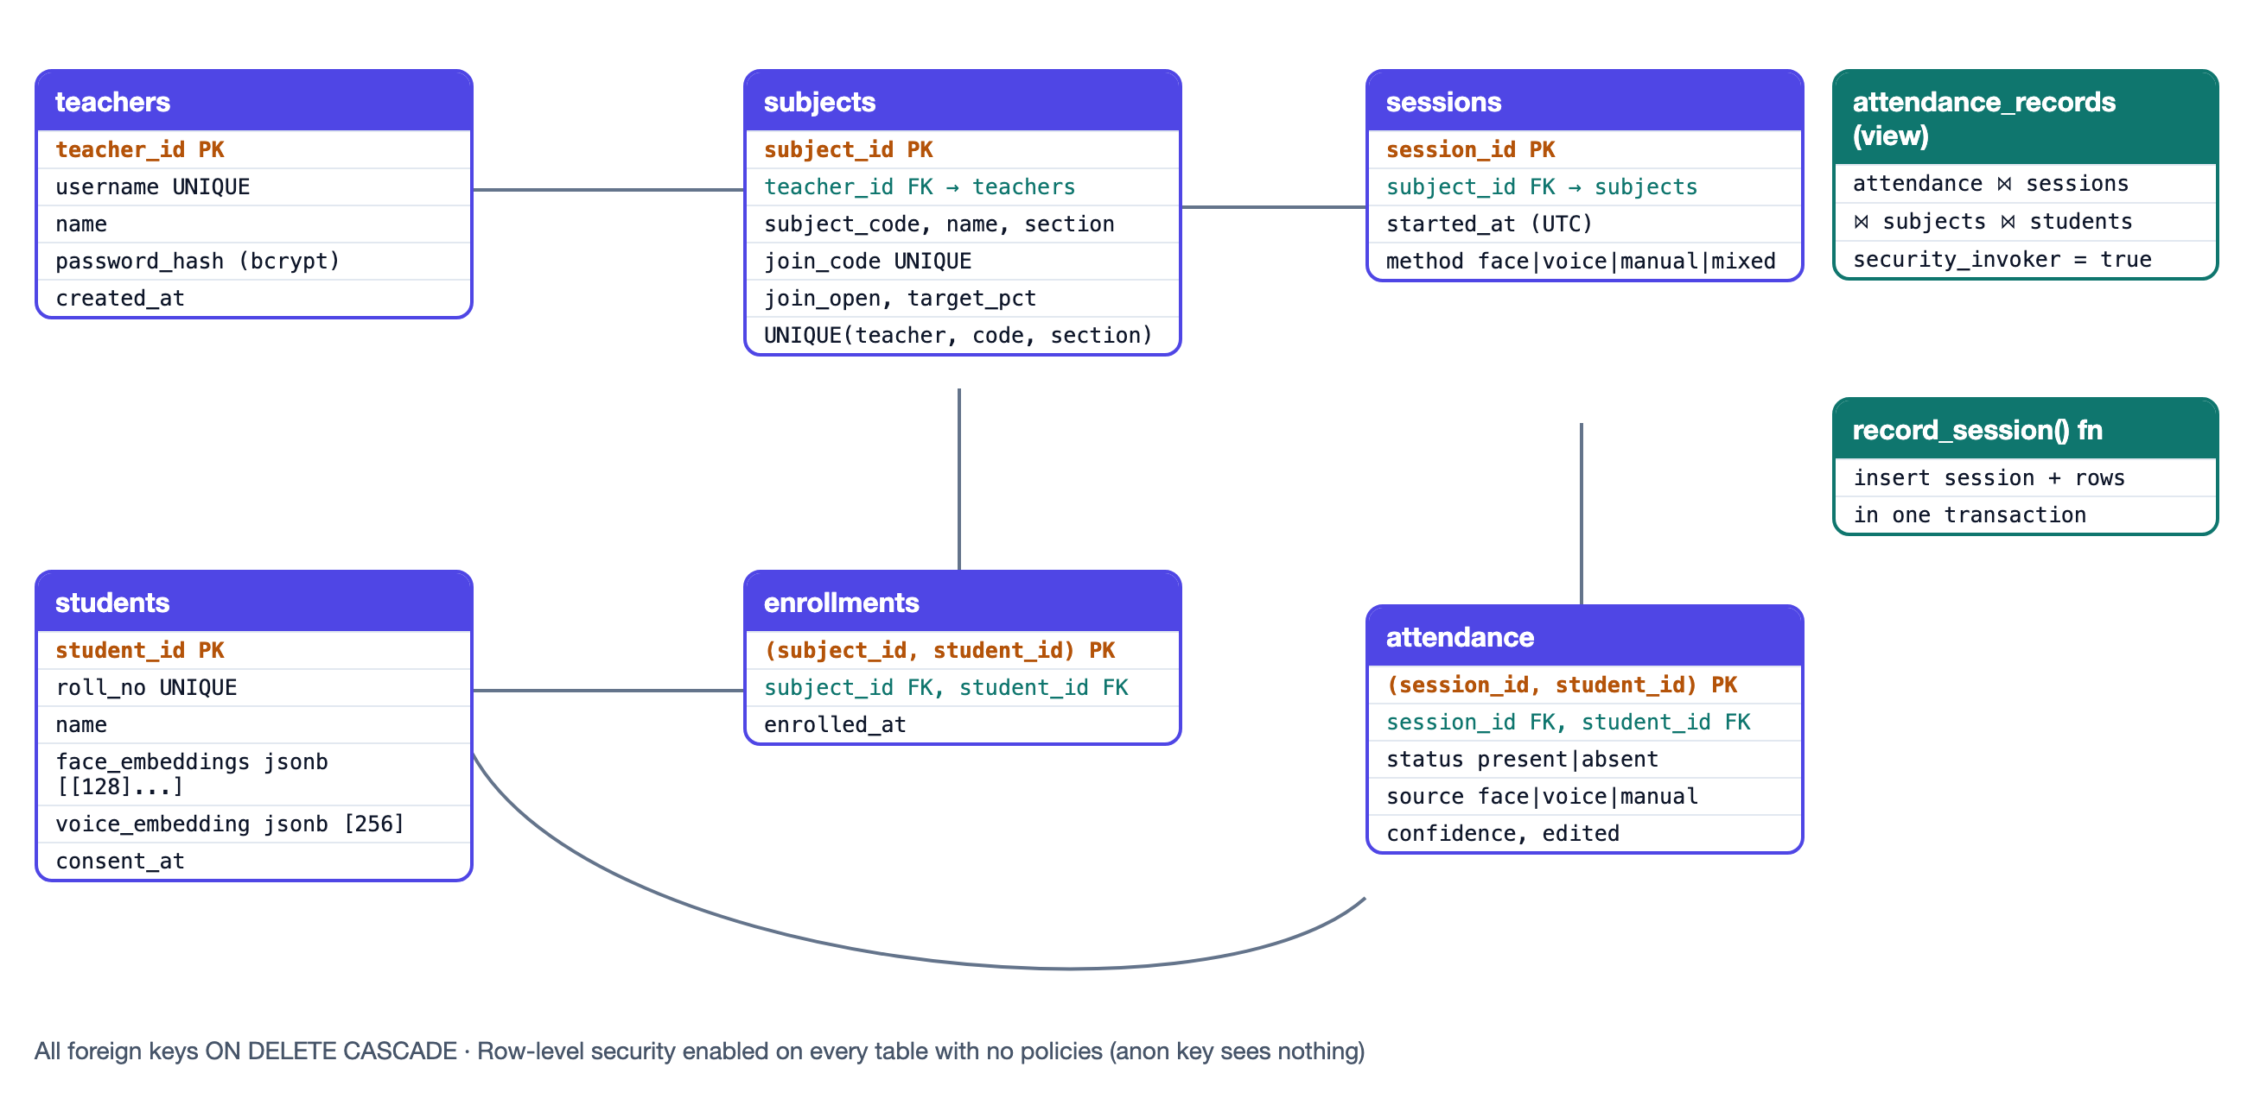
Figure 3. Database schema
Key decisions, each fixing a problem from section 2.2:
- students.roll_no is UNIQUE and is the login identity. face_embeddings is a JSON list of 128-d lists, one per enrollment photo.
- subjects.join_code is a separate random code, unique across the system; UNIQUE(teacher_id, subject_code, section) stops one teacher creating duplicates while allowing two teachers to both teach CS101.
- sessions makes a class an explicit row, so 'classes held' is a count, not a guess based on timestamps.
- attendance has a composite primary key (session_id, student_id), so a student cannot be marked twice in one class. It records source, confidence and an edited flag.
- ON DELETE CASCADE everywhere: deleting a student removes their templates, enrollments and marks in one statement. This is the right to erasure.
supabase/schema.sql: the students table
create table if not exists students (
student_id bigint generated always as identity primary key,
roll_no text not null unique check (roll_no = upper(roll_no)),
name text not null,
-- list of 128-d dlib embeddings, one per enrollment photo
face_embeddings jsonb not null default '[]'::jsonb,
-- 256-d Resemblyzer embedding, null when the student skipped voice
voice_embedding jsonb,
consent_at timestamptz not null,
created_at timestamptz not null default now()
);

Every screen reads through one view that flattens the joins. security_invoker = true makes the view obey the caller's row-level security; otherwise views run with the owner's rights and could be used to read around the policies.
supabase/schema.sql: attendance_records view
create or replace view attendance_records with (security_invoker = true) as
select
a.session_id,
se.started_at,
se.method,
su.subject_id,
su.subject_code,
su.name as subject_name,
su.section,
su.teacher_id,
st.student_id,
st.name as student_name,
st.roll_no,
a.status,
a.source,
a.confidence
from attendance a
join sessions se on se.session_id = a.session_id
join subjects su on su.subject_id = se.subject_id
join students st on st.student_id = a.student_id;

Saving a class must be all-or-nothing. PostgREST (the Supabase API) runs each request in its own transaction, so the session row and its attendance rows are inserted by one Postgres function:
supabase/schema.sql: record_session()
create or replace function record_session(p_subject_id bigint, p_method text, p_rows jsonb)
returns bigint
language plpgsql
as $$
declare
v_session_id bigint;
begin
insert into sessions(subject_id, method)
values (p_subject_id, p_method)
returning session_id into v_session_id;

insert into attendance(session_id, student_id, status, source, confidence)
select v_session_id,
(r->>'student_id')::bigint,
r->>'status',
r->>'source',
nullif(r->>'confidence', '')::real
from jsonb_array_elements(p_rows) as r;

return v_session_id;
end;
$$;

10.2 Row-level security
Supabase exposes every table through a public API. A project has a public *anon* key, which is safe to put in a browser only if row-level security (RLS) restricts it, and a *secret* key that bypasses RLS. AttendSense runs all database calls on the Streamlit server with the secret key; no browser ever sees it. RLS is enabled on every table with no policies, so the anon key can read or write nothing. Even if it leaked, no biometric data would be exposed.
supabase/schema.sql: security section
alter table teachers enable row level security;
alter table students enable row level security;
alter table subjects enable row level security;
alter table enrollments enable row level security;
alter table sessions enable row level security;
alter table attendance enable row level security;

revoke all on function record_session(bigint, text, jsonb) from public, anon, authenticated;
grant execute on function record_session(bigint, text, jsonb) to service_role;

10.3 Application security
- Passwords: bcrypt with a per-password salt; at least 8 characters with a letter and a digit. Login gives the same error for an unknown user and a wrong password, so it doesn't reveal which usernames exist.
- Throttling: 5 failed attempts lock the form for 60 seconds.
core/security.py: LoginThrottle
class LoginThrottle:
"""Lock a login form for a while after too many failures.

State is a plain dict so it can live in st.session_state.
"""

def __init__(self, state: dict, key: str) -> None:
self.state = state.setdefault(f"_throttle_{key}", {"fails": 0, "until": 0.0})

def locked_for(self) -> int:
return max(0, int(self.state["until"] - time.time()))

def fail(self) -> None:
self.state["fails"] += 1
if self.state["fails"] >= config.MAX_LOGIN_ATTEMPTS:
self.state["until"] = time.time() + config.LOGIN_LOCKOUT_SECONDS
self.state["fails"] = 0

def succeed(self) -> None:
self.state.update(fails=0, until=0.0)

- Join codes: 6 characters from an alphabet without 0/O and 1/I/L (they are read off a projector), generated with the secrets module rather than random. Teachers can pause joining or regenerate the code.
core/security.py: join codes
# No 0/O or 1/I/L: join codes are read aloud and typed from a projector.
_CODE_ALPHABET = "ABCDEFGHJKMNPQRSTUVWXYZ23456789"

def new_join_code(length: int = config.JOIN_CODE_LENGTH) -> str:
return "".join(secrets.choice(_CODE_ALPHABET) for _ in range(length))

- Authorisation: every teacher action on a subject first checks that the subject belongs to that teacher (owned_subject).
- HTML injection: any user-supplied text placed into custom HTML goes through html.escape (ui.esc).
- Duplicate identities: a new registration is compared with every existing face; a match within 0.42 is refused, so one person cannot hold two roll numbers.
screens/student/face_capture.py: find_duplicate
def find_duplicate(all_embeddings: dict[int, list], new_shots: list, exclude: int | None = None) -> int | None:
"""student_id of an existing student with the same face, if any."""
for sid, samples in all_embeddings.items():
if sid == exclude or not samples:
continue
for emb in new_shots:
ok, _ = face.verify_face(emb, samples, config.FACE_DUPLICATE_THRESHOLD)
if ok:
return sid
return None

10.4 Privacy
- Explicit consent checkbox at registration; consent time stored.
- Classroom photos, selfies and audio are processed in memory and never written to disk or the database. Only the numeric templates are stored.
- Students can see exactly what is stored, replace or remove their voice profile, retake face photos, and delete their account and every record.

11. Data access layer: db/
Screens never write SQL. They call a Repository interface (db/base.py) with methods such as create_subject, roster, record_session and records. Two classes implement it:
- SupabaseRepository: production. Uses the supabase-py client. Two details matter: (1) unique-constraint errors (Postgres code 23505) become a DuplicateError, so screens can say "username taken"; (2) PostgREST returns at most 1,000 rows per request, so _all() pages through results. Otherwise a class of 40 students over 30 classes (1,200 rows) would silently lose data.
db/supabase_repo.py: error mapping and pagination
@staticmethod
def _run(query):
from postgrest.exceptions import APIError

try:
return query.execute().data
except APIError as e:
if getattr(e, "code", None) == "23505": # unique_violation
raise DuplicateError(e.message) from e
raise

def _all(self, make_query) -> list[Row]:
"""Fetch every row, page by page. `make_query()` builds a fresh query."""
out: list[Row] = []
start = 0
while True:
page = self._run(make_query().range(start, start + _PAGE - 1))
out.extend(page)
if len(page) < _PAGE:
return out
start += _PAGE

- SqliteRepository: the same schema in a local file. It's used automatically when no Supabase secrets exist, which is how the app ran before any accounts were created, and by the tests (in memory). A lock makes it safe across Streamlit's threads, and record_session uses a real transaction with rollback.
db/sqlite_repo.py: record_session
def record_session(self, subject_id, method, rows):
with self._lock: # one transaction: all or nothing
try:
cur = self._conn.execute(
"INSERT INTO sessions (subject_id, method) VALUES (?, ?)", [subject_id, method])
sid = cur.lastrowid
self._conn.executemany(
"INSERT INTO attendance (session_id, student_id, status, source, confidence) "
"VALUES (?, ?, ?, ?, ?)",
[(sid, r["student_id"], r["status"], r["source"], r.get("confidence")) for r in rows])
self._conn.commit()
except Exception:
self._conn.rollback()
raise
return int(sid)

db/__init__.py: choosing the backend
@st.cache_resource(show_spinner=False)
def get_repo() -> Repository:
if config.use_supabase():
from src.db.supabase_repo import SupabaseRepository

return SupabaseRepository(config.supabase_url(), config.supabase_key())
from src.db.sqlite_repo import SqliteRepository

return SqliteRepository(config.local_db_path())

A test (test_schema_parity) parses schema.sql and checks every table has exactly the same columns in SQLite, so the two backends cannot drift apart.

12. The application screens

12.1 Router: app.py
Streamlit reruns the whole script on every interaction, so navigation is a small state machine in st.session_state. A join link (?join=CODE) stores the code, switches to the student portal and removes the parameter from the URL.
app.py
repo = get_repo()
st.session_state["_backend_name"] = repo.backend_name

join = st.query_params.get("join")
if join:
st.session_state["pending_join"] = normalise_join_code(join)
st.session_state["portal"] = "student"
del st.query_params["join"]

match st.session_state.get("portal"):
case "teacher":
teacher_main.render(repo)
case "student":
student_main.render(repo)
case _:
home.render(repo)

ui.footer()

12.2 Model caching: services.py
The dlib models (~100 MB) and the Resemblyzer network are loaded once per server process with st.cache_resource, not on every click.
services.py
@st.cache_resource(show_spinner="Loading face models...")
def face_models() -> face.FaceModels:
return face.FaceModels()

def analyse_class_photo(
data: bytes, label: str, roster: list[dict], threshold: float, margin: float
) -> PhotoResult:
image = face.load_image(data)
faces = face.detect_faces(image, face_models(), upsample=config.FACE_UPSAMPLE_CLASSROOM)
gallery = {s["student_id"]: s["face_embeddings"] for s in roster}
names = {s["student_id"]: s["name"] for s in roster}
matches = face.match_faces([f.embedding for f in faces], gallery, threshold, margin)
return PhotoResult(label, face.annotate(image, faces, matches, names), matches)

12.3 Teacher portal
Sign in / create account (teacher/auth.py): forms with validation, bcrypt and throttling.
screens/teacher/auth.py: _login
def _login(repo: Repository) -> None:
throttle = security.LoginThrottle(st.session_state, "teacher")
with st.form("teacher_login"):
username = st.text_input("Username", placeholder="ananya.roy")
password = st.text_input("Password", type="password")
submitted = st.form_submit_button("Sign in", type="primary", width="stretch",
icon=":material/login:")
if not submitted:
return
if wait := throttle.locked_for():
st.error(f"Too many failed attempts. Try again in {wait} s.")
return
teacher = repo.get_teacher_by_username(security.normalise_username(username))
# Same message for unknown user and wrong password: don't reveal which.
if teacher and security.check_password(password, teacher["password_hash"]):
throttle.succeed()
_sign_in(teacher)
else:
throttle.fail()
st.error("Incorrect username or password.")

Take attendance (teacher/take_attendance.py): choose a subject; optionally adjust strictness sliders; add photos (upload or camera) and/or a voice recording; see annotated photos and a segment table; review the editable table (with "mark everyone present/absent" shortcuts); save.
screens/teacher/take_attendance.py: saving
if st.button("Save attendance", type="primary", icon=":material/save:", width="stretch"):
rows = att.rows_from_draft(original, edited)
sources = set(draft["sources"]) | {r["source"] for r in rows if r["status"] == "present"}
try:
repo.record_session(subject_id, att.session_method(sources), rows)
except Exception as e:
st.error(f"Saving failed, nothing was written. ({e})")
return
st.session_state["draft"] = _new_draft(subject_id)
st.toast(f"Saved: {n_present}/{len(rows)} present", icon=":material/check_circle:")
st.rerun()

Subjects (teacher/subjects.py): create a subject (code, name, section, target %); each card shows students, classes, target, join code and status, with Share (QR + link + download), Roster (remove students), Settings (rename, target, pause joining, regenerate code) and Delete (type the code to confirm).
screens/teacher/subjects.py: link and QR code
def join_link(join_code: str) -> str:
return f"{config.app_url()}/?join={join_code}"

def qr_png(text: str) -> bytes:
buf = io.BytesIO()
segno.make(text, error="m").save(buf, kind="png", scale=10, border=2, dark="#0F172A")
return buf.getvalue()

Analytics (teacher/analytics.py): subject and date-range filters; four KPI tiles; Overview tab (trend with target line, weekday bars, recognition-method donut, heatmap); Students tab (progress bars, must-attend / can-miss columns, defaulter CSV); Sessions tab (select a past class to correct marks or delete it); Export tab (Excel and CSV).

12.4 Student portal
Registration: name, roll number, three guided photos (straight, one side, other side), optional voice sample, consent. Checks: exactly one face per photo, the three photos are the same person, the roll number is free, and the face is not already registered.
Sign in with liveness: roll number → a front photo (must be roughly frontal and match) → a head-turned photo (the head-turn estimate must change by ≥ 0.15 and the face must still match). A flat photograph cannot turn its head.
screens/student/auth.py: the liveness step
elif state["step"] == "turn":
st.markdown("**Step 2 of 2:** now **turn your head to one side** and take another photo. "
"This proves you're a real person, not a picture.")
pic = st.camera_input("Turned photo", key="s_login_turn", label_visibility="collapsed")
if pic is not None:
res = services.analyse_selfie(pic.getvalue())
if not res.ok:
st.error(res.message)
return
if abs(res.turn - state["front_turn"]) < config.LIVENESS_TURN_MIN_OFFSET:
st.warning("Turn your head a little more (about 30°) and retake.")
return
ok, _ = face.verify_face(res.embedding, student["face_embeddings"],
config.FACE_MATCH_THRESHOLD + 0.05) # profile views are harder
if not ok:
throttle.fail()
st.error("Face does not match this roll number.")
st.session_state["s_login"] = {"step": "front", "student_id": student["student_id"]}
return

Dashboard: a card per subject with percentage, a coloured progress bar, and a plain-language instruction ("Attend the next 4 classes in a row to reach 75%" or "On track. You can miss 2"); a History tab with a running-percentage chart; Join by code; Leave subject; and the Profile & privacy tab.
screens/student/main.py: join rules
def join_subject(repo: Repository, student_id: int, code: str) -> tuple[bool, str]:
"""Enroll a student by join code. Returns (joined, message)."""
subject = repo.subject_by_join_code(security.normalise_join_code(code))
if subject is None:
return False, "No subject with that code. Check it with your teacher."
if not subject["join_open"]:
return False, "Joining is closed for this subject. Ask your teacher to open it."
if not repo.enroll(subject["subject_id"], student_id):
return False, f"You're already in {subject['name']}."
return True, f"Joined {subject['name']} ({subject['teacher_name']})"

13. Landing page
A one-page site doesn't need a server: the landing page is plain HTML, CSS and JavaScript with no build step, so Vercel serves it from its CDN. It has an animated illustration of recognised faces, how-it-works steps, a feature grid, an interactive 75% calculator, a privacy section, dark mode, and a responsive layout tested at phone width. The app URL is set in one place, landing/config.js. vercel.json adds security headers.
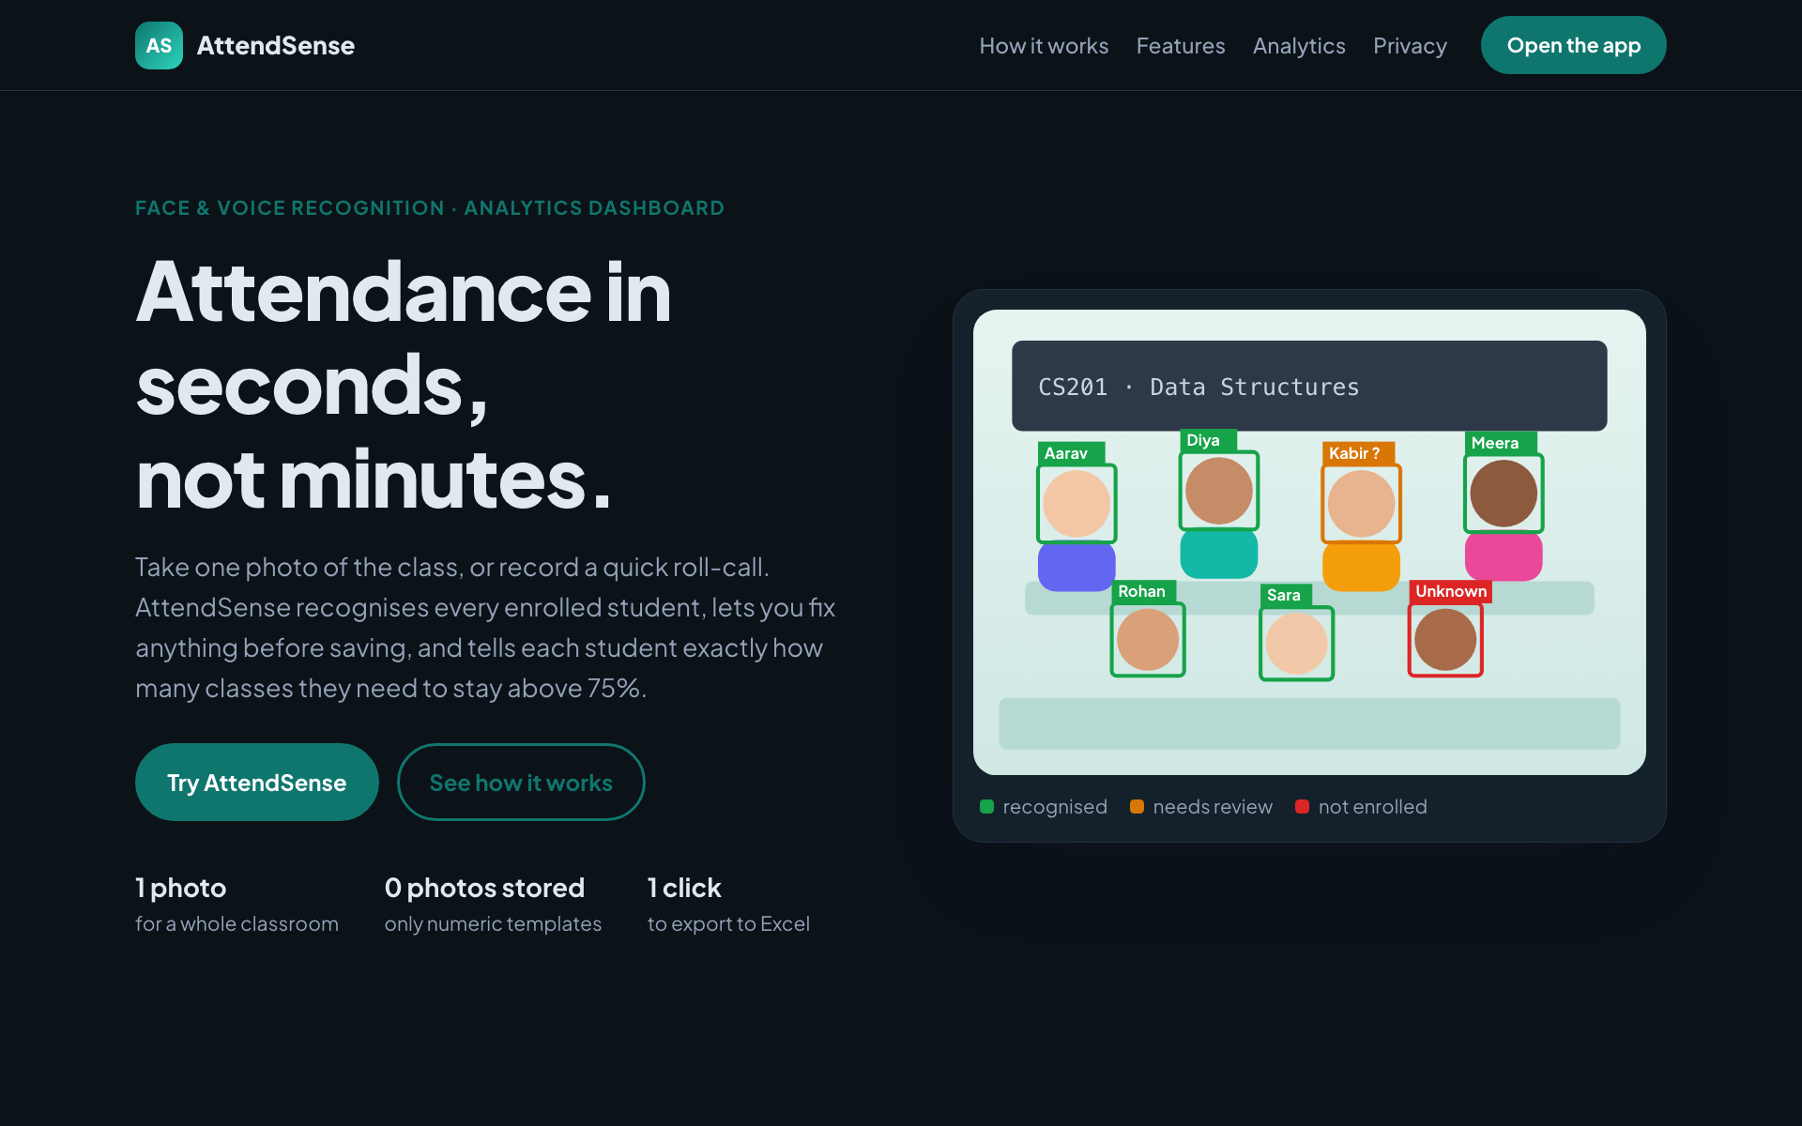
Figure 4. Landing page
landing/script.js: the same formulas as core/analytics.py
function classesNeeded(a, t, target) {
if (t === 0 || a / t >= target) return 0;
if (target >= 1) return a < t ? -1 : 0;
return Math.ceil((target * t - a) / (1 - target) - 1e-9);
}
function classesCanMiss(a, t, target) {
if (t === 0 || target <= 0 || a / t < target) return 0;
return Math.max(0, Math.floor(a / target - t + 1e-9));
}

14. Testing
Run with pytest (55 tests, about 7 seconds). CI runs ruff and pytest on every push.
File | Tests | What is covered
test_face_matching.py | 11 | closest-sample distance, match/unknown, one-to-one greedy assignment, ambiguity, empty inputs, 1:1 verify, head-turn geometry, EXIF rotation, annotation
test_voice_matching.py | 5 | threshold, margin/ambiguity, missing profiles, best-per-student, silence splitting on synthetic audio
test_analytics.py | 16 | classes-needed and can-miss tables of cases, IST conversion, all summaries, empty data, Excel sheets
test_attendance_draft.py | 3 | merging evidence, manual-edit detection, session method
test_security.py | 5 | bcrypt, password/username/roll rules, join-code alphabet, throttling with a fake clock
test_repository.py | 8 | uniqueness, JSON round-trip, counts, roster order, view filters, atomic rollback, cascading deletes, schema parity with Postgres
test_ui_flows.py | 7 | headless Streamlit (AppTest): home, weak-password rejection, teacher register → attendance → analytics → subjects, join links, student dashboard, join rules

tests/test_face_matching.py: the test that exposed the Hungarian flaw
def test_one_to_one_assignment(rng):
"""Two faces both nearest to student 1: only one may be marked as student 1,
and it must be the more confident one (Hungarian would pick the other)."""
a = _emb(rng)
d = rng.normal(0, 1, 128)
d /= np.linalg.norm(d)
f1 = a + 0.05 * d # 0.05 from student 1, 0.30 from student 2
f2 = a - 0.10 * d # 0.10 from student 1, 0.45 from student 2
gallery = {1: [a], 2: [a + 0.35 * d]}
res = face.match_faces([f1, f2], gallery, threshold=0.5, margin=0.0)
assert res[0].student_id == 1
assert res[1].student_id == 2
assert len({r.student_id for r in res}) == 2

tests/test_repository.py: an invalid row must leave no half-saved class
def test_record_session_is_atomic(repo):
_, s, a, _ = _setup(repo)
with pytest.raises(sqlite3.IntegrityError):
repo.record_session(s["subject_id"], "face", [
{"student_id": a["student_id"], "status": "present", "source": "face"},
{"student_id": a["student_id"], "status": "present", "source": "face"}, # duplicate key
])
assert repo.records(subject_id=s["subject_id"]) == []
assert repo.teacher_subjects(s["teacher_id"])[0]["n_sessions"] == 0 # no orphan session

14.1 Issues found and fixed during testing
Issue | Fix
Hungarian assignment gave a near-certain face to the wrong student | Greedy most-confident-first assignment (section 6.4)
Local database path was read at import time, so UI tests could silently share one database | Path read on every call (config.local_db_path()), plus a test that each test starts empty
Dialog interactions can't be driven by Streamlit's test harness | Join rules extracted into join_subject() and tested directly
Material icons showed as words ("database") because the font CSS overrode the icon font | Font applied to the app root only
Camera inside a collapsed expander still asked for camera permission on every page load | Camera shown only behind a toggle
Heatmap hid every other student name | Axis label limit and overlap settings

14.2 Manual checks
The app was run locally on the SQLite backend with demo data (scripts/seed_demo.py: teacher demo / demo1234, 3 subjects, 32 students, 6 weeks) and checked in a browser: home, teacher sign-in, take attendance, subjects with QR sharing, and analytics. The landing page was checked at desktop and 375 px phone width with no horizontal scrolling.
Still to verify with real people: face and voice recognition on real photos and recordings, and the camera-based student sign-in. These need a webcam and volunteers; the in-app browser used for automated checks blocks camera access. Do this before the first demo (section 15.4).

15. Deployment guide

15.1 Push the code to GitHub
cd /Users/sourabh/Developer/Intelligent_AI_Attendance_System
git remote add origin https://github.com/Sourabh16/Intelligent-AI-Attendance-and-Analytics-Dashboard.git
git push -u origin main

15.2 Supabase
- Sign up at supabase.com → New project. Region: Mumbai (ap-south-1). Save the database password.
- SQL Editor → New query → paste the whole of supabase/schema.sql → Run. Table Editor should now show 6 tables.
- Project Settings → API Keys → copy the Project URL and a Secret key (sb_secret_…), or the legacy service_role key. Never use the publishable/anon key.

15.3 Streamlit Community Cloud
- share.streamlit.io → sign in with GitHub → Create app → choose the repository, branch main, main file app/app.py.
- Advanced settings → Python version 3.11.
- Secrets: paste SUPABASE_URL, SUPABASE_KEY and APP_URL (the app's own address, used in QR codes).
- Deploy. The first build takes several minutes (dlib, CPU PyTorch). The home page banner about SQLite disappears when Supabase is connected.

15.4 First real test
- Register as a teacher; create a subject.
- On a phone, scan the QR; register as a student with three photos and a voice sample; confirm the join.
- Repeat with 3-5 volunteers. Take a classroom photo and a voice roll-call; check the annotated photo and table; save.
- If people are missed, loosen the face slider slightly (e.g. 0.55); if wrong names appear, tighten it. Record the values that work and set them in config.py.

15.5 Vercel
- Edit landing/config.js and set the deployed app URL; commit and push.
- vercel.com → Add New → Project → import the repository → Root Directory landing, Framework preset Other, no build command → Deploy.

16. Design decisions at a glance
Area | Decision | Why
Face samples | 3 per student, consistency + duplicate checks | robust to angle and lighting; one person, one roll number
Matching | closed set, nearest sample, no training | only the subject's students can match; new students usable instantly
Crowded photos | one-to-one greedy assignment | a student can't be counted twice; confident matches win
Uncertain faces | flagged for review | a wrong 'present' is worse than asking
Student login | roll no + 1:1 face + head-turn liveness + throttling | stops look-alikes and printed photos
Join codes | random, pausable, regenerable | no collisions; teacher controls access
Time | UTC stored, IST shown | correct on any server
Class record | sessions table | exact class counts; past classes editable
Saving | one atomic transaction | never half a class
Review | editable before and after saving | teacher stays in charge
Analytics | KPIs, trend, heatmap, weekday, defaulters, 75% calculator, Excel | turns a register into decisions
Security | RLS, server-side secret key, bcrypt, escaping, authorisation checks | biometric data stays private
Privacy | consent, templates only, re-enroll, delete account | DPDP Act principles
Engineering | 55 tests, CI, pinned deps, SQLite mode, demo data | reliable to change and deploy
Landing | static site on Vercel | fast, free, no server

17. Limitations and future work

17.1 Known limitations
- The head-turn check stops printed photos, but a video replayed on a phone could pass. Real anti-spoofing needs depth sensing or a trained presentation-attack model.
- The HOG detector misses very small or strongly turned faces. Take 2-3 photos from different corners in large rooms. dlib's CNN detector is more accurate but too slow on a free CPU server.
- Voice roll-call needs a fairly quiet room with one speaker at a time.
- The thresholds come from dlib's and Resemblyzer's published operating points, not from tuning on our own classrooms. The strictness sliders exist so they can be adjusted.
- Streamlit Community Cloud gives limited memory and sleeps idle apps; the first visit after a sleep is slow.

17.2 Possible next steps
- Collect a small consented validation set and choose thresholds from measured false-accept and false-reject rates.
- Email or WhatsApp alerts to students who fall below the target.
- Multiple institutions (a tenant column plus RLS policies) and an admin role.
- Move recognition to a separate API (FastAPI) so a mobile app could use it.

Appendix A. Command reference
Task | Command
Create environment | uv venv --python 3.11 .venv && source .venv/bin/activate
Install | uv pip install -r requirements-dev.txt
Demo data | python scripts/seed_demo.py --reset
Run the app | streamlit run app/app.py
Tests | pytest
Lint | ruff check app tests scripts
Preview landing page | cd landing && python3 -m http.server 8600

Appendix B. Dependency notes
All versions are pinned in app/requirements.txt to the versions the tests ran with. Two lines need explanation:
- face-recognition-models is installed from GitHub at a fixed commit, and needs setuptools<70 because it still imports pkg_resources.
- PyTorch (needed by Resemblyzer) is CPU-only on Linux. The default Linux wheel pulls several GB of NVIDIA CUDA libraries that a CPU server can't use, which slows or breaks the Streamlit Cloud build. Environment markers keep the normal wheel on macOS:
app/requirements.txt
# CPU-only PyTorch on Linux (Streamlit Cloud, CI). The default Linux wheel pulls
# several GB of CUDA libraries that a CPU-only server cannot use.
torch==2.12.1 ; sys_platform != "linux"
torch @ https://download.pytorch.org/whl/cpu/torch-2.12.1%2Bcpu-cp311-cp311-manylinux_2_28_x86_64.whl ; sys_platform == "linux"

