Flow

What is a flow? Slide 3

A flow is a type of test that comprises a logical set of business components, in a fixed sequence that performs a specific task.

Flows share the same functionality as business process tests (for example, iterations, parameters, and results) in addition to functionality unique to flows (validation, debug mode).

**Flows cannot contain other flows.**

You can use a flow in multiple business process tests. When you modify a flow or any of its components, all business process tests containing that flow reflect that modification.

Validate Test

Slide 4

You can check your business process tests and flows to locate any component errors that could halt the successful running of the test or flow.

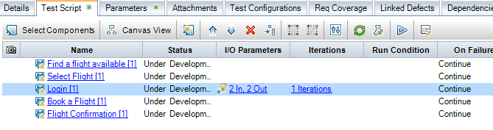

**Validate Tests(Cont.) slide5**

If errors are found, modify the test as required. Repeat the validation check. If the errors have been resolved, a message is displayed indicating that the validation completed successfully

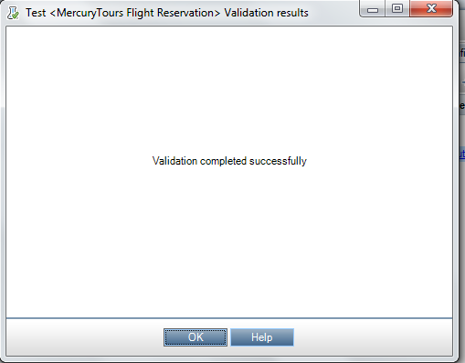

How to Create a flow

Slide 7

