SNO | CT Stoned Images | Size Prediction | Sizes
1. | 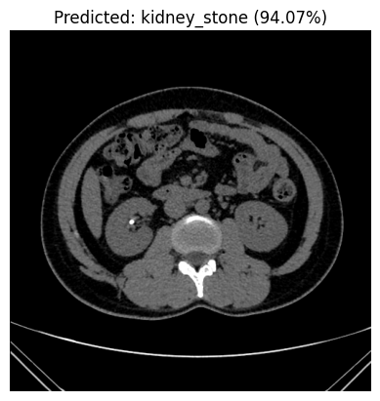 | 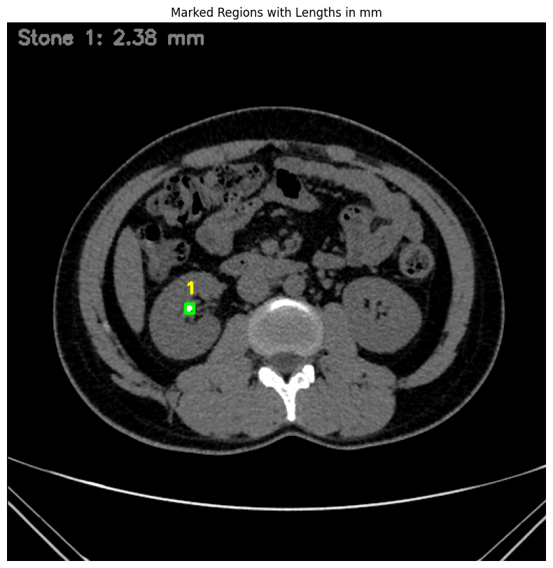 | Stone 1: 2.38mm
2. | 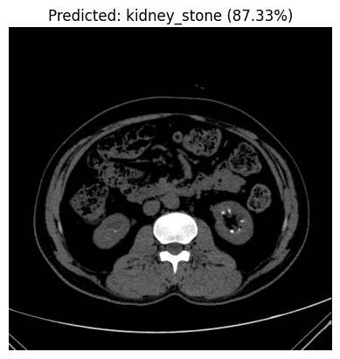 | 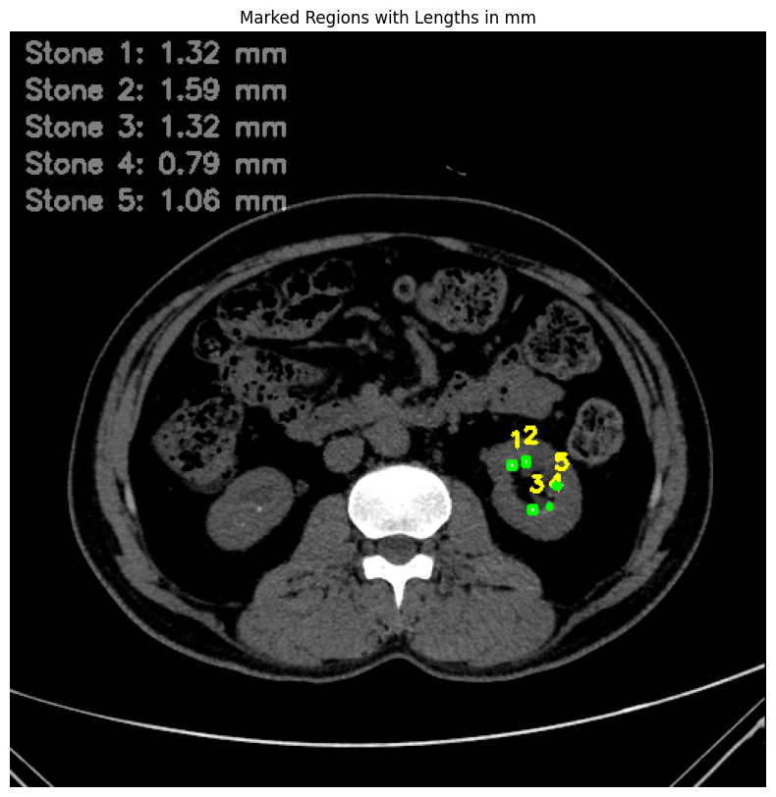 | Stone 1: 1.32 mm  Stone 2: 1.59 mm  Stone 3: 1.32 mm  Stone 4: 0.79 mm  Stone 5: 1.06 mm
3. | 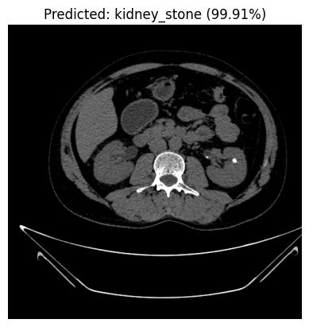 | 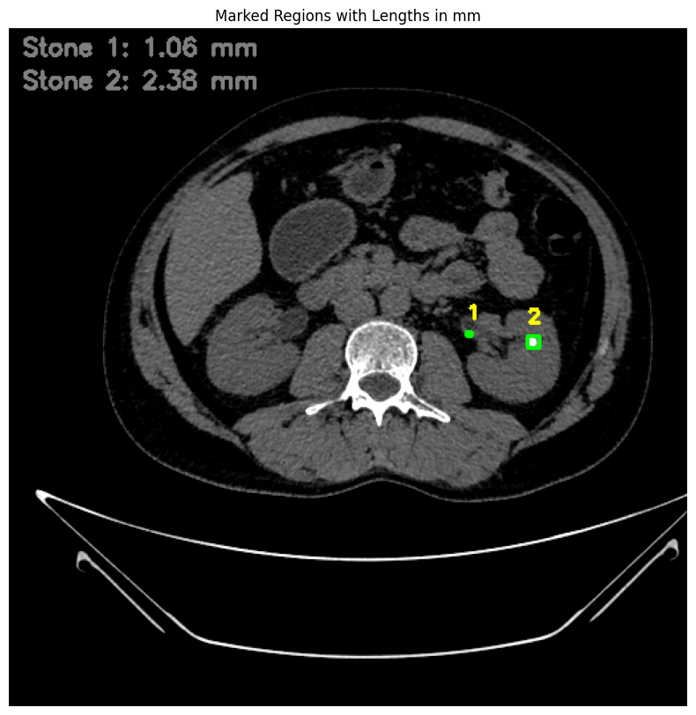 | Stone 1: 1.06 mm  Stone 2: 2.38 mm
4. | 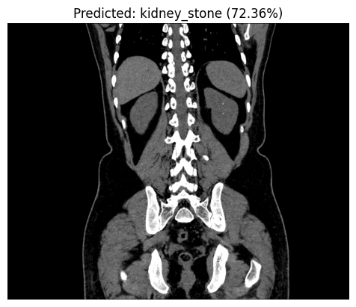 | 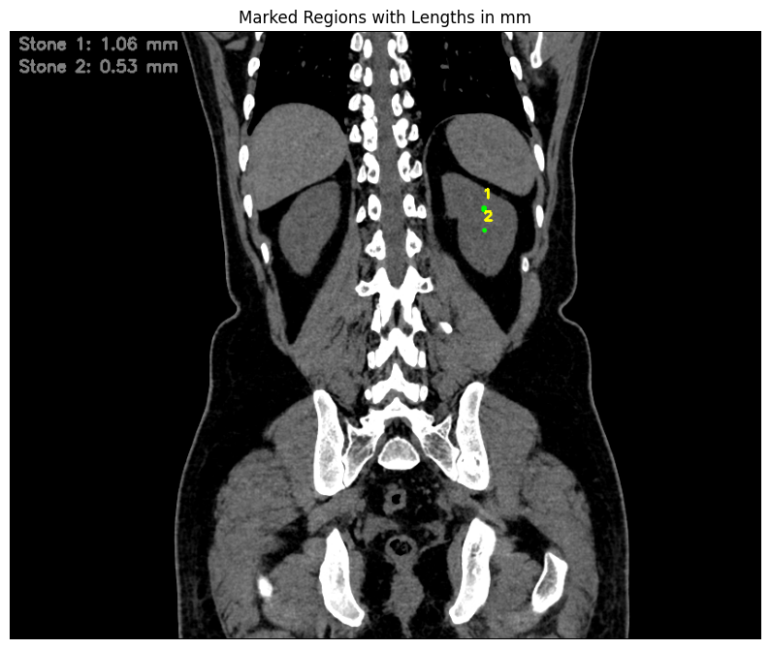 | Stone 1 : 1.06 mm  Stone 2: 0.53 mm
5. | 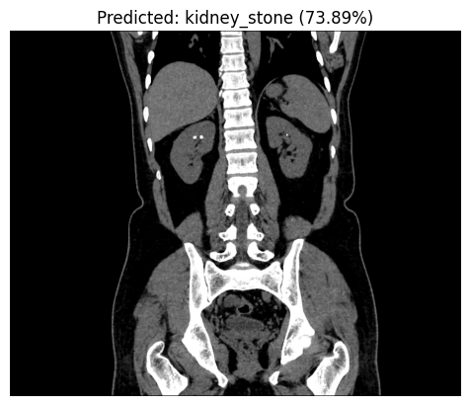 | 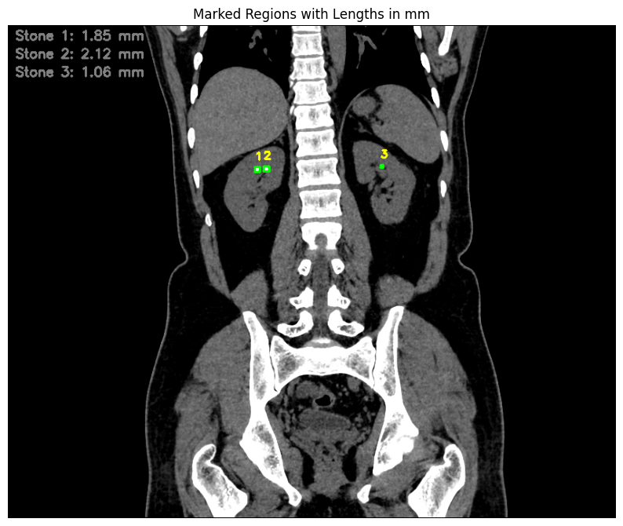 | Stone 1: 1.85 mm  Stone 2: 2.12 mm  Stone 3 : 1.06 mm
6. | 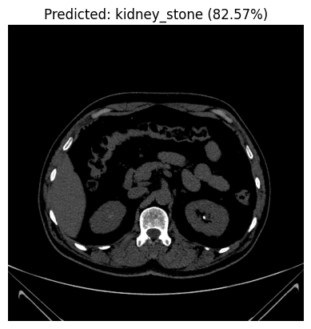 | 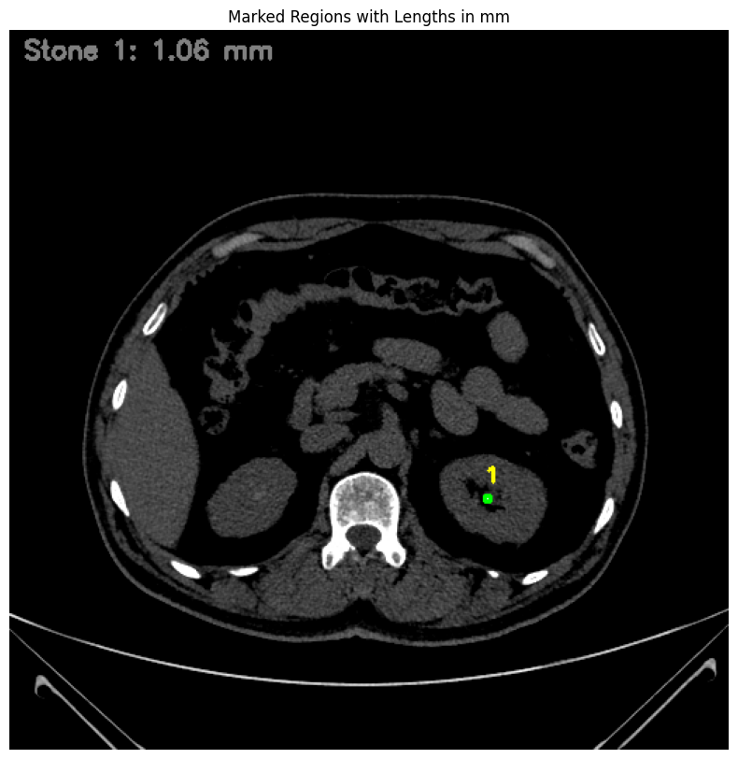 | Stone 1 : 1.06 mm
7. | 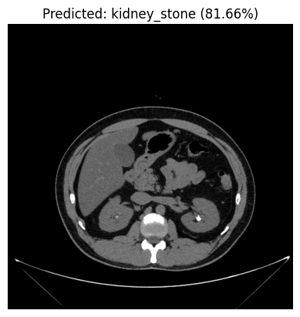 | 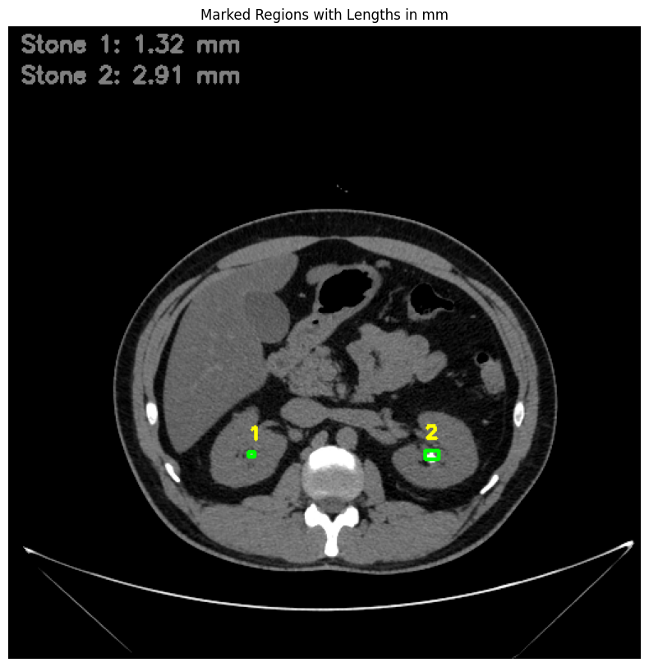 | Stone 1: 1.32 mm  Stone 2: 2.91 mm
8. | 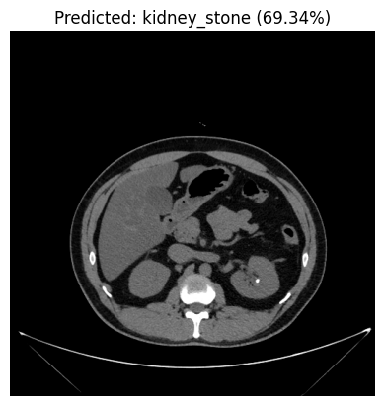 | 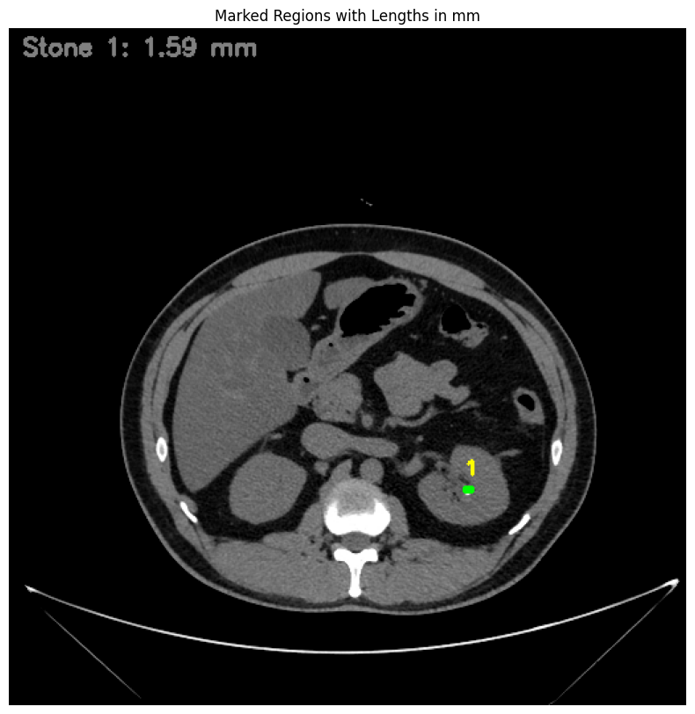 | Stone 1 : 1.59 mm
9. | 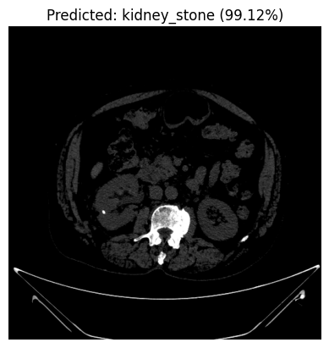 | 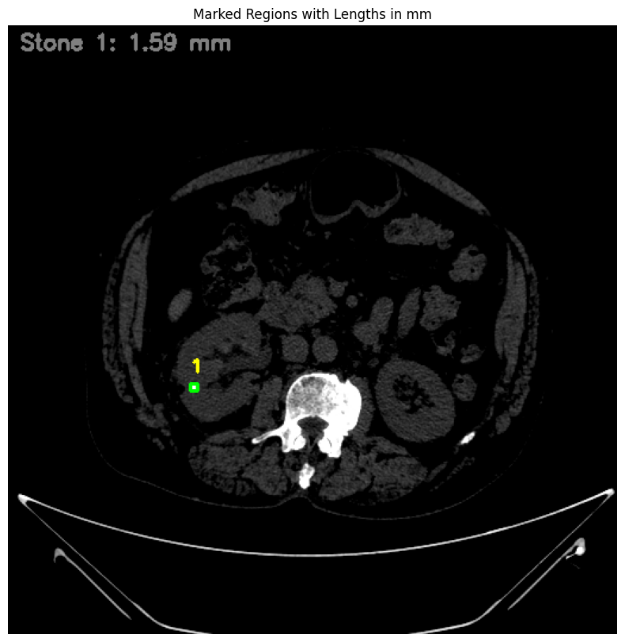 | Stone 1 : 1.59 mm
10. |  |  | Stone 1 : 1.32 mm  Stone 2 : 1.59 mm  Stone 3 : 1.32 mm  Stone 4 : 0.79 mm  Stone 5 : 1.06 mm
11. | 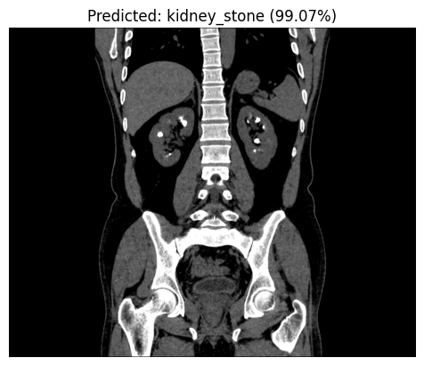 | 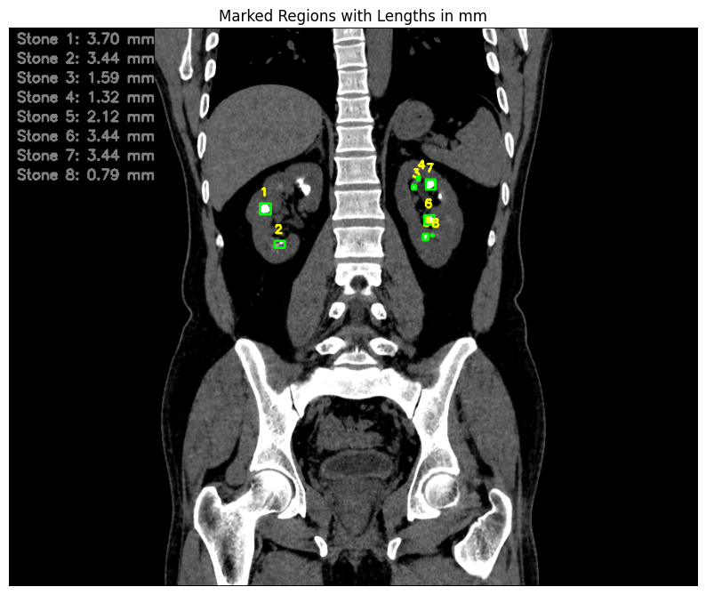 | Stone 1 : 3.70 mm  Stone 2 : 3.44 mm  Stone 3 : 1.59 mm  Stone 4 : 1.32 mm  Stone 5 : 2.12 mm  Stone 6 : 3.44 mm  Stone 7 : 3.44 mm  Stone 8 : 0.79 mm

