create database churn;
use churn;
-- 1. Total Customers
SELECT COUNT(*) AS total_customers
FROM churn;


-- 2. Total Churned Customers
select count(*) as Churn_Customers
from churn
where churn='Yes';
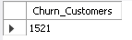

-- 3. Churn Rate (%)
select count(case when churn = 'Yes' then 1 end) * 100.0 /count(*) as churn_rate
from churn;
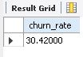

-- 4. Count by Gender
select gender,count(*) as Total
from churn
group by gender;
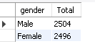

-- 5. Average Monthly Charges SELECT AVG(monthly_charges) AS avg_charges from churn;
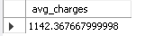

- 6. Max & Min Tenure
select min(tenure) as MIN_Tenure,
max(tenure) as MAX_Tenure
from churn;


-- 7. Churn by Gender
select gender, count(*) as Churn_Count
from churn
where churn='Yes'
group by gender;
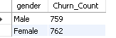

-- 8. Churn by Contract Type select contract_type, count(*) as Churn_Count from churn where churn = 'Yes' group by contract_type;
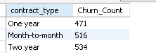

-- 9. Avg Charges by Churn SELECT churn, round(AVG(monthly_charges),2) AS avg_charges FROM churn GROUP BY churn;
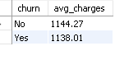

-- 10. Customers by Internet Service select internet_service,
count(*) as churn_count
from churn
group by internet_service;
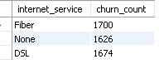

-- 11. High Paying Customers (>1500)
select *
from churn
where monthly_charges > 1500;
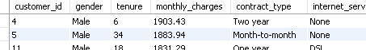

-- 12. Tenure Group Analysis
select
case
when tenure <12 then '0-1 Year'
when tenure <24 then '1-2 Year'
else '2+ Years'
end as Tenure_Group,
count(*) as Total_Customer
from churn
group by Tenure_Group;
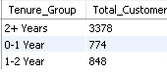

-- 13. Churn Rate by Contract Type
select contract_type,count(case when churn='Yes' then 1 end)* 100.0 /count(*) as churnCount
from churn
group by contract_type;
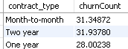

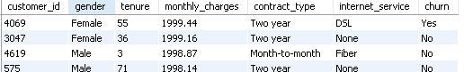
-- 14. Top 10 High Risk Customers
select *
from churn
order by monthly_charges desc,tenure asc
limit 10;

-- 15. Rank Customers by Monthly Charges
select customer_id,monthly_charges,
rank() over(order by monthly_charges desc) as Ranking
from churn;
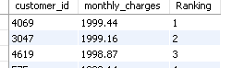

-- 16. Running Total of Customers
select customer_id, count(*) over(order by customer_id) as Running_Total
from churn;
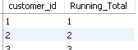

-- 17. Churn Percentage by Internet Service
SELECT
internet_service,
COUNT(CASE WHEN churn = 'Yes' THEN 1 END) * 100.0 / COUNT(*) AS churn_rate
FROM churn
GROUP BY internet_service;
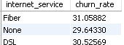

-- 18. Identify At-Risk Customers
select * from churn
where tenure <12
and monthly_charges >1200
and churn = 'Yes';
