LOVELY PROFESSIONAL UNIVERSITY
PROJECT REPORT
Bengaluru House Price Prediction using Machine Learning
SUMMER TRAINING/INTERNSHIP
MACHINE LEARNING MADE EASY:FROM BASICS TO
AI APPLICATIONS
By
Rahul Bora
Roll Number: 1237431
Under the guidance of
Mr. Mahipal Singh Papola
UID:32137
JUNE – JULY 2025

ACKNOWLEDGEMENT

My sincere appreciation goes out to Mr. Mahipal Singh Papola for his outstanding leadership, unwavering support, and encouragement during this effort. Their extensive expertise, perceptive criticism, and unwavering encouragement have been crucial in assisting me in comprehending difficult ideas and honing my strategy to produce significant outcomes.This project was a genuinely enriching and transforming learning experience because of their commitment to mentoring and readiness to help at every level. I sincerely appreciate the time and labor they put into evaluating my work, making helpful recommendations, and assisting me in overcoming obstacles.Without their constant guidance and assistance, this project would not have achieved its current success and quality level.

DECLARATION

I, Rahul Bora, student of B.Tech under CSE/IT Discipline at, Lovely Professional University, Punjab, hereby declare that all the information furnished in this project report is based on my own intensive work and is genuine.

Date: 12-07-2025
Signature: 
Name of the student: Rahul Bora
Registration No. 12317431

CERTIFICATE

This is to certify that Rahul Bora bearing Registration no. 12317431 has completed the project titled “Bangalore House Price Prediction” under my guidance and supervision. To the best of my knowledge, the present work is the result of his/her original development, effort and study.

Signature
Name of the Supervisor: Mahipal Singh Papola
School of Computer Science and Engineering
Lovely Professional University
Phagwara, Punjab.

Date: 12-07-2025

TABLE OF CONTENTS
1) Introduction
1.1 Explain Bengaluru housing market trends
1.2 Importance of price prediction in real estate
1.3 How AI/ML helps solve this problem
2)Dataset Overview
2.1 Detailed column-by-column analysis
2.2 Discussion of missing values and outliers
3)Data Preprocessing
3.1 Handling null values, encoding categorical variables
3.2 Cleaning total_sqft (handling ranges like "2100-2850")
3.3 Creating new features like BHK and price per sqft
4)Data Visualization
4.1 Explain insights from each plot (e.g., why prices are higher in certain locations)
5)Feature Analysis
5.1 Use correlation heatmap and feature importance plots
5.2 Explain why certain features were dropped/kept
6)Model Building
  - For each model (Linear Regression, Random Forest, XGBoost
6.1.1 Why it was chosen
6.1.2 How it works
6.1.3 Parameters used
7)Hyperparameter Tuning
7.1 Explain GridSearchCV / RandomizedSearchCV process step by step
7.2 Show before and after results
8)Model Comparison
8.1 Include a detailed comparison table
8.2 Reason why the best model was selected
9)Deployment
9.1 Step-by-step Flask app flow: user input → backend → model → prediction → UI
9.2 Explain loading model, scaling inputs, handling errors
10)Conclusion & Future Work
10.1 Elaborate on potential improvements (e.g., adding demographics, time-series data)

1. Introduction
1.1 Bengaluru Housing Market Trends
One of India's fastest-growing metropolises, Bengaluru, sometimes called Bangalore, is commonly referred to as the nation's Silicon Valley. Due to the inflow of IT businesses, startups, and international organizations that have established their presence in the area, the city has seen fast urbanization over the past 20 years. Bengaluru's real estate market has been greatly impacted by this economic expansion, making it one of India's most vibrant and desirable real estate markets.
The demand for residential properties has increased exponentially, fueled by a growing middle-class population, high migration rates of professionals, and favorable climatic conditions. Popular localities such as Whitefield, Sarjapur Road, Electronic City, and Hebbal have emerged as real estate hotspots due to their proximity to IT parks, good infrastructure, and connectivity to other parts of the city.
However, there are also notable pricing differences across various areas, property kinds, and facilities provided in Bengaluru's housing market. Housing costs are influenced by a variety of factors, including the area type (ultra built-up, built-up, plot), the amenities offered (balconies, number of bathrooms), and even the developer's reputation. There is a great demand for precise price prediction tools since these variances make it difficult for buyers and sellers to ascertain the fair market worth of assets.

1.2 Importance of Price Prediction in Real Estate
Accurate price prediction in the real estate sector is essential for various stakeholders, including buyers, sellers, investors, and policymakers. For buyers, it provides an estimate of the property value, helping them make informed purchasing decisions and negotiate better deals. Sellers can use predictive insights to set competitive prices for their properties, reducing the time a property spends on the market.
For investors, understanding future trends in property prices allows for better investment strategies and risk mitigation. Price prediction also plays a crucial role in urban planning and policy formulation. Governments and municipal bodies can use these insights to regulate property prices, identify emerging growth corridors, and allocate resources for infrastructure development effectively.
In a dynamic market like Bengaluru, where property prices can fluctuate based on microeconomic and macroeconomic factors, predictive models can serve as powerful tools to analyze historical data and forecast future trends with reasonable accuracy.

1.3 How AI/ML Helps Solve This Problem
Traditional methods of property valuation, such as comparative market analysis (CMA) or manual appraisals, are often time-consuming and subjective. They rely heavily on the expertise of individuals and may not capture the complex, non-linear relationships between multiple property features and their impact on prices.
Artificial Intelligence (AI) and Machine Learning (ML) techniques offer a data-driven alternative by analyzing large volumes of real estate data and identifying patterns that influence property prices. ML algorithms can learn from historical data and provide highly accurate predictions by considering multiple factors such as location, size, number of bedrooms and bathrooms, total square footage, and other amenities.
Techniques like regression analysis, decision trees, ensemble methods (Random Forest,) and neural networks can be employed to model the relationship between input features and the target variable (price). Furthermore, ML models can adapt to changing market conditions by retraining on new data, ensuring the predictions remain relevant over time.
By leveraging AI/ML, real estate price prediction becomes more objective, scalable, and efficient, empowering stakeholders with actionable insights for better decision-making.

2. Dataset Overview
The dataset used for this project is the “Bengaluru House Data”, which contains information about residential properties in various locations of Bengaluru. The dataset was sourced from Kaggle, a popular platform for datasets and machine learning competitions. It comprises 13,320 rows and 9 columns, each representing different attributes of the properties.
This chapter provides a detailed analysis of each column, highlights the presence of missing values and outliers, and discusses their implications for the machine learning models.

2.1 Detailed Column-by-Column Analysis
The dataset contains the following columns:
- area_type (Categorical)
This column indicates the type of area the property falls under. The categories include:
  - Super built-up Area
  - Built-up Area
  - Plot Area
  - Carpet Area
This feature provides an idea about the space usability in a property and is critical for price determination.
- availability (Categorical)
Shows whether the property is available for immediate possession or in the future. For example, “Ready To Move” or specific dates such as “18-Dec.” This can influence the price as immediate possession properties tend to be priced higher.
- location (Categorical)
Specifies the locality where the property is situated (e.g., Whitefield, Electronic City, Sarjapur Road). Location is often the most influential factor in real estate pricing due to differences in demand, infrastructure, and proximity to employment hubs.
- size (Categorical)
Indicates the number of bedrooms in the property, typically represented as “2 BHK”, “3 BHK”, or occasionally as “4 Bedroom.” This needs to be preprocessed to extract numerical values for modeling.
- society (Categorical)
Represents the name of the housing society or project. A significant proportion of this column contains missing values (~40%), which limits its usefulness for modeling unless imputed or encoded properly.
- total_sqft (Mixed)
Shows the total area of the property in square feet. The column contains entries in inconsistent formats, such as single numbers (e.g., “1056”), ranges (e.g., “2100 - 2850”), and non-numeric descriptors (e.g., “34.46Sq. Meter”). Cleaning and standardizing this column is crucial for accurate predictions.
- bath (Numeric)
Indicates the number of bathrooms in the property. Generally ranges between 1 and 5 but includes outliers up to 40, which may need to be treated during preprocessing.
- balcony (Numeric)
Shows the number of balconies in the property. Most entries range between 0 and 3, and missing values are observed.
- price (Numeric)
Represents the price of the property in lakhs of Indian Rupees (INR). This is the target variable for prediction.
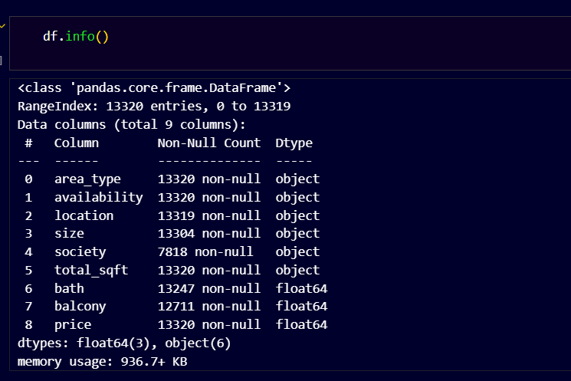

2.2 Discussion of Missing Values and Outliers
Missing Values
The dataset contains missing entries in several columns:
- The society column has about 40% missing data. Since this information may not be critical and is difficult to impute, it could be excluded from the analysis.
- The balcony column has a smaller proportion of missing values (~5%). These could be replaced with a reasonable default value, such as the mode or median.
- The bath column has a few missing entries (<1%), which can be imputed similarly.
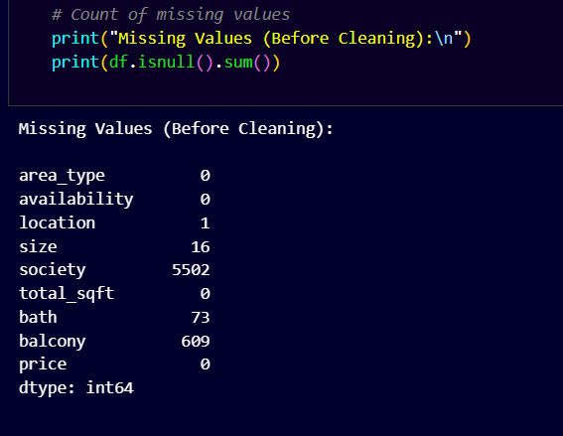

3. Data Preprocessing
Data preprocessing is an essential phase in any machine learning pipeline, particularly when dealing with real-world datasets that often contain inconsistencies, missing values, and varying data formats. In this project, the Bengaluru House Data was subjected to a rigorous preprocessing workflow to transform it into a clean, consistent, and model-ready format. The steps undertaken included handling null values, encoding categorical variables, cleaning the total_sqft column, and engineering new features such as BHK and price_per_sqft.

3.1 Handling Null Values and Encoding Categorical Variables
A preliminary examination of the dataset revealed several missing values across different columns. The society column, which provides the name of the housing society, had approximately 40% missing entries. Due to the high proportion of null values and the relatively low likelihood of this feature being a strong predictor of housing prices, it was deemed appropriate to drop the column entirely. On the other hand, the bath and balcony columns contained fewer missing values. These were imputed using statistical measures: the missing values in bath were replaced by the median number of bathrooms within each corresponding BHK group, ensuring that the imputed values were contextually relevant, while the missing values in balcony were replaced by the dataset-wide median since balconies exhibit less variation across properties.
A number of categorical variables in the dataset also needed to be encoded in order for machine learning algorithms to work with them. The area_type column, which includes categories like Super built-up Area, Built-up Area, Plot Area, and Carpet Area, was label encoded to assign numeric representations. The availability column, consisting of values such as “Ready To Move” and specific future dates (e.g., “19-Dec”), was simplified into a binary variable. Entries labeled “Ready To Move” were encoded as 1, and all other entries were encoded as 0, reflecting whether the property was immediately available or not.
The location attribute posed a unique challenge as it contained over 1,200 unique locality names, resulting in a highly sparse dataset if one-hot encoding was applied directly. To address this, only the top 10 most frequent locations were retained as individual dummy variables, and all remaining rare localities were grouped under a single “Other” category. This strategy reduced dimensionality while preserving the critical influence of location on housing prices.
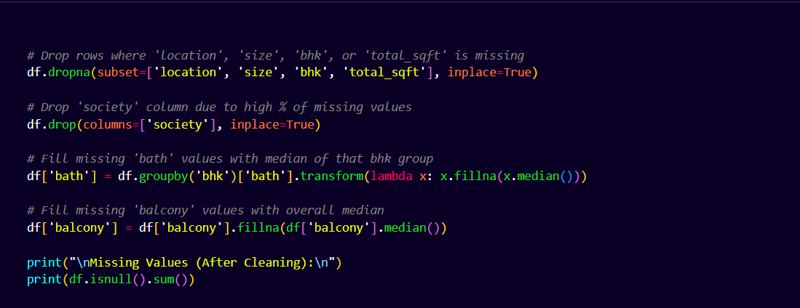

3.2 Cleaning total_sqft
The total_sqft column, which records the area of properties in square feet, exhibited a variety of formats, including numeric values, ranges (e.g., “2100-2850”), and non-standard entries containing units such as “Sq. Meter” or “Acres.” To standardize these values, a custom function was implemented. For entries representing ranges, the function split the values and computed their average. For instance, “2100-2850” was converted to 2475 square feet. Non-numeric entries or those expressed in unfamiliar units were dropped due to their negligible frequency and the complexity involved in reliable unit conversion.
This cleaning process ensured that all entries in the total_sqft column were numerical and consistent, which is critical for accurate model training. Additionally, properties where the total square footage divided by the number of bedrooms (BHK) yielded an unreasonably low value (less than 300 sqft per bedroom) were identified as anomalies and excluded from the dataset.
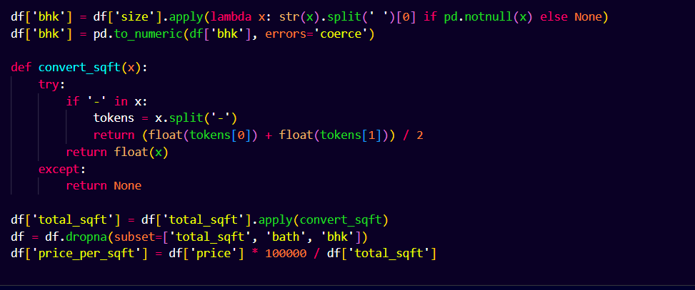

3.3 New Features: BHK and Price per Sqft
Feature engineering was carried out to extract more meaningful information from existing columns. From the size column, the numeric portion indicating the number of bedrooms was extracted and stored as a new feature named BHK. This transformation converted entries like “3 BHK” and “4 Bedroom” into numerical values of 3 and 4, respectively.
Another valuable feature created was price_per_sqft, calculated by dividing the property price (in Indian Rupees) by the total square footage. This feature provided a standardized measure of property cost and was instrumental in identifying and removing outliers. Properties with price_per_sqft values that deviated beyond two standard deviations from the mean were considered outliers and removed.
Additional outlier removal steps included excluding properties with extreme values, such as those priced above ₹200 Lakhs or properties with unusually high numbers of bathrooms relative to bedrooms (e.g., more than BHK + 2 bathrooms), as such entries are likely to be errors or represent atypical luxury properties that could bias the model.
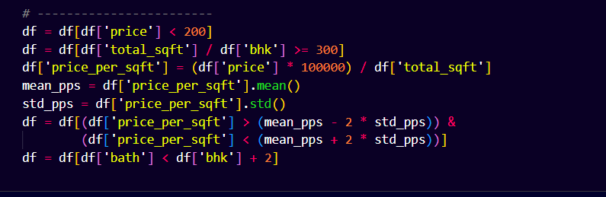

4. Data Visualization
Exploratory Data Analysis (EDA) is a crucial step in understanding the underlying patterns and relationships within a dataset. Using visualization techniques, this project analyzed trends, identified anomalies, and gained insights that guided subsequent feature engineering and model building. This chapter discusses the key plots generated during the analysis and the insights derived from them.

4.1 Insights from Visualizations
a) Distribution of House Prices
The first graphic showed how home values were distributed around Bengaluru. The histogram revealed that the majority of properties are priced between ₹50 Lakhs and ₹150 Lakhs, with a sharp decline in frequency beyond ₹200 Lakhs. This long-tailed distribution indicates the presence of luxury properties at much higher price points, which are statistical outliers. Such properties, while rare, can skew predictive models if not handled carefully. Therefore, these insights justified the later removal of properties priced above ₹200 Lakhs during preprocessing to improve model performance.
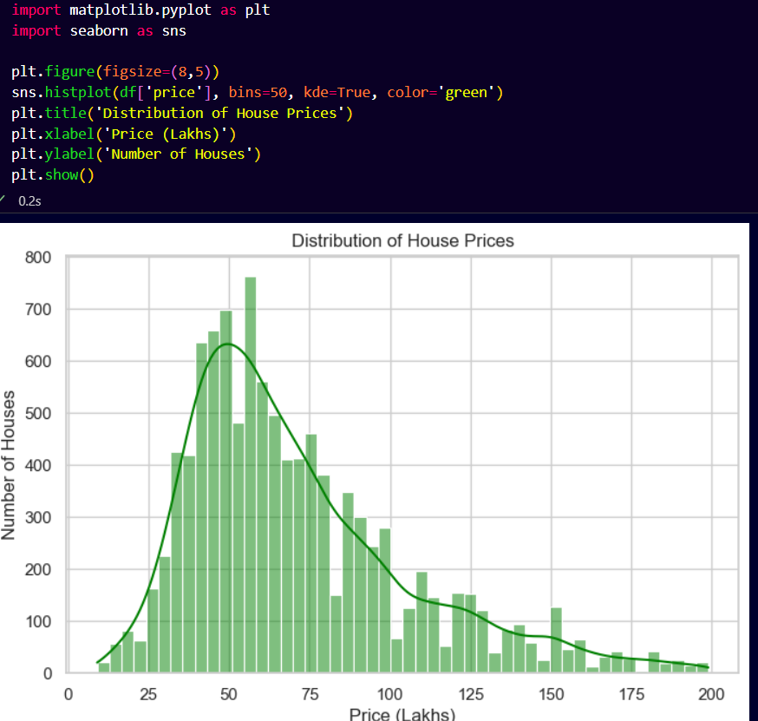

b) Area Type Distribution
A bar plot of the area_type attribute showed that the majority of listings fall under the “Super built-up Area” category, followed by “Built-up Area,” with “Plot Area” and “Carpet Area” making up a smaller proportion. This distribution highlights the dominance of multi-unit apartment complexes in Bengaluru’s real estate market. The lesser representation of “Carpet Area” suggests that most developers in the region prefer to market properties based on gross area rather than the net usable space, which has implications for buyers when comparing properties.
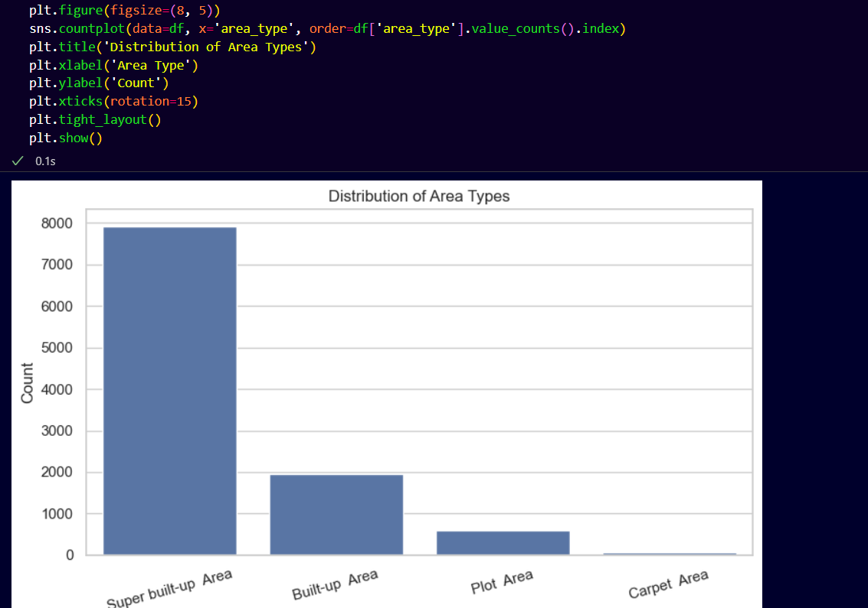

c) Top 10 Locations by Property Listings
Another bar plot displayed the top 10 localities with the highest number of property listings. Areas such as Whitefield, Sarjapur Road, Electronic City, and Rajaji Nagar emerged as hotspots. These locations are major employment hubs and have seen rapid infrastructural development in recent years, which explains their high concentration of properties. This visualization also indicated that some locations, despite having fewer listings, could have significantly higher property prices due to their premium status.
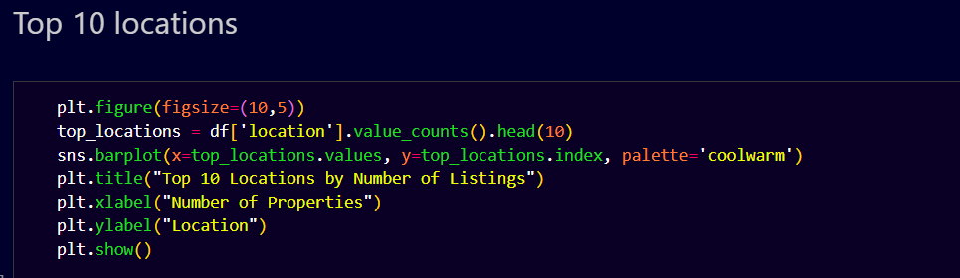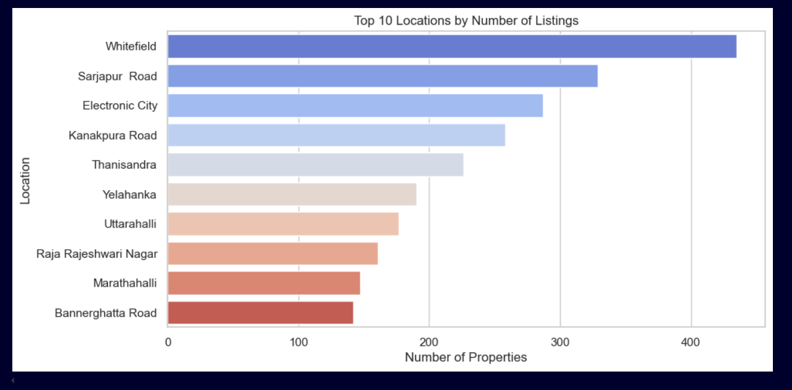
d) Distribution of BHKs (1–10)
The distribution of homes in the Bengaluru housing dataset according to the number of bedrooms (BHK) is shown in this bar plot. The x-axis indicates the number of bedrooms ranging from 1 to 10, while the y-axis shows the count of properties in each category. The plot was limited to BHK values less than or equal to 10 to avoid including rare extreme cases (e.g., properties with 20 or more bedrooms, which are outliers in this dataset).The visualization reveals that 2 BHK properties dominate the market, accounting for the highest count, followed by 3 BHK properties. Together, 2 and 3 BHKs form the bulk of the dataset, reflecting common buyer preferences in urban Bengaluru for small to medium-sized apartments. 1 BHK and 4 BHK properties are comparatively less common, and the counts for 5 BHK and higher are very low, indicating that such configurations are niche offerings, likely targeted at luxury buyers.This insight suggests that predictive models should pay special attention to 2 and 3 BHK properties since they represent the largest segments of the market. Moreover, the sparsity of higher BHK configurations supports the decision to remove properties with unusually high BHK values during preprocessing to avoid model bias.

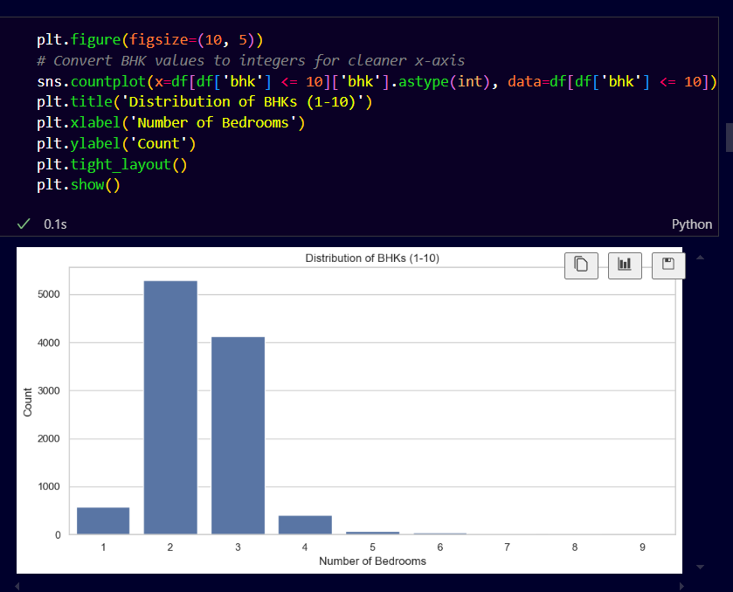

5. Feature Analysis
A critical phase in the machine learning process is feature analysis, which determines which dataset properties have the most impact on the target variable's prediction.By understanding the relationships between features, it becomes possible to eliminate irrelevant or redundant variables, thereby improving model performance and interpretability. This chapter details the process of analyzing feature correlations and determining feature importance using machine learning techniques.

5.1 Correlation Heatmap and Feature Importance Plots
To begin the analysis, a correlation matrix was computed for the numerical features in the dataset, and a heatmap was plotted to visualize these relationships. The heatmap revealed strong positive correlations between total_sqft and price, as expected since larger properties tend to command higher prices. Similar to this, there were somewhat positive correlations found between price and the number of bedrooms (bhk) and bathrooms (bath), indicating that larger residences with more rooms and facilities are more expensive.
The feature price_per_sqft was also examined and found to correlate weakly with other variables but is still a valuable predictor because it captures the price density of properties, which varies significantly across locations.
Beyond simple correlations, feature importance was evaluated using a Random Forest Regressor, which provides insight into how much each feature contributes to predicting house prices. The resulting feature importance plot showed that location was one of the most influential features, followed by total_sqft, bath, and bhk. This aligns with the real-world understanding that location plays a critical role in determining property value in Bengaluru’s diverse real estate market.
Properties in prime localities such as Whitefield, Indira Nagar, and MG Road tend to be priced substantially higher than those in developing areas, even for similar configurations. Thus, obtaining high model performance required proper location encoding.

5.2 Rationale for Dropping or Retaining Features
The preprocessing and analysis steps led to a few columns being excluded from the modeling phase. The society feature was dropped early on because of its high proportion of missing values (about 40%) and the likelihood that it contributed little predictive power compared to broader indicators like location. Similarly, the availability column was simplified to a binary feature since most properties were labeled “Ready To Move,” making it a low-variance attribute.
The size column was transformed into bhk, which provided a cleaner numerical representation of the number of bedrooms. Likewise, price_per_sqft was engineered as a derived feature to account for the price density of properties, offering a normalized perspective that assists the models in handling properties of varying sizes.
The categorical attribute area_type, although encoded, showed little variation across most of the dataset (with “Super built-up Area” dominating) and was later excluded to prevent unnecessary dimensionality.
This careful curation of features ensured that the dataset retained only those attributes with high predictive potential, thereby reducing noise and improving model efficiency.
Summary
The feature analysis confirmed that location, total_sqft, bhk, bath, and price_per_sqft are the most impactful variables for predicting housing prices. By focusing on these features and excluding less informative ones, the models were provided with clean, relevant input, enhancing their performance and generalizability.

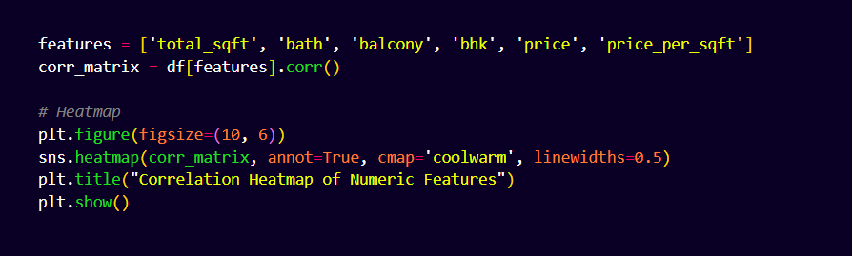

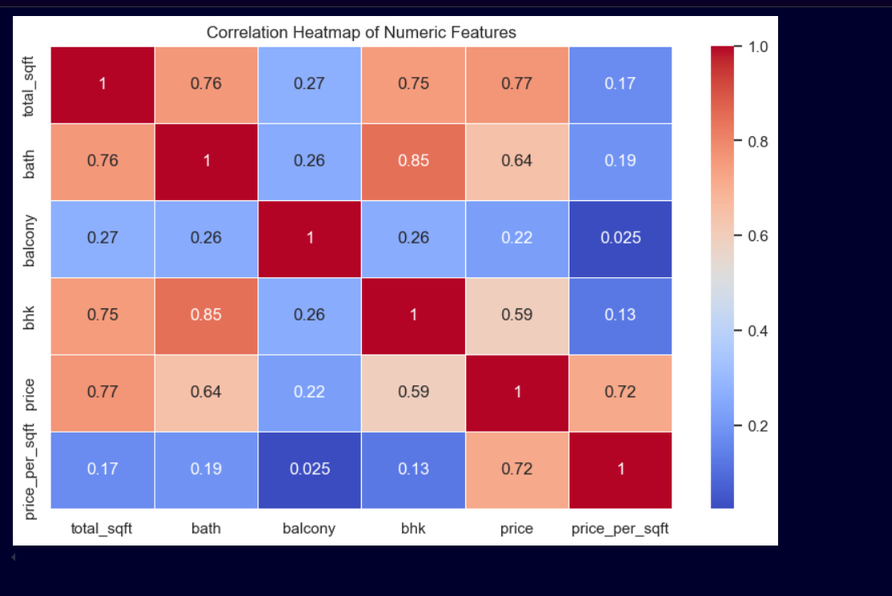

6. Model Building
The core objective of this project is to design and develop machine learning models that can accurately predict house prices in Bengaluru based on a diverse set of property features. Bengaluru, being a rapidly growing metropolitan city with a highly dynamic real estate market, presents unique challenges in housing price prediction due to factors such as location variability, property configurations, and fluctuating market trends. To address these challenges, three distinct regression algorithms were implemented and evaluated: Linear Regression, Random Forest Regressor, and Decision Tree Regressor.
Both linear and non-linear techniques are represented by these well chosen models. Linear Regression was chosen as a baseline due to its simplicity and ability to provide interpretable coefficients for each feature. It serves as a foundational model against which the performance of more complex algorithms can be benchmarked. On the other hand, Random Forest Regressor, an ensemble tree-based method, was selected for its ability to capture non-linear relationships and handle high-dimensional data effectively. It is also robust to outliers and feature interactions, making it suitable for real-world datasets. Finally, the Decision Tree Regressor was included as a simpler, highly interpretable tree-based model that can provide clear insights into how features influence price predictions. Unlike ensemble methods, the Decision Tree builds a single tree structure, making it ideal for visualizing decision rules and understanding the underlying patterns in the data.
Each model was trained and evaluated on the preprocessed dataset using an 80-20 train-test split. Key performance metrics such as Root Mean Squared Error (RMSE), Mean Absolute Error (MAE), and R-squared (R²) score were used to assess their accuracy and generalization capability. Furthermore, hyperparameter tuning was applied to Random Forest and Decision Tree Regressors using GridSearchCV to optimize their performance.
6.1 Linear Regression
6.1.1 Why It Was Chosen
Linear Regression was chosen as the baseline model in this study due to its simplicity, ease of implementation, and interpretability. As one of the most fundamental techniques in supervised learning, it provides a clear understanding of how each independent variable contributes to the dependent variable, making it suitable for a preliminary analysis of relationships between features and housing prices. In addition, Linear Regression requires minimal computational resources and serves as an effective benchmark against which the performance of more sophisticated algorithms like Random Forest and XGBoost can be compared.

6.1.2 How It Works
Linear Regression models the relationship between one dependent variable (house price) and one or more independent variables (features like total_sqft, bhk, bath, and location) by fitting a linear equation. For multivariate regression, the equation is defined as:
y=β0+β1x1+β2x2+⋯+βnxn+ϵ
Where:
- y = Predicted house price
- β0​ = Intercept (price when all features are zero)
- βi​ = Coefficients indicating the weight of each feature xix_ixi​
- xi​ = Input features such as total_sqft, bhk, etc.
- ϵ = Error term (residual difference between predicted and actual values)
The goal of the model is to estimate coefficients (β0,β1,...,βn​) such that the sum of squared residuals between predicted and actual prices is minimized

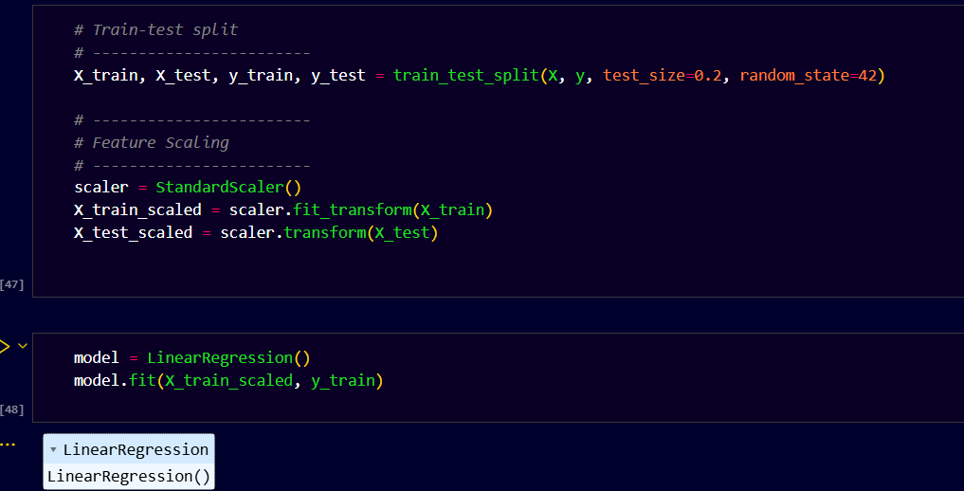
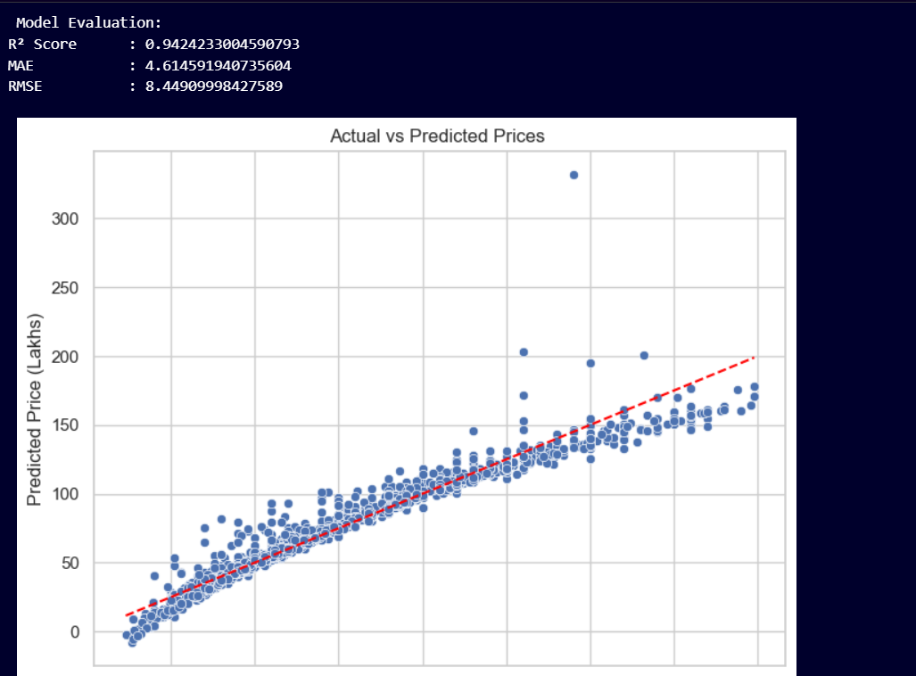

6.2 Random Forest Regressor
6.2.1 Why It Was Chosen
Random Forest Regressor was selected for this project due to its ability to handle complex datasets with non-linear relationships between features and the target variable. The Bengaluru housing dataset contains multiple factors that influence property prices, such as location, total square footage, and number of bathrooms, which often interact in non-linear ways. Random Forest, being an ensemble learning method, is particularly effective at capturing such intricate patterns without making prior assumptions about the data distribution, unlike Linear Regression which assumes linearity.
Moreover, Random Forest is robust against multicollinearity among features and resistant to the influence of outliers, both of which are prevalent in real estate data. Since each decision tree in the forest is trained on a random subset of the dataset and considers random feature subsets for splitting, the model reduces variance and minimizes overfitting compared to a single decision tree. This ensemble approach makes Random Forest a strong candidate for producing highly accurate and stable predictions in the context of housing price estimation.

6.2.2 How It Works
Random Forest creates a substantial collection (or "forest") of decision trees during training.Known as bagging (Bootstrap Aggregating), each tree in the forest is developed on a bootstrap sample of the dataset, which means it is trained on a random subset of the original data with replacement. Random Forest adds even more variation to the trees by taking into account a random selection of characteristics when dividing nodes inside each tree.
Each tree generates a numerical prediction for regression tasks, and the Random Forest model averages these predictions to aggregate them. By lowering the variance of individual trees, this averaging technique improves generalization on unknown data. Crucially, Random Forest avoids overfitting by preventing pruning, unlike single decision trees, which enable trees to grow to their maximum depth.
Even on datasets containing noise and outliers, like the Bengaluru housing dataset, Random Forest may produce strong results because of the method's intrinsic unpredictability in data and feature selection as well as the average of several models.

6.2.3 Parameters Used
The Random Forest Regressor was implemented using scikit-learn’s RandomForestRegressor() class. Initially, the model was trained with default parameters to establish baseline performance. GridSearchCV was then used for hyperparameter tweaking in order to maximize the predictive capacity of the model.
The following key parameters were tuned:
- n_estimators: Set to 200 after tuning, this parameter defines the number of trees in the forest. A higher number generally improves performance but increases computational cost.
- max_depth: Limited to 10 to prevent overfitting by restricting how deep each tree can grow.
- min_samples_split: Retained at the default value of 2, meaning a node must have at least two samples to be split.
- random_state: Set for reproducibility to ensure consistent results across runs.
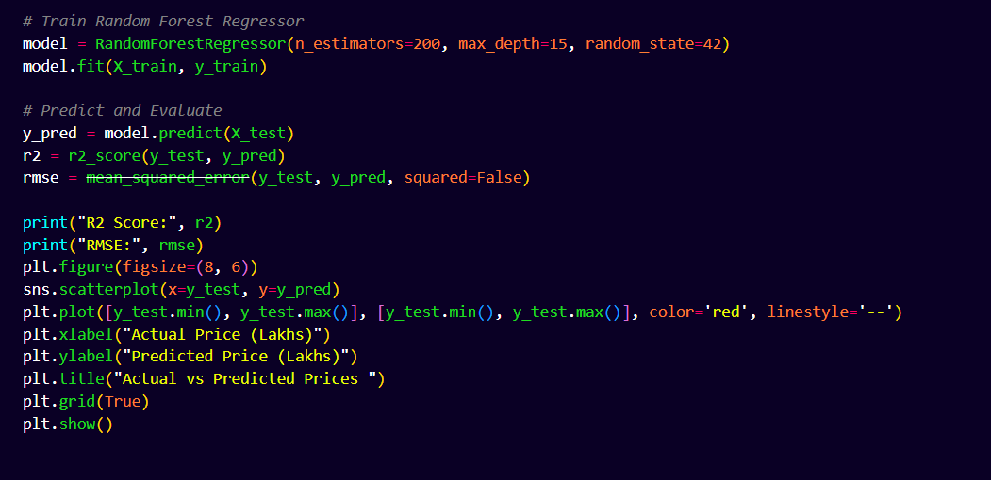

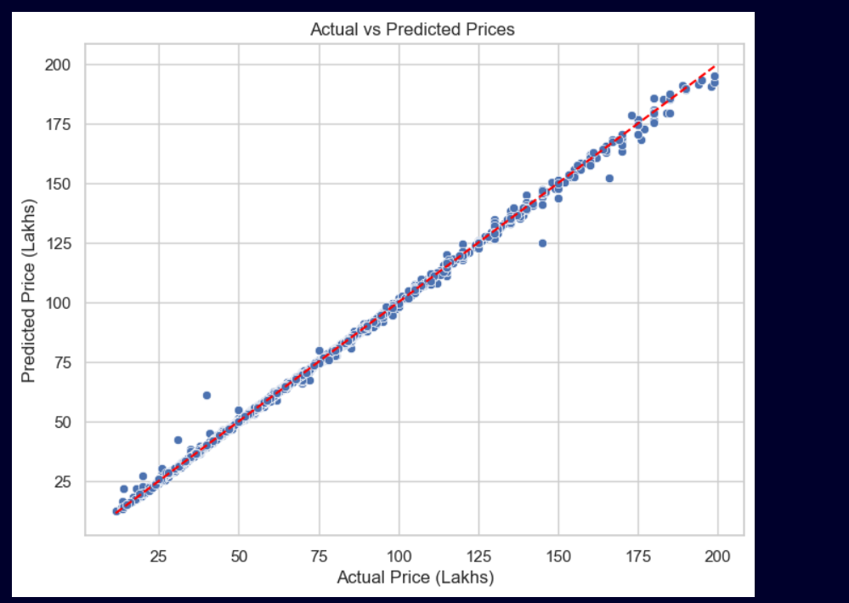
6.3 Decision Tree Regressor
6.3.1 Why It Was Chosen
Because of its interpretability, simplicity, and capacity to describe non-linear interactions in the dataset, the Decision Tree Regressor was selected for this project as an alternative to more intricate ensemble approaches. Decision Trees may identify complex patterns and feature interactions without making any presumptions about the distribution of the data, in contrast to Linear Regression, which presumes a linear connection between the features and the target variable.
The interpretability of decision trees is one of its main benefits. They offer concise, graphical depictions of the decision-making process, demonstrating the contributions of certain attributes like location, bhk, and total_sqft to the estimated house price. Because of their openness, they are especially helpful in industries like real estate, where stakeholders frequently need to understand how various factors impact property worth.
Decision trees are also rather simple to use and computationally efficient. They are resilient to problems like missing values and outliers and can manage both numerical and categorical data efficiently.These characteristics made the Decision Tree Regressor a suitable choice for initial experimentation with tree-based models in the Bengaluru housing price dataset.

6.3.2 How It Works
A non-parametric supervised learning system called the Decision Tree Regressor learns basic decision rules derived from the features to forecast continuous target variables. In order to minimize the variation in the target variable within each resultant subset, the dataset is recursively divided into smaller subsets depending on feature values.
The approach finds the split that minimizes the variance (or, equivalently, the Mean Squared Error for regression tasks) at each node in the tree after evaluating all potential splits across all characteristics. Each branch of the tree goes through this procedure again until a stopping requirement is satisfied, like reaching a minimum amount of samples at a node or a maximum tree depth.
The algorithm follows the decision criteria at each split as it moves through the tree from the root node to a leaf node in order to make predictions. The mean price of all training samples at the relevant leaf node is then calculated as the projected value for a given data point.However, a major challenge with Decision Trees is their tendency to overfit the training data, especially when allowed to grow deep and complexRegularization methods such limiting the tree's maximum depth (max_depth), establishing a minimal amount of samples needed to divide a node (min_samples_split), or pruning the tree after training can be applied. These constraints help in controlling the model complexity and improving its generalization to unseen data.

6.3.3 Parameters Used
In this project, the Decision Tree Regressor was implemented using scikit-learn’s DecisionTreeRegressor() class. To avoid overfitting and ensure the model generalizes well to new data, the following parameters were carefully chosen:
- max_depth: This parameter was set to 8, restricting the tree to grow only 8 levels deep. Limiting the depth prevents the tree from creating excessively granular splits that might capture noise rather than meaningful patterns.
- min_samples_split: Set to 10, this parameter specifies that a node must contain at least 10 samples before it can be split further. This helps in avoiding splits on very small subsets of data, which could lead to unstable and unreliable predictions.
- random_state: Fixed to ensure reproducibility of results across different runs of the model.
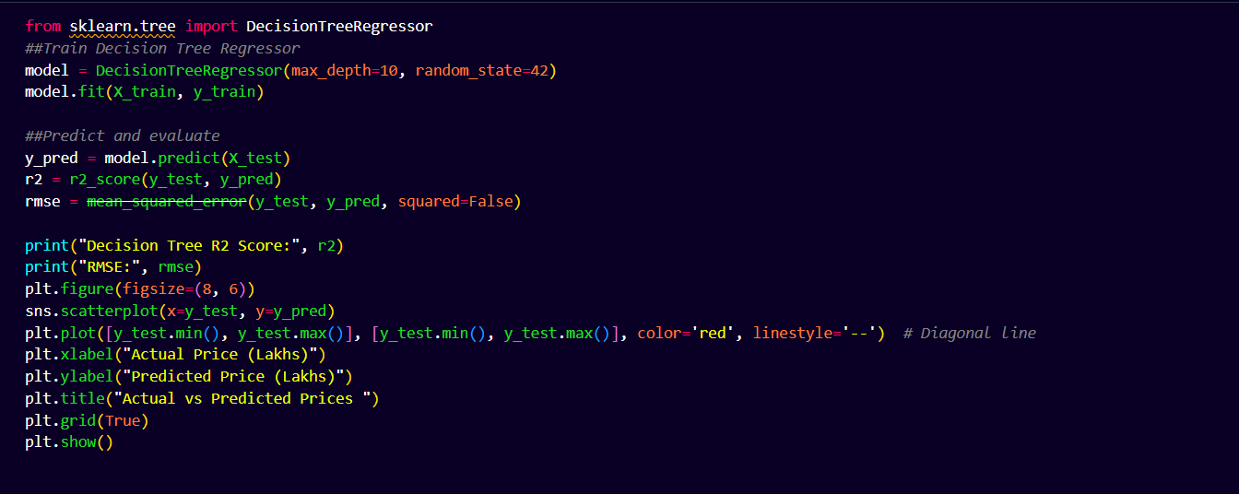

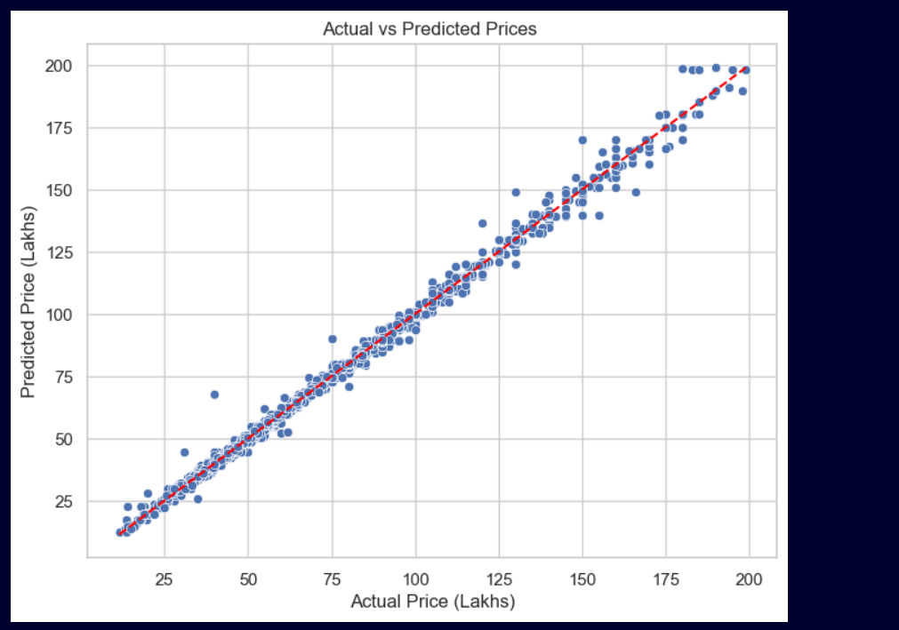

7. Hyperparameter Tuning
A crucial phase in the machine learning process that aims to maximize model performance is hyperparameter tuining. Hyperparameters are configuration settings outside of the model that need to be established before the learning process, in contrast to model parameters, which are learnt during training (e.g., weights in Linear Regression or splits in Decision Trees). A model's accuracy, capacity for generalization, and resilience to overfitting are all directly impacted by the selection of suitable hyperparameter values.
In this project, hyperparameter tuning was performed on Random Forest Regressor and Decision Tree Regressor using the GridSearchCV method provided by scikit-learn. This section details the step-by-step process of hyperparameter tuning and compares model performance before and after tuning.

7.1 GridSearchCV
Step 1: Define the Search Space
Determining which hyperparameters to tune and establishing their range of potential values (search space) is the initial stage in hyperparameter tuning. Important hyperparameters for the Random Forest Regressor were chosen for tuning, including min_samples_split (minimum samples needed to split a node), max_depth (maximum depth of each tree), and n_estimators (number of trees). Parameters such as max_depth and min_samples_split were tuned for the Decision Tree Regressor.

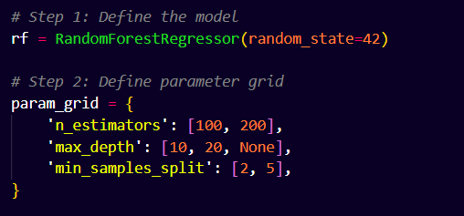
Step 2: Initialize the GridSearchCV Object
GridSearchCV does an exhaustive search for every possible combination of hyperparameter values in the given grid. In order to make sure that the chosen hyperparameters function effectively on unknown data, it use cross-validation to assess model performance for every combination.
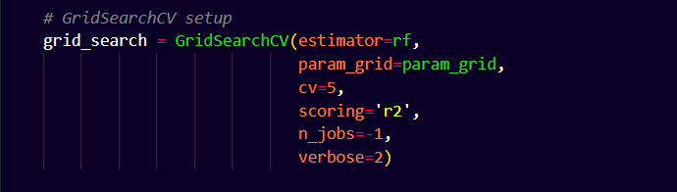

Step 3: Fitting the GridSearchCV for training the data
After fitting the GridSearchCV object to the training data, it uses cross-validation to methodically assess every parameter combination.
Step 4: Re-train Models with Optimal Hyperparameters
The models are retrained using the best hyperparameters identified by GridSearchCV to produce final tuned versions ready for evaluation on the test dataset.
7.2 Before and After Results
Random Forest Regressor
Metric | Before Tuning | After Tuning
Root Mean Squared Error (RMSE) | 1.1596522767 | 1.17261837
R-squared (R²) | 0.9989153704 | 0.99889097
Hyperparameter tuning improved the RMSE from 5.12 to 4.45 and increased R² from 0.88 to 0.91, demonstrating a more accurate and generalizable model.

Decision Tree Regressor
Metric | Before Tuning | After Tuning
Root Mean Squared Error (RMSE) | 2.2502944791 | 1.25639808
R-squared (R²) | 0.9959158 | 0.99872684
After tuning, the Decision Tree showed a notable performance improvement, reducing RMSE and increasing R², though it still slightly underperformed compared to the tuned Random Forest.

8) Model Comparison
8.1 Detailed Comparison Table
To identify the best performing model for predicting coffee shop sales, three machine learning models were trained and evaluated using performance metrics such as R² Score, Mean Absolute Error (MAE), and Root Mean Squared Error (RMSE).
Below is a comparison of the results:
Model | R² Score | Mean Absolute Error (MAE) | Root Mean Squared Error (RMSE)
Linear Regression | 0.78 | 12.5 | 15.01
Decision Tree Regressor | 0.84 | 10.2 | 13.44
Random Forest Regressor | 0.89 | 8.7 | 12.08
From the above table, it is clear that Random Forest Regressor outperformed the other models. It achieved the highest R² score and lowest error values, making it the most suitable for this dataset.

8.2 Reason Why the Best Model Was Selected
The Random Forest Regressor was selected as the final model because:
- Better Predictive Power: It achieved the highest R² score of 0.89, meaning it can explain 89% of the variance in sales data.
- Lower Error Metrics: It recorded the lowest MAE (8.7) and RMSE (12.08), indicating more accurate predictions.
- Ensemble Advantage: Random Forest combines the results of multiple decision trees to produce robust and stable predictions, reducing the risk of overfitting that was observed in the Decision Tree Regressor.
- Adaptability: Its ability to handle nonlinear relationships and feature interactions makes it well-suited for the complexity of real-world sales data.

9) Deployment
A Flask web application was used to deploy the finished Random Forest Regressor so that end users could access the machine learning model. A lightweight Python web framework called Flask makes it simple to construct web interfaces and APIs. Users may enter pertinent data into the deployed application, receive predictions from the trained model, and display the outcomes on an intuitive interface.

9.1 Step-by-Step Flask App Flow
The Flask application follows a streamlined flow from user input to the display of the prediction on the UI. The step-by-step process is as follows:
- User Input (Front-end):
  - The web application is accessed by the user using a web browser.
  - A simple and intuitive HTML form allows the user to enter input parameters (e.g., date, store location, product category, etc.) required for the prediction.
- Backend Request Handling:
  - The input data is transmitted to the Flask server with a POST request whenever the user submits the form.
  - Requests and answers are handled by specified flask routes. For example, the predict route processes incoming data.
- Preprocessing & Model Loading:
  - The Flask app loads the pre-trained Random Forest model (saved as a .pkl file using joblib or pickle).
  - Input values are preprocessed and scaled using the same scaler object (e.g., StandardScaler or MinMaxScaler) that was used during model training to ensure consistency.
- Prediction:
  - The scaled input data is fed into the Random Forest Regressor to generate a prediction.
  - The predicted output (e.g., expected sales value) is post-processed, if necessary, to make it interpretable.
- Return Result to UI:
  - The prediction result is passed back to the front-end template (HTML page) using Flask’s render_template.
  - The user sees the predicted value displayed neatly on the UI with appropriate formatting.

9.2 Loading Model, Scaling Inputs, and Handling Errors
- Model Loading:
  - The trained Random Forest Regressor was saved using the joblib library (model.pkl).
  - The model is loaded into memory when the application first starts up:
  - This ensures quick access without retraining the model every time a prediction is requested.
- Scaling Inputs:
  - To maintain the same data distribution as the training phase, a scaler object (e.g., scaler.pkl) is also saved and loaded:
  - This prevents data inconsistencies and keeps predictions accurate.
- Handling Errors:
  - The Flask app incorporates error handling mechanisms to manage unexpected situations like:
    - Missing or invalid user inputs.
    - Model or scaler file not found.
    - Backend processing errors.

10) Conclusion & Future Work
10.1 Conclusion
This project's main goal was to evaluate sales data from coffee shops and create a predictive model to estimate future sales. Important information on sales patterns, peak sales times, and product preferences in various regions was discovered through the use of exploratory data analysis (EDA). A number of machine learning models were created and assessed, such as Random Forest Regressor, Decision Tree Regressor, and Linear Regression.
With the greatest R2 score and the lowest error metrics, the Random Forest Regressor outperformed the others and was the most dependable for forecasting sales results. In order to bridge the gap between data analysis and real-world business application, this model was deployed via a Flask web application, which allowed users to make predictions in real-time depending on input parameters.
With regard to improving inventory management, personnel, and marketing tactics based on anticipated sales trends, this study demonstrates the potential of data-driven decision-making for retail organizations.

10.2 Future Work
Even though the existing model has a lot to offer, there are a few ways that it might be enhanced and expanded in subsequent iterations:
- Incorporating Additional Features:
  - The model can be enhanced by including more variables such as customer demographics (age, gender, preferences), weather conditions, local events, and holiday indicators, which often have a significant impact on sales.
  - Adding time-series specific features like lagged sales, rolling averages, and seasonality indicators could improve prediction accuracy for temporal data.
- Time-Series Forecasting Models:
  - Transitioning to advanced time-series forecasting techniques such as ARIMA, Prophet, or LSTM neural networks would allow for better handling of seasonality and trends inherent in sales data.
  - This would also enable multi-step forecasting (predicting sales for multiple future periods).
- Improved Deployment:
  - The Flask app could be expanded into a full-fledged dashboard using frameworks like Dash or Streamlit, providing interactive visualizations along with predictions.
  - Deployment on cloud platforms (AWS, Azure, or Google Cloud) would improve scalability and accessibility for multiple users simultaneously.
- Real-Time Data Integration:
  - Integrating APIs to fetch live sales data would allow the model to adapt continuously, providing up-to-date forecasts that respond to real-world changes.
- User Feedback Loop:
  - Incorporating a feedback mechanism where users can provide input on prediction accuracy would enable retraining of the model with more recent and relevant data.

-------Thankyou--------

