GCP AI Helpdesk Chatbot — Alerting & Monitoring Policy Documentation

Document type: Consolidated Monitoring & Alerting Reference Platform: Sabre GCP AI Helpdesk Chatbot (RAG + ServiceNow escalation) Environment documented: Dev (sab-dev-hd-chatbot-4154, us-central1) Alerting product: Google Cloud Monitoring (native, fully managed) Notification channel: Email — RAG Alerts (dev) (verified, delivering) Active alert policies: 27 Companion documents: GCP AI Helpdesk Chatbot — Technical Documentation, Teams Integration Architecture Documentation

⚠️ Scope note — this documents the DEV configuration
Thresholds in this document are deliberately set low/tight for the dev environment, to exercise the full escalation mechanism end to end — metric → condition → incident → email — and confirm every link fires and reaches a human inbox. The design, severities, and structure are final; only the numeric thresholds are expected to move for cert/prod after a baselining period on real traffic.

1. Executive Summary
The chatbot is monitored entirely with Google Cloud Monitoring, a native, fully managed GCP service. There is no monitoring server to run, patch, or keep alive — the same platform that runs the workloads also observes them.
Twenty-seven alert policies cover every component in the request path and the ingestion path: the agents, Vector Search, Firestore, the Cloud Composer ingestion pipeline, the embedding service, and the ServiceNow escalation function. Each policy carries an embedded runbook that travels inside the alert email, so the responder gets the fix, not just the symptom.
Every alert routes to a verified email notification channel, proven delivering.

2. Why GCP-Native Alerting Is Reliable
Alerting is not something built from scratch — it is a managed capability configured for this platform. For each alert, only the following are configured:
- Select the metric the service already emits (GCP publishes these automatically — no agent, no code).
- Scope it to the resource by tagging the resource id / labels.
- Set the threshold and the evaluation window.
- Attach the email notification channel.
Everything after that — metric collection, evaluation every 60 seconds, incident creation, de-duplication, notification delivery, auto-close, and retention — is operated by Google under the Cloud Monitoring SLA.
Reliability property | Who owns it | Consequence
Metric ingestion & storage | Google (managed) | No collector to keep alive
Condition evaluation (60 s floor) | Google (managed) | Alerting keeps working even if the app is down
Notification delivery | Google (managed) | Email is sent from Google's infrastructure
Incident lifecycle & auto-close | Google (managed) | No state machine to maintain
High availability of the alerting plane | Google (managed) | Independent of the chatbot's own health

The critical design win: because the alerting plane is external to the application, it can report that the application is down. Several CRITICAL policies (Composer environment health, scheduler heartbeat, embedding probe absence) rely on exactly this independence — they fire on silence, which only an external observer can detect.
Native metrics vs. our own log-based metrics. Where GCP already emits a metric (Agent Engine, Vector Search, Firestore, Composer) alerts use the native signal — it exists whether or not the application code is healthy. Where the signal is application-specific (RAG latency, escalation rate, ingestion outcome) a structured log line is emitted and Cloud Monitoring turns it into a log-based metric. Both kinds are evaluated by the same managed engine.

3. Architecture — How a Signal Becomes an Email
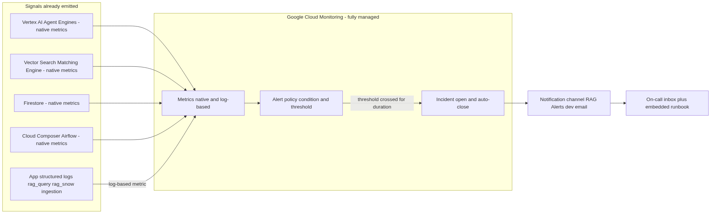
Figure: architecture / flow diagram
Every user request is itself a health check, so a user-facing failure is caught within the 60-second alerting minimum regardless of any probe schedule:
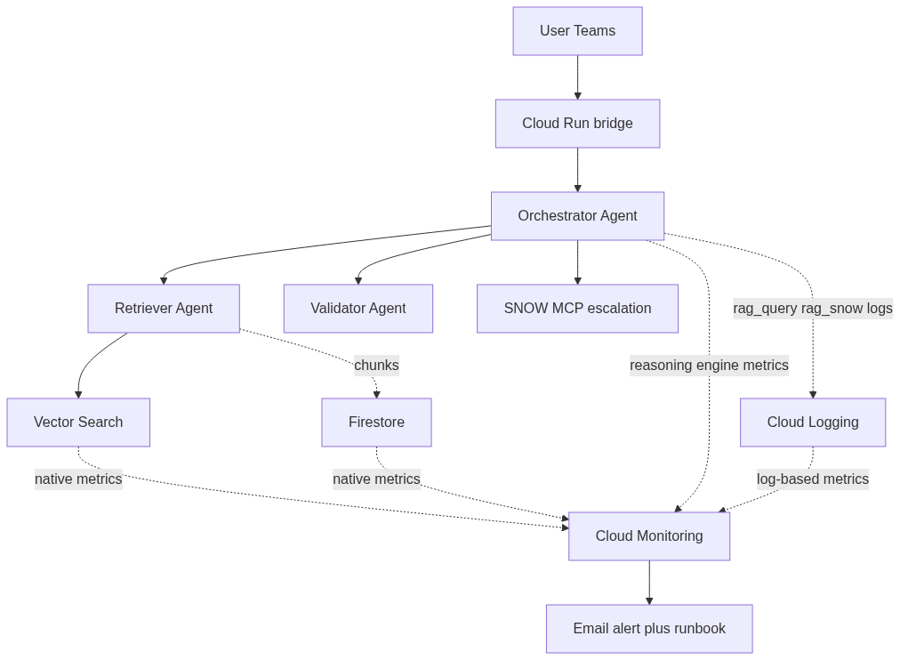
Figure: architecture / flow diagram

4. Live Health Dashboard
A single Cloud Monitoring dashboard shows every component at a glance. Green tiles are healthy; a tile turns red the moment its metric crosses the same threshold its alert policy uses, so the dashboard and the alerts always agree.
Health-at-a-glance tiles — RAG volume, answer latency p95, query-failure rate, escalation rate, Vector Search latency, ingestion success, agent errors, child-agent timeouts, orphan chunks, and embedding-probe status:
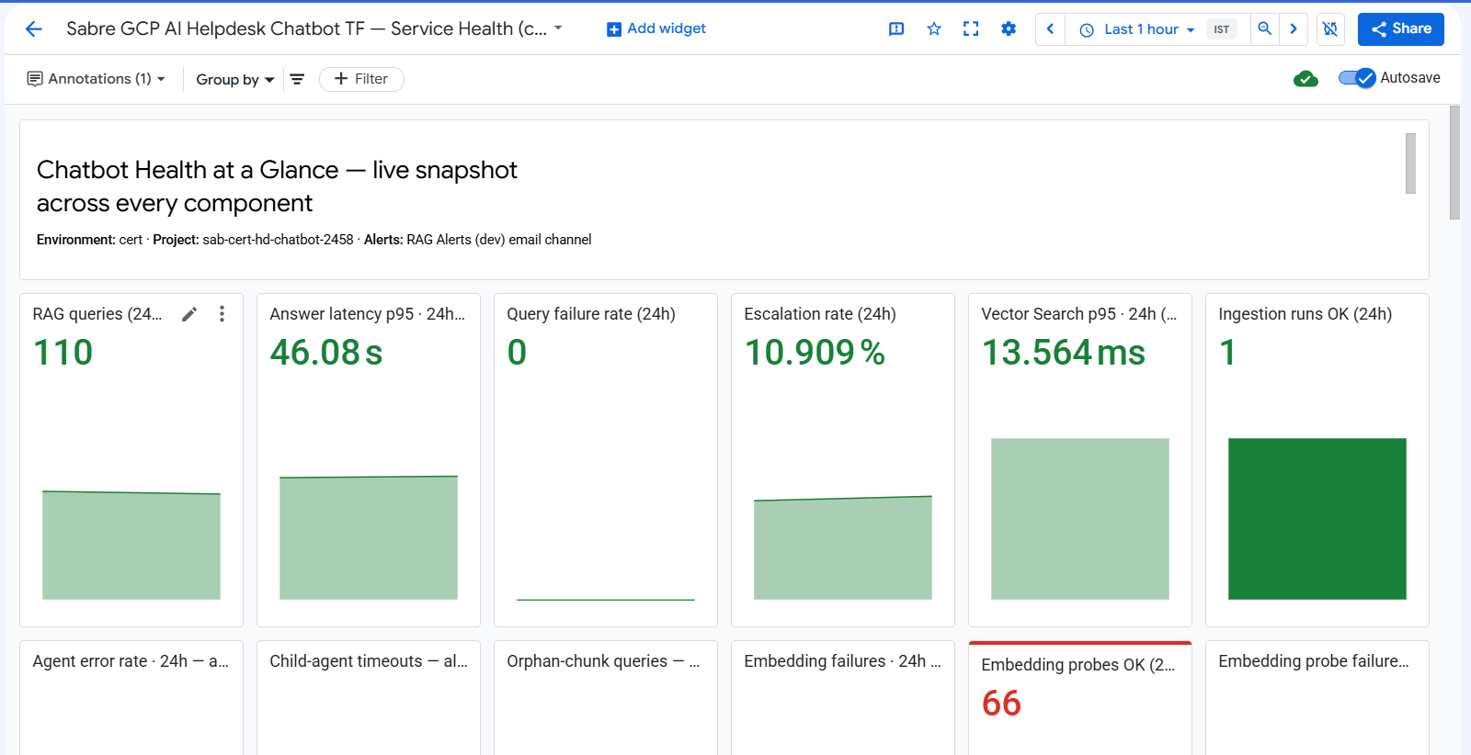
Chatbot health-at-a-glance dashboard
Traffic & errors row — requests by status class (2xx vs errors), per-agent request rate, per-agent native p95 latency (with the 60 s alert line drawn in), and traffic share per agent engine:
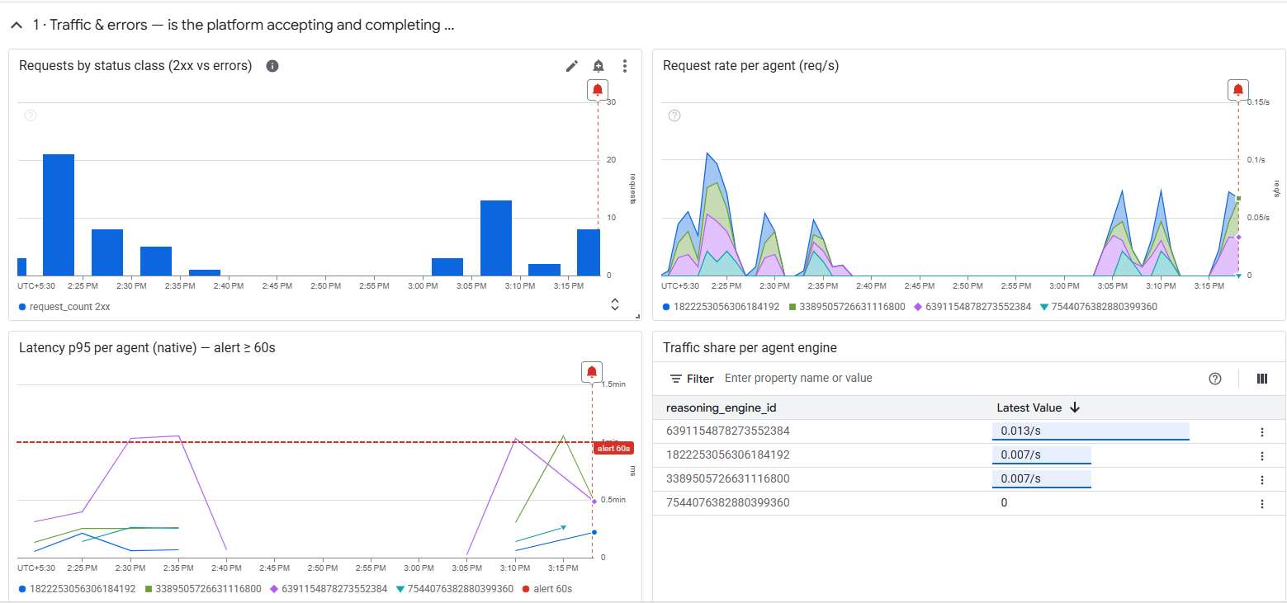
Traffic and errors dashboard row

5. What an Alert Looks Like — Evidence of the Full Pipeline
The following are real alert emails received in dev, proving each stage of the flow works: the metric crossed a threshold, Cloud Monitoring opened an incident, and the email — with its embedded runbook — reached the inbox.
5.1 — Agent Engine p95 latency (WARNING). Native Vertex AI Reasoning Engine metric crossed 60 000 ms; the email header carries the exact resource labels:
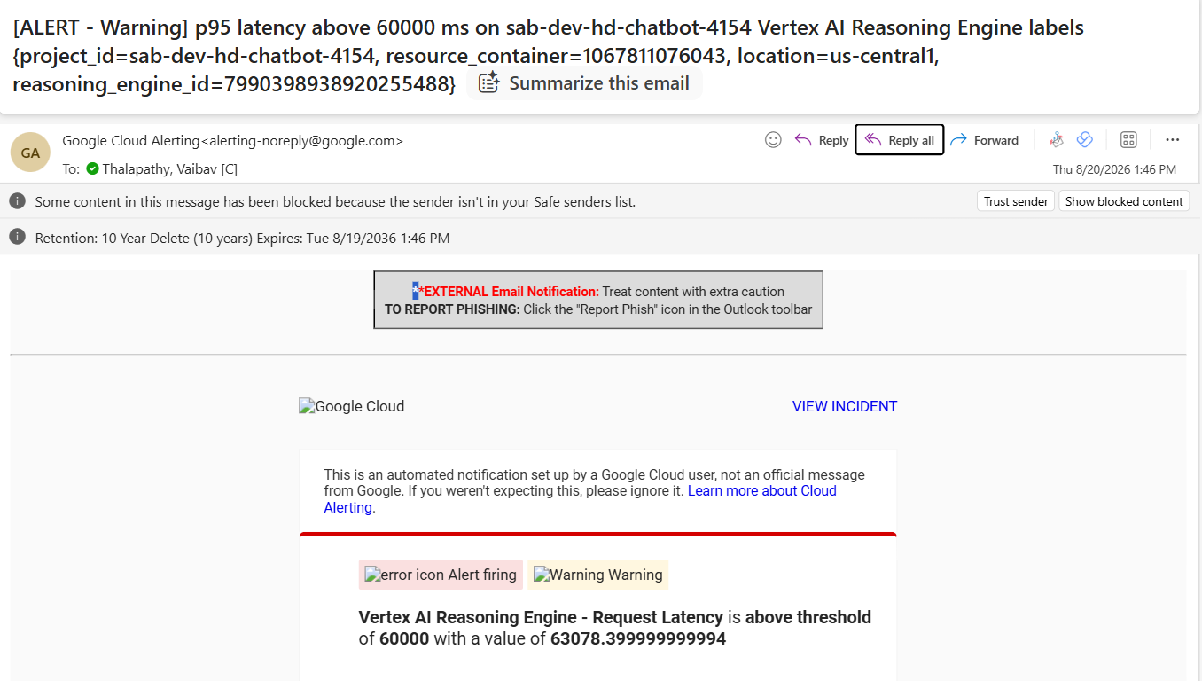
Agent latency alert email header
5.2 — The same alert, showing the embedded runbook. The policy, the exact condition, every resource label, and the full "Policy documentation" runbook travel inside the email — why it is WARNING not CRITICAL, where the threshold came from (measured p50 23.3 s / p95 46.6 s / worst 53.9 s), and what to check:
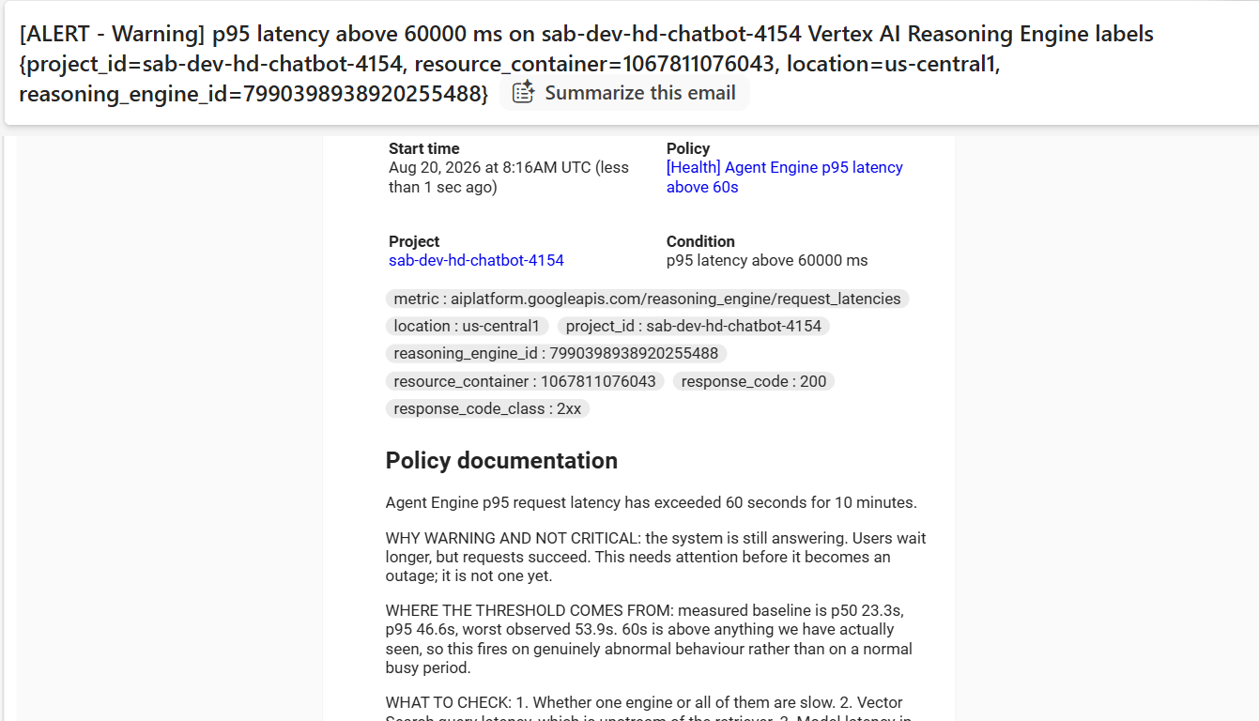
Agent latency alert with runbook
5.3 — Embedding health check not running (CRITICAL, absence). This fires on silence — "no successful probe in 1h". Only an external, managed observer can detect that the watcher itself has stopped:
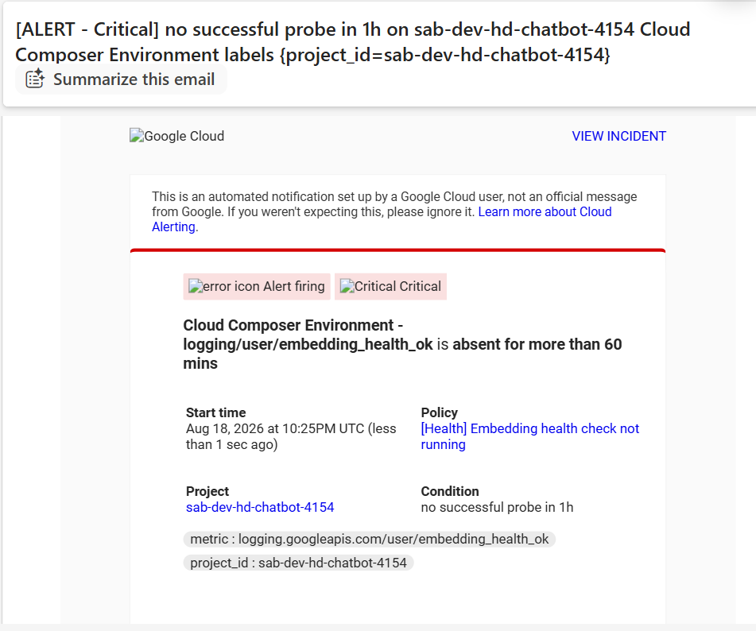
Embedding probe absence alert
5.4 — Child-agent timeouts, RESOLVED (WARNING). Cloud Monitoring also auto-closes incidents when the metric recovers and sends a RESOLVED email — no manual clean-up. The runbook explains the retry-amplification mechanism:
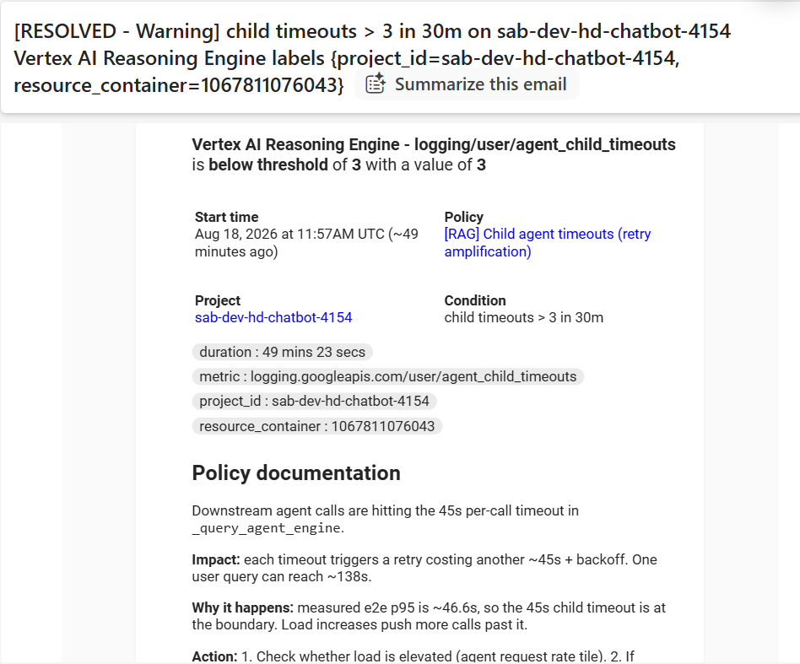
Child agent timeouts resolved email
These four emails are the reliability proof: metric → condition → incident → email → runbook → auto-resolve, all managed by Google, all confirmed reaching a human.

6. Notification Channel — Proof of Delivery
Property | Value
Display name | RAG Alerts (dev)
Type | Email
Status | Enabled, delivering (confirmed)
Attached to | All 27 policies (0 silent policies)

Why this matters. A policy with no notification channel still evaluates, still opens incidents, and still renders red on the dashboard — but pages nobody, while looking fully armed in the console. Every one of the 27 policies is confirmed attached to the channel; there are zero silent policies.

7. Policy Catalogue
Severity contract
Severity | Meaning | Response
CRITICAL | System functionality is broken — users impacted now, or the pipeline has stopped. | Act immediately
WARNING | Needs attention but is not a threat — degradation, not outage. | Next business day

Summary by component
Component | Policies | CRITICAL | WARNING
A · RAG pipeline (user experience) | 5 | 0 | 5
B · Agent Engine (Vertex AI Reasoning) | 4 | 2 | 2
C · Vector Search (Matching Engine) | 2 | 1 | 1
D · Firestore | 1 | 0 | 1
E · Ingestion — Cloud Composer platform | 6 | 5 | 1
F · Ingestion — content integrity | 4 | 1 | 3
G · Embedding service | 4 | 3 | 1
H · ServiceNow escalation | 1 | 0 | 1
Total | 27 | 12 | 15

A · RAG pipeline — end-user experience (5)
All WARNING by design: slow or lower-quality answers are degradation, not an outage — the chatbot still responds.
# | Policy | Sev | Signal | Condition (dev) | Rationale
1 | [RAG] E2E latency p95 regression (> 75000ms) | WARNING | rag_e2e_latency_ms (log) | p95 > 75 000 ms for 5 m | Measured p95 is 46.6 s; 75 s is ~40% above worst observed (53.9 s)
2 | [RAG] Query failure rate > 20% (min 20 queries/h) | WARNING | rag_query_failures / rag_query_total | ratio > 0.20 AND ≥ 20 q/h | Volume floor stops 1-of-3 overnight misses paging as "33%"
3 | [RAG] Escalation rate > 50% (min 20 queries/h) | WARNING | rag_escalation_total / rag_query_total | ratio > 0.50 AND ≥ 20 q/h | Content-gap signal — knowledge base does not cover what users ask
4 | [RAG] Child agent timeouts (retry amplification) | WARNING | agent_child_timeouts (log) | > 3 in 30 m | 45 s per-call timeout × 3 retries → one query can reach ~138 s
5 | [RAG] Orphan chunks detected (index/Firestore drift) | WARNING | rag_orphan_chunk_count (log) | > 5 /h | Vector index has drifted from Firestore

B · Agent Engine — Vertex AI Reasoning Engines (4)
Native `reasoning_engine` metrics, kept as a rate-based and a count-based pair so a low-volume error burst and a sustained error percentage are both caught.
# | Policy | Sev | Signal | Condition (dev) | Rationale
6 | [Health] Agent error rate > 5% | CRITICAL | reasoning_engine/request_count non-2xx ÷ total | ratio > 0.05 for 5 m | Primary "is the chatbot working?" signal
7 | [Health] Agent Engine returning errors | CRITICAL | reasoning_engine/request_count (non-2xx) | count > 5 in window | Catches an error burst even at low volume
8 | [Health] Agent latency p95 high (> 60000ms) | WARNING | reasoning_engine/request_latencies | p95 > 60 000 ms for 5 m | Slow but succeeding; baseline p95 46.6 s
9 | [Health] Agent Engine p95 latency above 60s | WARNING | reasoning_engine/request_latencies | p95 > 60 000 ms for 10 m | Longer-window confirmation of the same signal

Cert/prod will consolidate #6/#7 and #8/#9 to the rate-based pair (#6, #8); both formulations are kept in dev to validate each.

C · Vector Search — Matching Engine (2)
# | Policy | Sev | Signal | Condition (dev) | Rationale
10 | [Health] Vector Search has no serving replicas | CRITICAL | matching_engine/current_replicas | replicas < 1 | Retrieval cannot run — most user-visible failure
11 | [Health] Vector Search latency p95 high (> 1000ms) | WARNING | matching_engine/query/latencies | p95 > 1 000 ms for 5 m | Retrieval slow → raises end-to-end latency

D · Firestore (1)
# | Policy | Sev | Signal | Condition (dev) | Rationale
12 | [Health] Firestore API latency p95 high (> 2000ms) | WARNING | firestore/api/request_latencies | p95 > 2 000 ms for 5 m | Session/cache lookups slow. ABORTED is normal contention — deliberately not alerted

E · Ingestion — Cloud Composer platform (6)
Native Composer/Airflow metrics. Several fire on absence — only an external managed observer can detect that a component went silent.
# | Policy | Sev | Signal | Condition (dev) | Rationale
13 | [Health] Composer environment unhealthy | CRITICAL | environment/healthy (BOOL) | healthy fraction < 0.5 for 10 m | Airflow not reporting healthy → ingestion at risk
14 | [Health] Composer database unhealthy | CRITICAL | environment/database_health (BOOL) | health fraction < 0.5 for 10 m | Airflow metadata DB failing
15 | [Health] Composer scheduler heartbeat stopped | CRITICAL | environment/scheduler_heartbeat_count | absence 15 m | No scheduler → nothing runs at all
16 | [Health] Composer workload restarting repeatedly | WARNING | workload/restart_count (CUMULATIVE→ΔELTA) | > 3 restarts / 10 m | Crash-loop symptom; OOM is usual cause
17 | [Health] Ingestion DAG run failed | CRITICAL | workflow/run_count state=failed | > 0 | The ingestion run failed
18 | [Health] No successful ingestion run (84600s) | CRITICAL | workflow/run_count state=success | absence 84 600 s | Knowledge base going stale (84 600 s = platform max)

F · Ingestion — content integrity (4)
Application-specific ingestion outcomes, emitted as structured logs.
# | Policy | Sev | Signal | Condition (dev) | Rationale
19 | [Ingestion] Mass-reap blocked (circuit breaker) | CRITICAL | ingestion_reap_blocked (log) | > 0 | Safety breaker stopped a bulk vector deletion — firing means it worked
20 | [Ingestion] Delete failures (orphaned vectors) | WARNING | ingestion_delete_failures (log) | > 0 | Deleted docs remain searchable — stale citations
21 | [Ingestion] High per-file failure ratio | WARNING | ingestion_high_failure_ratio (log) | > 0 | Many source docs failed to process — silent coverage loss
22 | [Ingestion] Run completed with errors | WARNING | ingestion_run_status =completed_with_errors | > 0 | Run finished but partially

G · Embedding service — GKE, VPC-internal (4)
Reachable only inside the VPC, so a public uptime check cannot see it. The DAG calls it from inside the VPC and logs every attempt. Retries are not failures — only retries-exhausted count as hard failures.
# | Policy | Sev | Signal | Condition (dev) | Rationale
23 | [Health] Embedding service failures (retries exhausted) | WARNING | embedding_service_failures (log) | > 3 /h | Some docs skipped; run may still complete
24 | [Health] Embedding service DOWN (sustained) | CRITICAL | embedding_service_failures (log) | > 20 /h | Ingestion effectively cannot embed
25 | [Health] Embedding service DOWN (active probe) | CRITICAL | embedding_health_failed (log) | > 1 failed probe / 30 m (2 consecutive misses) | Continuous probe, independent of ingestion runs
26 | [Health] Embedding health check not running | CRITICAL | embedding_health_ok (log) | absence 3 600 s | Blind-spot detector — the watcher itself died

H · ServiceNow escalation (1)
# | Policy | Sev | Signal | Condition (dev) | Rationale
27 | [Health] SNOW MCP function errors (> 5 in 30m) | WARNING | cloudfunctions/execution_count status!=ok | > 5 in 30 m | Escalation path broken; not >0 because the function retries internally

8. Design Principles Applied Across All 27 Policies
- Every policy has a notification channel. Zero silent policies.
- Every policy carries an embedded runbook that travels in the email, so the responder gets the fix, not just the symptom.
- Ratio alerts have a volume floor. "> 20%" is meaningless over 3 queries; both the ratio and a minimum query count must hold in the same window.
- Retries are not failures. Alerts fire on retries-exhausted, so a healthy self-recovering service does not page anyone at 03:00.
- Absence conditions catch silence. A dead component emits no metric, not a bad one — the most dangerous failures are detected by watching for the absence of a healthy signal.
- Thresholds are measured, not guessed (dev baseline p50 23.3 s / p95 46.6 s / worst 53.9 s), and every threshold is documented in its own runbook.

9. Dev → Prod
Aspect | Dev (this document) | Cert / Prod (planned)
Structure, severities, runbooks | Final | Unchanged
Ratio volume floor (min queries/h) | 20 (low, to exercise alerts) | Raised after baselining real traffic
Latency / error thresholds | Tuned tight to trigger and verify escalation | Re-baselined on ~2 weeks of prod traffic
Agent Engine rate/count pair | Both kept, to validate both formulations | Consolidate to the rate-based pair
Delivery | Managed by Google Cloud Monitoring | Identical (same managed service)

10. How Monitoring & Alerting Was Enabled — Terraform Module
This section documents the actual deployed configuration: the SABRE_CHATBOT_MONITORING_TF Terraform module. The consumer/support team inherits redeploying this exact module to cert/prod (by changing only the tfvars), so understanding the file map, not just the alert list, is required.

10.1 What Gets Created
24 log-based metrics, 21 alert policies (native GCP components add further native-metric alerts — 27 total across the platform), and one multi-tile dashboard.
File | Creates
metrics_rag.tf | 8 RAG metrics — latency, tokens, outcomes, SNOW
metrics_agent_quality.tf | 4 metrics — child timeouts/retries, orphan chunks
metrics_ingestion.tf | 10 Composer metrics — 7 ingestion + 3 embedding health probe
alerts_embedding.tf | 2 embedding metrics + 4 alerts (WARNING/CRITICAL pair + 2 probe)
alerts_rag.tf | 5 RAG alerts
alerts_native.tf / alerts_platform.tf | Platform alerts needing no code instrumentation
alerts_ingestion.tf | 4 ingestion alerts
alerts_bridge.tf | Teams-bridge alerts (cert/prod only — the bridge does not exist in dev)
dashboard.tf | The full multi-tile dashboard, templated per environment
notification.tf | Email notification channel
uptime.tf | SNOW MCP uptime check (optional)
logsink_bigquery.tf | 30-day BigQuery export of rag_* events

10.2 Deploy Sequence
cd SABRE_CHATBOT_MONITORING_TF
cp terraform.tfvars.example terraform.tfvars # edit for your environment
terraform init
terraform plan
terraform apply
Required APIs: monitoring, logging, aiplatform, composer, cloudfunctions, firestore.

10.3 Prerequisites (Nothing Errors — Metrics Just Stay Empty)
Agent instrumentation. The rag_* and agent_child_* metrics are fed by structured log lines the agents emit. Without the instrumented agents deployed, those metrics exist but stay empty. Three files carry it: the retriever tools (rag_retrieval, orphan_chunks_detected), the orchestrator agent (rag_query, rag_snow), and the validator agent (rag_escalation, rag_scores).
They emit via `print(..., flush=True)`, not `logger.info()`. The Agent Engine ADK runtime reconfigures Python logging for its own OpenTelemetry pipeline and can swallow logger calls. stdout is always captured. This is not a style choice — logger.info() produces silently empty metrics with no error anywhere.
Native metrics (agent latency, error rate, Vector Search, Firestore, Composer, Cloud Functions) need no code and work immediately.
The embedding health-check DAG. The three embedding_health_* metrics are fed by a Composer DAG that probes the embedding endpoint every 10 minutes. It exists because the endpoint is VPC-internal, so a Cloud Monitoring uptime check cannot reach it. Without this DAG deployed, the two probe alerts will fire on absence — correctly, since nothing would be watching the service.
`notification_email` placeholder trap. The example tfvars ships a deliberately rejected placeholder address. A syntactically valid but wrong address would otherwise create a channel that looks fully configured (channels=1, attached to every policy) while pointing at a mailbox nobody reads — worse than an empty channel, which at least is visibly channels=0. variables.tf rejects the placeholder on purpose so terraform plan fails loudly instead.

10.4 Design Decisions — Read Before Changing Thresholds
Each of these looks like a bug until the reason is known.
- Composer logs land in `textPayload`, agent logs in `jsonPayload`. Agent Engine output is parsed into jsonPayload, but Airflow worker logging.info(json.dumps({...})) output arrives as a plain string in textPayload and is never parsed into fields. Seven ingestion metrics were originally written against jsonPayload.event and matched zero entries for weeks — including the one behind the CRITICAL mass-reap alert — because an empty metric and a healthy system render identically. Composer metrics therefore match the raw text, matching the full key/value pair (not the bare event name) to avoid false hits from scheduler log lines that merely mention a DAG file name.
- Retries are not failures. call_function_with_backoff retries 4 times and logs "Timeout on attempt N" for every attempt; attempts 1–3 usually succeed. Only "Function error" (no retry) or "…on attempt 4" (retries exhausted) count as real failures. Transient attempts feed a separate embedding_service_retries signal with no alert by design.
- Some thresholds are deliberately `> 0`. The ingestion DAG applies the business threshold before emitting the event (e.g. failure_ratio > 0.10), so > 0 on the alert is correct — the DAG is the threshold. Raising these to a count-per-hour would silence them permanently, since a daily DAG cannot produce three events inside one hour.
- Ratio alerts carry a volume floor. Query-failure and escalation alerts require ratio > threshold AND total queries > rag_min_queries_per_hour (combiner AND) — without the floor, one miss out of three overnight queries reads as 33% and pages someone over statistical noise. Raise rag_min_queries_per_hour for production volumes; the default of 20 is a dev-scale number.
- Latency is WARNING, not CRITICAL. Slow is not broken; users still receive answers. 75 000 ms sits ~40% above the measured maximum (dev: p50 23 s, p95 47 s, max 54 s).
- Scorecards use 24-hour buckets. Cloud Monitoring scorecards render the most recent aligned bucket, not a window total; short buckets show "–" whenever traffic pauses, so a 24h bucket keeps them populated between bursts.
- The Composer workflow label is not the DAG id. Composer labels workflows <environment>.<dag_id>; filtering on the bare DAG id matches nothing and the alert stays silently green. Two CRITICAL alerts were broken this way before it was caught.
- One failed health probe is not an outage. The probe runs every 10 minutes, so the CRITICAL threshold is > 1 failure in 30m (two consecutive misses, roughly 20 minutes genuinely unreachable) — a single transient blip must not page at 3am. Its partner alert, "Embedding health check not running," exists because a dead probe and a healthy service produce the same dashboard (zero failures); without the absence alert, monitoring could fail silently.

10.5 Tuning
All thresholds are variables — change terraform.tfvars, not the module.
rag_e2e_regression_ms = 75000 # measured: p95 47s, max 54s
rag_min_queries_per_hour = 20 # RAISE for production
child_timeout_threshold = 3 # per 30m
snow_error_threshold = 5 # per 30m, not 0 - it retries internally
embedding_failure_warning = 3 # per 1h
embedding_failure_critical = 20 # per 1h
embedding_probe_failure_critical = 1 # per 30m = two consecutive misses
embedding_probe_absence_seconds = 3600 # probe interval is 10 min
Re-baseline after ~2 weeks of production traffic. Current values come from dev plus a single 50-user load test.

10.6 Dashboard Regeneration
Regenerate the template from the live dev dashboard rather than hand-editing:
python sync_dashboard_to_tf.py
Layout is drill-down ordered, not technology ordered: header + at-a-glance scorecards ("is the chatbot healthy right now?") → Traffic & errors (symptom) → RAG performance & quality (symptom) → Dependencies (cause) → ServiceNow escalation (cause) → Ingestion & KB freshness (data supply) → Runbook (what to do). Every scorecard threshold is identical to its alert threshold, so what is red on screen is exactly what pages.

10.7 Known Gaps
Gap | Impact
CRITICAL alerts are email-only | Nothing pages out of hours until PagerDuty/Opsgenie is wired up
Thresholds from dev + one load test | Re-baseline after ~2 weeks of production traffic
Embedding observed only during DAG runs (daily) | The Composer health-check DAG gives continuous coverage plus absence alerting
No SLOs or burn-rate alerts | "99% of queries under 30s" is not yet defined

11. Ingestion-Specific Monitoring Deployment Notes
Ownership model: the AI/platform team stands up monitoring in dev — real metrics, alert policies, and a dashboard, as Terraform. The receiving team replicates the same module to cert/prod by changing only the tfvars.
Log-based metrics from ingestion markers (jsonPayload.event=..., emitted by the ingestion DAG): reap_blocked, delete_failures, run_status (failed/success), crawl_summary (reap count), unknown_files.
Why both a log-metric AND a native metric for run health. The DAG's structured markers only emit if the run reaches its cleanup step — a hard crash (worker OOM, import error) never emits. The native Composer dag_run/failed_count (CRITICAL) and the run_ok absence alert (CRITICAL) together catch what the markers can't; all three are kept.
Baselining note. reap_count_baseline (500) and unknown_files_baseline (50) are starter guesses. After ~2 weeks of normal post-rebuild runs, set them from real volume so cert/prod don't alert-storm.
Embedding is on GKE, not Cloud Run. Fill the embedding_gke_* tfvars (cluster, namespace, container) from kubectl/console to enable the embedding GKE alerts (restarts, memory). If the ingress url_map is unknown, leave embedding_lb_url_map empty — the GKE container alerts still work; only the edge-5xx alert is skipped. An embedding outage also surfaces via the DAG's own run_failed/delete_failures alerts.

