// Bayesian two category classification

#include<iostream>

#include<vector>

using namespace std;

int main()

{

vector<int> c1,c2;

int t,i,x,n1,n2,x1,x2;

float px,xw1,xw2,w1,w2,w1x,w2x;

cout<<"\n\t\nBayesian decision theory\n\n";

cout<<"\nClassification of male and female on basis of height\n";

cout<<"\nEnter the value of n1: ";

cin>>n1;

cout<<"\nEnter the value of n2: ";

cin>>n2;

cout<<"\nEnter the data for male class (C1): ";

for(i=0;i<n1;i++)

{

cin>>t;

c1.push_back(t);

}

cout<<"\nEnter the data for female class (C2): ";

for(i=0;i<n2;i++)

{

cin>>t;

c2.push_back(t);

}

cout<<"\nMale\tFemale\n";

for(i=0;i<n1;i++)

{

cout<<c1[i]<<"\t"<<c2[i]<<endl;

}

/*cout<<"\nEnter the data for female class (C2): ";

for(i=0;i<n2;i++)

{

cin>>t;

c2.push_back(t);

}*/

cout<<"Enter the height to be classified: ";

cin>>x;

w1=(float)(n1)/(float)(n1+n2);

w2=1-w1;

x1=x2=0;

for(i=0;i<n1;i++)

{

if(c1[i]==x)

x1++;

}

for(i=0;i<n2;i++)

{

if(c2[i]==x)

x2++;

}

px=float(x1+x2)/float(n1+n2);

xw1=float(x1)/float(n1);

xw2=float(x2)/float(n2);

w1x=(xw1*w1)/px;

w2x=(xw2*w2)/px;

cout<<"\nP(w1/x) = "<<w1x<<"\t P(w2/x)="<<w2x<<endl;

if(w1x>w2x)

cout<<"\nHeight belongs to male class.";

else

cout<<"\nHeight belongs to female class.";

return 0;

}

**OUTPUT**

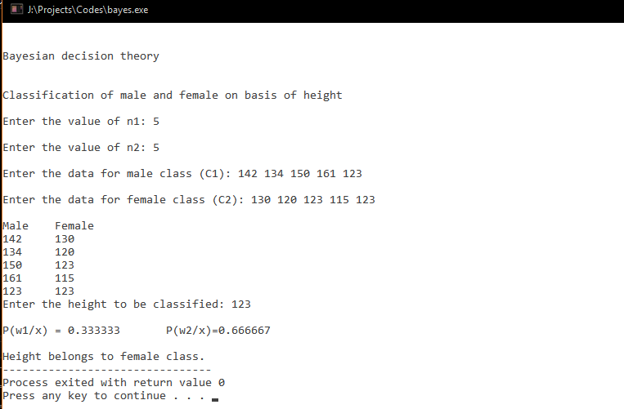

// Minimum Risk Classifier

#include <iostream>

#include <cstdio>

using namespace std;

int main()

{

int total,i,j,ft[2][2];

float loss[2][2],p[2][2];

total=0;

float risk1,risk2;

for(i=0;i<2;i++)

{

cout<<"\nEnter the value of feature "<<i+1<<" for two classes : ";

for(j=0;j<2;j++)

{

cin>>ft[i][j];

total+=ft[i][j];

}

}

cout<<endl;

p[0][0] = ft[0][0]/(float)total;

p[0][1] = ft[0][1]/(float)total;

p[1][0] = ft[1][0]/(float)total;

p[1][1] = ft[1][1]/(float)total;

for(i=0;i<2;i++)

for(j=0;j<2;j++)

printf("P(x%d/c%d)= %.2f\t",i+1,j+1,p[i][j]);

float p1 = (ft[0][0] + ft[0][1]) / (float)total;

float p2 = (ft[1][0] + ft[1][1]) / (float)total;

cout<<"\nP(c1)= "<<p1<<"\tP(c2)= "<<p2<<endl;

float px1 = (ft[0][0] + ft[1][0]) / (float)total;

float px2 = (ft[0][1] + ft[1][1]) / (float)total;

loss[0][0] = 0.01;

loss[0][1] = 0.69;

loss[1][0] = 0.74;

loss[1][1] = 0.01;

for(i=0;i<2;i++)

for(j=0;j<2;j++)

printf("\nloss(alpha%d/w%d)= %.2f\t",i+1,j+1,loss[i][j]);

float pw1x = (p[0][0]*p[1][0]*p1)/(px1*px2);

float pw2x = (p[0][1]*p[1][1]*p2)/(px1*px2);

risk1 = loss[0][0]*pw1x + loss[1][0]*pw1x;

risk2 = loss[0][1]*pw2x + loss[1][1]*pw2x;

cout<<"\n\nRisk (alpha1|x) = "<<risk1<<endl;

cout<<"Risk (alpha2|x) = "<<risk2<<endl;

if(risk1<risk2)

cout<<"\nFeatures belong to Class 1.";

else if(risk2<risk1)

cout<<"Features belong toClass 2.";

else cout<<"Cannot decide.";

return 0;

}

**OUTPUT**

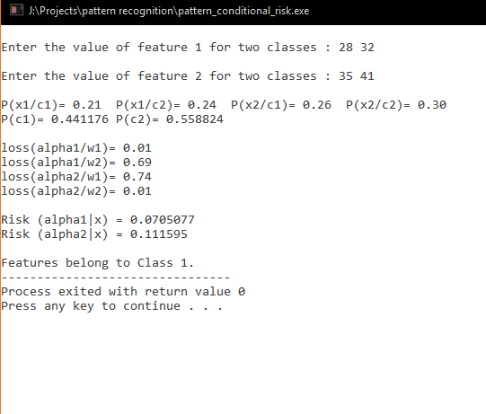

// Minimum error rate classification

#include <iostream>

#include <cstdio>

using namespace std;

int main()

{

int total,i,j,ft[2][2];

float loss[2][2],p[2][2];

total=0;

float risk1,risk2;

for(i=0;i<2;i++)

{

cout<<"\nEnter the value of feature "<<i+1<<" for two classes : ";

for(j=0;j<2;j++)

{

cin>>ft[i][j];

total+=ft[i][j];

}

}

cout<<endl;

p[0][0] = ft[0][0]/(float)total;

p[0][1] = ft[0][1]/(float)total;

p[1][0] = ft[1][0]/(float)total;

p[1][1] = ft[1][1]/(float)total;

for(i=0;i<2;i++)

for(j=0;j<2;j++)

printf("P(x%d/c%d)= %.2f\t",i+1,j+1,p[i][j]);

float p1 = (ft[0][0] + ft[0][1]) / (float)total;

float p2 = (ft[1][0] + ft[1][1]) / (float)total;

cout<<"\nP(c1)= "<<p1<<"\tP(c2)= "<<p2<<endl;

float px1 = (ft[0][0] + ft[1][0]) / (float)total;

float px2 = (ft[0][1] + ft[1][1]) / (float)total;

loss[0][0] = 0.0;

loss[0][1] = 1.0;

loss[1][0] = 1.0;

loss[1][1] = 0.0;

for(i=0;i<2;i++)

for(j=0;j<2;j++)

printf("\nloss(alpha%d/w%d)= %.2f\t",i+1,j+1,loss[i][j]);

float pw1x = (p[0][0]*p[1][0]*p1)/(px1*px2);

float pw2x = (p[0][1]*p[1][1]*p2)/(px1*px2);

risk1 = loss[0][0]*pw1x + loss[1][0]*pw1x;

risk2 = loss[0][1]*pw2x + loss[1][1]*pw2x;

cout<<"\n\nRisk (alpha1|x) = "<<risk1<<endl;

cout<<"Risk (alpha2|x) = "<<risk2<<endl;

if(risk1<risk2)

cout<<"\nFeatures belong to Class 1.";

else if(risk2<risk1)

cout<<"Features belong toClass 2.";

else cout<<"Cannot decide.";

return 0;

}

**OUTPUT**

