Comprehensive Capstone Report: Aerial Object Classification & Detection (Bird vs. Drone)

1. Project Summary
The rapid increase in drone usage has introduced significant challenges in airspace management, security surveillance, and wildlife protection. This project presents a robust, deep learning-based computer vision solution capable of accurately differentiating between birds and drones in real-world aerial imagery. By systematically comparing a Custom Convolutional Neural Network (CNN) against a state-of-the-art Transfer Learning architecture (MobileNetV2), the project established a highly efficient classification pipeline. The final Transfer Learning model achieved an outstanding 97.21% test accuracy. To ensure real-world usability, the model has been successfully deployed as an interactive web application via Streamlit Cloud, with full version control and documentation maintained on GitHub.

2. Introduction & Problem Statement
Distinguishing between a bird and a drone at a distance is a highly complex visual task due to similarities in size, operational altitude, and silhouettes against dynamic backgrounds (e.g., cloudy skies, varied terrain). Accurate identification is critical for several real-time business use cases:
- Aviation Safety: Monitoring airport runways to prevent fatal bird-strikes while simultaneously tracking authorized drone operations.
- Security & Defense: Identifying unauthorized drones in restricted airspace to provide timely threat alerts.
- Wildlife Monitoring: Tracking avian populations near wind farms or nature reserves without misclassifying mechanical objects.
The core objective of this project is to build an automated, AI-driven classifier that minimizes false positives (e.g., triggering a security alarm for a flock of birds) and false negatives (e.g., ignoring a rogue drone).

3. Dataset Analysis & Preprocessing
To ensure the model learns generalized spatial features rather than memorizing the dataset, a rigorous data handling pipeline was established.
3.1 Exploratory Data Analysis (EDA)
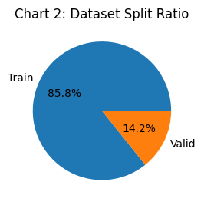
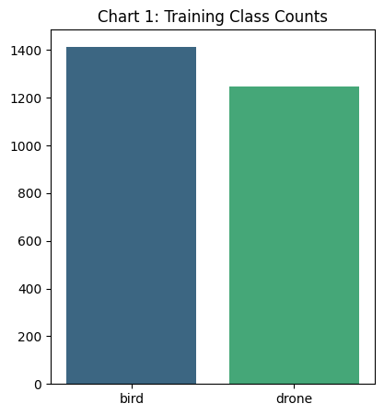
An initial analysis of the dataset confirmed a well-balanced distribution, negating the need for complex synthetic oversampling techniques like SMOTE. The dataset was split into robust Training, Validation, and Testing sets.

Caption: Charts 1 & 2 illustrating the balanced class distribution (1,414 Bird images vs. 1,248 Drone images) and the overall dataset split ratio.

3.2 Preprocessing & Augmentation
- Standardization: All images were strictly resized to 224 × 224 pixels to match standard CNN input requirements. Pixel values were normalized to a [0, 1] scale to stabilize gradient descent and accelerate convergence during training.
- Data Augmentation: To prevent overfitting and simulate varied real-world flight conditions, geometric transformations were applied to the training set. These included a 40-degree rotation range, horizontal flipping, width/height shifting (20%), and zooming (20%).
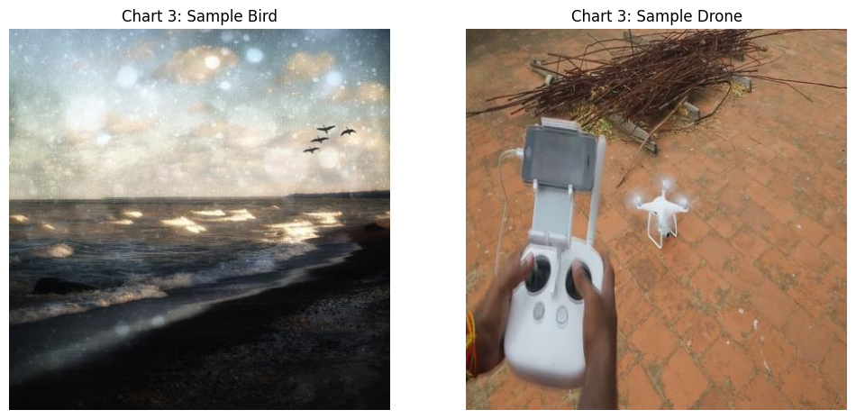Caption: Visual grid of sample aerial images and the applied geometric data augmentations used to prevent model overfitting.

4. Methodology & Model Architecture
The project utilized a comparative methodology, evaluating two distinct deep learning architectures to find the optimal balance between computational efficiency and accuracy.
4.1 Baseline Model: Custom CNN
A Custom CNN was built from scratch to learn hierarchical features directly from the dataset.
- Architecture: Three sequential convolutional blocks (32, 64, and 128 filters) using ReLU activation to capture low-level edges and high-level object shapes.
- Regularization: BatchNormalization was applied after every convolutional layer to stabilize learning, followed by MaxPooling2D to reduce spatial dimensions. A heavy Dropout rate of 50% was applied before the final dense layer to enforce network robustness.
4.2 Advanced Model: Transfer Learning (MobileNetV2)
To leverage features learned from millions of generic images, a Transfer Learning approach was implemented. MobileNetV2 was selected for its use of depthwise separable convolutions, making it incredibly lightweight and highly suited for real-time inference.
- Configuration: Pre-trained ImageNet weights were loaded, and the base layers were frozen. A GlobalAveragePooling2D layer was added to flatten the output, followed by a dense layer (128 neurons) and the final Sigmoid binary classification node.

5. Training Strategy & Results
Both models were compiled using the Adam optimizer and binary_crossentropy loss. To capture the best possible weights and avoid unnecessary computational cost, Early Stopping (patience=5) and ModelCheckpoint callbacks were utilized.
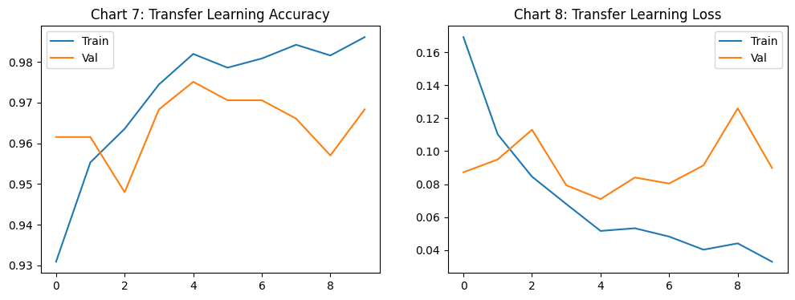
Caption: Training and Validation Accuracy/Loss curves for the Custom CNN and Transfer Learning models. Notice the rapid convergence and superior stability of the Transfer Learning architecture.
5.1 Model Evaluation
The models were evaluated on a strictly unseen test dataset of 215 images to test true real-world generalization.
- Performance Comparison: While the Custom CNN established a strong baseline (~80.5% validation accuracy), the Transfer Learning model significantly outperformed it, achieving an exceptional 97.21% Test Accuracy.
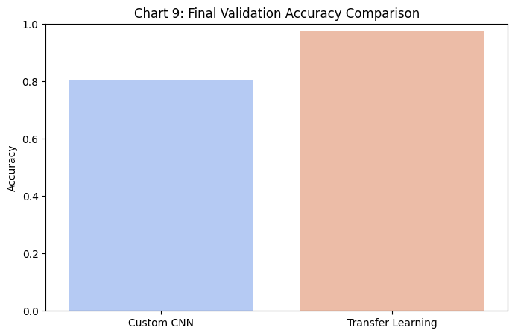
Caption: Direct comparison of generalization performance, highlighting MobileNetV2's superiority for this specific task.
5.2 Detailed Metrics
- Confusion Matrix: Out of 215 test images, the model made only 6 misclassifications (3 false positives, 3 false negatives), proving its reliability for safety-critical applications.
- Precision & Recall: The model achieved an F1-score of 0.97 for Drones and 0.98 for Birds, indicating it handles both categories with nearly equal expertise.
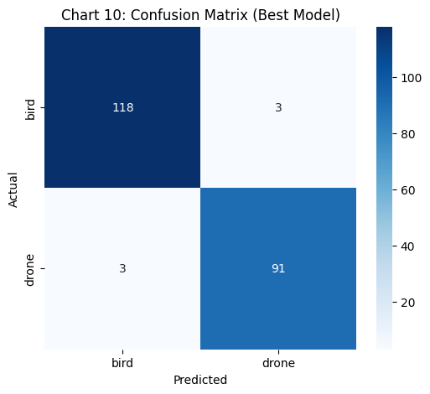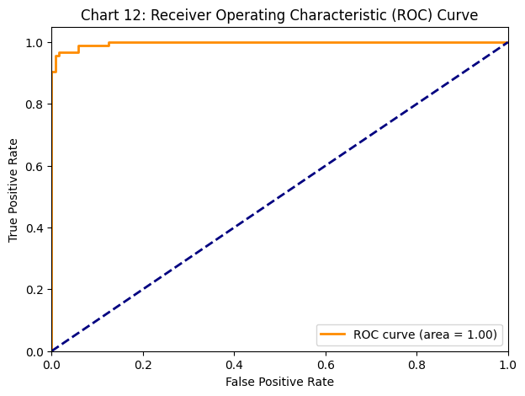
Caption: Confusion Matrix displaying the exact prediction counts, and the ROC Curve demonstrating near-perfect class separability (AUC = 1.00).

6. Streamlit Web Application & Deployment
To transition the model from a local Jupyter Notebook to a production-ready environment, an interactive web application was developed and deployed.
6.1 Application Features
The application was built using the Streamlit framework to provide an intuitive UI for end-users. Key features include:
- Dual Input Methods: Users can upload existing aerial photos via drag-and-drop or use live camera input.
- Automated Preprocessing: The application autonomously resizes, normalizes, and reshapes inputs to match the model's expected (1, 224, 224, 3) tensor format.
- Dynamic Analytics: The UI features visual progress bars detailing the exact probability breakdown between classes, alongside automated warnings if the model's confidence drops below 70%.
6.2 Deployment & Version Control
The complete application pipeline has been deployed to the cloud:
- Streamlit Cloud Deployment: The application is hosted live, allowing stakeholders to interact with the deep learning model in real-time from any web browser without requiring a local Python environment.
- GitHub Integration: The entire codebase—including the Jupyter notebooks, model weights (.keras), Streamlit app.py, and requirements.txt—is version-controlled and publicly accessible on GitHub, ensuring strict academic reproducibility.
[🖼️ INSERT IMAGES HERE: Screenshot 2026-04-14 195925.png AND Screenshot 2026-04-14 195939.png]
Caption: The deployed Streamlit Web Application showcasing the clean user interface, probability progress bars, and real-time classification results for both Bird and Drone inputs.

7. Conclusion & Future Scope
This project successfully proves that Transfer Learning architectures like MobileNetV2 are highly effective for complex, real-world aerial image classification. The end-to-end pipeline—from rigorous dataset augmentation to cloud deployment—proves the model's viability for commercial security, defense, and wildlife monitoring systems.
Future Enhancements:
The next planned evolution for this project expands beyond Image Classification into Object Detection. A separate module utilizing YOLOv8 (You Only Look Once) has been structured to not only classify the object but to draw precise bounding boxes around multiple targets simultaneously, paving the way for advanced spatial tracking in live drone video feeds.

