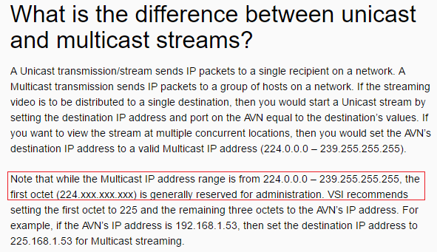

RTP was specifically designed for delivering realtime multimedia and has capabilities built in for detecting out of sequence packets and jitter compensation. it sits atop of UDP and is usually implemented as a library used from within userspace. What it does is providing you with additional capabilities that the UDP alone cannot provide you with:

* Identification of the payload type
* Identification of stream sources in a protocol-neutral way (the SSRC and CSRC fields)
* Identification of important frames (for sync purposes, for example)
* Sequencing used to detect lost and reordered segments
* Timestamping to synchronize and correlate multiple streams (video and audio, for example)

**UDP streaming(Multicast):** Default SLA Camera sends packets on udp://224.10.10.10:15004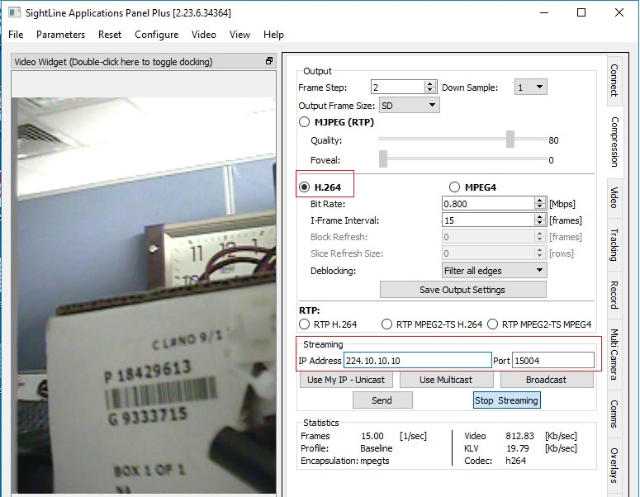

**RTSP streaming(Multicast):** Now u will get stream on VLC at rtsp://192.168.1.232 which is

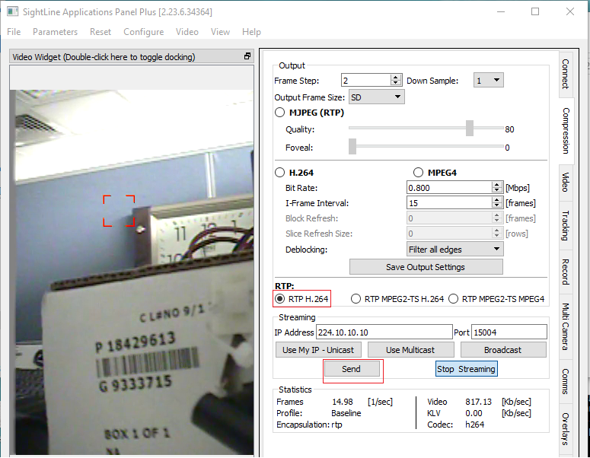

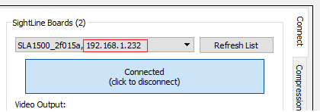

**RTP(Unicast):** Perform below steps and close SLA application without closing video streaming.

Create a “XYZ.SDP” file in any directory and save it after putting below lines.

m=video 5600 RTP/AVP 96

a=rtpmap:96 H264/90000

where “5600” is port number describe in image below. And open this file in VLC

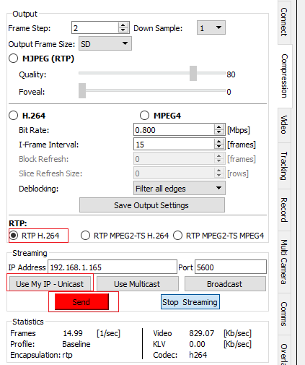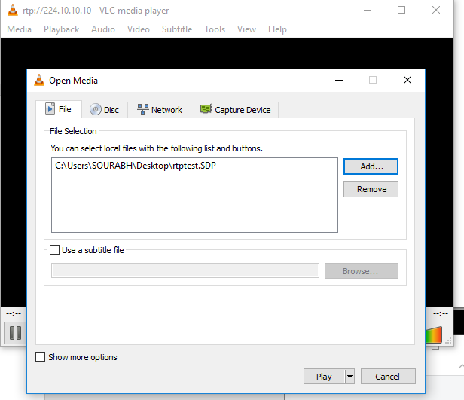

**RTP(multicast):**

rtp://224.10.10.10:15004

rtps://192.168.1.232

