1. get [VS-2017](https://www.visualstudio.com/en/downloads/) with full compiler like: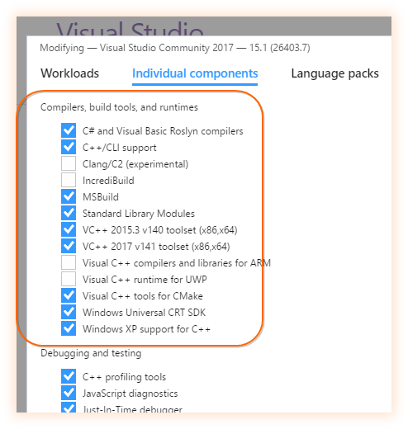
2. get the newest [CMake](https://cmake.org/) (uninstall older versions)
3. get from github the sourceCode <https://github.com/opencv/opencv/tree/2.4> and place those in C:/openCV folder, create a BUILD folder there too
4. open Cmake, select the opencv master folder... in the build write the build directory like:

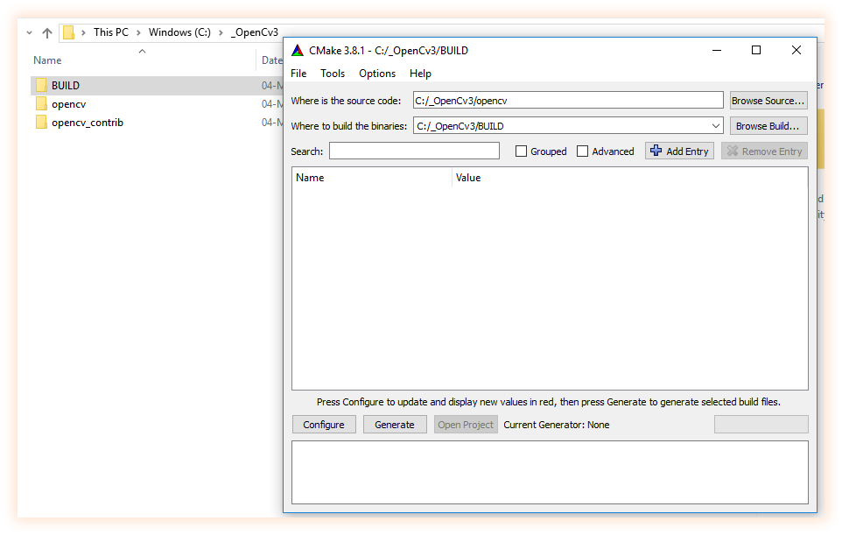

1. click configure, select visual studio 15 2017 and leave selected "use default native compilers", then press "finish"...

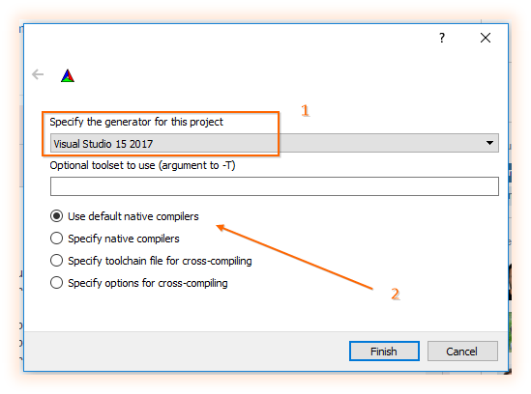

1. now you should see cmake doing its job :)

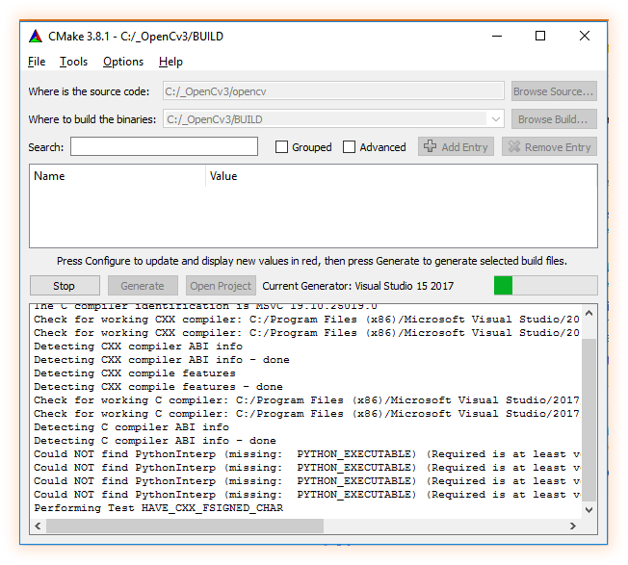

1. once configuration is done set the opencv extra modules path and click configure again, and when is done click generate! :)

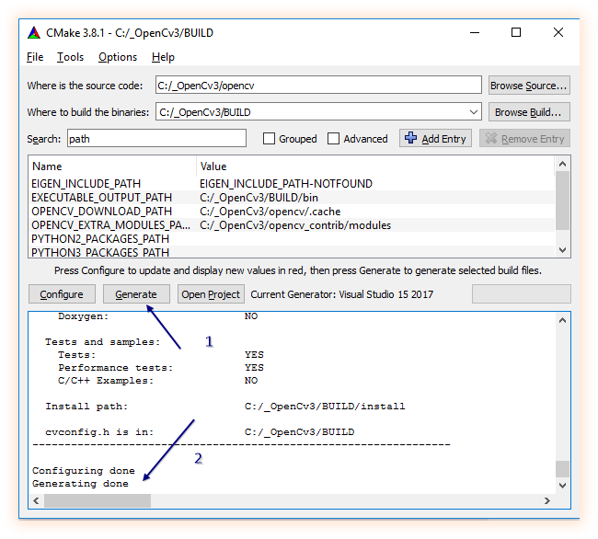

1. when generation is done click "open project", this will open a huge project in visual studio named "opencv", now you can close cmake, we dont need that anymore.
2. now, when the solution is ready, be sure you are in "debug" conf and do right click on "ALL_BUILD" and then "build" (that can take a while) once build succeed change to "release" config and do right click on "ALL_BUILD" and then "build" again.
3. now,be sure you are in "debug" conf and do right click on "INSTALL" and then "build" (that can take a while) once build succeed change to "release" config and do right click on "INSTALL" and then "build" again.

