**PUNE INSTITUTE OF COMPUTER TECHNOLOGY,**

**DHANKWADI, PUNE - 411043**

CLASS: TE-3

BATCH: N3

SUBJECT: DSBDAL

Group Members:

Shantanu Jain (31369 )

Adarsh Tambe (31381)

Rutik Wagh (31387)

Yash Rajput (31389)

**Mini Project**

**Title:** SaaS Application for uploading and downloading files from cloud.

**Problem Statement:** Setup your own cloud for Software as a Service (SaaS) over the existing LAN in your laboratory. In this assignment you have to write your own code for cloud controller using open-source technologies to implement with HDFS. Implement the basic operations may be like to divide the file in segments/blocks and upload/ download file on/from cloud in encrypted form.

**Objectives:**

* To understand the hosting SaaS application.
* To explore cloud computing for SaaS.

**Outcomes:**

* To be able to build application.
* To be able to host it on any cloud platform.

**Requirements:**

* Computer System with: I5 processor, 256 GB SSD, 8GB RAM.
* Firebase

**Introduction to Project:**

What exactly is a Cloud Document Management System? A cloud DMS is a web-based data storing and managing app that surpasses traditional in-house data servers, allowing smarter businesses to store, analyse, and track electronic files and folders.

**Key capabilities**

**•** Flexibility

• Expressive querying

• Realtime updates

• Offline support

• Designed to scale

**Cloud Firestore is a cloud-hosted, NoSQL database that your Apple, Android, and web apps can access directly via native SDKs.**

Following Cloud Firestore's NoSQL data model, you store data in documents that contain fields mapping to values. These documents are stored in collections, which are containers for your documents that you can use to organize your data and build queries. Documents support many different data types, from simple strings and numbers, to complex, nested objects. You can also create subcollections within documents and build hierarchical data structures that scale as your database grows. The Cloud Firestore data model supports whatever data structure works best for your app.

**What is SaaS**

SaaS provides a complete software solution which you purchase on a pay-as-you-go basis from a [cloud service provider](https://azure.microsoft.com/en-in/overview/choosing-a-cloud-service-provider/). You rent the use of an app for your organisation and your users connect to it over the Internet, usually with a web browser. All of the underlying infrastructure, middleware, app software and app data are located in the service provider’s data center. The service provider manages the hardware and software and with the appropriate service agreement, will ensure the availability and the security of the app and your data as well. SaaS allows your organisation to get quickly up and running with an app at minimal upfront cost.

**Advantages of SaaS cloud computing layer**

1) SaaS is easy to buy

SaaS pricing is based on a monthly fee or annual fee subscription, so it allows organizations to access business functionality at a low cost, which is less than licensed applications.

Unlike traditional software, which is sold as a licensed based with an up-front cost (and often an optional ongoing support fee), SaaS providers are generally pricing the applications using a subscription fee, most commonly a monthly or annually fee.

2. One to Many

SaaS services are offered as a one-to-many model means a single instance of the application is shared by multiple users.

3. Less hardware required for SaaS

The software is hosted remotely, so organizations do not need to invest in additional hardware.

4. Low maintenance required for SaaS

Software as a service removes the need for installation, set-up, and daily maintenance for the organizations. The initial set-up cost for SaaS is typically less than the enterprise software. SaaS vendors are pricing their applications based on some usage parameters, such as a number of users using the application. So SaaS does easy to monitor and automatic updates.

5. No special software or hardware versions required

All users will have the same version of the software and typically access it through the web browser. SaaS reduces IT support costs by outsourcing hardware and software maintenance and support to the IaaS provider.

6. Multidevice support

SaaS services can be accessed from any device such as desktops, laptops, tablets, phones, and thin clients.

7. API Integration

SaaS services easily integrate with other software or services through standard APIs.

8. No client-side installation

SaaS services are accessed directly from the service provider using the internet connection, so do not need to require any software installation.

**What is Firebase?**

Cloud Firestore is a flexible, scalable database for mobile, web, and server development from Firebase and Google Cloud. Like Firebase Realtime Database, it keeps your data in sync across client apps through real-time listeners and offers offline support for mobile and web so you can build responsive apps that work regardless of network latency or Internet connectivity. Cloud Firestore also offers seamless integration with otherFirebase and Google Cloud products, including Cloud Functions.

**Architecture**

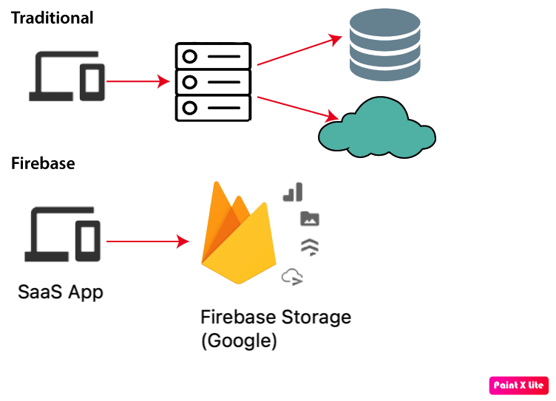

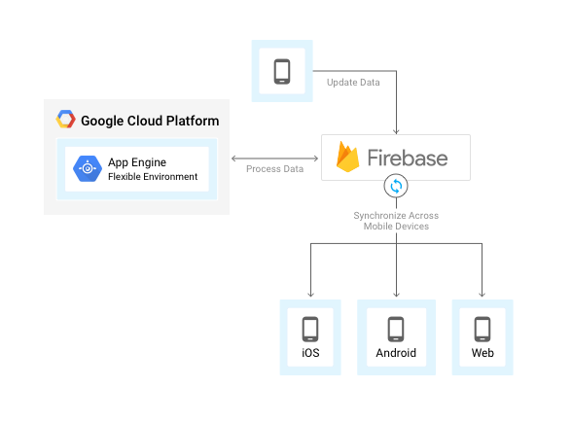

**Implementation:**

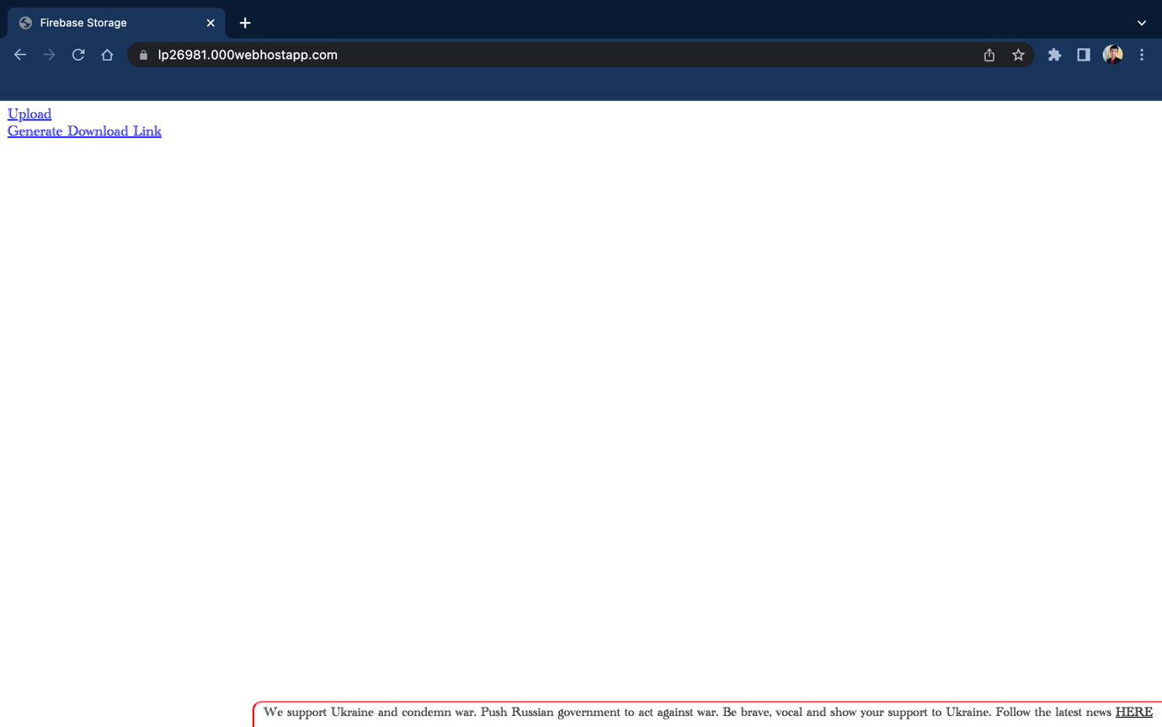

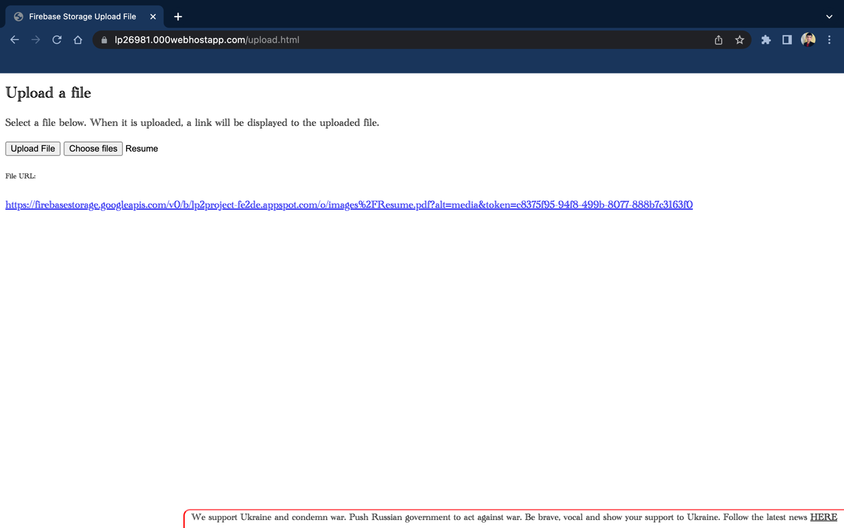

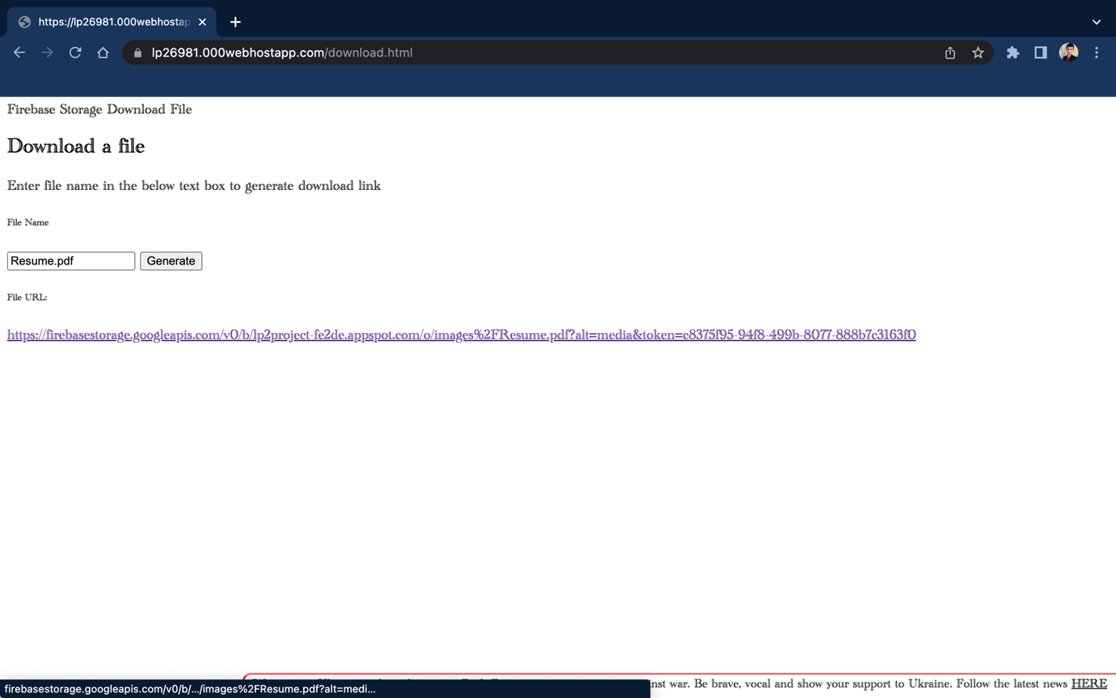

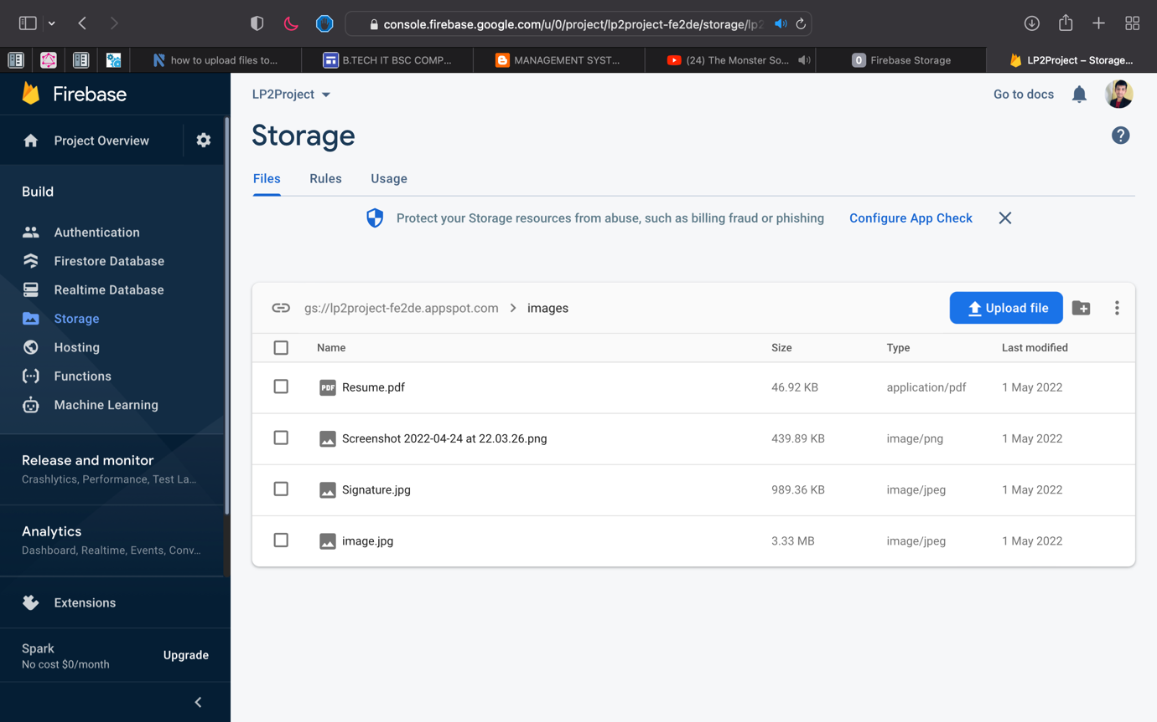

**Conclusion**

We have implemented SaaS application using Google Firebase and hosted it on 000webhost.com. We are able to create SaaS application using Firebase Cloud.