**New Screenshot**

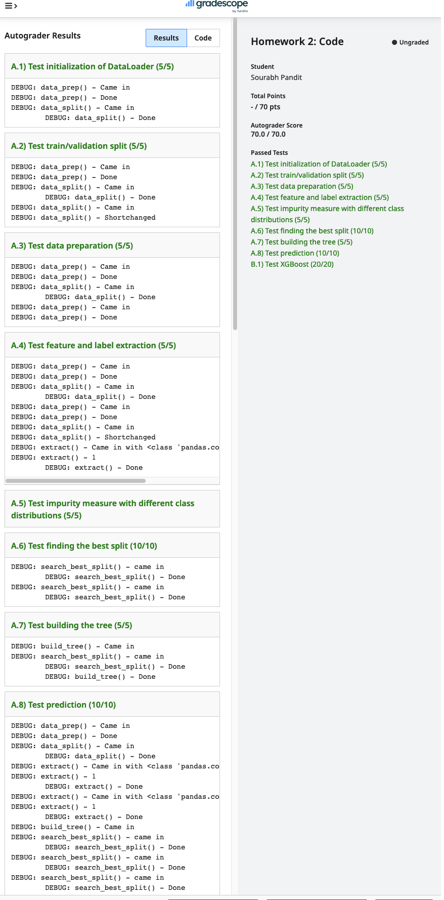

**OLD Screenshot**

