**Changes made in To Do App to implement microphone audio input from user and accept it as task:**

1]We imported the microphone icon from Material UI website.

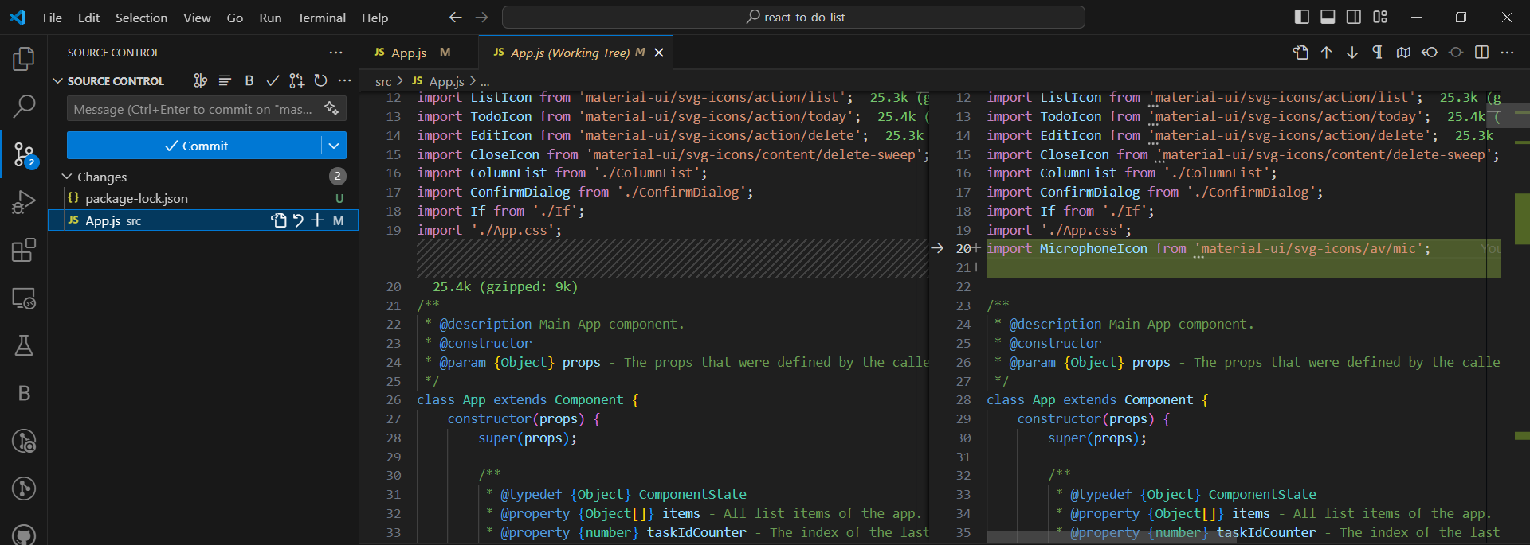

import MicrophoneIcon from 'material-ui/svg-icons/av/mic';

2]We add speechInput as empty string to our object this.state.

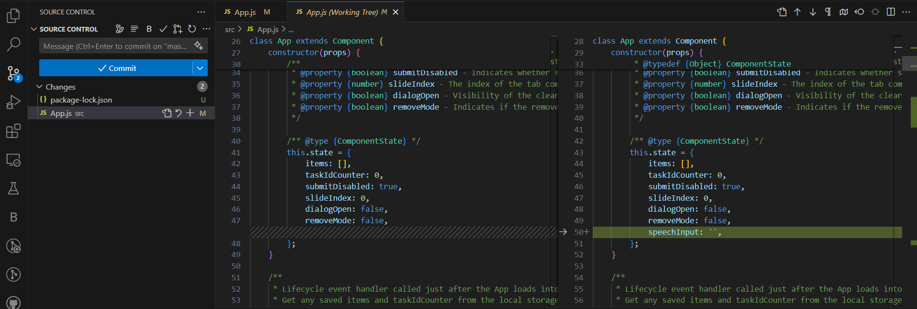

speechInput: '',

3] We add 2 functions addAudioTask and handleSpeechRecognition. addAudioTask() for appending our task to existing tasks.

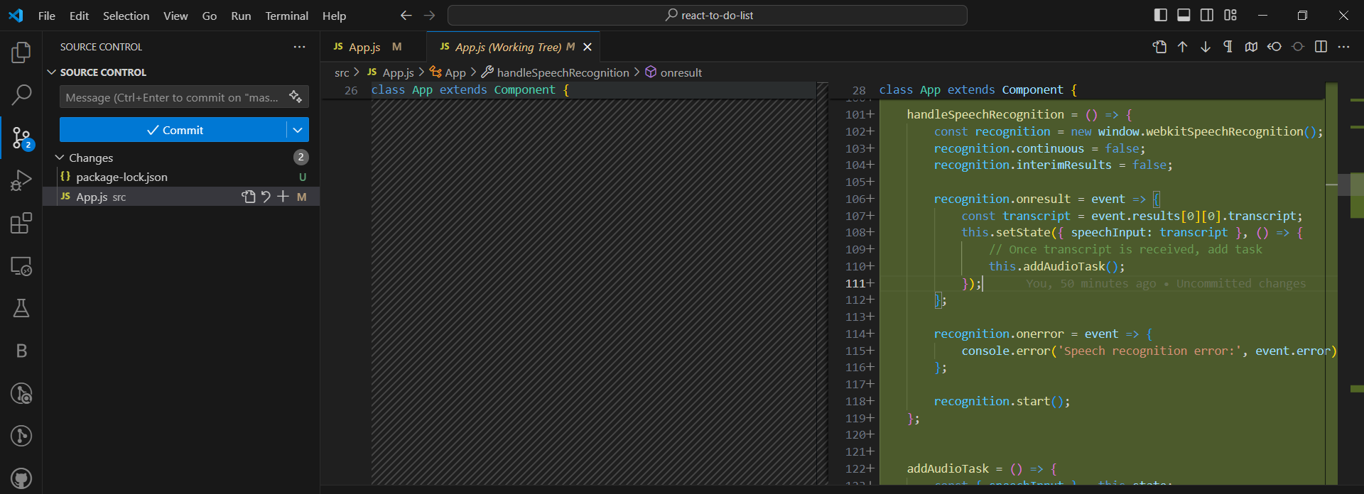

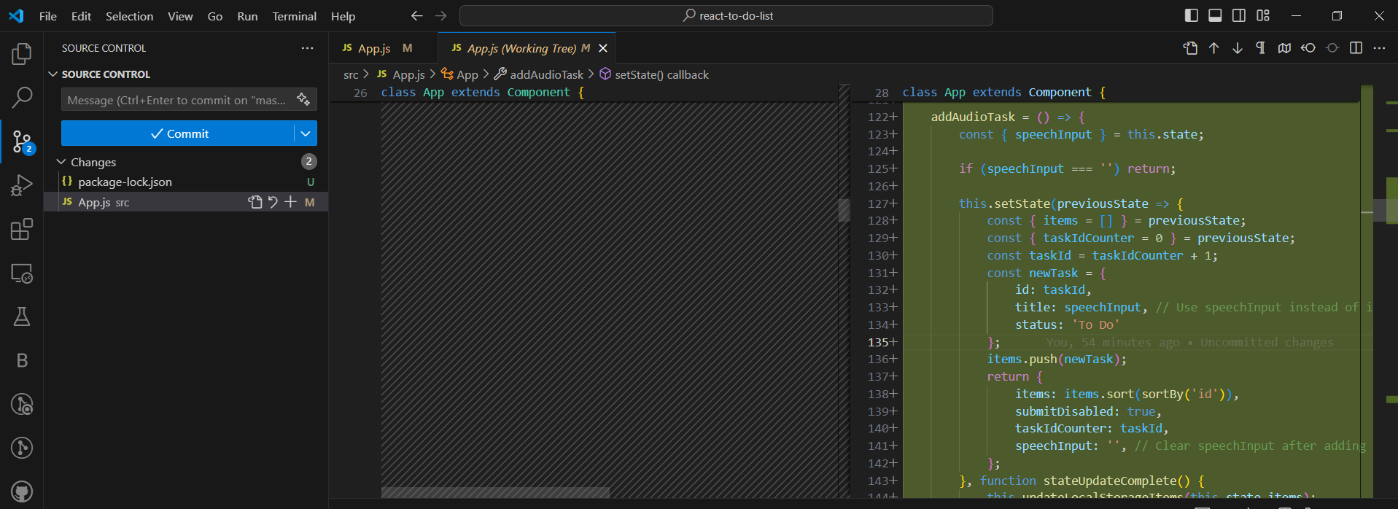

handleSpeechRecognition = () => {

        const recognition = new window.webkitSpeechRecognition();

        recognition.continuous = false;

        recognition.interimResults = false;

        recognition.onresult = event => {

            const transcript = event.results[0][0].transcript;

            this.setState({ speechInput: transcript }, () => {

                // Once transcript is received, add task

                this.addAudioTask();

            });

        };

        recognition.onerror = event => {

            console.error('Speech recognition error:', event.error);

        };

        recognition.start();

    };

    addAudioTask = () => {

        const { speechInput } = this.state;

        if (speechInput === '') return;

        this.setState(previousState => {

            const { items = [] } = previousState;

            const { taskIdCounter = 0 } = previousState;

            const taskId = taskIdCounter + 1;

            const newTask = {

                id: taskId,

                title: speechInput, // Use speechInput instead of input value

                status: 'To Do'

            };

            items.push(newTask);

            return {

                items: items.sort(sortBy('id')),

                submitDisabled: true,

                taskIdCounter: taskId,

                speechInput: '', // Clear speechInput after adding task

            };

        }, function stateUpdateComplete() {

            this.updateLocalStorageItems(this.state.items);

            this.updateTaskCounter(this.state.taskIdCounter);

        }.bind(this));

    };

4] We add new button “Speak” which is similar to “Create”.

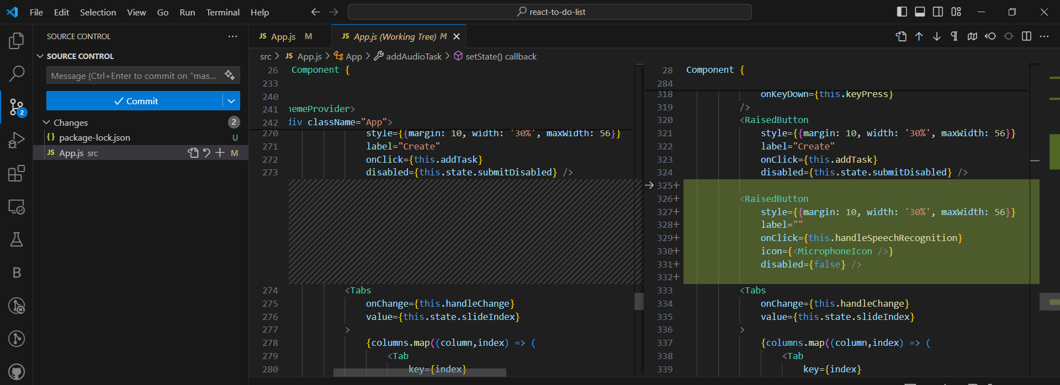

<RaisedButton

      style={{margin: 10, width: '30%', maxWidth: 56}}

      label=""

      onClick={this.handleSpeechRecognition}

      icon={<MicrophoneIcon />}

      disabled={false} />